Project Report
Project Title: Cosmetic Insights: Navigating Cosmetics Trends and Consumer Insights with Tableau
Name: Yerragundla Mishal
College: Annamacharya Institute of Technology and Sciences, Tirupati
Department: Artificial Intelligence and Data Science
Internship Company: SmartBridge
Tableau Public: https://public.tableau.com/app/profile/yerragundla.mishal/vizzes
GitHub Repository: <Add GitHub Repository Link Here>

1. INTRODUCTION
Project Overview
This project analyzes cosmetic product data using Tableau to uncover trends in product categories, pricing, brands, customer ratings, and skin-type suitability. Interactive dashboards and story points help present insights for decision-making.

Purpose
The purpose is to transform raw cosmetic product data into meaningful visual insights that help understand consumer preferences and market trends.

2. IDEATION PHASE
Problem Statement
Consumers and businesses often find it difficult to compare cosmetic products across brands, prices, and skin types. The project addresses this by creating an interactive Tableau dashboard.

Empathy Map Canvas
Users want reliable comparisons, simple visualizations, and quick insights.

Brainstorming
Potential KPIs identified include category distribution, top brands, pricing trends, revenue analysis, and product ratings.

3. REQUIREMENT ANALYSIS
Customer Journey Map
Collect Data → Prepare Data → Build Worksheets → Dashboard → Story → Insights.

Solution Requirements
Dataset, Tableau Public, Excel, interactive charts.

Data Flow Diagram
Excel Dataset → Tableau Data Preparation → Worksheets → Dashboard → Story → User.

Technology Stack
Microsoft Excel, Tableau Public, GitHub.

4. PROJECT DESIGN
Problem Solution Fit
Interactive visualizations simplify cosmetic market analysis.

Proposed Solution
Develop worksheets, combine them into a dashboard, and present findings through a Tableau Story.

Solution Architecture
Dataset → Tableau Processing → Visualizations → Dashboard → Story → End User.

5. PROJECT PLANNING & SCHEDULING
Planning included data import, cleaning, worksheet creation, dashboard design, story creation, testing, and publishing.

6. FUNCTIONAL AND PERFORMANCE TESTING
Dataset Size: 1,472 rows × 10 columns.
Filters and interactions were tested successfully. Dashboard and Story loaded correctly. Visualizations rendered smoothly.

7. RESULTS
Created visualizations:
• Brand Count
• Skin Type Count
• Category-wise Distribution
• Category-wise Revenue
• Top 10 Brands
• Average Brand Pricing
• Price vs Rank
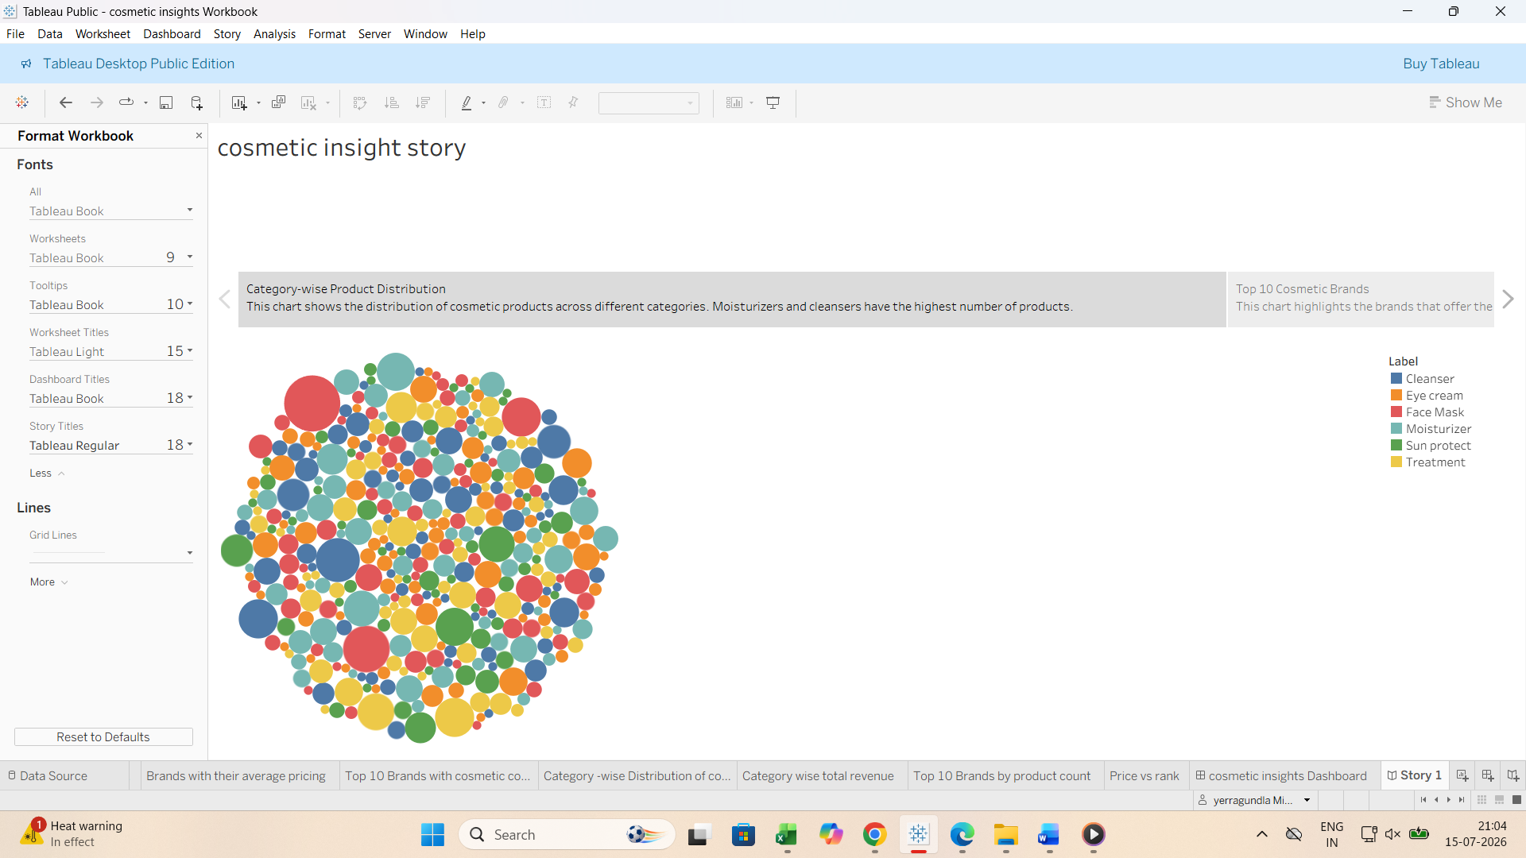

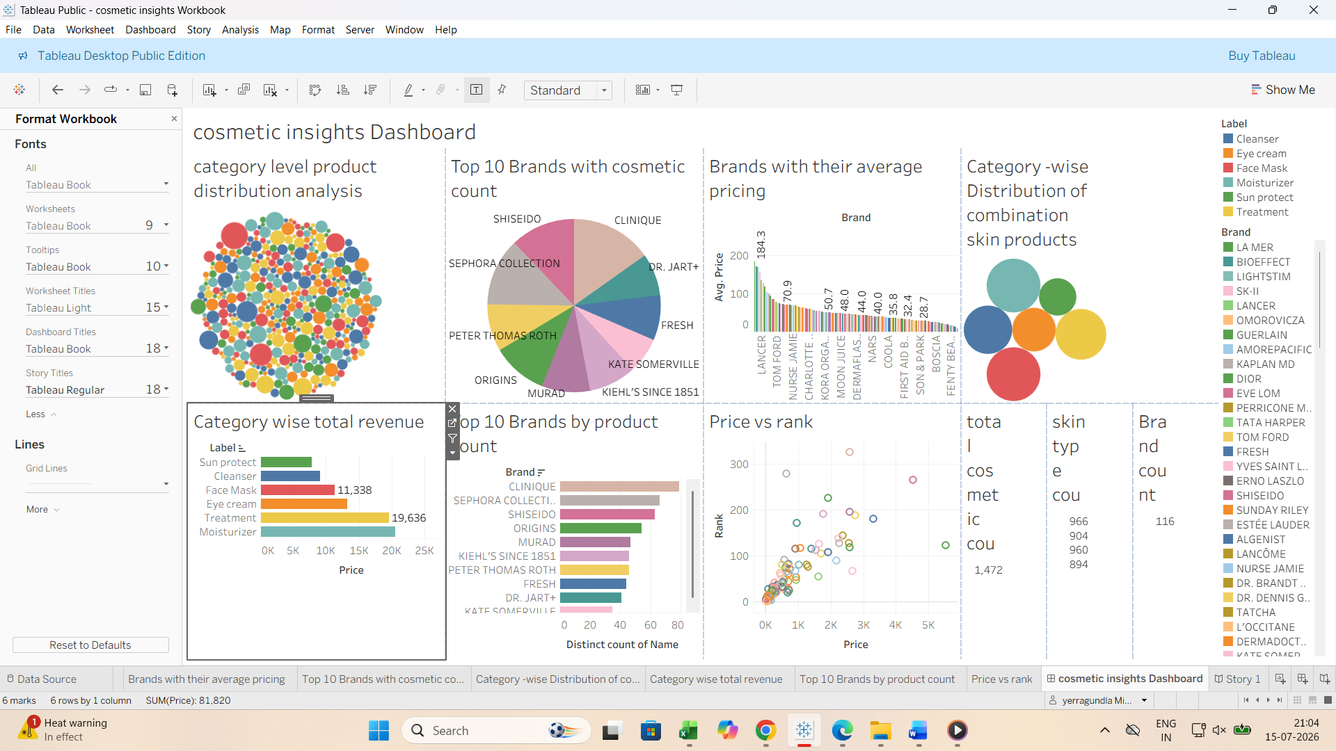

8. ADVANTAGES & DISADVANTAGES
Advantages:
• Interactive analysis
• Easy comparison of brands and prices
• Clear storytelling

Disadvantages:
• Depends on dataset quality
• Tableau Public requires internet for sharing.

9. CONCLUSION
The project successfully demonstrates how Tableau can transform cosmetic product data into meaningful business insights through dashboards and stories.

10. FUTURE SCOPE
Add sentiment analysis from reviews, predictive analytics, recommendation systems, and live data integration.

11. APPENDIX
Dataset: Cosmetics Dataset
Tableau Public: https://public.tableau.com/app/profile/yerragundla.mishal/vizzes

