Lab Taks-1

Question-
Draw the object-

Graph Plot (Picture)-

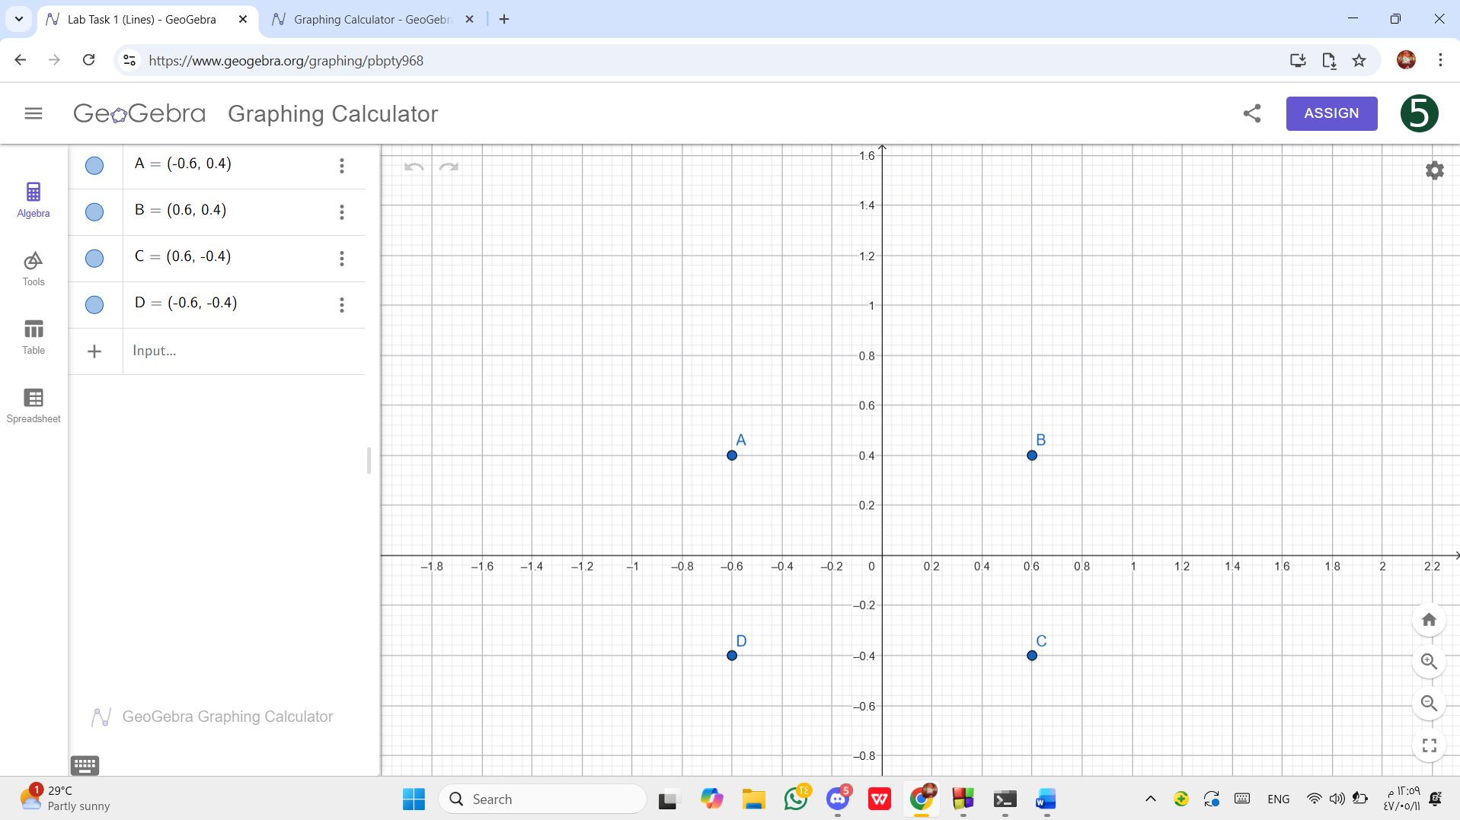

Code-
#include <windows.h>
#include <GL/glut.h>
void display() {
glClearColor(1.0, 1.0, 1.0, 1.0);
glClear(GL_COLOR_BUFFER_BIT);

glColor3f(0.0f, 0.0f, 0.0f); // Black color
glLineWidth(5.0f); // line thickness
glBegin(GL_LINE_LOOP); // Connects points as lines in a loop
glVertex2f(-0.6f, 0.4f); // A
glVertex2f( 0.6f, 0.4f); // B
glVertex2f( 0.6f, -0.4f); // C
glVertex2f(-0.6f, -0.4f); // D
glEnd();

glFlush();
}

int main(int argc, char** argv) {
glutInit(&argc, argv);
glutInitWindowSize(500, 500);
glutInitWindowPosition(50, 50);
glutCreateWindow("Rainbow Flag");
glutDisplayFunc(display);
glutMainLoop();
return 0;

}

Output Screenshot (Full Screen)-

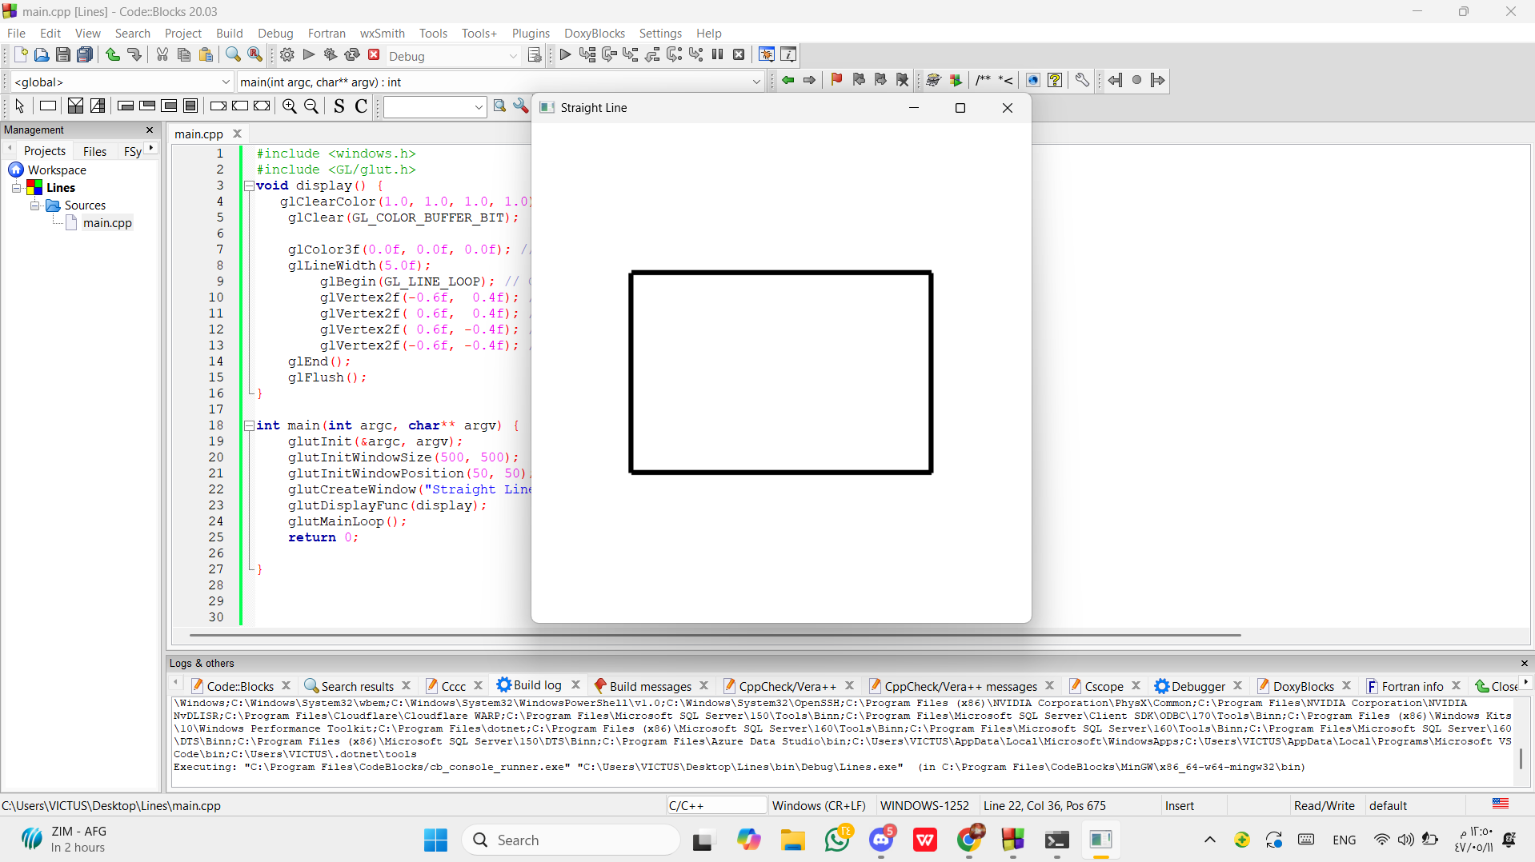

Question-
Draw the object-

Graph Plot (Picture)-

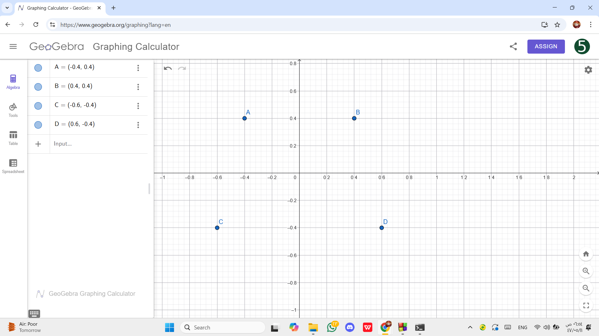

Code-
#include <windows.h>
#include <GL/glut.h>
void display() {
glClearColor(1.0, 1.0, 1.0, 1.0);
glClear(GL_COLOR_BUFFER_BIT);

glColor3f(1.0f, 0.0f, 0.0f);
glBegin(GL_QUADS);
glVertex2f(-0.4f, 0.4f); // A
glVertex2f( 0.4f, 0.4f); // B
glVertex2f( 0.6f, -0.4f); // D
glVertex2f(-0.6f, -0.4f); // C
glEnd();

glFlush();
}

int main(int argc, char** argv) {
glutInit(&argc, argv);
glutInitWindowSize(500, 500);
glutInitWindowPosition(50, 50);
glutCreateWindow("Rainbow Flag");
glutDisplayFunc(display);
glutMainLoop();
return 0;

}

Output Screenshot (Full Screen)-

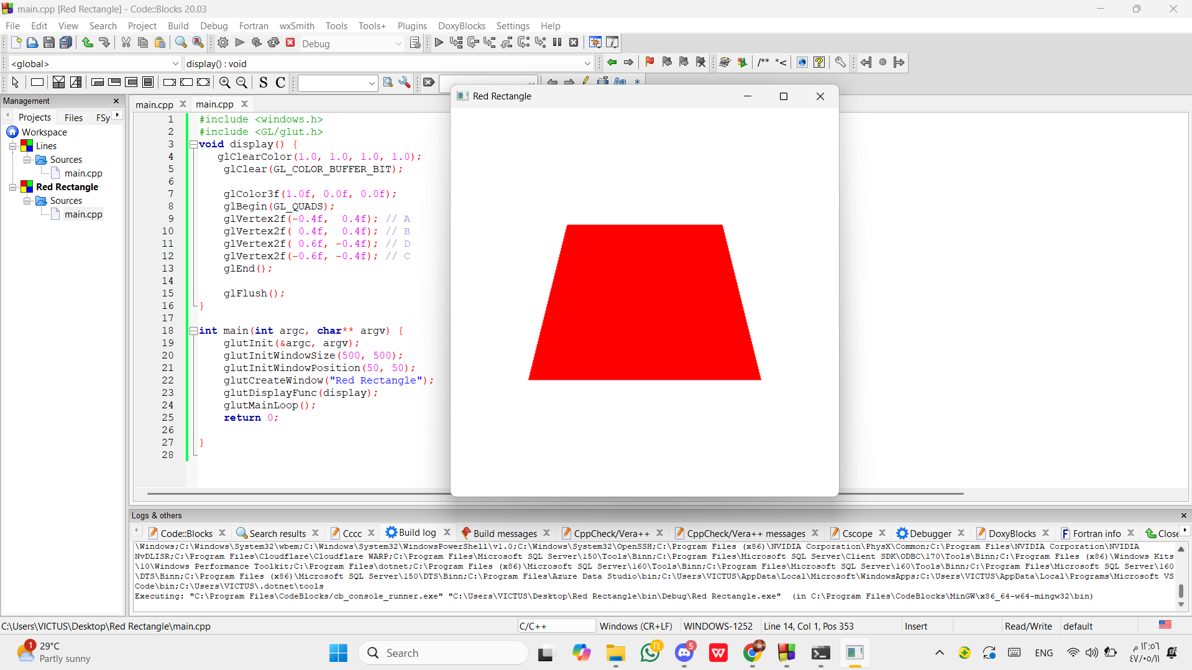

Question-
Draw the object-

Graph Plot (Picture)-

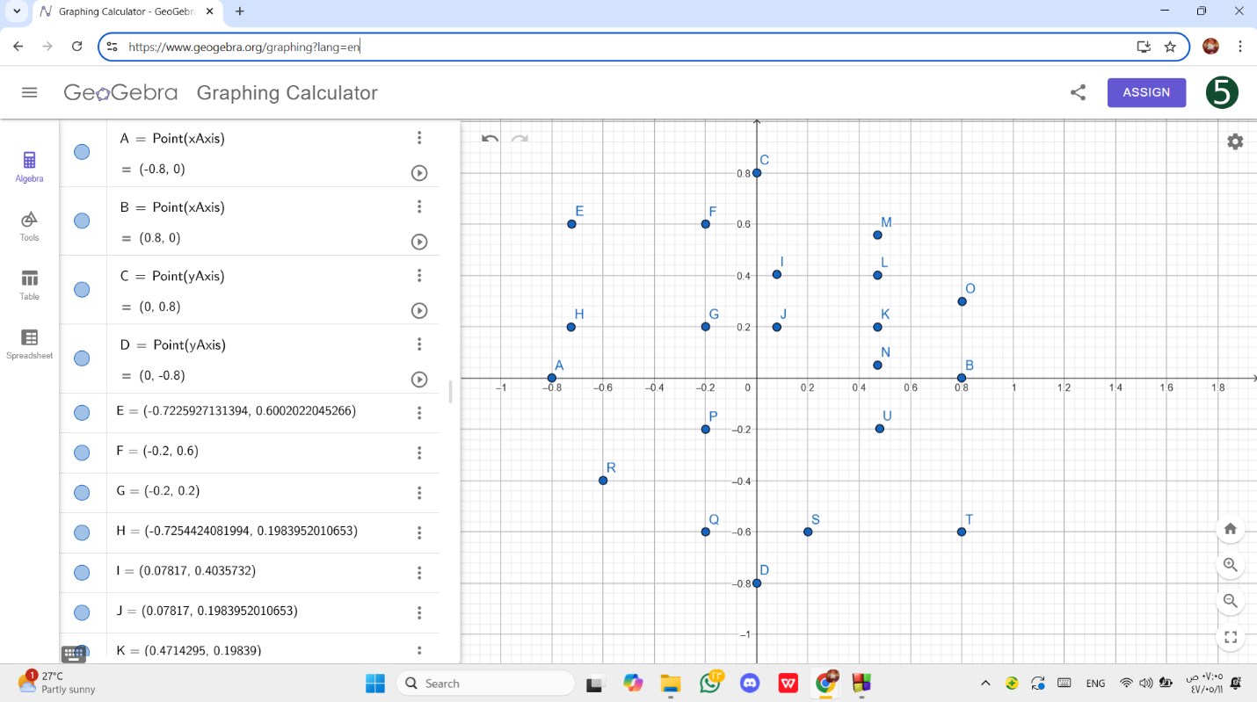

Code-
#include <windows.h>
#include <GL/glut.h>
void display() {
glClearColor(1.0, 1.0, 1.0, 1.0);
glClear(GL_COLOR_BUFFER_BIT);

glColor3f(0.0f, 0.0f, 0.0f); // Black color
glLineWidth(3.0f); // Line thickness
glBegin(GL_LINES); // Start drawing a line
glVertex2f(-0.8f, 0.0f); // Point A
glVertex2f( 0.8f, 0.0f); // Point B
glEnd();
glBegin(GL_LINES); // Start drawing a line
glVertex2f( 0.0f, 0.8f); // C
glVertex2f( 0.0f, -0.8f); // D

glEnd();

glColor3f(1.0f, 0.0f, 0.0f);
glBegin(GL_QUADS);
glVertex2f(-0.7225927f, 0.6002022f); // E
glVertex2f(-0.2f, 0.6f); // F
glVertex2f(-0.2f, 0.2f); // G
glVertex2f(-0.7254424f, 0.1983952f); // H

glEnd();
glColor3f(0.0f, 1.0f, 0.0f); // Green
glBegin(GL_POLYGON); // Start polygon
glVertex2f(0.07817f, 0.4035732f); // I
glVertex2f(0.07817f, 0.1983952f); // J
glVertex2f(0.4714295f, 0.19839f); // K
glVertex2f(0.4714295f, 0.4035732f); // L
glEnd();
glBegin(GL_TRIANGLES); // Start drawing triangle
glVertex2f(0.4714295f, 0.557456f); // M
glVertex2f(0.4714295f, 0.050211f); // N
glVertex2f(0.8019941f, 0.2981345f); // O
glEnd();

glColor3f(1.0f, 0.0f, 1.0f); // Purple color
glBegin(GL_TRIANGLES); // Draw filled triangle
glVertex2f(-0.2f, -0.2f); // P
glVertex2f(-0.2f, -0.6f); // Q
glVertex2f(-0.6f, -0.4f); // R
glEnd();

glColor3f(1.0f, 1.0f, 0.0f); // Yellow color
glBegin(GL_TRIANGLES); // Draw filled triangle
glVertex2f(0.2f, -0.6f); // S
glVertex2f(0.8f, -0.6f); // T
glVertex2f(0.4799786f, -0.1977124f); // U
glEnd();

glFlush();
}

int main(int argc, char** argv) {
glutInit(&argc, argv);
glutInitWindowSize(500, 500);
glutInitWindowPosition(50, 50);
glutCreateWindow("Rainbow Flag");
glutDisplayFunc(display);
glutMainLoop();
return 0;

}

Output Screenshot (Full Screen)-

