**Project Report**

**Name:** Shaown(肖恩) **---** **ID:** 201762000021

**Task One: Add at least 3 more courses to the Student Class**

**Code changes for the task:**

First in the “Student” class added three extra variables for 3 new courses.

Then had to add these to following functions:

calculate(), getdata(), showdata(), show_tabular()

**The reasons you made this change:**

To store three more course’s score in had to add new variables. And had to add those to functions to calculate average, to get input from user, to show individual result and show class result.

**The effect of the change:**

User can see and add three extra courses from existing multiple commands.

….

**Task Two:** **Add the average score of students in a class**

**Code changes for the task**:

To show the average score of all students, I used “average” score of each student, which was already calculated by default. So the trick was, get “average” marks of each student and divide it by total student number.

Added “double student::average()” in the Student class, to get “average” score of individua student.

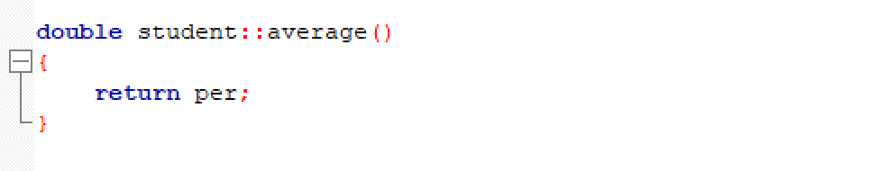

In “**class_result()**” function there is a loop which shows each result by reading from “student.dat” file line by line. So, I used the loop to sum up the average of each student and also counted total students numbers. 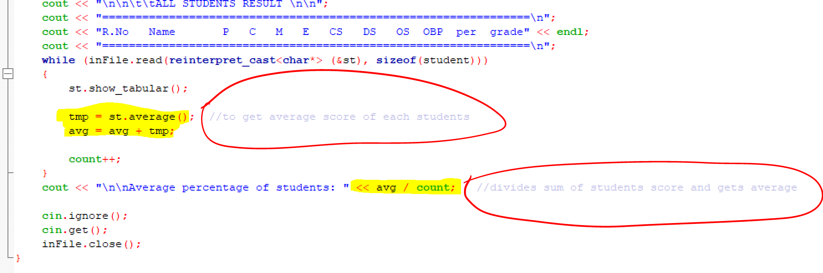

**The reasons i made this change:**

Average score of all students can be found in ‘’Class_result” option.

Since all student’s record were shown there, it is convenient to show it there. I find this quite efficient to do it this way. And I used an previously existing loop. So, had to add only 3 new variables.

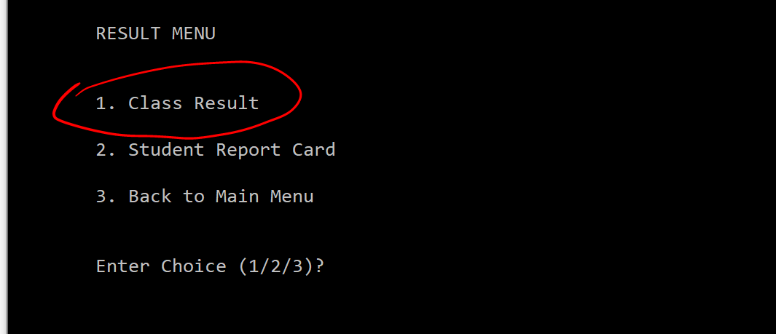

**The effect of the change:**

You can always get the average score all students no matter the data was already given or newly updated. It’s always shows calculates and shows the latest data.

…

**Task Three: Reading student score from txt file and add to student File**

**Code changes for the task**:

Added function **void read_data()**.

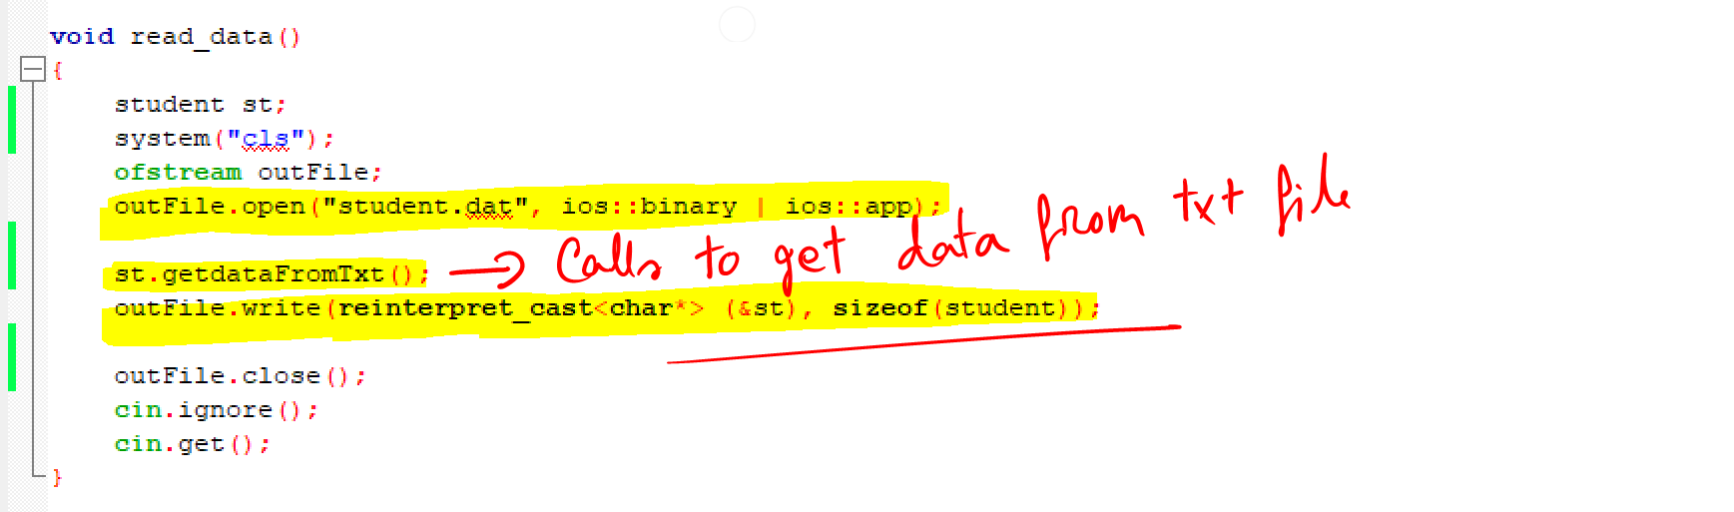

Added **void student::getdataFromTxt()** in Class to store values to Student Structure.

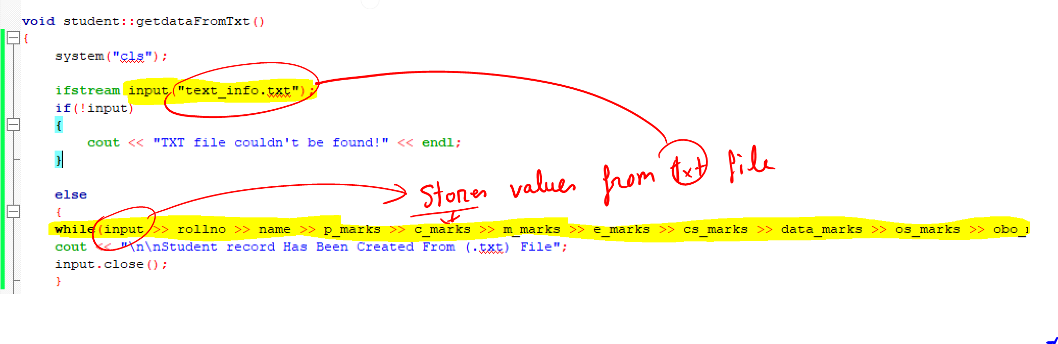

Function **read_Data()** copies the information from TXT file and saves it to “student.dat”, in similar way the source code stores student record.

To do that, it calls **getdataFromTxt().** This function reads data from TXT file using ifstream. It stores data to existing variables in Student class.

Then, this piece of code does the trick and saves a new student record.

outFile.write(reinterpret_cast<char*> (&st), sizeof(student));

in read_data() function.

**The reasons i made this change:**

I Find this way of reading the txt file and copying information to the main file is quite useful. It doesn’t require to add new variables. Also, this process of copying data was done in similar fashion as the source code does to write a new record. So, other people who is reading the code can easily understand what’s going on.

**The effect of the change:**

In the main function I added an option which allows the user to read the txt file and automatically copy the information to main file.

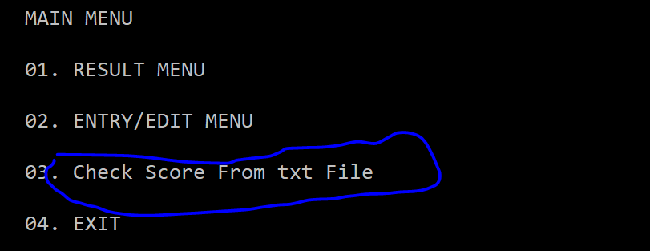

Addition, You have to have an existing txt file named as “text_info.txt” in the same folder with the source code and written information in similar fashion as shown below.

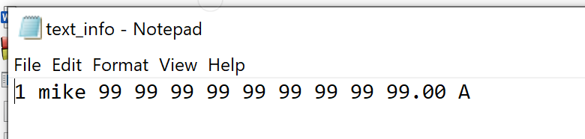

When I run the copy command, it copies text data to main file.

