VxT Authorization and Routing Services

Distributed Routing and Authorization:

The VxT routing system is built around the notion of a services database and it may be used to support bare metal and hypervisor based systems. In all cases the authorization database is accessed across a secure communication media. In the hypervisor style layout, the database is distributed in a hub and spoke fashion with each Dom0 serving as a hub. The authorization database records reside in the Dom0 virtual machines with the primary database operating from the Master node. Records are updated by agents in the respective Dom0’s and access queries come from the VxT controller back-ends and direct queries made over the default VxTMsg device from the guest.

The VxT subsystem provides a means of attaching and exercising physical and emulated devices. Many devices are defined prior to creation to connect to a service and or a resource others have an inherent connection domain VxT accommodates this. The agent writing the routing/authorization record sets up the remote endpoint and service, the VxT subsystem uses default controller code and device specific plug-ins to carry out the actual circuit connection.

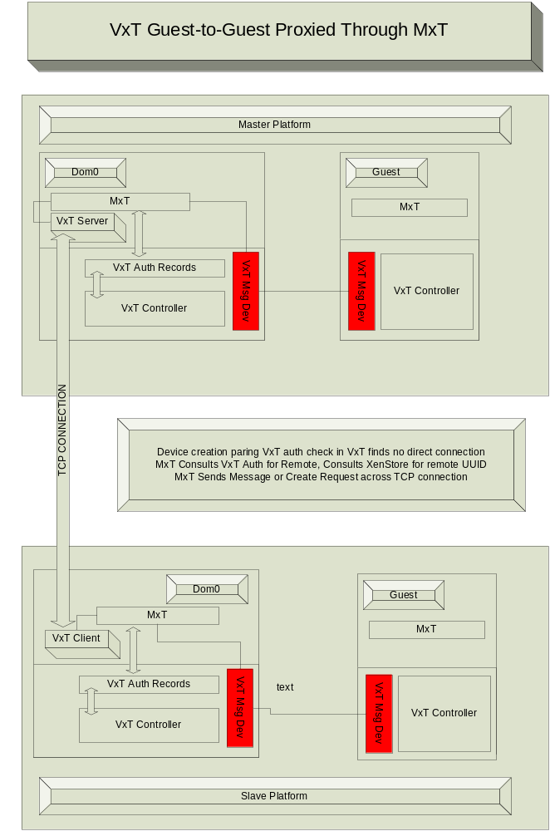

There are 3 main ways that devices exhibit routing properties.

- Some devices come with an inherent connection to a resource or a remote endpoint.
- Some devices have the means to connect themselves to endpoints. In this group, there may be a two stage process. The device may be configured by the VxT subsystem or the actions to configure may fall to the guest after VxT device creation.
- Some devices connect to services that have no fixed location.

VxT supports all of these mechanisms and shields the user from concerns about system topology where possible. It does so through a combination of cached and default routing information and dynamic resolution.

All guests provided with a VxT controller that provides basic device connection services via VxT device plug requests. Each guest is also provided with a VxT message device that attaches to the secure authorization and routing service.

High Availability:

The minimum configuration for the VxT routing and authorization service consists of a single authorization database. In a hypervisor setting this database sits in Dom0. In a native system setting, the service may be provided via a local daemon or across a secured communications pipe. High availability in the advent of a system crash is provided by migration. The VxT routing database is synchronized at all times in storage. In a clustered setting, the VxT router may recover from a system crash by restarting on a second node.

Service Oriented Provisioning:

VxT devices may be created on demand by a management service, or by the guest operating system. In either case, the VxT controller on the parent side consults the authorization database before allowing a connection to be made. In this way, a guest may be pre-approved for a collection of resources and choices of endpoint connections. The approval is of low cost. The connections themselves can be made on-demand.

Attachment to a service:

A VxT record holds fields for UUIDs of the two endponts and a device name. The endpoint ID’s are generally for Guest operating systems. The remote guest may or may not be on the same physical node. Upon connection request the authorization end of the default VxT message device will consult the database. If it finds a record it will connect accordingly.

Device attachment in the hypervisor setting:

When a guest operating system requests the opening of a device, the request proceeds over the default VxT front-end/back-end controller mechanism. The local Dom0 will access the resident VxT authorization database. If an entry is found and the remote endpoint is either local or can be connected through a physical device which is available, The VxT controller executes the connection order on behalf of the guest.

If a record is found but the proxy field is set or the endpoint is remote, Dom0 will connect with the proxy service. This will either be the default proxy service or the service recommended by the device type named in the connection request.

If the record is not found the primary controller device configuration call will fail. In this event, the guest will request authorization/routing via the default VxT messaging device. The primary service is located in the master node of the cluster. If no cached entry is found in the local Dom0, the primary node is consulted. Authorization records carry inherent routing information based on the routing services ability to locate the remote node and the access to information regarding available communications paths.

The primary communications service will provide a local authorization record, possibly substituting a different UUID for the endpoint. The connection may be ginned up by an agent of the routing service as a result. The connection can be a proxy service, a direct shared memory connection device, or a physical device, properly configured.

Cached Database entries:

VxT implementation in a hypervisor context offers a good example of the interplay between connection establishment and the authorization database. In its simplest form, the VxT backend sits in the hypervisor, or Dom0 space and performs lookups in the authorization database in order to fulfill connection requests. The actions of the VxT backend are secure as it is part of the trusted computing base. If the authorization database and the means to access it are secure the entire process of endpoint connection is governed by Mandatory Access Control, (MAC). However, endpoint connection actions may extend beyond plug and play of primary VxT devices. As an example let a private network port be wrapped in a VxT device. Further, let the network be used as a means of iSCSI attachments.

Local device attachment may look like pluggable disks, fiber-channel, almost any form of storage, wrapped by a VxT device. The VxT device will perform the emulation. In this case, the iQN/s, passwords, key challenges, etc. may all be held in a VxT authorization record. The central VxT authorization service may be consulted. However, security profile is dictated by the security actions on the physical device, this is unavoidable. Security is based on the authorization mechanisms present in the private network. On this basis, one may choose to cache the connection information, authorization keys, and routing details in a VxT record at the guest as a means of improving connection speeds

This is the best of both worlds. Efficiency is enhanced by being able to pick up routing and authorization information locally. Configuration simplicity and definition is maintained by defining the connection protocols through the VxT model. Indeed the underlying method of storage delivery can be changed without affecting the applications or services using it.

Configuration caches can be kept at the guest nodes and updated through default VxT message device actions. Access is revoked via the particular security mechanisms associated with the bridge device, in this case the authorization keys for iSCSI.

Because the local VxT authorization cache is consulted before attempting to query the TCB based VxT element, all guest devices then can be plugged through the common VxT protocol, establishing a point to point connection between two UUID labeled endpoints, even when the routing mechanisms and security sit outside of VxT control proper.

Service termination:

Services may be terminated by removal of configuration information or more abruptly by immediate cessation of connection activity. The termination mechanism is an intrinsic property of the VxT architecture but the specific method is implemented within the VxT device. All communication disconnects take place through the associated VxT device driver callback. In this way shared memory, proxied, and physical devices can all be supported through the same abstraction.

The VxT Authorization Database

The VxT Authorization Database exists as a synchronized data file. Each time a record is changed the backing file is updated synchronously.

For performance reasons, the VxT Authorization Database also has a runtime in-memory form. Here the database records are all hashed based on their endpoint uuids. The endpoints are identified as either client or server. Fast lookups are available for either field. Server entries differ from clients in that they may support more than one simultaneous attachment.

Each database record has a device name, this name corresponds to a device type and a configuration or usage profile. In this way endpoint connection can have tailored communication properties. To this end another field is available. A device may be proxied and/or indirect. In the case of proxied, the device is emulated through the service in the TCB. An indirect device does not actually connect through shared memory, all communication is copied, allowing for full audit of the communication taking place.

Finally there is a label field, this field is large allowing for the storage of endpoint or routing data that is opaque to the VxT authorization database.

Architecture

Interfaces

