The VXT Communication Subsystem
Christopher Youngworth
July 30, 2007

Overview:

The VXT communication subsystem provides a set of abstractions to provision guest devices and to manage guest communications with external entities. Use of VXT communications, (VXTcom), allows Symantec to fully enforce a MAC security model. The VXTcom model is based on a communications controller abstraction, (VXTctrlr) which behaves like a pseudo bus. The VXTctrlr allows devices to be “plugged in”. The types of devices supported depend on the specific device libraries that have been registered with the controller. Registration consists of loading the appropriate device library into the controller. The loading process includes a swap of callbacks. The library provides calls for create, attach, detach, remove, query, as well as others. The VXTctrlr provides utilities for resource requests.

VXTcom device communication modeling is based on shared memory constructs, this provides for maximally efficient and fast communication when the two endpoints of the communication lie within the same physical memory space. It also allows for optimally efficient hardware support extensions.

The VXTcom controller allows the manipulation of devices; Ultimately, most of these devices are based on shared memory and event channels. Shared memory may be the primary connection device between the ultimate endpoints, or it may serve to connect the task level client with a hardware device. The VXTctrlr vends shared memory queues and event channels to the driver through its internal device library utilities. This allows the device layer to shape the resources into different device emulations.

The shared memory queuing communication subsystem has a default library, (VXTqueue), this queue mechanism is depended upon to arbitrate the actions of consumers and producers and is relied on for most pure shared memory implementations. Support of hardware devices will involve esoteric shared memory communications stacks and will require customized communications queue libraries.

Task level clients can request the creation of a new device or find a device and connect to it. In either case, the client finds, creates, and queries the device through the controller, but becomes aware of the properties and resources of the device through device specific data passed on the controller calls.

Device allocation depends upon the connection to a viable remote endpoint. The VXTcom subsystem requires the inclusion of a universal name that is associated with the authorized point to point connection on and device creation request. VXTcom consults a security authority for ultimate routing and security vetting based on the name.

The VXTctrlr in a guest is paired with a mirror in the security authority. In the Xen implementation this is carried out through the front-end/back-end driver model. The DomU, (non security authority), has a front-end driver, the Dom0, (security authority, TCB), has a back-end driver. The front-end/back-end pair are initialized using the traditional XEN, xenbus mechanisms. During initialization a shared memory communications path is established. This path is used strictly for the configuration of devices. The endpoints of a device may bypass Dom0, but the configuration of the devices at the endpoints must be done through Dom0. The TCB in Dom0 serves to proxy request for device connection between guests.

VXT controller device configuration

The protocol for the configuration communication channel is based on a simple request response model. Only one request can be outstanding at any one time, and there is only one recipient, i.e. the shared memory communication path connects only two endpoints. Based on this, there is no congestion, there are no communication loops, and there are no deadly embraces. A requestor can only hang if the matching reply is not sent. This problem is handled with a timeout and message generation numbers.

The inter-controller configuration protocol is carried on two shared memory buffers and signaled on an event channel which has been tied to an interrupt. Message handling is triggered off of the channel based interrupt.

The two shared buffers act as two one-way pipes with the controller associated with the back-end driver sending on the first and receiving on the second, and the controller associated with the front-end driver reversing the arrangement.

The buffers themselves are broken into two parts. The first half of the buffer is used for requests, the second half is used for replies. In this way, a request can be active while a reply is fashioned and sent for a separate configuration activity. This avoids the need to synchronize initiatives taken up by either endpoint or to limit initiation of configuration activity to one or the other player.

While only one request configuration call can be active at one time, a number of request messages may be sent within a single call. When all the requests have been replied to, the controller making the original request call is free to send another one.

Below is a diagram detailing the layout of the VXTctrlr configuration queues:

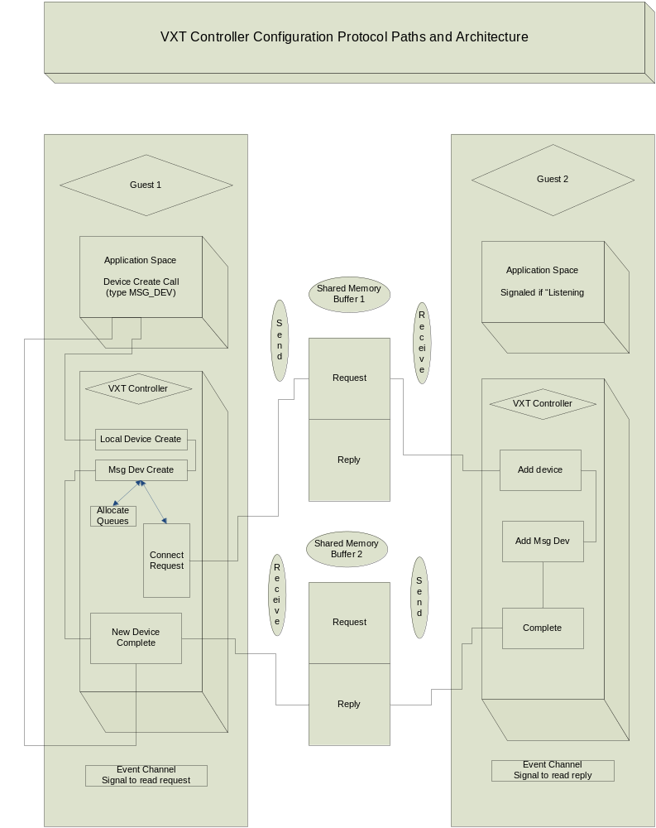

The diagram above shows the configuration queues and the actions taken when a task level client requests a new device connection.

The client makes an add device request of its VXT controller, the controller checks the device type to see if it has the appropriate device library. Upon finding the device library, the controller creates a new local device, associates it with a slot and calls the device library, device create call.

The device library, (IPC msgdev) requests the resources it will need, i.e. shared memory queues, extra events, etc. Once it is complete locally, it makes a callback into the controller requesting remote connection.

The VXT controller fashions a controller configuration request message asking for a device connection. All of the device type specifics are included, all of the queue page references for shared mapping are passed.

Once the message is written, the VXT controller signals the remote.

The remote controller checks to see if the device type is loaded in its device libraries. If it is, the remote controller creates a device, associates it with a slot and calls the device_connect callback in the msg_dev device library.

The remote msg_dev library connects the queues and event and returns.

The remote controller replies to the local VXT controller.

The local VXT controller wakens the waiting request thread and control returns to the requesting client.

Proxy configuration actions:

The configuration actions depicted in the diagram above are correct for cases that involve the security authority as an end point. If Dom0 either initiates the add connection attempt or is the target of such an attempt, the description is complete.

In cases of guest to guest add connection requests, the initiating party must still make its request through its paired controller in Dom0. In this case Dom0 will act as proxy. The Dom0 controller will not only request connection on behalf of the caller, it also maps the pages associated with shared memory buffers and allocates the event channel that will be shared. In this way, guest domains never need be given the capability to direct the sharing of an event or a piece of physical memory with another untrusted guest. This is a critical part of the security profile of the VXT communication system, allowing the transport authority to track each shared resource and the nature of the resources.

Controller Device Configuration in Xen

The VXT controller is functionally independent of the hypervisor or operating system it is running in. However, the VXT controller runs as a kernel level driver and therefore must be adapted to the system it is embedded in.

Xen has an idealized driver architecture that simplifies communication and controller setup. It sits on top of an abstracted pseudo bus architecture called xenbus. The device abstraction has an unusual pairing. Rather than connecting to a physical peripheral, each driver in a guest operating system is mated to a complimentary driver in a special domain. The driver in the guest is referred to as the “front-end”, the driver in the special domain is referred to as the “back-end”. The special domain is known as Dom0 and it hosts connections to physical devices. The back-end driver provides the adapter, or device emulation necessary to front requests to the physical hardware.

The VXT controller device driver has both a front-end and a back-end version. The back-end version is loaded into Dom0 at boot or at least before the loading of any Symantec aware guests. The front-end version is present at the boot of the guest or can be downloaded after boot.

The Xen front-end/back-end driver model depends on the xenbus for device loading. Xenbus “watches” the XenStore data base. XenStore tracks the provisioning of guests on a system running the xen hypervisor.

When a new guest arrives with a VXT controller provisioned. Xend or its equivalent signals the back-end driver probe routine, indicating a “hot-plug” event. The front-end driver is similarly signaled, causing its probe routine to run.

The back-end probe routine sets up a new controller and waits for a signal from the front-end to map the configuration buffers. During the front-end probe the configuration buffers are allocated, along with an event channel. The front-end writes the memory page references and the event port to a XenStore record, publishing them so that the back-end will be able to find them. It then signals the back-end through as xenbus convention known as “otherend-changed”.

The back-end receives the device level asynchronous “otherend-changed” event. The event handler looks in XenStore for the memory references and event port. The memory is mapped, the port is connected and XenStore returns, now ready for configuration events on the new configuration channel.

VXT Controller Device Support

The VXT controller vends shared memory queues and event channels. However it does so through the abstraction of a device. Devices types come to be known to the controller through the registration of device libraries. At library registration time, the library is given a series of callbacks for controller utilities including queue creation, queue connection, queue removal, and remote device connection. At the same time, the library publishes a series of callbacks for device creation, device removal, device query and so on.

Task level clients communicate with a specific device library through common VXT controller calls. There are device specific buffers passed when appropriate on the VXT controller ioctls.

Devices come to populate slots in a VXT controller though two methods:

1: Task level device add request ioctl

2: Remote controller connect request

In the task level case, the client creates a new device by making an IOCTL_VXTCTRL_DEV_CREATE ioctl call on a VXT controller. The client requests a specific type of device on the call and includes a field which is the collection of all of the information the specific device library will need to instantiate the appropriate object. The device specific field is treated as a “void *” buffer with an accompanying length field by the VXT controller. Also included on the call is the universal name identifying the remote endpoint and specific connection instance. These must be correct and authorized for the creation call to complete successfully.

Upon successful completion of the call, a local device of the specified type will be created. It will be known to the device specific library, it will also be known to the VXT controller where it will occupy a controller slot, have runtime state, and will have a pointer to the device specific instance and type.

The task level client can gain access to the resources associated with the device by doing
a device query, (IOCTL_VXTCTRLR_QUERY_DEV). The query will give back tokens for memory mapping calls to give the client access to shared memory queues. The query also contains port label identifiers for event channel ports that need to be attached. The client must also do a IOCTL_VXTCTRLR_ATTACH to gain proper permissions to use the resources.

Remote controllers can also initiate a device creation action. When a VXT controller receives a “create device” message on an open configuration link with a remote controller, it checks its device library to make certain it has access to the requested type of device. If so and if the remote controller is authorized to institute a connection, the local controller goes through the same device construction steps as above. The remote controller request includes device specific fields for the specific device initialization steps.

No attempt is made to connect a task level service to the new device. The task level client may query for new devices from time to time, may receive a signal of the arrival of a new device through another channel, or may listen for new devices on the local controller. When a new device is detected, the same query and attach steps as outlined in the direct device create case are taken.

VXT IPC Messaging Device

The IPC messaging device is implemented on top of the VXT controller. There is a library imported into the VXT front-end and back-end controllers and a task level library that communicates with the driver level support through IOCTLs. The bus query has a device type field and the device query allows for information to be sent directly from the device.

When a task level client decides to add a device to the VXT controller, it does so through the VXT controller IOCTL_VXTCTRL_DEV_CREATE ioctl. The create call has an escape for device specific fields.

The VXT controller creates a device of the specified type provides it with a slot number for later identification and calls the device specific creation routine to allow for the allocation of resources needed.

The IPC messaging device requests the creation of two queues through the VXT controller facilities. It also queries for the generic signaling port. A unique signaling port linking a device to its remote endpoint is provided to each active device on a controller. The IPC messaging device has no need for additional signaling capacity.

The messaging device registers the two queues with the controller for subsequent access through memory mapping. The task level client is made aware of the tokens via a device query on the specific device instance and a device attach. The VXT messaging device supports only one client attaching to a device at a time.

The tokens exported to the client are used to track the pages of a shared memory queue so that they can be the target of a task level shared memory mapping action.

Once the shared memory is mapped and the event port is registered at the task level, the
Kernel level VXT messaging device code is not active in the communications between endpoints.

The IPC messaging device client uses the VXT streaming queue library to initialize and communicate over the shared memory queues it has mapped. The queue library institutes a one-way streaming queue. The two queues mapped by the client provide 2-way communication with one appearing as a send queue and the other as a receive queue locally. On the remote client, the roles are reversed.

Each queue is carved into sub-queues. Get’s and Put’s are done to against the next buffer in a directed circular list. After initialization by the VXT queue library, all sub-buffer are owned by the producer, (the sender). After a buffer has experienced a “get/put” action the buffer’s ownership shifts. Ownership is readable in the shared memory headers. This allows for streaming without underlying system involvement. The guest operating system’s kernel and the hypervisor only become involved when a signal must be sent.

The figure below depicts the major components and relationships of an end to end VXT messaging device. The configuration relationships are not visible and not relevant to runtime activity.

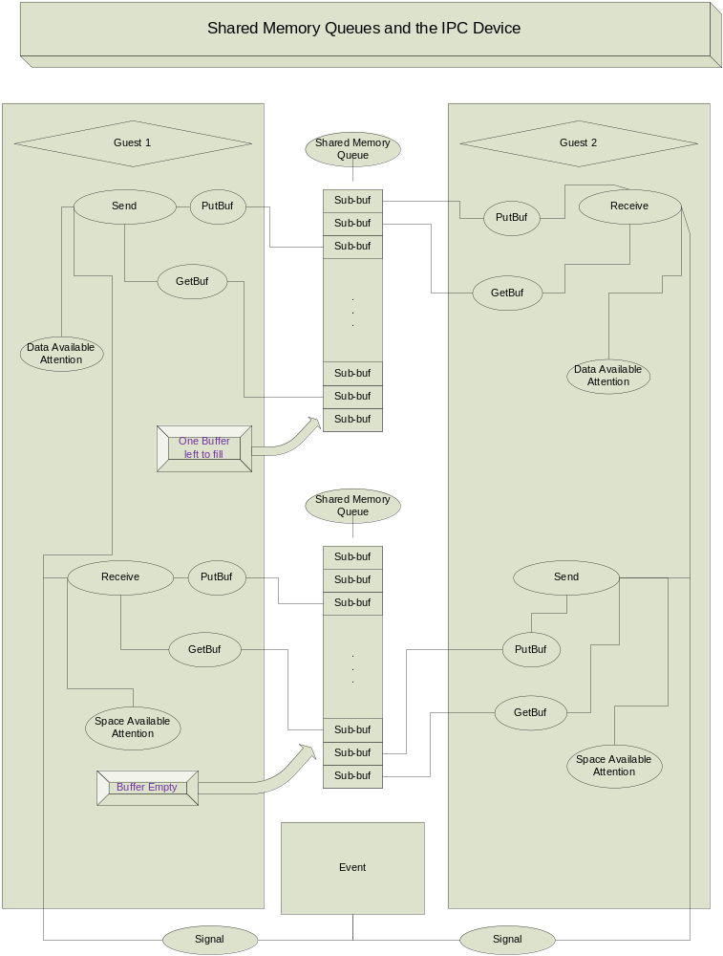

In the two-way communication with paired queues depicted above, the private “putbuf” and “getbuf” pointers of the two guests are chosen to elucidate the relationship between the producer and consumer of a VXT queue. The “putbuf/getbuf” pointers are private and can range over all of the buffers available to the producer/consumer however by convention this queue library accesses them in order. Therefore one can assume that all of the buffers before the “putbuf” are now owned by the other endpoint. (The buffers between getbuf and putbuf are being actively worked on.)

Based on this we can see how the send queue for guest 1 has only one remaining empty sub-buffer. i.e. The guest 1 getbuff is on the next to last sub-buffer in the queue and the guest 2 putbuf pointer is on the first buffer of the queue. (The queue pointers flow in one direction with wrap). From this configuration we can assume that the last buffer is owned by the producer and a single additional getbuf from guest 1 on the send queue will succeed. All subsequent getbuf requests will either wait or fail until guest 2 does one or more putbuf actions.

In the case of guest 1’s receive queue, we see that the queue is entirely empty. Guest 2 is actively working on one buffer, but it is in the client data packing phase and will not be available until a putbuf is done on it. Guest2’s putbuf pointer is pointing to the next to last sub-buffer, guest 1’s getbuf pointer is point to the buffer before this. An attempt to receive on the queue will result either in a no data available failure or a wait for guest 1.

Signaling the remote endpoint can be done by either party at any time. This approach is fine for sporadic data communication of low volume. However, signals should be kept to a minimum when large amounts of data are being transferred. This reduces overhead and increases throughput.

Several measures have been employed to reduce signaling. First, when streaming mode is in force, both sides read all data available in the buffer before considering suspending operations. Second, producers on both sides signal when necessary before all the data buffers are full, allowing the consumer to react and start making more space available before all the buffers are filled. Finally, shared memory locations are present that indicate that the remote side needs either a data available or space available signal. i.e. that the queue is no longer being actively checked. This serves to significantly widen the conditions under which a producer and consumer can operate without signaling and substantially reduce the number of signals necessary when the two sides do not quite match speed. When the basic facility is augmented by data send and data receive threads that will pause without suspension for a short time when no resource is available, the amount of pause can be customized to obviate slight scheduling and execution abnormalities allowing perfect streaming to persist. If there is a difference in execution speed between the producer and the consumer, this can also be compensated for if the difference is small.

Socket Emulation on top of the VXT message device

The VXT message device provides a complete IPC and streaming message facility. The shared memory constructs are ideal for device queues and device emulation but are not common in IPC and application communication models. Most application level services either were designed to use or have been adapted to use sockets.

To make VXT message device easier to use for IPC applications, a socket layer wrapper has been created. The wrapper is implemented as the VXT socket library.

The vxt socket support library provides a complete programming interface, allowing applications to establish, use, and shutdown connections all within the socket abstraction.

For the user of vxt sockets, all of the underlying mechanism is hidden. Connections can be established via vxt_bind or vxt_connect on the proper remote endpoint. Vxt sockets rely on unique destination names to hide internal vxt controller routing.

The vxt_bind and vxt_connect calls require a unique name. The name is passed along to the task level IPC message device layer and then down to the VXT controller where it is translated into a routing regime involving domain endpoints. The translation is done through an external addressing service which is connected with the transport authority, (Dom0). The socket layer only deals with the unique endpoint name and is never exposed to the underlying details.

Bootstrapping communications:

VXT communications may be the only or the initial communications resource available to a guest. A method is needed to establish communication with the transport authority in order to bootstrap I/O operations. To do this we utilize the bus device abstraction. i.e. We initially provision the guest with an IPC device that is connected to the DOM0 configuration services.

When the system first boots, an IOCTL query can be done to find vxt_msg/socket devices. The query will return the unattached device and its universal id. The task level guest configuration service can do a vxt_connect to the device found. If the guest task level configuration daemon manages to initialize before the device is present, it can do a wait for new devices. In the VXT socket context, this can be done with vxt_listen.

As an alternate to Dom0 adding a device, a specific universal id can be provided to the guest. It can be pushed into XenStore or made available through some other means. The guest configuration daemon can use this in a vxt_bind operation to connect with the Dom0 configuration services.

With the communication channel opened between DOM0 and the guest, other endpoints of interest to the guest can be made known. The guest can initiate connections with these endpoints through the vxt_bind call.

Socket Interfaces and type definitions:

/*
* Socket State
*/

#define VXT_SOCKET_DISCONNECTED 0x1
#define VXT_SOCKET_CONNECTED 0x2
#define VXT_SOCKET_SUSPENDED 0x3
#define VXT_SOCKET_ERROR 0x4

int vxt_socket(int domain, int type, int protocol)

vxt_socket creates a socket and returns a handle. The socket must be domain PF_UNIX and of type SOCK_STREAM. It is initially created in the disconnected state and must be the target of a vxt_bind or vxt_connect in order to connect with a remote endpoint.

int vxt_bind(int socket_handle,
vxt_dev_addr_t *uname, int uname_len)

vxt_bind attempts to create a vxt_msg device and connect it to the targeted endpoint. The underlying vxt controller will contact the transport authority through DOM0 and translate the universal name to a local guest domain. It will work with DOM0 to establish shared memory and a shared event with the domain.

From the socket library perspective, endpoint to endpoint connection is entirely determined by the universal endpoint name. All underlying infrastructure is hidden. Upper system layers will support multiple connections between endpoints through unique universal names.

RETURNS:

VXT_SUCCESS => 0

EISCON – Device already exists

ENETUNREACH – VXT communications controller is down or unreachable

ENOTSOCK – Catch-all for non-enumerated errors.

int vxt_connect(int socket_handle,
vxt_dev_addr_t *uname, int uname_len)

vxt_connect searches for a vxt_msg device with uname as an endpoint. If one is found, vxt_connect attempts to attach it. If the device does not exist, vxt_connect will attempt to create it. Vxt_connect will fail if the remote party either does not exist or is prohibited via mandatory access control checks. The nature of the underlying transport is implementation specific but must conform to fully performant streaming socket semantics.

RETURNS:

VXT_SUCCESS => 0

EISCON –
Endpoint connection already made;
Connection may be active or in some state of fault.

ENETUNREACH –
VXT communications controller is down or unreachable

ENOTSOCK – Catch-all for non-enumerated errors.

int vxt_send(int socket_handle, void *buf, int *len, int flags)

vxt_send supplies data on a specified connection. When the vxt_send call is completed, the data may be retained in intermediate caches. In this way it is unnecessary to exercise the transport machinery on less than full buffers in a streaming context. When an endpoint requires immediate action or is at the end of a transfer, it may do a send with the VXT_SOCK_SIGNAL flag asserted. This will cause a flush of all intermediate buffers and will guarantee that the remote endpoint is aware of the data.

Flags:

VXT_SOCK_SIGNAL –
Flush data, make certain remote endpoint is aware of data, (signal when necessary)

VXT_SOCK_WAIT –
If there is not enough room for data in the shared memory buffers, write what can be written and wait. If wait is not asserted, all the data that can be written will be and the call will return with an altered length field.

VXT_AUTO_STREAM –
When this flag is set, signaling is done only when the transport layer deems it necessary to maintain remote participation. The signaling is altered in conjunction with the hysteresis values placed on the device.

int vxt_recv(int socket_handle, void *buf, size_t *len, int flags)

vxt_recv receives data on a specified connection. Vxt_recv will copy data to the buffer provided up to the length requested. If less data is available and the VXT_SOCK_WAIT flag is not set the “len” field is altered to reflect the data found and the call returns. If more data is present in the shared memory queue than the receive buffer can hold, additional data is held for a subsequent vxt_receive call.

Flags:

VXT_SOCK_WAIT –
If there is not enough data to fill the receive buffer, wait for more before returning. If VXT_SOCK_WAIT is not set we will return whatever data is available and shorten the length field to reflect the amount of data retrieved.

int vxt_ioctl(int socket_handle, int cmd, void *buffer, int arg_len)

vxt_ioctl delevers commands to communicate with the vxt controller and to signal specific endpoints.

Controller actions can be undertaken on a socket in any connection state. This allows the caller to open a socket and probe the underlying controller directly without establishing connections to any remote endpoints.

While many modes of operation depend on existential, a-priori connection information, the IOCTL controller query actions offer a method of ground-up discovery.

Connection oriented actions such as VXT_IOCT_SIGNAL_SEND must be undertaken on an active connection.

IOCTL Commands:

VXT_IOCTL_QUERY_BUS –
VXT_IOCTL_QUERY_DEV –
VXT_IOCTL_SIGNAL_SEND –
VXT_IOCTL_SIGNAL_RCV –
VXT_IOCTL_QUERY_SEND –
VXT_IOCTL_QUERY-RCV –
VXT_IOCTL_SET_SEND_ERROR –
VXT_IOCTL_SET_RCV_ERROR –
VXT_IOCTL_RESET_SEND –
VXT_IOCTL_RESET_RCV –
VXT_IOCTL_SET_SEND_HYSTERESIS
VXT_IOCTL_SET_RCV_HYSTERESIS
.

int vxt_close(int socket_handle, int options)

vxt_close will unlink the targeted socket structure from the underlying vxt_msg device and its connection. Depending on the options provided it may go further, shutting down the underlying transport and removing the vxt controller device and its connection.

The options available are:

VXT_CLOSE_REMOTE
VXT_CLOSE_LOCAL

If neither option is asserted, the queues are flushed and quiesced.

If VXT_CLOSE_LOCAL is asserted, the socket and task level vxt_msg resources are freed and the task level context is detached from the underlying device.

If VXT_CLOSE_REMOTE is set, the underlying devices are disconnected and the controller "unplugs" the device from its bus. The remove configuration protocol is exercised and the remote device is told of the "unplugging" of the local device.

All combinations of options are acceptable, the VXT_CLOSE_LOCAL is unnecessary when VXT_CLOSE_REMOTE is set.

int vxt_shutdown(int socket_handle)

vxt_shutdown operates at the queue level. Shutdown is signaled to the remote endpoint and the data is flushed. A handshake is employed and the call waits until all of the data has been retrieved.

The queues are left in a suspended condition, ready for a reset action.

int vxt_poll(struct pollfd *fds, nfds_t nfds, int timeout)

vxt_poll waits on the set of sockets. The poll operation can be used to wait on multiple events, space available, data available, and device events such as shutdown or close.

The fds field is built upon the standard pollfd structure and the field for thread events is valid. Both vxt sockets and standard file descriptors are accepted. Vxt sockets are recognized via a new define, “POLLVXT”. When this flag is asserted, the VXT socket support layer identifies the fd field as a vxt socket descriptor. In this way the caller can wait simultaneously on vxt sockets and traditional file descriptors.

As with standard, streaming socket poll, timeout specifies the time in milliseconds the poll will wait. A negative value will disable the timeout and the poll will wait until one of the events it is targeted for occur.

int vxt_listen(int socket_handle)

vxt_listen provides an asynchronous method to discover new connections. Each device type in the vxt_controller has a wait queue. The vxt_listen here calls the vxt_msg layer which does a poll on the open controller. The poll information indicates the type of device we are waiting on, and optionally the remote address. When a new device request comes up matching the criteria, the vxt_listen thread returns.

VXT communications system connection security and routing

The VXT communications system relies on an external naming service to achieve its routing. The create IOCTL must be passed a unique identifier for a connection. The VXT controller will dereference the unique connection identifier by contacting the transport authority. The VXT controller in the transport authority calls out to a task level routing service. The service translates the unique connection name into a pair of endpoints, the remote and local domains needed for the connection.

It is possible that the remote endpoint is not within the same physical memory space. In this case, the routing service and its agents will have established a proxy handoff agent. The domain for this handoff agent is provided.

VXT configuration actions are always between a guest domain and the transport authority, (Dom0). Since Dom0 is part of the trusted computing base, (TCB), all shared memory and all channel event connection requests between guests is overseen and filtered by Dom0 services.

When a guest wishes to connect to another guest the request for connection is actually made to Dom0. Dom0 interprets the request and sends a proxy request to the VXT controller on the remote guest. Dom0 is also responsible for actually establishing the mapping of pages into the remote guest and of allocating the channel event on behalf of its caller. In this way, VXT communications can meet the most stringent requirements of Mandatory Access Control security. (MAC). Because all connection establishment passes through Dom0. All connections can be tracked. Further, if a particular connection must be audited, the Dom0 VXT controller can place itself in the middle, ferrying data between the two endpoints.

