**3 Wireless Communications in Vehicular Environments 39**  
*Pekka Eloranta and Timo Sukuvaara*

3.1 Background and History of Vehicular Networking 39

3.2 Vehicular Networking Approaches 46

3.3 Vehicular Ad‐hoc Networking 48

3.3.1 Vehicle‐to‐infrastructure Communication 50

3.3.2 Vehicle‐to‐vehicle Communication 51

3.3.3 Combined Vehicle‐to‐vehicle and Vehicle‐to‐infrastructure Communication 52

3.3.4 Hybrid Vehicular Network 53

3.3.5 LTE and Liquid Applications 54

References 55

**4 The Case for Wireless Vehicular Communications Supported by Roadside Infrastructure 57**  
*Tiago Meireles, José Fonseca and Joaquim Ferreira*

4.1 Introduction 57

4.1.1 Rationale for Infrastructure‐based Vehicle Communications for Safety Applications 59

4.2 MAC Solutions for Safety Applications in Vehicular Communications 61

4.2.1 Infrastructure‐based Collision‐free MAC Protocols 63

4.2.2 RT‐WiFi – TDMA Layer 65

4.2.3 Vehicular Deterministic Access (VDA) 65

4.2.4 Self‐organizing TDMA (STDMA) 66

4.2.5 MS‐Aloha 66

4.3 Vehicular Flexible Time‐triggered Protocol 68

4.3.1 Model for RSU Deployment in Motorways 68

4.3.2 RSU Infrastructure Window (IW) 69

4.3.3 V‐FTT Protocol Overview 71

4.3.4 Synchronous OBU Window (SOW) 74

4.4 V‐FTT Protocol Details 75

4.4.1 Trigger Message Size 75

4.4.2 Synchronous OBU Window Length (lsow) 77

4.4.3 V‐FTT Protocol Using IEEE 802.11p/WAVE / ITS G‐5 78

4.5 Conclusions 80

References 81

**5 Cyber Security Risk Analysis for Intelligent Transport Systems and In‐vehicle Networks 83**  
*Alastair R. Ruddle and David D. Ward*

5.1 Introduction 83

5.2 Automotive Cyber Security Vulnerabilities 84

5.2.1 Information Security 85

5.2.2 Electromagnetic Vulnerabilities 85

5.3 Standards and Guidelines 86

5.3.1 Risk Analysis Concepts 86

5.3.2 Functional Safety Standards 87

5.3.3 IT Security Standards 87

5.3.4 Combining Safety and Security Analysis 88

5.4 Threat Identification 88

5.4.1 Use Cases 88

5.4.2 Security Actors 89

5.4.3 Dark‐side Scenarios and Attack Trees 90

5.4.4 Identifying Security Requirements 93

5.5 Unified Analysis of Security and Safety Risks 93

5.5.1 Severity Classification 93

5.5.2 Probability Classification 95

5.5.3 Controllability Classification 95

5.5.4 Risk Classification 95

5.5.5 Evaluating Risk from Attack Trees 97

5.5.6 Prioritizing Security Functional Requirements 100

5.5.7 Security Assurance and Safety Integrity Requirements 101

5.6 Cyber Security Risk Management 102

5.7 Conclusions 103

Acknowledgements 104

References 104

**6 Vehicle Interaction with Electromagnetic Fields and Implications for Intelligent Transport Systems (ITS) Development 107**  
*Lester Low and Alastair R. Ruddle*

6.1 Introduction 107

6.2 In‐vehicle EM Field Investigation and Channel Characterization 109

6.3 Field Simulation Tools and Techniques 112

6.4 In‐vehicle EM Field Measurement 116

6.5 Simulation of Field Distribution and Antenna Placement Optimization 118

6.6 Occupant Field Exposure and Possible Field Mitigation Methods 122

6.6.1 Human Exposure to Electromagnetic Fields 122

6.6.2 Field Mitigation Methods 125

6.7 Conclusions 127

Acknowledgements 128

References 128

**7 Novel In‐car Integrated and Roof‐mounted Antennas 131**  
*Rus Leelaratne†*

7.1 Introduction 131

7.2 Antennas for Broadcast Radio 132

7.2.1 Roof‐mounted Radio Antennas 132

7.2.2 Hidden Glass Antennas 134

7.2.3 Hidden and Integrated Antennas 136

7.3 Antennas for Telematics 137

7.3.1 Roof‐mounted Telematics Antennas 137

7.3.2 Hidden Telematics Antennas 140

7.3.3 Future Trend of Telematics Antennas 141

7.4 Antennas for Intelligent Transportation Systems 141

7.4.1 Car2Car Communication Antennas 141

7.4.2 Emergency Call (E‐Call) Antennas 143

7.4.3 Other ITS Antennas 144

7.5 Intelligent and Smart Antennas 145

7.5.1 Intelligent Antenna for Broadcast Radio 145

7.5.2 Intelligent Antenna for GNSS 146

7.6 Conclusions 147

References 147

**Part 3 Sensors Networks and Surveillance at ITS 149**

**8 Middleware Solution to Support ITS Services in IoT‐based Visual Sensor Networks 151**  
*Matteo Petracca, Claudio Salvadori, Andrea Azzarà, Daniele Alessandrelli, Stefano Bocchino, Luca Maggiani and Paolo Pagano*

8.1 Introduction 151

8.2 Visual Sensor Networks and IoT Protocols 153

8.2.1 Visual Sensor Networks 153

8.2.2 Internet of Things 156

8.3 Proposed Middleware Architecture for IoT‐based VSNs 158

8.3.1 RESTful Web Service 159

8.3.2 Configuration Manager 160

8.3.3 Resource Processing Engine 160

8.4 Middleware Instantiation for the Parking Lot Monitoring Use Case 161

8.4.1 Use Case Scenario, Exposed Resources and Their Interaction 161

8.4.2 Middleware Implementation 163

8.5 Conclusions 164

References 165

**9 Smart Cameras for ITS in Urban Environment 167**  
*Massimo Magrini, Davide Moroni, Gabriele Pieri and Ovidio Salvetti*

9.1 Introduction 167

9.2 Applications to Urban Scenarios 169

9.3 Embedded Vision Nodes 171

9.3.1 Features of Available Vision Nodes 172

9.3.2 Computer Vision on Embedded Nodes 173

9.4 Implementation of Computer Vision Logics on Embedded Systems for ITS 175

9.4.1 Traffic Status and Level of Service 175

9.4.2 Parking Monitoring 178

9.5 Sensor Node Prototype 180

9.5.1 The Vision Board 181

9.5.2 The Networking Board 182

9.5.3 The Sensor 182

9.5.4 Energy Harvesting and Housing 182

9.5.5 The Board Layout 183

9.6 Application Scenarios and Experimental Results 184

9.7 Conclusions 185

References 187

**Part 4 Data Processing Techniques at ITS 189**

**10 Congestion Prediction by Means of Fuzzy Logic and Genetic Algorithms 191**  
*Xiao Zhang, Enrique Onieva, Victor C.S. Lee and Kai Liu*

10.1 Introduction 191

10.2 Hierarchical Fuzzy Rule‐based System (HFRBS) 193

10.3 Genetic Hierarchical Fuzzy Rule‐based System (GHFRBS) 194

10.3.1 Triple Coding Scheme 194

10.3.2 Genetic Operators 196

10.3.3 Chromosome Evaluation 197

10.3.4 Mechanism and Characteristics of the Algorithm Framework 197

10.4 Dataset Configuration and Simplification 197

10.5 Experimentation 199

10.5.1 Experimental Setup 199

10.5.2 Results 199

10.5.3 Analysis of the Results 201

10.6 Conclusions 202

Acknowledgment 203

References 203

**11 Vehicle Control in ADAS Applications: State of the Art 206**  
*Joshué Pérez, David Gonzalez and Vicente Milanés*

11.1 Introduction 206

11.2 Vehicle Control in ADAS Application 206

11.3 Control Levels 207

11.4 Some Previous Works 208

11.5 Key Factor for Vehicle Control in the Market 210

11.6 ADAS Application From a Control Perspective 211

11.6.1 Lane Change Assistant Systems 212

11.6.2 Pedestrian Safety Systems 212

11.6.3 Forward‐looking Systems 213

11.6.4 Adaptive Light Control 213

11.6.5 Park Assistant 214

11.6.6 Night Vision Systems 215

11.6.7 Cruise Control System 215

11.6.8 Traffic Sign and Traffic Light Recognition 215

11.6.9 Map Supported Systems 216

11.6.10 Vehicle Interior Observation 217

11.7 Conclusions 217

References 218

**12 Review of Legal Aspects Relating to Advanced Driver Assistance Systems 220**  
*Alastair R. Ruddle and Lester Low*

12.1 Introduction 220

12.2 Vehicle Type Approval 221

12.3 Trends in Vehicle Automation 223

12.3.1 EU Policy 223

12.3.2 Brake Assist Systems 223

12.3.3 Advanced Vehicle Systems 225

12.3.4 Advanced Driving Assistance Systems 226

12.3.5 Categorization of Vehicle Automation Levels 227

12.4 Vienna Convention on Road Traffic 227

12.4.1 Implications for Driving Assistance Systems 230

12.4.2 Proposed Amendments 231

12.4.3 Implications for Autonomous Driving 233

12.5 Liability Issues 234

12.5.1 Identifying Responsibilities 234

12.5.2 Event Data Recorders 236

12.6 Best Practice for Complex Systems Development 237

12.6.1 Safety Case 238

12.6.2 Safety Development Processes 239

12.6.3 ECWVTA Requirements 240

12.6.4 Cyber Security Issues 241

12.7 Conclusions 242

Acknowledgements 243

References 243

**Part 5 Applications and Services for Users and Traffic Managers 247**

**13 Traffic Management Systems 249**  
*António Amador, Rui Dias, Tiago Dias and Tomé Canas*

13.1 Introduction 249

13.1.1 Objectives 249

13.1.2 Traffic Management 250

13.1.3 Traffic Environments 251

13.2 Traffic Management Framework 253

13.2.1 Inputs 255

13.2.2 Analysis 260

13.2.3 Outputs 265

13.3 Key Stakeholders 266

13.4 Traffic Management Centres 266

13.4.1 Scope 267

13.4.2 Operation Platforms 268

13.5 Conclusions 270

References 271

**14 The Use of Cooperative ITS in Urban Traffic Management 272**  
*Sadko Manduka, Edouard Ivanjko, Miroslav Vujić, Pero Škorput and Martin Gregurić*

14.1 Introduction 272

14.2 Cooperative Ramp Metering 274

14.2.1 Ramp Metering 275

14.2.2 Cooperation between Local Ramp Meters 277

14.2.3 Cooperation between Ramp Metering and Other Traffic Management Systems 278

14.3 Incident Management in Urban Areas 280

14.4 Public Transport Cooperative Priorities 284

14.5 Conclusions 287

Acknowledgment 287

References 288

**15 Methodology for an Intelligent in‐Car Traffic Information Management System 289**  
*Nerea Aguiriano, Alfonso Brazalez and Luis Matey*

15.1 Introduction 289

15.2 Validation Framework 291

15.3 HMI Design Methodology 292

15.3.1 Signal Model 295

15.3.2 Interpretation Model 296

15.3.3 Representation Model 302

15.4 Case Study 305

15.4.1 Signal Model for Received Messages 305

15.4.2 Interpretation Model 306

15.4.3 Representation Model 310

15.5 Conclusions 311

References 311

**16 New Approaches in User Services Development for Multimodal Trip Planning 313**  
*Asier Moreno, Itziar Salaberria and Diego López‐de‐Ipiña*

16.1 Introduction 313

16.1.1 Multimodal Transport 314

16.1.2 Travel User Services 315

16.2 Travel Planning Information Systems 316

16.2.1 Standard Travel Planning Services 316

16.2.2 Transit Information Formats and Standards 319

16.2.3 New Trends in Transit Information 320

16.3 Integrating Linked Open Data for Multimodal Transportation 321

16.3.1 Related Work 323

16.3.2 Management and Provision of Multimodal Transport Semantic Information 324

16.4 Conclusions 328

References 329

ITS

Development of [Intelligent Transportation Systems](https://www.sciencedirect.com/topics/social-sciences/intelligent-transportation-system) (ITS) began in the 1970s, and expensive research programs are under way. One of the long-term goals of ITS is to assemble information about travel conditions and make it available to travelers at public places, by phone or Internet, or directly to vehicles equipped with on-board computers and Global Positioning Systems receivers. Computer simulations suggest that information can help drivers avoid hot spots of congestion by switching routes, changing departure times, and canceling trips. Travelers without access to information may also benefit from the adjustments made by informed travelers.

Despite these encouraging research findings, the potential of ITS is limited by the fact that they do not make drivers pay for the congestion they create. Indeed, provision of information can make congestion worse if it induces drivers to overreact; e.g. by switching en masse to Route 2 after learning about an accident on Route 1 (Ben-Akiva et al. 1991). And, similar to the effects of capacity expansion, congestion can be exacerbated if information induces people to travel more, or to concentrate their travel on congestion-prone routes and at peak times. These drawbacks can in principle be avoided by implementing road pricing in tandem with ITS.

With the conception of smart city transmuting cities into digital societies, making the life of its citizens easy in every facet, Intelligent Transport System becomes the indispensable component among all. In any city mobility is a key concern; be it going to school, college and office or for any other purpose citizens use transport system to travel within the city. Leveraging citizens with an Intelligent Transport System can save their time and make the city even smarter. Intelligent Transport System (ITS) aims to achieve traffic efficiency by minimizing traffic problems. It enriches users with prior information about traffic, local convenience real-time running information, seat availability etc. which reduces travel time of commuters as well as enhances their safety and comfort.

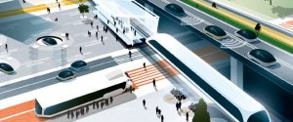Intelligent Transport System (ITS) aims to achieve traffic efficiency by minimizing traffic problems. It aims to reduce time of commuters as well as enhances their safety and comfort.

The application of ITS is widely accepted and used in many countries today.  The use is not just limited to traffic congestion control and information, but also for road safety and efficient infrastructure usage. Because of its endless possibilities, ITS has now become a multidisciplinary conjunctive field of work and thus many organizations around the world have developed solutions for providing ITS applications to meet the need.

One such example is the city of Glasgow. In the city, Intelligent Transport System gives regular information to the daily commuters about public buses, timings, seat availability, the current location of the bus, time taken to reach a particular destination, next location of the bus and the density of passengers inside the bus.

Iain Langlands, GIS and Data Manager, Glasgow City Council explains, bus operators in the city have the sensors in their buses. So, if the bus is going to be early to the next bus stop the bus is temporarily and very slightly is slowed down at the red light little longer than it should be to make sure the bus is on time and do not ahead of the schedule”. The system has been designed so smartly that passengers and even drivers are unaware of the delay as they are very little delays.

**Application areas of Intelligent Transport System**

The entire application of ITS is based on data collection, analysis and using the results of the analysis in the operations, control and research concepts for traffic management where location plays an important role.

Here sensors, information processors, communication systems, roadside messages, GPS updates and automated traffic prioritization signals play an imperative role in the application of:

1-      Advanced Traffic Management System

2-      Advanced Traveler Information System

3-      Advanced Vehicle Control system

4-      Advanced Public Transportation System

5-      Advanced Rural Transportation Systems

6-      Advanced Commercial Vehicles Operations system

**How Intelligent Transport System works?**

Traffic Management Centre (TMC) is the vital unit of ITS. It is mainly a technical system administered by the transportation authority. Here all data is collected and analyzed for further operations and control management of the traffic in real time or information about local transportation vehicle.

Well-organized and proficient operations of Traffic Management Centre depends on automatized data collection with precise location information than analysis of that data to generate accurate information and then transmitting it back to travelers.  Let’s understand the entire process in a more detailed way.

**Data collection**:  Strategic planning needs precise, extensive and prompt data collection with real-time observation. So the data here is collected via varied hardware devices that lay the base of further ITS functions. These devices are Automatic Vehicle Identifiers, GPS based automatic vehicle locators, sensors, camera etc. The hardware mainly records the data like traffic count, surveillance, travel speed and travel time, location, vehicle weight, delays etc. These hardware devices are connected to the servers generally located at data collection centre which stores large amounts of data for further analysis.

**Data Transmission**: Rapid and real-time information communication is the Key to proficiency in ITS implementation so this aspect of ITS consists of the transmission of collected data from the field to TMC and then sending back that analyzed information from TMC to travelers. Traffic-related announcements are communicated to the travelers through internet, SMS or onboard units of Vehicle. Other methods of communications are dedicated short-range communications (DSRC) using radio and Continuous Air Interface Long and Medium Range (CAILM) using cellular connectivity and infra-red links.

**Data Analysis**: The data that has been collected and received at TMC is processed further in various steps. These steps are error rectification, data cleaning, data synthesis, and adaptive logical analysis. Inconsistencies in data are identified with specialized software and rectified. After that data is further altered and pooled for analysis. This mended collective data is analyzed further to predict traffic scenario which is available to deliver appropriate information to users.

**Traveler Information:** Travel Advisory Systems (TAS) is used to inform transportation updates to the traveling user. The system delivers real-time information like travel time, travel speed, delay, accidents on roads, change in route, diversions, work zone conditions etc. This information is delivered by a wide range of electronic devices like variable message signs, highway advisory radio, internet, SMS, automated cell.

With urbanization expanding with speedy stride, number of vehicles on road is also increasing. Combination of both in return puts enormous pressure on cities to maintain a better traffic system so that the city keeps on moving without any hassle. For the purpose application of Intelligent Transport System is the only solution. ITS is a win-win situation for both citizens and city administrators where it provides safety and comfort to citizens and easy maintenance and surveillance to city administrators.

**DIRECT Benefit:**

Direct benefits from ITS deployment can be analyzed based on different sets of factors so called categories of ITS benefits. In literature ITS benefits are classified into the following categories, [1, 2]:

1. Safety,

2. Flow efficiency,

3. Productivity and cost reduction,

4. Environment benefits.

Beside the measurable benefits, many other advances can also be noticed, including new business opportunities, increase of employment; improvement of regional/urban/national technology status etc. Among common users and stakeholders, the following groups can be recognized: end users, network operators, system owners (stakeholders), service providers, tour operators, local authorities, civil government, etc. There are many approaches to measuring influences and benefits of new projects related to ITS development and deployment. Designing effective and usable ITS solution includes a possibility for estimating the ITS benefits using suitable methods, such as:

1. Method for physical impact measurement

2. Benefit analysis method

3. Cost – effectiveness analysis (C/E)

4. Benefit – cost analysis (B/C).

2. DEVELOPMENT OF ITS ARCHITECTURE:

Architecture can be defined as a basic system organisation consisting of crucial components, their relations and connections to environment, as well as principles for system design and development during the whole lifecycle, [1]. In order to enable development and upgrades, complex systems have to include additional characteristics such as: Compatibility, Expandability, Interoperability, Integrability, Standardability, [4]. Lack of architecture can result in difficulties because of incompatible components, higher cost for updates and complications in introducing or adjusting new technologies. ITS architecture provides a general framework for planning, designing and implementing integrated system in a given period and geographical area.

An ITS Architecture is important for a number of reasons:

o it ensures an open market for services and equipment, because there are “standard” interfaces between components;

o an open market permits economies of scale in production and distribution, thus reducing the price of products and services;

o it ensures consistency of information delivered to end-users;

o it encourages investment in ITS since compatibility is ensured;

o it ensures inter-operability between components, even when they are produced by different manufacturers, which is also good for SMEs (Small and Medium sized Enterprises);

o it permits an appropriate level of technology independence and allows new technologies to be incorporated easily;

o it provides the basis for a common understanding of the purpose and functions of the ITS, thus avoiding conflicting assumptions, [5]. Based on the content and mandatory use, three main type of ITS Architecture are defined:

o Framework ITS Architecture;

o Mandated ITS Architecture;

o Service ITS Architecture,

[1]. Framework Architecture, most suitable for national level architecture, focuses on user needs and functional viewpoint. This type of architecture can be also considered as a starting point for the development of other two types of architecture. Mandated Architecture consists of physical, logical and communication viewpoints but also includes additional outputs (Cost-Benefit analysis, Risk analysis etc.), [4]. Content of Mandated Architecture is strictly defined and, as a consequence, choices for deployment options are limited. Service Architecture is similar to Mandated Architecture, but includes services. Additionally, there are also physical and logical (functional) architecture. While the logical architecture consists of processes and interconnecting data flows, physical architecture includes physical components (parts of equipment) and related data flows. ITS architecture can live to its potentials only when logical architecture is based on user needs, vision and operational concept, and when physical architecture is developed based on the logical architecture. Defining the physical architecture is strongly connected with standardization and implementation strategy.

Initial standardization of ITS services, focused on road transport, was set up by ISO (International Standardization Organization). First reference model for ITS included 8 functional areas and 32 services (ISO TR 14813-1 - Transport information and control systems - Reference model architecture(s) for the TICS Sector), [1]. The reference models for ITS architecture were improved in 1999 in the way that Part I (1999.), describing ITS Fundamental Services, replaced standards presented in Technical Report on Transport Information and Control Systems. Intention of new taxonomy is to relate similar and complementary ITS services. The taxonomy includes 11 functional areas:

1. Traveller Information

2. Traffic Management and Operations

3. Vehicles

4. Freight Transport

5. Public Transport

6. Emergency

7. Transport Related Electronic Payment

8. Road Transport Related Personal Safety

9. Weather and Environmental Monitoring

10. Disaster Response Management and Coordination

11. National Security.

The EU Directive establishes four priority areas:

1. Optimal use of road, traffic and travel data;

2. Continuity of traffic and freight management ITS services;

3. ITS road safety and security applications;

4. Linking the vehicle with the transport infrastructure, [8].

These four priority areas are also the priority areas of Action plan for ITS deployment. Data security and protection, and liability issues, which was included in the Action plan, is not included in the Directive but references to relevant legislation framework are made. European ITS cooperation and coordination, the sixth area in the Action plan, can be considered as a general issue. The existence of the Directive itself proofs the existence of mentioned cooperation. Within the priority areas, six priority actions are defined:

1. the provision of EU-wide multimodal travel information services

2. the provision of EU-wide real-time traffic information services;

3. data and procedures for the provision, where possible, of road safety related minimum universal traffic information free of charge to users;

4. the harmonised provision for an interoperable EU-wide eCall;

5. the provision of information services for safe and secure parking places for trucks and commercial vehicles;

6. the provision of reservation services for safe and secure parking places for trucks and commercial vehicles.

#### **Autonomous Cars**

[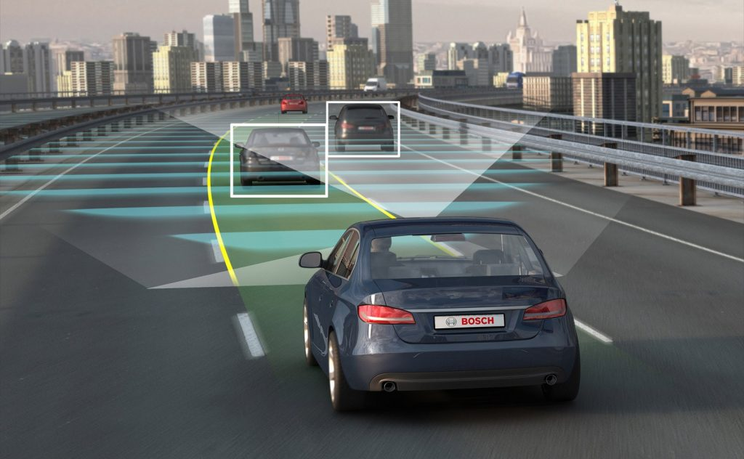](https://geospatialmedia.s3.amazonaws.com/wp-content/uploads/2018/05/autonomous-cars.jpg)

Recent developments in Cloud computing and emerging technologies like AI, IoT and LiDAR have turned autonomous cars from a vision to a present reality, as so many companies have announced their plans of launching autonomous cars and trial runs of these cars are already going on in different cities of the world.

Companies like Waymo and Tesla are the forefront of the autonomous revolution. Recently, Drive.ai, a Silicon Valley-based startup building self-driving car software, announced that it will offer free rides to passengers in Frisco, Texas. Autonomous cars will overwhelm the existing automobile industry and undertake will be its biggest and most breathtaking transformation since its inception in the beginning of the 20th century.

#### **Convertible cab cum store**

[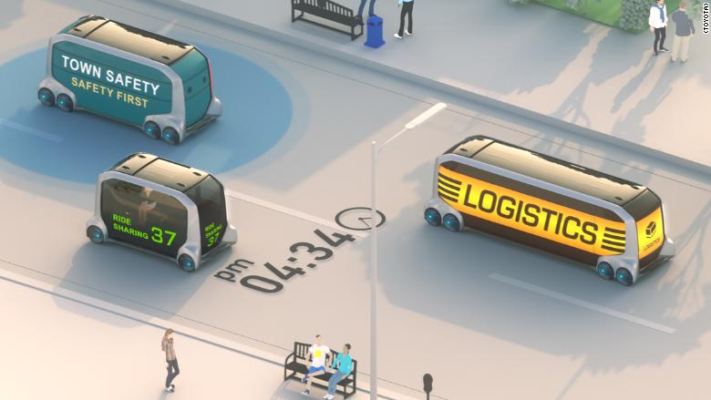](https://geospatialmedia.s3.amazonaws.com/wp-content/uploads/2018/05/Store.jpg)Image Courtesy: CNN

Ride-sharing cars of the future would have the ability to metamorphose into different forms. This would also increase the basic level of their functionality along with versatility. Toyota has developed a concept vehicle knows as e-Palette that can be transformed from a normal cab to store selling any kind of merchandise or into a delivery van.

What this practically means is that a cab in the morning could become a T-shirt store in the evening and food-delivery van at night. Companies would also modify seats in vans and buses so as to make them more convertible in the upcoming future. User-data determined personalized routes would also soon see the light of the day.

#### **Futuristic Subways**

[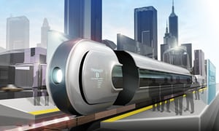](https://geospatialmedia.s3.amazonaws.com/wp-content/uploads/2018/05/5950.jpg)Image Courtesy: The Guardian

Tesla and its founder Elon Musk have a well-deserved reputation for being technological mavericks. Yet another plan of Musk is creating a localized, futuristic subway system. Construction of new subway systems is going at a slower pace in the USA. But the futuristic loop is already being tried in Los Angeles.

Tesla has finished building its first stretch of a tunnel in the city that will transport people in their own cars or pedestrian “pods” at speeds up to 150 mph. The system will allow people to avoid traffic and commute swiftly. However, the downside is the risk associated with congestion and gridlock at the entrance of the tunnel as more and more people will take up to these pods as a superfast means of transportation.

#### **Hyperloop**

[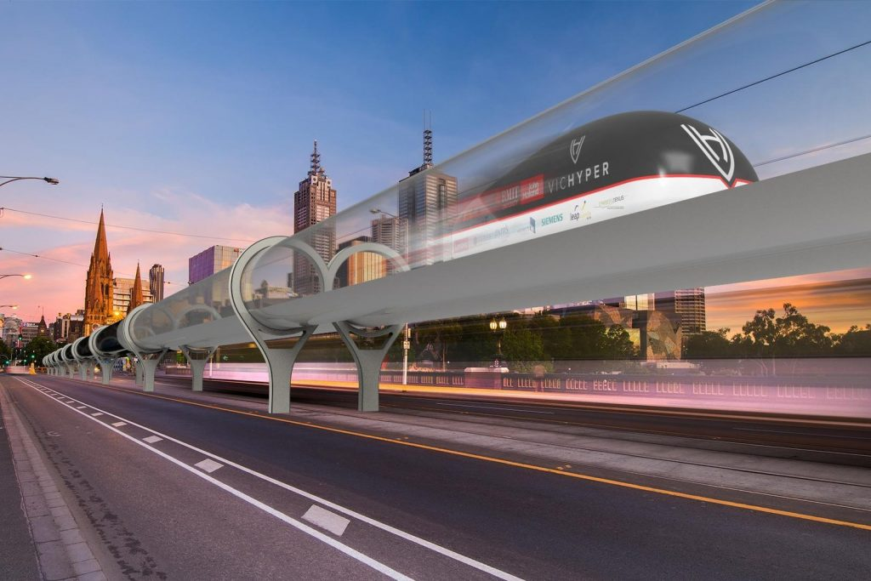](https://geospatialmedia.s3.amazonaws.com/wp-content/uploads/2018/05/hyperq.jpg)Hyperloop, as the name suggests, is a sealed tube or system of tubes through which a pod may travel free of air resistance or friction conveying people or objects at high speed. Tesla and Hyperloop One are two of the biggest companies that are developing Hyperloop.

Hyperloop would allow passengers to travel at a top speed of 600 miles per hour, which is more than twice the highest speed of the fastest train. Hyperloop projects are being developed in many parts of the world, including San Francisco and Baltimore.

Tesla has also built a 500-meter test track in Nevada. But there are many challenges in the development of Hyperloop, including the painstaking task of building a vacuum tube over hundreds of miles of land and investing billions of dollars. Other than that, the Hyperloop must travel only in a straight line so passengers don’t fall ill. Getting environmental and other clearances for the purpose of hyperloop is a difficult task and a lot of people assume it to be overblown and extravagant.

#### **Flying Taxis**

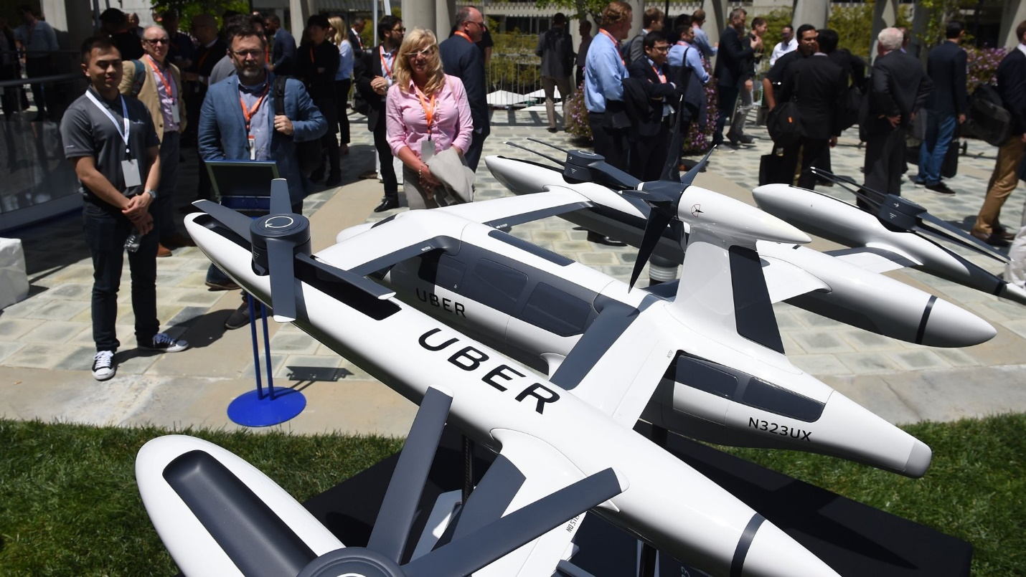

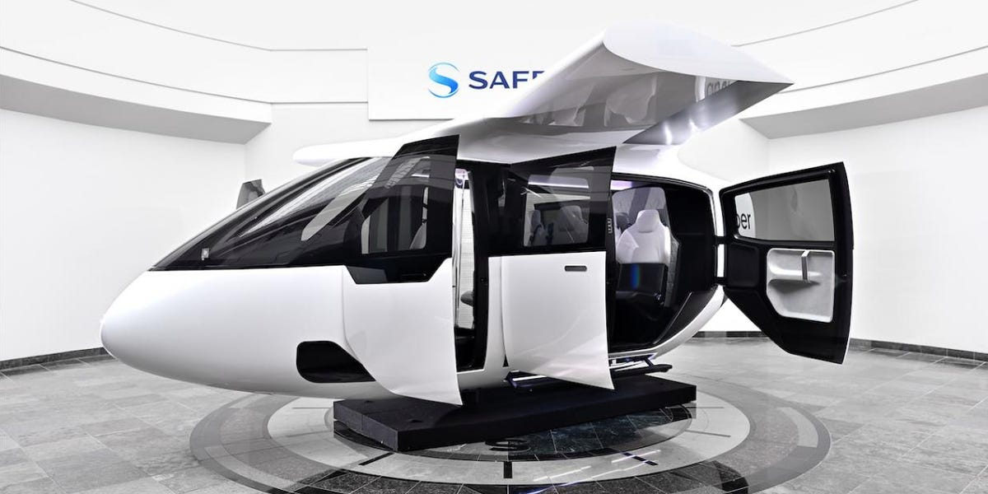

Image Courtesy: The Telegraph

Flying taxis may seem straight out of a science fiction novel or a fantasy of the human mind, but flying taxi project is as realistic as it gets. Big companies such as Uber, Boeing, and Airbus have started developing this technology. Silicon Valley startups are also showing enthusiasm about flying taxis. Uber plans to fly these taxis by 2023 and for this endeavor it has also partnered with NASA.

As per the agreement between the two, Uber will share its plans for implementing an urban aviation rideshare network. NASA will use the latest in airspace management computer modeling and simulation to assess the impacts of small aircraft – from delivery drones to passenger aircraft with vertical take-off and landing capability – in crowded environments.

“NASA is excited to be partnering with Uber and others in the community to identify the key challenges facing the UAM market, and explore necessary research, development and testing requirements to address those challenges,” said Jaiwon Shin, associate administrator for NASA’s Aeronautics Research Mission Directorate.

