Министерство науки и высшего образования Российской Федерации
НАЦИОНАЛЬНЫЙ ИССЛЕДОВАТЕЛЬСКИЙ
ТОМСКИЙ ГОСУДАРСТВЕННЫЙ УНИВЕРСИТЕТ (НИ ТГУ)
Институт прикладной математики и компьютерных наук

ОТЧЁТ ПО ЛАБОРАТОРНОЙ РАБОТЕ

по дисциплине «Системы управления базами данных»

«ИДЗ»

Выполнил:
студент группы932323
Пронин Л. С.

Проверил:
Преподаватель
Мокина Е. Е.

Томск – 2024
Задание 1. ER-модель в 2х нотациях.
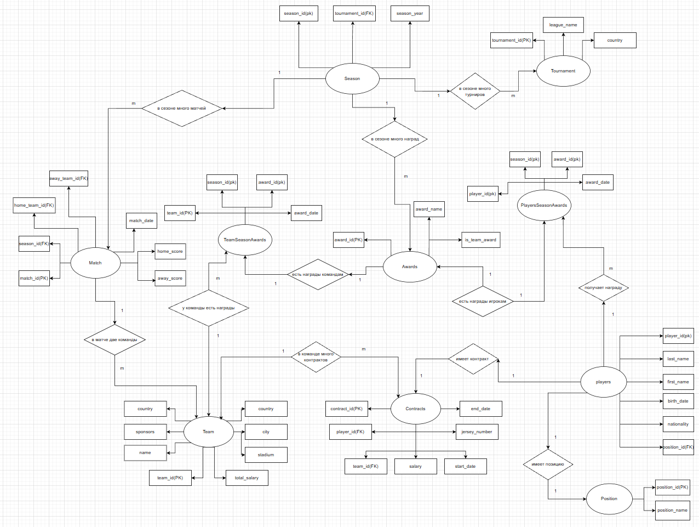
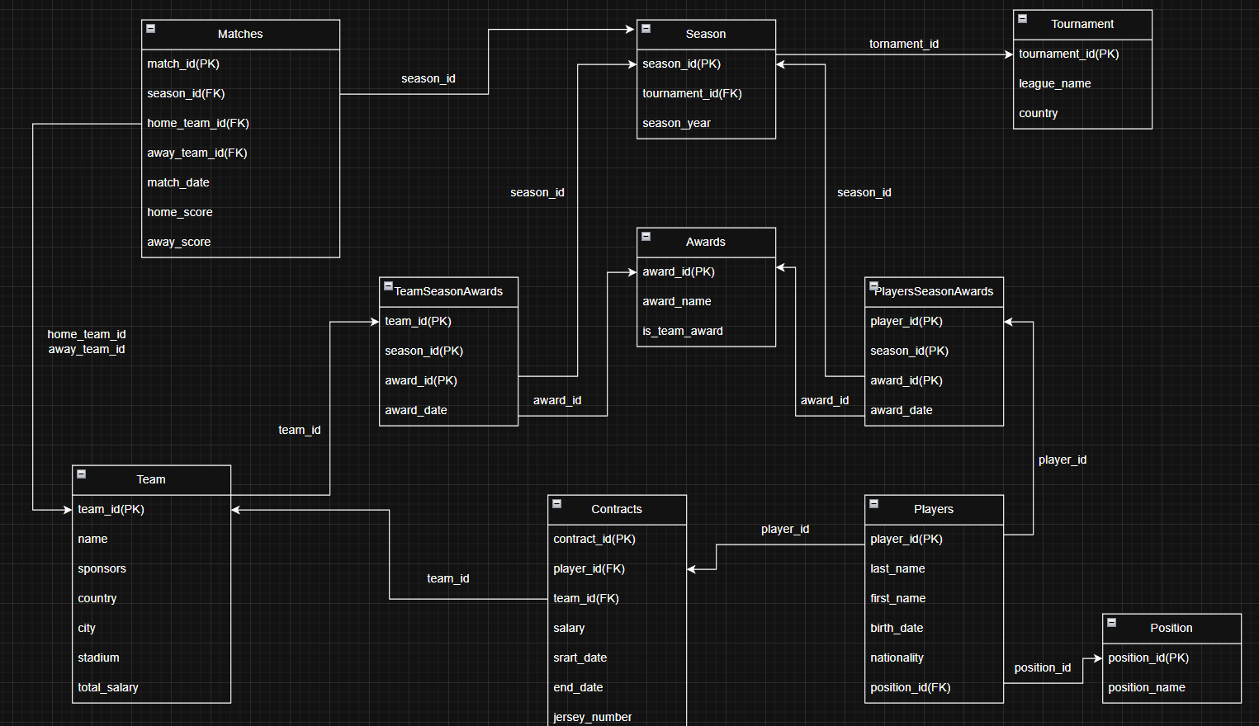

Задание 2. Таблица индексов (Уникальные индексы для всех таблиц с искусственным РК, индексы для ускорения поиска и FK)

Таблица | DDL индекса | Обоснование
TeamSeasonAwards(team_id, award_id, season_id, award_date) | CREATE INDEX idx_team_awards_season ON TeamSeasonAwards(season_id); | Ускоряет выборку наград команд по конкретному сезону.
 | CREATE INDEX idx_team_awards_all ON TeamSeasonAwards(team_id, award_id, season_id); | Ускоряет запросы с фильтрацией или соединением по team_id, award_id, season_id (дополнение к PK).
PlayerSeasonAwards(player_id, award_id, season_id, award_date) | CREATE INDEX idx_player_awards_season ON PlayerSeasonAwards(season_id); | Ускоряет выборку индивидуальных наград игроков по конкретному сезону.
 | CREATE INDEX idx_player_awards_all ON PlayerSeasonAwards(player_id, award_id, season_id); | Ускоряет запросы с фильтрацией или соединением по player_id, award_id, season_id (дополнение к PK).
Position (position_id, position_name) | CREATE UNIQUE INDEX idx_positions_name_unique ON Positions (position_name); | Обеспечивает уникальность названия позиции и ускоряет поиск по названию.
Players (players_id, last_name, first_name, birth_date, nationality, position_id) | CREATE INDEX idx_players_name_search ON Players (last_name, first_name); | Ускоряет поиск игроков по фамилии и имени.
 | CREATE INDEX idx_players_position_id ON Players(position_id); | Ускоряет фильтрацию и JOIN-запросы по позиции игрока.
 | CREATE INDEX idx_players_nationality ON Players(nationality); | Ускоряет поиск игроков по национальности.
 | CREATE INDEX idx_players_birth_date ON Players(birth_date); | Ускоряет поиск игроков по дате рождения.
 | CREATE INDEX idx_players_nationality_position ON Players(nationality, position_id); | Ускоряет сложные запросы с фильтрацией по национальности и позиции одновременно.
Contracts (contract_id, player_id, team_id, salary, start_date, end_date, jersey_number) | CREATE INDEX idx_contracts_end_date ON Contracts (end_date); | Ускоряет запросы по дате окончания контракта (например, поиск истекающих контрактов).
 | CREATE INDEX idx_contracts_player_id ON Contracts (player_id); | Ускоряет поиск контрактов по идентификатору игрока.
 | CREATE INDEX idx_contracts_team_id ON Contracts(team_id); | Ускоряет поиск контрактов по идентификатору команды.
 | CREATE INDEX idx_contracts_start_date ON Contracts(start_date); | Ускоряет запросы по дате начала контракта.
 | CREATE INDEX idx_contracts_player_date ON Contracts(player_id, start_date, end_date); | Оптимизирует запросы, связанные с историей контрактов игрока и их временными интервалами.
Matches (match_id, season_id, home_team_id, away_team_id, match_date, home_score, away_score) | CREATE INDEX idx_matches_season ON Matches(season_id); | Ускоряет поиск матчей по сезону.
 | CREATE INDEX idx_matches_home_team ON Matches(home_team_id); | Ускоряет поиск матчей по домашней команде.
 | CREATE INDEX idx_matches_away_team ON Matches(away_team_id); | Ускоряет поиск матчей по гостевой команде.
 | CREATE INDEX idx_matches_date ON Matches(match_date); | Ускоряет поиск матчей по дате проведения.

Скрипт для создания:

CREATE INDEX idx_team_awards_season ON TeamSeasonAwards(season_id);
CREATE INDEX idx_player_awards_season ON PlayerSeasonAwards(season_id);
CREATE INDEX idx_team_awards_all ON TeamSeasonAwards(team_id, award_id, season_id);
CREATE INDEX idx_player_awards_all ON PlayerSeasonAwards(player_id, award_id, season_id);
CREATE UNIQUE INDEX idx_teams_name_unique ON Teams (name);
CREATE UNIQUE INDEX idx_positions_name_unique ON Positions (position_name);
CREATE INDEX idx_players_name_search ON Players (last_name, first_name);
CREATE INDEX idx_contracts_end_date ON Contracts (end_date);
CREATE INDEX idx_contracts_player_id ON Contracts (player_id);
CREATE INDEX idx_matches_season ON Matches(season_id);
CREATE INDEX idx_matches_home_team ON Matches(home_team_id);
CREATE INDEX idx_matches_away_team ON Matches(away_team_id);
CREATE INDEX idx_matches_date ON Matches(match_date);
CREATE INDEX idx_players_position_id ON Players(position_id);
CREATE INDEX idx_players_nationality ON Players(nationality);
CREATE INDEX idx_players_birth_date ON Players(birth_date);
CREATE INDEX idx_players_nationality_position ON Players(nationality, position_id);
CREATE INDEX idx_contracts_team_id ON Contracts(team_id);
CREATE INDEX idx_contracts_start_date ON Contracts(start_date);
CREATE INDEX idx_contracts_player_date ON Contracts(player_id, start_date, end_date);

Задание 3. Представления (описание что выбирается и для чего, код, скрин с данными).

1) зарплаты в командах
CREATE VIEW team_salary_statistics AS
SELECT
t.team_id,
t.name AS team_name,
t.country,
t.city,
t.stadium,
COUNT(DISTINCT c.player_id) AS total_players,
COUNT(DISTINCT p.position_id) AS different_positions,
SUM(c.salary) AS total_salary_budget,
AVG(c.salary) AS average_salary,
MAX(c.salary) AS highest_salary,
MIN(c.salary) AS lowest_salary,
STRING_AGG(DISTINCT pos.position_name, ', ' ORDER BY pos.position_name) AS positions_covered
FROM Teams t
LEFT JOIN Contracts c ON t.team_id = c.team_id
LEFT JOIN Players p ON c.player_id = p.player_id
LEFT JOIN Positions pos ON p.position_id = pos.position_id
GROUP BY t.team_id, t.name, t.country, t.city, t.stadium
ORDER BY total_salary_budget DESC;

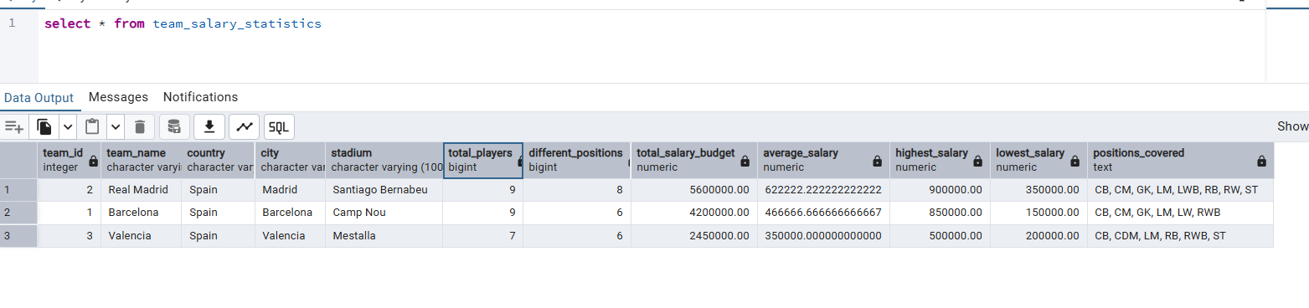

2) вся информация о игроках
CREATE VIEW player_team_info AS
SELECT
p.player_id,
p.first_name,
p.last_name,
p.first_name || ' ' || p.last_name AS full_name,
EXTRACT(YEAR FROM AGE(CURRENT_DATE, p.birth_date)) AS age,
p.nationality,
pos.position_name,
t.name AS team_name,
c.jersey_number,
c.salary
FROM Players p
JOIN Positions pos ON p.position_id = pos.position_id
JOIN Contracts c ON p.player_id = c.player_id
JOIN Teams t ON c.team_id = t.team_id
ORDER BY t.name, p.last_name;

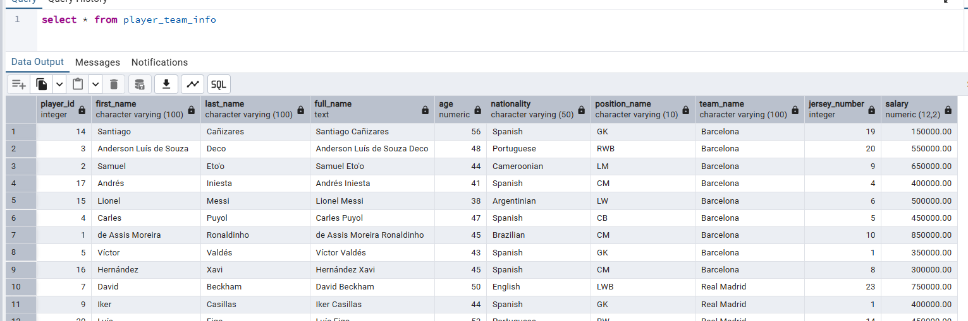

Синоним: CREATE OR REPLACE VIEW player_info AS
SELECT * FROM player_team_info;

SELECT * FROM player_info;

3) турниры и сезоны

CREATE VIEW tournament_season_summary AS
SELECT
t.tournament_id,
t.league_name,
t.country AS tournament_country,
s.season_id,
s.season_year,
COUNT(m.match_id) AS total_matches,
COUNT(DISTINCT m.home_team_id) + COUNT(DISTINCT m.away_team_id) AS total_teams_involved,
SUM(m.home_score + m.away_score) AS total_goals_scored,
ROUND(AVG(m.home_score + m.away_score)::numeric, 2) AS avg_goals_per_match,
SUM(CASE WHEN m.home_score > m.away_score THEN 1 ELSE 0 END) AS home_wins,
SUM(CASE WHEN m.away_score > m.home_score THEN 1 ELSE 0 END) AS away_wins,
SUM(CASE WHEN m.home_score = m.away_score THEN 1 ELSE 0 END) AS draws,
MIN(m.match_date) AS first_match_date,
MAX(m.match_date) AS last_match_date
FROM Tournaments t
JOIN Seasons s ON t.tournament_id = s.tournament_id
LEFT JOIN Matches m ON s.season_id = m.season_id
GROUP BY t.tournament_id, t.league_name, t.country, s.season_id, s.season_year
ORDER BY t.league_name, s.season_year DESC;

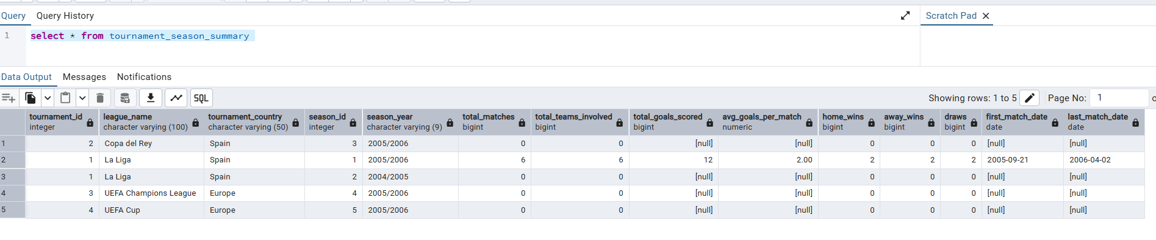

Задание 4. Таблица триггеров (для какой таблицы\столбца, описание для чего, заголовок)

№ | Таблица | Триггер | Функция
1 | Автоматическое заполнение ID в таблице Teams Работает перед вставкой, если team_id не указан, присваивает уникальный ID из последовательности team_id_seq. Аналог SERIAL, но явно через триггер.
 | Teams (team_id, name, sponsors, country, city, stadium, total_salary) | CREATE TRIGGER trg_team_id BEFORE INSERT ON Teams FOR EACH ROW EXECUTE FUNCTION set_team_id(); | CREATE SEQUENCE IF NOT EXISTS team_id_seq;  CREATE OR REPLACE FUNCTION set_team_id() RETURNS TRIGGER AS $$  BEGIN  IF NEW.team_id IS NULL THEN  NEW.team_id := nextval('team_id_seq');  END IF;  RETURN NEW;  END;  $$ LANGUAGE plpgsql;
2 | Логирование изменений в таблице Contracts После любой операции вставки, обновления или удаления в Contracts записывает изменения в таблицу contracts_log с типом операции, старыми и новыми данными, пользователем и временем.
 | contracts_log (log_id, operation_type, contract_id, old_data, new_data, changed_by, changed_at) | CREATE TRIGGER trigger_log_contracts_changes AFTER INSERT OR UPDATE OR DELETE ON Contracts FOR EACH ROW EXECUTE FUNCTION log_contracts_changes(); | CREATE OR REPLACE FUNCTION log_contracts_changes() RETURNS TRIGGER AS $$  BEGIN  INSERT INTO contracts_log (  operation_type, contract_id, old_data, new_data, changed_by, changed_at  ) VALUES (  TG_OP, COALESCE(NEW.contract_id, OLD.contract_id),  CASE WHEN TG_OP IN ('UPDATE','DELETE') THEN row_to_json(OLD)::jsonb ELSE NULL END,  CASE WHEN TG_OP IN ('INSERT','UPDATE') THEN row_to_json(NEW)::jsonb ELSE NULL END,  CURRENT_USER, CURRENT_TIMESTAMP  );  RETURN COALESCE(NEW, OLD);  END;  $$ LANGUAGE plpgsql;
3 | Обновление общей зарплаты команды в таблице Teams После изменений в Contracts пересчитывает total_salary для соответствующей команды.
 | Teams (team_id, name, sponsors, country, city, stadium, total_salary) | CREATE TRIGGER trigger_update_team_salary AFTER INSERT OR UPDATE OR DELETE ON Contracts FOR EACH ROW EXECUTE FUNCTION update_team_total_salary(); | CREATE OR REPLACE FUNCTION update_team_total_salary() RETURNS TRIGGER AS $$  BEGIN  UPDATE Teams  SET total_salary = (  SELECT COALESCE(SUM(salary), 0)  FROM Contracts  WHERE team_id = COALESCE(NEW.team_id, OLD.team_id)  )  WHERE team_id = COALESCE(NEW.team_id, OLD.team_id);  RETURN COALESCE(NEW, OLD);  END;  $$ LANGUAGE plpgsql;
4 | Возможность вставки через представление player_team_info Триггер INSTEAD OF INSERT для представления player_team_info. Позволяет вставлять данные в несколько таблиц (Positions, Teams, Players, Contracts) через одно представление.
 |  | CREATE TRIGGER trg_instead_of_insert_player_team_info INSTEAD OF INSERT ON player_team_info FOR EACH ROW EXECUTE FUNCTION insert_via_player_team_info(); | CREATE OR REPLACE FUNCTION insert_via_player_team_info() RETURNS TRIGGER AS $$  DECLARE  v_position_id INTEGER;  v_player_id INTEGER;  v_team_id INTEGER;  BEGIN  -- проверка и вставка позиции  -- проверка и вставка команды  -- вставка игрока  -- вставка контракта  RETURN NEW;  EXCEPTION WHEN OTHERS THEN  RAISE EXCEPTION 'Ошибка при вставке через представление: %', SQLERRM;  END;  $$ LANGUAGE plpgsql;

Задание 6. Код для создания всех объектов БД и внесения данных.

CREATE TABLE Positions (
position_id SERIAL PRIMARY KEY,
position_name VARCHAR(10) NOT NULL UNIQUE,
CONSTRAINT check_position_name CHECK ( position_name IN ('GK', 'CB', 'RB', 'LB', 'LWB', 'RWB', 'CM', 'LM', 'RM', 'CDM', 'CAM', 'ST', 'CF', 'LW', 'RW') ),
CONSTRAINT check_position_name_not_empty CHECK (LENGTH(TRIM(position_name)) > 0) );

CREATE TABLE Teams (
team_id SERIAL PRIMARY KEY,
name VARCHAR(100) NOT NULL UNIQUE,
sponsors TEXT DEFAULT 'unknown',
country VARCHAR(50) DEFAULT 'unknown',
city VARCHAR(50) DEFAULT 'unknown',
stadium VARCHAR(100) DEFAULT 'unknown',
total_salary DECIMAL(15,2) DEFAULT 0,
CONSTRAINT check_team_name_not_empty CHECK (LENGTH(TRIM(name)) > 0),
CONSTRAINT check_total_salary_non_negative CHECK (total_salary >= 0));

CREATE TABLE Players (
player_id SERIAL PRIMARY KEY,
last_name VARCHAR(100) NOT NULL,
first_name VARCHAR(100) NOT NULL,
birth_date DATE NOT NULL,
nationality VARCHAR(50) DEFAULT 'unknown',
position_id INTEGER,
CONSTRAINT check_last_name_not_empty CHECK (LENGTH(TRIM(last_name)) > 0),
CONSTRAINT check_first_name_not_empty CHECK (LENGTH(TRIM(first_name)) > 0),
CONSTRAINT check_birth_date_reasonable CHECK ( birth_date BETWEEN '1900-01-01' AND CURRENT_DATE ),
CONSTRAINT fkey_player_position FOREIGN KEY (position_id) REFERENCES Positions(position_id) ON DELETE SET NULL );

CREATE TABLE Contracts (
contract_id SERIAL PRIMARY KEY,
player_id INTEGER NOT NULL,
team_id INTEGER NOT NULL,
salary DECIMAL(12,2) NOT NULL,
start_date DATE NOT NULL,
end_date DATE NOT NULL,
jersey_number INTEGER,
CONSTRAINT check_salary_positive CHECK (salary > 0),
CONSTRAINT check_dates_valid CHECK (start_date < end_date),
CONSTRAINT check_jersey_number_range CHECK ( jersey_number IS NULL OR (jersey_number BETWEEN 1 AND 99) ),
CONSTRAINT fkey_contract_player FOREIGN KEY (player_id) REFERENCES Players(player_id) ON DELETE CASCADE,
CONSTRAINT fkey_contract_team FOREIGN KEY (team_id) REFERENCES Teams(team_id) ON DELETE CASCADE,
CONSTRAINT unique_player_active_contract UNIQUE (player_id, team_id));

CREATE TABLE contracts_log (
log_id SERIAL PRIMARY KEY,
operation_type VARCHAR(10) NOT NULL,
contract_id INTEGER,
old_data JSONB,
new_data JSONB,
changed_by VARCHAR(100),
changed_at TIMESTAMP DEFAULT CURRENT_TIMESTAMP);

CREATE TABLE Tournaments (
tournament_id SERIAL PRIMARY KEY,
league_name VARCHAR(100) NOT NULL,
country VARCHAR(50) NOT NULL,
CONSTRAINT check_league_name_not_empty CHECK (LENGTH(TRIM(league_name)) > 0),
CONSTRAINT check_country_not_empty CHECK (LENGTH(TRIM(country)) > 0));

CREATE TABLE Seasons (
season_id SERIAL PRIMARY KEY,
tournament_id INTEGER NOT NULL,
season_year VARCHAR(9) NOT NULL, -- Например: "2023/2024"
CONSTRAINT check_season_year_format CHECK (season_year ~ '^\d{4}/\d{4}$'),
CONSTRAINT fkey_season_tournament FOREIGN KEY (tournament_id)
REFERENCES Tournaments(tournament_id) ON DELETE CASCADE,
CONSTRAINT unique_tournament_season UNIQUE (tournament_id, season_year));

CREATE TABLE Matches (
match_id SERIAL PRIMARY KEY,
season_id INTEGER NOT NULL,
home_team_id INTEGER NOT NULL,
away_team_id INTEGER NOT NULL,
match_date DATE NOT NULL,
home_score INTEGER DEFAULT 0,
away_score INTEGER DEFAULT 0,
CONSTRAINT check_home_away_different CHECK (home_team_id != away_team_id),
CONSTRAINT check_scores_non_negative CHECK (home_score >= 0 AND away_score >= 0),
CONSTRAINT check_match_date_reasonable CHECK (
match_date BETWEEN '1900-01-01' AND (CURRENT_DATE + INTERVAL '1 year')),
CONSTRAINT fkey_match_season FOREIGN KEY (season_id)
REFERENCES Seasons(season_id) ON DELETE CASCADE,
CONSTRAINT fkey_home_team FOREIGN KEY (home_team_id)
REFERENCES Teams(team_id) ON DELETE CASCADE,
CONSTRAINT fkey_away_team FOREIGN KEY (away_team_id)
REFERENCES Teams(team_id) ON DELETE CASCADE);

CREATE TABLE Awards (
award_id SERIAL PRIMARY KEY,
award_name VARCHAR(100) NOT NULL,
is_team_award BOOLEAN NOT NULL, -- TRUE(1) - награда команде, FALSE(0) - награда игроку
description TEXT,
CONSTRAINT check_award_name_not_empty CHECK (LENGTH(TRIM(award_name)) > 0));

CREATE TABLE PlayerSeasonAwards (
player_id INTEGER NOT NULL,
award_id INTEGER NOT NULL,
season_id INTEGER NOT NULL,
award_date DATE DEFAULT CURRENT_DATE,
CONSTRAINT fkey_player_award_player FOREIGN KEY (player_id)
REFERENCES Players(player_id) ON DELETE CASCADE,
CONSTRAINT fkey_player_award_award FOREIGN KEY (award_id)
REFERENCES Awards(award_id) ON DELETE CASCADE,
CONSTRAINT fkey_player_award_season FOREIGN KEY (season_id)
REFERENCES Seasons(season_id) ON DELETE CASCADE,
CONSTRAINT check_award_date_reasonable CHECK (
award_date BETWEEN '1900-01-01' AND CURRENT_DATE
),
CONSTRAINT unique_player_award_per_season UNIQUE (player_id, award_id, season_id),
PRIMARY KEY (player_id, award_id, season_id) -- Составной первичный ключ
);

CREATE TABLE TeamSeasonAwards (
team_id INTEGER NOT NULL,
award_id INTEGER NOT NULL,
season_id INTEGER NOT NULL,
award_date DATE DEFAULT CURRENT_DATE,
CONSTRAINT fkey_team_award_team FOREIGN KEY (team_id)
REFERENCES Teams(team_id) ON DELETE CASCADE,
CONSTRAINT fkey_team_award_award FOREIGN KEY (award_id)
REFERENCES Awards(award_id) ON DELETE CASCADE,
CONSTRAINT fkey_team_award_season FOREIGN KEY (season_id)
REFERENCES Seasons(season_id) ON DELETE CASCADE,
CONSTRAINT check_award_date_reasonable CHECK (
award_date BETWEEN '1900-01-01' AND CURRENT_DATE
),
CONSTRAINT unique_team_award_per_season UNIQUE (team_id, award_id, season_id),
PRIMARY KEY (team_id, award_id, season_id) -- Составной первичный ключ
);

------------------------------------------
--индексы
------------------------------------------

CREATE INDEX idx_team_awards_season ON TeamSeasonAwards(season_id);
CREATE INDEX idx_player_awards_season ON PlayerSeasonAwards(season_id);
CREATE INDEX idx_team_awards_all ON TeamSeasonAwards(team_id, award_id, season_id);
CREATE INDEX idx_player_awards_all ON PlayerSeasonAwards(player_id, award_id, season_id);
CREATE UNIQUE INDEX idx_teams_name_unique ON Teams (name);
CREATE UNIQUE INDEX idx_positions_name_unique ON Positions (position_name);
CREATE INDEX idx_players_name_search ON Players (last_name, first_name);
CREATE INDEX idx_contracts_end_date ON Contracts (end_date);
CREATE INDEX idx_contracts_player_id ON Contracts (player_id);
CREATE INDEX idx_matches_season ON Matches(season_id);
CREATE INDEX idx_matches_home_team ON Matches(home_team_id);
CREATE INDEX idx_matches_away_team ON Matches(away_team_id);
CREATE INDEX idx_matches_date ON Matches(match_date);
CREATE INDEX idx_players_position_id ON Players(position_id);
CREATE INDEX idx_players_nationality ON Players(nationality);
CREATE INDEX idx_players_birth_date ON Players(birth_date);
CREATE INDEX idx_players_nationality_position ON Players(nationality, position_id);
CREATE INDEX idx_contracts_team_id ON Contracts(team_id);
CREATE INDEX idx_contracts_start_date ON Contracts(start_date);
CREATE INDEX idx_contracts_player_date ON Contracts(player_id, start_date, end_date);

--------------------------------
--представления
--------------------------------
CREATE VIEW team_salary_statistics AS
SELECT
t.team_id,
t.name AS team_name,
t.country,
t.city,
t.stadium,
COUNT(DISTINCT c.player_id) AS total_players,
COUNT(DISTINCT p.position_id) AS different_positions,
SUM(c.salary) AS total_salary_budget,
AVG(c.salary) AS average_salary,
MAX(c.salary) AS highest_salary,
MIN(c.salary) AS lowest_salary,
STRING_AGG(DISTINCT pos.position_name, ', ' ORDER BY pos.position_name) AS positions_covered
FROM Teams t
LEFT JOIN Contracts c ON t.team_id = c.team_id
LEFT JOIN Players p ON c.player_id = p.player_id
LEFT JOIN Positions pos ON p.position_id = pos.position_id
GROUP BY t.team_id, t.name, t.country, t.city, t.stadium
ORDER BY total_salary_budget DESC;

CREATE VIEW player_team_info AS
SELECT
p.player_id,
p.first_name,
p.last_name,
p.first_name || ' ' || p.last_name AS full_name,
EXTRACT(YEAR FROM AGE(CURRENT_DATE, p.birth_date)) AS age,
p.nationality,
pos.position_name,
t.name AS team_name,
c.jersey_number,
c.salary
FROM Players p
JOIN Positions pos ON p.position_id = pos.position_id
JOIN Contracts c ON p.player_id = c.player_id
JOIN Teams t ON c.team_id = t.team_id
ORDER BY t.name, p.last_name;

CREATE VIEW tournament_season_summary AS
SELECT
t.tournament_id,
t.league_name,
t.country AS tournament_country,
s.season_id,
s.season_year,
COUNT(m.match_id) AS total_matches,
COUNT(DISTINCT m.home_team_id) + COUNT(DISTINCT m.away_team_id) AS total_teams_involved,
SUM(m.home_score + m.away_score) AS total_goals_scored,
ROUND(AVG(m.home_score + m.away_score)::numeric, 2) AS avg_goals_per_match,
SUM(CASE WHEN m.home_score > m.away_score THEN 1 ELSE 0 END) AS home_wins,
SUM(CASE WHEN m.away_score > m.home_score THEN 1 ELSE 0 END) AS away_wins,
SUM(CASE WHEN m.home_score = m.away_score THEN 1 ELSE 0 END) AS draws,
MIN(m.match_date) AS first_match_date,
MAX(m.match_date) AS last_match_date
FROM Tournaments t
JOIN Seasons s ON t.tournament_id = s.tournament_id
LEFT JOIN Matches m ON s.season_id = m.season_id
GROUP BY t.tournament_id, t.league_name, t.country, s.season_id, s.season_year
ORDER BY t.league_name, s.season_year DESC;

SELECT * FROM team_salary_statistics;
SELECT * FROM player_team_info;
SELECT * FROM tournament_season_summary;

--------------------------------
--тригеры
CREATE SEQUENCE IF NOT EXISTS team_id_seq;

CREATE OR REPLACE FUNCTION set_team_id()
RETURNS TRIGGER AS $$
BEGIN
IF NEW.team_id IS NULL THEN
NEW.team_id := nextval('team_id_seq');
END IF;
RETURN NEW;
END;
$$ LANGUAGE plpgsql;

CREATE OR REPLACE FUNCTION log_contracts_changes()
RETURNS TRIGGER AS $$
BEGIN
INSERT INTO contracts_log (
operation_type,
contract_id,
old_data,
new_data,
changed_by,
changed_at
)
VALUES (
TG_OP,
COALESCE(NEW.contract_id, OLD.contract_id),
CASE
WHEN TG_OP IN ('UPDATE', 'DELETE') THEN row_to_json(OLD)::jsonb
ELSE NULL
END,
CASE
WHEN TG_OP IN ('INSERT', 'UPDATE') THEN row_to_json(NEW)::jsonb
ELSE NULL
END,
CURRENT_USER,
CURRENT_TIMESTAMP
);

RETURN COALESCE(NEW, OLD);
END;
$$ LANGUAGE plpgsql;

CREATE OR REPLACE FUNCTION update_team_total_salary()
RETURNS TRIGGER AS $$
BEGIN
UPDATE Teams
SET total_salary = (
SELECT COALESCE(SUM(salary), 0)
FROM Contracts
WHERE team_id = COALESCE(NEW.team_id, OLD.team_id)
)
WHERE team_id = COALESCE(NEW.team_id, OLD.team_id);

RETURN COALESCE(NEW, OLD);
END;
$$ LANGUAGE plpgsql;

CREATE TRIGGER trg_team_id
BEFORE INSERT ON Teams
FOR EACH ROW
EXECUTE FUNCTION set_team_id();

CREATE TRIGGER trigger_log_contracts_changes
AFTER INSERT OR UPDATE OR DELETE ON contracts
FOR EACH ROW
EXECUTE FUNCTION log_contracts_changes();

CREATE TRIGGER trigger_update_team_salary
AFTER INSERT OR UPDATE OR DELETE ON Contracts
FOR EACH ROW
EXECUTE FUNCTION update_team_total_salary();

CREATE OR REPLACE FUNCTION insert_via_player_team_info()
RETURNS TRIGGER AS $$
DECLARE
v_position_id INTEGER;
v_player_id INTEGER;
v_team_id INTEGER;
BEGIN
-- првоерка позиции
SELECT position_id INTO v_position_id
FROM Positions
WHERE position_name = NEW.position_name;

IF v_position_id IS NULL THEN
IF NEW.position_name NOT IN ('GK', 'CB', 'RB', 'LB', 'LWB', 'RWB', 'CM', 'LM', 'RM',
'CDM', 'CAM', 'ST', 'CF', 'LW', 'RW') THEN
RAISE EXCEPTION 'Недопустимое название позиции: %', NEW.position_name;
END IF;

INSERT INTO Positions (position_name)
VALUES (NEW.position_name)
RETURNING position_id INTO v_position_id;
END IF;

--првоерка команды
SELECT team_id INTO v_team_id
FROM Teams
WHERE name = NEW.team_name;

IF v_team_id IS NULL THEN
INSERT INTO Teams (name)
VALUES (NEW.team_name)
RETURNING team_id INTO v_team_id;
END IF;

-- таблица игроков
INSERT INTO Players (
last_name,
first_name,
birth_date,
nationality,
position_id
) VALUES (
NEW.last_name,
NEW.first_name,
CURRENT_DATE - INTERVAL '1 year' * NEW.age,
COALESCE(NEW.nationality, 'unknown'),
v_position_id
)
RETURNING player_id INTO v_player_id;

-- для контрактов
INSERT INTO Contracts (
player_id,
team_id,
salary,
start_date,
end_date,
jersey_number
) VALUES (
v_player_id,
v_team_id,
COALESCE(NEW.salary, 100000.00),--так же указываем зарплату по умолчанию
CURRENT_DATE,
CURRENT_DATE + INTERVAL '3 years',
NEW.jersey_number
);

RETURN NEW;

EXCEPTION
WHEN OTHERS THEN
RAISE EXCEPTION 'Ошибка при вставке через представление: %', SQLERRM;
END;
$$ LANGUAGE plpgsql;

-- Создаем INSTEAD OF триггер для представления
CREATE TRIGGER trg_instead_of_insert_player_team_info
INSTEAD OF INSERT ON player_team_info
FOR EACH ROW
EXECUTE FUNCTION insert_via_player_team_info();

--------------------------
--синоним
--------------------------
CREATE OR REPLACE VIEW player_info AS
SELECT * FROM player_team_info;

SELECT * FROM player_info;

------------
--данные
------------

INSERT INTO positions (position_name) VALUES ('GK'), ('CB'), ('RB'), ('LB'), ('LWB'), ('RWB'), ('CM'), ('LM'), ('RM'),
('CDM'), ('CAM'), ('ST'), ('CF'), ('LW'), ('RW');

INSERT INTO teams (name, country, city, stadium, sponsors) VALUES
('Barcelona', 'Spain', 'Barcelona', 'Camp Nou', 'UNICEF, Nike'),
('Real Madrid', 'Spain', 'Madrid', 'Santiago Bernabeu', 'Siemens, Adidas'),
('Valencia', 'Spain', 'Valencia', 'Mestalla', 'Toyota, Joma');

INSERT INTO players (last_name, first_name, birth_date, nationality, position_id) VALUES
-- Barcelona
('Ronaldinho', 'de Assis Moreira', '1980-03-21', 'Brazilian', 7), ('Eto''o', 'Samuel', '1981-03-10', 'Cameroonian', 8),
('Deco', 'Anderson Luís de Souza', '1977-08-27', 'Portuguese', 6), ('Puyol', 'Carles', '1978-04-13', 'Spanish', 2),
('Valdés', 'Víctor', '1982-01-14', 'Spanish', 1),

-- Real Madrid
('Ronaldo', ' Luís Nazário de Lima', '1976-09-22', 'Brazilian', 8),
('Beckham', 'David', '1975-05-02', 'English', 5),
('Zidane', 'Zinedine', '1972-06-23', 'French', 7),
('Casillas', 'Iker', '1981-05-20', 'Spanish', 1),
('Roberto Carlos', 'da Silva Rocha', '1973-04-10', 'Brazilian', 3),

-- Valencia
('Villa', 'David', '1981-12-03', 'Spanish', 8),
('Ayala', 'Roberto', '1973-04-14', 'Argentinian', 2),
('Albelda', 'David', '1977-09-01', 'Spanish', 6),
('Cañizares', 'Santiago', '1969-12-18', 'Spanish', 1);

INSERT INTO contracts (player_id, team_id, salary, start_date, end_date, jersey_number) VALUES
-- Barcelona contracts
(1, 1, 850000.00, '2003-07-01', '2008-06-30', 10), -- Ronaldinho
(2, 1, 650000.00, '2004-07-01', '2010-06-30', 9), -- Eto'o
(3, 1, 550000.00, '2004-07-01', '2008-06-30', 20), -- Deco
(4, 1, 450000.00, '1999-07-01', '2010-06-30', 5), -- Puyol
(5, 1, 350000.00, '2002-07-01', '2010-06-30', 1), -- Valdés

-- Real Madrid contracts
(6, 2, 900000.00, '2002-08-31', '2007-06-30', 9), -- Ronaldo
(7, 2, 750000.00, '2003-07-01', '2007-06-30', 23), -- Beckham
(8, 2, 800000.00, '2001-07-01', '2007-06-30', 5), -- Zidane
(9, 2, 400000.00, '1999-07-01', '2011-06-30', 1), -- Casillas
(10, 2, 600000.00, '1996-07-01', '2007-06-30', 3), -- Roberto Carlos

-- Valencia contracts
(11, 3, 500000.00, '2005-07-01', '2010-06-30', 7), -- Villa
(12, 3, 450000.00, '2000-07-01', '2007-06-30', 4), -- Ayala
(13, 3, 400000.00, '2000-07-01', '2009-06-30', 6); -- Albelda

-- Дополнительные данные для таблицы Tournaments (турниры)
INSERT INTO Tournaments (league_name, country) VALUES
('La Liga', 'Spain'),
('Copa del Rey', 'Spain'),
('UEFA Champions League', 'Europe'),
('UEFA Cup', 'Europe'),
('Supercopa de España', 'Spain');

-- Дополнительные данные для таблицы Seasons (сезоны)
INSERT INTO Seasons (tournament_id, season_year) VALUES
(1, '2005/2006'), -- La Liga 2005/2006
(1, '2004/2005'), -- La Liga 2004/2005
(2, '2005/2006'), -- Copa del Rey 2005/2006
(3, '2005/2006'), -- Champions League 2005/2006
(4, '2005/2006'); -- UEFA Cup 2005/2006

-- Дополнительные данные для таблицы Matches (матчи сезона 2005/2006)
INSERT INTO Matches (season_id, home_team_id, away_team_id, match_date, home_score, away_score) VALUES
(1, 1, 2, '2005-11-19', 3, 0), -- Barcelona - Real Madrid (3:0)
(1, 1, 3, '2006-02-12', 1, 0), -- Barcelona - Valencia (1:0)
(1, 2, 3, '2005-12-04', 1, 2), -- Real Madrid - Valencia (1:2)
(1, 2, 1, '2006-04-02', 0, 1), -- Real Madrid - Barcelona (0:1)
(1, 3, 1, '2005-09-21', 2, 2), -- Valencia - Barcelona (2:2)
(1, 3, 2, '2006-03-12', 0, 0); -- Valencia - Real Madrid (0:0)

-- Дополнительные данные для таблицы Awards (награды)
INSERT INTO Awards (award_name, is_team_award, description) VALUES
('La Liga Champion', TRUE, 'Чемпион Ла Лиги'),
('Pichichi Trophy', FALSE, 'Лучший бомбардир Ла Лиги'),
('Zamora Trophy', FALSE, 'Лучший вратарь Ла Лиги'),
('UEFA Champions League Winner', TRUE, 'Победитель Лиги Чемпионов'),
('Ballon d''Or', FALSE, 'Золотой мяч'),
('FIFA World Player', FALSE, 'Игрок года по версии FIFA');

-- Дополнительные данные для таблицы TeamSeasonAwards (награды команд в сезоне)
INSERT INTO PlayerSeasonAwards (player_id, award_id, season_id, award_date) VALUES
(1, 2, 1, '2006-05-20'), -- Роналдиньо - Pichichi Trophy (26 голов)
(9, 3, 1, '2006-05-20'), -- Икер Касильяс - Zamora Trophy
(1, 5, 1, '2005-11-28'), -- Роналдиньо - Ballon d''Or 2005
(1, 6, 1, '2005-12-19'); -- Роналдиньо - FIFA World Player 2005

-- Добавляем недостающую запись в TeamSeasonAwards
INSERT INTO TeamSeasonAwards (team_id, award_id, season_id, award_date) VALUES
(1, 1, 1, '2006-05-20'), -- Barcelona - чемпион Ла Лиги 2005/2006
(1, 4, 4, '2006-05-17'); -- Barcelona - победитель Лиги Чемпионов 2005/2006

-- Дополнительные футболисты для таблицы Players (еще игроки из сезона 2005/2006)
INSERT INTO players (last_name, first_name, birth_date, nationality, position_id) VALUES
-- Barcelona дополнительные игроки
('Messi', 'Lionel', '1987-06-24', 'Argentinian', 14), -- LW
('Xavi', 'Hernández', '1980-01-25', 'Spanish', 7), -- CM
('Iniesta', 'Andrés', '1984-05-11', 'Spanish', 7), -- CM
('Marquez', 'Rafael', '1979-02-13', 'Mexican', 2), -- CB
-- Real Madrid дополнительные игроки
('Raúl', 'González', '1977-06-27', 'Spanish', 12), -- ST
('Figo', 'Luís', '1972-11-04', 'Portuguese', 15), -- RW
('Guti', 'Guti', '1976-10-31', 'Spanish', 7), -- CM
('Salgado', 'Míchel', '1975-10-22', 'Spanish', 3), -- RB
-- Valencia дополнительные игроки
('Baraja', 'Rubén', '1975-07-11', 'Spanish', 10), -- CDM
('Vicente', 'Rodríguez', '1981-07-16', 'Spanish', 8), -- LM
('Mista', 'Mista', '1978-11-12', 'Spanish', 12), -- ST
('Moretti', 'Emiliano', '1981-06-11', 'Italian', 4); -- LB

-- Дополнительные контракты для новых игроков
INSERT INTO contracts (player_id, team_id, salary, start_date, end_date, jersey_number) VALUES
-- Barcelona дополнительные контракты
(14, 1, 150000.00, '2004-07-01', '2010-06-30', 19), -- Messi
(15, 1, 500000.00, '1998-07-01', '2010-06-30', 6), -- Xavi
(16, 1, 300000.00, '2002-07-01', '2010-06-30', 8), -- Iniesta
(17, 1, 400000.00, '2003-07-01', '2010-06-30', 4), -- Marquez
-- Real Madrid дополнительные контракты
(18, 2, 700000.00, '1994-07-01', '2010-06-30', 7), -- Raúl
(19, 2, 650000.00, '2000-07-01', '2007-06-30', 10), -- Figo
(20, 2, 450000.00, '1995-07-01', '2010-06-30', 14), -- Guti
(21, 2, 350000.00, '1999-07-01', '2009-06-30', 2), -- Salgado
-- Valencia дополнительные контракты
(22, 3, 350000.00, '2000-07-01', '2010-06-30', 8), -- Baraja
(23, 3, 300000.00, '2000-07-01', '2011-06-30', 14), -- Vicente
(24, 3, 250000.00, '2001-07-01', '2006-06-30', 20), -- Mista
(25, 3, 200000.00, '2004-07-01', '2009-06-30', 24); -- Moretti

