Practice Project 11

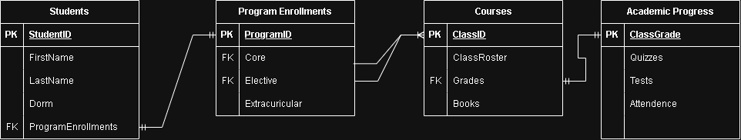

Entities:
Students, Program Enrollments, Courses, Academic Progress
Attributes:
FirstName, LastName, Dorm, ProgramEnrollments, Core, Elective, Extracurricular, ClassRoster, Grades, Books, Quizzes, Tests, Attendence
Relationships:
ProgramEnrollements -> one to one -> ProgramID
Core -> one to many -> ClassID
Elective -> one to many -> ClassID
Grades -> one to one -> ClassGrade

