Artificial Neural Network

Assignment 1

Vukan Turkulov | Mihaela Stoycheva | Learning Systems | March 1, 2016

## 1. Structure of neural network selected

The structure of the neural network is configurable by the user, but for the results presented below we used three-layer ANN with 3 inputs, 5 hidden units and 1 output.

## 2. Learning algorithm used

The algorithm used for learning is backpropagation – basically it is iterative algorithm and on each iteration the inputs are forwarded though the network and the outputs are calculated. Then the error of each output is calculated and weights are modified. The first iteration uses random small weights.

## 3. Evolving of performance

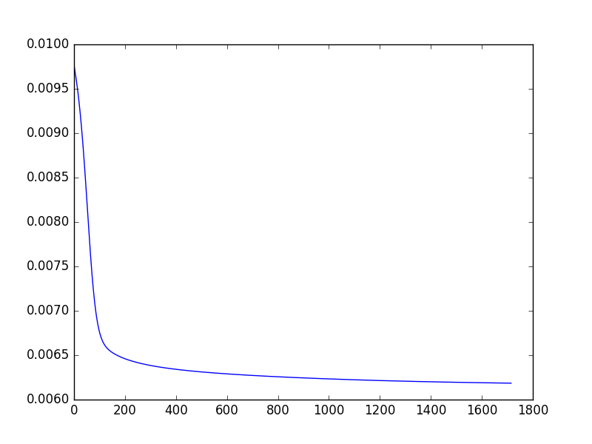

On the vertical axis is the error and on the horizontal axis there is the number of iterations that have passed.

## 4. Performance on training data

Error on whole training data set: 0.00591729466547751

## 5. Performance on test data

Test data error is 0.004609162462734982