Vukan Turkulov | Mihaela Stoycheva | Learning Systems | February 25, 2016

Genetic Algorithm

Assignment 3

## 1. Explain the important operations of the employed algorithm (e.g. GA) to solve this problem

One of the most important decisions that need to be made when using GA is the representations of individual because the success of the algorithm depends on this. Fortunately, for the problem we are solving this is quite intuitive and is described in details below. Another aspect that is of great importance is the definition of the fitness function which is also intuitive in our case. GA manages to solve the problem because of its evolutionary approach - an initial population of individuals is generated randomly and is evaluated. After that few of the best individual (fittest) are transferred to the next population. Using a selection mechanism few of the rest individual are chosen to be parent and to crossover between each other to create the rest of the next population. After that mutation operator is executed that mutates the children and brings diversity to the population. This prevents the algorithm from getting into a local minimum or over-fit. Eventually after the error has become small or after a maximum number of iterations have passed the algorithm terminates and gives the best solution found so far.

## 2. Explain the representation of the individual solutions in your algorithm.

The individual is represented as an array containing the IDs of the cities that will be visited. In index 0 is the ID of the city that will be visited first and is always equal to 1. In index 1 is the seconds city, in index 2 is the third city, etc. and the last index in the array is the city where we will finish, which is always equal to 1.

## 3. Give the equation of the fitness function used by your algorithm.

Let x be an individual: $x=\left({id}_{1},{id}_{2},…, {id}_{n}\right)$, where ${id}_{i}$ is the id of the i-th city and there exists a tuple $(x_{{id}_{i}},y_{{id}_{i}})$ that are the coordinated for the i-th city’s location. Then fitness is defined at:

$$fitness\left(x\right)=\sum_{i=1}^{n-1}{\sqrt{{(x_{{id}_{i+1}}-x_{{id}_{i}})}^{2}+{(y_{{id}_{i+1}}-y_{{id}_{i}})}^{2}}}$$

## 4. Give the parameters used in your algorithm. Examples: population size, crossover rate…

The population size that we used is 500. The elitism rate is 0.1 which means that 10% of the best individuals will be inherited in the next generation without any change. The tournament rate is 0.1 which means that whenever a parent is to be chosen 10% of the population will be chosen randomly and the parent will be the fittest one, according to the formula above. The parent rate is 0.2 which means that 20% of the populations will be parents and will be used creating the next population. The crossover strategy that is used is a crossover operator with an order representation, as described in the lectures. The maximum number of iterations that is used is 500 and the algorithm is executed 10 times with different starting population every time.

## 5. Illustrate how performance of the population evolves with generations (preferably with a figure)

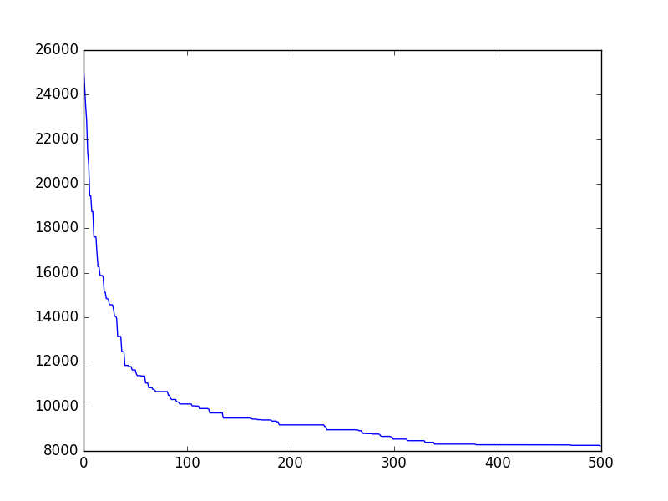

## 6. Show the best result obtained by your algorithm (the order of locations to visit and the total distance of this route).

Best result is 8228.576874458458

Best result is [1, 18, 3, 17, 21, 42, 7, 2, 30, 29, 16, 46, 35, 49, 32, 45, 19, 41, 8, 9, 10, 43, 33, 51, 28, 27, 26, 47, 13, 14, 52, 11, 12, 25, 4, 15, 5, 6, 48, 24, 38, 37, 40, 39, 36, 34, 44, 50, 20, 23, 31, 22, 1]