*BI-ARD*

**Indoor Air Quality Measurement Station**HW Documentation

Michal Dobes

# Components

* **Sensors**
  + Dust sensor – GP2Y1010AU0F
  + Tempeature and humidity sensor – DHT22
  + Carbon dioxide sensor – MH-Z19B
* **Peripheries**
  + OLED Display – SSD1306 128x64
  + Ethernet module – W5500
* **Other**
  + Button
  + RGB LED

# Wiring

* Illustration

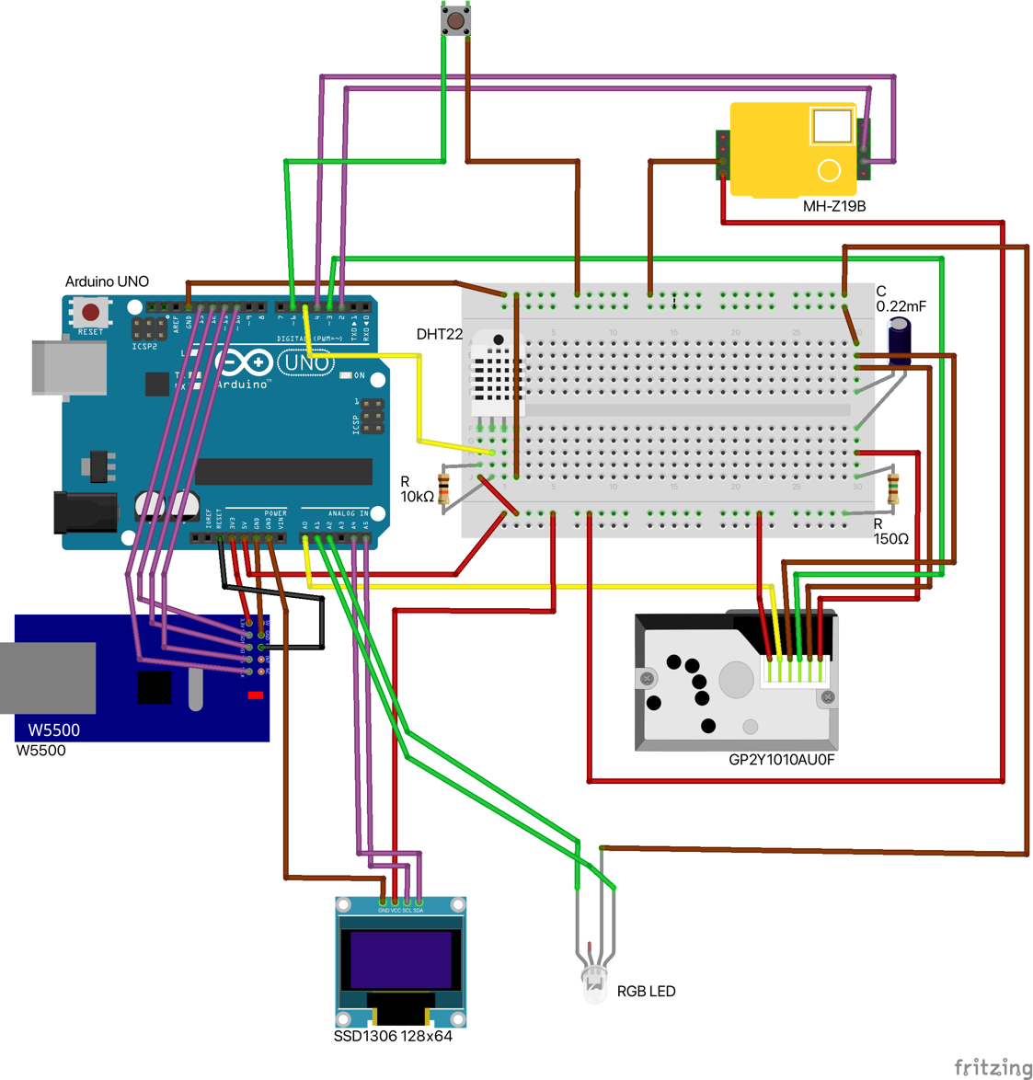

* Schematic

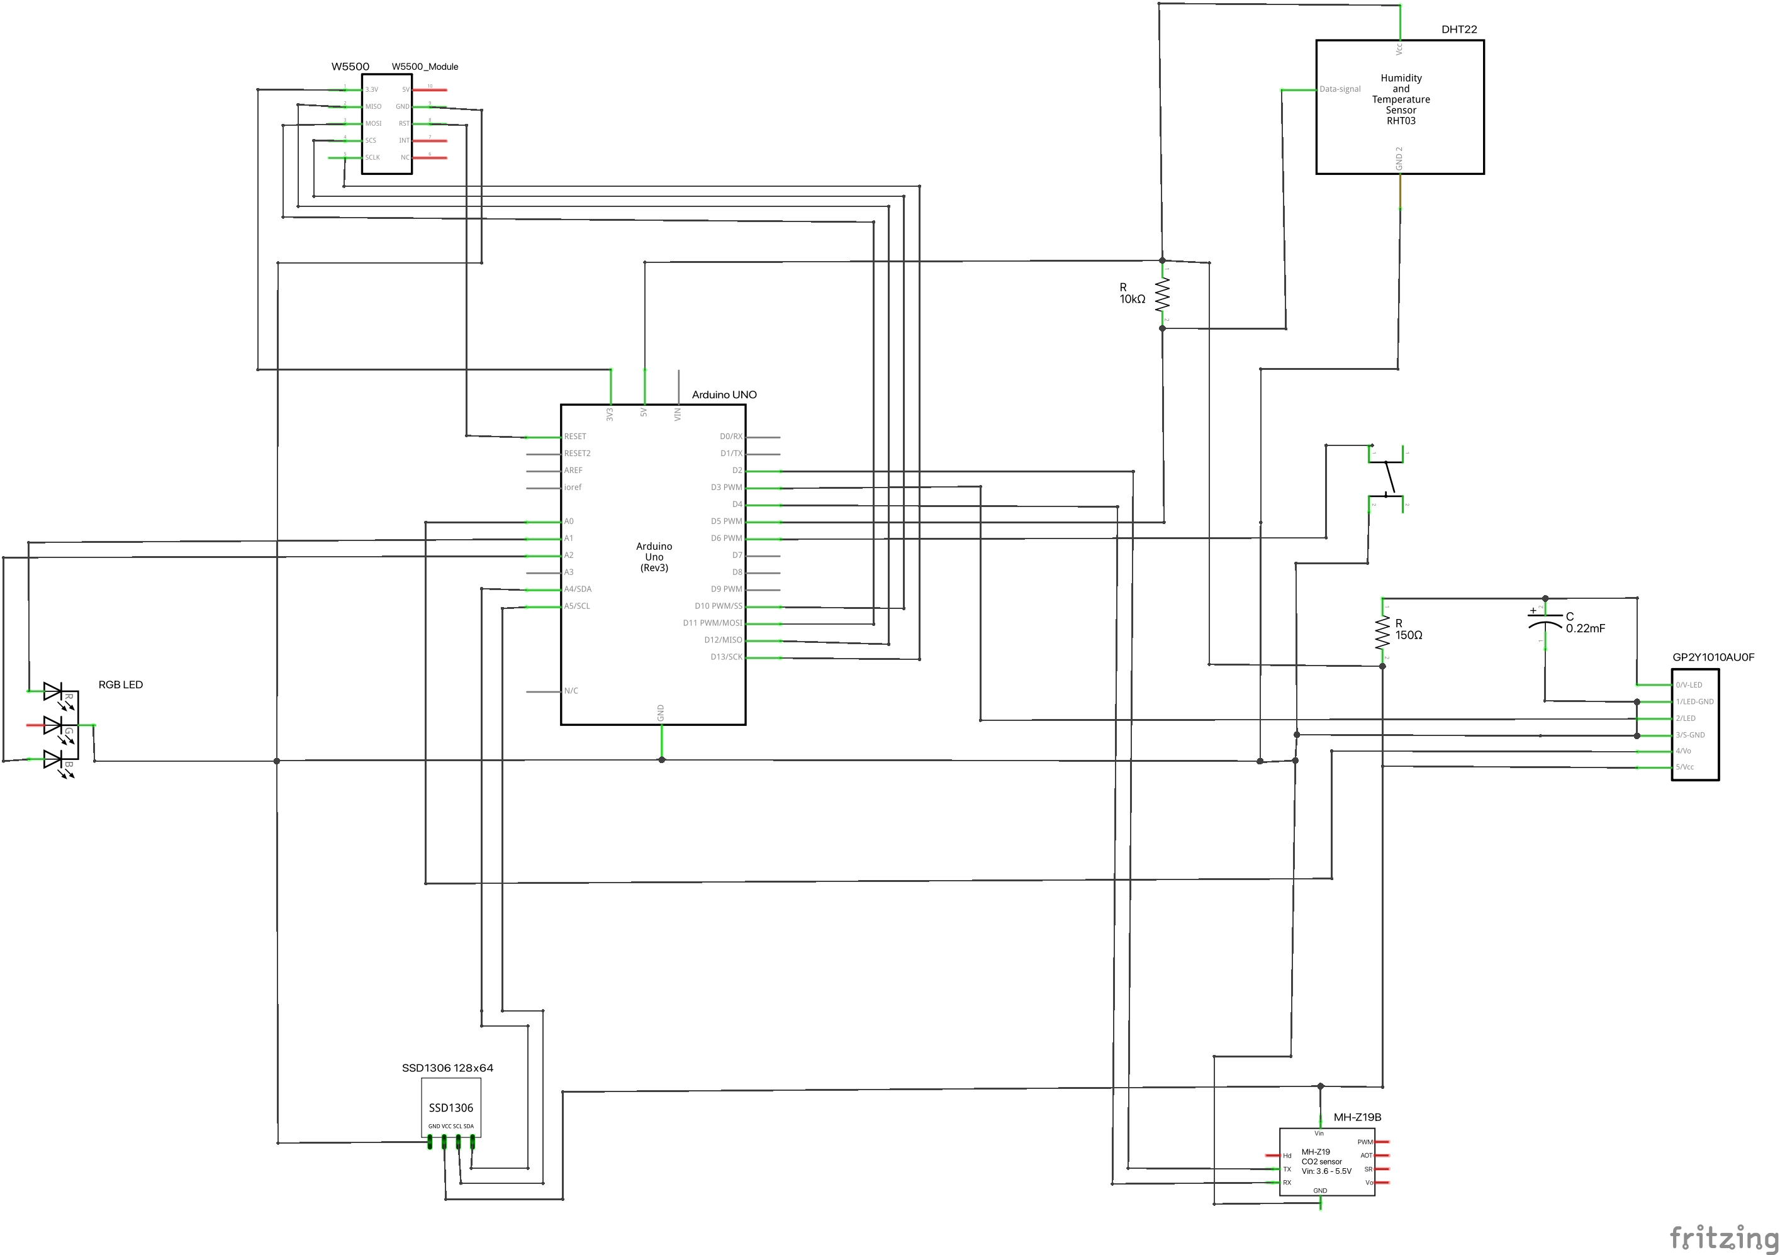

* Real

# Settings

## Pins

If the pins on the Arduino were wired differently, this must be taken into account by changing the pin in the code.

All pins are defined in the header of *AirQuality.ino* file where they can be changed.

## Measurement frequency

The period of regular sensor data measurement is defined in the header of the *AirQuality.ino* file, where this time can be changed. The unit is milliseconds. The minimum value is 2000 ms, but more is recommended.

## Internet connection

For the correct functioning of the web server that displays the results it is necessary to set up the Ethernet module correctly. To connect, you must know the MAC address of the module and have a static IP address assigned. These values must be set in the header of the *AirQuality.ino* file.

