**TITLE:** **HOME AUTOMATION**

**ABOUT THE PROJECT**:

Home automation refers to the automatic and electronic control of household features, activity and appliances in order to build up what is called Smart Homes. In our attempt to do the same, we have made an automated gate. The gate automatically opens for a visitor and subsequently the number of people entering the home is counted. We also tried to make a smart room wherein there is temperature controlled fan and a lighting system which works when the intensity of light in the room is less than a particular parameter.

**COMPONENTS USED:**

* Microcontroller board (2 Arduino boards) : -

An Arduino is such a board, and contains a microcontroller, typically an 8-bit AVR such as the ATmega8, ATmega168, ATmega328, ATmega1280, and ATmega2560, plus power supplies, crystal, and female headers to interface with various peripheral boards.

* Light Dependent Resistor : -

A photo resistor (or light-dependent resistor, LDR, or photocell) is a light-controlled variable resistor. The resistance of a photo resistor decreases with increasing incident light intensity.

* Temperature Sensor (LM35): -

The LM35 series are precision integrated-circuit temperature devices with an output voltage linearly-proportional to the Centigrade temperature.

* Infrared Sensor Module :-

An infrared sensor is an electronic device, that emits in order to sense some aspects of the surroundings. An IR sensor can measure the heat of an object as well as detects the motion.These types of sensors measures only infrared radiation, rather than emitting it that is called as a passive IR sensor.

* Motors :-

A device that converts electrical energy to mechanical energy.

* Light Emitting Diodes: -

A LED is a semiconductor device that emits visible light when an electric current passes through it.

* Resistors:-

A resistor is an electrical component that limits or regulates the flow of electrical current in an electronic circuit.

* Gears:-

A gear is a rotating machine part having cut teeth, or cogs, which mesh with another toothed part to transmit torque.

* Relay Modules:-

A relay is an electrically operated switch.Relays are switches that open and close circuits electromechanically or electronically. They control one electrica**l** circuit by opening and closing contacts in another circuit. When a relay contact is normally open (NO), there is an open contact when the relay is not energized.

* Connecting wires

**DESCRIPTION:**

* The Main Gate:

We have attached 2 IR Sensors. When someone comes near the gate, the IR Sensors pick up the signal and we have programmed the microcontroller to increment a counter whenever the IR Sensors pick up the signal. Along with it the gate opens with the help of a motor.

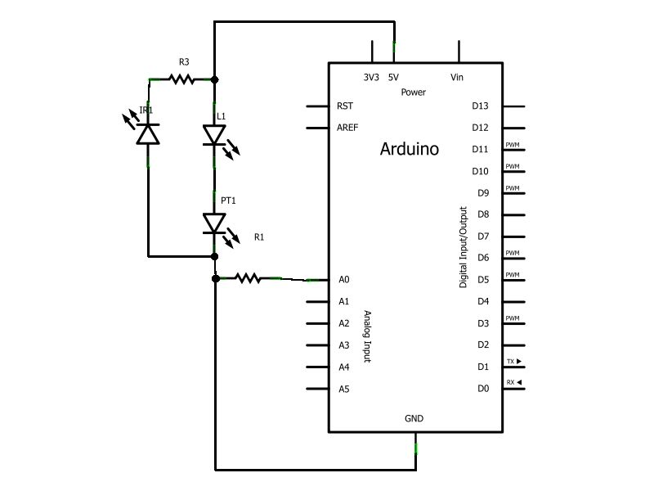

Diagram: IR Sensor-Arduino Connection Schematics

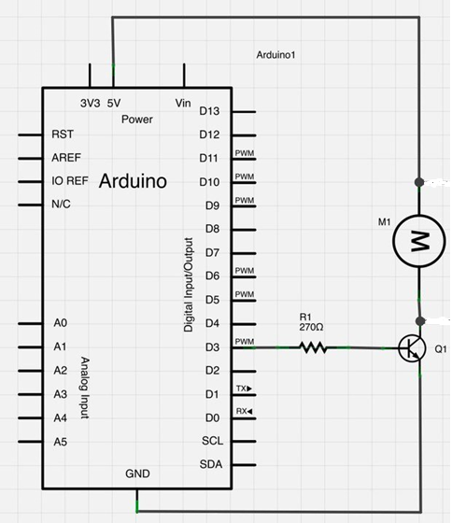

Diagram: Motor-Arduino Connection Schematics

* The Room:

We have attached 2 IR Sensors. When someone enters the rooms, a counter is incremented and the number of people inside the room is counted. We have used a LDR and programmed the Arduino board so as to switch on the LEDs when the output given by LDR is below certain parameter. In this way, when the intensity of light in the room is less, the bulbs will glow. We have used a temperature sensor, LM35, whose output voltage is inversely proportional to the temperature in Celsius. When the temperature is less than a certain temperature, the fan is switched on automatically and the microcontroller is programmed accordingly for the same.

When someone gets out of the room, the counter is decremented. In this way, when there is no one in the room, the fan and the light is automatically turned off.

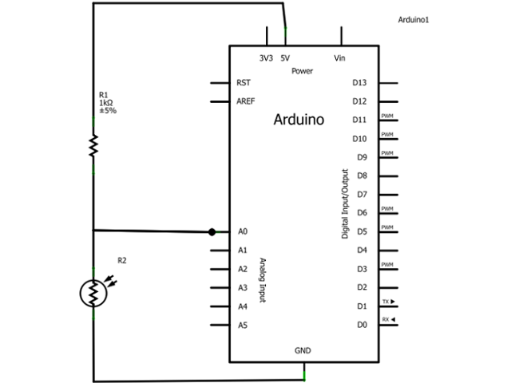

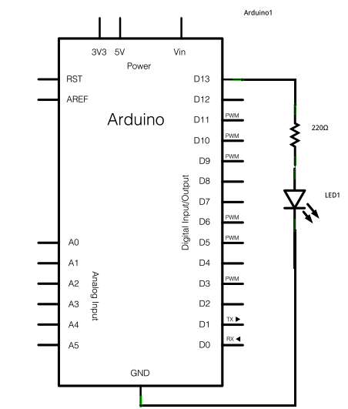 Diagram: LDR Sensor-Arduino Connection Schematics

Diagram: LED Sensor-Arduino Connection Schematics

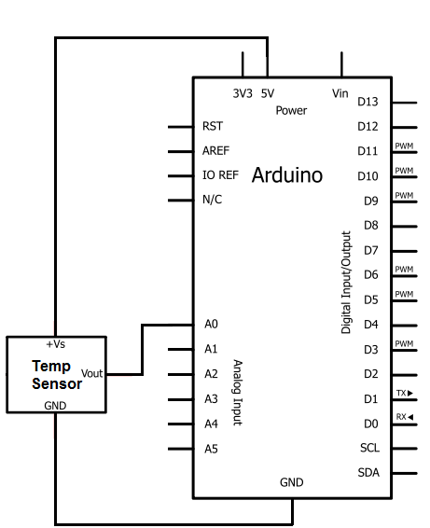

Diagram: Temperature Sensor- Arduino Connection Schematic

**CONCLUSION:**

Indeed, automation is the talk of the town and rigorous research is going on to improve our day-to-day life. Companies like Facebook, Microsoft, Bell Labs are employing huge resources to bring dissolve digitalization in our daily life.

We simply implemented a small variable of automation in our project. Further development will be implemented in the near future.