prince_resume.exe 01 / 02
PRINCE  KUMAR MISHRA  BTECH ECE / SOFTWARE INTERNSHIP  PYTHON / WEB / ROBOTICS | 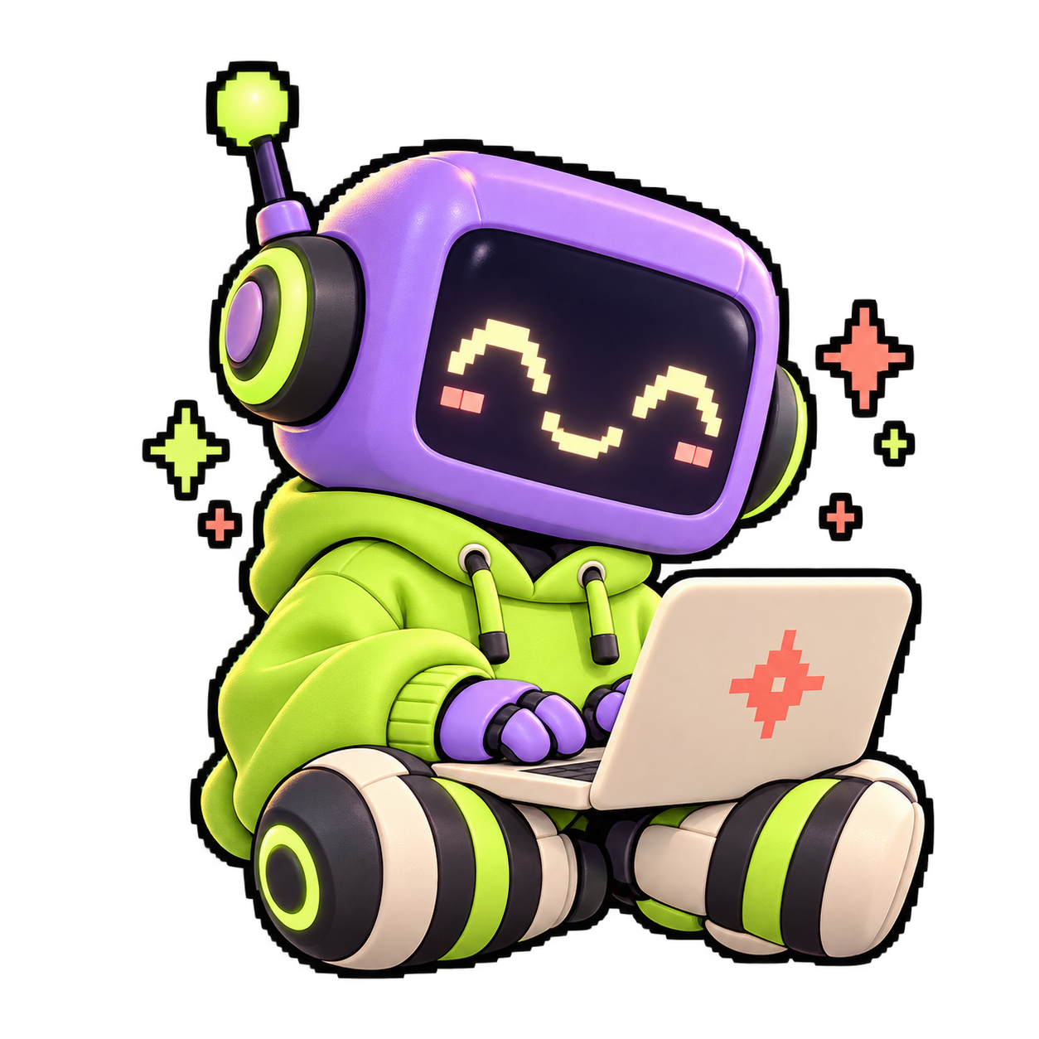
pm023847@gmail.com / +91 7838956795
New Delhi 110008 / github.com/mishra-prince
01 / PROFILE
First-year BTech ECE student at ADGIPS (GGSIPU), with intermediate Python and projects across web applications, automation and robotics. Seeking a software internship to contribute, learn and build useful tools.

02 / EDUCATION  BTech / ECE  ADGIPS, GGSIPU  First year  Class XII / 2025  DTEA Sr. Sec. School, New Delhi  Class X / 2023  DTEA Sr. Sec. School, New Delhi  Passed | 03 / TOOLKIT  PROGRAMMING  Python (intermediate); C / C++ foundations  WEB AND DATA  JavaScript, TypeScript, React, FastAPI, Express, REST APIs, SQLite, SQLAlchemy, Qdrant  TOOLS AND HARDWARE  Git, GitHub, pytest, ESP32-C3, Arduino IDE, Wokwi, UDP / JSON  PRODUCTIVITY  Microsoft Office: Word, Excel, PowerPoint

04 / WORLD ROBOT OLYMPIAD / VOLUNTEER / JAN 2023
• Assisted with organizing robotics events and coordinating participants.
• Provided technical support, troubleshooting and guest guidance.
• Maintained event records and developed teamwork and leadership through coordination.

05 / CREDENTIALS  Rockwell Automation / Certification / 2023  WRO India / Future Innovators Senior / Participation / 2022  Zonal Level Science Exhibition / Transport and Innovation / 2022  National Science Olympiad / Participation / 2022 | 06 / BEYOND THE CODE  Chess and strategic problem-solving. Interests in robotics, technology and innovation; school competitions, hackathons and science fairs.  Teamwork, leadership, communication, time management and adaptability.  English B2 / Hindi C2

prince_resume.exe 02 / 02

PROJECT FLASHCARDS
SELECTED BUILDS / 2023-2026
BUILD_01  SpendOath  Agent commerce demo  TypeScript / React / Express / SQLite  • Built a payment demo with server-enforced budgets, idempotent retries and SHA-256 delivery checks.  • Added result verification, audit receipts and 15 automated tests for budget, retry and integrity cases.  OPEN REPO > | BUILD_02  Hackathon Calendar  Discovery and deadline automation  Python / FastAPI / React / SQLite / Telegram  • Created four source adapters, normalized records and scheduled Telegram deadline reminders.  • Added change alerts, a calendar dashboard and tests for parsing, reminders and announcements.  OPEN REPO >

BUILD_03  SwasthyaVoice  Voice intake prototype  Python / FastAPI / React / Qdrant  • Built recoverable conversations, patient-history retrieval and a human-review dashboard.  • Separated urgency rules from LLM extraction; added 14 synthetic scenarios for memory, recovery and escalation.  OPEN REPO > | BUILD_04  ANT-X Micro  Robotics communication prototype  Python / Arduino C++ / ESP32-C3 / UDP  • Built a JSON protocol with 5 Hz telemetry, CSV logs and a robot emulator.  • Added contact-stop logic, packet validation and command expiry; documented staged hardware development.  OPEN REPO >

05 / PASSENGER DETECTOR SYSTEM MAY 2023
CIRCUIT & DESIGN DEVELOPER
• Designed the circuit and integrated electrical components to detect a passenger extending a hand or head outside a vehicle window.
• Integrated a driver alarm and seat-number display to identify the passenger; focused on hardware design and system integration for passenger safety.

MORE BUILDS > github.com/mishra-prince

