FEEDBACK API
Task: Feedback API with PostgreSQL
Create 4 APIs to create feedback, get feedback, delete feedback, list all feedbacks
Utilize PostgreSQL DB to store multiple user feedbacks and follow PEP8 standards
Note: Installed postgres on WSL as I was having some issue while installing directly on the system.

- Configure Database
Commands used:
root@LAPTOP-9TNU45UQ:~# sudo -u postgres psql
psql (12.22 (Ubuntu 12.22-0ubuntu0.20.04.4))
postgres=# CREATE DATABASE feedback_db;
postgres=# ALTER USER postgres PASSWORD '<password>’

- Ensure PostgreSQL is running and a database named feedback_db exists.
Database URL used in database.py:
postgresql://<username>:<password>@localhost:5432/feedback_db
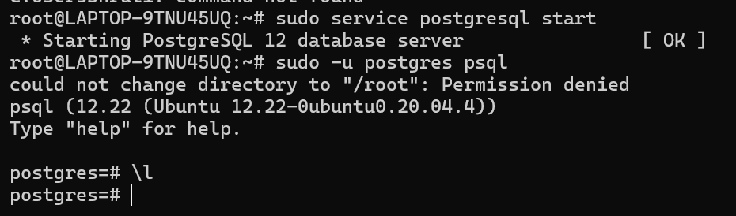
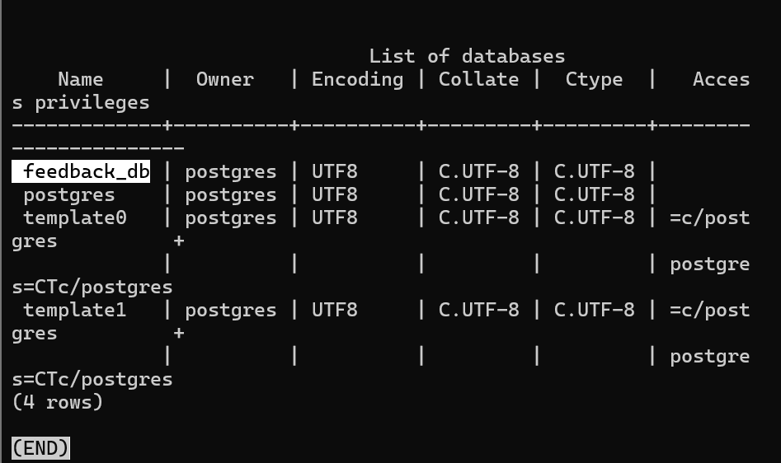
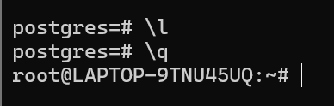

- On VSCode, connect to WSL Ubuntu on the bottom left.
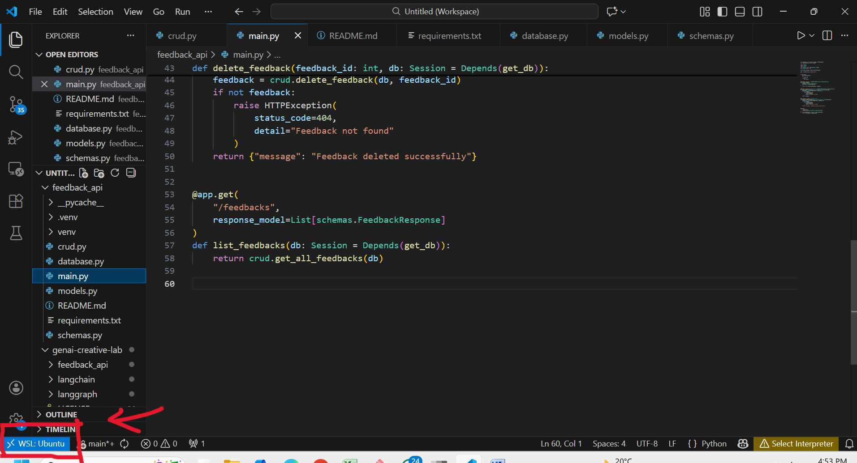

- Execute below commands in the terminal in vscod
# Open the project
cd feedback_api
# Create and activate virtual environment
python3 -m venv venv
. venv/bin/activate
# Install dependencies
pip install -r requirements.txt

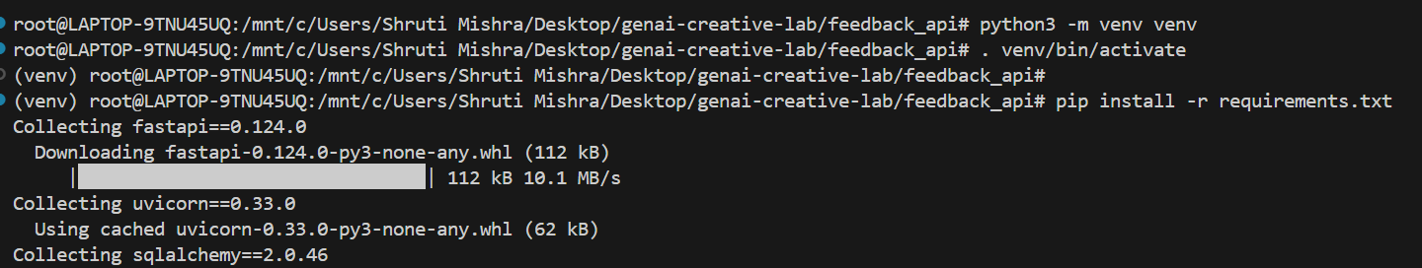

# Run the application
uvicorn main:app –reload

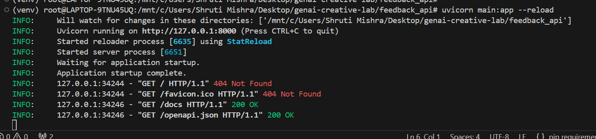

- Open your browser and go to:
http://127.0.0.1:8000/docs
Swagger UI provides an interactive interface to test all APIs.
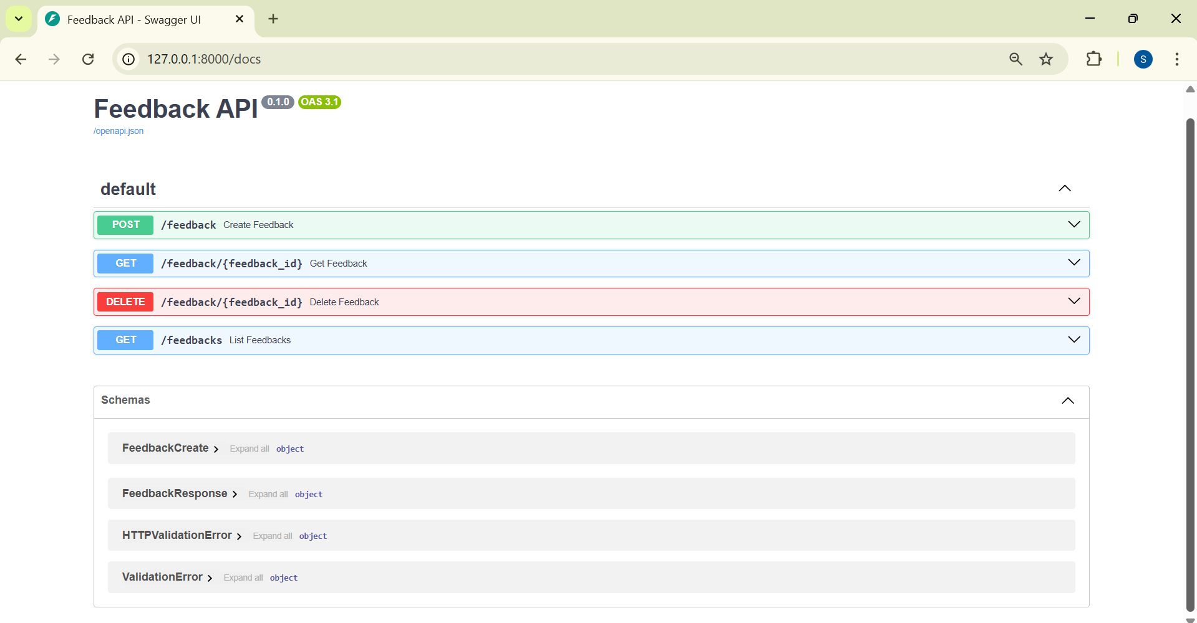

- Test API Endpoints
➤ Create Feedback
POST /feedback
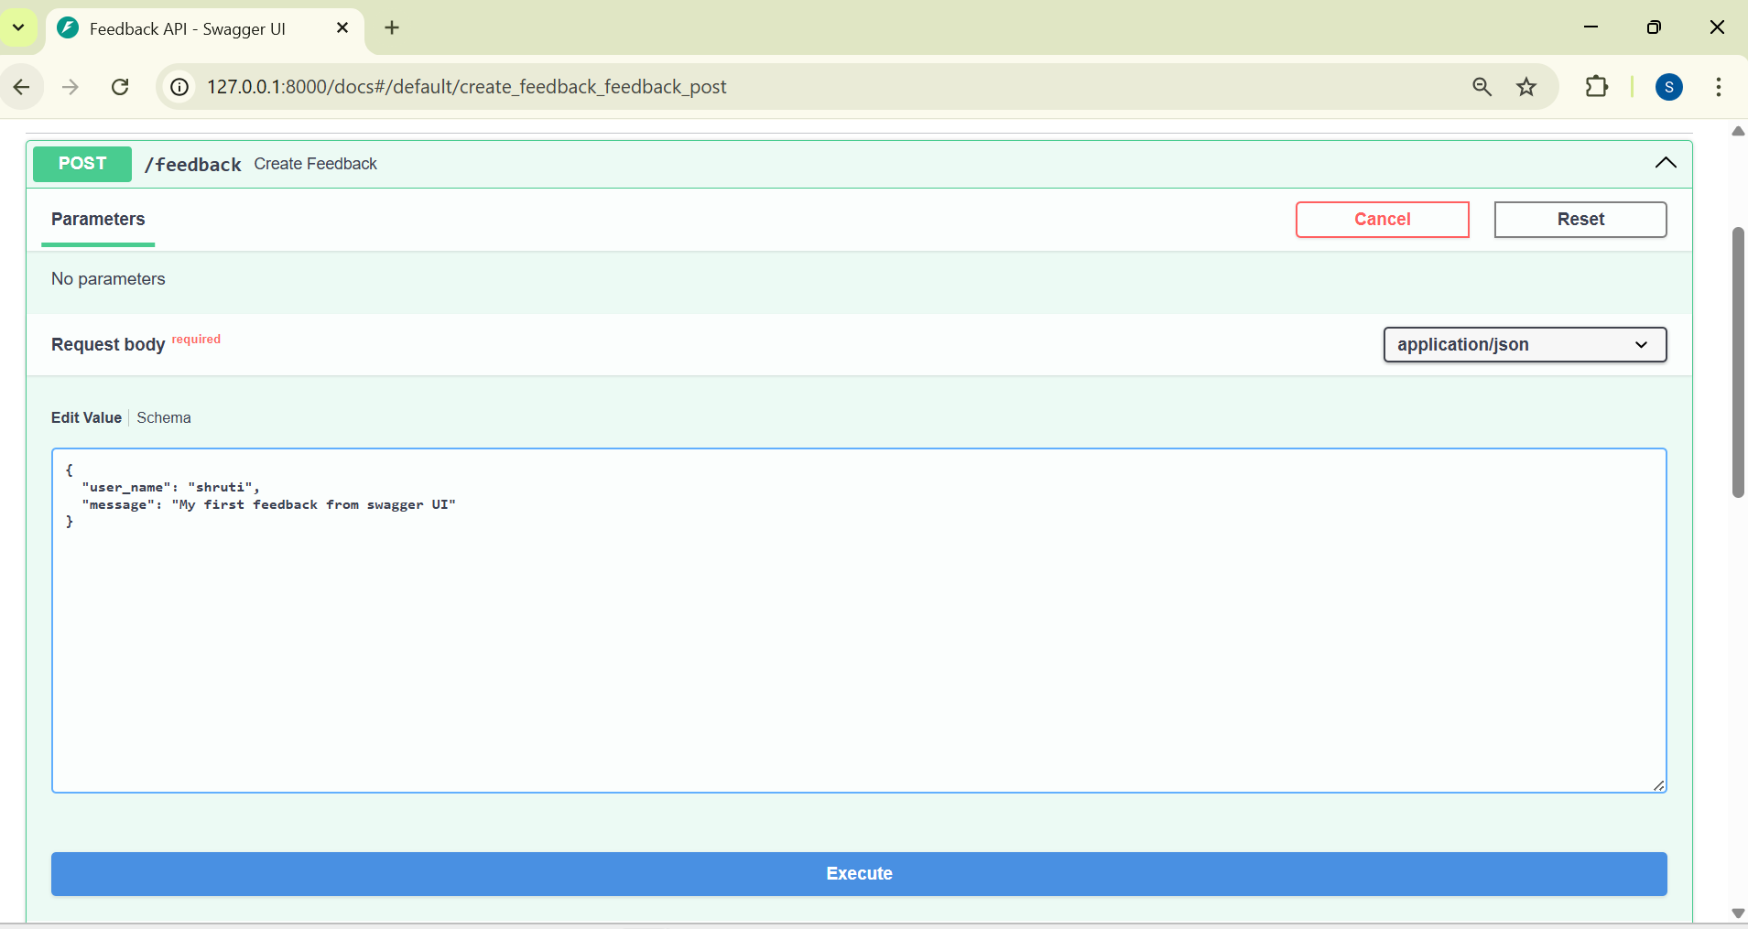
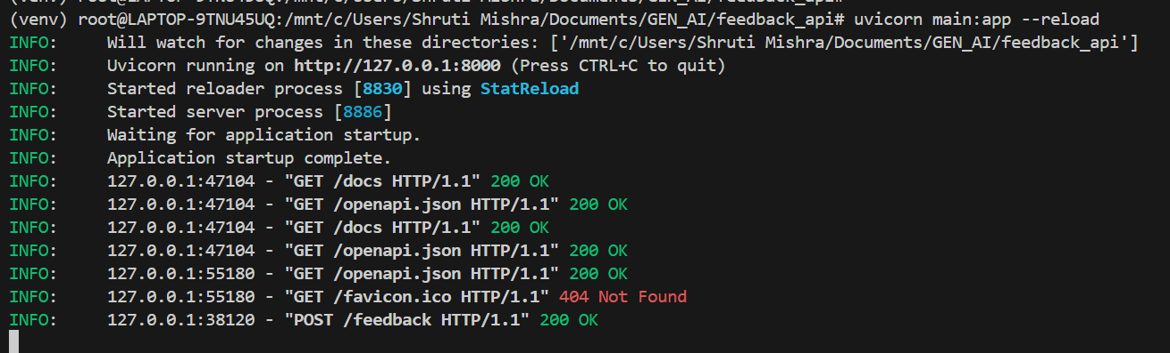
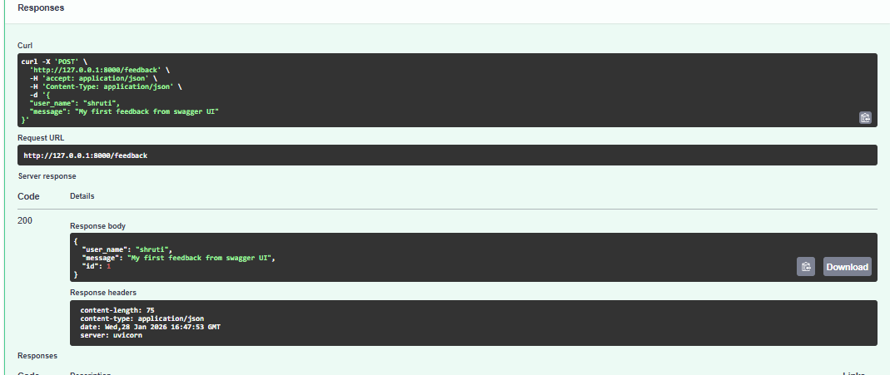

➤ Get Feedback by ID
GET /feedback/{feedback_id}

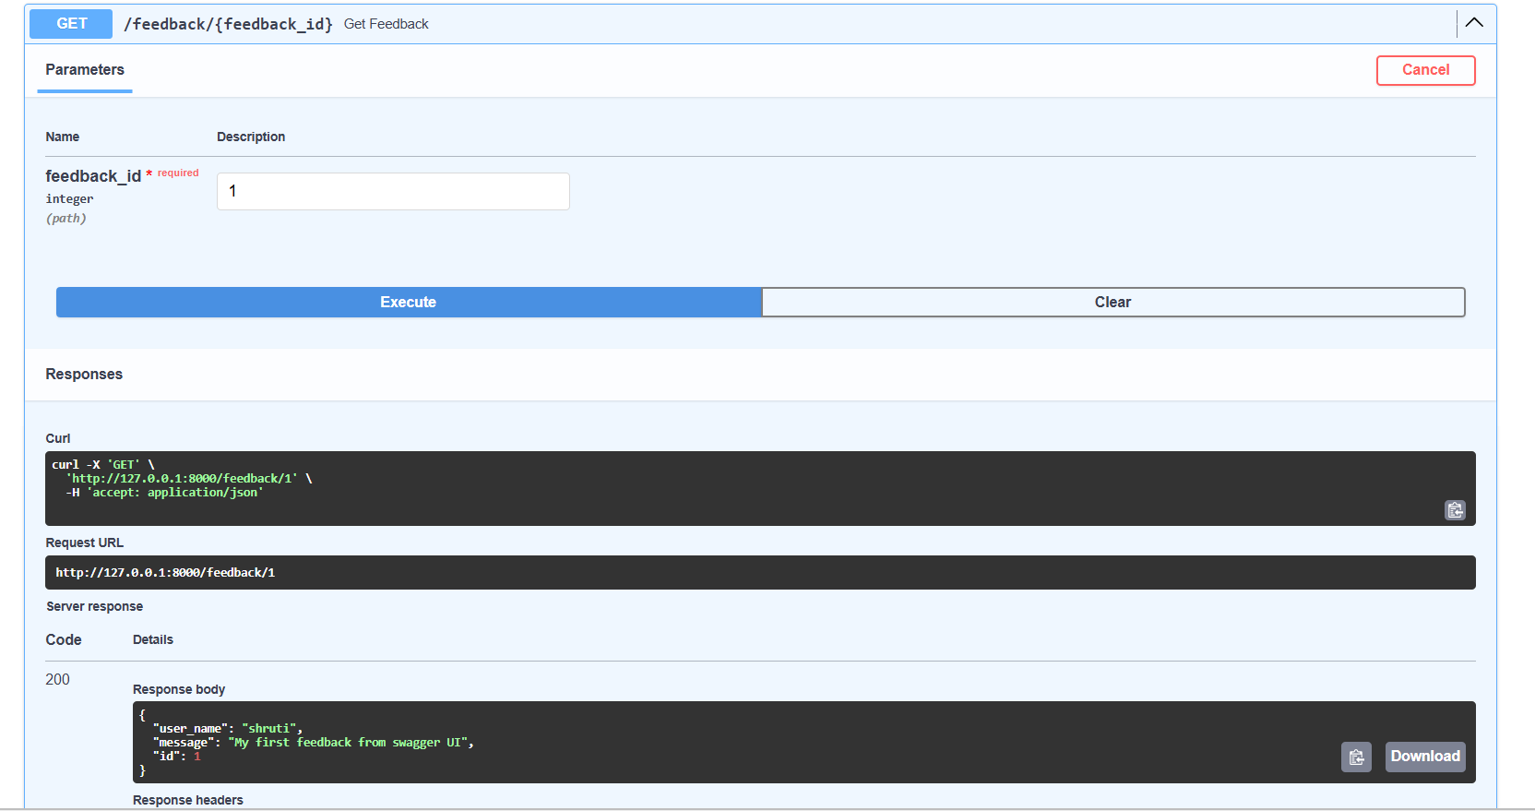

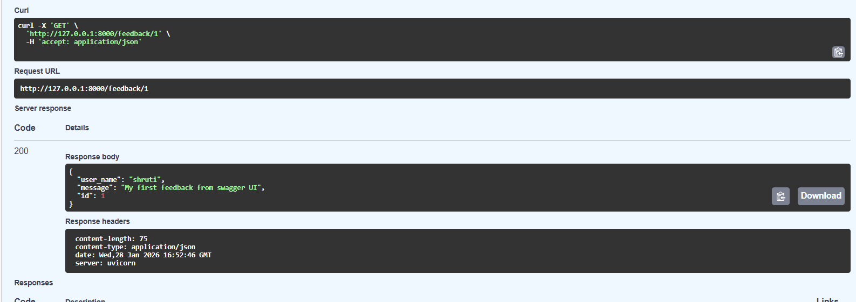
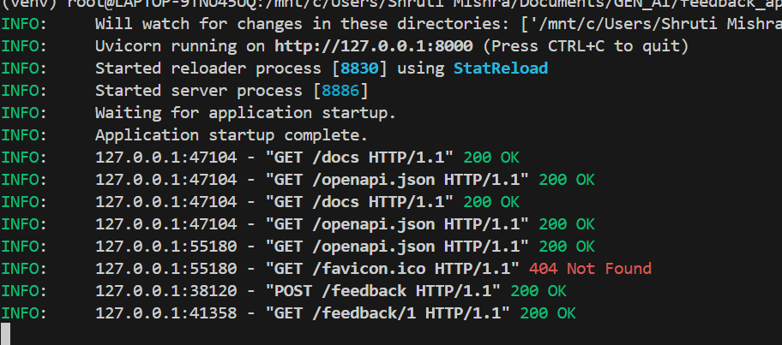

➤ Delete Feedback
DELETE /feedback/{feedback_id}
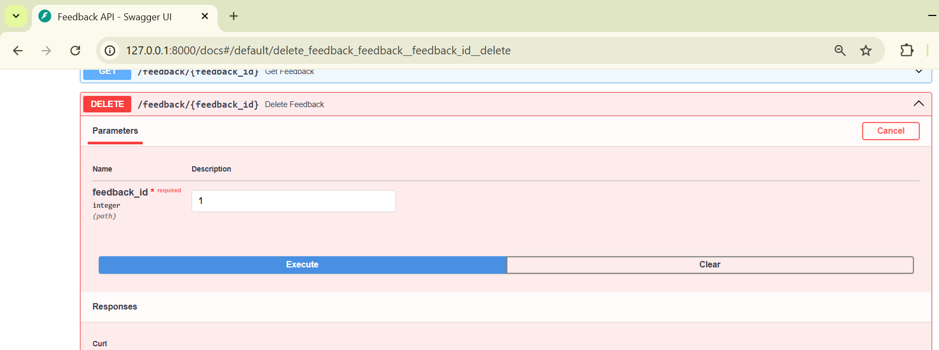
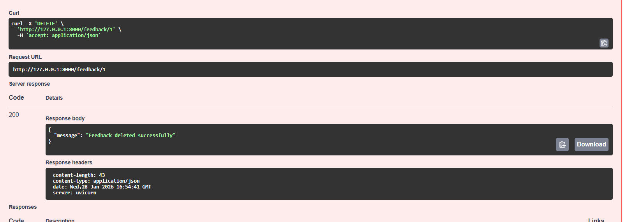
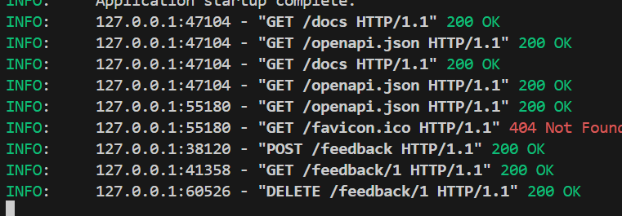

➤ List All Feedbacks
GET /feedbacks
