Handwritten Digit Classification using CNN

1. Problem Statement
The project aims to build a deep learning system that classifies grayscale handwritten digit images into one of ten classes: 0 through 9. This is a supervised multiclass image classification problem. The solution uses a Convolutional Neural Network (CNN), which is suitable because digit images contain spatial patterns such as curves, edges, loops, and strokes that CNN filters can learn automatically.

2. Dataset Description and Preprocessing
The MNIST dataset is used through the TensorFlow/Keras datasets API. It contains 60,000 training images and 10,000 testing images. Each image is 28 × 28 pixels, grayscale, and has one corresponding label from 0 to 9. The training data is further split into training and validation subsets using an 80:20 split with stratification to preserve class distribution.

Dataset | Image Shape | Classes | Split
MNIST | 28×28×1 | 10 digits | 48k train, 12k validation, 10k test

Preprocessing includes reshaping images to (samples, 28, 28, 1), converting pixel values to float32, normalizing from 0–255 to 0–1, and one-hot encoding labels for categorical cross-entropy loss. Normalization improves gradient-based optimization, while one-hot encoding aligns the labels with the 10-neuron softmax output layer.

3. Methodology and Logical Correctness
A CNN is selected because it preserves spatial relationships in images and learns local visual features using convolutional filters. The approach is logically correct for handwritten digit classification: low-level filters detect strokes and edges, pooling reduces spatial size while retaining important patterns, and dense layers convert extracted features into final digit probabilities. The test set is kept separate and used only for final evaluation, preventing leakage from training decisions.

4. Neural Network Architecture

Layer | Configuration | Activation | Output Role | Reason
Conv2D | 32 filters, 4×4 kernel | ReLU | Feature maps | Learns digit strokes/edges
MaxPool2D | 2×2 pool | - | Reduced maps | Lower computation, shift tolerance
Flatten | - | - | 1D vector | Prepares features for dense layer
Dense | 128 neurons | ReLU | High-level features | Learns digit patterns
Dropout | 0.3 | - | Regularization | Reduces overfitting
Dense | 10 neurons | Softmax | Class probabilities | One output per digit

5. Experimental and Implementation Details

The model is implemented in TensorFlow/Keras using the Sequential API. The optimizer is Adam because it adapts learning rates during training and generally performs well on image classification tasks. The loss function is categorical_crossentropy because the labels are one-hot encoded and the model predicts a probability distribution over 10 mutually exclusive classes. Accuracy is used because the dataset is approximately balanced and the task requires correct class prediction.

Item | Value | Item | Value
Optimizer | Adam | Loss | Categorical cross-entropy
Batch size | 128 | Epochs | 10 maximum
Callback | EarlyStopping | Monitor | Validation loss
Patience | 2 | Restore best weights | True

6. Results and Discussion
In the current implementation, the CNN reaches high test performance for MNIST digit classification. The original implementation achieved approximately 98.39% test accuracy. The final notebook is structured to save the actual training history, loss curve, accuracy curve, classification report, confusion matrix, and exported model after execution. The loss and accuracy plots help verify whether the model is learning consistently or overfitting. The confusion matrix is useful for identifying digit pairs that are visually similar, such as 4/9, 3/5, or 7/9.

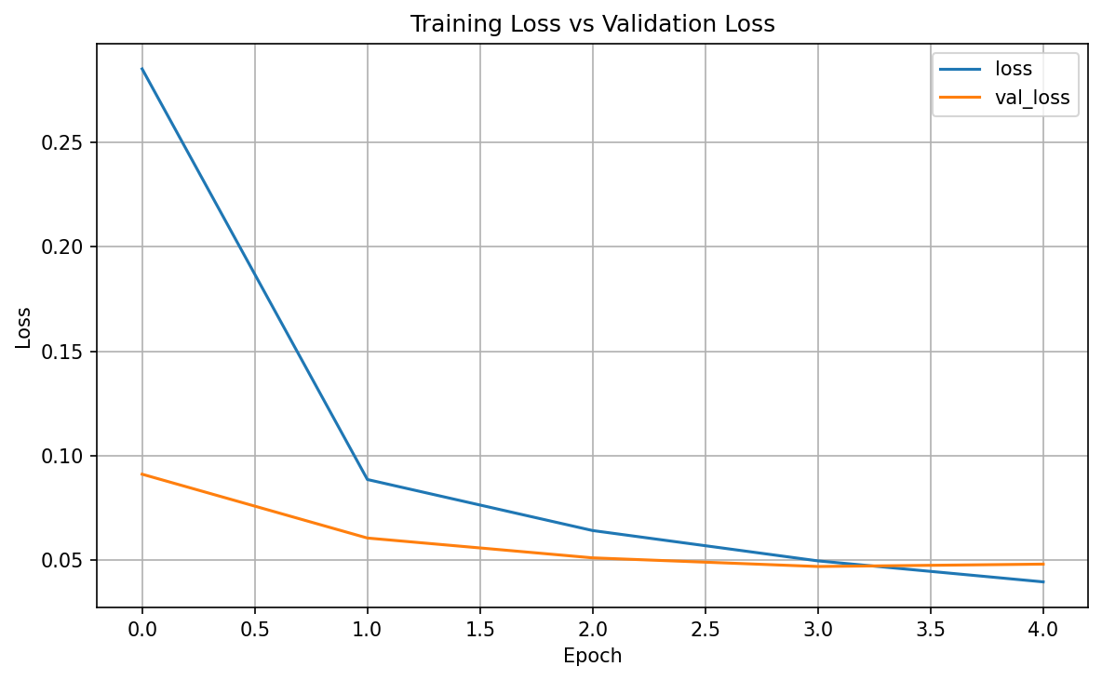 | 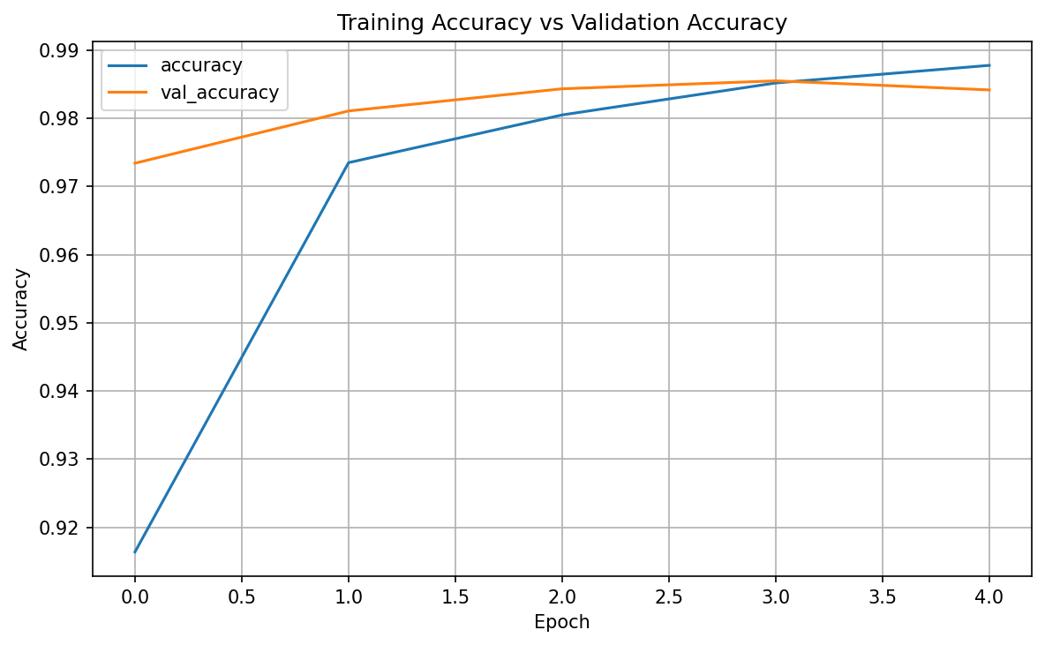

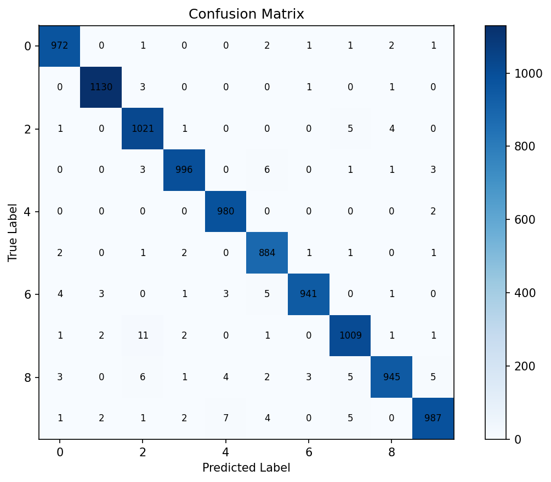
The approach works well because MNIST is clean, centered, grayscale, and relatively simple. However, performance on real external images may vary if the digit is not centered, has noise, uses a different background color, or differs from MNIST writing style. The prediction pipeline therefore converts custom images to grayscale, resizes them to 28×28, normalizes pixels, and optionally inverts colors.

7. Explicit Alignment with Project Evaluation Procedure

Grading Aspect | How This Project Addresses It | Evidence in Submission
Logical Correctness | CNN is appropriate for image classification because it learns spatial features from pixels. The train-validation-test process avoids leakage. | Methodology, architecture description, dataset split, final test evaluation cell
Proper Implementation | Code is modular, commented, and includes preprocessing, training, evaluation, model export, and custom-image prediction. | Jupyter notebook, train.py, predict.py, saved outputs
Choice of Evaluation Criteria | Accuracy is suitable for balanced multiclass classification; loss tracks optimization; report and confusion matrix expose class-level performance. | Accuracy/loss plots, classification report, confusion matrix
Report Preparation | The report follows the required structure and documents problem, dataset, method, experiments, results, analysis, limitations, and improvements. | This report and capstone notebook

8. Improvements and Future Work

• Add a second Conv2D block with BatchNormalization to improve feature learning and training stability.
• Use carefully selected data augmentation such as rotation, zoom, width shift, and height shift; avoid horizontal flipping for digits.
• Analyze misclassified images to understand whether errors come from similar digit shapes or preprocessing limitations.
• Improve external-image preprocessing with thresholding, centering, cropping, and noise removal.
• Deploy the model using Streamlit, Flask, or FastAPI so users can upload a digit image and receive a prediction.
• Train related datasets such as Fashion-MNIST, EMNIST, or custom handwritten digit images to test generalization.

9. Conclusion
This project demonstrates a complete deep learning workflow for handwritten digit recognition: dataset loading, preprocessing, CNN design, training, validation, testing, evaluation, export, and inference on custom images. The method is logically sound, properly implemented, evaluated with suitable metrics, and documented according to the capstone guidelines. The main limitation is that MNIST images are cleaner than real-world inputs, so future improvements should focus on stronger preprocessing, augmentation, deeper architectures, and deployment.

10. Project Contributors
Name | Email ID | Role
Himanshu Mishra | mishra00724@gmail.com | Project Lead
Harsimranjeet Kaur | rabiasodhi23@gmail.com | Team Member
Kusum Rani | kusum_mca@rediffmail.com | Team Member
Ashutosh Gupta | ashutosh105@gmail.com | Team Member
Santosh Shankar Gaikwad | ssgaikwad@gmail.com | Team Member

