One of the Leading Cymmetri Partners
Why Choose Cymmetri?
Cymmetri is a leading Identity and Access Management (IAM) and Identity Governance & Administration (IGA) platform designed to help organizations secure user identities, manage access privileges, and enforce Zero Trust security across enterprise environments.
Cymmetri enables businesses to automate identity lifecycle management, strengthen authentication, improve compliance, and provide secure access to applications, systems, and digital resources across hybrid IT infrastructures.
Top Reasons to Choose Cymmetri
1. Comprehensive Identity & Access Management (IAM)
Cymmetri helps organizations manage:
- User identities
- Role-based access control
- Authentication workflows
- User provisioning & deprovisioning
- Identity governance
2. Zero Trust Security Framework
Enable secure access using Zero Trust principles with strong authentication and least-privilege access controls.
3. Single Sign-On (SSO)
Allow users to securely access multiple enterprise applications through a single authentication platform.
4. Multi-Factor Authentication (MFA)
Strengthen enterprise security using advanced MFA and adaptive authentication mechanisms.
5. Automated User Lifecycle Management
Automate onboarding, access provisioning, role changes, and employee offboarding processes.
6. Compliance & Governance
Support regulatory and compliance requirements with:
- Access governance
- Audit trails
- Role management
- Compliance reporting
- Identity risk visibility
7. Ideal for Every Industry
Cymmetri solutions are widely used in:
- Banking & financial services
- Healthcare organizations
- Government sectors
- Manufacturing industries
- Large enterprises
- Educational institutions

Why Choose Trace Network & Engineering Pvt Ltd?
- Quick Resolution: Issues addressed within 6 hours of complaint
- Certified Experts: Skilled IAM & cybersecurity specialists
- Proven Experience: 1000+ successful enterprise deployments
- End-to-End Solutions: IAM, cybersecurity, networking & infrastructure
- Multi-Channel Support: Email, WhatsApp & dedicated support portal
- Scalable Solutions: Designed for enterprise and hybrid environments
- Customer-First Approach: Reliable, fast, and result-driven execution

Our team Certification
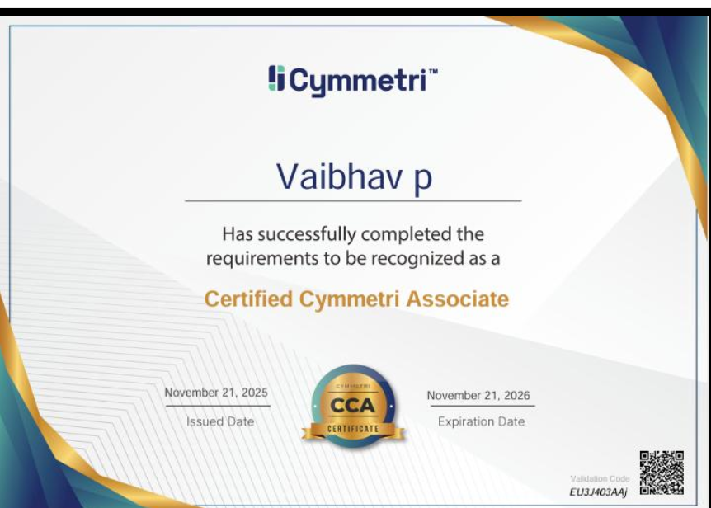

Cymmetri Use Cases (Successfully Deployed by Trace Network)
1. Banking & Financial Services
Problem:
Financial institutions require strict identity governance, secure user authentication, and controlled access to critical banking systems and customer data.
Our Solution (Deployed by Trace Network):
- Identity and access management deployment
- Multi-factor authentication (MFA)
- Role-based access control (RBAC)
- Single Sign-On (SSO) integration
- Privileged access governance
Impact:
- Improved access security and compliance
- Reduced unauthorized access risks
- Centralized identity governance and visibility
Our Strength:
- BFSI-grade IAM deployment expertise
- Strong compliance and governance implementation capabilities

2. Healthcare Organizations
Problem:
Healthcare providers require secure access management for doctors, staff, applications, and patient management systems.
Our Solution (Deployed by Trace Network):
- Secure user authentication
- Centralized identity management
- MFA-enabled healthcare access
- Role-based access for medical staff
- Audit trail and compliance monitoring
Impact:
- Enhanced protection for healthcare systems
- Improved access control and accountability
- Better compliance readiness
Our Strength:
- Expertise in healthcare identity security deployments
- Experience securing critical healthcare environments

3. Government Sector
Problem:
Government organizations require secure identity governance, controlled user access, and centralized authentication across departments and systems.
Our Solution (Deployed by Trace Network):
- Enterprise IAM implementation
- Single Sign-On deployment
- Zero Trust access controls
- Identity lifecycle automation
- Centralized authentication management
Impact:
- Improved security across departments
- Faster and secure user access management
- Enhanced governance and operational control
Our Strength:
- Expertise in secure government infrastructure deployments
- Strong experience in high-security access management

4. Manufacturing Industry
Problem:
Manufacturing organizations require secure access to ERP systems, production applications, and operational infrastructure across multiple locations.
Our Solution (Deployed by Trace Network):
- Role-based access control implementation
- MFA-enabled application access
- Secure identity governance
- Centralized user lifecycle management
- SSO integration for enterprise applications
Impact:
- Reduced identity-related security risks
- Improved operational security
- Streamlined access management across locations
Our Strength:
- Expertise in industrial identity management deployments
- Strong operational access security capabilities

5. Large Enterprises
Problem:
Large enterprises require centralized identity governance and secure authentication for thousands of users, applications, and distributed environments.
Our Solution (Deployed by Trace Network):
- Enterprise-wide IAM deployment
- Automated user provisioning workflows
- Adaptive authentication mechanisms
- Centralized identity governance dashboards
- Compliance and audit reporting
Impact:
- Improved user access visibility and control
- Reduced administrative overhead
- Enhanced enterprise security posture
Our Strength:
- Enterprise-scale IAM deployment expertise
- Strong hybrid workforce security implementation capabilities

6. Educational Institutions
Problem:
Educational organizations require secure and simplified access for students, faculty, administrators, and digital learning platforms.
Our Solution (Deployed by Trace Network):
- Student and faculty identity management
- SSO for academic applications
- MFA-enabled access security
- Automated onboarding and offboarding
- Centralized authentication systems
Impact:
- Simplified user access experience
- Improved security for academic platforms
- Reduced IT management complexity
Our Strength:
- Expertise in campus identity management deployments
- Scalable access management solutions for large user bases

🚀 SPECIAL OFFER — MUST BE HIGHLIGHTED
🔥 FREE POC (Proof of Concept) Available
🎁 Exclusive Offers on Cymmetri Solutions

CONTACT TRACE NETWORK
📞 Get in Touch for a FREE Demo & Consultation
👉 CONTACT TRACE NETWORK (Add a CTA Button Redirecting to Contact Page)
Reference format based on the Aruba Networking content shared by the user.

