One of the Leading Safetica Partners in SAARC
Why Choose Safetica?
Safetica is a leading Data Loss Prevention (DLP) and Insider Risk Management solution that helps organizations protect sensitive business data from accidental leaks, insider threats, and unauthorized transfers. Safetica provides complete visibility into user activities, data movement, and security risks—helping businesses secure their critical information while maintaining productivity.
With advanced content inspection, user behavior analytics, and policy-based protection, Safetica enables organizations to monitor, detect, and prevent data breaches across endpoints, cloud applications, USB devices, email, and web channels.
Top Reasons to Choose Safetica
1. Advanced Data Loss Prevention (DLP)
Safetica helps organizations prevent sensitive data leakage through USB devices, email, cloud apps, web uploads, printing, and unauthorized file transfers.
2. Insider Risk Management
Monitor user activities and detect risky behavior before it leads to data theft, policy violations, or security incidents.
3. Real-Time Visibility & Monitoring
Gain centralized visibility into employee activity, file movement, application usage, and security events through a unified dashboard.
4. Policy-Based Data Protection
Create and enforce security policies based on users, departments, file types, applications, and business requirements.
5. Endpoint & Cloud Protection
Protect data across:
- Endpoints & laptops
- USB devices & removable media
- Email communication
- Cloud applications
- File sharing platforms
- Remote workforce environments
6. Ideal for Every Industry
Safetica solutions are widely used in:
- Large enterprises
- Banking & financial services
- Healthcare & hospitals
- Educational institutions
- Manufacturing industries
- IT & software companies
Why Choose Trace Network & Engineering Pvt Ltd?
- Quick Resolution: Issues addressed within 6 hours of complaint
- Certified Experts: Skilled engineers & cybersecurity specialists
- Proven Experience: 1000+ successful enterprise deployments
- End-to-End Solutions: Cybersecurity, networking, cloud & infrastructure
- Multi-Channel Support: Email, WhatsApp & dedicated support portal
- Scalable Solutions: Designed for enterprise, healthcare, BFSI & retail
- Customer-First Approach: Reliable, fast, and result-driven execution
Our TEAM certification
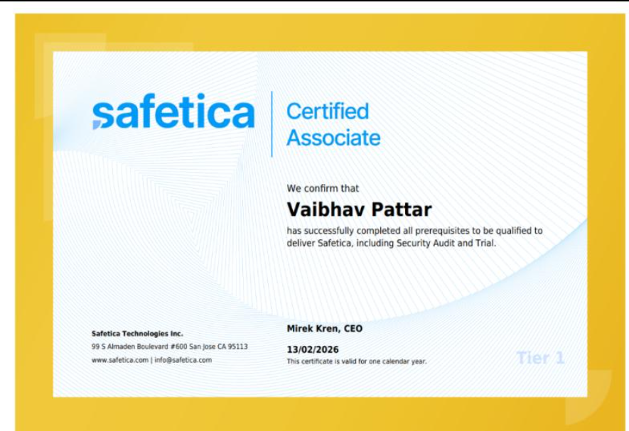

Safetica Use Cases (Successfully Deployed by Trace Network)
1. Defence Sector (Preventing Sensitive Data Leakage)
Problem:
Defence organizations require strict monitoring and prevention of confidential data leakage across endpoints and removable devices.
Our Solution (Deployed by Trace Network):
- Safetica Data Loss Prevention
- USB & removable media control
- User activity monitoring
- File transfer monitoring
- Policy-based access restrictions
Impact:
- Prevention of unauthorized data transfers
- Complete visibility into user activity
- Strong protection for confidential defence data
Our Strength:
- Expertise in high-security environments
- Strong insider threat prevention capabilities

2. Education Sector (Protecting Student & Institutional Data)
Problem:
Educational institutions need to secure student records, examination data, and internal documents while supporting BYOD environments.
Our Solution (Deployed by Trace Network):
- Data Loss Prevention policies
- USB device control
- Application monitoring
- Cloud upload monitoring
- User activity analytics
Impact:
- Protection of confidential academic data
- Reduced risk of data leakage
- Improved compliance and visibility
Our Strength:
- Experience in campus cybersecurity deployments
- Scalable solutions for high-user environments
3. Retail Sector (Securing Customer & POS Data)
Problem:
Retail businesses require protection for customer information, billing systems, POS data, and branch operations.
Our Solution (Deployed by Trace Network):
- Endpoint DLP protection
- USB and peripheral device control
- Monitoring of file transfers and uploads
- Insider risk detection
- Centralized monitoring dashboard
Impact:
- Secure customer and transaction data
- Reduced insider threats
- Better compliance and operational visibility
Our Strength:
- Multi-branch deployment expertise
- Retail-focused security optimization
4. Banking Sector (Compliance & Data Security)
Problem:
Banks require strict control over confidential financial data, customer records, and regulatory compliance.
Our Solution (Deployed by Trace Network):
- Sensitive data classification
- DLP policy enforcement
- Insider threat monitoring
- USB & email data protection
- Centralized compliance monitoring
Impact:
- Reduced risk of financial data leakage
- Stronger compliance posture
- Enhanced visibility into employee activities
Our Strength:
- BFSI-grade cybersecurity deployments
- Strong compliance-focused implementation
5. Healthcare Sector (Protecting Patient Information)
Problem:
Hospitals and healthcare organizations need to secure patient records, medical reports, and sensitive healthcare data.
Our Solution (Deployed by Trace Network):
- Patient data protection policies
- Endpoint monitoring
- USB and device control
- File activity tracking
- Insider threat detection
Impact:
- Protection of patient confidentiality
- Reduced risk of data breaches
- Secure handling of medical information
Our Strength:
- Expertise in healthcare compliance requirements
- Experience in securing sensitive medical environments

6. Large Enterprises (Enterprise Data Protection)
Problem:
Large organizations require centralized visibility and control over data movement across departments and branch locations.
Our Solution (Deployed by Trace Network):
- Enterprise-wide DLP deployment
- User behavior monitoring
- Cloud application visibility
- Centralized policy management
- Endpoint data protection
Impact:
- Improved data governance
- Centralized monitoring and control
- Reduced insider and accidental data leaks
Our Strength:
- Enterprise-scale deployment expertise
- Strong cybersecurity implementation capabilities
- SPECIAL OFFER — MUST BE HIGHLIGHTED
- 🔥 FREE POC (Proof of Concept) Available
- 🎁 Exclusive Offers on Safetica Solutions

- CONTACT TRACE NETWORK
- 📞 Get in Touch for a FREE Demo & Consultation
- 👉 CONTACT TRACE NETWORK (Add a CTA Button Redirecting to Contact Page)

