Assignment: Git Hands-on Practice

Task 1: Configure Git
1. Set your username and email in Git.
2. Verify the configuration.
//Command ->

Admin@LAPTOP-DPMU8UHT MINGW64 ~
$ git config --global user.name "shubham_mishra"

Admin@LAPTOP-DPMU8UHT MINGW64 ~
$ git config --global user.email "shubhamrajeshmishra001@gmail.com"

Admin@LAPTOP-DPMU8UHT MINGW64 ~
$ git config user.name
shubham_mishra

Admin@LAPTOP-DPMU8UHT MINGW64 ~
$ git config user.email
shubhamrajeshmishra001@gmail.com

O/P ->
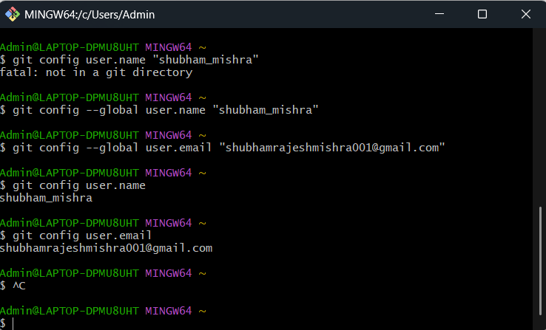
Task 2: Initialize a Local Repository
1. Create a new folder named `git-hands-on`.
2. Initialize it as a Git repository.
3. Check the repository status.
Command ->
Admin@LAPTOP-DPMU8UHT MINGW64 /d/Cdac/SDN/git-hands-on
$ git init
Initialized empty Git repository in D:/Cdac/SDN/git-hands-on/.git/

Admin@LAPTOP-DPMU8UHT MINGW64 /d/Cdac/SDN/git-hands-on (master)
$ git status
On branch master

O/P->
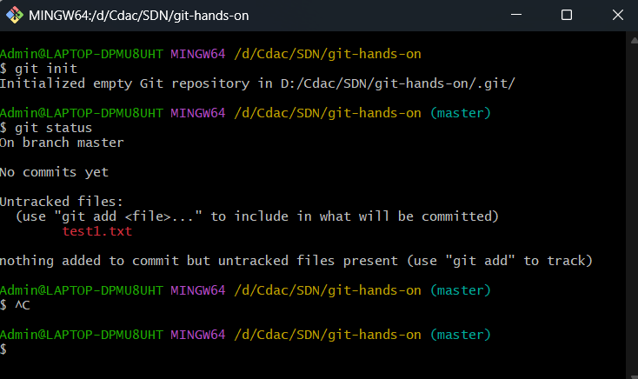

Task 3: Create and Track Files
1. Create a file named `documentation.txt`.
2. Add a short project description inside it.
3. Check file status.
4. Stage the file.
5. Commit the changes with an appropriate message.
​Command ->
Admin@LAPTOP-DPMU8UHT MINGW64 /d/Cdac/SDN/git-hands-on
$ git init
Initialized empty Git repository in D:/Cdac/SDN/git-hands-on/.git/

Admin@LAPTOP-DPMU8UHT MINGW64 /d/Cdac/SDN/git-hands-on (master)
$ git status
On branch master

Admin@LAPTOP-DPMU8UHT MINGW64 /d/Cdac/SDN/git-hands-on (master)
$ git add .

Admin@LAPTOP-DPMU8UHT MINGW64 /d/Cdac/SDN/git-hands-on (master)
$ git commit -m "first commit done by shubham"

O/P->
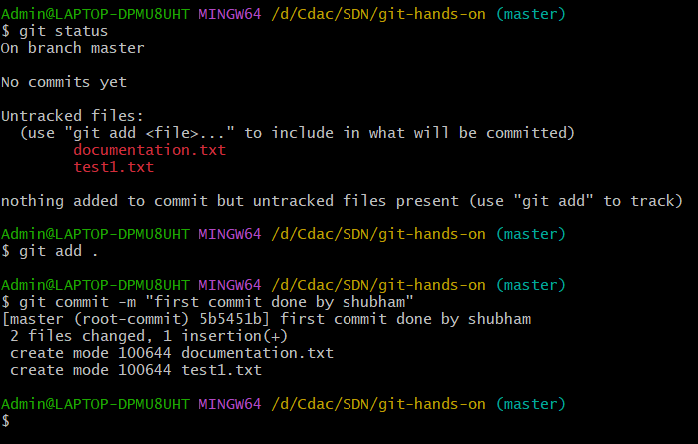

Task 4: Modify and Commit Changes
1. Edit `documentation.txt` and add one more line.
2. View the differences between working directory and staging area.
3. Stage and commit the changes.
Command ->
Admin@LAPTOP-DPMU8UHT MINGW64 /d/Cdac/SDN/git-hands-on (master)
$ git diff
diff --git a/documentation.txt b/documentation.txt
index 637c64e..870bb98 100644
--- a/documentation.txt
+++ b/documentation.txt

Admin@LAPTOP-DPMU8UHT MINGW64 /d/Cdac/SDN/git-hands-on (master)
$ git status
On branch master

Admin@LAPTOP-DPMU8UHT MINGW64 /d/Cdac/SDN/git-hands-on (master)
$ git add documentation.txt

Admin@LAPTOP-DPMU8UHT MINGW64 /d/Cdac/SDN/git-hands-on (master)
$ git status
On branch master

Admin@LAPTOP-DPMU8UHT MINGW64 /d/Cdac/SDN/git-hands-on (master)
$ git commit -m "second commit done by shubham"
[master 68555cd] second commit done by shubham
1 file changed, 3 insertions(+), 1 deletion(-)

O/P->
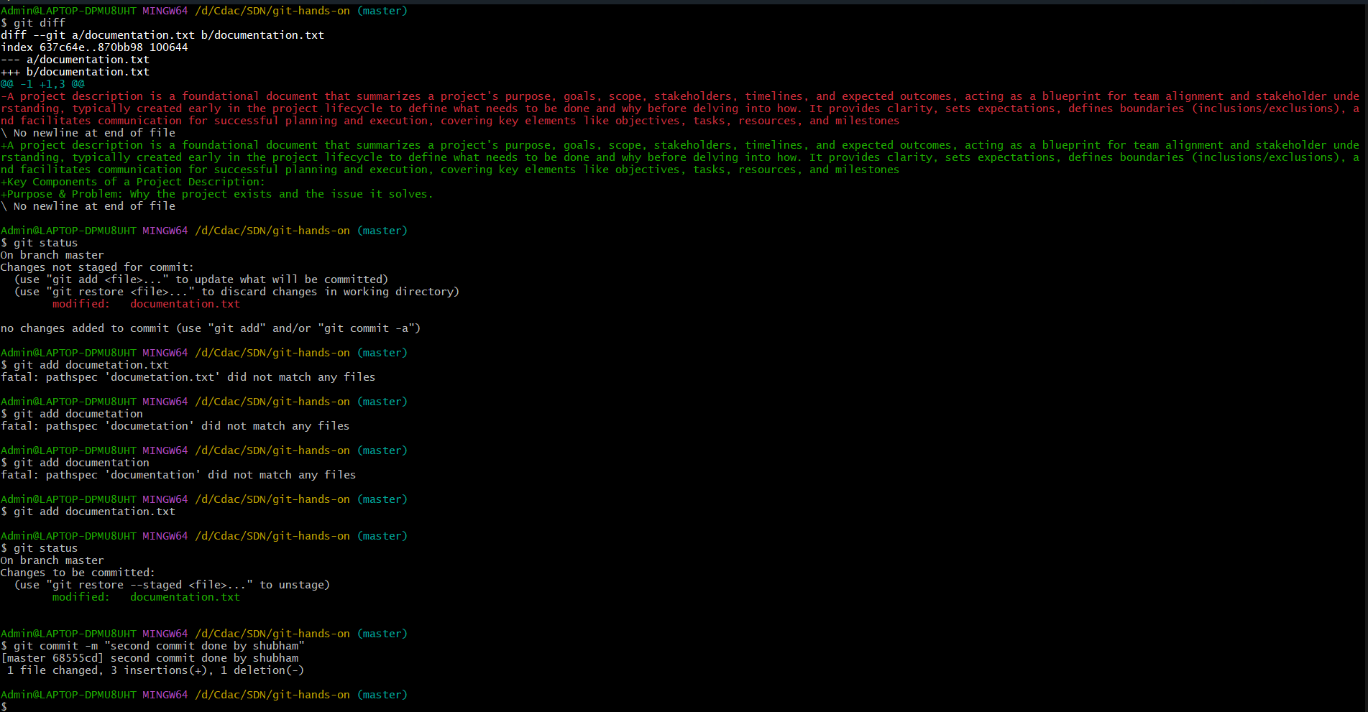

Task 5: View Commit History
1. View the complete commit history.
Admin@LAPTOP-DPMU8UHT MINGW64 /d/Cdac/SDN/git-hands-on (master)
$ git log
O/P->
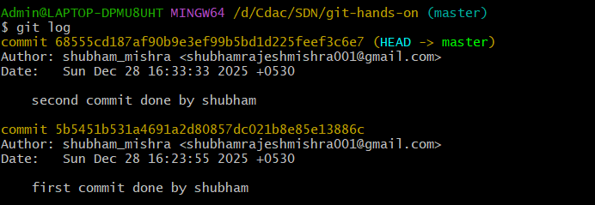
2. View commit history in one-line format.
​Admin@LAPTOP-DPMU8UHT MINGW64 /d/Cdac/SDN/git-hands-on (master)
$ git log --oneline

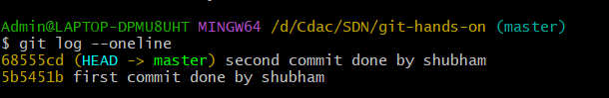

Task 6: Create and Work with Branches
1. Create a new branch named `feature-1`.
2. Switch to the new branch.
Command ->
Admin@LAPTOP-DPMU8UHT MINGW64 /d/Cdac/SDN/git-hands-on (master)
$ git checkout -b feature-1

O/P ->
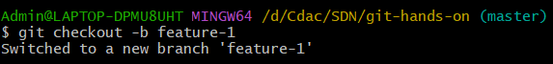
3. Create a new file `feature.txt`.
4. Commit the changes.
5. Switch back to the main branch.
Command ->
Admin@LAPTOP-DPMU8UHT MINGW64 /d/Cdac/SDN/git-hands-on (feature-1)
$ git status
On branch feature-1

Admin@LAPTOP-DPMU8UHT MINGW64 /d/Cdac/SDN/git-hands-on (feature-1)
$ git add feature.txt

Admin@LAPTOP-DPMU8UHT MINGW64 /d/Cdac/SDN/git-hands-on (feature-1)
$ git commit -m "feature.txt commit done by shubham"

Admin@LAPTOP-DPMU8UHT MINGW64 /d/Cdac/SDN/git-hands-on (feature-1)
$ git checkout master

O/P->
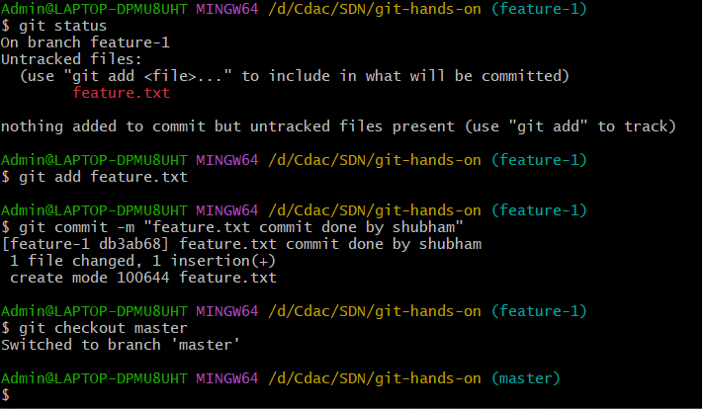

Task 7: Merge Branches
1. Merge `feature-1` branch into `main`.
2. Verify the merge using commit history.
Command ->
Admin@LAPTOP-DPMU8UHT MINGW64 /d/Cdac/SDN/git-hands-on (master)
$ git merge feature-1

Admin@LAPTOP-DPMU8UHT MINGW64 /d/Cdac/SDN/git-hands-on (master)
$ git log
O/P->
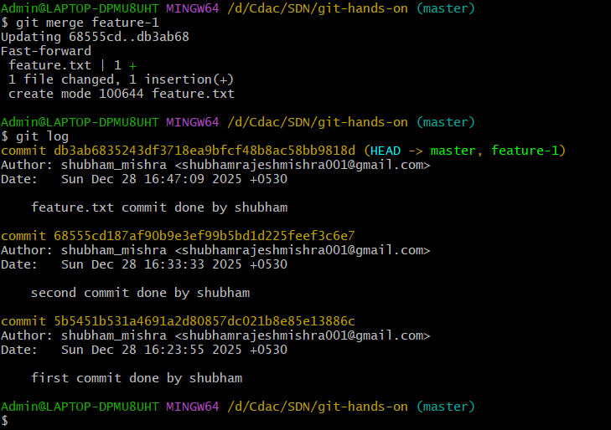

Task 8: Connect to a Remote Repository

1. Create a new repository on GitHub.
2. Add the remote repository URL to your local repo.
3. Verify the remote connection.
Command –>
Admin@LAPTOP-DPMU8UHT MINGW64 /d/Cdac/SDN/git-hands-on (master)
$ git remote add origin https://github.com/mishraShubham22/git-hands-exp.git

Admin@LAPTOP-DPMU8UHT MINGW64 /d/Cdac/SDN/git-hands-on (master)
$ git remote -v

O/P->
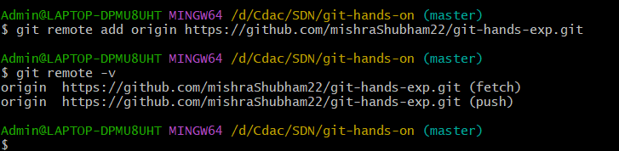

Task 9: Push Code to GitHub

1. Push the `main` branch to GitHub.
2. Verify files on GitHub.
//Command ->

Admin@LAPTOP-DPMU8UHT MINGW64 /d/Cdac/SDN/git-hands-on (main)
$ git push -u origin main
Enumerating objects: 10, done.
branch 'main' set up to track 'origin/main'.

Admin@LAPTOP-DPMU8UHT MINGW64 /d/Cdac/SDN/git-hands-on (main)
$ git status
On branch main
Your branch is up to date with 'origin/main'.

nothing to commit, working tree clean

O/P->
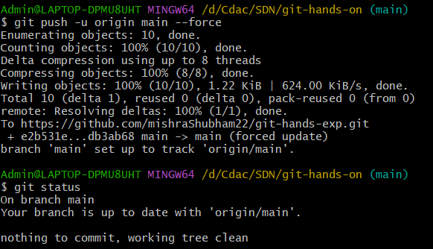

Task 10: Clone a Repository
1. Clone the same GitHub repository into a different folder.
2. Verify the cloned content.
Command ->
Admin@LAPTOP-DPMU8UHT MINGW64 /d/Cdac/SDN/git-clone
$ git clone https://github.com/mishraShubham22/git-hands-exp.git

O/P->
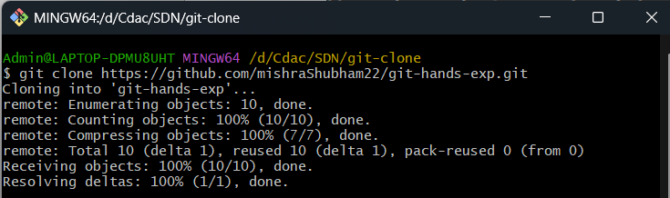
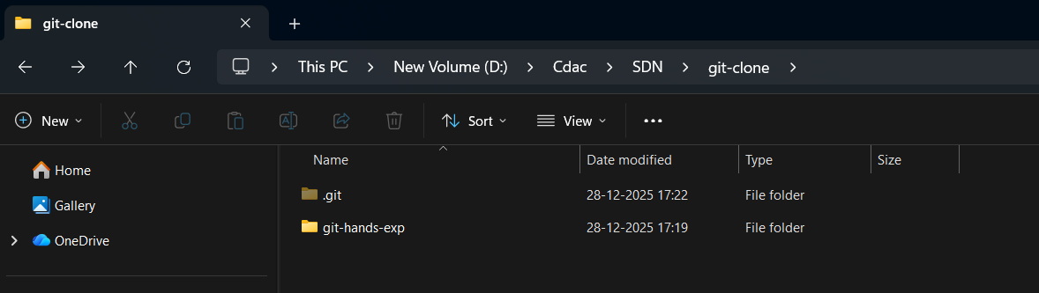
Task 11: Undo Changes
//Command ->
1. Make a change in `documentation.txt` but do not commit.
2. Discard the changes.
3. Verify the file status.
Admin@LAPTOP-DPMU8UHT MINGW64 /d/Cdac/SDN/git-hands-on (main)
$ git status
On branch main

Admin@LAPTOP-DPMU8UHT MINGW64 /d/Cdac/SDN/git-hands-on (main)
$ git restore documentation.txt

Admin@LAPTOP-DPMU8UHT MINGW64 /d/Cdac/SDN/git-hands-on (main)
$ git status
On branch main
Your branch is up to date with 'origin/main'.

O/P->

//Before -
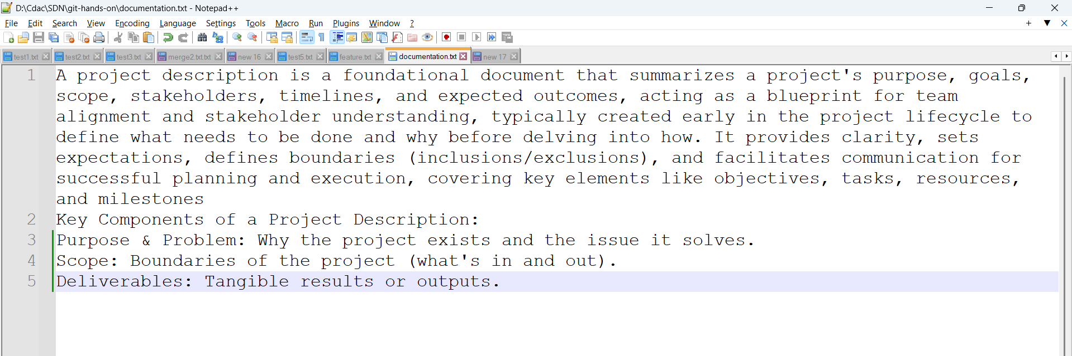
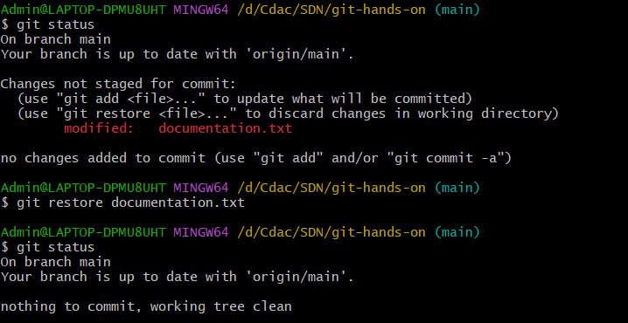
//After ->
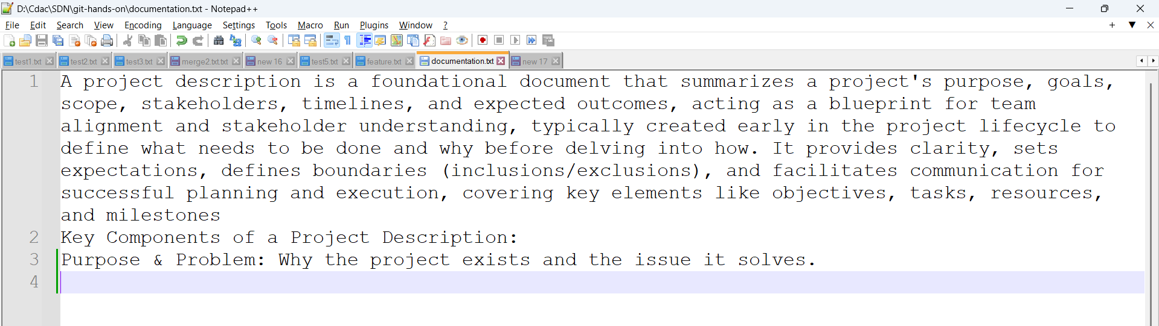
Task 12: Remove Files
1. Delete `feature.txt` using Git.
2. Commit the deletion.

//Command ->
Admin@LAPTOP-DPMU8UHT MINGW64 /d/Cdac/SDN/git-hands-on (main)
$ git rm feature.txt
rm 'feature.txt'

Admin@LAPTOP-DPMU8UHT MINGW64 /d/Cdac/SDN/git-hands-on (main)
$ git commit -m "feature.txt deleted by shubham"
[main a66d5f6] feature.txt deleted by shubham
1 file changed, 1 deletion(-)
delete mode 100644 feature.txt

//O/P ->
//Before ->
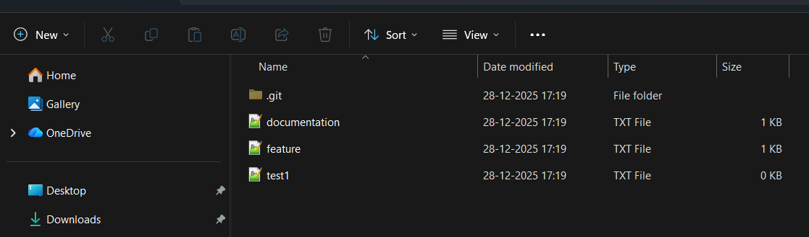

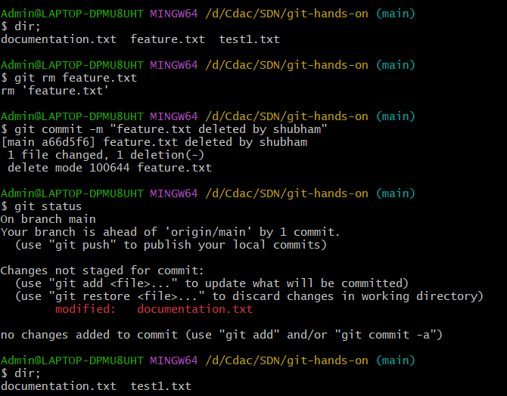

//After ->
