This document contains the steps that you need to run to successfully compile this React-Express app and play around with the software.

**Step 1:** Download Node.js from <https://nodejs.org/en/> (Recommended for most users)

**Step 2:** Download the shopping cart solution from GitHub (<https://github.com/mishraabhi1297/AmazingCo>)

To run this app, you will need to run the client and the server in two separate terminals. I am using React for front-end as well as Express server for back-end.

**Step 3:** Open first terminal (cmd) and make sure you are in root directory (i.e., AmazingCo-master). You can also see the server.js file in this directory.

**Step 4:** Enter command “npm install” (This will install all the backend dependencies)

**Step 5:** Enter command “”node server” (This will start the backend server)

**Step 6:** Open second terminal (cmd) and make sure you are in client directory (i.e., AmazingCo-master/client).

**Step 7:** Enter command “npm install” (This will install all the frontend dependencies)

**Step 8**: Enter command “npm start” (This will start the React app)

These are the steps you need to perform to run this React app. A screenshot of the landing page is displayed below:

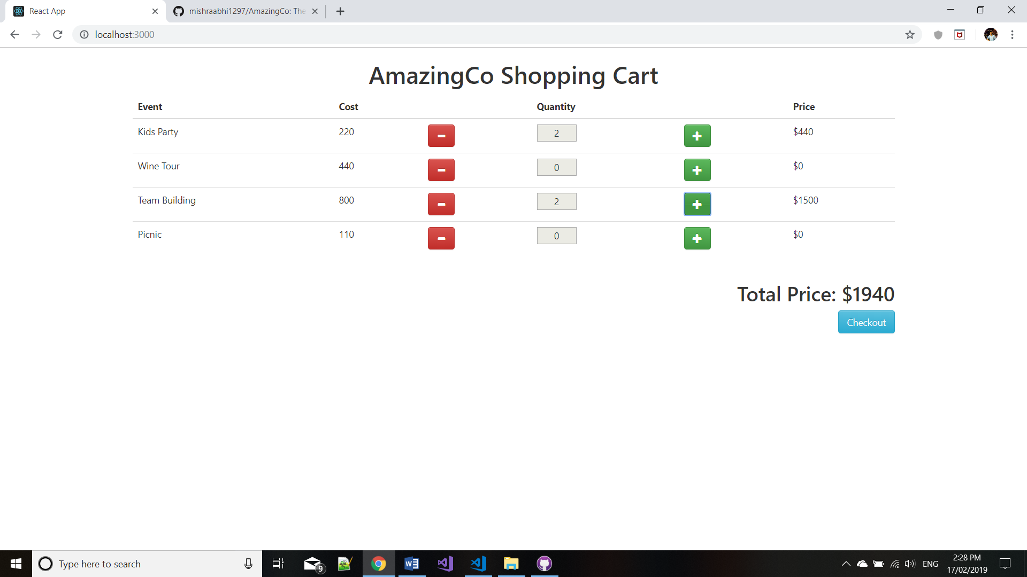

You can select the quantity of each event that you wish to buy and click on the “Checkout” button to see all the items added to your shopping cart. A screenshot of this is shown below.

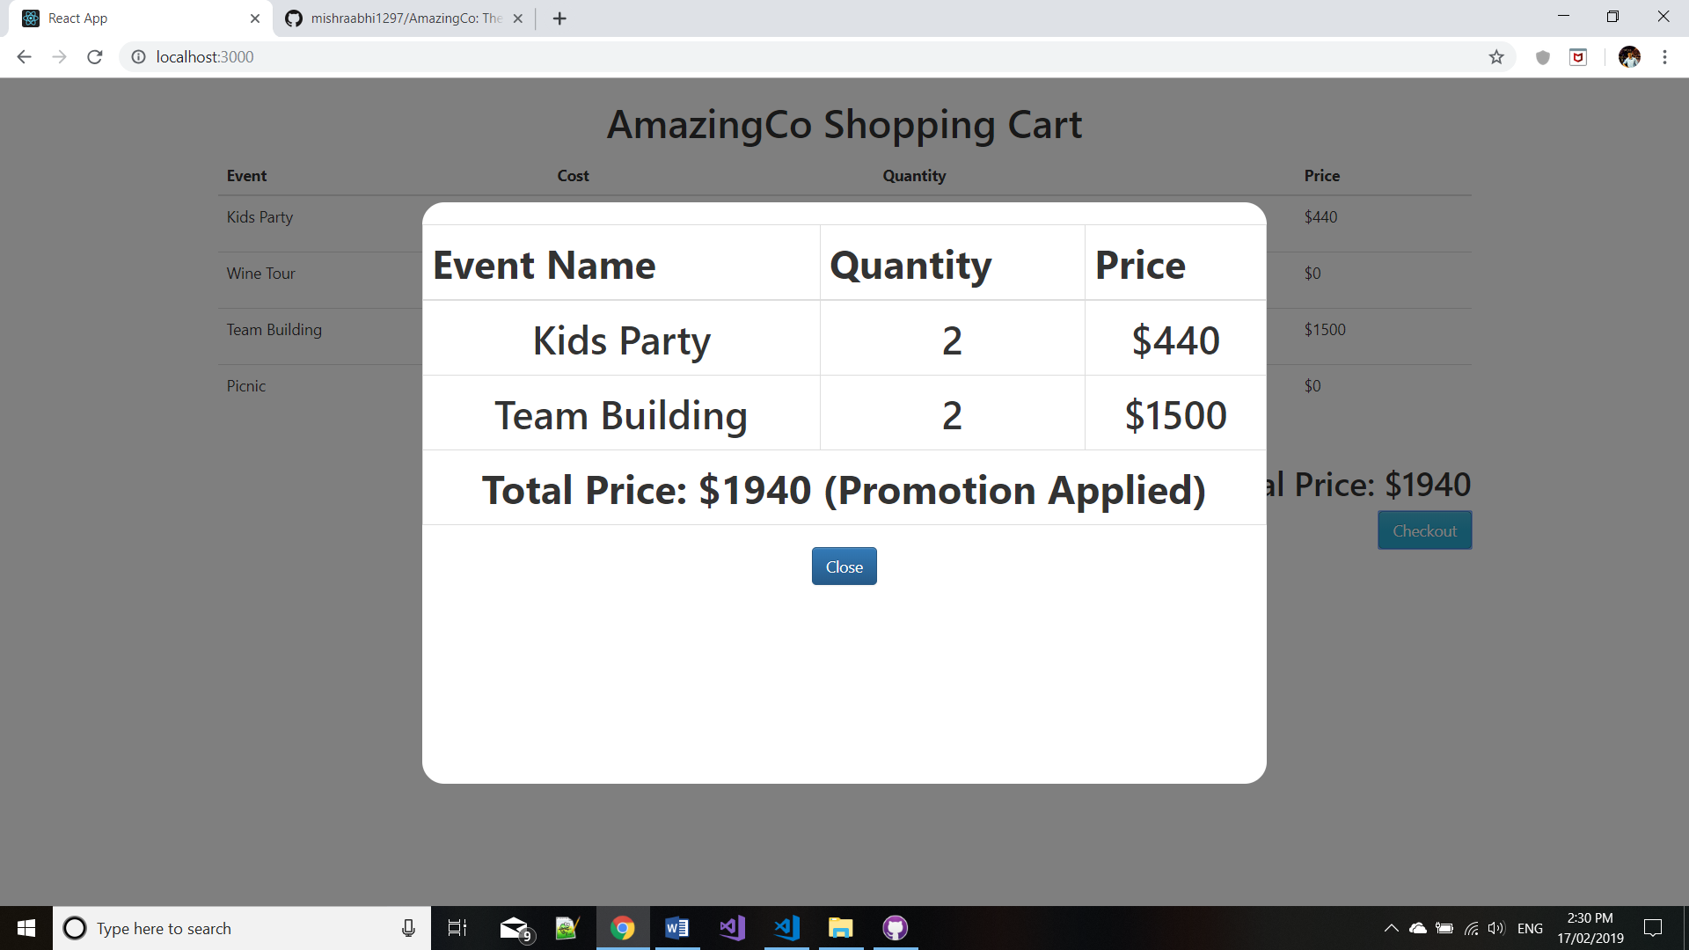

Thank you!!