driver.findElement(By.xpath("//label[text()='Username']/following::input[1]")).sendKeys("Arti"); 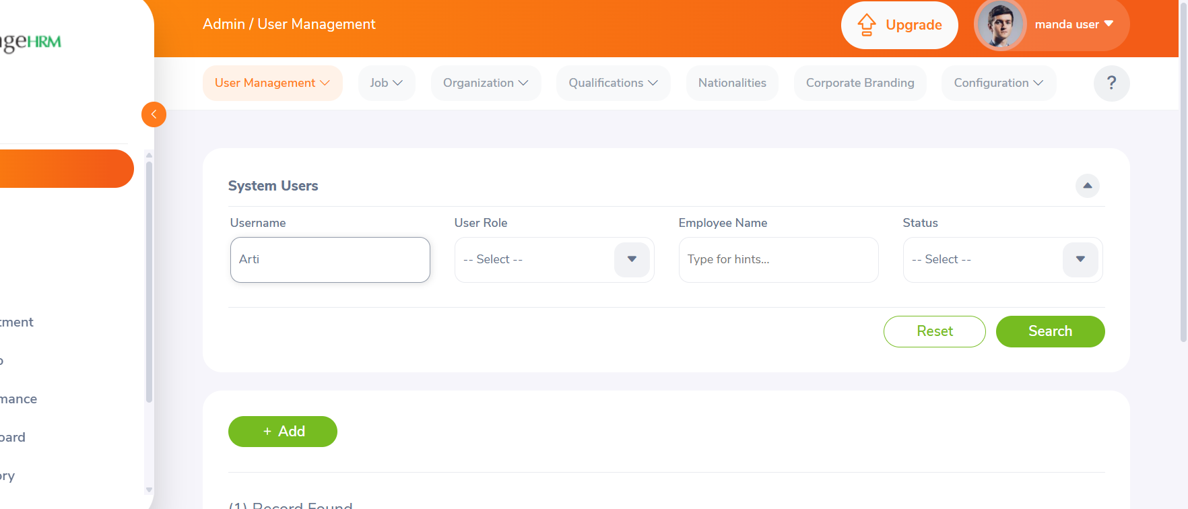
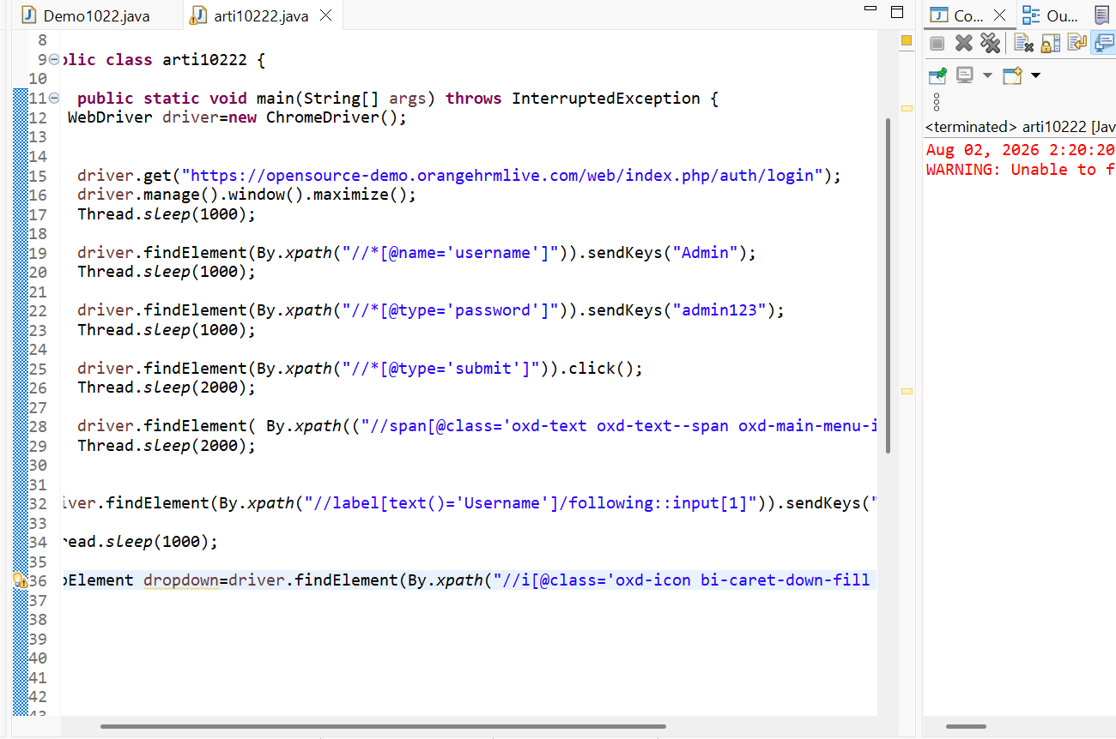
driver.findElement(By.xpath("//*[@name='username']")).sendKeys("Admin");
Thread.sleep(1000);

driver.findElement(By.xpath("//*[@type='password']")).sendKeys("admin123");
Thread.sleep(1000);

driver.findElement(By.xpath("//*[@type='submit']")).click();
Thread.sleep(2000);

driver.findElement( By.xpath(("//span[text()='PIM']"))).click();
Thread.sleep(2000);

driver.findElement(By.xpath("//button[@class='oxd-button oxd-button--medium oxd-button--secondary']")).click();
Thread.sleep(1000);

driver.findElement(By.xpath("//input[@name='firstName']")).sendKeys("Arti");
Thread.sleep(1000);

driver.findElement(By.xpath("//input[@name='lastName']")).sendKeys("Mishra");

Thread.sleep(2000);

driver.findElement(By.xpath("//label[contains(text(),'Employee Id')]/following::input[2]")).clear();

Thread.sleep(1000);

//driver.findElement(By.xpath("//lebel[text()='Employee id']")).sendKeys("0501");

//Thread.sleep(1000);

//driver.findElement(By.xpath("//span[text()='Submit']")).click();
//Thread.sleep(1000);

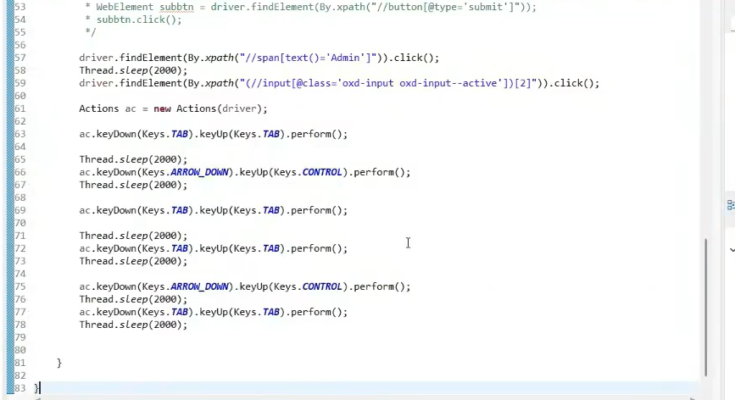
(//div[@class=\"inventory_item_name \"])[1]

public class arti10222 {

public static void main(String[] args) throws InterruptedException {
WebDriver driver=new ChromeDriver();

driver.get("https://testautomationpractice.blogspot.com");
driver.manage().window().maximize();
Thread.sleep(1000);

driver.findElement(By.xpath("//input[@id='name']")).sendKeys("Arti");

driver.findElement(By.xpath("//input[@id='email']")).sendKeys("mishraarti476@ gmail.com");

driver.findElement(By.xpath("//input[@id='phone']")).sendKeys("9719007570");

driver.findElement(By.xpath("//*[@id='textarea']")).sendKeys("Vill.Lalupur, Post- Lalupur,Mainpuri, 205001");

driver.findElement(By.xpath("//input[@id='female']")).click();

driver.findElement(By.xpath("//input[@id='sunday']")).click();

WebElement country = driver.findElement(By.xpath("//select[@id='country']"));

Thread.sleep(1000);

Select sc= new Select(country);

sc.selectByIndex(9);

WebElement colour = driver.findElement(By.xpath("//select[@id='colors']"));

Thread.sleep(1000);
Select sc1= new Select(colour);

sc1.selectByIndex(0);

WebElement animal = driver.findElement(By.xpath("//select[@id='animals']"));

Thread.sleep(1000);
Select sc2= new Select(animal);

sc2.selectByValue("lion");

driver.findElement(By.xpath(" //input[@id='datepicker' ]")).sendKeys("10/21/1995");

driver.findElement(By.xpath("//input[@name='SelectedDate' ]")).click();

driver.findElement(By.xpath("//select[@class='ui-datepicker-month']")).click();
driver.findElement(By.xpath("//option[text()='Oct']")).click();
Thread.sleep(1000);

driver.findElement(By.xpath("//select[@class='ui-datepicker-year']")).click();
Thread.sleep(1000);
driver.findElement(By.xpath("//option[text()='2033']")).click();
Thread.sleep(1000);

driver.findElement(By.xpath("//a[text()='21' ] ")).click();

driver.findElement(By.xpath(" //input[@id='start-date' ]")).sendKeys("21-10-1995");

Thread.sleep(1000);

driver.findElement(By.xpath(" //input[@id='end-date' ]")).sendKeys("21-10-1995");
Thread.sleep(1000);
driver.findElement(By.xpath("//button[text()='Submit' ][1]")).click();

complete auto
package arti10112;

import java.util.List;

import org.openqa.selenium.By;
import org.openqa.selenium.Keys;
import org.openqa.selenium.WebDriver;
import org.openqa.selenium.WebElement;
import org.openqa.selenium.chrome.ChromeDriver;
import org.openqa.selenium.chrome.ChromeOptions;
import org.openqa.selenium.interactions.Actions;
import org.openqa.selenium.support.ui.Select;

public class arti10222 {

public static void main(String[] args) throws InterruptedException {

ChromeOptions opt= new ChromeOptions();

opt.addArguments("--Incognito");
WebDriver driver= new ChromeDriver(opt);

driver.get("https://testautomationpractice.blogspot.com");

Thread.sleep(2000);
driver.manage().window().maximize();
Thread.sleep(1000);

driver.findElement(By.xpath("//input[@id='name']")).sendKeys("Arti");

driver.findElement(By.xpath("//input[@id='email']")).sendKeys("mishraarti476@ gmail.com");

driver.findElement(By.xpath("//input[@id='phone']")).sendKeys("9719007570");

driver.findElement(By.xpath("//*[@id='textarea']")).sendKeys("Vill.Lalupur, Post- Lalupur,Mainpuri, 205001");
List<WebElement> gender= driver.findElements(By.xpath("//input[@name='gender']"));

System.out.println(gender.size());

for(int i = 0; i<gender.size(); i++) {

gender.get(i).click();
Thread.sleep(1000);

driver.findElement(By.xpath("//input[@id='monday']")).click();
driver.findElement(By.xpath("//input[@id='monday']")).clear();

Thread.sleep(1000);

}

List<WebElement> day= driver.findElements(By.xpath("//input[@class='form-check-input' and @type='checkbox']"));

for(WebElement element:day) {
if(element.isSelected()) {
break;
}
element.click();

Thread.sleep(1000);

}

WebElement country = driver.findElement(By.xpath("//select[@id='country']"));

Thread.sleep(1000);

Select sc= new Select(country);

sc.selectByIndex(9);

WebElement colour = driver.findElement(By.xpath("//select[@id='colors']"));

Thread.sleep(1000);
Actions ac=new Actions(driver);

ac.click(colour).sendKeys("B").sendKeys(Keys.ENTER).perform();

WebElement animal = driver.findElement(By.xpath("//select[@id='animals']"));

Thread.sleep(1000);
Select sc2= new Select(animal);

sc2.selectByValue("lion");

driver.findElement(By.xpath(" //input[@id='datepicker' ]")).sendKeys("10/21/1995");

driver.findElement(By.xpath("//input[@name='SelectedDate' ]")).click();

Actions ac1=new Actions(driver);

ac1.click(driver.findElement(By.xpath("//select[@class='ui-datepicker-month']")))
.sendKeys("o").sendKeys(Keys.ENTER).perform();
Thread.sleep(1000);

driver.findElement(By.xpath("//select[@class='ui-datepicker-year']")).click();
Thread.sleep(1000);
driver.findElement(By.xpath("//option[text()='2033']")).click();
Thread.sleep(1000);

driver.findElement(By.xpath("//a[text()='21' ] ")).click();

driver.findElement(By.xpath(" //input[@id='start-date' ]")).sendKeys("11-10-1995");

Thread.sleep(1000);

driver.findElement(By.xpath(" //input[@id='end-date' ]")).sendKeys("21-10-1995");
Thread.sleep(1000);

driver.findElement(By.xpath("//button[text()='Submit' ][1]")).click();
Thread.sleep(1000);

}}
Selected option by all options
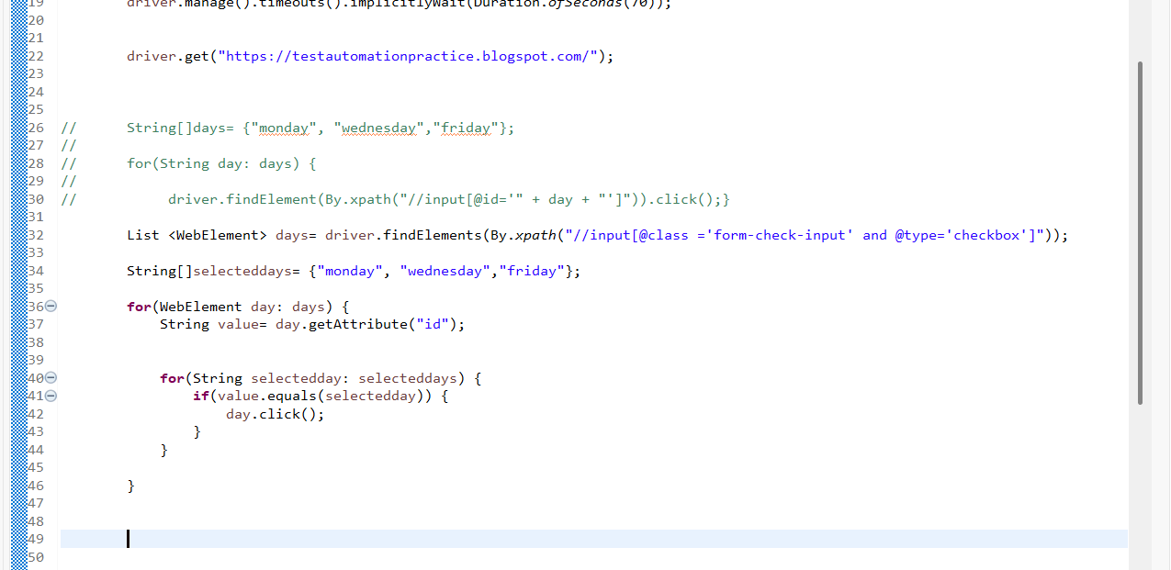
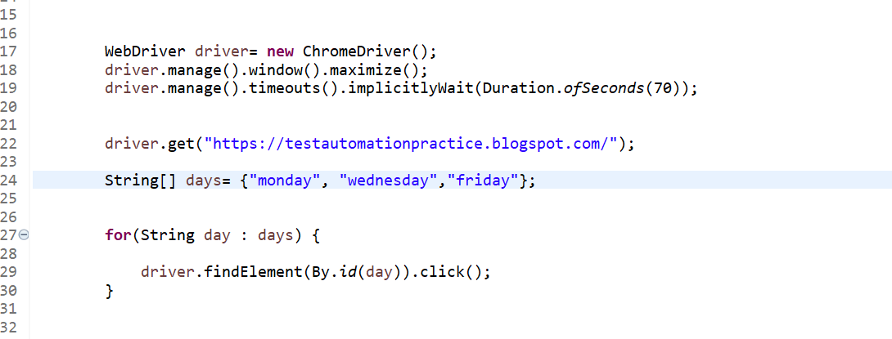
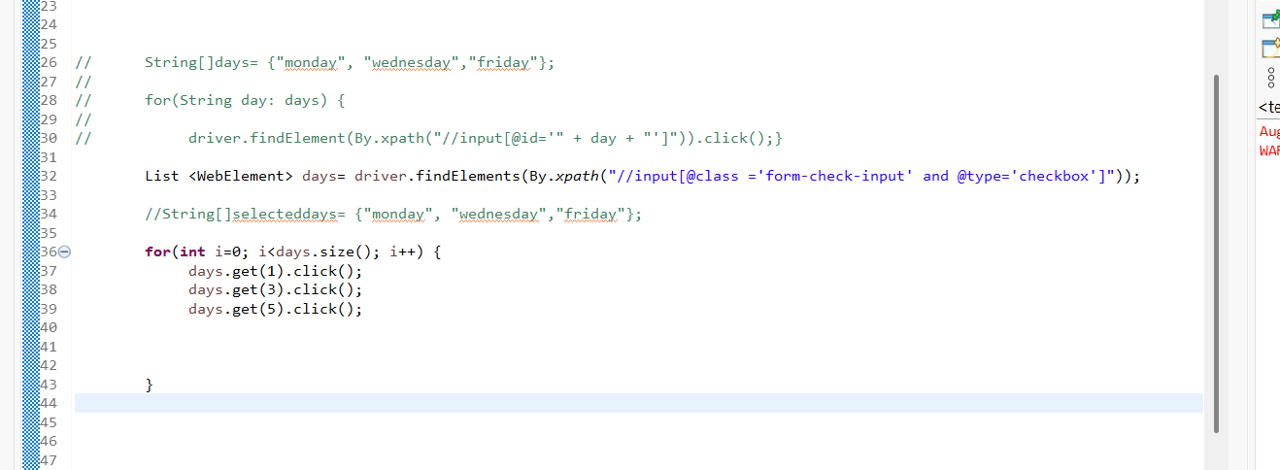
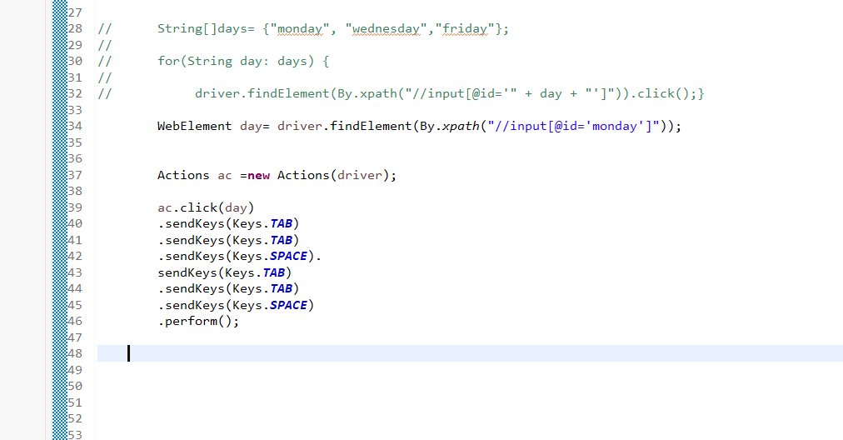

Without xpath using days select
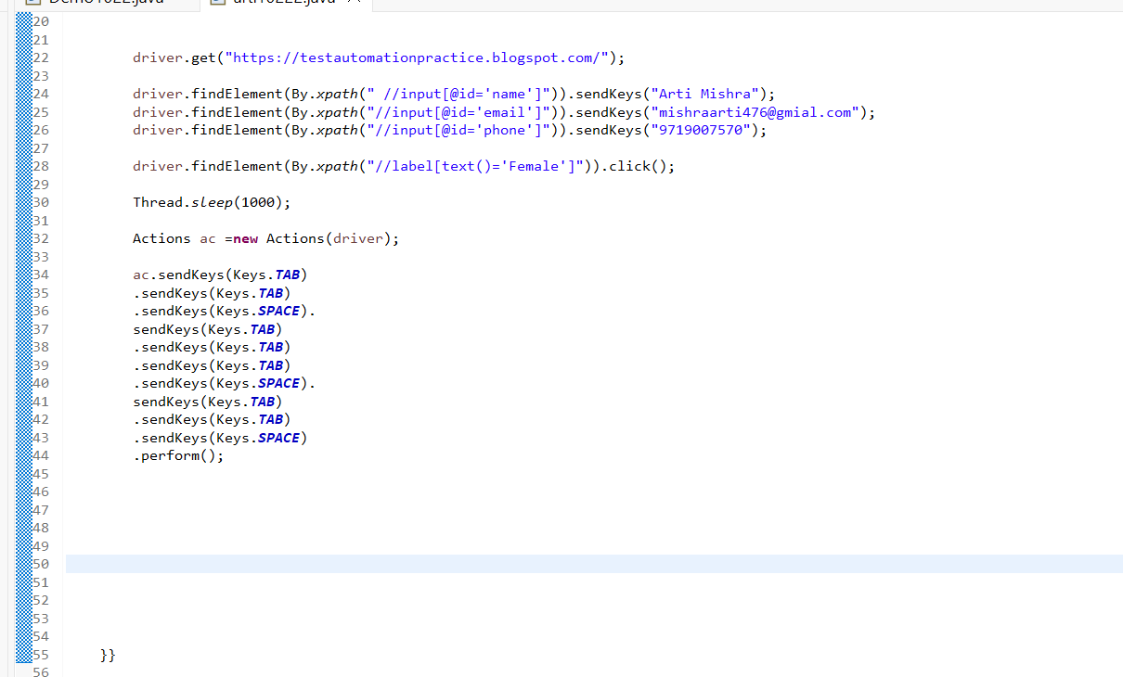
Select use
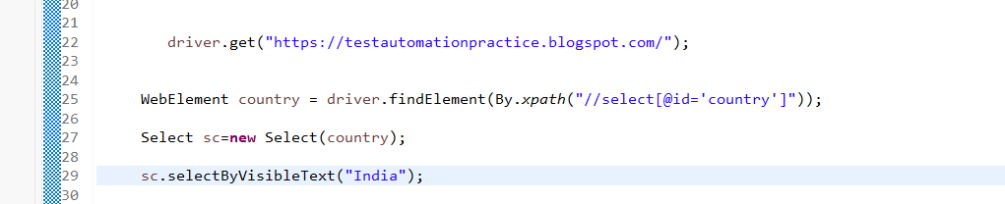
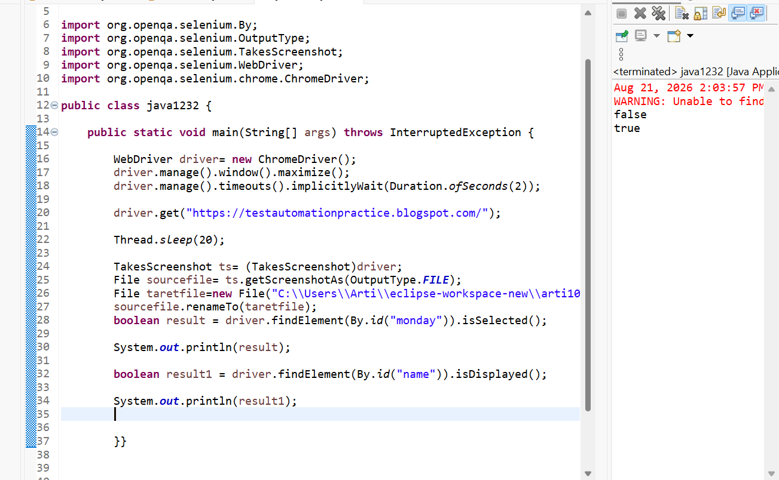
File upload
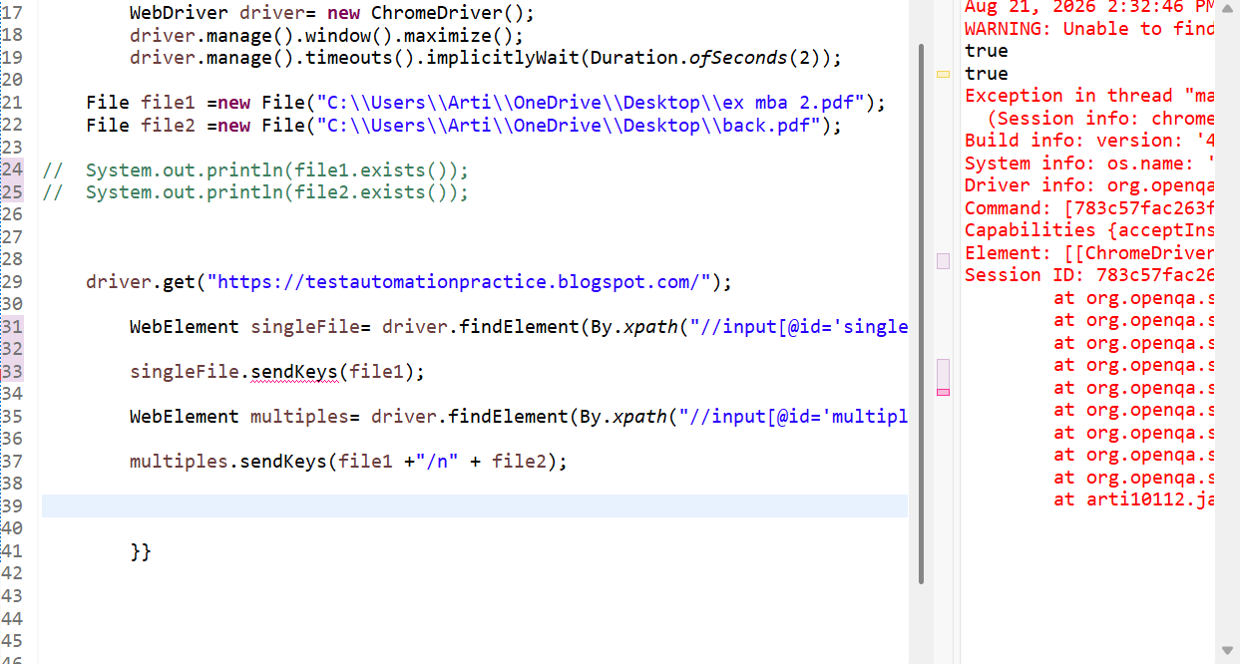
Keyboard action to copy,paste
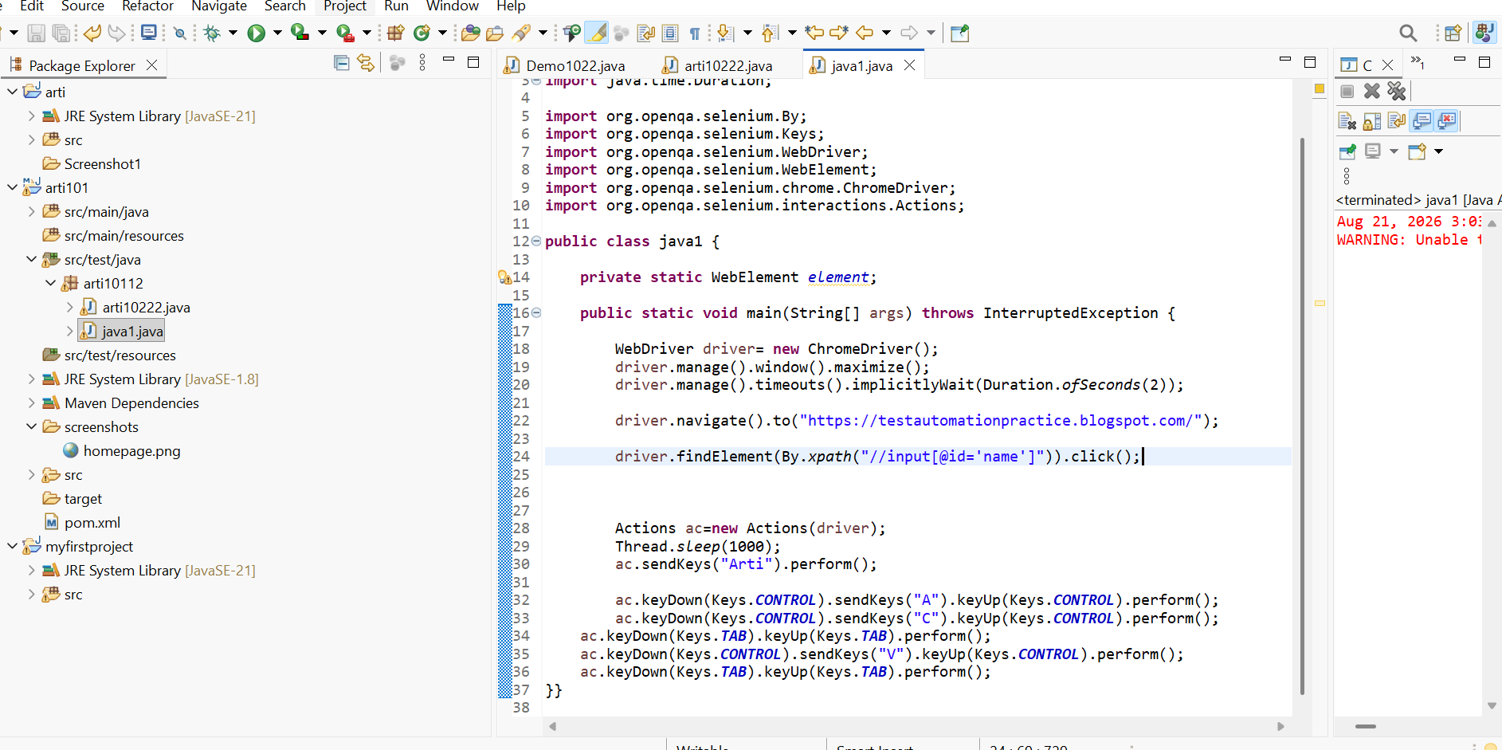
driver.findElement(By.xpath("//button[text()=' Add ']")).click();
driver.findElement(By.xpath("//input[@name='firstName']")).sendKeys("Arti");
driver.findElement(By.xpath("//input[@name='middleName']")).sendKeys("k");
driver.findElement(By.xpath("//input[@name='lastName']")).sendKeys("Mishra");

driver.findElement(By.xpath("//button[@type='submit']")).click();

