1.Power integration
n=3
for i in range(n):
Print(i**2)
Output-9
2.
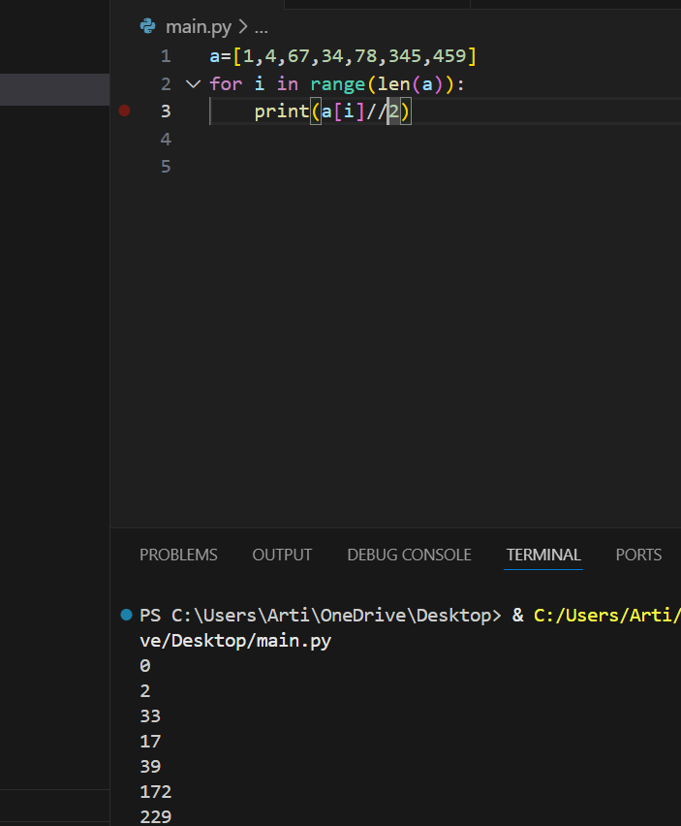

3. 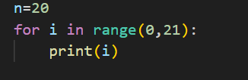
4. n=20
for i in range(0,21):
if n%2==0:
print(n,"is even")
else:
print(n,"is odd")
output=20 is even
5. for i in range (0,21):
if i%2==0:
print (i,"is even")
else:
print (i,"is odd")
output-0 is even,1 is odd,2 is even,3 is odd
6.String
n=”Arti”
Print(n)- Arti
Add 2 string
n="ARTI"
v=" Mishra"
print(n+v)- Arti Mishra
n="Krishansundar"
v=" Mishra"
print(n[2:3])
7. Functionality
X=1
Y=2
- def addition(x,y):-parameters
def addition(x,y):
a=x+y
print(a)-
addition(x,y)
- def subtraction(x,y):
b=x-y
print(b)
subtraction(x,y)

- def multiply(x,y):
c=x*y
print(c)
multiply(x,y)

- def divide(x,y):
d=x/y
print(d)
divide(x,y)
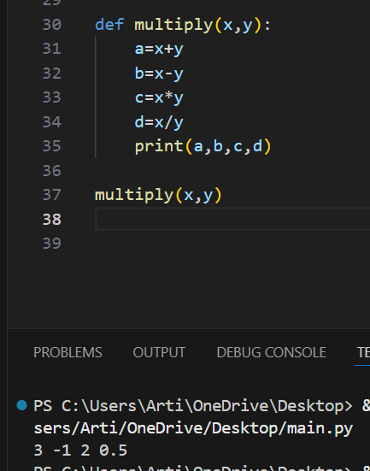
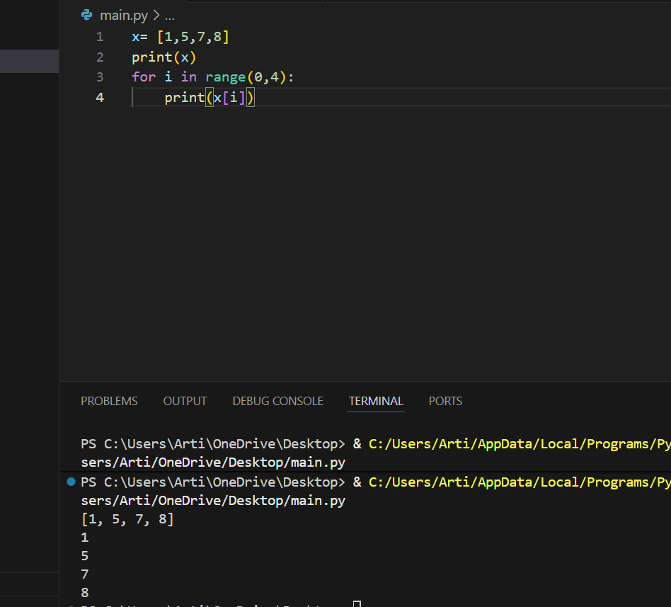
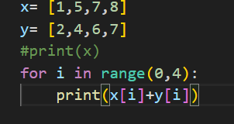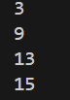
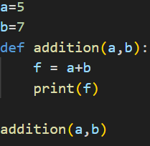12
- a=5
b=5
x=a+b
print(x)
def addtion(a,b):
x= a+b
print(x)

addtion(a,b)
output-10

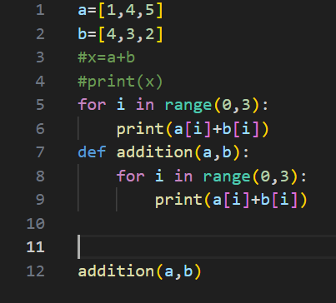5,7,7
- a = [7, 8, 9]
b = [3, 2, 1]

for i in range(0,3):
print("Subtract is =",a[i]-b[i])----- Subtract is = 4
Subtract is = 6
Subtract is = 8

- a = [7, 8, 9]
b = [3, 2, 1]
result=[]
for i in range (0,3):
result.append(a[i]-b[i])

print("Subtract is =",result)
output- Subtract is = [4, 6, 8]
- a = [7, 8, 9]
b = [3, 2, 1]
result=[]
def subtract(a,b):
for i in range(0,3):
result.append(a[i]-b[i])

subtract(a,b)
- print("Subtract is =",result)-------output- Subtract is = [4, 6, 8]

- a = [5, 15, 25,5]
- b = [2, 5, 8,55]
- result=[]
- def devide(a,b):
- for i in range(0,4):
- result.append(a[i]//b[i])

- devide(a,b)
- print("divid is =",result)-----output - divid is = [2, 3, 3, 0]

- exmple
- a = [5, 15, 25,5]
- b = [2, 5, 8,55]
- add = []
- sub = []
- mul = []
- div = []

- def calculate(a,b):
- for i in range(0,4):
- add.append(a[i] + b[i])
- sub.append(a[i] - b[i])
- mul.append(a[i] * b[i])
- div.append(a[i] / b[i])

- calculate(a,b)
- print("Addition =", add)
- print("Subtraction =", sub)
- print("Multiplication =", mul)
- print("Division =", div)
- OUTPUT- Addition = [7, 20, 33, 60]
- Subtraction = [3, 10, 17, -50]
- Multiplication = [10, 75, 200, 275]
- Division = [2.5, 3.0, 3.125, 0.09090909090909091]

a={
"name":"Arti",
"rule":100,
"Company_name": "NTT data"
}
print(a)
a["name"]="prasoon"
print(a)
a["rule"]=200
print(a)
a["Company_name"]= "Mindtree"
print(a)

OUT PUT-{'name': 'Arti', 'rule': 100, 'Company_name': 'NTT data'}
{'name': 'prasoon', 'rule': 100, 'Company_name': 'NTT data'}
{'name': 'prasoon', 'rule': 200, 'Company_name': 'NTT data'}
OUT PUT-
{'name': 'prasoon', 'rule': 200, 'Company_name': 'Mindtree'}

List, itereges,

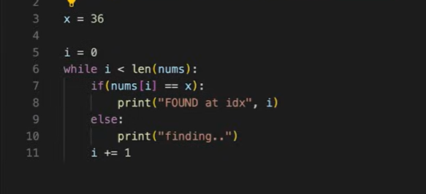
- n=3
for i in range(1,n+1):
print(i,end="")-----output- 12345.

- i=1
while i<=5:
i+=1
print(i)-
output-1
1
2
3
4
5

- x=[]
- x.insert(1,5)
- x.insert(0,6)
- x.insert(2,10)
- print(x)
- x.remove(6)
- x.append(9)
- x.append(1)
- x.sort()
- print(x)
- x.pop()
- x.reverse()
- print(x)
- 0utput-
[6, 5, 10]
[1, 5, 9, 10]
[9, 5, 1]

- x=1
- y=3
- z=4
- n=1
com=[]
for i in range(0,x+1):
for j in range(0,y+1):
for k in range(0,z+1):
if(i+j+k)!=n:
com.append([i,j,k])

print(com)
output- [[0, 0, 0], [0, 0, 2], [0, 0, 3], [0, 0, 4], [0, 1, 1], [0, 1, 2], [0, 1, 3], [0, 1, 4], [0, 2, 0], [0, 2, 1], [0, 2, 2], [0, 2, 3], [0, 2, 4], [0, 3, 0], [0, 3, 1], [0, 3, 2], [0, 3, 3], [0, 3, 4], [1, 0, 1], [1, 0, 2], [1, 0, 3], [1, 0, 4], [1, 1, 0], [1, 1, 1], [1, 1, 2], [1, 1, 3], [1, 1, 4], [1, 2, 0], [1, 2, 1], [1, 2, 2], [1, 2, 3], [1, 2, 4], [1, 3, 0], [1, 3, 1], [1, 3, 2], [1, 3, 3], [1, 3, 4]]

- n=[2,4,5,6,7]
unique_score= list(set(n))
unique_score.sort()

print("unique score",n)
print("2 runner-up score", unique_score[-2])----output- unique score [2, 4, 5, 6, 7]
2 runner-up score 6
n=[2,3,6,6,5]
print(n[-1])-----output-5

- Function Without Parameters
- def greet():
- print("Hello ,Welcome to home!")

- greet()
- output-Hello,Welcome to home!

- Function With Conditional Logic
- def check_even_odd(num):
- if num%2==0:
- print("even is", num)
- else:
- print("odd is", num)

- check_even_odd(7)
- check_even_odd(10)
Output- odd is 7
even is 10

- def square(num):
- return num*num

- print("square of 5 =", square(5))
- print("square of 3 =", square(3))

Output- square of 5 = 25
square of 3 = 9

- def maximum(num):
- if a>=b and b>=c:
- return a
- if b>=c and c>=a:
- return b
- else:
- return c

- print("maximum is ", max(18,25,67))
Output
maximum is num 67

- def factorial(num):
fact=1
for i in range(1,num+1):
fact*=i
return fact

print("Factoriaal is =",factorial(5))

output-Factorial is = 120

- fruits = ["apple","orange","grappes","jeera","ram"]
- x=[]
- def my_fruits(start,end):
    - for i in range(start,end):
      - x.append(fruits[i])

- my_fruits(0,4)
- print(x)
Output-['apple', 'orange', 'grappes', 'jeera']

- Myvechles = {
- "Car": ["Tesla","Honda"],
- "Bike": ["TVS"],

}

- Myvechles["Car"].append("Audi")
- Myvechles["Bike"].append("Hero")
- print(Myvechles)
Output-{'Car': ['Tesla', 'Honda', 'Audi'], 'Bike': ['TVS', 'Hero']}

records=[['harry',37.21],
['Berry',37.21],
['Tina',37.2],
['Akriti',41],
['Harsh',39]]

print(records)

output-[['harry', 37.21], ['Berry', 37.21], ['Tina', 37.2], ['Akriti', 41], ['Harsh', 39]]

#scores = sorted(list(set([marks for harry, marks in records])))

a={
"alpha":[20,30,40],
"beta":[30,50,70]
}

marks=[a["beta"][i] +a["alpha"][i]
for i in range (len(a["alpha"]))]

total=sum(marks)

print(total)
print(marks)

output-240
[50, 80, 110]

a={
"alpha":[20,30,40],
"beta":[30,50,70]
}

marks=[a["beta"][i] +a["alpha"][i]
for i in range (len(a["alpha"]))]

total=sum(marks)
percentage=(total/(len(a["alpha"])*2))

print(total)
print(marks)
print(percentage,"%")
output-240
[50, 80, 110]
40.0 %

def loan_eligiblity(loan_amount,age,salary,nationality,employee_type):
if(
loan_amount >=50000 and
25 <= age and
age <=45 and
salary >= 50000 and
nationality=="indian" and
employee_type=="salaried"
):

print("Loan approved")

else:
print("Loan declined")

loan_amount = 50000
age = 35
salary = 450000
nationality = "indian"
employee_type= "salaried"
print(loan_eligiblity(loan_amount,age,salary,nationality,employee_type))
print(loan_amount)

Output—Loan approved
50000

