VPC- Virtual private cloud

A VPC is a virtual network that closely resembles a traditional network that you'd operate in your own data center. After you create a VPC, you can add subnets.

Subnet
A subnet is a range of IP addresses in your VPC. A subnet must reside in a single Availability Zone.

IP address-define range to create limits or spread to limits.
Routing-determine where network traffic from your subnet or gateway is directed.
Gateways and endpoints
A gateway connects your VPC to another network.

connect to AWS services privately, without the use of an internet gateway or NAT device.
Peering connections-
to route traffic between the resources in two VPCs.
Traffic Mirroring
Copy network traffic from network interfaces and send it to security and monitoring appliances for deep packet inspection

Transit gateways
transit gateway, which acts as a central hub, to route traffic between your VPCs, VPN connections, and AWS Direct Connect connections.
VPC Flow Logs
A flow log captures information about the IP traffic going to and from network interfaces in your VPC.
VPN connections
Connect your VPCs to your on-premises networks using AWS Virtual Private Network (AWS VPN).

AWS organisation
AWS Organizations is a service that allow users to create and manage multiple AWS account from a single location. It is providing a governance framework to define, manage and govern groups of aws accounts, enabling centralized management of policies and services.

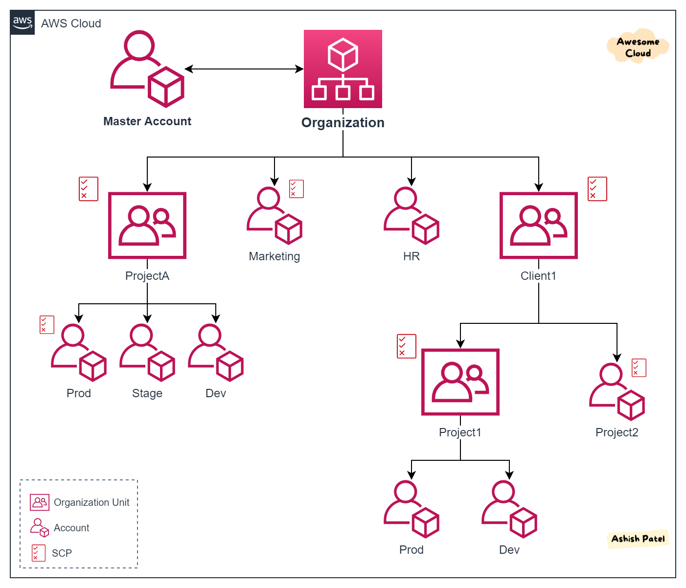
IAM -identify access management.
IAM stands for Identity and Access Management in AWS. It is a web service that helps you securely control access to AWS resources.
you can manage permissions that control which AWS resources users can access. IAM provides the infrastructure necessary to control authentication and authorization for your AWS accounts.
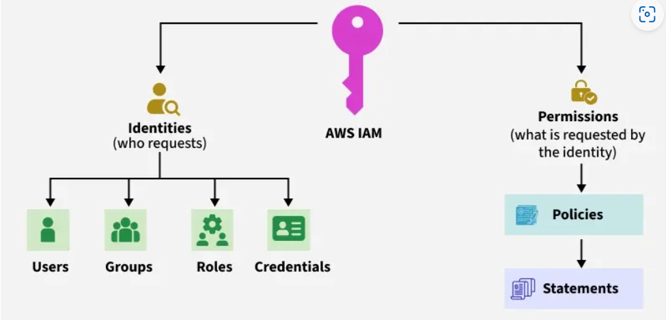

What is testing?
Software testing is the process of evaluating a software application to ensure it functions as expected, is free of bugs, and meets all specified requirements
Software testing is a process of verifying and validating whether the Software Product or Application is working as expected or not.

Types of Testing
-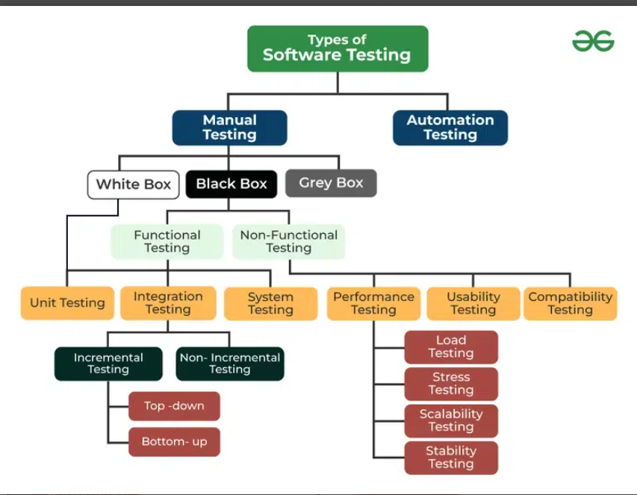

Manual testing- The tester manually checks the application to find bugs, errors, or missing requirements.

White Box-White Box Testing means testing inside the code — the tester knows how the code works internally.
Black Box-Black Box Testing means testing a software without knowing the internal code.
You only check the input and output — like a user.
The tester does not see the code, only the application's behavior
Grey Box-the tester has partial knowledge of the internal system
Functional Testing-Checks whether each function of the software works as expected.
Example: Login, Signup, Add to Cart, Payment.
N0n-Functional Testing-Checks how well the system performs.
Includes:
- Performance Testing
- Load Testing
- Stress Testing
- Security Testing
- Usability Testing
- Compatibility Testing

User Acceptance Testing (UAT)
Testing by real users or clients to ensure system is ready for release
Ad-hoc Testing
Unstructured testing without any documentation.
Tester tries to “break” the system.
Exploratory Testing
Tester explores the application using creativity and experience.
No predefined test cases

Boundary Value Analysis (BVA)
Test at boundary values (min, max limits).
Example:
If age allowed = 18 to 60
Test → 17, 18, 60, 61

Unit Testing: Developers test small pieces of code like functions or methods.
Ensures each unit works correctly.

- Integration Testing: This testing checks if combined modules work together.
  - Incremental Testing
    - Top-down: Starts from top modules and integrates downward.
- • Start testing from top-level (main module)
- • Move downwards to lower modules
- • Use stubs for missing modules

    - Bottom-up: Begins with lower-level modules and integrates upward.
- • Start testing from lowest-level modules
- • Move upwards
- • Use drivers for missing higher modules

  - Non-Incremental Testing: All modules are integrated at once (also known as Big Bang Testing).
- System Testing: Validates the complete and integrated software system.
• Testing the entire system end-to-end.
• Ensures system meets business requirements.

- Performance Testing: Assesses speed, responsiveness, and stability.
- Checks how fast and stable the application works under conditions.
  - Load Testing: Check performance under normal load (expected number of users)
  - Stress Testing: Check behavior under extreme load (very high users).
  - Scalability Testing: Evaluates system’s ability to grow.
  - Check if system can scale up when users increase
  - Stability Testing: Checks system reliability over time.
  - Check if system runs continuously without crashing for long periods
- Usability Testing: Focuses on user experience and interface.
• Checks how easy and user-friendly the application is.
• Example: UI design, navigation, readability

- Compatibility Testing: Ensures software works across different environments (OS, browsers, devices).
Ensures the application works on:
- Different browsers (Chrome, Firefox)
- Different devices (Mobile, Tablet)
- Different OS (Windows, Android)

Software Testing Life Cycle (STLC)
STLC is a step-by-step process followed during testing to ensure quality of the software.
Requirement Analysis
The testing team studies:
- What to test?
- Functional requirements
- Non-functional requirements
- Testable and non-testable requirements
Output:
✔ Requirement understanding document
✔ List of queries/assumptions
Test Planning
Planning how testing will be done.
Activities:
- Create test strategy
- Decide tools (JIRA, Selenium, etc.)
- Estimate effort & cost
- Assign roles & responsibilities
- Prepare test plan document
Output:
✔ Test Plan
Test Case Development
Testers create:
- Test cases
- Test data
- Expected results
Output:
✔ Test Cases
✔ Test Data
Test Environment Setup
Preparing where tests will run.
Activities:
- Install software
- Setup database
- Set up test servers
- Configure tools
Output:
✔ Ready Test Environment
Test Execution
Executing the test cases on the application.
Activities:
- Run test cases
- Mark test cases as Pass/Fail
- Log defects/bugs
- Re-testing bugs
- Regression testing
Output:
✔ Test Execution Report
✔ Defect Report
Test Cycle Closure
Final phase — testing team evaluates the complete testing.
Activities:
- Analyze testing completed
- Check defect count
- Prepare test closure report
- Lessons learned
- Handover to development or support team
Output:
✔ Test Summary Report
✔ Closure Report
What is bugs?
A bug is a mistake or problem in software that makes it work wrong.
👉 When the software does not do what it is supposed to do → that is a bug.
A bug is any incorrect behavior in the software.

Types of bugs
- Functional Bug
The feature does not work properly.
Example:
Login button not working.
- UI / Design Bug
- Problem in the look of the app.
- Example:
Text is not visible, button is cut.
- Performance Bug
- The app is slow.
- Example:
Page takes 10 seconds to load.
- Compatibility Bug
- App works on one device/browser but not on another.
- Example:
Works on Chrome → but not on Firefox.
- Security Bug
- Users can see or access data.
- Example:
User A can see User B’s profile.
- Logical Bug
- Calculation or logic is wrong.
- Example:
100 + 50 = 120 (wrong result).

- ⚫ 7. Crash Bug
- App suddenly closes or crashes.
- Example:
Game closes when you click “Play”.
- What is a Bug Report? (Simple)
- A bug report is a written document that tells developers:
- 👉 What is the problem?
👉 Where does it happen?
👉 How to reproduce it?
👉 What is expected?
👉 What is actually happening?
Example:
Bug Title: Login button not working
Steps:
- Open app
- Enter username
- Enter password
- Click Login
Expected: User should log in
Actual: Nothing happens

What is Agile methlogy
Agile is a way of developing software in small parts and delivering it fast, while getting continuous feedback from the customer.
👉 Work is divided into small cycles called Sprints (1–4 weeks).
👉 After every sprint, a working feature is delivered.
👉 Changes can be done anytime.
Why Agile? (Simple)
- Fast delivery
- Easy to change requirements
- Customer gets regular updates
- Team works together closely
- Less risk, fewer surprises
Team Members
- PO – Product Owner → Gives requirements
- SM – Scrum Master → Manages the Scrum process
- Team Members → Developers + Testers
- Scrum
- Scrum is an Agile framework used to develop software in small cycles.
User Story / Work Item
- A User Story describes a requirement.
- It contains Acceptance Criteria (what must be done).
Daily Scrum / Daily Stand-up
- A 15-minute meeting every day.
- Everyone answers 3 questions:
  - What did I do yesterday?
  - What will I do today?
  - Any blockers?
Sprint
- A time-boxed cycle (usually 2 weeks).
- Work is planned and completed inside the sprint.

✅ 6. Sprint Review
- The team shows (demo) the completed work to the Product Owner.
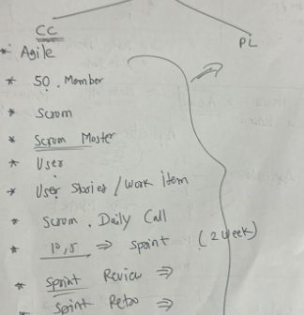
Sprint Retrospective
- A meeting after the sprint to discuss:
✔ What went well
✔ What didn’t go well
✔ What to improve
Way of metho-
In Agile:

- Requirements are written as User Stories.
- Work is planned in the Sprint Planning meeting.
- The team meets daily in a Daily Standup (15 minutes).
- At the end of the sprint, a Sprint Review is done to show the completed work.
- A Sprint Retrospective is done to discuss improvements for the next sprint.

- STLC Short Notes
- 1️⃣ Requirement Analysis
- Understand requirements and identify what to test.
- 2️⃣ Test Planning
- Plan testing strategy, schedule, resources, and tools.
- 3️⃣ Test Case Design
- Write test cases and prepare test data.
- 4️⃣ Test Environment Setup
- Set up hardware/software needed for testing.
- 5️⃣ Test Execution
- Run test cases, record results, and log defects.
- 6️⃣ Test Closure
- Prepare test summary, ensure defects are closed, and finalize testing.

- If you want, I can also provide:

API
Application programme interface

API is a bridge that allow two software applications to talk each other.
API is massager that allows app to exchange data and perform actions without sharing whole code.

Example-
I am going to in resturent and oder something according menu to waiter .
Here:
i-application
waiter-api
kitchen -server/database

• When you use Google Pay to check your bank balance → Google Pay sends a request to the bank’s server through an API and gets the balance.
• When you login with Facebook/Google in another app → that app uses Facebook/Google’s API to read your profile info.

uses of api-
Share data between applications
Connect frontend and backend
Improve security (only allowed data sharing)
Make development faster
Type of api
Type | Description | Example
REST API | Uses HTTP methods (GET, POST, PUT, DELETE), lightweight | Most web services today
SOAP API | XML-based, strict, very secure | Bank and telecom services
Web API | Runs on web over HTTP | Login with Google
Operating System API | Interact with OS features | Windows API, iOS API
Database API | Communication with DB | MySQL, JDBC
Hardware API | To control hardware components ----Camera API, Bluetooth API
UI vs Api testing
UI Testing checks how application looks and works for users, while API Testing checks backend functionality, database communication, and data processing without using a user interface.
200 | OK | Successful request

201 | Created | New resource added

400 | Bad Request | Wrong input

401 | Unauthorized | Login/auth required

403 | Forbidden | No permission

404 | Not Found | Endpoint wrong

500 | Server Error | Bug in serve
What is an API request and response?
- Request: Sent from client → server asking for data/action
- Response: Returned by server → contains data + status code
What is JSON? What is XML?
- JSON: Lightweight data format used in APIs ({ "name": "Arti" })
- XML: Markup language with tags (<name>Arti</name>)

Difference between GET and POST
GET | POST
Only fetches data | Creates/sends data
Parameters visible in URL | Data hidden in body
Safe and Idempotent | Not Idempotent

HTTP Methods
- GET → read data
- POST → create new data
- PUT → update data (full update)
- PATCH → partial update
- DELETE → remove data
What is REST API?
A style of API using HTTP methods where response is mostly in JSON format.
What is an Endpoint?
A specific URL where API receives request.
What is Payload?
Actual data sent in API request body (mostly in POST/PUT/PATCH).
What is Token?
A secure string used for user identity verification in APIs.
Tools used for API Testing
- Postman
- Swagger
- JMeter
- RestAssured
- SOAP UI

What is Idempotent Method?
API method that gives same result no matter how many times you repeat it.
Examples: GET, PUT, DELETE
What is Response Time?
Time server takes to send response after request.
What is API Versioning?
Handling multiple API versions like:
/v1/student , /v2/student
What is CORS?
Cross-Origin Resource Sharing → allows server to permit requests from different origins (domains).
How do you validate API response in testing?
✔ Status code
✔ Response body data
✔ Schema validation
✔ Headers
✔ Database validation
If API returns 500, what will you do?
Check server logs, request body, DB connectivity, and backend logic.
What is Swagger?
API documentation + testing tool for REST APIs.
.

If API response code is 500, what will you do?
➡ Server-side error
✔ Check request payload format
✔ Validate mandatory fields
✔ Check headers like Content-Type
✔ Inform backend team with logs
✔ Re-test after fix
Request returns 200 OK but data is wrong in UI. What is your action?
✔ Compare API response data vs UI display
✔ Identify if UI mapping/display logic issue
✔ Check DB values if required
✔ Report defect with evidence (API response screenshot + UI screenshot)

You are testing login API — what validations will you perform?
✔ Correct credentials → 200
✔ Wrong credentials → 401/403
✔ Empty fields → 400
✔ Token generated and stored
✔ Session expiration
✔ Security check for SQL Injection & Brute Force

API response is slow — how do you handle?
✔ Measure response time
✔ Perform load testing
✔ Report delay with threshold comparison
✔ Check if payload is too large
✔ Discuss performance improvement with backend team
How do you validate data returned in API?
✔ Status code
✔ Response body fields
✔ JSON schema validation
✔ Data in DB must match
✔ Business rules check

How do you test API security?
✔ Token / Auth validation
✔ Check unauthorized access returns 401/403
✔ Try SQL Injection
✔ Verify HTTPS
✔ Sensitive data must be encrypted

API returns duplicate data — what do you check?
✔ Backend logic
✔ DB primary keys
✔ Pagination settings
✔ Filters in request

API is not supporting special characters — what do you do?
✔ Check URL encoding
✔ Validate server-side input sanitization
✔ Report improper handling of user input
Pagination not working — How to test?
✔ Check correct page number results
✔ Validate item count per page
✔ Check next/previous navigation
✔ Verify sorting filters remain applied

🔟 How will you test file upload API?
✔ File size limit
✔ Allowed file types
✔ Invalid file → 415 error
✔ Upload success → 201
✔ Virus/security scan check
Test cases
Detailed steps to execute the scenarios
Included input valid, pre-conditions, expected result
Help in step by step in testing and defect detection.
- Example-
  - Enter valid username
  - Enter valid password
  - Click login button
  - Verify user logins successfully

Difference Table
Feature | Test Scenario | Test Case
Definition | What to test | How to test
Detail Level | High-level | Very detailed
Focus | Functionality coverage | Accuracy & validation
Documentation Effort | Less | More
Used When | Time is limited or agile approach | Detailed testing required
Example | “Check Login Module” | Multiple test cases like valid login, invalid login, blank fields etc.
Test scenario
• A high-level description of what to test
• Focuses on end-to-end functionality
• Ensures complete coverage of requirements
• Example: Verify user login functionality
Example Together (Login Page)
Test Scenario | Related Test Cases
Verify login functionality | 1️⃣ Login with valid credentials  2️⃣ Invalid username  3️⃣ Invalid password  4️⃣ Blank fields  5️⃣ Check "Forgot Password" link
• Verify login with valid credentials
• Verify login with invalid username
• Verify login with invalid password
• Verify login with blank username and password
• Verify behavior of “Forgot Password” link
• Verify password masking (•••• type)
• Verify login with special characters
• Verify Remember Me functionality
• Verify error message for incorrect login
• Verify login redirection to dashboard/home page

Input validation
It is process to checking that the data entered by used is correct or not.
If incorrect data-then show error massage
Example-f you enter:
- Phone number: only numbers
- Email: must contain @
- Password: cannot be empty
System checks → Is the input valid?
If yes → accept
If no → show error
What is Test Coverage?
Test Coverage means how much of the application or requirement is tested.
It tells:
- how many features are tested
- how many test cases are executed
- what areas are still not tested

Example
If a software has 10 features
and tester tested 7 features
Then test coverage = 7/10 = 70%

What is End-to-End Testing?
End-to-End (E2E) testing means testing an entire application from start to finish to make sure that all components and systems work together properly.
It simulates real user flow.
Example---
E-commerce Website
User journey:
- Login to the website
- Search a product
- Add to cart
- Make payment
- Order confirmation email received
All these steps are tested together in one flow → End-to-End Test
When do we perform E2E Testing?
✔ After Integration Testing
✔ Before UAT (User Acceptance Testing)
✔ Before software release
What is Customer Details Validation?
Customer Details Validation means checking the information a customer enters (like name, email, phone, address) is correct and acceptable before saving or using it.
If the data is wrong → system shows an error message.
Why is Customer Details Validation Important?
✔ Avoid wrong or fake information
✔ Prevent system errors
✔ Improve user experience
✔ Ensure correct delivery (E-commerce)
✔ Ensure correct communication (Email/SMS)
What is Customer Application Validation?
Customer Application Validation means checking that all details filled in a customer form/application (like Name, Address, Contact, ID proof, etc.) are correct, complete, and follow business rules before submission.
It ensures:
✔ Correct data
✔ No missing information
✔ No fake or incorrect entries
✔ Compliance with system rules
This is commonly used in:
- Bank Account Opening Form
- E-commerce Customer Profile
- Loan Application
- Insurance Application
- Online Registration Forms
Decision validation
Decision Validation means verifying that the system takes the correct action or decision based on given rules and inputs.
Example
Loan Application System:
Salary | System Decision
Above ₹30,000 | Loan Approved
Below ₹30,000 | Loan Rejected
We check:
✔ Is the system approving when it should approve?
✔ Is the system rejecting when it should reject?
This checking = Decision Validation
PL Validation
PL Validation means checking whether a customer is eligible for a Personal Loan based on bank rules like:
✔ Age
✔ Income
✔ Credit Score
✔ Employment Type
✔ Location
✔ Documents provided
➡ If all rules are correct → Loan Approved
➡ If any rule fails → Loan Rejected
Condition | Business Rule | System Decision
Age | Must be 21–60 | If not → Reject
Monthly Income | Min ₹25,000 | If less → Reject
Credit Score | 700+ | If low → Reject
Employment | Salaried/Self-employed | If unemployed → Reject
System must follow these rules correctly → this checking = PL Validation

Why it is done?
To ensure:
✔ Bank gives loan to eligible customers only
✔ Reduce risk of fraud
✔ Correct EMI calculation
✔ Document correctness
Pay load Validation
Payload validation means checking the data sent between client and server (API request/response) to ensure:
✔ Data format is correct
✔ Required fields are present
✔ Data type is correct
✔ No missing or extra fields
✔ Values are valid (within rules)
✔ Security is maintained (no malicious input)

Why Payload Validation is Important?
- Prevents invalid data entering system
- Ensures API security
- Avoids application crash
- Ensures smooth end-to-end integration

Phases of SDLC (Short & Simple):
- Requirement Gathering
– Understand what the customer wants.
- Analysis
– Check feasibility, cost, and technical details.
- Design
– Create architecture, UI design, database design.
- Development (Coding)
– Developers write the code.
- Testing
– Testers test the software for bugs.
- Deployment
– Release software to production/users.
- Maintenance
– Fix issues and update the software after release.

✅ STLC (Software Testing Life Cycle) – Short Notes
STLC is the process followed by testers to test the software.
Phases of STLC (Short & Simple):
- Requirement Analysis
– Understand what to test.
- Test Planning
– Plan testing strategy, schedule, budget.
- Test Case Design
– Write test cases & test data.
- Test Environment Setup
– Prepare system, tools, and environment for testing.
- Test Execution
– Run test cases and record results.
- Defect Reporting
– Log bugs in defect tool (JIRA, Bugzilla etc.)
- Test Closure
– Final report, metrics, and sign-off.

Verification-check the work before product is built.
Check-document, design, requirement it means checking the plan
Ex-username is required, password is required and forgot password option required
Validation-checking after product is built.
Checking product is working correctly.
Ex-can I enter user name, password, show error msg after enter incorrect credential.
Static testing = Testing without running the code.
You check documents, design, requirements, and code review.
Dynamic testing = Testing by running the software.
You execute the code, give input, check output.
QA does not test the software. QA checks the process where create software is correct way.
• Defines standards
• Creates testing processes
• Reviews documents
• Makes guidelines
• Ensures team follows the right method
Ex-• Are requirements clear?
• Are test cases written properly?
• Are coding standards followed?
QC-QC tests the software to find defects.
• Executes test cases
• Finds bugs
• Reports defects
• Validates the software output
EX-• Runs the login page
• Checks if login works
• Finds a bug: "Login fails with correct password"
• Reports it to developer
Unit Testing = Testing individual functions or modules.
Only ONE function is tested, not the whole login page.
Ex-password validation function:
- If password < 6 characters → Show error
- If password is correct → Return “Success
Integration Testing = Testing how two or more modules work together.
You test connection between modules.

Ex-Modules involved:
- Login page
- Database
Tester checks:
- When user enters valid username → system fetches data from database.
- When wrong password → database returns “Invalid”.
System Testing = Testing the entire software end-to-end.
Done by testers.
Whole system is tested like a real user.
Example (E-commerce App):
Tester checks:
- Login
- Search product
- Add to cart
- Payment
- Order confirmation
UAT-UAT (User Acceptance Testing)
UAT = Testing done by real users or clients
Purpose: Check if the software meets business needs.
Example:
Client checks:
- Can they order a product easily?
- Payment and invoice generated correctly?
- Delivery address selection working?
👉 If the client is satisfied → software is accepted.
Performance Testing
Checks how fast and stable the application works under load.
It checks speed, response time, load, and stress.
Example:
You test an e-commerce website:
- Can website handle 1,000 users at the same time?
- Does the homepage open within 2 seconds?
- Does the site crash during Big Sale?

Security Testing
Checks if the application is safe from attacks or unauthorized access.
It checks data protection, login security, and vulnerabilities.
Example:
For a banking app:
- Can someone break into the account without password?
- Does the system encrypt passwords?
- Does the system block after 3 wrong login attempts?
- Is payment data safe?

Compatibility Testing
Checks if the software works properly on different devices, OS, browsers, and versions.
Example:
You test a shopping website on:
- Chrome
- Firefox
- Edge
- Safari (Mobile)
- Windows, Android, iOS
- Different screen sizes (mobile, tablet, laptop)
You check:
- Does the layout break?
- Do all buttons work on all devices?
- Does the app crash on old Android versions?
Exploratory Testing
Tester explores the application without any plan or test cases.
They learn the app while testing.
Example:
You open a shopping app and start exploring:
- Try adding items randomly
- Try searching with symbols
- Try invalid promo codes
- Try checking out without login
👉 You explore freely to find unexpected bugs.
Smoke Testing
Basic check to see if the main features are working after a new build.
Also called “Build Verification Testing”.
Example:
After developers release a new build, tester checks quickly:
- App opens
- Login works
- Homepage loads
- Major buttons clickable
👉 If smoke testing fails → stop testing.
Sanity Testing
Quick testing of a specific module after a fix or update.
Checks whether new changes work properly.
Example:
A bug was fixed in the payment page.
Sanity testing checks only that area:
- Payment button works
- Correct amount deducted
- Payment success message shows
👉 Only focused testing, not full testing.
Regression Testing
Re-testing the whole app to ensure nothing is broken after new changes.
Example:
Developer adds a new discount feature.
Regression tester checks:
- Login
- Search
- Add to cart
- Previous payment flow
- Order history
👉 Ensures old features still work after changes.
Ad-hoc Testing
Informal, unstructured testing without documents or planning.
Tester uses creativity and experience to break the system.
Example:
- Try entering long numbers
- Try uploading huge files
- Try entering emojis in input fields
- Click multiple buttons quickly
- Try invalid actions
👉 Goal: Try to break the system.

Test Plan (Project-specific Document)
A Test Plan is a detailed document that explains how testing will be done for a specific project.
Think of it like a roadmap for testing.
What Test Plan Contains (Simple):
- What to test
- How to test
- Who will test
- What tools to use
- Testing schedule (timeline)
- Entry & Exit criteria
- Risks + Solutions
Simple Example of Test Plan (Login Module):
- Scope: Test Login page
- Testing Types: Functional, Security
- Testers: 2 testers (A & B)
- Tools: JIRA for bug tracking
- Schedule: 2 days
- Entry Criteria: Build available with login module
- Exit Criteria: All test cases executed, no critical bugs
- Risk: Server may be slow
- Mitigation: Use backup test environment
👉 Test Plan = Detailed document for one project.
Test Strategy (Organization-level Document)
Test Strategy is a high-level document that explains the overall testing approach to be followed across all projects in a company.
Created by Test Manager or QA Lead.
What Test Strategy Contains (Simple):
- Testing approach
- Testing levels (Unit, Integration, System, UAT)
- Testing types (Functional, Performance, Security, etc.)
- Test environment details
- Defect reporting process
- Tools & standards
Simple Example of Test Strategy:
- All projects must follow Functional + Regression testing
- Use UAT before production release
- Use JIRA for bug reporting
- Follow Agile model
- Maintain 100% requirement traceability
- Weekly QA review meetings
👉 Test Strategy = High-level rules followed by the whole company.
What is RTM? (Simple Explanation)
RTM (Requirement Traceability Matrix) is a document that maps each requirement to its test cases.
👉 It helps to check whether all requirements are tested and nothing is missed.
Why RTM is Important?
- Ensures 100% test coverage
- Easy to find missing test cases
- Helps in UAT, audits, and reports
- Tracks requirement ↔ test case relationship
Example
Requirements for Login Page
- R1 – User must be able to login with valid credentials
- R2 – Error message should display for invalid login
Boundary Value Analysis (BVA)
- BVA = Test the boundaries (edges) of input values.
Most bugs occur at the minimum and maximum values.
- Example:
- Age must be 18 to 60.
- Test boundaries:
- Below minimum: 17
- Minimum: 18
- Just above minimum: 19
- Just below maximum: 59
- Maximum: 60
- Above maximum: 61
- 👉 These boundary points give best test coverage
- R3 – Forgot password link should work
Equivalence Partitioning (EP)
EP = Divide input into valid and invalid groups (partitions).
Test only 1 value from each group.
Example:
Age must be 18 to 60.
Partitions:
- Invalid partition 1: Less than 18
  - Example: 10
- Valid partition: Between 18 and 60
  - Example: 30
- Invalid partition 2: More than 60
  - Example: 70
👉 Instead of testing all values, test only one value from each group.
Decision Table Testing
Used when there are multiple conditions and different actions.
EX-
C1 (Username) | C2 (Password) | Result
Correct | Correct | Login successful
Correct | Wrong | Error message
State Transition Testing
Used when system behavior changes based on current state + input.
- BVA = Test edges
- EP = Groups of values
- Decision Table = If/Else combinations
- State Transition = Movement between states
Used when system has steps, levels, or screens.
- BVA = Test edges
- EP = Groups of values
- Decision Table = If/Else combinations
- State Transition = Movement between states

Example (ATM Card):
States:
- Card Inserted
- PIN Entered
- Account Locked
Transitions:
- If PIN correct → go to next state (menu screen)
- If PIN wrong 3 times → move to Account Locked state
Severity (Impact of the bug)
How bad the defect is for the system.
👉 “How serious is the bug?”
Example:
- Login button not working = High Severity
- Wrong spelling: “Logn” = Low Severity
Priority (Urgency to fix the bug)
How soon the defect must be fixed.
👉 “How fast should we fix it?”
Example:
- Wrong price shown during payment = High Priority
- Rare crash when clicking 10 times on hidden button = Low Priority

Defect Life Cycle (Bug Life Cycle)
The stages a defect goes through from finding → closing.
Here is the simple flow:
1️⃣ New → Tester logs the bug
2️⃣ Assigned → PM/Lead assigns to developer
3️⃣ Open → Developer starts working on it
4️⃣ Fixed → Developer fixes the bug
5️⃣ Retest → Tester retests the bug
6️⃣ Verified → Bug is working fine now
7️⃣ Closed → Tester closes the bug
Sometimes bugs are rejected:
- Rejected → Not a valid bug
- Duplicate → Already reported
- Deferred → Fix later
- Not Reproducible → Tester cannot reproduce bug
JIRA (Most popular tool)
Used for:
- Reporting bugs
- Tracking tasks
- Workflow management
- Agile (Scrum/Kanban)
Azure DevOps (Microsoft Tool)
Used for:
- Bug tracking
- CI/CD
- Repositories
- Agile planning
Test plan
A Test Plan in software testing is a document that describes how, what, when, and who will test an application.
✅ Simple Definition
A test plan is a step-by-step guide that tells the testing team:
- What to test
- How to test
- When to test
- Who will test
- What resources are needed
It ensures testing happens in a planned, organized, and controlled way.
Why Test Plan is Important?
- Avoids missing any important testing activity
- Helps team work in the same direction
- Ensures quality
- Helps estimate time & resources
- Reduces risk
Main Sections of a Test Plan
Here are the major components:
- Test Plan ID
Unique number or code.
- Introduction
Overview of the project.
- Scope of Testing
  - In-Scope: What will be tested
  - Out-Scope: What will NOT be tested
- Test Objectives
What you want to achieve (e.g., find defects, validate requirements).
- Test Strategy
Approach of testing: functional, non-functional, smoke, regression, etc.
- Resources & Roles
Who is the tester, lead, developer, etc.
- Test Environment
Details of hardware, software, URL, database, browser.
- Test Schedule
Timeline for testing.
- Entry Criteria
When testing can start.
- Exit Criteria
When testing can stop.
- Test Deliverables
What documents will be delivered (test cases, bug report, summary report).
- Risk & Mitigation
Possible risks + solutions.
- Tools Used
Jira, Postman, Selenium, etc.
Test Strategy-
A Test Strategy is a document that defines the testing approach, types of testing, test levels, test tools, and overall guidelines used by the testing team.
It is usually created by the Test Manager or QA Lead.

⭐ Key Components of a Test Strategy
Here are the main sections:
1️⃣ Scope
What will be tested and what will not be tested.
2️⃣ Testing Types
Types of testing to be performed:
- Functional Testing
- Non-functional Testing
- Smoke Testing
- Regression Testing
- API Testing
- UI Testing
- UAT
- Security & Performance (if included)
3️⃣ Test Levels
- Unit Testing (Dev)
- Integration Testing
- System Testing
- UAT
4️⃣ Test Approach
How testing will be executed:
- Manual testing
- Automation testing
- Tools used (Postman, JIRA, Selenium)
- Test data preparation
- Bug reporting process
5️⃣ Test Environment
Details of:
- Servers
- Browsers
- DB
- Tools
- Hardware/Software
6️⃣ Test Deliverables
- Test Plan
- Test Scenarios/Test Cases
- Bug Report
- Summary Report
7️⃣ Risk & Mitigation
Possible risks + solutions.
8️⃣ Entry & Exit Criteria
9️⃣ Roles and Responsibilities

📌 Simple Test Strategy Example (Easy to Understand)
Test Strategy – Loan Application System
1. Scope
Testing will cover:
- Customer details validation
- Salary, age, loan amount checks
- API response validation
- UI form validation
Out of Scope:
- Load testing
- Security audit

2. Testing Types
- Smoke Testing
- Functional Testing
- Boundary Value Analysis
- Equivalence Partitioning
- API Testing
- Regression Testing
- System Testing
- User Acceptance Testing (UAT)

3. Test Levels
- Unit Testing: By Developers
- Integration Testing: Tester
- System Testing: Tester
- UAT: Business team

4. Test Approach
- Manual testing for UI
- API testing using Postman
- Logs will be checked for failures
- Bugs will be logged in JIRA system
- Regression will be done after every bug fix
- Test cases will be prepared before execution

5. Test Environment
- Chrome, Firefox
- Test Server URL
- Database: MySQL
- API Tool: Postman

6. Test Deliverables
- Test Plan
- Test Strategy
- Test Cases
- Bug Reports
- Daily Status Report
- Test Summary Report

7. Risks
Risk | Mitigation
Requirement changes | Maintain version control
Server downtime | Contact DevOps immediately
test data issues | Prepare test data in advance

8. Entry Criteria
- Requirements are final
- Build deployed
- Environment ready
9. Exit Criteria
- All test cases executed
- No high/critical bugs
- Summary report submitted
3. Testing Approach
a) Functional Testing
- Validate all features as per requirements
- Use techniques like BVA, EP, Decision Table
b) Integration Testing
- Verify data flow between modules
- Test API integrations
c) System Testing
- End-to-end workflow testing
d) Regression Testing
- Execute after each build
- Use smoke + sanity testing
e) User Interface Testing
- Check layout, alignment, colors
- Verify responsive design

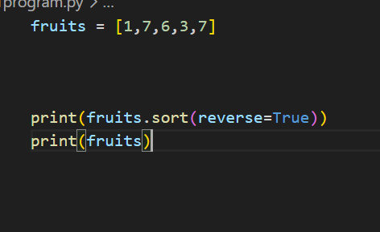
In last add
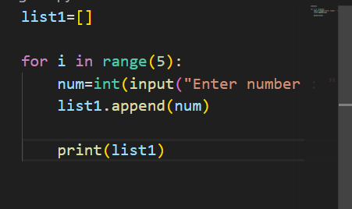
In meddle
