EIN - Core Transport Network Design
Abstract
This document describes the concepts and principles of unicast and multicast IP routing, IRB, MPLS and VPN deployment, which are used for building an EIN Core Transport Network. It also contains fundamental design decisions and recommendations based on SE/SSR for the network topology, the routing and forwarding of traffic within the backbone network.
Limited Distribution
This document is intended for internal use only.
The use of extracts of the design documentation, in offers and other documentation provided to third parties should only be made with the permission of an EIN Product Manager or Product Marketing Manager and only under the condition that a proper Confidentiality Agreement is in effect between Ericsson and the relevant third party.

Contents
1 Introduction 5
1.1 General 5
1.2 Scope 5
1.2.1 Assumptions 6
1.2.2 Limitations 6
1.3 Value Argumentation 6
1.4 Further Information 6
1.5 Changes since Previous Release 6
1.6 Notation 6
2 Terminology and Concepts 7
3 Principles and Guidelines 9
3.1 EIN Core Transport Network 9
3.2 EIN Core Transport Network Requirements 10
3.2.1 Traffic Types and Interfaces 11
3.2.2 Network Separation 11
3.2.3 Traffic Differentiation and QoS 11
3.2.4 Path Diversity and Availability 12
3.2.5 Scalability 12
3.2.6 Congruent Topology for IPv4 and IPv6 13
3.2.7 Connectivity to External Networks 14
3.3 EIN Core Transport Network Design Principle 14
Inter-Site SDH Connectivity 17
3.3.1 EIN Core Transport Network Topology 18
3.3.2 Small Scale EIN Core Transport Network 23
3.3.3 Medium Scale EIN Core Transport Network 24
3.3.4 Large Scale EIN Core Transport Network 25
3.3.5 Extra Large Networks 27
3.3.6 Physical Connectivity 27
4 Routing Basics 32
4.1 Static Routing 32
4.1.1 Static IPv4 routing with VRRP 32
4.1.2 Static IPv6 Routing 33
4.1.3 SmartEdge/SSR Configuration 33
4.2 Dynamic Routing 35
4.2.1 OSPF 36
4.2.2 IS-IS 39
4.2.3 IGP Convergence 43
4.3 MP-BGP 44
4.3.1 Concepts 44
4.3.2 MP-BGP Usage in EIN Core Transport Network 46
4.3.3 BGP Tuning 49
4.3.4 SmartEdge/SSR Configuration 51
4.3.5 BGP FRR 52
4.4 Summary of IPv6 Routing in SmartEdge/SSR 54
5 Integrated Routing and Bridging 54
5.1 Introduction 54
5.2 Hardware 54
5.3 BVI Port Feature Description 55
5.3.1 Terminology and Concepts 55
5.3.2 Bridge Details 57
5.3.3 BVI Port Feature Use in EIN Core Transport Network 57
5.4 Client Network Connectivity 58
5.4.1 Client Network Generic Physical Connectivity 58
5.4.2 Client Network Generic Logical Connectivity 59
5.5 Redundancy 61
5.5.1 L2 Circuit Failure 61
5.5.2 Intra-Site Link Failure 61
5.5.3 Controller Card Switchover 61
5.6 Quality of Service 62
5.6.1 Packet Classification and Marking 62
6 MPLS 66
6.1 Principles 67
6.2 MPLS with LDP Signaled LSP 69
6.3 Traffic Engineering in Core Transport Network 72
6.3.1 Implementation 73
6.4 End-to-End RSVP-TE Tunnels 73
6.4.1 LSP Recovery Mechanisms 73
6.4.2 LSP Layout 74
7 MPLS Layer 3 VPNs 81
7.1 Implementing VPN Topologies 82
7.1.1 Full Mesh VPN 84
7.1.2 Partial Mesh VPN 84
7.1.3 Central Services VPN 85
7.1.4 Hub and Spoke VPN 86
7.2 L3VPN over Multi-AS 88
7.3 MPLS/VPN Deployment Options and Carrier’s Carrier VPNs 91
7.4 Connecting IPv6 Islands – 6VPE 91
7.4.1 6VPE Signaling 91
7.4.2 6VPE Forwarding 93
7.4.3 PE Router IPv6 Addressing 93
7.4.4 6VPE over Multi-AS 94
7.5 Connecting IPv6 CE via 6VPE 94
7.5.1 Design Cornerstones 94
7.5.2 IPv6 Client Connectivity Routing 95
7.5.3 IPv6 Addressing 95
7.5.4 Sub-netting 96
8 MPLS Layer 2 VPNs 96
8.1 VPWS / VLL 99
8.1.1 Service Instance Bindings 100
8.1.2 Signaling for PW Setup 100
8.1.3 VPWS Data Encapsulation and Forwarding 102
8.2 Virtual Private LAN Services (VPLS) 103
8.2.1 VPLS Concepts 103
8.2.2 Control Plane Functions for signaling PW Labels using LDP 106
8.2.3 Data Plane Functions 110
8.2.4 CE - PE Connectivity and Loop Prevention 112
8.2.5 VPLS Design Recommendations 114
9 IP Multicast 116
9.1 Multicast VPNs (mVPNs) 116
9.1.1 PIM + GRE Profile 119
9.1.2 MP-BGP + MPLS/P2MP LSPs Profile 124
9.2 mVPN Technology Comparison 129
9.2.1 Anycast-RP setup in mVPNs 130
9.3 Multicast IP Addressing 132
9.4 Resilience in Multicast Networks 134
9.5 IP Multicast Security 137
9.5.1 IGMP Security 137
9.5.2 PIM Security 138
9.6 QoS Implementation 140
10 References 141
11 Annex 145
11.1 VPN/VRF Names used in EIN Core Transport Network 145
11.2 IPv6 Routing workaround without OSPFv3 DN-bit 149

Introduction

General
This document describes the primary concepts and principles for building an EIN Core Transport Network. The Core Network offers LTE, WCDMA and GSM client networks a transport solution for both circuit switched and packet switched domains. In addition, the Core Network should be able to carry multiple services in parallel, such as multicasting, and L2VPN (VPLS and VPWS), without any interference to the mobile circuit or packet switched traffic being carried.
The main goal is to offer a flexible, scalable and highly reliable network for many service types. This document describes design fundamentals for small, medium and large scale EIN Core Transport Networks. The provision of a large/extra-large scale end-to-end transport network based on IP/MPLS is shown in [9].

Scope
The scope of this document includes:
- EIN Core Transport Network design based on Ericsson SSR and SmartEdge routers.
- Detailed description of the backbone network design including the overall network topology and the services/interfaces provided for each of the client networks
- The IGP and MP-BGP routing architecture
- IP/MPLS based on LDP or RSVP-TE
- L3VPN and L2VPN carried over IP/MPLS
- Multicast VPN
To avoid duplication of information the following aspects are excluded from this document:
- Detailed designs of the client networks carried over the backbone. Please refer to the respective client design documents for more details.
- Detailed description of the backbone dimensioning, and the result of the dimensioning. These are described in [21].
- Backbone node level KPIs are described in [20].
Note: All IP addresses and subnets in this document are examples.
These are intended to show the VLANs and subnet sizes required by the design and may not comply with EIN Core Transport Network's recommended IP addressing scheme.
Further information about IP addressing concepts in the EIN Core Transport Network can be found in [7].

Assumptions
It is assumed that the readers of this document have basic understanding of routing, switching and standards used for telecommunications.

Limitations
All transport limitations for the EIN are listed in [1].

Value Argumentation
The EIN Core Transport Network design document provides full technical information about various design decisions and recommendations related to the EIN transport solution. In focus are transport network topology, IGP choice and MPLS L2 and L3 VPN as well as IP multicast examples. This can be used as a solution reference in order to better design and faster deploy a resilient and convergent IP/MPLS network. It helps the customers to offer various L2 and L3 services using one common and reliable transport network, therefore reducing CAPEX and OPEX required.

Further Information
If further information is required about the design described in this document, the reader is invited to contact EIN PLM.

Changes since Previous Release
This document is based on EIN - Core Transport Network Design, 102/102 62-IPM 101 41/2 Uen rev C.
The following changes have been made:
- SSR BVI feature is updated

Notation
In the following chapters, design recommendations, design decisions and design alternative are marked as follows:
R 1 <Recommendation>
Design Recommendations are important points/aspects of the EIN solution that should be considered when designing a network. These recommendations should always be followed unless there are constraints that prevent compliance.
D 1 <Design Decision>
Design Decisions document the main decisions taken in the reference network design. They generally comply with the design recommendations, but are more specific. In rare cases, due to constraints in the reference design, a Design Decision may deviate from the respective design recommendation.
Design Alternative is an additional documented and verified design within EIN, and is an alternative to the main design.
Design Alternatives can be generic, meaning suitable for any customer, or they can be specific to a certain market requirement. No special marking is used to denote this in the documentation.
<Unverified Design Option>
The Unverified Design Option marking indicates aspects of the given design that have not been verified by the EIN program. One example could be a newly introduced design that has not yet been verified or only partly verified. Another example could be a customer-specific design, verified by another organization, but having generic value for other customers.
- <Caution>
Caution markings are used infrequently to highlight aspects that could cause problems or where mistakes could easily be made.

Terminology and Concepts
This chapter lists the terminology and concepts central to this document. Abbreviations used in EIN are listed in [3].

AS | An autonomous system (AS) is a network or group of networks under a common administration and with common routing policies
BGP session | First, a TCP connection needs to be established between the two BGP speakers. Then, routing information is exchanged over the TCP connection; this is called a BGP session
Client or CE | Customer Edge normally indicates a client node performing a certain (telecom service) function, such as MSC-S, M-MGw, EPG, SGSN, Firewall, RNC, BSC, which connects to the PE (Provider Edge) of the EIN Core Transport Network using any routing protocol. The physical connection could be single or dual.
Client Network | Server farm which is connected to the EIN Core Transport Network through CE in order to transport the End-to-End traffic among individual servers via MPLS based L2VPN or L3VPN
Route Reflector | By configuring a route reflector in an iBGP domain, BGP connections are maintained to all other BGP speakers in the AS, so that not all other BGP speakers must be fully meshed. When a BGP speaker in the AS receives messages from an external router, it is sufficient to advertise these routes only to the route reflector, which then re-advertises the best path of each route to all other iBGP speakers in the AS
iBGP Confederation | By dividing a single AS into multiple sub-ASs and grouping them into a single confederation, the iBGP full-mesh can be reduced. The confederation is viewed as a single autonomous system externally and can be accessed using the confederation identifier. Each sub-autonomous system is fully meshed internally and can have connections to other sub-autonomous systems inside the confederation. Neighbors of these sub-autonomous systems are treated as special external BGP peers and the routing information is exchanged as if they were internal BGP peers.
L3VPN | A layer 3 MPLS VPN (L3VPN) combines enhanced BGP signaling, MPLS traffic isolation and router support for VRFs (VPN Routing and Forwarding instances) to create an IP based VPN service. Sometimes an L3VPN is also referred to as BGP/MPLS IP VPN.
L2VPN | L2VPNs employ layer 2 services over MPLS to build a topology of point-to-point connections that connect end customer sites in a VPN. L2VPNs provide an alternative to private networks that have been provisioned by means of dedicated leased lines or by means of layer 2 virtual circuits that employ ATM or Frame Relay.
VPWS | A Virtual Private Wire Service employs layer 2 services over MPLS to build a topology of point-to-point connections that connect end customer sites in a VPN. It creates pseudowires that emulate L2 circuits and can have either a full-mesh or a hub-and-spoke topology.
MPLS | Multi-Protocol Label Switching
LSR | Routers that perform routing based only on the label are called label switch routers (LSRs).
LER | Label edge routers are the entry and exit points of an MPLS network, which, respectively, push an MPLS label onto an incoming packet and pop it off the outgoing packet.
PE Router | Provider Edge routers, in the specific context of an MPLS-based virtual private network, are LERs that function as ingress and/or egress routers to the VPN.
P Router | Provider routers, in MPLS-based VPNs, are devices that function only as transit routers. The job of a P router is significantly easier than that of a PE router.
VPLS | Virtual Private LAN Service is a way to provide Ethernet based multipoint to multipoint communication over IP/MPLS networks. It allows geographically dispersed sites to share an Ethernet broadcast domain by connecting sites through pseudo-wires.
mVPN | Multicast VPN enables a service provider to transport multicast traffic across MPLS based core networks for IP VPN customers. It supports the routing and forwarding of multicast packets for each individual VRF instance, that is, the coexistence of separate routing constructs. The SP does not participate in customer multicast routing, and the mVPN configuration is performed only on the PEs, allowing for transparency of the SP network.
IPsec VPN | By establishing IPsec tunnels across different sites, the IPsec VPN provides secure IP communications by authenticating and encrypting each IP packet of a communication session, see [12].
VRF | VRF (VPN Routing and Forwarding instance) is used for VPNs to keep Routing and Forwarding separate for each client/customer.
6VPE | 6VPE (IPv6 VPN Provider Edge Router) is basically an L3VPN for IPv6 over an IPv4-only MPLS backbone. IPv6 traffic from VRFs are MPLS tunneled over the IPv4 backbone, see [65]

Principles and Guidelines

EIN Core Transport Network
BGP/MPLS has been chosen to build a network in order to fulfill the requirements / suggestions listed above. This is a proven technology that provides inherent virtualization over a common shared infrastructure that can be reused for various other traffic types. It can provide operational efficiency when a new IP VPN is being deployed, because the different VPNs share the basic horizontal building blocks in the architecture, and only a new VPN service is required on top of the existing design. It also provides security via VRF and label stacking in the core. As an additional advantage, overlapping of address space is possible in different VPNs and traffic engineering capabilities can be used in the transport network. Furthermore, VPNv6 can be provided in parallel with VPNv4 with minimal configuration efforts.
The structure of the solution is intended to be hierarchical. The recommendation is to build a layered solution in which security, scalability, and resilience are kept in mind for the relevant layers.
This approach is illustrated in Figure 1. The solution consists of horizontal building blocks that need to be constructed from the bottom to the top. Each of the horizontal blocks will be designed with the relevant considerations of security, scalability and resilience, which are reflected in the figure as vertical blocks.
For the horizontal layers the first step is to lay out the physical infrastructure, which includes the routing equipment and the transport infrastructure topology.
In order to provide MPLS services, three building blocks are required and their layered relationship is well defined. The lower layer of an IP/MPLS backbone is an IGP (Interior Gateway Protocol), which provides connectivity between the backbone routers’ loopback interfaces. With this foundation in place, an MPLS protocol for label distribution (either LDP or RSVP) runs on top of it, so that transport is based on MPLS labels instead of IP addresses. The topmost logical block is a fully meshed MP-BGP peering structure for signaling of BGP/MPLS VPNs. It is the set of these three features that makes an operational IP/MPLS backbone.
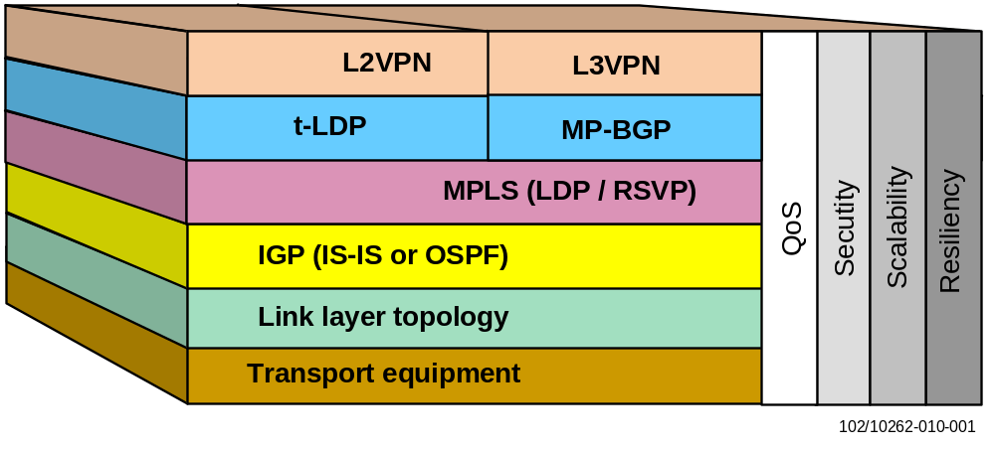
Figure 1 Layered approach to building and IP/MPLS multi-service backbone

EIN Core Transport Network Requirements
This chapter looks into the requirements that client networks put on the backbone. These are structured into the following categories:
- Traffic types and supported interfaces
- Network separation
- Traffic differentiation and Quality of Service
- Path Diversity and Availability
- Congruent Topology for IPv4 and IPv6
- Connectivity to external networks

Traffic Types and Interfaces
As a multi-service backbone, the Mobile Core Network shall support a variety of both IPv4 and IPv6 based traffic. The majority of client networks in the current scope of EIN Core Transport Network are IPv4 based, however packet switched traffic is migrating to IPv4v6 dual-stack on user plane, transport plane and control plane. This makes the support of dual-stack transport a mandatory requirement for an EIN Core Transport Network; for more details see [6].

Network Separation
When common transport nodes and transmission facilities are used to support multiple client networks, mechanisms must be implemented to guarantee that traffic belonging to a particular network can only be exchanged between nodes belonging to that client network. Moreover, each client network should be able to evolve independently of the others in terms of numbering and addressing (address overlapping) so that scalability can be easily achieved without any compromises.
Requirements:
- The backbone shall implement multiple logical subnetworks on top of a shared IP infrastructure.
- The logical subnetworks must be able to use overlapping IP addresses.
- No propagation of traffic or routing information must occur between subnetworks, except where explicitly controlled through policies, for example in firewalls.
For the backbone this has the following implications:
- Separate interfaces must be provided toward client nodes. When possible, the use of interface types that allow sub-interface definition (e.g. Ethernet VLANs) is recommended to use the port density in the site routers efficiently.
- A mechanism or set of mechanisms is needed to maintain the separation between the different sites. In the EIN Core Transport Network, BGP/MPLS IP L3 VPNs are used for this purpose. For further information please refer to [8].

Traffic Differentiation and QoS
The EIN Core Transport Network has to transport different types of traffic with different requirements in terms of bandwidth guarantees, sensitivity to delay and jitter, etc.
For this purpose, a coordinated and scalable mechanism is needed to communicate Class of Service (CoS) requirements between client networks and the backbone. Differentiated Services (DiffServ) provides the required mechanisms and is recommended for this purpose by both IETF and 3GPP standards. The site routers are configured to ensure that proper forwarding resources are allocated to the different forwarding classes defined through DiffServ.
Requirements:
- The backbone must provide differentiated forwarding treatment for traffic classes with different transport requirements.
- The backbone must implement bandwidth guarantees for several traffic classes independently of each other.
- The backbone must fulfill the quantitative forwarding characteristics in terms of delay, loss, and jitter analyzed in [24].
See [10] for details of the EIN Quality of Service design.

Path Diversity and Availability
For most client networks, the backbone provides recovery mechanisms that repair the forwarding path if a node or link fails inside or at the edge of the backbone.
Exceptions to this are signaling protocols, which implement their own failover mechanisms based on the SCTP protocol. To support this, the backbone must provide independent paths for SCTP failover mechanisms to switch between in the event of a failure.
Requirements:
- Availability: the backbone must ensure transport availability equal or greater than 99.999% at the interfaces toward client nodes.
- In the event of a node or link failure, transport must be restored within a given maximum recovery time. For example, the recovery time stated by MSS requirements is 2 seconds and is related to the recovery of any failure in the transport infrastructure located between the Nb interfaces of two M-MGws.
- Path diversity for telephony signaling (SS7oIP): the backbone must implement at least two independent physical paths between each pair of sites. The backbone must ensure that between two pairs of signaling IP subnets (two in each site), independent paths through the backbone are used. Independent paths are paths that do not have a common point of failure. The probability of both the above paths failing at the same time must be lower than or equal to the required availability of the end-to-end transport.
The availability requirement implies that the backbone provides a guaranteed amount of forwarding bandwidth even in the event of a single node or link failure.

Scalability
As the number of subscribers or the traffic volume increases, an existing EIN Core Transport Network needs to be expanded accordingly. It is important that the network is built in such a way that it can be scaled without service disruption.

- The same service types can be extended to the new sites by using the deployed technique with a similar approach for configuration. The same characteristics and requirements on traffic transport can be fulfilled with minimal effort.
- Apart from the number of client nodes and site infrastructure equipment, no network topology update shall be needed. In other words, the initial network shall be built with possible future expansion in mind, so that the backbone network can be easily expanded to cover larger sites by following the same principles, e.g. expanding the EIN Core Transport Network from small scale to medium scale.
- Exception: If the network needs to be evolved so that a much larger network can be reached with similar end-to-end performance and a similar convergence time in the EIN Core Transport Network, e.g. scaling from a small or medium network to a large network, the network topology may be changed. However, choices will be made such that the new network topology can be deployed in a step-by-step manner, so that no service break will be experienced by the end users.

Congruent Topology for IPv4 and IPv6
The requirement of transporting IPv6 and/or the IPv4/v6 dual-stack traffic within the mobile packet switched network imposes the support of dual stack in the EIN Core Transport Network. In such a case, the IPv4 and IPv6 traffic share the same physical and logical interfaces, however, on the network layer, the IPv4 and IPv6 traffic each still needs to be assigned with a separate IP address and be transported independently. It is possible for the transport of IPv4 and IPv6 traffic to rely on different resilience mechanisms and use distinct routing protocols, however maintaining separate network topologies for IPv4 and IPv6 increases the network complexity and operational cost.
To simplify the configuration, operation and maintenance efforts, it is recommended that:
- Corresponding IP addresses be assigned on the same physical interface for IPv4 and IPv6; the same VLAN can be shared between IPv4 and IPv6.
- The same transport resilience and link/node failure detection mechanism be used for IPv4 and IPv6 traffic whenever possible; one example would be BFD for both IPv4 and IPv6 nodes that are indirectly connected to the site routers.
- The same network topology be used for IPv4 and IPv6 transport, for example when a client node uses OSPFv2 to communicate with site routers for IPv4 connectivity, OSPFv3 with the same area ID shall be considered for IPv6 traffic.
- The same configuration parameters are used for tuning IPv4 and IPv6 routing when this is possible. As a consequence, the convergence for IPv4 and IPv6 traffic would be on a similar level in the case of failover, which will not cause service degradation when switching between IPv4 and IPv6 as bearer.

Connectivity to External Networks
One essential target for the backbone is to provide connectivity to users and services connected to other networks. Extending the connectivity domain to an external network will mainly require public numbering and addressing to guarantee that traffic can be exchanged on a global basis. See [13] and [15].

EIN Core Transport Network Design Principle
The designed EIN Core Transport Network should fit the aforementioned requirements in terms of traffic separation, QoS, path diversity, IPv4v6 dual-stack capability, redundancy and scalability.
The EIN Core Transport Network is mainly used to transport mobile traffic between different client nodes. Thus, service nodes contained in different modules can be seen as server farms, which are connected with each other via site infrastructure. Service nodes (UDC, PS, CS, access nodes) may reside in a Primary or Secondary site.
The EIN Design Overview [2] gives a general description of the Core Network site structure, common structure of each site, definition of primary, secondary (where always a pair of site routers are deployed, the site can be with or without site switch, primarily connected with each other directly – it also possible to connect a remote site through an ISP’s network) and cell site (where it is possible to have dual site router or even single site router for cost reasons, see [25]).
A hierarchical model can be used to facilitate the distribution of core network nodes and redundant connections to make the model fault tolerant. A set of aggregation devices in the aggregation network and their accompanying access network entities form a two-layer aggregation architecture – where the layer 1 aggregation is named the access network (ANW) and the layer 2 aggregation can be referred to as the aggregation network (AGNW). This model is based on and aligned with the principles described in EIN Converged Aggregation and Access [9].
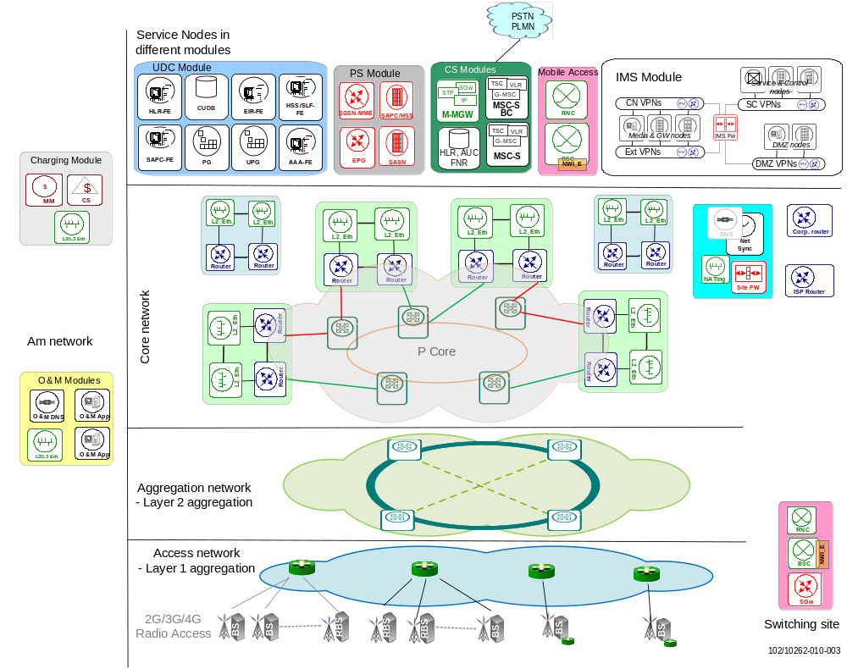
Figure 2 Hierarchical Design of EIN Core Transport Network
The first step is to decide how many sites are to be deployed in the network and the inter-site connectivity scenario. Various factors shall be considered, such as the number of subscribers served in the whole network and each site, traffic volume derived from the applied traffic module, geographical location, service types and coverage requirements.
The traffic (mobile, enterprise and residential) aggregated from lower level networks, such as the layer 1 (access network) and/or layer 2 (aggregation network) is to be transported across the core network with guaranteed QoS (including delay and jitter) and according to specific requirements (such as no-fate-sharing for SS7 signaling) within each separate VPN between the access nodes and service nodes. Note, traffic also spans between different core network sites, because of the inter-communication between service nodes residing on different EIN Core Transport Network sites.
- It is recommended that the EIN Core Transport Network site-type be determined based on geographical location as well as the possible traffic volume to be handled in each site
Inter-site connectivity is typically done through a ring topology as described in sections 3.3.2 and 3.3.3 later. Furthermore, it is possible to deploy a hierarchical structure within the core network level, that is, EIN Core Transport Network sites where the site routers in primary sites (and possibly secondary sites, depending on geographic location) are served by a central P-core network. These routers do not have any client networks attached and thus act only as transit routers. They connect Primary sites from different regions together. The introduction of a P-Core network brings certain flexibility to the EIN Core Transport Network – for example, the RSVP-TE can be deployed in the P-core to achieve fast failover. Whereas LDP is used among different sites for simplicity, with the LDP over RSVP feature, the network can take advantage of both RSVP-TE and LDP.
The decision regarding whether a P-core network needs to be deployed and its corresponding topology (e.g. redundant structure or not) mainly depends on the number of sites as well as cost, redundancy and flexibility requirements. Future expansion should be considered as well.
The hierarchical design helps explain how redundancy fits into networks, but still does not adequately specify other parts of network design.
For example, provisioned services in the network determine the VPN plan – thus, it is highly recommended that the VPN structure given in chapter 11.1 be followed. If new services need to be introduced in the EIN Core Transport Network, it is important to consider each and every aspect from an end-to-end perspective as well as any possible impact on existing VPNs, such as bandwidth consumption, planning of IP addresses, QoS handling, physical and logical CE-PE connectivity (including routing) and the deployed redundancy mechanism.
The next decision is which routing protocol is to be used in the backbone. The upper layer MPLS transport relies on IGP for fast convergence and shortest path calculation. The most important aspects of routing protocols are that they are fast and classless.
Fast convergence means that the routing protocol is able to recognize a problem and fix it faster than a user can call to report the problem. OSPF and IS-IS can be classified as “fast” routing protocols. BGP is rather a “slow” routing protocol. However, eBGP is used to pass routing information between autonomous systems, especially with the deployment of larger networks. It has to be used if the network is to be connected to the Internet.
OSPF, IS-IS and BGP are all public standards, supported on a wider variety of equipment than proprietary protocols, which protects against incompatibilities with legacy equipment or vendors. Therefore, OSPF, IS-IS and BGP may be used in the EIN Core Transport Network.
The following step is to decide the protocol used for MPLS label assignment and exchange. Depending whether traffic engineering is desired or not, LDP or RSVP-TE can be chosen. Generally, EIN Core Transport Network recommends LDP due to its simplicity, as described in chapter 6.
Details about the deployment of inter-connection points toward corporate networks or internet service providers may be found in [13].The placement of certain network entities and their required inter-communication can follow the general principles described in the corresponding client node documents, as well as the CE-PE connectivity information given in [8].
In the EIN Core Transport Network, inter-site transport can be done using Ethernet directly over optical fibers or through SDH rings.

Inter-Site SDH Connectivity
In order to fulfill the availability and path diversity requirements described in section 3.2, the following rules should be followed when SDH transport is used for WAN connectivity:
- If SDH is used all sites should use dually connected to SDH rings.
- It is desirable, although not strictly required, that independent transport providers be chosen for each of the SDH rings. This avoids fate sharing in the event that one of the providers’ networks fails. On the other hand, it is a requirement that the two SDH rings are both in forwarding state. That is, they cannot operate in an active/standby mode with one protecting the other. Some of the client traffic, such as SS7oIP, needs to have two disjoint forwarding paths available at any time. For that reason, it is not permissible for both forwarding paths to belong to the same protected ring with one in active and the other in standby mode.
- Optionally (not strictly required) the SDH rings are protected at SDH level.
The conditions above are depicted in Figure 3.
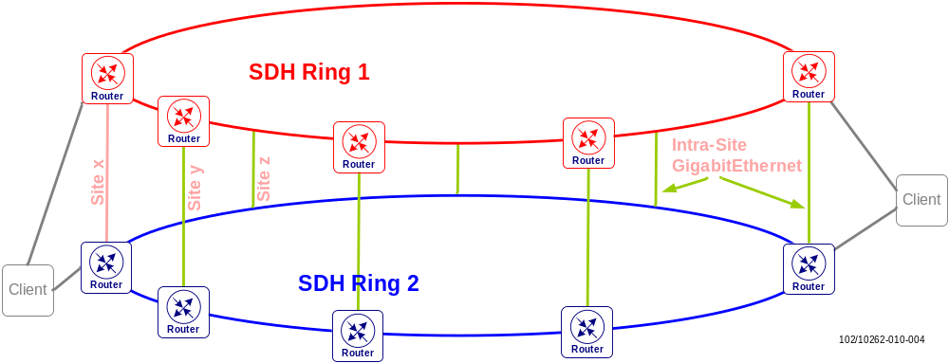
Figure 3: SDH transport infrastructure
In Figure 3, the different EIN Core Transport Network sites are connected to the red and blue SDH rings. In some cases, the SDH rings will be provided with their own protection scheme. In the event of link failure, the restoration times provided by optical transport/SDH are in the order of 50-60ms. Optical protection in the SDH ring is not strictly needed if there are convergence mechanisms in the IGP and MPLS layers that provide sufficiently fast failover times, in the sub-second range, should a link failure occur.
By default the failover mechanism will react to all link defects with no hold time. However, up and down hold timers can be applied if it is preferable not to declare an SDH interface “down” as soon as an alarm is received. For each trigger defect, a specific “up and down hold timer” can be configured. This is useful if there is SDH transmission protection (e.g. protected rings), in which path and line protection exists. The hold down timer could be set to 60 ms, so that failover does not occur on layer 3 if the SDH protection mechanism fixes the problem within 50 ms.
If the available SDH protection mechanisms are unknown, the recommendation is to leave the defaults with no up or down hold-time on the inter-site links.

EIN Core Transport Network Topology
As example, the network topology in the EIN solution is built upon a 10-site model based on some assumed dimensioning figures given in [21]:
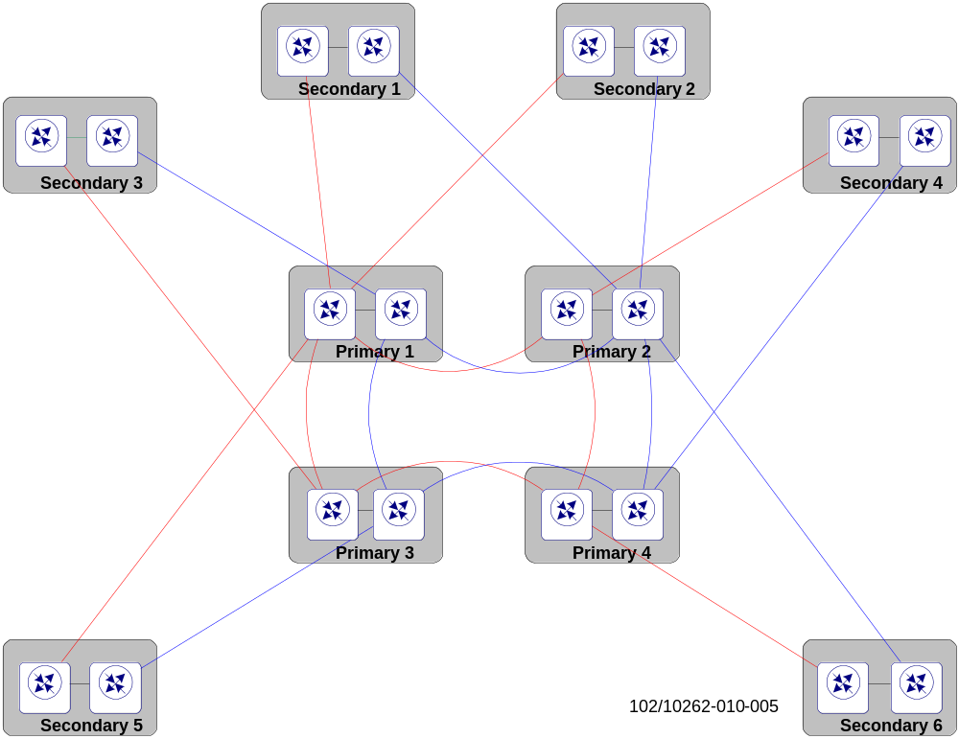
Figure 4 One typical example of an EIN Core Transport Network Topology
Figure 4 shows the backbone topology with blue and red colors referring to links from the two independent aforementioned SDH rings. The core of the EIN implementation is formed by the Primary sites. Secondary sites form a distribution layer.
This topology is based on the following general principles. These should be followed by any network in order to be EIN Core Transport Network compliant:
- Primary sites are connected in the form of a dual ring (red and blue), with intra-site connections between the two rings in each site. Instead of a dual ring topology, a full mesh between Primary sites can be used.
- A Secondary site should be connected to two Primary sites. That is, one site router in the Secondary site connects to a core router of the red ring, and the other one connects to a core router of the blue ring in a different Primary site. This condition ensures that a Secondary site is not isolated even if a complete Primary site fails.
- The two Primary sites to which one Secondary site connects should be direct neighbors, i.e. the two Primary sites should be directly connected with no other Primary sites between them. There is no direct connection between Secondary sites.
The above conditions, combined with adjustment of link metrics (where needed), ensure that no transit traffic passes through Secondary sites. If this condition is violated for some reason, individual consideration of link metrics is needed to make sure that no transit traffic is directed via the Secondary site. See chapter 6 for Traffic Engineering details.
Some details of this design, such as link metric considerations for path diversity and dimensioning for failure cases, rely on the above conditions being fulfilled.
In this topology, each Primary or Secondary site is connected to an underlying optical transport infrastructure making use of physical path diversity (i.e. relying on separate blue and red fiber topologies). The Primary sites form the central distribution ring topology connecting Secondary sites with geographical redundancy in a hub & spoke fashion.
All sites in the EIN Core Transport Network are generally built with transport node redundancy and represent so-called Provider Edge (PE) sites, meaning that they always connect mobile core, access or other service nodes to the transport network. Certain Secondary sites might alternatively be built without redundancy to minimize the site infrastructure cost. They could also be connected without geographical redundancy to a single Primary site.
In addition, the Primary sites are also transit sites for traffic exchanged between Secondary or other Primary sites. The requirement to absorb transit traffic is one reason for deploying routers with higher capacity in Primary compared to Secondary sites. Another reason is that Primary sites aggregate larger numbers of mobile core and access nodes to the transport network.
Alternative Topologies
The reference EIN Core Transport Network demonstrates the deployment of pure transit sites with Provider (P) routers in the backbone design [25] for large-scale network scenarios, with the motivation to reduce the direct connectivity mesh between edge sites and to optimize packet transport by relying on the switching intelligence of higher protocol layers (e.g. MPLS, IP).
For dedicated P-router deployments it is necessary to consider certain factors including:
- Capacity and scalability requirements matching the overall packet forwarding and interface card bandwidths of the router platform to be deployed
- Protocol specific features to support scaling with respect to the number of routers in IGP areas, adjacent neighbors, IGP routes, MPLS LSPs as well as fast convergence with respect to the IGP (e.g. IP Fast Reroute FRR) and MPLS domains (e.g. RSVP-TE FRR) among others
- The redundancy desired in the provider core network, balancing service availability against infrastructure cost
With respect to redundancy, either non-redundant core sites with single P-routers or redundant core sites with P-router pairs can be deployed. In the former case node failures can be compensated by relying on the redundancy available in the network topology:
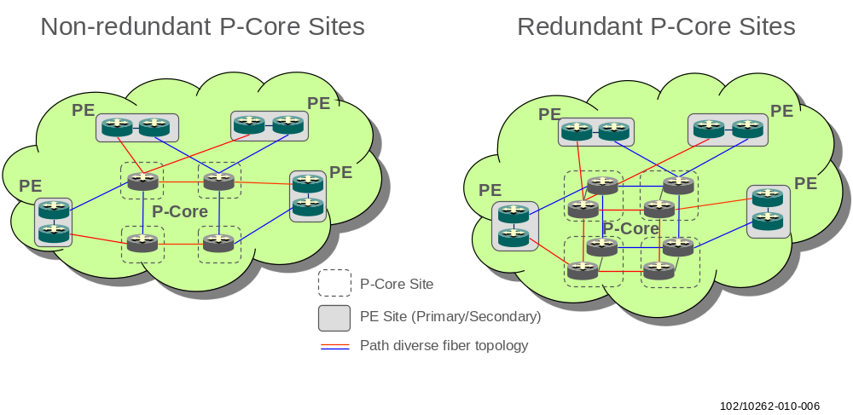
Figure 5 Alternative EIN Core Transport Network topologies
- P-routers in different sites should always be inter-connected through a path diverse optical infrastructure (shown as red and blue fiber strands in the drawings above) to avoid fate sharing during fiber cuts.
- Edge sites with redundant PE routers shall always be connected to different non-redundant P-core sites to avoid isolation in the event of P-router failures (geographical redundancy).
- Non-redundant P-core site deployments are generally sufficient if the previous two recommendations are satisfied and network level redundancy is available. Redundant P-core sites may be considered for scalability reasons or if the P-routers take on extra functions to support certain network operations (e.g. Route Reflection)
Note: There are many other ways of constructing P-Core and connected PE topologies. These can be influenced by the fiber, facility (power, cooling) and service availability in different sites, customer requirements or the traffic patterns that need to be accommodated in the network.
Deviations from the general resilience recommendations given above are not further addressed here, as the trade-off between cost and wanted/offered availability in the network is a customer-specific decision.
Transport Modules
The transport modules in the EIN Core solution are implemented as in Figure 6 below.
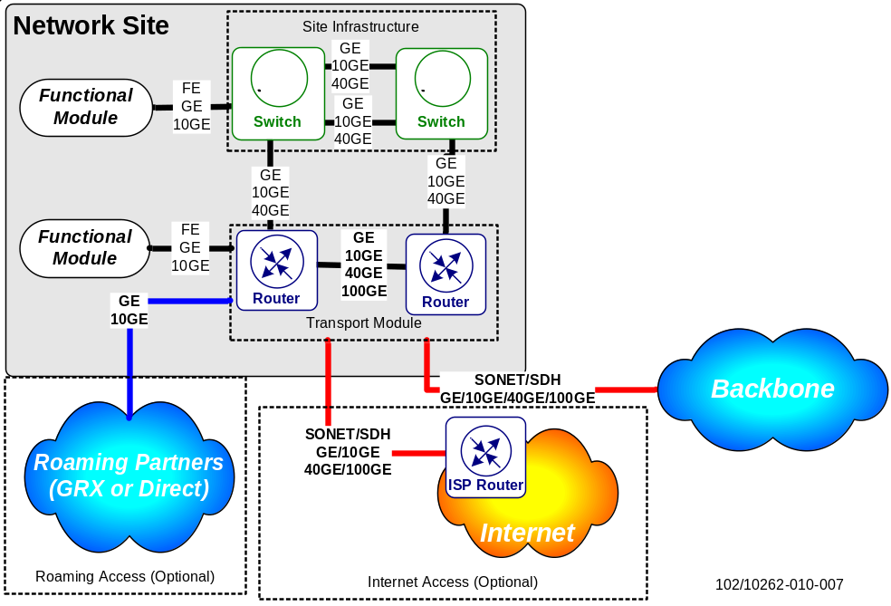
Figure 6 Generic implementation of an IP Backbone site
Transport modules can be complemented by the site switches present in the site infrastructure modules. When using IRB functionality, the logical site infrastructure and transport modules are collapsed onto the same physical device (i.e. the routers).
- A pair of site routers is deployed per site in order to avoid site isolation in the event of a router failure.
All client nodes requiring redundancy are dual homed to the site switches or routers.
The main technologies and VPN services chosen for the inter-site transport of mobile and other service traffic in EIN Core Transport Network are IP/MPLS based including the following VPN types:
- Layer 3 VPN [42]: To support mobile service-related IPv4/IPv6 traffic exchanged between EIN sites
- Layer 2 VPN [45]: To support service traffic requiring transparent Ethernet connectivity (VPLS [53] for Data Centers, VPWS [36] for Enterprises or Wholesale)
- Multicast VPN [48]: To support service traffic requiring IP multicast capabilities from the transport network. Depending on the feature set available on routers, multicast packets might be forwarded via GRE tunnels, point-to-multipoint or multipoint-to-multipoint LSPs
- IPsec VPN [42]: To support service traffic requiring additional transport protection. Note: IPsec VPNs are not dependent on IP/MPLS technologies and are just listed for completeness. They are used in the EIN Core solution as a more secure VPN technology for the packet exchange between EIN Core Transport Network and/or external sites
The underlying routing and MPLS protocol machinery (IS-IS, OSPFv2, BGP, RSVP-TE, LDP) to establish those VPN services and the related resilience, security, and QoS designs are detailed in the following chapters.
Scale of an EIN Core Transport Network
The scale of an EIN Core Transport Network can be distinguished as below:
- Small site: 2 to 10 sites; the number of BB routers is normally less than 20
- Medium site: 10 to 30 sites; the number of BB routers is normally less than 60
- Large site: between 30 to 100 sites; the number of BB routers is greater than 60
- Extra Large site: above 100 sites; the number of BB routers is greater than 200

Small Scale EIN Core Transport Network
A small scale EIN can be seen as a subset of the aforementioned example EIN Core Transport Network; thus the ring topology can be applied here.
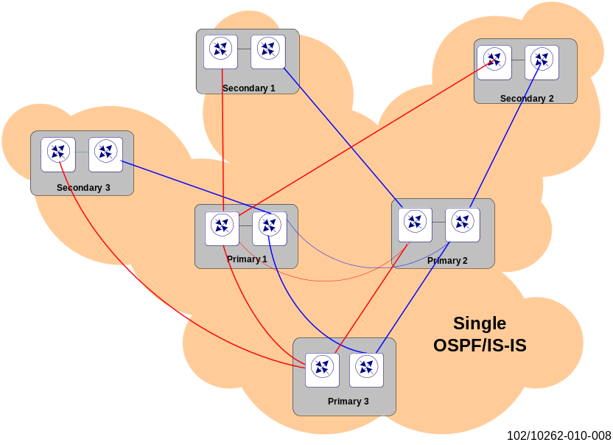
Figure 7 Small-scale network

Medium Scale EIN Core Transport Network
The EIN example can be used as a module for a medium scale EIN Core; as a result the typical ring topology can be applied. However, it is also possible to keep a small scale P-core network (meaning that the core network can consist of just 6 or 8 routers) instead of collapsing it with primary site routers.
The inner level P-core network consists of pure IP Core routers (P routers). See Figure 8 below as an example. Note that for simplicity only a limited number of primary and secondary sites are shown in the diagram. In a real EIN deployment, more sites can be accommodated by applying this topology.
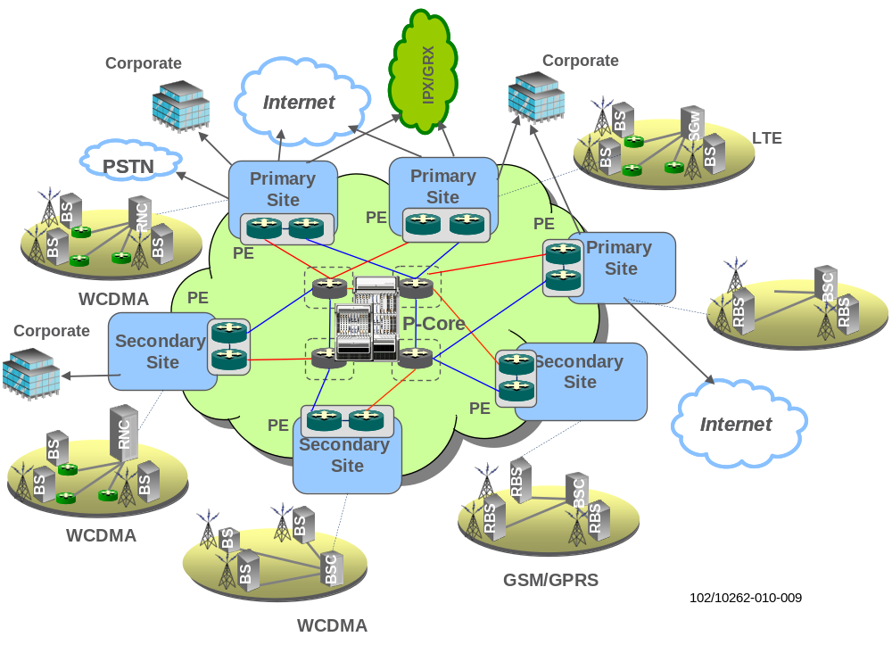
Figure 8 Medium-scale EIN Core Transport Network with P-core deployment

Large Scale EIN Core Transport Network
This section provides a high-level design for large networks with more than 30 sites in a single administrative domain. The main highlights are the use of pure core routers (P routers) and BGP route reflectors. It will also consider scalability issues concerning IGP and MPLS.
As can be seen in Figure 9, an EIN large-scale network will consist of three levels. The outer level contains Secondary sites, which are connected to Primary sites as normally happens in the EIN Core Transport Network. The Primary sites are at the middle level and they are connected in a dual SDH/SONET or 10/40/100GE ring fashion; see [25] for more details. Typical numbers of routers for this scenario are about 5~10 IP Core sites, 15~30 Primary sites and 30~60 Secondary sites.
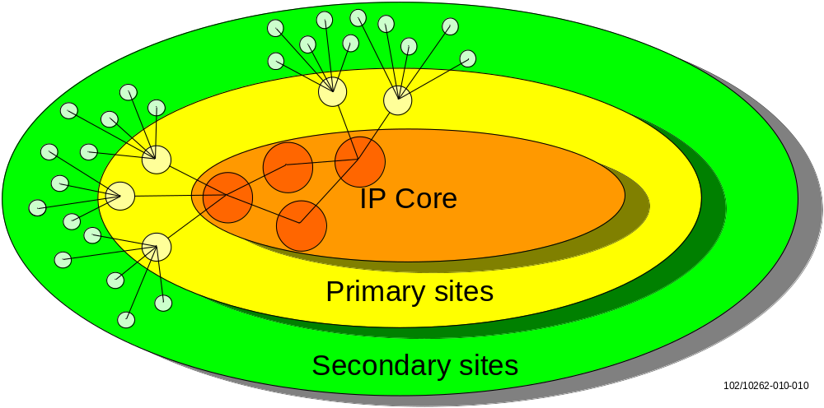
Figure 9 Overview of the three site levels including the new IP Core in large-scale EIN Core Transport Network
Further details can be found in the figure below.
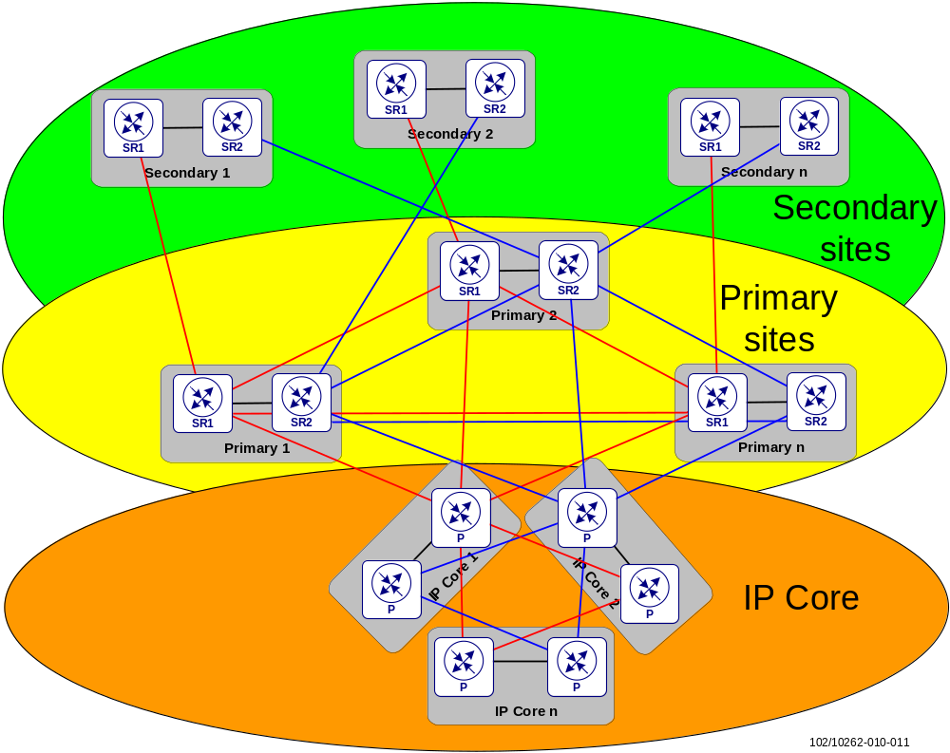
Figure 10 Example of physical connections between all levels (red/blue symbolize different rings)
In Figure 10 an example of the physical links is included for each level and also between levels. Secondary sites connect to different Primary sites for geographical redundancy. Primary sites are connected to each other in the red and blue rings. Each Primary Site also connects to different IP Core sites for geographical redundancy. The blue and red path concepts are still applicable, also between the IP Core routers.

Extra Large Networks
When scaling even further, such as beyond the scope of 10K nodes, the EIN recommendation is to deploy an MPLS transport network as outlined in Converged Aggregation and Access [9].

Physical Connectivity
The physical connectivity between backbone routers is assumed to be mainly based on Ethernet over fiber which reflects the current trend in Core and Aggregation networks. Either electrical or optical Ethernet can be used for connectivity between customer edge devices (client nodes) and backbone routers.
- In addition to the consideration of cost, the choice between electrical or optical Ethernet shall follow the requirement on speed of link state transition detection, which can impact convergence time a lot – the electrical ports are slower than optical.
Depending on the required bandwidth, the backbone and client connectivity can be realized with GE or 10GE interfaces and clients can be directly connected to the routers or aggregated via dedicated Layer 2 switches. Some clients in EIN Core Transport Network still require FE speeds for their connection to the backbone transport network. Link bundling technologies to scale interface bandwidth can also be used as described in [5]. Moreover, as the future traffic volume is predicted to grow exponentially, there is also a requirement to offer 40/100GE interface speeds on backbone routers placed at central switching points of the transport network.
Corresponding line cards for the SSR are supported. The high capacity card integrates 40GE and 100GE ports. It can be configured to run in 40Gb or 100Gb mode using ‘card mode’ command.
Note: The router must be reloaded to switch from one mode to the other. For 2-port 40GE/1-port 100GE line card, a distinct C-Form Factor Pluggable (CFP) is required. Moreover, the SSR detects and disables unsupported transceivers, thus only Ericsson approved transceivers shall be used.
For a tighter integration with the optical transport layer, the site router shall also support certain CWDM and DWDM SFPs/XFPs for both line cards (e.g. 40-port GE and 10-port 10GE in SSR). These can be used to avoid additional Optical-Electrical-Optical (OEO) conversions and transponder investments.
Note: The detailed integration of the optical Ethernet media that is provided by routers into the underlying optical transport layer (Physical Layer) is outside the scope of this document. Only the data link (Layer 2) and network layers (Layer 3) of the Open Systems Interconnection (OSI) model are of relevance to the EIN Core Transport Network solution.
Physical CE-PE Connectivity
Ethernet-based clients can either be connected directly to the routers or via dedicated switches. The latter is realized using dedicated aggregation switches, i.e. the EIN Core Transport Network site switches. If the Integrated Routing and Bridging (IRB) function is supported (e.g. by SmartEdge), this can be employed to connect with CE, in which case the site switch can be seen as being collapsed into the router.
If dedicated switches are used to interconnect the clients with the routers, the switches serve a twofold purpose:
- Aggregate Ethernet-based traffic, reducing the number of interface cards required at the site routers
- Provide VLAN support to client networks.
Each switch is connected to the site router by means of Ethernet interfaces (GE, 10GE, 40GE). If more than one link is needed, the recommendation is to aggregate the Ethernet interfaces according to the IEEE 802.1AX standard [27].
- Electrical GE has been chosen between site routers and switches because electrical interfaces are cheaper on the switches. For 40GE connectivity only optical interfaces are available.
Depending on the importance of cost, optical GE interfaces may be used toward site switches as a verified option in EIN Core Transport Network. As link failure detection with optical interfaces is faster, this should allow faster rerouting of traffic from the routers toward the switches.
By default, up and down events in the interfaces are honored with no hold time. This means that if an interface fails it will be declared down immediately, and as soon as it recovers, it will be declared up. This behavior can sometimes be problematic for Ethernet interfaces toward switches or nodes with inbuilt switching boards and functions. For example, depending on the connected switch model it is possible that after a switch reboot, the interfaces will come up before the switch is ready to forward traffic. This will result in an outage.
- To give site switches time to get operational after a reboot, a “hold-time up” of 30 seconds shall be used for router interfaces toward site switches.
A similar problem may occur at site router power up, restart, or reboot. The state of the router interfaces may already be up, but not all the router’s applications are ready to provide the various services. Connected clients, which rely on the interface status, may send traffic toward the restarted router, but this may not yet be ready to forward the traffic to the destination. If supported by the router model, link dampening can be used to suppress the link state until all the applications are up after a system restart.
The link dampening time depends on how quickly the routing engine returns to full operation. This depends on the router model and hardware configuration, and needs to be determined case by case.
- In order to give site routers time to get fully operational after a cold start or reboot, link dampening shall be used for router interfaces toward site switches and directly connected client nodes.
In the case of IRB, the Layer 2 switch function can be achieved as an integral component of the router and the dedicated site switches can be omitted. For more information about connectivity using the Integrated Routing and Bridging function see chapter 5.
Physical PE-PE Connectivity
Gigabit Ethernet links (GE, 10GE, 40GE or 100GE) are used to interconnect site routers located in the same site. It is important to note that these links represent backbone links carrying MPLS traffic. However, intra-site traffic can also cross these links. In such cases the Ethernet link will be VLAN tagged and use one dedicated VLAN for the MPLS backbone traffic and one or several other VLANs for intra-site traffic. Alternatively, if router implementations support untagged and VLAN tagged traffic on the same physical interface, the MPLS backbone traffic can be transported as untagged.
- It is recommended that a higher order of Ethernet standard should be considered with cost efficiency in cases where there are more than two 10GE or 40GE circuits in a LAG.
- In general optical GE links (1000Base-X or 10GBase-R, 40GBase-R, 100GBase-R) are recommended for PE – PE connectivity within the core site as failure detection via the physical media on the router is much faster with optical than with electrical Ethernet (e.g. 1000Base-T)..
- The EIN Core Transport Network recommends increasing the MTU size on Ethernet based backbone links to match the MTU size of 4470 bytes (on IP level) on SDH based backbone links, in order to have a uniform MTU across the backbone.

SmartEdge/SSR Parameters
In general, to minimize the convergence time,
- Optical connectivity is preferred over electrical, especially when the SSR is used
Physical Inter-Site Connectivity
- SmartEdge shall be used when SONET/SDH transport network is used as WAN connectivity between any two EIN Core Transport Network sites; when using Ethernet over optical fiber, the choice of router module (SmartEdge/SSR) depends on the dimensioning result: if high port density and/or transport capacity are desired, SSR shall be selected over SmartEdge.
This is mainly because some particular IGP and BGP features (such as IGP prefix hiding, BGP RR only) are only available on the SSR.
Physical Intra-Site PE-PE Connectivity
When the IRB function is used between site (PE) routers, the Ethernet link between the two site routers transports intra-site switched (Layer 2), intra-site routed (Layer 3) and IP/MPLS backbone traffic.
- When IRB is deployed, a GE or 10GE link group according to 802.1AX must be deployed between the two site routers for redundancy purposes. The member links of the link groups shall be distributed across different cards.
If dedicated switches were used, the intra-site switched traffic would be transported between the switches (across the inter-switch link) instead of across the intra-site PE-PE link, whereas in the switchless deployment, only intra-site routed and IP/MPLS traffic passes across these intra-site PE-PE links.
Physical CE-PE Connectivity
The clients can either be directly or indirectly connected to the routers (via dedicated site switches, or through IRB).
Interface Hold Timers
SmartEdge/SSR supports a link dampening timer that can be configured to delay the interface state transitions between up and down states. The link-dampening up timer is controlled by the control card and starts when the XCRP/RPSW comes up, independent of the restart of the interface card. Lab tests have shown that a value greater than 250s is effective. Since this time may depend on the router model and the interface cards with which the router is equipped, lab tests with the applied configuration are recommended to determine the link-dampening up delay time for a specific customer case.
- On SSR/SmartEdge routers, a hold time of 30s (given in milliseconds) with a link dampening timer greater than 600s (given in seconds) must be used even with quite small SSR hardware and software configurations. The Ethernet interface configuration toward switching nodes is:
port ethernet 1/1
link-dampening up 30000 down 0 restart 600
Note: in both SE and SSR, the specified timers are not in effect when using the shutdown or no shutdown commands.

Routing Basics

Static Routing
Static routing is always used either on direct interfaces, i.e. not through site switches, or in combination with VRRP or other high availability protocols like JSRP on Juniper SRX firewalls.
- Although firewalls are capable of running dynamic routing protocols, the EIN Core Transport Network prefers static routing in the firewalls to simplify the design and to have better control over routes for security purposes.
Some client networks use their own proprietary redundancy mechanisms for the PE-CE connection. Nb over IP uses RPS (Router Path Supervision). This mechanism, like VRRP, provides redundancy for static or default routes. The difference is that with RPS, it is the client that monitors the availability of the default gateway with ICMP messages. If the default gateway is down, the client node (M-MGw) will failover to an alternative default gateway.

Static IPv4 routing with VRRP
Static routing is usually used for CE-PE connectivity. To fulfill the resilience requirements, static routing is commonly deployed with VRRP, where the CE is configured to use the VRRP address as next-hop / default gateway. For reverse traffic, both site routers shall point to the interface address of the client node.
The configuration of static routing is straightforward, and is the same on the SmartEdge and SSR. Similar to other router modules, as well as the next-hop address, the SmartEdge and SSR also support the use of an interface as its next-hop for reaching the destination. Similar to the next-hop address scenario, the configured static route will be withdrawn from the RIB once the interface becomes un-available (due to failure). However, BFD is recommended for connectivity monitoring with static routing, when the CE is indirectly connected.
Generally, multiple static routes can be defined toward the same destination. If all static routes are assigned with the same cost value, traffic will be balanced among them (ECMP).
Static routes can also be used to configure inter-VPN route leaking. Intercontext static routing between two non-local contexts is not allowed unless the “service inter-context routing” command is enabled. The prefix using the next-hop context is valid only if the next-hop context has the routes that are being covered by this prefix. The prefix is installed in the RIB only if the next-hop context can reach those networks.
The Ethernet-based client networks that support static routing protocol usually use Virtual Router Redundancy Protocol (VRRP) for redundant connectivity toward the network (access, aggregation or core network). VRRP allows hosts on a LAN to make use of redundant routers on that LAN without requiring more than the static configuration of a single default route on the hosts. The VRRP routers share the IP address corresponding to the default route configured on the hosts. At any time, one of the VRRP routers is the master (active) and the others are backups. If the master fails, one of the backup routers becomes the new master, thus always providing a virtual default router and allowing traffic on the LAN to be routed without relying on a single router.

Static IPv6 Routing
Apart from the prefix and next-hop being IPv6, the configuration syntax of static routes on IPv6 is usually the same as in IPv4.
- Apart from the prefixes and logical interfaces, the same configuration shall be used for IPv4 and IPv6 for dual-stack static routing.
Note that the SmartEdge/SSR router does not support a link-local address as the next-hop IPv6 address (with the “next-hop-ipv6-addr” argument in the “ipv6 route” command); any attempt to do so will be rejected as mentioned in MPBN13B-C-09 [1] .
Normally, the use of a global unicast address as the next-hop is not recommended for static routing of IPv6 traffic. This is because the ICMPv6 redirect message will not work if a global unicast address is used as next-hop. According to RFC 2461 [62], a router must be able to determine the link-local address of each of its neighboring routers in order to ensure that the target address of a Redirect message identifies the neighbor router by its link-local address. However, the support of only a global unicast address in the SmartEdge/SSR is not seen as a problem in an EIN Core Transport Network, due to the fact that redirect is not used (there is no case that hosts need to be informed of a better first hop to reach a destination).
VRRPv3 includes support for both IPv4 and IPv6. It also includes sub-second hello timer support which many vendors have already added (proprietary) to VRRPv2 implementations.

SmartEdge/SSR Configuration
In contrast to router modules from other vendors, SE and SSR routers only reply to ICMP echo messages (PING) toward the VRRP VIP (virtual IP address) when the VIP resides on the VRRP master router. This could be different from other router vendors’ implementations where the SR holding the VRRP VIP always replies to ICMP echo messages. It is not possible to change this behavior by command.
However, there is a workaround that facilitates this behavior by creating a loopback interface within a separate routing context, using the VRRP virtual IP address as interface address. Intercontext routing using a static route pointing to the loopback IP address in the isolated context (and a default route pointing back to the VRRP context) will then allow the loopback interface to reply to ICMP echoes:
context vrrp-ctx
interface hosts
ip address 10.1.1.2/24
vrrp 1 backup
virtual-address 10.1.1.1
priority 254
ip route 10.1.1.1/32 context vrrp-ping
context vrrp-ping
interface ping-interface loopback
ip address 10.1.1.1/32
service ssh
ip route 0.0.0.0/0 context vrrp-ctx
Authentication is not supported for VRRP with sub-second advertisement intervals, but this does not imply a limitation for the EIN Core Transport Network design, since authentication is not recommended.
SSR and/or SmartEdge support the use of BFD for liveness detection of the VRRP master, in addition to the standardized VRRP advertisement mechanism.
With VRRP using BFD, a backup VRRP router monitors connectivity to the master VRRP router using BFD with timers down to 10 ms. A change of the BFD session to state “down” triggers the backup VRRP router to become master immediately. With very aggressive timers (10ms and detection multiplier 3), VRRP switchover times below 50ms can be achieved. When using VRRP with BFD, the VRRP advertisement interval cannot be set to sub-second values (if this is done, it automatically changes to 1 second).
See [5] for details about the behavior of VRRP in combination with LAG.
- For CE-PE connectivity with static IPv4 pointing to VRRP, BFD shall be used to track the liveness of the VRRP master. The BFD timer shall be set to 30 ms; the VRRP advertisement interval should be set to 1 second.
Sub-second VRRP advertisement intervals are a proprietary feature supported in SSR and SmartEdge routers.
- The advertisement interval for VRRP should be set to 300 ms unless VRRP tracking with BFD is used (see [5]). This will minimize the failure recovery for VRRP clients.

SSR Specific
VRRPv3 support is planned in a coming release for static IPv6 as mentioned in MPBN13B-N-05 [1] .

Smart Edge Specifics
There is no support for VRRPv3 in the case of static IPv6 routing as mentioned in MPBN13B-N-05 [1] .

Dynamic Routing
Dynamic routing protocols are used to exchange routes and to provide redundancy in the client network to backbone connection; for more information see [4]. For example, OSPF is used to exchange routes between the GSNs and the site routers. The corporate connection may use any of the routing protocols available for PE-CE routing, in addition to static and BGP.
- As for the backbone internal routing protocols, always configure a router-id either globally for all (dynamic) routing protocols or locally for the specific routing protocol that is used for the CE – PE peering (such as OSPF or BGP) within the corresponding routing context. The loopback address of the router should be used as identifier.
This is to prevent unpredictable behavior and convergence problems if the router selects its own default, for example the IP address of the first interface coming online, and the interface address changes due to re-configuration or link failures. As the router-id identifies the router as the originator of protocol packets to its peers it is essential to keep it stable.
For more information about the Ethernet based client network connectivity, please refer to [14]. For more information about OSPF as dynamic routing protocol for the CE-PE connectivity, see [8].
The main purpose of an Interior Gateway protocol (IGP) in this backbone design is to provide IP connectivity between P/PE routers. Provided the connectivity between loopback interfaces is in place, it is possible to distribute MPLS labels for the forwarding plane. These steps are mandatory so that forwarding in the backbone is done according to MPLS labels instead of IP addresses.
EIN Core Transport Network has no clear preference between OSPF and IS-IS; either IS-IS or OSPF can be chosen as backbone IGP. The IGP choice is mainly determined by a customer’s familiarity with one or the other protocol. There is no technical reason to prefer a certain IGP, but it is worth noting that there are some slight scalability advantages with IS-IS compared to OSPF. There is also a feature gap between IS-IS and OSPF for certain resilience features (such as non-stop routing) and IPv6 support (such as, routing protocol as a client of BFD). This is explained in [5].

OSPF

OSPFv2
OSPF is standardized in IETF [57] and is fully IP based. Control messages are either IP multicast or directed IP sessions. OSPF was designed from scratch to distribute IP prefix information. The operational principle is based on the SPF algorithm. All routers in the OSPF domain maintain the same Link-State Database. From the information contained in the Link-State Database routers calculate their own individual Shortest Path Tree to every destination.
OSPF is to be configured as a single backbone area (area 0). Any other area identifier is also valid but it is recommended that it be implemented as area 0 in the backbone. In this way, if future growth or modifications in the network require the configuration of additional areas, there will be no need for reconfiguration. It is important to respect the single area configuration. For MPLS label distribution to operate optimally, it is required that summarization does not happen in the network, which would interrupt the seamless forwarding of packets based on labels instead of IP headers.
- The backbone is defined as an OSPF domain with a single area 0.0.0.0 (the backbone area) that includes the following interfaces:
- Core interfaces, i.e. those connecting site routers
- Loopback interfaces used as Router ID and as termination points for all LSPs in the backbone.
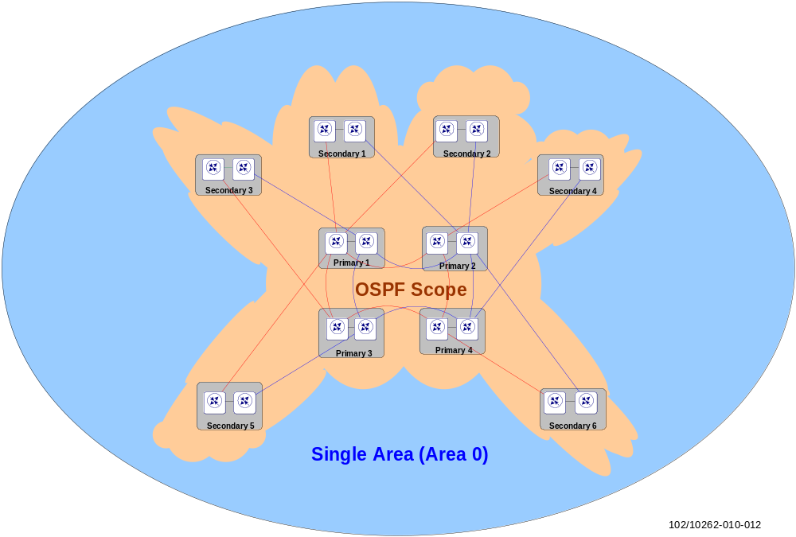
Figure 11 OSPF scope in the backbone
OSPF supports Traffic Engineering extensions. Information required to set up Traffic Engineering tunnels is distributed in Opaque LSAs (Type 10 LSAs defined in [29]). Therefore generation of Opaque LSAs needs to be enabled.
- Enable Traffic Engineering extensions for OSPF when using RSVP.
OSPF metrics are calculated as the sum of the cost associated with the links to a given destination. Cost is a non-dimensional figure, which results from dividing a constant bandwidth by the interface bandwidth as in 10¹¹ / (interface bandwidth in bits/s). It is recommended that the reference bandwidth be increased to reflect the high bandwidth interfaces in the network. Using the default reference bandwidth yields the same cost for a Fast Ethernet interface as for a Gigabit Ethernet interface.
Table 1 Link Metrics
Interface | Bandwidth [bit/s] | OSPF Metric
10GE | 10 000 000 000 | 10
1 GE | 1 000 000 000 | 100
OC-3c/STM-1c | 155 520 000 | 650
STM-4 | 622 080 000 | 160
STM-16 | 2 488 320 000 | 40
STM-64 | 9 953 280 000 | 10
FE | 100 000 000 | 1 000
- Set the reference bandwidth to 100 Gbit/s.
The above link metrics are to be configured as a default, with the exception of specific cases in which modifications are needed to preserve path diversity for LDP LSPs. Refer to section 6.3 for further details.
Control messages are exchanged in clear text by default. This default behavior is discouraged for the same reasons stated in 4.2.2 above. An intentionally or unintentionally misconfigured router could introduce bogus routing information in the network.
- It is recommended that MD5 authentication be enabled for OSPF messages.

OSPFv3
OSPFv3 is a modified and enhanced version of OSPFv2 that supports IPv6 addressing.
As OSPFv3 and OSPFv2 are equivalent, they will be used for the same client cases and reasons in the EIN Core Transport Network. In other words, there are no changes to the EIN Core Transport Network design in terms of CE-PE connectivity due to OSPFv3. No native IPv6 backbone is in the scope of this document, so PE/P connectivity using OSPFv3 is outside the scope.
NOTE: OSPFv3 uses a 32 bit router-id which means that same router-id can be used for IPv4 and IPv6.
When supported by the site router, OSPFv3 with Support of Address Families [69] could be used for dynamic dual-stack routing for existing OSPFv2 clients.

SmartEdge/SSR Configuration
These are the recommended OSPF parameters:
- Use default values for hello (10 s) and dead (40 s) timers
- Configure fast convergence with OSPFv2, SPF delay = 50 ms;
- SPF timer with SPF delay = 0 s; SPF holdtime = 5 s
- Enable fast convergence for the OSPFv2 interface with delay interval = 0; max SPF runs = 3; keep fast convergence for OSPFv3 interface as enabled (which is the default setting for OSPFv3 instances)
- Transmit pacing = transmit up to four LSAs within 5 seconds by using fast-lsa-origination command
- reference bandwidth = 100 Gbps
In terms of OSPFv3, SEOS supports OSPFv3 as CE-PE routing protocol but does not support domain-id/DN-bit. See RFC [64] for details of DN-bit (the RFC is intended for IPv4 but also valid for IPv6). This brings route flapping and loops when using 6VPE; a workaround could be to use route-tags when redistributing routes from BGP to OSPFv3 and vice versa.

The lack of domain-id/DN-bit can also take away the possibility of load balancing VPN prefixes from other PEs when using this workaround. A dual-link OSPFv3 speaking client, connected to two routers, will only see one route from one of the connected routers, due to asymmetric SPF timer configuration, instead of seeing the same route from both routers. Details of this workaround and an example of configurations are described in Annex 11.2.
In contrast to SEOS, IPOS has supported the DN-bit with OSPFv3 configuration since the SSR14A release. This is simply done by enabling vpn dn-bit-only in the OSPFv3 configuration.
Normally, the OSPFv3 DN-bit should be enabled to prevent looping in the BGP/MPLS VPN network. CE-PE connectivity works fine in most cases when BGP routes are redistributed into OSPFv3. However, there is a problem when the DN-bit enabled LSA is forwarded from one VPN to a different one. This OSPFv3 route will not be installed on the Site Routers in the later VPN, since they cannot identify that the LSA update is from a different VPN. This applies to the IGF solution when OSPFv3 is used for IPv6 traffic flowing between toExt_open VPN and Ext_Inet VPN. Please refer to [19] for detailed information.

IS-IS

IS-IS General
IS-IS is a hierarchical routing protocol like OSPF. IS-IS uses two levels of hierarchy: Level 1 and Level 2. Level 1 systems route within an area.
- Due to the size of the network, a single backbone area is sufficient. All backbone routers are configured to be part of a single Level 2 area. Disable Level 1 on all routers.
IS-IS implements hierarchy with the prerequisite that Level 1 areas cannot communicate directly among themselves and have to do it by means of a Level 2 area. Implementing the backbone as a Level 2 area allows it to be easily expanded in the event of future growth.

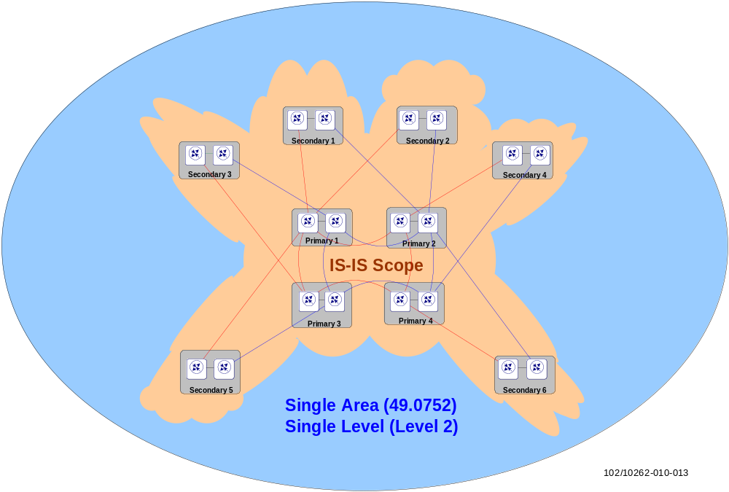
Figure 12 IS-IS scope in the backbone
As IS-IS runs on top of Layer 2, it cannot rely on IP for fragmentation and reassembly functions. Layer 2 does not have a fragmentation/reassembly function; therefore IS-IS uses its own L3 protocol to implement fragmentation and reassembly. Each LSP is fragmented by the originating router in PDUs that include a byte indicating the fragment number. IS-IS does not allow segmentation of any received protocol PDUs, and Link State PDUs (LSPs) must be propagated without modification on all IS-IS enabled links throughout the area/domain.
Thus, it is essential to configure a maximum size that all routers can forward, receive, and store. To make sure there are no problems due to PDU size, all interfaces (PPP and Ethernet) must have an MTU >=1497 bytes. Note that the EIN Core Transport Network generally recommends that the MTU size be set to a higher value as described in section 3.3.6.
In the EIN solution the IS-IS routing domain is a collection of P2P links, for both inter-site links and intra-site router links. In the case of Ethernet interfaces, the type of network point-to-point needs to be explicitly configured, as by default it would be configured as Broadcast Ethernet LAN links. The point-to-point type of network does not need to be explicitly configured with SONET/SDH links.
Defining P2P links between routers connected by Ethernet links eliminates the mandate of generating pseudo nodes among the routers. A pseudo node is a concept concerning LAN environments that must be implemented even if only a couple of routers form the LAN environment. Within any EIN Core Transport Network site, this is a useless overhead.
IS-IS sends the routing information packets directly over the link layer. It does not encapsulate the packets in IP as does OSPF.
In IS-IS the routing information is stored in Link State PDUs (LSPs). IS-IS is capable of carrying Traffic Engineering information.
Wide metrics are used in the routers for every type of link.
It is also recommended that the same reference bandwidth be set for both OSPF and IS-IS, that is, a reference bandwidth of 10¹¹ bit/s should be defined in order to calculate the wide metrics for all the inter-site links. The calculated metrics are:
Metric = Reference Bandwidth / Interface Nominal Bandwidth (in bits per second)
Table 2 Wide metrics calculated for each type of interface in IS-IS
Interface | Bandwidth [bit/s] | IS-IS Metric
10GE | 10 000 000 000 | 10
1 GE | 1 000 000 000 | 100
OC-3c/STM-1c | 155 520 000 | 650
STM-4 | 622 080 000 | 160
STM-16 | 2 488 320 000 | 40
STM-64 | 9 953 280 000 | 10
FE | 100 000 000 | 1 000
- Use a reference bandwidth of 100 Gbit/s.
- It is recommended that IS-IS messages be authenticated with an HMAC-MD5 hash on IS-IS domain (Level 2) and link scope.
To avoid devices external to the backbone injecting undesirable routing information into the IGP, authentication is recommended. When using authentication, unauthenticated IS-IS PDUs are rejected without further processing.

ISO Addressing – NETs
IS-IS uses ISO addressing. ISO addressing is based on NSAP addresses. An NSAP address consists of an OSI address to identify the device itself plus a field identifying higher layer protocols, for more details see [4].

IS-IS for IPv6
When a single SPF runs per level for both IPv4 and IPv6, and all routers in an area run the same set of protocols (IPv4-only, IPv6-only, IPv4-IPv6), the same network topology will be reached within this area. However, this requires all interfaces configured with IS-IS to support dual-stack, thus it brings the restrictions below:
- It may not suitable for an existing IPv4 IS-IS network where the operator wants to turn on scattered IPv6 support.
- The IPv4 and IPv6 topologies must match exactly. They cannot run in a flexible way, such as IS-IS IPv6 on some interfaces, IS-IS IPv4 on others.
- Adjacencies are only formed with similarly-configured routers. For example, an IS-IS IPv6-only router will not form an adjacency with an IS-IS IPv4/IPv6 router.
- Two IPv6 areas cannot be joined via an IPv4-only area. L2 adjacencies will form but IPv6 traffic will black-hole in the IPv4 area.
Multi-topology IS-IS was introduced to fix the limitation of using a single SPF process to serve both IPv4 and IPv6 topologies, while maintaining the IS-IS IPv6 functions.
This is done by adding of new multi-topology TLVs to IS-IS.
- Multi-topology TLV (code 229): contains one or more multi-topology IDs. It is possible to advertise up to 127 MTs. This TLV is announced in IIH (IS-IS Hello) and the first fragment of a LSP, and can occur multiple times.
- MT Intermediate Systems TLV (code 222): This is aligned with extended IS reachability TLV type 22 with an additional two bytes of MT membership at the beginning of the TLV, in which a 12 bits MT ID is specified. This TLV appears as many times as the number of topologies a node supports.
- Multi-Topology Reachable IPv4 Prefixes TLV (code 235): This is aligned with extended IP reachability TLV type 135 with an additional two bytes of MT membership in front. The followed MT IPv4 content is in the same format as extended IP reachability TLV.
- Multi-Topology Reachable IPv6 Prefixes TLV (code 237): This is aligned with extended “IPv6 reachability TLV” type 236, with an additional two bytes of MT membership in front. The followed MT IPv4 content is in the same format as IPv6 reachability TLV.
Please refer to RFC [67] for more details.
- Within the network, routers run IS-IS for IPv6 or IPv4/IPv6 dual-stack is recommended to enable multi-topology. If IPv4 and IPv6 are configured on the same physical interface, they must run the same IS-IS level.
Note that this multi-topology feature is not compatible with the previous single SPF model, as new TLVs are used to transmit and advertise IPv6 capabilities.
All routers on a LAN or point to point must have at least one common supported topology (IPv4 or IPv6) when operating in Multi-Topology IS-IS mode. A router that is not operating in Multi-Topology IS-IS IPv6 mode cannot form an adjacency with a Multi-Topology IS-IS IPv6 router, even if IPv6 is the common supported topology. However, if IPv4 is the common supported topology between those two routers, an adjacency should be formed.
- IS-IS with support of multi-topology should be used for dynamic dual-stack routing for existing IS-IS clients

SmartEdge/SSR Configuration
These are the recommended parameters for IS-IS configuration:
- LSP interval = 100 ms on IS-IS interfaces
- LSP max-lifetime = 65535 s for IS-IS LSP
- LSP refresh-interval = 65535 s - 371 s
- LSP gen-interval = 1 s
- Enable fast-convergence with SPF delay = 50 ms; max SPF runs = 3
- SPF interval = 5 s
- Use default values for hello and dead timers (i.e. do not configure IGP fast hellos)
- Enable MPLS traffic engineering if RSVP-TE is used
- Reference bandwidth = 100 Gigabit/s (no global command, calculate metric manually and configure per interface)
IS-IS Level 2 should be configured under router isis using is type level-2-only and under each IS-IS interface using circuit type level-2-only.
Note, from SEOS 6.1.5.3 onward, IS-IS domain (Level-2) or area (Level-1) scoped authentication configured under router isis no longer automatically enables link scope authentication using IS-IS Hello TLVs. Link scope authentication has to be configured explicitly per IS-IS interface.
Note that when configuring the SPF delay using the fast-convergence command, the LSP pacing (lsp interval) is overruled. Instead of pacing the LSP transmission according to the given LSP interval, the router transmits the LSPs as fast as possible.
Incremental SPF calculation is not supported by SmartEdge/SSR routers. However, because processors nowadays are powerful enough to do full SPF runs in a short time even for large topologies, this is not seen as critical.

IGP Convergence
The same approach is followed for any IGP implementation: try to achieve the fastest possible convergence in a failure situation but also try to avoid route flapping in normal operation.
The first step toward fast convergence is fast detection of the failure. The EIN Core Transport Network relies on physical media detection for failures of directly connected links or adjacent routers, and BFD for indirect failures that are not propagated back to the routers by intermediate infrastructure/transmission devices.
The next step in fast convergence is the fast triggering of the SPF algorithm once a link failure is detected, and promptly informing the other routers about the failure condition. Those can be achieved by tuning SPF and interface parameters.
However, tuning the transmit pacing of self-originated LSPs/LSAs to very low values could be detrimental to network stability as routers start to dominate the transmission links with LSP/LSA updates and cause intensive router SPF runs all over the network. Some router vendors therefore do not allow tuning of the pacing of self-originated LSPs/LSAs, or prevent the use of very low timer values (e.g. SmartEdge). Therefore the SPF calculation needs to be tuned properly. The delay for SPF calculations, and the flooding and generation of IS-IS LSPs or OSPF LSAs indicating changes, should be reduced to increase the responsiveness of the routers.
Increasing the IGP responsiveness helps to improve the convergence at various other protocol levels such as:
- LDP: Since LDP signaled MPLS LSPs strictly follow the IGP best path, a faster converging IGP routing domain will in turn lead to a faster converging MPLS forwarding plane
- BGP: Due to the use of the BGP next-hop address tracking feature, the BGP routing domain convergence (e.g. L3 VPN convergence) will improve the faster the IGP propagates next-hop related changes across the network topology to all BGP speakers
Being two common used mechanisms for preventing routing protocol reconvergence during a processor switchover, Graceful Restart (GR) and Non Stop Routing (NSR) are recommended for IGP in EIN Core Transport Network. See [5] for further details.
See also [52] for further discussions about IGP tuning and the use of IS-IS or OSPF in large scale networks.

MP-BGP
In contrast to IGP that has limited scalability, BGP is a very robust and scalable routing protocol. In the EIN, BGP can be used in the following situations:
- Connections to corporate networks or external networks, such as the Internet, may use any of the routing protocols available for PE-CE routing, however BGP is considered to be the most likely choice
- As one exception, MP-BGP is used for building an IP/MPLS backbone where it is used as the carrier for label exchange between L3VPN sites which are attached to the EIN network – be it a core backbone with single AS, or a network across the access, the aggregation and core networks associated with multiple ASs.
Multiprotocol BGP (MP-BGP) is an extension of BGP version 4 (BGP-4). MP-BGP is able to distribute different types of network layer addresses, referred to as Network Layer Reachability Information (NLRI).

Concepts
The Border Gateway Protocol (BGP) is an Exterior Gateway Protocol (EGP) based on distance-vector algorithms with added twists; BGP is used to exchange dynamic routing information between peers in autonomous systems. In contrast to IGP, BGP focuses more on computing the optimal path and controlling route exchange, instead of finding and calculating the shortest path.
BGP uses the Transmission Control Protocol (TCP) on port 179 as its transport protocol. This makes BGP a reliable protocol. When a connection is established, BGP neighbors exchange complete copies of their routing tables. However, when changes to the routing table are detected, only changes (deltas) are exchanged, which makes long running BGP sessions more efficient than shorter ones. BGP routing updates advertise only the optimal path to a destination network.
Classless inter-domain routing (CIDR) is used by BGP to reduce the size of the routing tables. With CIDR, routers use the network prefix to determine the dividing point between the network number and the host number. Additionally, CIDR does not require a network to be of standard size, as is the case in classful addressing, which provides 8-bit (Class A), 16-bit (Class B), and 24-bit (Class C) network deployment. This flexibility in CIDR enables the creation of arbitrarily sized networks, allowing a significant reduction in the BGP routing tables. Detailed information about BGP-4, see RFC [41].
Because of its robustness and scalability, EIN Core Transport Network BGP can be used in the EIN Core Transport Network for interconnectivity between different administrative networks (such as core network and aggregation/access network) or connecting with external data packet networks (such as cooperation network or ISPs – in which BGP is used to exchange customer and ISP routes).
Multi-Protocol BGP (MP-BGP) is an extension/enhancement of BGP-4, which primarily allows unicast routes for multicast routing to be carried in interconnect-networks – to this extent, MP-BGP allows protocols other than IPv4 to be carried (multicast, IPv6, CLNS, MPLS VPN etc.) for IP forwarding. This is done by:
- Introducing new BGP “capability advertisement” in open message to determine if a peer supports MP-BGP extensions
- Introducing optional non-transitive attributes: MP_REACH_NLRI / MP_UNREACH_NLRI
Moreover, the types of NLRI supported in MP-BGP are characterized by a combination of Address Family (AF) and Subsequent Address Family Identifier (SAFI). Those are used to distinguish corresponding network layers, see RFC [58] for more information
The main purpose of MP-BGP in the EIN Core Transport Network is to distribute VPN-IPv4 NLRI between the PE routers, i.e. VRF routes, In other words, MP-BGP is used as customer route distribution protocol (AF=1, SAFI=128 for VPNv4; AF=2, SAFI=128 for VPNv6), in which MPLS is used as forwarding plane.
In addition to client VRF routes, MP-BGP can also be used to distribute client prefixes from the Generic Routing Domain (GRD). Distributing these prefixes in MP-BGP ensures that MPLS forwarding and MPLS protection (e.g. RSVP Fast Re-route) is used for these routes. Note, for this to happen it must be assured that those routes are not known to the IGP due to the administrative distance of IGPs being lower than for BGP. Re-distribution of GRD prefixes into MP-BGP is not used in the EIN Core Transport Network.
BGP Attributes
To achieve scalability, BGP uses many route parameters, called attributes, to define routing policies and maintain a stable routing environment.
Routes learned via BGP have associated properties that are used to determine the best route to a destination when multiple paths exist to a particular destination. These properties are referred to as BGP attributes, and an understanding of how BGP attributes influence route selection is required for the design of robust networks. This section describes the attributes that BGP uses in the route selection process:
- Local preference is used to prefer an exit point from the local AS. When there are multiple exit points from the AS, the local preference attribute is used to select the exit point for a specific route; the attribute is propagated throughout the local AS.
- Multi-exit discriminator is used as a suggestion to an external AS regarding the preferred route into the local AS that is advertising the metric.
- Origin indicates how BGP learned about a particular route. The origin attribute can have one of three possible values : IGP (NLRI is inside the originating AS), EGP (NLRI is learned via EGP) and Incomplete (NLRI is unknown or learned via some other means)
- AS_path is used to avoid loops when BGP passes through multiple ASs. When a route advertisement passes through an AS, the AS number is added to an ordered list that the route advertisement has traversed.
- Next hop is the IP address that is used to reach the advertising router. For eBGP peers, the next-hop address is the IP address of the connection between the peers. For iBGP, the eBGP next-hop address is carried into the local AS.
- Community, as implied from the name, the community provides a way of grouping destinations, to which routing decisions (such as acceptance, preference, and redistribution) can be applied. Route maps are used to set the community attribute.
BGP could possibly receive multiple advertisements for the same route from multiple sources. BGP selects only one path as the best path. When the path is selected, BGP puts the selected path in the IP routing table and propagates the path to its neighbors. BGP uses the criteria specified in RFC [41], in the order presented, to select a path for a destination.
If the path specifies a next hop that is inaccessible, the update is dropped. .
BGP with Label
When BGP is used to distribute a particular route, it can also be used to distribute an MPLS label that is mapped to that route (see chapter 5 for more information about MPLS). For example, this could be used for label distribution between two adjacent LSRs which are also BGP peered, where the label distribution protocol (e.g. LDP) cannot be used for label distribution (when the two LSRs are located in two different administrative domains).
In the EIN Core Transport Network, the scale of the MPLS network can be expanded across multiple domains, such as inter-AS connectivity, by using this feature.
This is done by expanding the MP-BGP NLRI attribute, so that the label mapping information is carried as part of the NLRI in the Multiprotocol Extensions attributes. The AFI indicates, as usual, the address family of the associated route. The fact that the NLRI contains a label is indicated by using SAFI value 4; for details see the RFC [34] .

MP-BGP Usage in EIN Core Transport Network
To distribute VPN-IPv4 NLRI between the PE routers, MP-BGP is required in every PE router where client networks are connected. Within the administrative domain, all the BGP peers belong to the same Autonomous Systems; hence the BGP sessions are established as iBGP.
To provide a loop-free topology, iBGP peers do not typically re-advertise NLRIs learnt through other internal peers. The consequence would be that it is required to have a full-mesh of iBGP sessions or use solutions such as route-reflectors to break the full-mesh iBGP rule, or divide the Autonomous System into a confederation and reduce the number of internal BGP sessions.
The use of iBGP full-mesh sessions, route-reflectors or confederations is directly related to the number of BGP peers.
- When the number of sessions per router is not too high (<100) a full mesh of iBGP sessions should be used. With two routers per site this corresponds to a network of not more than 50 sites. For larger networks, route reflector clusters or a hierarchy of them is recommended.
- For the ten site reference model with 20 site routers, a full BGP mesh is used.
Autonomous System (AS): according to [41], an AS represents a collection of IP networks under the control of one or several network operators, that presents a single common routing policy (routing decision) to the Internet. The AS number is a 16-bit integer (32-bit values have also been allowed). The numbers 64512 through 65535 are reserved for private purposes, which shall be used if the AS is not connected to any public AS.
- The EIN Core Transport Network should be implemented as a single AS.
Peer Groups: It is advisable to configure BGP peering session as peer-groups instead of individual sessions. With peer-groups control messages are generated once for the peer-group and retransmitted to its members, as opposed to individual sessions where the same message is created for each of the individual neighbors. It is also less configuration work with respect to specifying policies. You specify them once for the complete group instead of several times for each BGP neighbor.
- Configure iBGP peer groups. For a full-mesh iBGP setup, it is recommended that a single peer group be configured per PE and define the other PEs in the backbone statically as neighbor in the created peer group.
Authentication
- The recommendation is to use MD5 authenticated sessions to increase security.
Multi-Path (handling in SE/SSR)
By default, BGP installs a single path in the RIB for each destination. If that path fails and no other path has installed a path for that prefix, traffic destined for that path is lost until the path is available again.
When BGP multipath is enabled, BGP installs multiple best equal-cost paths in the routing table for load-balancing traffic to BGP destinations. With multipath, the paths can be:
- iBGP (with the multi-paths internal path-num in SE/SSR)
- eBGP (with the multi-paths external path-num in SE/SSR)
- In the VPN context, a combination of iBGP and eBGP, where only one eBGP path is allowed, and the number of allowed iBGP equal-cost paths is equal to the maximum number of paths (with the multi-paths eibgp path-num) allowed minus one.
- If desired, multiple best equal-cost paths in the routing table for load balancing traffic to BGP destination can be achieved in networks by enabling of multi-paths using BGP route advertisement
Note that even though multiple paths are installed in the RIB, BGP advertises only one path (the best path) to its peers. Multipath load-balancing in a BGP/MPLS VPN does not support IPv6 traffic in current release of SEOS or IPOS.
Route Dampening
- The use of route flap dampening in BGP is not recommended in the EIN Core Transport Network.
This is discouraged in [28] as it has been observed that the dampening mechanism causes more instability than stability in the network. Moreover, as the CPUs of modern routers are powerful enough, a flapping route will no longer create exceptional overload situations.
IGP/BGP Route Redistribution
BGP route sourcing includes redistribution from other routing protocols into the BGP routing domain and origination of BGP routes through the network command in BGP address family (AF) configuration mode.
IPv4 or IPv6 routes learned through other routing protocols can be redistributed into the BGP routing domain by using the redistribute command. Redistributed routes are advertised to all BGP neighbors for the address family. Multiple redistribute must be used to redistribute routes from several different kinds of routing protocols into the BGP routing domain.
- Backbone infrastructure routes are only carried in the IGP. They must not be exported into iBGP.
- Client VPN routes and external routes are carried only in iBGP. They are not to be exported into the IGP.
Other BGP Options
- Enable Graceful Restart
- Configure BGP next-hop-self (if having any eBGP sessions to external AS)

BGP Tuning
The original purpose of BGP was to provide connectivity between different Autonomous Systems. The amount of information, NLRI, to be managed is much higher than in an IGP and hence BGP is more focused on stability and scalability than fast convergence.
The extensions made to the original BGP have changed the original requirements on BGP (or more accurately MP-BGP). MP-BGP provides IPv4-VPN connectivity and in order to minimize service interruption, it is desirable to reduce the convergence time of MP-BGP from minutes to seconds. However, the desired result of obtaining convergence times similar to those in the IGP is not possible. The mechanisms in place at the time of writing this document allow for a convergence time in the order of seconds for a worst case scenario. Nevertheless, the tuning below can be performed to minimize the convergence on MP-BGP:
Timers: BGP keepalive messages are sent regularly. If keepalive messages are not received during the BGP Hold Time period, the session is torn down. The failure of a peer may take up to the “Hold Time Period” to be detected. Reducing the keepalive and Hold Time results in faster convergence.
- If BGP supports next-hop address tracking (see below), then the BGP Hold Time should be left at the default values. Otherwise, the Hold Time may be reduced to lower values but in alignment with existing TCP retransmission timers to prevent premature session terminations in the case of spurious unacknowledged or dropped TCP packets that require retransmission. A Hold Time of 5s should be safe to use.
Some BGP implementations might not allow the Hold Time period to be tuned down to a value that would allow a peer failure detection in the range of a couple of seconds. This would mean that, without any other mechanism, the traffic would be blackholed until the BGP session expires if a remote BGP peer fails. There are some ways to reach faster convergences which are listed below:
The “BGP Support for Next-Hop Address Tracking” feature is useful for IPv4-VPN convergence. With Next-Hop Address Tracking, BGP registers its NLRI next-hops with the Routing Information Base (RIB) when these are learned from its peers. If for any reason there is a change in the routing table regarding one of the registered NLRI next-hop addresses, then the forwarding table immediately notifies the BGP process and the related NLRI is removed from the routing and BGP tables. This is an event driven process. Note that for the same next-hop address there are generally separate routes installed by the IGP process on one hand, and the LDP process on the other hand. The removal of any such route creates a separate event. The behavior of the “BGP Support for Next-Hop Address Tracking” feature differs, depending on the character of two consecutive events (see Design Decision D 37 below).
Fast Peering Session Deactivation works in a similar manner. The RIB is monitored for the presence of the IP address with which BGP sessions are established, and if the peering IP address is not present, the session is torn down.
Increase packet size for BGP control message transmission. BGP convergence is related to the number of BGP messages that can be sent across the network within a certain amount of time. BGP sessions are TCP sessions where the limit on the number of bytes that can be sent within a single packet is determined by the MSS size.
The maximum segment size (MSS) for the TCP session is calculated from the interface MTU size minus IP and TCP header overheads. Increasing the MTU size thus improves the throughput of BGP messages, but increases the risk of fragmentation if there are router interfaces with smaller MTU sizes on the transmission path between the BGP speakers.
To optimize throughput, avoiding fragmentation, use of Path MTU Discovery is recommended. Note that when a uniform MTU size is used on all interfaces on the transmission path between BGP speakers, Path MTU Discovery is not strictly needed.
MTU Path Discovery
- Configure Path MTU discovery to avoid fragmentation in networks with different MTU settings. Even though not strictly required, Path MTU discovery shall also be used in networks with uniform MTU settings.
Fast-Reset of BGP Sessions
The BGP fast-reset feature enables fast resetting of a BGP peer session when the links used to reach a neighbor go down and triggering a BGP best path calculation before the hold time expires. With fast-reset disabled, the BGP session is not reset immediately if the link used to reach that peer goes down. The BGP sessions remain connected to the peer until the configured BGP holdtime timer (set by using timers keepalive) expires. If no packets are received from a peer within the configured hold time, the BGP session is reset.
When fast-reset is enabled, the configured hold time is ignored, and BGP drops its session with a peer immediately if the link to that peer goes down. This fast reset minimizes routing convergence times, and therefore packet loss, during network failures.
- If BGP supports next-hop address tracking (see above), then the BGP fast-reset should not be used. Otherwise, the fast-reset may be used with lower interval for directly connected peers. A fast-reset interval of 5s should be safe to use.
Minimum Route Advertisement Interval (MRAI) for iBGP. MRAI determines the amount of time that must elapse between two consecutive advertisements or withdrawal of routes to a particular destination by a BGP speaker to its peers. It is recommended that the MRAI be set to the minimum value (‘0’) in order to achieve optimal network convergence after network connectivity changes. This setting can result in a higher number of BGP UPDATE messages, but this is not an issue in EIN Core Transport Networks.
- Set MRAI to ‘0’ for optimal network convergence.

SmartEdge/SSR Configuration
In the EIN Core Transport Network, BGP is used to implement the BGP/MPLS IP VPNs [43] and as CE – PE protocol to routing peers in external Autonomous Systems.
The basic BGP functionality, behavior and configuration are identical in SmartEdge (SEOS) and SSR (IPOS). However, the SSR scales much better than SE in terms of the number of supported BGP routes and sessions (see also [5] and [6] ).
The BGP implementation currently supports the following Address Families (AFs):
- IPv4 unicast, multicast, and labeled unicast (AFI=1; SAFI=1,2 and 4)
- IPv6 unicast, labeled unicast (AFI=2; SAFI=1,4)
- VPNv4 unicast (AFI=1; SAFI=128)
- VPNv6 unicast (AFI=2; SAFI=128)
- In a small or medium EIN Core Transport Network, to enable the site routers (as PE/P in context of IP/MPLS) to carry exchange label among L3VPN sites, a full-meshed iBGP in a single AS shall be deployed.
- To reduce BGP re-advertisements and ease the iBGP configuration in a large scale EIN Core Transport Network, Route-Reflector is recommended. Normal P/PE can be used as RR; for better redundancy RR shall be always deployed in pairs.
- To distribute VPN-IPv4 or VPN-IPv6 routes the address-family ipv4 VPN or address-family ipv6 VPN must be configured in the BGP configuration mode under router bgp asn to allow the routing instance to exchange those NLRIs and in the BGP peer-group configuration mode to allow the use of VPN routes for all specified peers in this group.
An iBGP peer group is configured with the command peer-group group-name internal.
- BGP next-hop tracking (command nexthop triggered) with a minimal delay, holdtime and no backoff (i.e. delay 0 holdtime 1 backoff 0) must be enabled for the corresponding address family under router bgp ASN.
To realize fast convergence for BGP/MPLS IP VPN routes, the BGP next-hop tracking delay should be set to the 0, allowing BGP to react immediately on a next-hop change.
Moreover, the given holdtime of 1s should be generally sufficient to prevent churn on the BGP scanning. Note that in test measurements, hold time values between 100ms and 5s did not significantly affect the length of time needed for network convergence.
The hold time takes effect only if two consecutive triggers are received from the same process (e.g. IGP) and for the same next-hop address.
If the BGP process receives, for example, a next-hop change message regarding address 1.2.3.4 from the IGP process, and shortly after that another next-hop change message regarding the same address from the LDP process, the hold time is ignored.
Because the holdtime is evaluated for different next-hops separately, the same also applies when two consecutive next-hop change messages regarding different addresses, e.g. 1.2.3.4 and 5.6.7.8, respectively. With this behavior network convergence is optimized, while excessive BGP scanning, caused by eventual route-flapping, is avoided.
There is no need to additionally utilize an incremental back-off even in larger topologies.
- The router-id shall be configured for the BGP routing instance and set to the loopback address that is used for backbone routing purposes. The same applies to the IPv6 routing via MP-BGP
- To bind the iBGP session locally to the loopback address instead of a physical interface, the update-source command should be used for the internal peer group.
- If eBGP peers are directly connected, the eBGP session can be bound to the physical interface; otherwise, bind the eBGP session locally to the loopback address, eBGP-multihop 255 shall be specified. The update-source command is used for the external neighbor (for former scenario) or external peer group (for later scenario).
- Path MTU discovery is enabled globally using the command tcp path-mtu-discovery.

BGP FRR
Under normal circumstances, BGP can take between several seconds and a few minutes to converge after a network change. BGP FRR can be used to change this behavior and achieve sub-second convergence even for large-scale networks.
BGP Fast Reroute (FRR) provides a best path and a backup/alternate path in BGP, RIB, and FIB. In this way it can provide a very fast reroute mechanism into the RIB and FIB, using the backup BGP next-hop to reach a destination, when the current best path next-hop is not available. With BGP FRR, the data plane can converge before the control plane has converged.
To make use of BGP FRR the target network design must provide multiple BGP next-hops per prefix route. A BGP FRR enabled node must have the multiple next-hops in the BGP routing table. This can be catered for in many ways; the following are the most common examples:
- A small network using a full mesh iBGP topology provides all possible BGP next-hops for prefixes within the same AS
- Engineering of the Route Reflector topology, e.g. the hierarchical RR design in [9], can to a large extent provide multiple BGP next-hops.
- Where BGP RR topologies prevent multiple paths from being visible or cannot fully support this, BGP diverse path [5] can be used to overcome BGP RR only advertising the best path from the stand point of the RR.
- Make use of the BGP best external feature [5] on the ASBR, where the best external is otherwise suppressed from being advertised.
- For address family VPNv4 or VPNv6, a unique Route Distinguisher per PE should be configured. This way VPN Route Reflectors treat the same VPN routes from different PEs as being unique routes.
BGP FRR depends on a hierarchical forwarding chain to achieve fast convergence. BGP routes are located at the highest level. When a failure happens on a lower level, e.g. on the IGP/LDP level, this level converges (by the means of fast IGP or LFA) and automatically applies to the higher levels. This way every level, e.g. IP FRR, LFA (Loop Free Alternate) and BGP FRR, can combine to improve end to end convergence.
If BGP FRR is supported and there are strict transport network resilience requirements, configure BGP FRR for address family IPv4 labeled unicast on PE routers and BRs. This is valid both for small and large networks that have a design containing multiple next-hops for transport network prefixes.
For redundant VPN PE scenarios requiring fast convergence, use BGP FRR (if supported) on ingress and egress PEs for address family VPN. Use multi-hop BFD as BGP FRR trigger on the ingress PE to monitor the status of egress PEs.
SSR support for BGP FRR will come in a future release (please refer to roadmap).

Summary of IPv6 Routing in SmartEdge/SSR
The SmartEdge and SSR support IPv6 (which is mainly used for CE-PE connection, while 6VPE is recommended to transport IPv6 traffic in the backbone). The following functions and features are available:
- IPv6 unicast routing, Neighbor Discovery (ND) and PMTUD
- IPv6 static routes, OSPFv3 [68] , MT IS-IS, RIPng and BGP
- IPv6 BFD for static, OSPFv3 and eBGP
- IPv6 ACL, port mirroring
- QoS
The major IPv6 functions, behavior and configuration in the SSR are identical to those in the SmartEdge SEOS with a few exceptions; for example BFD with MT IS-IS is supported by SEOS but not yet available in SSR. However the SSR scales much better than SmartEdge in terms of the number of supported IPv6 routes and adjacent neighbors.
The features below are not yet supported on the SE or SSR:
- IPv6 PBR
- OSPFv3, Authentication ([63] , [70] ) and Address Families [69] .

Integrated Routing and Bridging
This chapter describes the IRB function on SmartEdge and SSR products.

Introduction
The router supports an Integrated Routing and Bridging (IRB) function to allow a single device deployed in the site infrastructure to provide the L3 IP routing and L2 bridging/switching required. Separate Layer 2 switches are thus not needed in the site infrastructure.
In general, client networks are connected to the site infrastructure in the same way when using routers with the IRB function as when using separate switches and routers. However, the IRB function does not currently support all functions required in the site infrastructure.

Hardware
When routers with the IRB function are used, the number of ports required in the routers is substantially greater than when separate L2 switches are used for port aggregation; for further details see [6].
On SSR the below line cards support the BVI function:
- 10-Port 10 Gigabit Ethernet Card
- 40-Port Gigabit Ethernet Card
- There is a restriction that the other line cards should not be installed on SSR where BVI is configured (EIN15A-N-08), for detail see [26].

BVI Port Feature Description

Terminology and Concepts
The IRB function provides simultaneous support for Layer 3 IP routing and Layer 2 bridging in the same device. IRB allows local traffic to be bridged between the L2 circuits in the same bridge group, while routable traffic will be routed to other routed interfaces by use of the BVI port.
A BVI port is a pseudo circuit and functions as the mediator between the bridged and routed domains.
In order for a VLAN to span a router, the router must be capable of forwarding frames from one interface to another while maintaining the VLAN header. If the router is configured for routing, it will terminate the VLAN and MAC layers at the L2 circuit on which a frame arrives. The MAC layer header is maintained if the router is bridging the IP packet; however, regular bridging still terminates the VLAN header. Using the BVI Port feature, the terminated VLAN header is restored on a frame at the egress L2 circuit. This behavior is similar to a standalone L2 Switch.

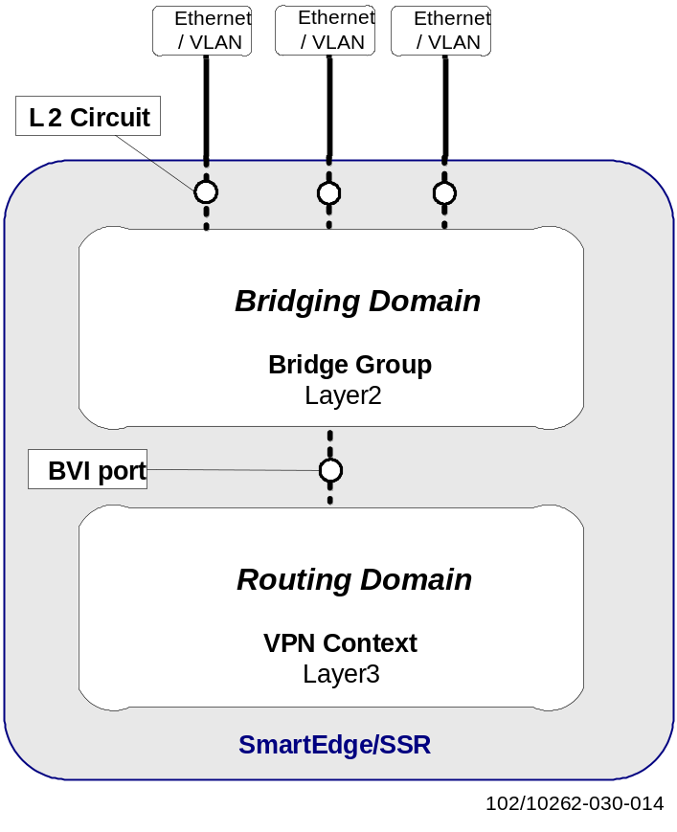
Figure 13 IRB function based on the BVI Port Feature

Context | A context is a virtual router instance running within a single physical device. A context includes routing and bridging domains.
Bridge Group | A standard Layer 2 bridge domain is called a bridge group in terminology, and is a set of bridged L2 circuits that share the same broadcast domain. Each bridge group maintains its own forwarding database of MAC addresses learned from packets received on L2 circuits belonging to that bridge group.
Layer 2 circuit | The term circuit refers to the endpoint of any segment of a communications path that terminates on the routing device. A Layer 2 circuit corresponds to a port-based untagged VLAN connection or a tagged VLAN connection configured in the router.
BVI Port | A Bridged Virtual Interface (BVI) port is a pseudo circuit which ties L2 bridging and L3 routing in the same context. A BVI port is created by inserting a virtual IP interface with a virtual MAC into the bridge group.

Bridge Details

Bridge Aging-Time
The traffic flow between a client and the routers within a site may be asymmetric for certain traffic scenarios. In such a case it is possible that a router will not receive any IP packets from the client.
- Due to aging and eventual time-out, the router may lose the mapping entry of a MAC address to the port for the corresponding host. If the router loses such an entry, it would normally broadcast all received packets. However, for traffic from the routing domain to the bridging domain, broadcasting of traffic is not supported. Instead a time out triggers an ARP message to be sent out on the bridge to refresh the MAC entry for the corresponding host. To avoid packet loss, the aging timer of the bridge must be greater than the aging timer of the ARP entry. The bridge aging-time should be set to 3660 seconds, make it greater than ARP default aging timer 3600 seconds.
The bridge aging-time specifies the minimum time after which inactive learned MAC addresses are deleted for all circuits that are bound to an interface that is associated with the bridge. The actual aging time depends on the value of the aging-time argument. For a value n >=600 seconds, the actual aging time can vary between n and n+300 seconds.

MAC Address Limitation
On SmartEdge, by default, a maximum of four dynamic MAC addresses are allowed for an L2 circuit bound to an interface that is associated with a bridge.
To overcome the MAC address limitation of SmartEdge, a bridge profile that specifies the type of each bridged L2 circuit to trunk is assigned to each L2 circuit. For a circuit type trunk the maximum number of dynamic MAC addresses is unlimited.
To promote simplicity the following applies:
- In the EIN Core Transport Network it is recommended that, for SmartEdge, all L2 circuits bound to an interface that is associated with a bridge be set to type “trunk”, to allow an unlimited number of dynamic MAC addresses.
On the SSR, there is no limit is imposed on the number of learned MAC addresses.

BVI Port Feature Use in EIN Core Transport Network
The following functions are used by clients in the EIN Core Transport Network and supported in conjunction with the BVI port feature:
- OSPF runs over a BVI port
- VRRPv2 runs over a BVI port
- An L3 interface associated with a BVI port replies to ICMP echo request packets
- An L3 interface (or a VRRP VIP) associated with a BVI port replies to fast ARP request packets
- BFD runs over a BVI port
- Link Aggregation is supported for inter-router Ethernet links in a BVI port configuration
- The QoS implementation is described in chapter 5.6.
Limitation on the BVI port feature in SmartEdge:
- BFD does not run over a BVI port
- If BFD on SmartEdge is required by a client to provide failure detection, a pure Layer 3 port not using the BVI port feature shall be used in the router.
Limitation on the BVI port feature in SSR:
- VRRPv3 is not supported over a BVI port, see limitation EIN15A-N-07 in [1].
If VRRPv3 over SSR BVI port is required, the SSR BVI solution with External Loopback Cable could be a workaround, see [22] for details.

Client Network Connectivity

Client Network Generic Physical Connectivity
In general, client nodes are connected to both routers using FE, GE or 10GE links to avoid single points of failure.
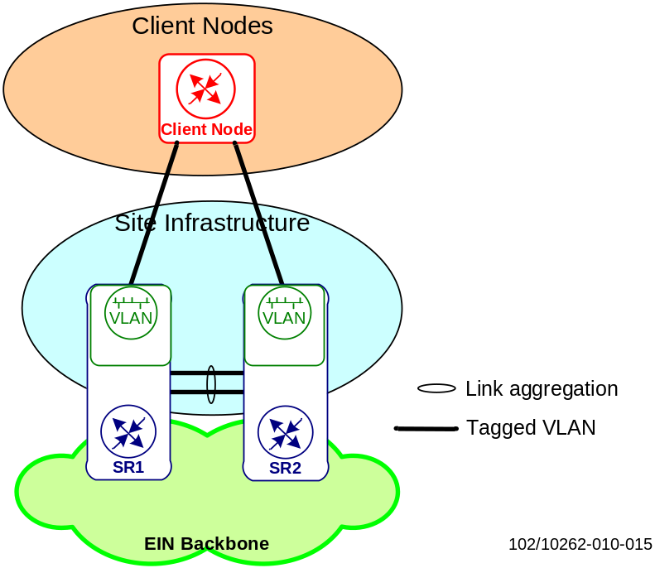
Figure 14 IRB Site Infrastructure, Physical connectivity
- Two or more GE/10GE links shall be link-aggregated between the router pair to provide redundancy and capacity. The GE/10GE links shall be connected to separate interface cards in each router to increase redundancy.
The aggregated GE links are shared and used both for backbone traffic and bridged client traffic. Refer to [25] for further details about LAG configuration on the intra-site link.

Client Network Generic Logical Connectivity
Two main types of logical connectivity setups are used to connect client nodes:
- a setup for clients using dynamic routing-redundancy
- a setup for clients using static routing-redundancy
Client nodes that use a dynamic routing protocol, such as OSPF, use L2 connectivity with two separate VLANs as shown in Figure 15.
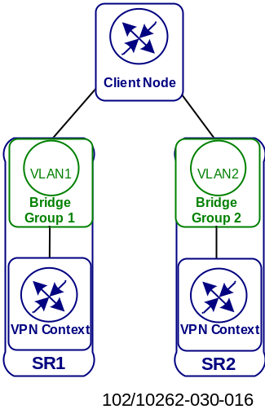
Figure 15 IRB Logical connectivity, dynamic routing-redundancy
Client nodes that use static routing in combination with a mechanism such as VRRP or RPS, use L2 connectivity with one VLAN as shown in Figure 16.
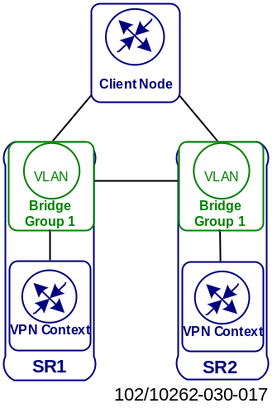
Figure 16IRB Logical connectivity, static routing-redundancy
- The logical connectivity should be the same for clients connected to IRB enabled routers and for clients connected to separate L2 switches and routers.
Clients optionally use a port-based VLAN connection or a tagged VLAN connection to a router. A VLAN is either local to one router or expanded over the intra-site link to the co-located router.
- One bridge group shall be used per VLAN in the router. Bridge groups configured in different routers that correspond to the same VLAN are inter-connected by expanding the VLAN over the intra-site links.
- One BVI port shall be used for each bridge group configured in the router. A BVI port is created by inserting a virtual IP interface with a virtual MAC into the bridge group. Only one BVI port is supported per bridge group.

Redundancy
This chapter describes the impact on IRB specific components, such as the BVI port and corresponding bridge group/L2 circuits, of different types of failures.

L2 Circuit Failure
The BVI port is up until all L2 circuits associated with the corresponding bridge group are down.
Note: The BVI port is not tied to one specific interface board, meaning that the BVI port stays up also after an interface card failure.
For clients connected using the static routing-redundancy scheme, the BVI port would never go down, since the intra-site trunk link is assumed never to fail. The client would notice the L2 circuit failure and take the required actions to use the remaining link for incoming and outgoing traffic.
For clients connected using the dynamic routing-redundancy scheme, the BVI port would go down only when the last L2 circuit associated with the bridge group goes down. The client and the BVI router would notice the L2 circuit failure and the routing protocol would react. Please refer to [25] for further details.

Intra-Site Link Failure
Dual physical links are bundled in a LAG to achieve one logical link between the routers. The logical link stays up after a failure to one of the physical links. It is also recommended that the physical links be connected to separate interface cards in the router.

Controller Card Switchover
Dual Controller Cards(XCRP-SmartEdge/RPSW-SSR) in a redundant configuration shall be used in each SmartEdge/SSR router deployed in the EIN Core Transport Network. If the active Controller Card fails, a switchover to the second Controller Card in the same router is performed. L3 forwarding and L2 bridging tables are stored on the interface cards, meaning that forwarding and bridging continues during the Controller Card switchover process using the existing tables. A routing engine is however needed for MAC address learning.
L2 circuits, bridge groups and the BVI ports stay up during the Controller Card switchover process. The L3 interface associated with a BVI port will reply to ICMP echo requests during a Controller Card switchover, meaning that clients using RPS or IPMP would not notice the switchover. ARP requests are however handled by Controller Card, meaning that clients using ARP monitoring or Link Bonding may notice the Controller Card switchover.

Quality of Service
The motivation and reasoning for using QoS in the Site Infrastructure is described in [14] The QoS implementation in the IP Backbone with SmartEdge/SSR routers is described in the [10] and [11].
The main consideration is that packet classification and marking are handled differently when IRB is enabled; queuing is not affected.

Packet Classification and Marking
QoS features are applied at:
- Client access L2 circuit
- Intra-site trunk port
- BVI port
- Backbone port

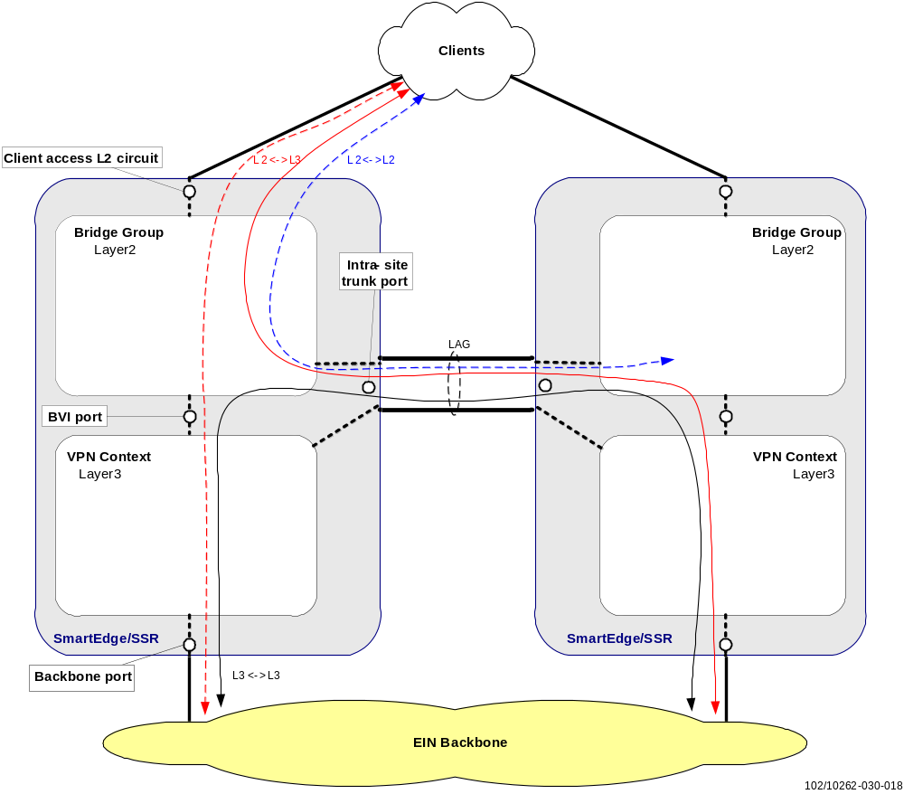
Figure 17 BVI QoS Overview
- All client nodes which are capable of DSCP marking should be configured to mark according to the DiffServ classes defined in [10]
A complete list of DSCP values expected from client nodes is available; see [14].
Policy ACLs are not supported on L2 circuits. Because of this, unmarked or incorrectly marked ingress packets cannot be correctly classified and marked at client ingress.
In the EIN Core Transport Network the classification based on DSCP differs from the classification provided by the default class-map in SmartEdge/SSR. Please refer to [11] for a description of the customized class-map.
According to the QoS architecture described in [10], seven out of the eight available egress queues are used. The customized mapping from PD priority to queues is described in [25]. Queuing is done on the intra-site trunk port and on the backbone ports, but not on the BVI ports or client ports.

Client Access L2 Circuit
An L2 circuit corresponds to a port-based untagged VLAN or to a tagged VLAN configured on a physical port in the router.
The router by default uses the 802.1p priority bits in the L2 header (802.1Q VLAN PCP field) to provide QoS handling for packets that ingress on L2 circuits. EIN Core Transport Network solely uses the DSCP settings in the L3 header to provide QoS handling and does not use the 802.1p priority bits. Consequently a class-map needs to be configured in the routers to force it to use the DSCP settings for packet classification.
Ingress packets that are untagged do not contain the 802.1p priority bits and they cannot, therefore, be associated with a class-map. DSCP settings cannot be used on an untagged L2 circuit for packet classification.
- A default PD priority marking should be applied to each untagged L2 circuit in order to classify IP ingress packets.
- If different packet types require different QoS ingress on the same untagged L2 circuit, all packets should in general be marked with the highest required PD priority if it corresponds to one of the Assured Forwarding treatment aggregates or to Best Effort. In other cases Assured Forwarding 3 should be used, unless a careful analysis shows that the traffic from that untagged L2 circuit could never cause congestion for the new treatment aggregate.
The following example shows a customized class-map named 8021p-to-pd to be used on tagged SmartEdge L2 circuits:

qos class-map 8021p-to-pd ethernet in
ethernet 0 use-ip dscp-to-pd
ethernet 1 use-ip dscp-to-pd
ethernet 2 use-ip dscp-to-pd
ethernet 3 use-ip dscp-to-pd
ethernet 4 use-ip dscp-to-pd
ethernet 5 use-ip dscp-to-pd
ethernet 6 use-ip dscp-to-pd
ethernet 7 use-ip dscp-to-pd
The class-map defines that for all possible 802.1p priority values, the customized DSCP to PD mapping class-map named dscp-to-pd shall be applied. The customized class-map dscp-to-pd is described in [25].
The SSR does not support the way described above for SmartEdge, so consistent planning and design is needed to keep the consistence of 802.1p and DSCP customized class-map.
Packets incoming on a client access tagged L2 circuit can either be correctly DSCP marked, incorrectly DSCP marked or unmarked.
- For correctly marked packets, a customized 802.1p to PD class-map should be applied to these tagged L2 circuits, in order to classify IP ingress packets based on the customized DSCP to PD mapping class-map.
Note: Unmarked L3 packets and L2 packets (ARP) incoming on a tagged L2 circuit where an 802.1p to PD mapping class-map is applied will be handled as best effort.
- For unmarked or incorrectly marked packets, a default PD priority marking should be applied to each tagged L2 circuit in order to classify IP ingress packets.
- If different packet types that require different QoS ingress on the same tagged L2 circuit, all packets should in general be marked with the highest required PD priority if it corresponds to one of the Assured Forwarding treatment aggregates or to Best Effort. In other cases Assured Forwarding 3 should be used, unless a careful analysis shows that the traffic from that untagged L2 circuit could never cause congestion for the new treatment aggregate.
Note: 802.1p to PD mapping and default priority marking cannot be used simultaneously on the same tagged L2 circuit.
The PD priority assigned by the customized DSCP to PD mapping or by a default marking at the ingress L2 circuit will be used for egress queuing on the intra-site trunk port (for VLANs expanded over the intra-site link).

Intra-site Trunk Port
The intra-site trunk port is used both for routed backbone traffic and bridged client traffic.
The PD priority assigned by the customized DSCP to PD mapping or by a default marking at the ingress L2 circuit will be used for egress queuing on the intra-site trunk port.
The customized 802.1p to PD class-map or a default PD priority marking cannot be applied to the intra-site trunk port since it is not supported for link groups.

BVI Port
Packets incoming on a BVI port can either be correctly DSCP marked, incorrectly DSCP marked or unmarked.
- For unmarked or incorrectly marked packets, L3 Policy ACLs, which are applied to incoming packets through a QoS policing policy, shall be configured on the BVI ports in order to classify IP ingress packets and perform PD priority marking.
Note: By using Policy ACLs different types of packets incoming on a BVI port can be classified differently. This is obviously not possible when using a default PD priority marking.
- For correctly marked packets, DSCP to PD mapping shall be applied to the L3 interfaces associated with the BVI ports.
Note: On a BVI port it is possible to use ACLs to classify unmarked or incorrectly marked traffic and at the same time at the corresponding L3 interface use a customized DSCP to PD mapping for correctly marked traffic.
The PD priority assigned to a packet at the client access L2 circuit is not preserved for the packet in the L3 domain; consequently the PD priority needs to be assigned again for all traffic.
It is not possible to configure a Policy ACL on a BVI port to first mark/remark the DSCP and then perform a DSCP to PD mapping using a customized class-map. Because of this, all packets will be correctly queued on the egress ports, but some packets, see [14], will unfortunately be unmarked or incorrectly DSCP marked when leaving the SmartEdge router. MPLS encapsulated packets will however be correctly queued across the backbone.

Backbone Port
QoS features used on the Backbone ports are described in [10] and [11] .

MPLS
Multiprotocol Label Switching (MPLS) is a highly scalable, protocol agnostic, data-carrying mechanism usually used in high-performance networks. It directs data from one node to the next based on short path labels rather than long network addresses; thus complex lookups in a routing table can be avoided. With MPLS, the labels identify virtual paths between distant nodes rather than endpoints.
MPLS can be distinguished on control plane (used to create, maintain and distribute MPLS labels; it uses networks learned via the Routing Protocol and binds prefix information to labels) and forwarding plane (on which packets are forwarded solely based on the contents of assigned labels, which are constructed from the information created in the control plane. Data forwarding decisions are made on Forwarding Information Base and the Label Forwarding Information Base)
Label Switched Paths (LSPs) are signaled with one of the following MPLS signaling protocols:
- Label Distribution Protocol (LDP)
- Resource Reservation Protocol with Traffic Engineering Extensions (RSVP-TE)
This chapter provides an analysis of the extent to which the current available feature set and capabilities can support the transport technologies that are required by the VPN deployment and EIN Core Transport Network services.

Principles
With MPLS, IP is encapsulated into an MPLS header (which contains MPLS labels) at the beginning of the MPLS tunnel and is de-encapsulated at the end of the MPLS tunnel. The end-to-end tunnel can be created across any type of transport medium by using any protocol. This eliminates dependence on a particular OSI model data link layer technology, and eliminates the need for multiple layer-2 networks to satisfy different types of traffic.
Additionally, MPLS attempts to preserve the traffic engineering as well as out-of-band control for deploying large-scale networks. Therefore, the traffic management benefits of MPLS are quite valuable (in terms of better reliability, increased performance).
In MPLS transport, when an unlabeled packet enters the ingress LER and needs to be passed on to an MPLS tunnel, the LER first determines the forwarding equivalence class (FEC) the packet should be in, then inserts one or more labels in the packet's newly created MPLS header. The packet is then passed onto the next hop router for this tunnel.
In the packet receiving router, the topmost label is examined. Based on the contents of the label a swap, push or pop operation can be performed on the packet's label stack. Routers can have prebuilt lookup tables that tell them which kind of operation to do based on the topmost label of the incoming packet so they can process the packet very quickly.
During those operations, the contents of the packet below the MPLS Label stack are not examined. The packet is forwarded based on the contents of the labels, allowing "protocol-independent packet forwarding" that does not need to look at a protocol-dependent routing table and avoids the expensive IP longest prefix match at each hop.
MPLS is used along the Label Switched Path, which gets set up either statically or dynamically. MPLS labels are only locally significant, although there can be labels stacked within labels to form tunnels. This means that LSRs along an LSP (ingress, transit, and egress) understand locally significant labels. An MPLS label is shown in Figure 18 below; for further detailed explanations about label, TTL, Experimental and Stacking bits please refer to RFC [32].

Label |  |  |  |  |  |  |  |  |  |  |  |  |  |  |  |  |  |  |  | Exp |  |  | S | TTL
0 |  |  |  |  |  |  | 7 |  |  |  |  |  |  |  |  |  |  |  | 19 | 20 |  | 22 | 23 |  |  |  |  |  |  |  | 31
Figure 18 MPLS Header
It is worth noting that an MPLS header does not identify the type of data carried inside the MPLS path. When two different types of traffic, which are treated differently by the core routers, need to be carried between the same two routers, a separate MPLS path for each type of traffic has to be established.
As mentioned, Label Switched Paths (LSPs) can be signaled with LDP or RSVP-TE. LDP signaled LSPs strictly follow the topology defined by the IGP and therefore do not provide any Traffic Engineering capabilities. On the other hand, by using RSVP-TE the operator can control how the traffic flows through the network, allowing optimal use of network resources.
The choice of label distribution protocol greatly influences the LSP provisioning. LDP label distribution is automatic and requires almost no effort except for the relatively simple initial configuration. Modifications to the network topology do not impose extra workload on its daily operation; RSVP-TE requires manual LSP configuration and hence the task of provisioning and daily maintenance grows at an exponential rate as opposed to linear in LDP. In terms of resilience, LDP does not have mechanisms available for fast link/node recovery. RSVP-TE is superior when Fast Reroute is in place and service restoration happens in the range of tenths of milliseconds.
On the other hand, LDP implicitly supports LSP load balancing over equal cost paths (i.e. equal cost MPLS next-hops) while for RSVP-TE several equal cost LSPs must be manually configured in order to allow load balancing.
LDP is the preferred protocol choice since it is less complex, scales better and is easier to provision than RSVP-TE.
RSVP-TE is supported as a design alternative in the EIN Core Network if traffic engineering and sub-50ms path protection (RSVP Fast Reroute) are needed in the core network.
Fast convergence for LDP should be possible to achieve when IP FastReroute is available. From an EIN Core Transport Network point of view, either LDP or RSVP-TE are valid options and convergence time in the event of failure is the main focus. Nevertheless, from a provisioning and maintenance point of view it is desirable to keep the solution as simple as possible.
- LDP signaled LSPs are used in the EIN Core Transport Network in order to have a simple solution for design, implementation and troubleshooting.
With LDP, labels are distributed between LERs and LSRs. LSRs in an MPLS network regularly exchange label and reachability information with each other, using standardized procedures to build a complete network topology that can be used to forward packets.

MPLS with LDP Signaled LSP
    - LSP Layout
With LDP, a full mesh of LSPs between all routers can be established automatically. A drawback of LDP is that no direct controls over LSP paths exist, other than through IGP metrics.
This section uses the concept of red and blue half-networks, to illustrate the establishment of non-fate sharing paths over independent transport infrastructure. Note that as a means of traffic engineering based on RSVP, link coloring is not needed to achieve disjoint traffic paths for most topologies. However, in some topologies, modifications of link metrics are required. This will be explained in section 6.3.
In the event of a router failure, failover will rely on IGP and LDP convergence to find an alternative path. It is important to note that there are no limitations on the number of failures that can be protected against, other than the limitations imposed by the physical topology. As the paths follow the IGP, an LSP path will be available as long as there is a physical path. On the other hand, this does not necessarily mean that service is not affected: this will depend on the dimensioning and how much traffic from other paths the remaining links can absorb. The QoS mechanisms (the bandwidth percentage assigned to each queue) will guarantee that traffic with bandwidth guarantees is not starved.
    - LDP Label Exchange
The LSP setup with LDP is described using an example showing two directly connected sites (Site_A and Site_B). As shown in Figure 19, straight, crossed and local LSPs are set up automatically between directly connected sites in which there is parallel connectivity on blue and red networks.
LDP always follows the IGP and thus uses the IGP to avoid routing loops. For LDP, each router announces associated labels for all the networks installed in its forwarding table. An outgoing filter can be applied on the LDP to only advertise the /32 networks.
Figure 19 shows the labels that router SA_SR1 receives via LDP. As the objective is to find out the LSPs for SA_SR1, it is important to analyze which IGP routes are installed in SA_SR1. This is relevant because labels received for a network via a neighbor interface will only be installed if that same interface is also the IGP next-hop for the route. Other labels are kept (liberal retention mode) and will be used for forwarding if failures change the IGP next-hop for the route.
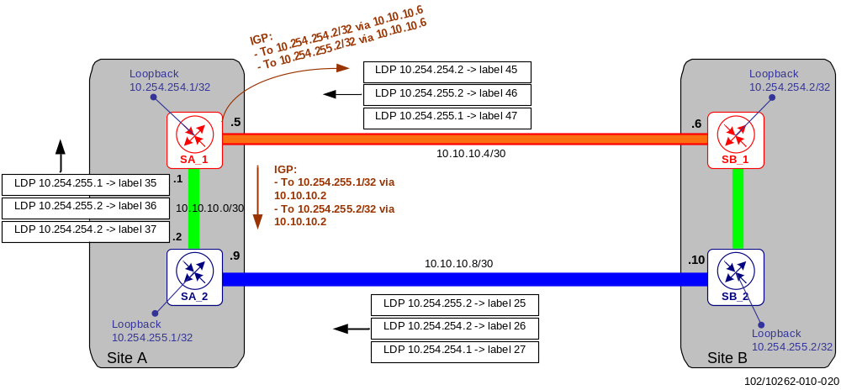
Figure 19 LDP and IGP announcements in SiteA_SR1
With load-balancing enabled, SB_SR2 will be reachable through SA_SR2 (the paired SR, same site) and SB_SR1 (directly connected, from remote site) with equal cost IGP routes. Among the LDP announcements received in SA_SR1, those highlighted in green (Figure 20) will be installed in SA_SR1 (only those for which an active IGP route exists).
Keeping the above in mind, the following LSPs are set up in SA_SR1:
- One Straight LSP “SA_SR1-SB_SR1”
- Two equal-cost crossed LSPs “SA_SR1 – SB_SR2”
- One local LSP ”SA_SR1 - SA_SR2”
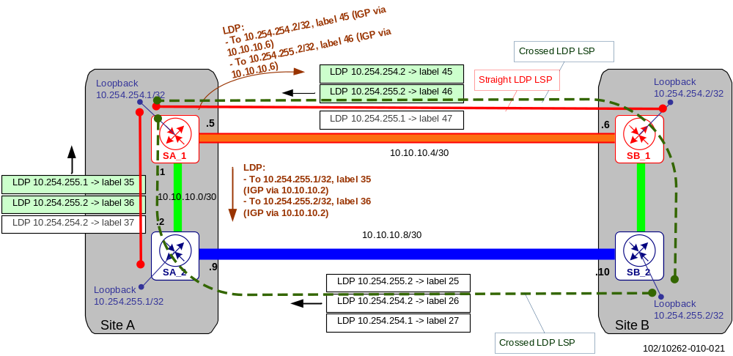
Figure 20 LDP labels installed in SiteA_SR1
The LSPs available in Site A to reach Site B are shown in Figure 21.
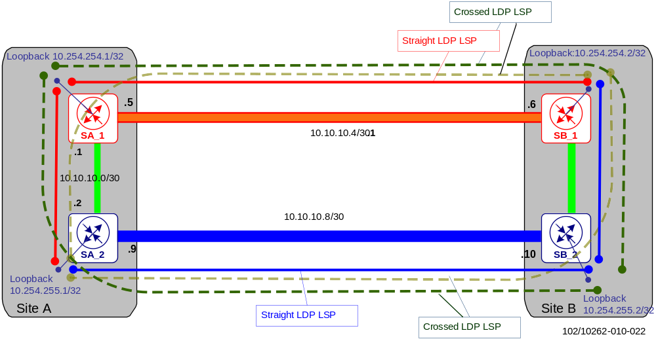
Figure 21 LSPs from Site A to Site B
As shown in Figure 21, two non-fate sharing straight LSPs are set up between sites A and B. The crossed LSPs are always installed as well. If load-balancing is enabled, two equal-cost crossed LSPs are established per router, but this is perfectly acceptable. The LSPs installed in SA_SR2 and SB_SR2 are equivalent.
    - SSR/SmartEdge Configuration
- All core interfaces must be configured under the protocol LDP
- The LDP LSP should inherit the IGP metric instead of using the default LDP metric. This is done by configuring IGP metric tracking under the protocol LDP.
- A router-id shall be configured for LDP which is used as transport address for the LDP session. The router-id can be configured under router ldp. The router loopback address that is re-distributed into the backbone IGP is to be used as router-id.
LDP-IGP synchronization is supported on a per-interface basis for IS-IS and OSPF only. Synchronization is supported on LAN interfaces that are point-to-point interfaces. The synchronization feature must be enabled on both the IGP routing protocol level and the LDP signaling protocol level. To limit the length of time IGP sessions must wait, the timeout values below shall be followed:
- Enable LDP – IGP synchronization under router isis instance or router ospf instance using the following command and timeout value (in seconds): ldp-igp-synchronization timeout 180
- Enable LDP – IGP synchronization under router ldp using the following command and timeout value (in seconds): igp-synchronization timeout 60
LDP Graceful Restart shall also be configured in an EIN Core Transport Network; it protects traffic when an LDP session is lost.
Note: Targeted-LDP (T-LDP) is also used for the dynamic signaling of Layer 2 VPNs (VPWS). It is worth noting that inter-area Label Switching Path extensions are not yet supported for LDP in SmartEdge (SEOS); however, these are supported in SSR (since IPOS13.1).

Traffic Engineering in Core Transport Network
Traffic Engineering (TE) is the process of steering some traffic across the backbone for better bandwidth management and utilization between routers. To implement a scalable and efficient TE methodology, it is essential to gather information about the traffic patterns as they traverse network so that bandwidth guarantees can be established.
To deploy traffic engineering on the IP/MPLS based EIN Core Transport Network, the following requirements must be fulfilled:
- Traffic between Primary sites should never be routed through a Secondary site
- Path diversity: SS7oIP failover mechanisms, which are based on the SCTP protocol, require that two non-fate sharing paths without any common network elements (link or node) exist between any two given sites in the network.
- In any failure case (link or node failure), the traffic should not be diverted through a path that was not dimensioned for it. The way the network is dimensioned guarantees that in the event of any single failure in the blue network, there is enough extra bandwidth in the red network for all traffic classes (except some BE traffic). This means that the alternative path for a failure in the blue network needs to be set up in the red network and vice versa.

Implementation
Traffic engineering, i.e. directing traffic over the desired links according to the aforementioned requirements, needs to consider two levels in an MPLS network. First of all, the LSPs need to be mapped to the right physical links. Secondly, actual traffic needs to take the right LSP to its destination.

End-to-End RSVP-TE Tunnels
RSVP is a signaling protocol that reserves resources for IP unicast and multicast flows, and requests quality-of-service (QoS) parameters for applications. The protocol was extended in RSVP-TE to enable RSVP to set up label switched paths (LSPs) that can be used for TE (Traffic Engineering) in MPLS networks [4].

LSP Recovery Mechanisms
Two main types of network recovery schemes are commonly differentiated:
- Protection
A backup path is pre-established for traffic on the primary path, and when a fault is detected the traffic will be switched over to the backup path
- Restoration (or rerouting)
A backup path is established on demand after detecting a network failure
Both types of recovery scheme can further be classified as local or global repairs with respect to the scope of recovery; see [5].

LSP Layout
End-to-end RSVP LSPs run between the site router’s loopback interfaces. Straight, crossed and local LSPs are defined on each ingress router as shown in Figure 22. By defining straight, crossed, and local LSPs on each PE, a full mesh of LSPs is created.
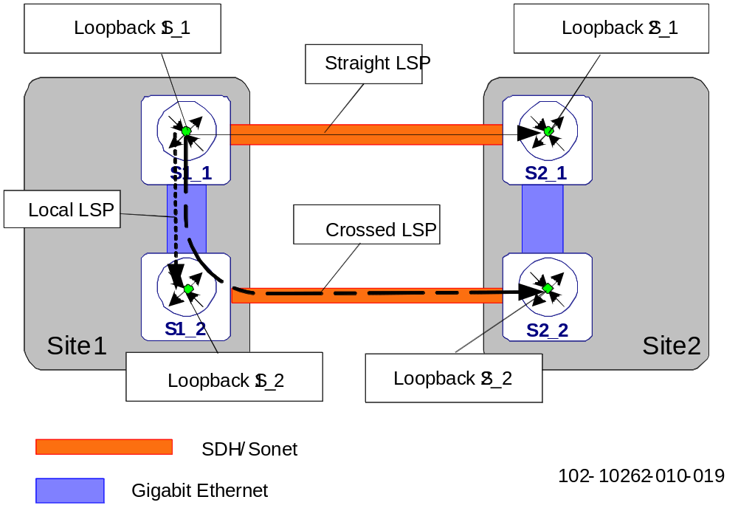
Figure 22 Straight, crossed and local LSPs
Different LSPs are used as follows:
- Straight LSPs: for most traffic streams, these represent the main traffic path in non-failure mode
- Crossed LSPs: for most traffic streams, but these LSPs are used only under specific failure scenarios. For a few other traffic cases these LSPs are used as the normal path in non-failure mode (like SS7oIP in which the SCTP association uses IP addresses announced via crossed routers)
- Local LSPs: for most traffic streams, these LSPs are used only under specific failure scenarios. For a few other traffic cases these LSPs are used as the normal path in non-failure mode (like SS7oIP traffic when the association is using IP addresses in the same site belonging to different IP networks)
Certain service access points may only be present at one of the two routers in the site (e.g. Internet PoP, GRX, etc.). In such case, the crossed LSP is also used in normal, non-failure scenarios. For the other client networks, the crossed LSPs are setup to protect against failures in the site connectivity.
Similarly, the local LSPs can be used in normal scenario but for intra-site traffic (SS7oIP, Internet PoP, Gp GRX access, etc.). For the other client networks, local LSPs are set up to protect against some other failures in the site connectivity.
No bandwidth reservation is used for any of the LSPs. The bandwidth reservation in RSVP-TE does not provide guarantees in the event of congestion. That is, it is a useful mechanism to track the resources that are been subscribed by the LSPs on a certain link, but it does not have any admission control or congestion handling mechanism to assure that such specific bandwidth is available at any time. As it is not possible to over-subscribe links in terms of RSVP-allocated bandwidth, it would be difficult to dimension the LSP bandwidth in such a way that it could also fit in failure cases. This is particularly the case if some traffic classes do not receive a 100% bandwidth guarantee in failure cases. Therefore the recommendation is not to use bandwidth reservation for RSVP LSPs. Instead, it is preferred to provision sufficient bandwidth for normal and failure situations; this is handled through link dimensioning and queue (transmit rate) configuration.
Dimensioning is done so that either the red or the blue half-networks can carry 100% of the traffic guaranteed in failure cases.
LSP Traffic Engineering
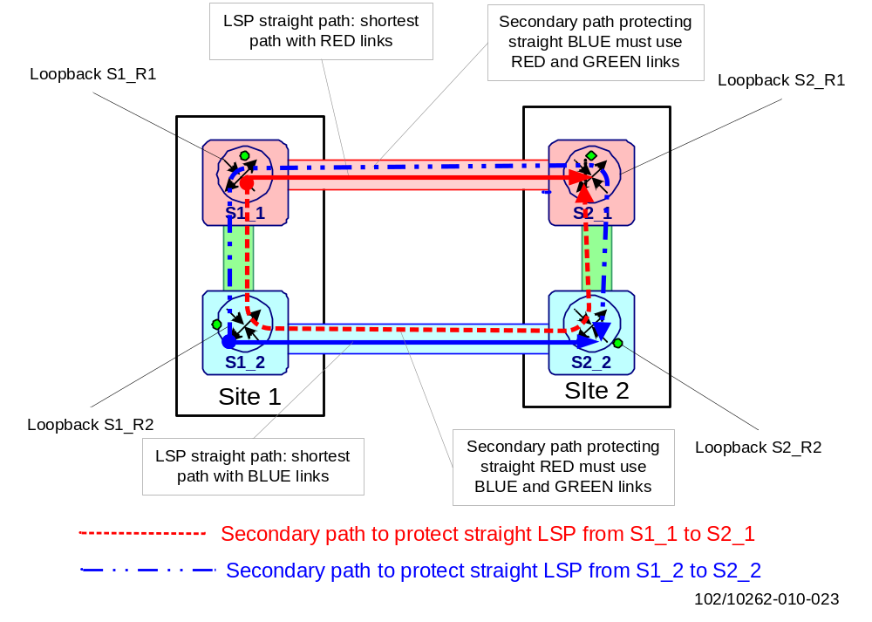
Figure 23 Number of LSPs joining two directly connected sites
As shown in the figure above, straight LSPs are setup with link color constraints to avoid fate sharing and provide path diversity inside the backbone.
The following is configured on the”red”site router in Site 1 (S1_SR1):
Straight LSP:
  - Primary path: exclude blue and green links
  - Secondary path: exclude red links
Crossed LSP:
  - Primary path: exclude red links
  - Secondary path: exclude blue links
Local LSP:
  - Primary path: exclude blue and red links
  - Secondary path: remote straight router as strict next-hop; no color restrictions
The following is configured on the “blue“ site router in Site 1 (S1_SR2):
Straight LSP:
  - Primary path: exclude red and green links
  - Secondary path: exclude blue links
Crossed LSP:
  - Primary path: exclude blue links
  - Secondary path: exclude red links
Local LSP:
  - Primary path: exclude blue and red links
  - Secondary path: remote straight router as strict next-hop; no color restrictions
An identical configuration is needed on S2_SR1 and S2_SR2 respectively.
- Constrained Shortest Path First (CSPF) [5] must be enabled to support link coloring. Traffic Engineering (TE) extensions of the IGP are a prerequisite for CSPF.
By default, LSPs track the IGP metric toward the destination, so that resolution of the BGP next-hop for L3 VPN prefixes always results in the shortest LSP path if several LSPs are available to the same BGP next-hop.
Due to network topology changes or failure conditions it might happen that the LSP path currently used to carry the traffic is sub-optimal and subsequent CSPF re-computations lead to a better path.
- Periodic LSP path re-optimization should be used for CSPF enabled LSPs. If configurable the re-optimization interval should be set to 60s.
- In general the RSVP hello timer should be left to the default value. The use of RSVP hellos is a pre-requisite to support RSVP graceful restart.
The reason for this is that the design does not rely on RSVP hellos for failure detection.
Load Balancing
ECMP load balancing across multiple equal-cost LSPs can be used with the end-to-end RSVP solution. For load balancing, one individual transport LSP per physical link must be created.
    - SmartEdge/SSR Configurations
The basic protocol function, behavior and configuration in the SSR are identical to those in SmartEdge (SEOS) and SSR (IPOS). However, the SSR scales much better than SE in terms of the number of LSPs it supports.
RSVP-TE requires that the RSVP protocol be configured on all site routers for the following interfaces:
- Loopback interface
- Core link interfaces
LSP Traffic Engineering
The SEOS/IPOS support TE extensions on IS-IS and OSPF, thus allowing constrained path LSP computation. Constrained path LSP computation is disabled by default and must be enabled per LSP by using the cspf command in LSP configuration mode under router RSVP.
With CSPF, administrative groups that associated with an LSP must be configured, for which link colors are typically used as values. Each value is associated with a specific class; up to 32 link attributes can be defined.
The administrative groups (link colors) are configured in RSVP configuration mode and applied to the RSVP enabled interfaces. The LSP paths are configured with the link color constraints to which they should adhere using the admin-group command. See the configuration example below (for router P1, which is connected according to the figure below):
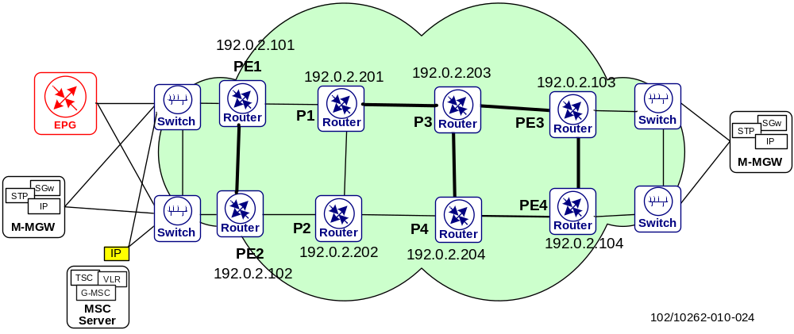
Figure 24 RSVP-TE example
[local]P1(config-rsvp)#
...

router ospf 1
mpls traffic-engineering

router mpls
interface if2P3
interface if2P2
interface ifLB

router rsvp
link-attributes
attribute gold 1
attribute silver 2
attribute bronze 3
constraint gold-service
admin-group exclude silver bronze
constraint silver-service
admin-group exclude bronze
constraint bronze-service
admin-group include-any gold silver bronze
interface ifLoB
interface if2P3
admin-group gold
interface if2P2
hello interval 5
admin-group silver

lsp ToPE3_gold-service
egress 192.0.2.103
cspf
constraint gold-service
lsp ToPE3_silver-service
egress 192.0.2.103
cspf
constraint silver-service
lsp ToPE3_bronze-service
egress 192.0.2.103
cspf
constraint bronze-service
...
LSP Recovery Mechanism
LSP global protection by use of standby secondary path and/or local protection with FRR facility backup tunnels is supported in SEOS/IPOS.
FRR one-to-one backup tunnels as in [37] is not supported.
To restore a primary LSP that is only locally protected with Fast Reroute, the local revertive mode according to [37] is implemented.
Note that secondary LSPs are called backup LSPs in SEOS/IPOS terminology.
With RSVP signaled LSPs the internal notification mechanism between the IGP and RSVP is limited. Even though a control or forwarding plane failure can be detected by the IGP reasonably quickly, causing the IGP adjacency to be taken down, the LSP will stay up until the RSVP has detected the failure by other means (such as, RSVP session timeouts, loss of RSVP Hellos or using RSVP BFD) for forwarding plane related failures that are not directly visible to the router. In this way RSVP can immediately react to link failures if the corresponding port goes down.
- For fast-convergence in scenarios where forwarding plane failures are hidden from the router, BFD shall be used with RSVP on the respective interfaces.
When graceful restart is used, graceful restart needs to be enabled both on RSVP global level and on interface level. On the interface level the RSVP hello interval must be configured. The reason for this is that RSVP hellos are used to negotiate graceful restart capabilities according to [46].
It is useful to note the following specific LSP recovery behaviors in different protection scenarios:
- In a scenario where global protection and local protection are used and there is a link failure directly at the LSP head-end router, the fast-reroute bypass LSP will never be used to carry traffic. Instead traffic is directly shifted to the standby secondary (backup) LSP to avoid further disruption
- After a primary LSP fails and traffic is shifted to a secondary (backup) LSP, the setup of a new primary LSP will be attempted. If CSPF is used, the new primary path must satisfy all the given constraints for the setup to be successful. If the setup fails, retries are scheduled at about 30sec intervals. If a new primary LSP is found traffic is shifted from the secondary to the new primary LSP
- In a scenario where only local protection is used, traffic will stay on the bypass LSP until the failure condition is cleared. No attempt is made by the head-end router to setup an alternative primary path (global revertive mode). After the failure condition is cleared, the PLR reverts the traffic back from the bypass to the original path (local revertive mode) after the configured frr-auto-revert-delay interval has expired; if frr-auto-revert-delay is not configured (i.e. disable) the traffic will stay on the bypass. Due to the different restoration mode implementations (local revertive in the SmartEdge/SSR versus global revertive in other vendors’ routers) interoperability problems might be encountered causing traffic to stay infinitely on a bypass LSP (see [37] for details). Global revertive is the recommended restoration mode in [27][37].
End-to-end RSVP Configuration Summary
- Enable RSVP on backbone loopback and core interfaces; enable all interfaces under router mpls
- Configure straight, crossed, and local LSPs with primary and standby backup paths according to the constraints described in 6.4.1.
- The cspf parameter must be specified for every LSP
- No bandwidth reservation is done for the RSVP LSPs
- To make hello messages function properly, this shall be enabled on the interface and the neighbor to which it connects for RSVP graceful restart. The RSVP hello timer (includes hello interval and hello keep-multiplier) should be left to the default value
- Recommended Refresh-interval for RSVP: 60s
- RSVP LSP administrative distance and priority are left to the default values
It might be worth knowing that the RSVP-TE implementation on SmartEdge/SSR does not support the following features:
- RSVP-TE Refresh Reduction [33].
- MPLS DiffServ-TE extensions [40].
- RSVP-TE Fast Reroute 1:1 backup protection as defined in [37] . Only n:1 facility backup protection is supported.
- Inter-area TE extensions according to the requirements [39].
SmartEdge Specific
SEOS supports MBB in release 12.1; however the following limitations exist for global reversion using MBB:
- MBB is not supported for backup and bypass LSPs.
- If more than 16 RSVP LSPs to the same egress node are present, the MBB performed on any of the LSPs might fail. All types of LSPs (including primary, backup, and bypass) count toward this number.
- MBB is not supported if the old LSP is on a non-link aggregation group (LAG) interface and the new LSP is on a LAG interface, or vice versa.
In addition, during the MBB process traffic loss might occur if:
- The old or new LSP goes down;
- A related process is restarted or a reload switchover is initiated.
LSP path re-optimization is not supported, thereafter there is the problem that traffic will follow a sub-optimal path even after the failure leading to the traffic forwarding along the sub-optimal path is cleared. In such a case
- The only way to prevent traffic flow via a sub-optimal LSP path is to apply extra constraints to prevent a sub-optimal new primary path being set up, thus forcing traffic to stay on the backup LSP until the failure condition is removed.
SSR Specific
The following limitations exist for global reversion using MBB:
- MBB is not supported for backup and bypass LSPs.
- If more than 16 RSVP LSPs to the same egress node are present, the MBB performed on any of the LSPs might fail. All types of LSPs (including primary, backup, and bypass) count toward this number.
In addition, during MBB process traffic loss might occur when:
- The old or new LSP goes down;
- A related process is restarted or a reload switchover is initiated.
The router supports re-optimization on primary ingress LSPs only. Backup LSPs (including backup 2) and bypass LSPs are not supported.

MPLS Layer 3 VPNs
Based on BGP/MPLS, [38] Layer 3 VPNs are used for client network communication in EIN. They are referred to as BGP/MPLS IP VPNs.
For each VPN, VPN Routing and Forwarding tables (VRFs) need to be defined only in those site routers where a connection to a client node belonging to that VPN exists, e.g. ipi VRFs are defined in site routers where a connection to the GRX or a roaming partner exists.
Candidate routers are then configured with VRFs. The following parameters must be configured as part of the routing instance definition:
- A Route Distinguisher (RD) needs to be associated so that advertised prefixes from this VRF can be disambiguated from the same prefixes in other VRFs (overlapping support).
- The interfaces that connect this VRF to the client nodes, e.g. tagged interface on a VLAN, or PVC.
- If through the previous interfaces a routing protocol is run against some or all of the client nodes, the protocol needs to be configured under the protocol section inside the VRF definition.
- A Route Target is one of the BGP extended community attributes and is primarily used to control the distribution (import and export) of routes to and from the VRF. Route Targets allow different VPN topologies (full mesh, partial mesh, hub and spoke). For simplicity all the VPNs defined in the EIN Core Transport Network are configured in full-mesh topology (the same Route Target is used in the export and import statements). Route Targets are included as part of the NLRI information advertised by routers.
- Depending on the protocol used in the PE-CE connection, an additional policy may be needed to control the redistribution of MP-BGP received routes into the PE-CE protocol.
Chapter 11.1 lists the BGP/MPLS IP VPNs used in EIN Core Transport Network. Note that the VPNs for the geographical redundancy of the IMS central module are not included.

Implementing VPN Topologies
Each VPN VRF is configured with Route Distinguisher (RD), either in the form of AS:NNN or IP:NNN, and imports or exports VPN routes with Route-Targets (RT) which are also in the format of AS:NNN or IP:NNN.
The RD is used as prefix for IP routes, and RT are used as filters for importing and exporting BGP routes in and out of the VRF.
When implementing VPNs for different customers, a naming convention for RT/RD is needed, e.g. for the format AS:NNN:

EIN AS number(16bit GlobalAdm) “:” customer VPN ID (16bit LocalAdm)
If one PE shall connect several sites to the same VPN, each customer site is configured with a dedicated VRF and a unique RD. Otherwise the BGP route selection process may lead to loss of routing information.
Depending on the customer’s requirements on the L3 routing topology, certain VPN topologies can be implemented: a full mesh, a partial mesh, hub-and-spoke, and a central services topology. Figure 25 provides an overview of the topologies, which are further discussed in the following sub-chapters.

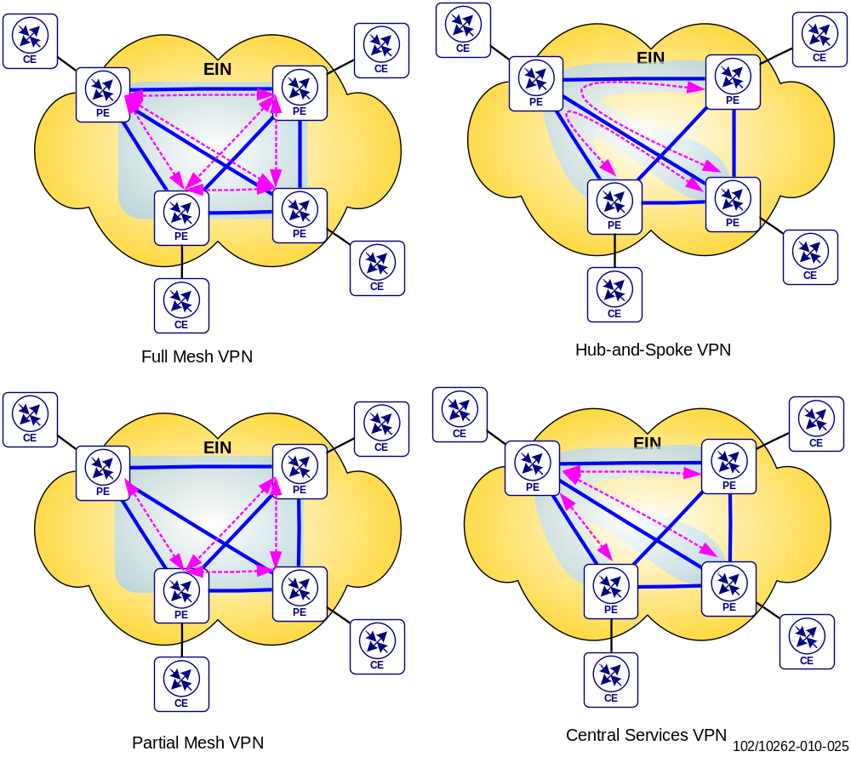
Figure 25 Examples of different VPN Topologies

Full Mesh VPN
A fully meshed VPN exists if all EIN Core Transport Network PE routers configured with a VRF for a specific customer VPN use the same route target in order to export and import the VPN routes. With this approach all CE routers can reach the networks connected to all other CE routers within the VPN. This is the default configuration currently used in EIN Core Transport Network for the mobile core network.
With this approach a customer CE for this VPN can be attached to every PE router in the EIN Core Transport Network backbone. On the other hand, a PE router without attached CE receives and processes unnecessary routing information.

Partial Mesh VPN
In a partially meshed VPN only a subset of the corporate sites within the VPN are logically connected with each other, although they are all part of the same VPN. This can be achieved by using different route targets on the PE routers for different parts of the VPN, as shown in Figure 26.
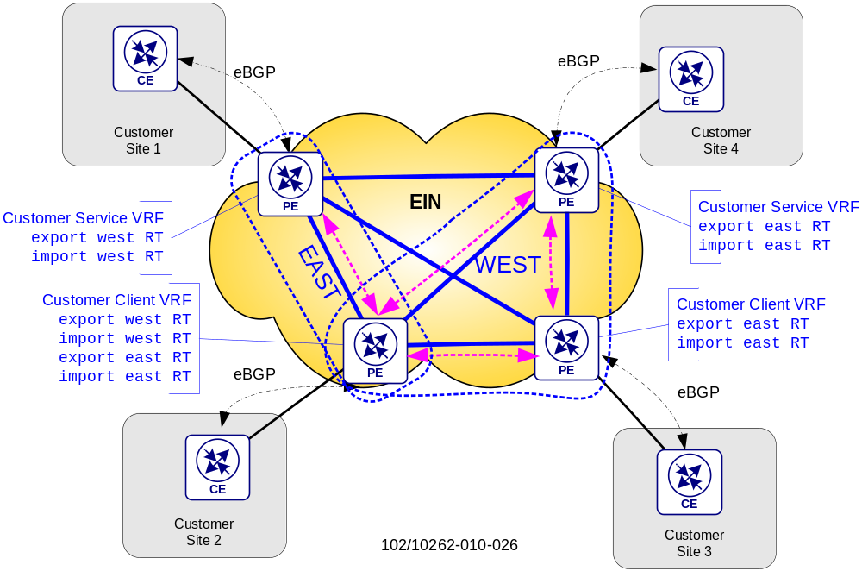
Figure 26 Different Router Targets in a Partially Meshed VPN
The example in Figure 26 divides the VPN into two groups, EAST and WEST. All routers in one group shall be able to communicate with each other. For this purpose each PE router in a group imports and exports routes with a route target defined for this particular group within the VPN. With this approach all routes for networks connected to the CEs in the group are only distributed to the other PEs and CEs within this group.
If a customer site is part of more than one group, all networks learned from the connected CE need to be distributed by the PE with router targets of all groups the site shall be part of. The route targets for all these groups also need to be imported by the PE.

Central Services VPN
In the central services topology the spoke sites are only allowed to connect to the hub site, and not with each other.
In order to implement this topology different route targets are used on the spoke PEs and the services PEs for the same VPN. All spoke PEs use the same export RT, but the PE connected to the services CE uses a dedicated export RT for the VPN. The spokes only import the services RT, and the services PE import the spoke RT. If there are several service PEs, each service PE also imports the services RT.
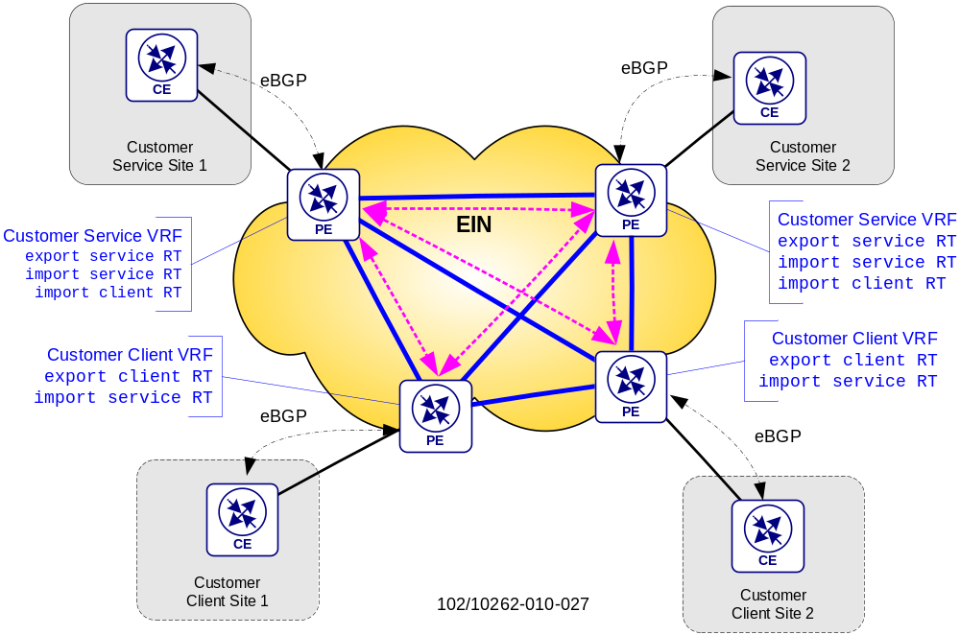
Figure 27 Uses of Route Targets in Central Services VPN
The CE routers on the spoke sites will only learn the CE router on the services site as next hop for all remote networks within the service sites via eBGP. In this way traffic between the spoke sites is prevented, and only traffic to/from the service sites is possible.

Hub and Spoke VPN
The goal of a hub-and-spoke topology is that the spoke sites can only communicate with one or more hub sites, but not directly with each other. Traffic between spoke sites is always routed via the hub sites. This requires that the hub PE router be advertised as next hop for all routes to spoke sites within the VPN.
Similar to the central services VPN different route targets are used on the spoke PEs and the hub PE for the same VPN in order to control the import and export of hub and spoke routes into the PE VRFs. See Figure 28.
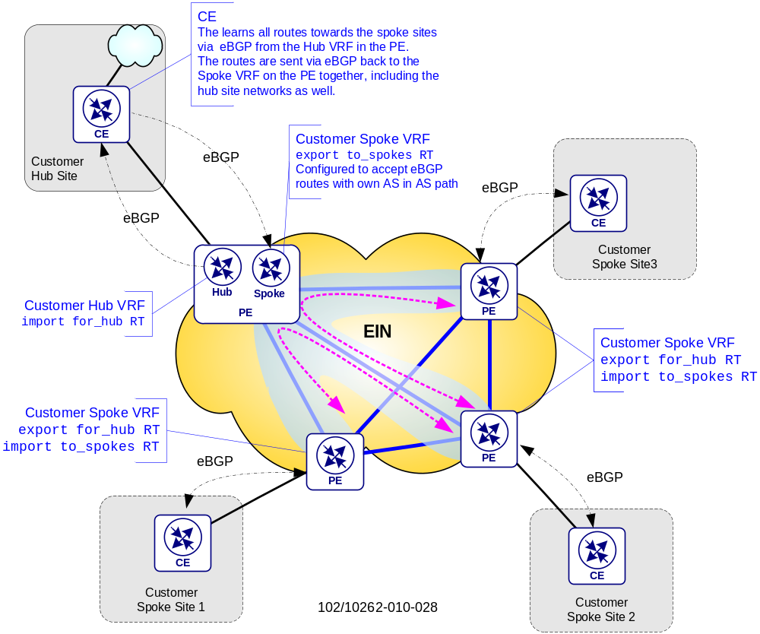
Figure 28 Example of a Hub-and-Spoke VPN Topology
Hub PE Router
The hub PE router uses two instead of one VRF for the same VPN:
- one Hub VRF, which is responsible for
  - importing all VPN routes towards the spoke sites with route target for_hub
  - distributing the spoke routes towards the hub CE via eBGP
- one Spoke VRF, which is responsible for
  - learning the spoke routes and the hub site networks via eBGP from the Hub CE,
  - export all spoke routes and hub site networks via iBGP into the VPN with route target to_spokes
Note that the Spoke VRF needs to be configured to accept BGP routes containing the own AS in the AS path in order to be able to learn the VPN routes towards the other spoke sites, which distributed back into the VPN.
Hub CE Router
The CE router has an eBGP session to the Hub VRF on the PE router and learns all the routes to the spoke sites. These routes are distributed back into the VPN. The Spoke VRF on the PE router learns and accepts these routes towards the spoke sites and registers them, marking the CE router on the hub site as next hop.
Spoke PE Router
The VRF on the Spoke PE routers export the networks learned from the Spoke CE router with a route target for_hub,and import all routes distributed with the router target to_ spokes. In this way traffic between the spoke sites will always traverse the CE router on the hub site.
Figure 29 below show the configuration for the EIN reference network with two CE and two PE routers.
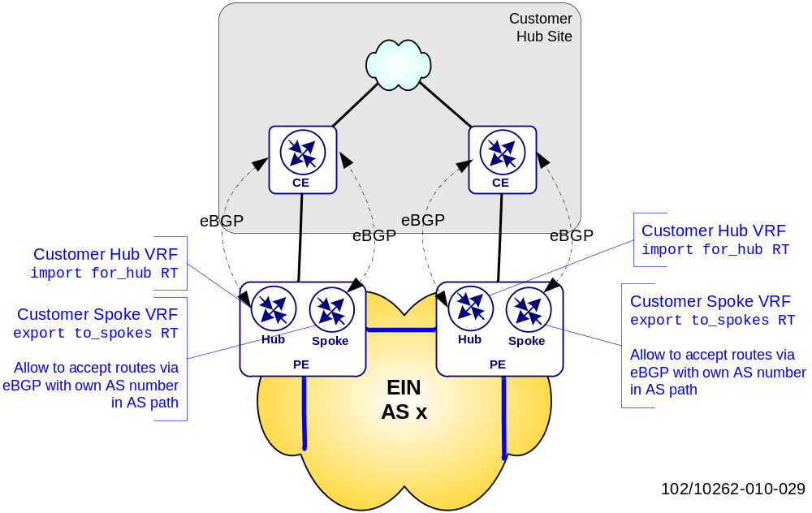
Figure 29 Hub-and-Spoke Roles with two CE and PE Routers

L3VPN over Multi-AS
In a Multi-AS scenario, to enable the exchange of VPN prefixes between customer PE routers or Route Reflectors, the multihop MP-eBGP must be used.
If Route Reflectors are used, it is important that the reflectors do not change the next-hop attribute of the route originator because then they would attract all traffic. Moreover, instead of having a single e2e LSP between customer PE routers, the result is a set of e2e LSPs that are stitched together. This is because changing the BGP next-hop causes the BGP speaker to replace an existing MPLS VPN label with a new one that is forwarded with the VPN prefix to its peers. A transport LSP must be set up toward this BGP speaker as it announces itself as the next-hop for the VPN prefix. The next-hop unchanged feature is supported by most vendors including Juniper, Ericsson SmartEdge/SSR, and Cisco.
It is also important to note that the above recommendation of not changing the next-hop is valid mainly for the RRs that mainly perform the VPN prefix reflection. For the H-MPLS solution described in [9], where RRs are also used to reflect the BGP+label prefixes for the transport, it is required to change the next-hop as this serves a specific purpose. Therefore it is important to note that the RRs reflecting AFI 1/2 and SAFI=128 prefixes do not need to change the next-hop, while for AFI=1 and SAFI=4 it is always necessary to change the next-hop.
The use of different AS numbers indicates that the customer wants to have independent routing domains at each customer network location and that eBGP might be the protocol for route exchange and label distribution (BGP IPv4 + labels according to [41]).
According to [38] there are three different options for implementing Inter-AS VPN services or Multi-AS backbones:
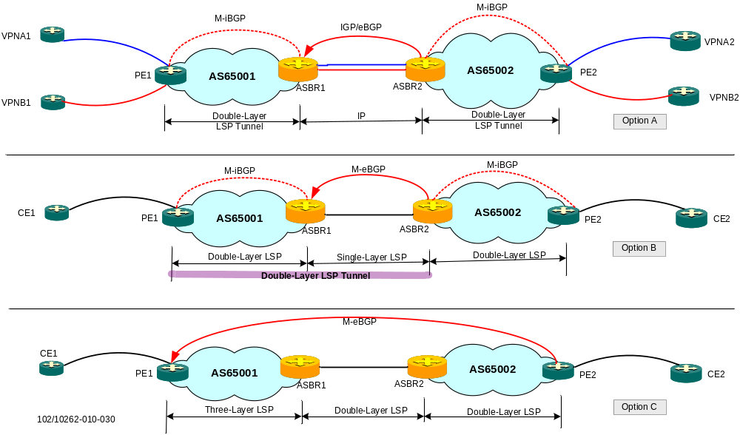
Figure 30 Example of Inter-AS Options described in RFC 4364
Option A) VRF-to-VRF connectivity between ASBRs
Option A) is also known as the “back-to-back” method. As shown in Figure 30, two ASBRs, serve as PE and CE mutually. That is, ASBR1 serves as the PE of AS1, ASBR2 can be regarded as the CE of ASBR1. The same is with ASBR2.
In this model, e2e MPLS forwarding is not possible because traffic is forwarded as IP traffic between the ASBRs.
Option B) MP-eBGP redistribution of customer labeled VPN prefixes between ASs
Option B) is also known as the “single-hop MP-eBGP” method. Inside an AS, normal MPLS/BGP is used to transfer VPN information and construct the LSP tunnel. Between ASs, the single-hop MP-eBGP is used to transfer VPN information and construct the LSP tunnel.
Within the same AS, PE transfers the VPN routing information over MP-iBGP to ASBR; the ASBR transfers the VPN route over single-hop M-eBGP to the ASBR in another AS, which in turn distributes them to the PE in that AS. If multiple ASs are crossed, VPN information is transferred over MP-iBGP within each AS and over single-hop MP-eBGP between each two ASBRs.
This requires the customer ASBR to maintain all the exchanged VPN prefixes in the BGP routing table, as the BGP default Route Target filtering used with VRFs has to be disabled. This will lead to a duplication of VPN prefixes if the customer ASBRs also maintain subsets of those prefixes in dedicated end-customer VRFs (i.e. if the ASBRs also play a PE role). The MP-eBGP session between customer ASBRs must be set up as a multihop session across the provider network, and multihop BGP sessions require further route and label distribution mechanisms to enable MPLS forwarding between the multihop endpoints. This automatically leads to option C).
Option C) Multihop MP-eBGP redistribution of labeled customer VPN prefixes between ASs
Option C) is also known as the “multi-hop MP-eBGP” method. Since BGP only requires a TCP connection to form a BGP neighbor and transfer route information, the Option C method transfers VPN route information between the source and destination PEs directly over multi-hop MP-eBGP, and constructs a public network LSP tunnel between the source and destination PEs.
For this option, VPN information transfer is simple. The information is transferred between the source and destination PEs directly over multihop MP-eBGP. As shown in Figure 30, a multihop MP-eBGP connection is established between PE2 and PE1 and VPN information is transferred from PE2 directly to PE1.
To enable end-to-end MPLS forwarding between the multihop MP-eBGP session endpoints, eBGP (IPv4 + labels) is used to distribute customer internal routing information (i.e. the remote PE or ASBR loopback addresses) with labels between the different customers.
Because VPN prefix redistribution with identical AS numbers is a simple adaptation of the more complex Inter-AS VPN service scenario, the design is based upon the use of different AS numbers for the connected MPLS signaling protocol in the customer and provider ASs.
- LDP is used as the MPLS signaling protocol inside the customer ASs to set up LSPs between customer PE routers.
- Any available MPLS signaling protocol can be used inside the provider network. For this design only LDP is considered.
Note that RSVP signaled LSPs cannot be set up end-to-end between customer PE routers through the Inter-AS VPN hierarchy. RSVP can still be used within the customer network, but only if the RSVP transports LSP is terminated at the local customer ASBR, that is used to exchange customer VPN prefixes with the other customer ASs.

MPLS/VPN Deployment Options and Carrier’s Carrier VPNs
The carrier’s carrier VPN option is another requirement where the transport infrastructure and services are not completely owned by the mobile operator but instead is provided through a separate transport provider. Detailed explanations of various scenarios and requirements associated with MPLS based Carrier’s Carrier VPNs may be found in the IP Backbone design from previous releases [25].

Connecting IPv6 Islands – 6VPE
For a long time IPv4 packet transport has been based on BGP/MPLS IP VPNs (L3VPNs), as specified in previous sections and IETF RFC [38]. As the EIN Core Transport Network solution now increasingly supports IPv6 packet transport, it is natural to make use of the existing L3VPN design for IPv6 transport, aka IPv6 VPN Provider Edge (6VPE).
Extensions to the standard BGP/MPLS IP VPN (for IPv4) model facilitate IPv6 transport for IPv6 enabled VPN customers over a backbone. These extensions are described in an RFC [61] and the mechanism is usually called 6VPE. 6VPE allows the connection of IPv6 VPN sites over an IPv4-only MPLS backbone, using MP-BGP to advertise the IPv6 VPN routes between sites and using the MPLS LSPs for forwarding across the backbone.

6VPE Signaling
6VPE introduces a new VPN-IPv6 address family (AFI=2, SAFI=128) for IPv6 VPN unicast routes, which is similar to the VPN-IPv4 address family (AFI=1, SAFI=128) used with IPv4 MPLS Layer3 VPNs. Both these address families can, of course, be supported over the same BGP peering. The VPN-IPv6 address is a 24-byte entity, beginning with an 8-byte route distinguisher (RD) and ending with a 16-byte IPv6 address. The role and encoding of the RD is exactly the same as with IPv4 VPNs.
When VPN IPv6 prefixes and IPv6 prefixes in general are advertised by a PE, the BGP protocol next-hop address has to be an IPv6 address, see RFC [61]. In this case, the router automatically constructs an IPv6 address in the format of its IPv4 loopback address together with a predefined IPv6 address block. This next-hop address is in a format called IPv4-mapped IPv6 address; an example of an IPv4-mapped address is: ::ffff:192.168.10.101
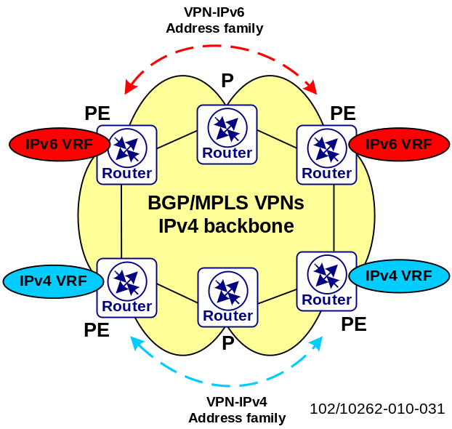
Figure 31 Outlining the MP-BGP signaling for IPv4 L3VPN and 6VPE
In the figure above, the blue color represents VRFs and interfaces which only have IPv4 addresses and its corresponding BGP-4 address family (AFI=1, SAFI=128). The red color represents VRFs and interfaces which only have IPv6 addresses and its corresponding BGP-4 address family (AFI=2, SAFI=128). Both these address families can be supported over the same BGP peering.
The VRFs can be set up on a very flexible basis:
- A dedicated VRF per IP version and per router. As shown in Figure 32, PE3 and PE4 are dedicated per protocol.
- A dedicated VRF per IP version in the same router. As shown in Figure 32, PE1 runs dedicated VRFs per protocol and uses separate interfaces/sub-interfaces for each protocol.
- A true dual-stack VRF in the same router. As shown in Figure 32, PE2 runs a dual-stack VRF on dual-stack interfaces/sub-interfaces i.e. IPv4 and IPv6 protocols; routing and forwarding are running in parallel toward the CE on the same interface. This is a very good and easy start of migration to IPv6 as no new cables or interfaces/ sub-interfaces have to be introduced to the network. This is the recommended variant and one of the design cornerstones, see chapter 7.5.1 and Figure 33.
- Other variants not described here.
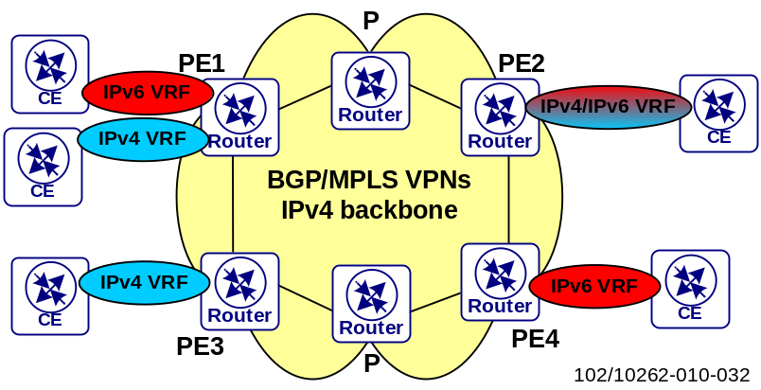
Figure 32 PE routers can be IPv4 VPN only (PE3), IPv6 VPN only (PE4) or can provide VPN service for both IP versions (PE1 and PE2). PE1 has two separate VRFs, one for each protocol. PE2 is using the same VRF for both protocols and also running both protocols in parallel over the same interface/subinterface to the clients
As with IPv4 MPLS Layer 3 VPNs, in IPv6 MPLS Layer3 VPNs, the 6VPE edge routers exchange IPv6 routes using regular IPv6-capable routing protocols (BGP, OSPFv3, RIPng, IS-IS) or can alternatively use static routes.

6VPE Forwarding
The forwarding plane for 6VPE will use (existing) IPv4 MPLS LSPs signaled by LDP (IPv4) and/or RSVP-TE (IPv4). It will be a two-label stack, the same as for IPv4 L3VPN, which means one inner label for the VPN and one outer label for the label switched transport.
Nothing has to be touched in the forwarding plane in the P/PE routers.

PE Router IPv6 Addressing
As the EIN Core Transport Network backbone shall support IPv6 over an MPLS network, the only nodes in the backbone that require IPv6 addresses are the PE routers which are facing IPv6 enabled CE devices. These routers do not require global reachability from the IPv6 hosts, so they do not strictly require a global unicast address to be assigned.
However to make it easy to design (and maintain a design), manage and troubleshoot these devices, it is recommended that global unicast IP addresses be assigned to the IPv6 interfaces of the backbone nodes. This allows ping/traceroute to work from any remote location, which would not be possible with link-local addresses.
- Use Global Unicast IPv6 addresses for all interfaces

6VPE over Multi-AS
When two sites of a VPN are connected to different Autonomous Systems (such as MPLS/VPN in the Access Network HRAN of the mobile backhaul and MPLS/VPN in the backbone), the PE routers attached to that VPN will then not be able to maintain iBGP connections with each other, or with a common route reflector. Rather, there needs to be a way to use eBGP to distribute VPN-IPv4 and VPN-IPv6 addresses. In RFC4364, three options are recommended; see section 7.2.
- 3-label LSP implementation of Inter-AS option C is recommended for the 6VPE over multiple AS scenario.
Because the 2-label implementation is only supported by some router models, this avoids any potential inter-operability problem. See [25] for further information.
This procedure is very similar to the "carrier’s carrier" scenario; it requires that there be a label switched path leading from a packet’s ingress PE to its egress PE.

Connecting IPv6 CE via 6VPE

Design Cornerstones
- 6VPE with dual-stack VRFs
- Use same client structure and design for IPv6 as for IPv4
- IPv4 and IPv6 run in parallel over the same links and sub-interfaces
- IS-IS for the IPv6 is used over the same sub-interface as IS-IS for IPv4-only, IPv6 only or dual-stack case
- OSPFv3 for the IPv6 case is used over the same sub-interfaces as OSPFv2 for IPv4-only/dual-stack case
- BGP-4 native IPv6 peering to Internet
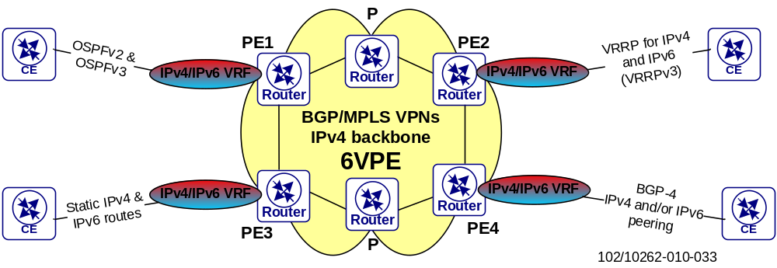
Figure 33 Design cornerstones for evolution to IPv6. Example in PE1: OSPFv2 and OSPFv3 could be running in parallel as CE-PE protocol over the same interface/subinterface in a dual-stack VRF. IPv4 and IPv6 user traffic are encapsulated in MPLS and transported over the IPv4-only backbone

IPv6 Client Connectivity Routing

IPv6 Addressing
This chapter gives a high-level IPv6 addressing plan which could serve as a basis for a deployment. Some details surrounding the EPG on Juniper interface are given to reflect an IPv6 migration for the PS User plane; see [17] for PS IPv6 details.
It is foreseen that global operators should apply for an address block from the different Internet Registries in the regions where the operator is active. This IP address separation into different blocks for a certain global operator shall allow an optimized forwarding when hierarchical routing for IPv6 is used.
The IP addressing plan should achieve:
- Easy identification of the device that is being addressed
- Easy aggregation of IPv6 addresses by keeping the address plan location dependent
- Easy filtering
- Easy growth
IPv6 Range for Documentation Purposes
To reduce the likelihood of conflict and confusion when relating documented examples to deployed systems, an IPv6 unicast address prefix is reserved for use in examples in RFCs, books, documentation, and the like. This address reservation is documented in RFC [66] and RFC [61], and describes the use of the IPv6 address prefix 2001:DB8::/32 as a reserved prefix for use in documentation.

Sub-netting
Taking as an initial assumption that a /32 is a big enough range for a mobile operator, it is possible to map the documentation range (2001:DB8:/32) into the real IPv6 range when deploying an IPv6 network.
2001:DB8::/32 Operator IP address allocation
- Bit 33-48:This range is not used and is reserved for future use. This also makes it possible to use a /48 prefix.
- Bit 49-52:This range is used as Site identifier giving a possibility for 16 sites. To increase this range, take bits from next bit range, the VPN/VLAN portion and reuse the VLAN-ids between sites, for example Gi_IAC_Int_SR VLAN-id=21 for all sites.
- Bit 53-64:This range is used for VPN/VLAN identification giving a possibility for 4096 identifiers. By reusing the VLAN-ids between sites, for example Gi_IAC_Int_SR VLAN-id=21 for all sites, bits from this range can be used by Site-id instead.
- Bit 65-128:This range is used as Host identifier and this covers prefix-lengths of 64-128. /64 is generally the recommendation for all links except PTP where /127 should be used.
Table 3 IPv6 addressing plan summary.
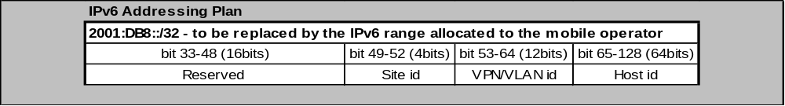

MPLS Layer 2 VPNs
Virtual Private Wire Service (VPWS) [36] and Virtual Private LAN Service (VPLS) [53] are the two available IP/MPLS based Layer 2 VPN services available on SmartEdge and SSR.
Described in [9], VPWS is a point-to-point L2VPN based service that can carry native traffic from one site to another over the IP/MPLS network.
VPLS enables networks at separate geographical locations to communicate with each other across a wide area network (WAN) as if they were connected to the same LAN.
The VPWS implementation has the following properties:
Supported
- Ethernet raw (type 5) or tagged (type 4) mode can be used as Pseudowire type
- Use of the control word is supported but only in the Generic PW MPLS format and not the Preferred PW MPLS format. Sequencing of mis-ordered packets by use of the Sequence Number field is not supported (i.e. the sequence number is always 0)
- VPWS can be setup statically or by using (targeted-) LDP as signaling protocol or on SSR by using RSVP-TE
- Attachment Circuits (ACs) bound to the VPWS must be configured as 801.2Q or 802.1ad encapsulated circuits
- VLAN tag manipulation functions (push, pop, or swap) can be applied to 802.1Q and 802.1ad VLAN tags. P-bit marking of C-VLAN and S-VLAN headers is also supported. Note: If both C-VLAN and S-VLAN P-bits are marked by means of propagation the P-bits in both headers are set to the same value based on the dot1q profile that is applied to the C-VLAN (i.e. P-bit marking through a dot1q profile applied to the S-VLAN is ignored). Moreover, when pushing or swapping VLAN tags on ingress the P-bit marking of the new VLAN header is always 0, i.e. the original P-bit value is currently lost (the remedy for this issue is candidate for SSR 14A).
- Pseudowire redundancy based on [48] can be configured but only for LDP signaled PWs
Not Supported
- Multi-Segment- Pseudowires [59].
- Certain Layer 2 control protocols are currently not forwarded through VPWS Pseudowires or local AC cross-connections; packets carrying corresponding destination MAC addresses will be dropped by the SSR. Most notably: STP domains or IS-IS adjacencies cannot be intersected by VPWS (Note: the list below is incomplete):
  - 01-80-C2-00-00-00/44 Spanning-tree-(for-bridges)
  - 01-80-C2-00-00-02 Slow-Protocols
  - 01-80-C2-00-00-03 Nearest customer bridge
  - 01-80-C2-00-00-0E LLDP_Multicast
  - 01-80-C2-00-00-0F Nearest non-TPMR bridge
  - 01-80-C2-00-00-10 Bridge-Management
  - 01-80-C2-00-00-11 Load-Server
  - 01-80-C2-00-00-12 Loadable-Device
  - 01-80-C2-00-00-14 ISIS-all-level-1-IS
  - 01-80-C2-00-00-15 ISIS-all-level-2-IS
Note: In contrast to the Layer 3 function, which is similar to that in the SE, most of the Layer 2 function has been implemented from scratch for the SSR. The Layer 2 configuration and behavior is thus different from that in the SE.
The SSR VPWS implementation introduces a new service instance construct that is applied to the AC (Ethernet port). The service instance allows control of which Ethernet frames go into the PW (by matching against certain VLAN tags). It also provides the means to apply VLAN manipulation functions.
The configuration fragments to create a simple VPWS without redundancy are shown in the figure below:
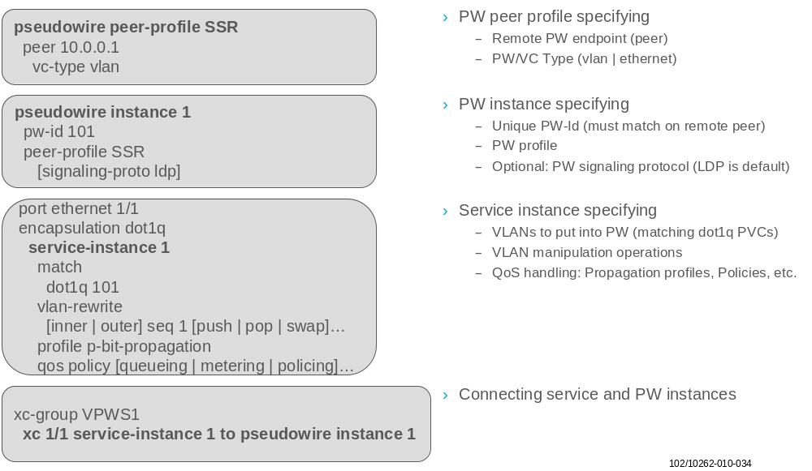
Figure 34 SSR VPWS Configuration Overview
The available PW type vlan (tagged mode) or ethernet (raw mode) has no influence on how Ethernet frames are forwarded through the PW. A frame received on an AC is put as is into the PW unless some VLAN manipulation functions have been applied through the corresponding service instance. In contrast, on the SmartEdge the outer VLAN header is always stripped off when using raw mode (unless certain VLAN transport options are configured in addition), whereas it is preserved in tagged mode.
- For SE – SSR interworking of the VPWS the different VLAN manipulation and PW transport mechanisms implemented on both platforms must take into consideration. The simplest approach is to use PW type vlan (tagged mode) on both SE and SSR to preserve the VLAN header during PW transport
- The control word is used to prevent packet mis-ordering, PW payload mis-interpretation and to support future OAM mechanisms such as VCCV.

VPWS / VLL
VPWS (Virtual Private Wire Service), as described in [54], is a point-to-point L2VPN based service that can carry native traffic from one site to another over the IP/MPLS based Converged Aggregation network. The VPWS service involves two PE routers; each PE router has one VPWS instance created with one AC (Attachment Circuit) and one pseudowire (PW) connected to the remote PE router. VPWS based service PE routers process native traffic received from the ingress AC and perform VPN encapsulation before sending the traffic to the remote PE router. The Ethernet based VPWS service can be either Ethernet Relay Service (ERS) or the Ethernet Wire Service (EWS). ERS takes into account Ethernet based VLAN numbering and offers a frame-relay like service to the end user, with the VLAN number replacing the function of the frame-relay DLCI. EWS delivers a port-based service, such that anything transmitted via the port is transported over a PW, and no specific treatment of VLAN numbers occurs.
The VPWS service uses MPLS based PWs to connect two PE router service instances. Targeted – LDP (T-LDP) is used to perform the PW establishment signaling, the tearing down of the PW, and the notification of the PW status change.
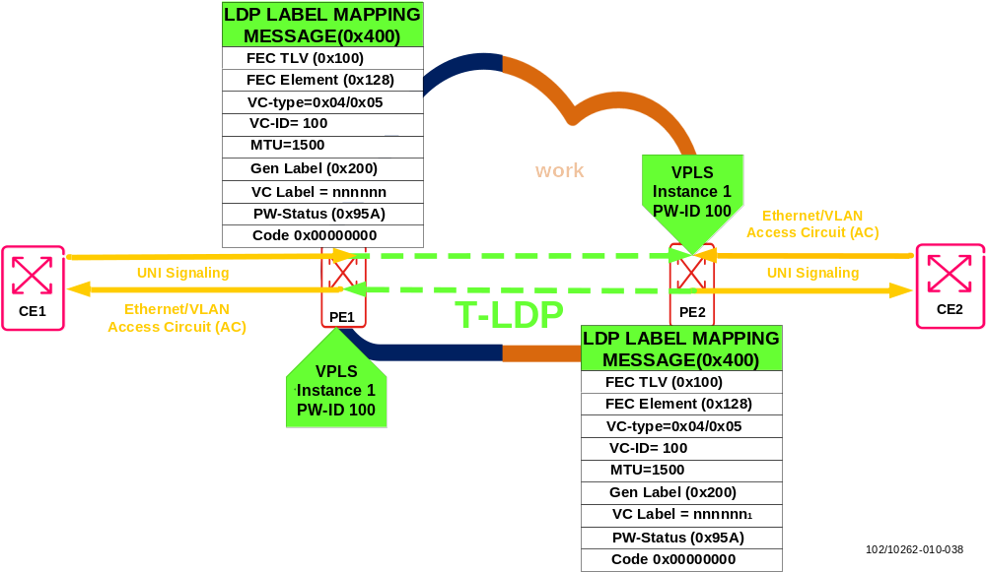
Figure 35 VPWS reference topology

Service Instance Bindings
As shown in Figure 36, specific service instances are configured and administratively enabled under a VPWS main instance to bind the PW to the AC on both PE routers. After this step, the PW establishment process begins. The two non-directly connected PE routers use the T-LDP session to negotiate for the PW setup. Both routers send T-LDP Label Mapping messages to establish the PW. In T-LDP based PW messaging, the PW is called a Virtual Circuit (VC). The use of T-LDP to signal VPN PWs is described in [55] .
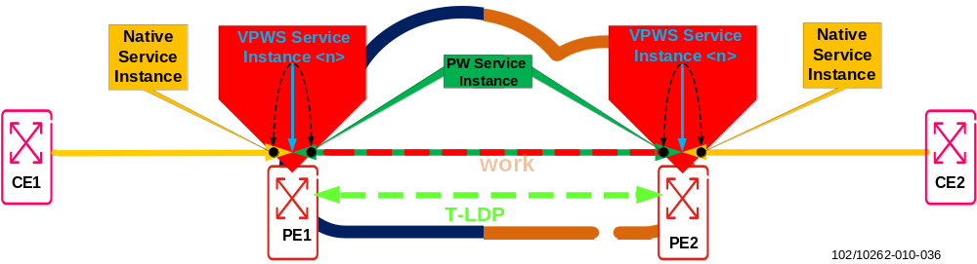
Figure 36 Service Instance Bindings

Signaling for PW Setup
Signaling procedures for point-to-point PWs are most common point-to-point procedures that are executed by the two PW endpoints (PEs). LDP extensions [56] can be defined for PW signaling. This form of signaling can be used for PWs that are to be carried in MPLS "tunnels”. For LDP, a 32-bit label stack entry is simply prepended to the emulated VC encapsulation, and hence will appear as the bottom label of an MPLS label stack. This label may be called the "VC label". The particular emulated VC identified by a particular label value must be agreed by the ingress and egress LSRs, using the signaling protocol (LDP in this case) shown in Figure 37.
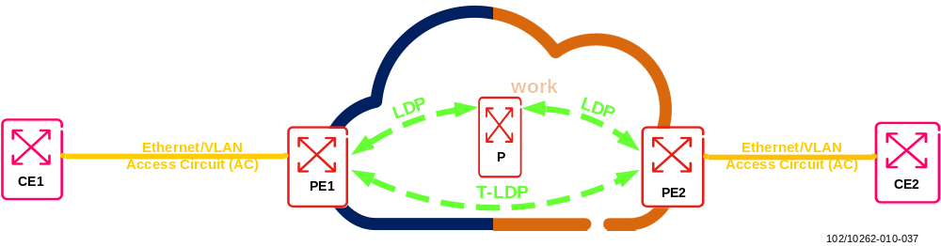
Figure 37 LDP Signaling for PW setup
Before VC labels can be exchanged between peer PE routers, LDP discovery and session establishment must take place.
- LDP Discovery
  - this consists of an exchange of hello messages and allows LSRs to discover each other, forming a hello adjacency. Discovery must be successfully completed before session establishment can begin.
- LDP Session Establishment
  - once LDP discovery has been successful, a two stage session establishment process can begin:
    - Transport connection establishment: a transport connection is initiated by the peer with the higher address (the active peer) to the peer with the lower address (the passive peer), using TCP (destination) port 646.
    - Session initialization: the session is then initialized and parameters such as LDP version and method of label distribution are negotiated.
Once the peering PE routers have established an LDP session, they can exchange label binding messages. VC labels are assigned to local attachment circuits, and the bindings are advertised to the peer (ingress) PE router in an LDP Label Mapping message.
As shown in Figure 38, the two non-directly connected PE routers use the T-LDP session to perform negotiation procedures in order to set up the PW. Both routers send LDP Label Mapping messages to establish the PW. In LDP PW messaging, the PW is called a Virtual Circuit (VC). The VC label binding consists of the VC label itself and associated VC information. This VC information is carried within the Label Mapping message using a new type (type 128) of Forwarding Equivalence Class (FEC) element.
Figure 38 LDP Message Mapping
- The use of a control word is recommended to prevent packet mis-ordering and PW payload misinterpretation

VPWS Data Encapsulation and Forwarding
As shown in Figure 39 , after a successful LDP label mapping exchange and negotiation, along with the clear PW status codes (code 0x00000000), the PW is established between the PE routers and can be used for traffic forwarding. The PW instance configured inside the VPWS service instance on PE1 performs VPN based encapsulation using the vc-label “VL” on the payload received from CE1, and it then forwards it further into the LDP tunnel. The LDP tunnel carrying the PW performs transport based tunnel encapsulation, using the transport LDP label “LL” on the payload, and then sends the frame to the egress PE router.
The payload is now stacked with two MPLS labels and travels across the Converged Aggregation network to the egress PE router (PE2). When the PE2 router receives the traffic, it removes the transport LDP label “LL” and uses the vc-label “VL” as a demultiplexor to identify the traffic’s VPWS service instance. The vc-label “VL” is then removed, and the actual payload Ethernet frame arrives at the native service instance, which sends it further to its destination CE2.
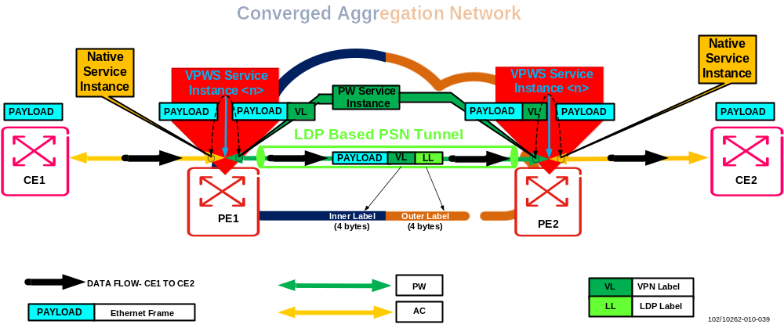
Figure 39 VPWS Data encapsulation and forwarding

Virtual Private LAN Services (VPLS)

VPLS Concepts
VPLS is an L2 multipoint VPN that allows multiple sites to be connected in a single bridged domain over a provider managed packet switched IP/MPLS network. All customer sites in a VPLS domain (that is, a VPLS for a particular enterprise) appear to be on the same Local Area Network (LAN), regardless of their location. VPLS uses an Ethernet interface with the customer, simplifying the LAN/WAN boundary and allowing rapid and flexible service provisioning.
A VPLS creates an emulated LAN segment for a given set of users; i.e., it creates a L2 broadcast domain that is fully capable of learning and forwarding on Ethernet MAC addresses and that is closed to a given set of users. Multiple VPLS instances can be supported from a single Provider Edge (PE) node.
The way VPLS domains are interconnected by pseudowires can follow various topological models. The most frequently used topologies are:
- Full mesh
- Partial mesh
- Hub and spoke
In a full mesh topology, each PE device establishes a pseudowire to every other PE device in the VPLS domain. The full mesh topology provides the most general and versatile VPLS network as it allows communication from anywhere to anywhere else in the whole network. One drawback of a full mesh topology is the large number of pseudowires being established, which potentially limits the scalability of the solution. However, due to the high scalability figures of the SE Routers, this is not considered an issue in practical deployments. Another drawback of full mesh topologies, which it has in common with partial meshes, is the need for loop prevention inside the network. Loop prevention is implicitly done through the VPLS “split horizon” rule, which is explained in chapter 8.2.4.
In a partial mesh topology, loop prevention is generally still needed. The number of pseudowires is reduced because connectivity is only implemented between some PEs, but not between others. A partial mesh topology can be used when the exact use case requires VPLS connectivity only between a limited number of sites.
In a hub and spoke topology, exactly one PE acts as the hub. All spoke PEs have pseudowires toward the hub PE. There are no pseudowires interconnecting spokes directly. Therefore all traffic between spokes must be forwarded through the hub. A hub and spoke topology is by definition loop free. Therefore no loop prevention has to be implemented in the network. In fact, VPLS “split horizon” must be disabled on the hub PE in order to allow traffic forwarding between the spokes. The hub and spoke topology is simple and straight forward, but on the downside, it creates a bottleneck in the hub PE. The PE also represents a single point of failure in the network. Deploying redundant pairs of hub PE often introduces loops into the topology.
Prerequisite for a full mesh topology is a full mesh of MPLS tunnels (LSPs, also called outer tunnels) within the PSN Network. However, if the pseudowire endpoints are immediately adjacent and penultimate hop popping behavior is in use, no MPLS label overhead may be necessary.
In addition, for every VPLS instance configured in a PE, a full mesh of inner tunnels (PWs) needs to be created between all the PEs that participate in the VPLS domain. The creation of PWs allows PE Routers to participate in MAC learning.
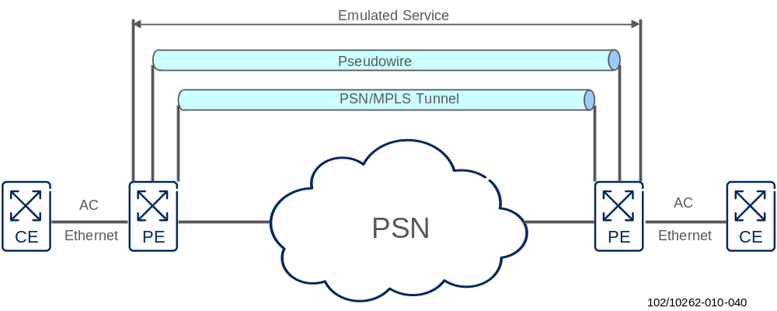
Figure 40 Overview inner (PW) and outer (MPLS) tunnels
VPLS Control Plane Functions
The VPLS control plane has two main functions: discovery and signaling.
Discovery refers to the process of finding all PE routers that participate in a given VPLS domain. A PE router can be configured with the identities of all the other PE routers in a given VPLS domain, or the PE router can use a protocol to discover the other PE routers. The latter method is called autodiscovery.
After discovery, each pair of PE routers in a VPLS network must establish pseudowires to each other, and in the event of topology change, the PE router must be able to tear down the established pseudowires. This process is known as signaling. Signaling is also used to transmit certain characteristics of the pseudowire that a PE router sets up for a given VPLS.
The control plane functions of signaling and maintaining pseudowire labels can be provisioned by either the LDP [55] or the BGP [54] protocol.
The main difference between the protocols is that BGP offers the autodiscovery function; LDP does not.
- LDP is the EIN Core Transport Network reference solution for assigning and distributing pseudowire labels.
The main reason for selecting LDP as the EIN Core Transport Network reference solution is that LDP is basically supported by all vendors while support for the BGP signaling function is limited to a few vendors. Thus in a multi-vendor backbone environment or in inter-operability scenarios between several service providers LDP might be the better, or even the only, solution.
The LDP-VPLS control plane does not support autodiscovery. Therefore LDP-VPLS signaling relies either on manual configuration or on a provisioning system to identify all PE routers to which customer sites are attached.
VPLS Data Plane Functions
Data plane procedures are basically the same for both BGP VPLS and LDP VPLS. For each VPLS instance, a PE VPLS data plane functions as a learning bridge and supports all the standard bridge operations, such as MAC address learning, aging, and flooding.
A MAC forwarding table is created for each VPLS instance on a PE router. This table is populated using a source MAC address learning function and is used to forward unicast VPLS traffic based on the destination MAC address of the received frame.

Control Plane Functions for signaling PW Labels using LDP

LDP Session establishment
[55] describes the use of LDP for signaling of the VPLS endpoints. Targeted LDP sessions between all PE routers’ loopback addresses are used to signal labels for pseudowire tunnels. A pseudowire is a bi-directional logical connection between end points. Therefore it is represented by two LSPs in MPLS, as LSPs are unidirectional. A pseudowire connects the VPLS instances of two PEs.
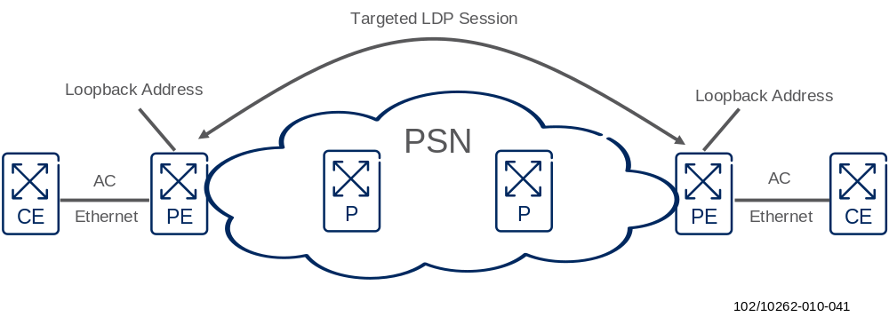
Figure 41 Targeted LDP Session for PW Label signaling
As the current LDP solution does not support auto-discovery the full mesh between all PE routers has to be manually provided. On each PE router the information regarding all other PEs has to be configured by the service provider, this can be done, for example, using a provisioning system.
Any change of topology requires a configuration update on all VPLS PEs.

Attributes of Pseudowires
The LDP protocol is used for setting up and maintaining the pseudowires. Dedicated TLVs, FEC elements, parameters, and codes for LDP are defined in [55] that enable LDP to identify pseudowires and to signal attributes of pseudowires.
The PW label bindings shall be distributed using the LDP “downstream unsolicited” mode. The PEs will then establish LDP Sessions using the extended discovery mechanism.
To distribute the PW label and attributes, a LDP mapping message is exchanged between the PEs. The message contains a FEC TLV, a Label FEC and zero or more optional parameter TLV’s. The FEC TLV is used to indicate the meaning of the label and to identify the particular pseudowire to which a particular label is bound. The FEC TLV contains exactly one FEC Element. There are two Ethernet PW dedicated FEC Elements available:
- PWid FEC Element, Element Type 128
- Generalized PWid FEC Element, Element Type 129
- SmartEdge only supports the PWid FEC Element.Type 128. Therefore Element Type 128 is recommended in EIN Core Transport Network for PW label and attribute information exchange

The PWid FEC element type 128 definition
Figure 42 shows the definition of the PWid FEC element type 128. A description of the most relevant parameters follows.
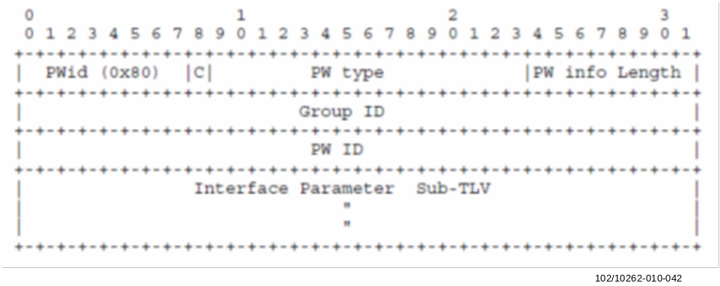
Figure 42 PWid FEC Element
C - Bit
The C-Bit is used to flag the presence of a control word.
During Ethernet PW setup, LDP advertises the control word capability to the underlying PW. If the peer does not have control word capabilities enabled, then the control word is not included in the header of the packets that are sent over the PW later on.
The Control Word is included between the Ethernet Frame and the MPLS labels.
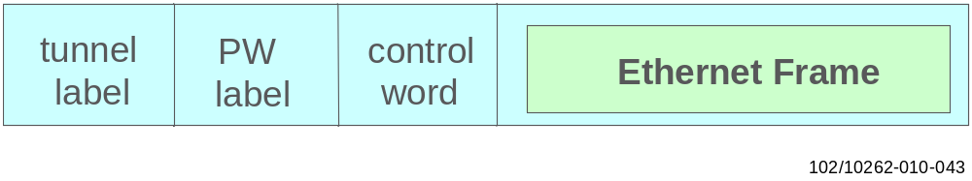
Figure 43 Tunnel MPLS label, PW MPLS label and control word included in the packet
The automatic load balancing operation in an MPLS network depends on both the MPLS LSP signaling protocol and on the capabilities of MPLS routers to go through the MPLS/PW header stack in order to inspect the encapsulated payload.
The following must be considered: PE routers have access to the original payload information and the VPN service context at ingress while MPLS core (P) routers only see MPLS encapsulated packets and are not service aware. Thus P routers are mainly capable of load balancing packets by using the MPLS label stack information.
Some P router implementations also try to guess the encapsulated payload by looking at the first four bits behind the label stack. If a value of 4 is found in this nibble the payload is regarded as an IPv4 packet (i.e. it relates to the version field in the IP header) and the following bytes are interpreted as IP source/destination address for load balancing.
However, such a heuristic opens room for misinterpretation and mainly works with L3 VPNs. With L2 VPNs like VPLS, the respective PWs and MPLS packets carry Ethernet frames and the P router does not know that it is an Ethernet frame as it is service unaware, i.e. it has no information that the PW is related to an Ethernet L2 VPN service.
To prevent such misinterpretations, use of the PW control word is recommended with Ethernet L2 VPN services. The control word enforces either the packet sequencing on transit through the P-core or at least the use of other information for load balancing by P routers, i.e. the MPLS label stack and sometimes also incoming/outgoing port IDs.
- The control word shall be used to prevent packet mis-ordering and PW payload misinterpretation
PW type
Ethernet pseudowires have two modes of operation:
- Raw mode, 0x0004
In raw mode, an Ethernet frame may or may not have an IEEE 802.1q VLAN tag. If the frame does have this tag, the tag is not meaningful to both the ingress and egress PE routers.
- Tagged mode, 0x0005
In tagged mode, each frame must contain an IEEE 802.1q VLAN tag. The tag value is meaningful to both the ingress and egress PE routers.
When an ingress PE receives an Ethernet frame from a CE router and the frame contains a VLAN tag, there are two possible scenarios:
- The VLAN tag is a service delimiter. The provider uses a service delimiter to distinguish one type of customer traffic from another. For example, each service-delimiting VLAN tag can represent a different customer who the provider is serving or a particular network service that the provider wants to offer. Some equipment that the provider operates usually places this VLAN tag onto the Ethernet frame.
- The VLAN tag is not a service delimiter. A CE router or some equipment that the customer operates usually places this VLAN tag. The VLAN tag is not meaningful to the ingress PE router.
If an Ethernet pseudowire operates in raw mode, a service-delimiting VLAN tag, if present, is removed from the Ethernet frame that is received from a CE router before the frame is sent over the pseudowire. If the VLAN tag is not a service delimiter, it is passed across the pseudowire transparently.
In raw mode, all Ethernet frames received on the local PE device are transmitted to the remote PE device on a single pseudowire.
If an Ethernet pseudowire operates in tagged mode, each Ethernet frame that is sent over the pseudowire must have a VLAN tag, regardless of whether it is a service-delimiting VLAN tag.
In tagged mode, the service delimiting tags are used to map Ethernet frames received on the local PE to respective pseudowires.
In both modes, the service-delimiting VLAN tags have only local significance. That is, these tags are meaningful only at a particular CE-PE interface.
When the egress PE router receives an Ethernet frame from the pseudowire, it references the operation mode and its local configuration to determine how to process this frame before transmitting it to the CE router.
If the egress PE is using raw mode, it might add a service-delimiting VLAN tag, but it will not rewrite or remove a VLAN tag that is already present in the frame.
If the egress PE is using tagged mode, it can rewrite, remove, or keep the VLAN tag that is present in the frame.
In both modes, non-service-delimiting tags (C-tags) placed by the customer are passed transparently across the PW as part of the payload.
PW information length
Length of the PW ID field and the interface parameters sub-TLV in octets:
PW ID
A non-zero 32-bit connection ID that, together with the PW type, identifies a particular PW. Note that the PW ID and the PW type must be the same at both endpoints.
Interface Parameter Sub-TLV
This variable-length TLV is used to provide interface-specific parameters, such as attachment circuit MTU.

Data Plane Functions

Forwarding
Ethernet Frames from an AC are classified as belonging to a given instance and the associated forwarding table based on the logical interface over which the frame is received from the CE. Frames are forwarded in the context of the service instance based on the destination MAC address.

MAC Address Learning
In contrast to L3 VPNs where routing information is exchanged via BGP, VPLS learns L2 forwarding information (MAC addresses) like a switch. VPLS emulates a LAN switch and a virtual port is used to emulate a physical port for all traffic via the MPLS LSPs. The virtual port emulates the behavior of a physical port, e.g. traffic can be learned, forwarded, or flooded to the virtual port in almost the same way as traffic sent to a local port. In addition to normal MAC learning the virtual port also has to learn the incoming and outgoing MPLS labels and add this information to the forwarding information database for all MAC addresses reachable via remote PEs.
Unlike IP addresses it is not possible to summarize learned MAC addresses. The maximum supported number of MAC addresses in the VPLS domain and the maximum number of hosts connected to VPLS domain by the CE switches are key figures for VPLS.
It is important to provide an efficient dimensioning for the MAC table size and the MAC table aging timer.
If the table size is configured too small the table limit will be reached and the router can no longer learn MAC addresses; the traffic will be flooded until an old value is removed from the table. The router does not automatically remove the oldest entry from the table; entries will only be removed when they expire.
If the MAC aging timer is too short, an unnecessary peak of flooding packets can occur in regular intervals; in particular if equipment is connected to the VPLS domain which communicates only on demand.
If the aging timer is too long this can result in an unnecessary large amount of MAC addresses being stored in the forwarding database, using memory and in the worst case prevent the router from learning new destinations.
Additionally the maximum number of MAC addresses learned by an interface can be restricted, to prevent the risk that a MAC address flooding on one interface can use the complete FDB space.
The default MAC table size is 512. The default aging time is 300 sec.
For each customer the MAC table size and MAC age timer has to be individually adapted. A dimensioning according to SLF is needed.
Another important factor to be considered is the broadcast domain size as each VPLS service represents a VLAN. Unknown Unicast flooding effects on VPLS bridges can heavily impact connected VPLS customers sharing the same broadcast domain.

Flooding/Broadcast/Unknown Unicast
When a bridge receives a packet to a destination that is not in its Forwarding Information Base, it floods the packet on all the other ports belonging to the respective VPLS Instance

VPLS based Multicast Frame transport
There are issues to transport Multicast Frames over a VPLS with respect to scalability and QoS. Details are described below.
Replication to non-member site:
An upstream PE simply floods multicast frames to all downstream PEs, and the downstream PEs forward them to directly connected CEs; however, those CEs might not be the members of any multicast group. From the perspective of customers, they might suffer from pressure on their own resources due to unnecessary traffic. From the perspective of Network Providers, they would not like wasteful overprovisioning to cover such traffic.
Replication of PWs on shared physical path:
Ethernet frames are replicated on one or more PWs that belong to the respective VPLS instance. This replication is often inefficient in terms of bandwidth usage if those PWs are traversing shared physical links in the backbone.
For example, suppose there are 20 remote PEs belonging to a particular VPLS instance, and all PWs happen to be traversing over the same link from one local PE to its next-hop P. In this case even if a CE sends 50 Mbps to the local PE, the total bandwidth of that link will be 1000 Mbps.
In other words, there are concerns over the scalability of multicast in VPLS today.
Limitations in SE
The multicast replication on SE is performed in a so called “two stage” fashion. This refers to the fact that multicast replication for the egress traffic cards is already performed at the iPPAs (ingress card). For the VPLS based approach, the replication has to be done per PW. If multicast frames have to be put onto e.g. 10 PWs those frames have to be replicated 10 times by the ingress card’s iPPA. As the connection between the iPPA and PMA can only carry 20Gbits’ worth of traffic, congestion can occur on this connection.
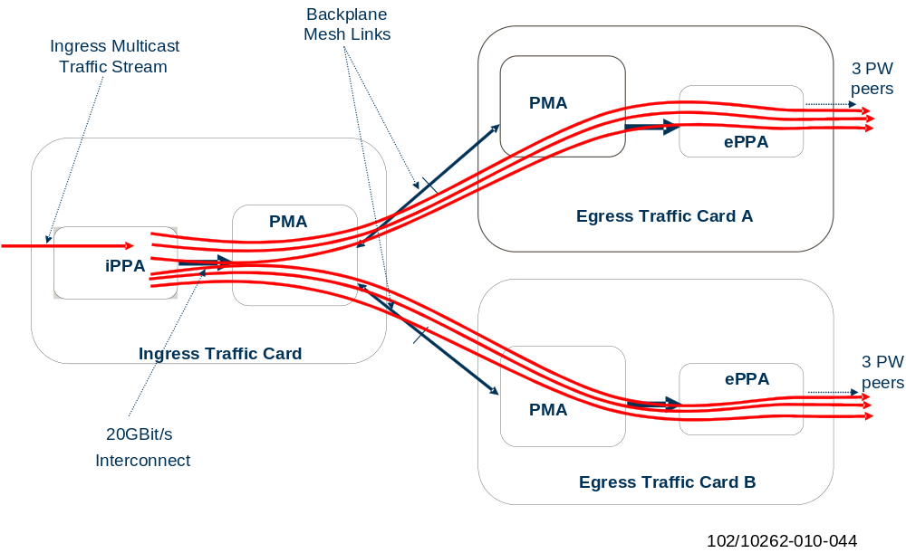
Figure 44 Multicast Replication for VPLS based Implementation
QoS related Issues
Another argument against the VPLS approach is the constraints on QoS capabilities.
Multicast traffic should not affect the QoS that unicast traffic receives and vice versa. That is, separation of multicast and unicast traffic in terms of QoS is necessary.
In a VPLS, cloud traffic with an unknown or multicast destination MAC address will be handled as best effort, i.e. the desired classification and marking as well as scheduling concept cannot be used for multicast traffic.
- Due to its inefficient bandwidth handling and restrictions on QoS capabilities a VPLS based multicast approach has not been chosen for the EIN Core Transport Network. Instead a L3 multicast VPN Service is recommended for multicast traffic.

CE - PE Connectivity and Loop Prevention
Figure 45 shows the two typical scenarios for connecting CE Routers to the PE Routers in an EIN Core Transport Network Site.
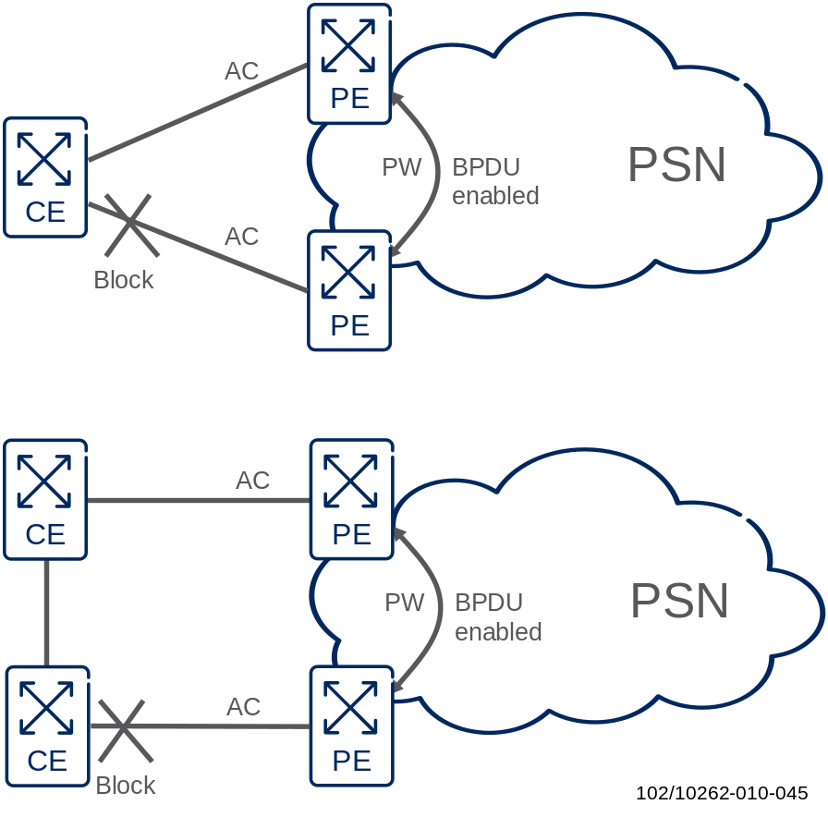
Figure 45 CE – PE connectivity with RSTP Protocol to avoid switching loops
- It is recommended that the CE or CEs always connect to both the PEs in an EIN Core Transport Network Core Site for a redundant connectivity and to follow EIN Core Transport Network rules
- It is recommended that the CEs be connected directly to the PE Routers, i.e. with no switches between them.
Without any countermeasure, switching loops would exist between the CEs and the PEs and also within the provider network.
VPLS uses the “split horizon” rule to prevent forwarding loops inside the provider network in a full mesh topology:
- A PE never forwards a frame received from a PE, to another PE. This requires a full mesh of pseudowires between all PEs participating in the same VPLS.
The split horizon principle only helps to prevent loops inside the provider network. However a customer could still introduce switching loops by building back doors outside the provider network between two peering points in a redundant set-up.
- It is recommended that the RSTP Protocol be run between the CE(s) and the two PEs to create a loop-free environment and to ensure fast convergence in the event of a link failure
- The RSTP shall be configured in such a way that only one AC is active toward an EIN Site; the other AC is passive due to a RSTP blocked port.
Setting up RSTP requires coordination with the EIN Core Transport Network Customer since the Spanning Tree needs to be established over both the Customer and the Provider Equipment.
In order to run a spanning tree between the CEs and PEs, the PEs need to allow transmission of STP BPDUs over the VPLS PW Connection.
If more than one customer is connected to the same PE it is important to ensure that the Spanning Tree domains for each customer are isolated from each other. This is to avoid dependencies between the customers due to the Spanning Tree protocol.
In the SE, separation of BPDUs for different customers can be ensured by configuring a dedicated Bridge Domain per Customer and a dedicated RSTP per Bridge Domain. BPDUs will only be exchanged between the interfaces assigned to the respective Bridge Domain.

VPLS Design Recommendations
The following sections describe a VPLS design based on SmartEdge routers and features available in SEOS software.

Prerequisites for VPLS Set-up
- Every PE router has a loopback interface that is configured with an IP address and a /32 network mask. This address is used as the Router ID in LDP signaling for the PE router.
- PE routers have IP connectivity to each other, and the IP routing tables contain those host routes that were previously configured on the loopback interfaces. This ensures that LDP sessions for pseudowire signaling can be established.

Configuration Steps in SEOS to set up a VPLS Instance
Targeted LDP Sessions
Targeted LDP sessions need to be established between the loopback addresses of all PE nodes in order to exchange labels for Ethernet pseudowires that are transported over MPLS. LDP targeted discovery will be a result of the established targeted sessions.
Configuring VPLS profile
To configure VPLS in SE, a VPLS profile needs to be created. The profile is referenced from the VPLS Instance configuration.
A VPLS profile contains one or more neighbors, with each neighbor defining the attributes necessary to establish a separate peer instance (pseudowire) to a remote PE device. When a VPLS profile is assigned to a VPLS-enabled bridge, the bridge uses the neighbors in the profile to establish the peer instances and enable bridging over the pseudowires.
VPLS-enabled bridge
To create pseudowires in SEOS, a VPLS-enabled bridge must first be configured on each PE router, and then peering (neighbor) sessions can be established across that bridge.
A VPLS-enabled bridge can have multiple peering sessions.
Attachment Circuit Configuration
The treatment of VLAN encapsulation in the ingress and egress PE bridges is determined by attachment circuit definition on the PEs. Attachment circuits are PVCs (VLANs) connecting CE devices into a VPLS service at the PE.
In the EIN Core Transport Network Solution all incoming frames on the PE are assumed to be VLAN encapsulated, either with a single or stacked VLAN header.
- Attachment circuits on the PE device shall be configured as transport PVCs, in order to carry the VLAN tags received from the CE transparently through the bridge.
Note: the attachment circuits defined as transport PVCs are not suitable for carrying non-VLAN encapsulated traffic.

Interface Cards
Since the EIN Core Transport Network recommends using dedicated physical ports for each corporate customer, interface cards with a high port density are needed for EIN Core Transport Network customers that want to offer VPLS to a high number of corporate customers.
In the SmartEdge, the following high density Interface Cards are available:
- 60-port Fast Ethernet (FE) card, which provides 60 FE ports and two Gigabit Ethernet (GE) ports
- 20-port Gigabit Ethernet

Class of Service
The SmartEdge supports mapping of 802.1p and DSCP based classification to EIN Core Transport Network CoS queues.

Rate Limiting
Class-of-Service based Rate Limiting can be applied in the ingress direction to VPLS enabled PVCs on a SmartEdge router.
CoS mapping to respective EIN Core Transport Network queues can be based on incoming p-bit marking or based on the DSCP marking. After the mapping Rate Limiting can be applied per EIN Core Transport Network queue. Traffic exceeding the applied limit shall be dropped or can be classified into a lower priority queue in the case of DSCP based CoS marking.

IP Multicast

Multicast VPNs (mVPNs)
The following standards define the technical solutions for mVPNs:
- Multicast in BGP/MPLS IP VPNs based on Cisco work, see [48]
- Multicast in BGP/MPLS IP VPNs based on IETF work, see [30] and [31]
The former is a purely Cisco driven standard defining the original work on mVPNs (aka draft-Rosen mVPNs) which have been widely deployed in the field for many years. The draft-Rosen mVPN work will not be standardized by the IETF working group. It is of “Informational” status only and used as a reference for interoperability with existing mVPN deployments that were based on this initial Cisco work.
The latter was developed as a joined corporation between Cisco, Juniper and France Telecom and will become the standards track within the IETF. It defines a superset of the draft-Rosen mVPN functionality in [48] and also uses a slightly different terminology.
One fundamental difference between the mVPN standardization efforts is that the Cisco mVPN work in [48] only foresees the use of PIM in the control plane for the distribution of customer multicast VPN routing information between PE routers, while [30] also propagates the use of BGP in alignment with the mechanisms that are in place for unicast VPNs as defined in [38]. Thus, the IETF work truly extends the BGP/MPLS IP VPN service in [38] with multicast capabilities.
From a high-level perspective the mVPN concept can be perceived as a set of hierarchical or stacked multicast trees: customer multicast trees and packets are tunneled through provider multicast trees. End users or multicast servers are the senders and receivers within the customer multicast domain, while in the provider multicast domain the PE routers are the senders and receivers of multicast traffic.
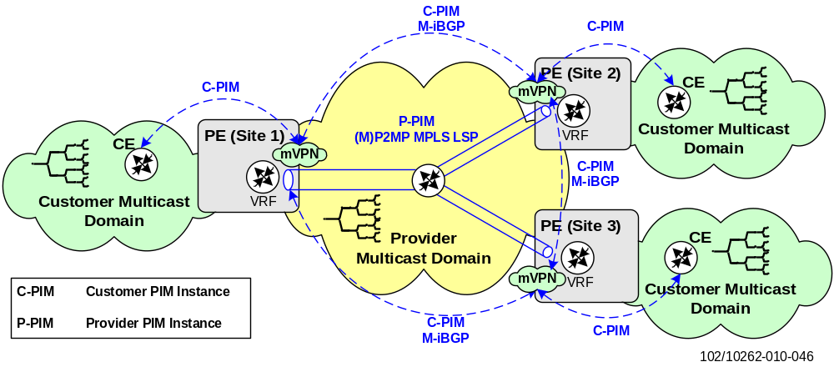
Figure 46 Multicast VPN (mVPN) concepts
If all customer multicast trees running inside the same mVPN are tunneled through a single provider multicast tree, the amount of multicast states to be maintained within the provider network is drastically reduced, which is one key aspect in achieving scalability. The customer multicast domains are logically separated from the provider multicast domain by means of tunneling, and no customer multicast routing information has to be known by the provider core routers.
In the control plane of the provider multicast domain two protocols can be used to exchange customer multicast routes between mVPNs and to steer the setup of the provider multicast trees between the PE routers:
- PIM
- Multiprotocol BGP
Most mVPN deployments use PIM in the control plane for the reason that this control plane protocol dates back to the original mVPN work done by Cisco as defined in [48]. As will be seen later, even when PIM is used in the control plane, Multiprotocol BGP is always needed in addition as certain PIM procedures (e.g. RPF interface check) will use unicast VPN prefix information (e.g. customer multicast source) distributed via MP-BGP.
In the data plane, the following tunneling or encapsulation technologies are envisaged in [30], among others, to transport the customer’s multicast packets through the provider network:
- GRE
- MPLS/P2MP LSPs signaled through RSVP-TE [60]
- MPLS/P2MP or MP2MP LSPs signaled through mLDP [50]
For the same reason as for the control plane, most mVPN deployments use GRE in the data plane to encapsulate the customer’s multicast packets. The majority of existing mVPN deployments are therefore PIM + GRE based.
One or several provider multicast trees can be set up between a set of sites (PE routers) belonging to the same mVPN. The IETF work in [30] denotes these trees (or the respective interfaces between PE routers spanning up these trees) as Provider Multicast Service Interfaces (PMSIs) while Cisco refers to them as Multicast Distribution Trees (MDTs) in [48]. For further details about the terminology and the differentiation into different PMSI-types like Aggregate/Multidirectional/Unidirectional Inclusive-PMSI or Selective-PMSI, refer to the respective RFC standards.
From a bird’s-eye perspective, the main differentiator between Inclusive- and Selective-PMSIs is that inclusive trees carry multicast traffic from all groups in a mVPN to all other PEs that have sites in the mVPN independent of whether there are interested receivers for the traffic or not. In contrast, selective trees only carry multicast traffic from certain groups and only to those mVPN PEs having receivers interested in the multicast flow for those groups.
The purpose of defining different PMSI types is to allow multicast routing optimality to be traded off against scalability in terms of the number of multicast routing states to be maintained by P routers. PMSIs are implemented or instantiated by one of the data plane tunneling/encapsulation technologies listed above. The IETF refers to these PMSI instantiations as provider tunnels (P-tunnels).
Cisco’s Default-MDTs are the equivalent to Multidirectional Inclusive-PMSIs (MI-PMSIs) and the Data-MDTs are the equivalent to Selective-PMSIs. One consequence of mainly supporting MI-PMSIs is that Cisco mVPNs have no inherent knowledge of traffic flow direction. There is no differentiation between sender or receiver only sites with Cisco mVPNs; all sites can send as well as receive multicast traffic. This may be regarded as another fundamental difference between [48] and [30].
In line with the IETF defined data plane encapsulations, Cisco has specified a number of profiles to be used with their mVPN work [48]. These profiles are defined in [49] for the purpose of reducing the number of possible control – data plane technology combinations to a set of recommended ones that should be implemented by all vendors in order to facilitate interoperability.
In the following subsections the focus will be on two kinds of control - data plane profiles because these are the main ones implemented by router vendors:
- PIM + GRE
- Multiprotocol BGP + MPLS/P2MP LSPs
The former profile is related to the Cisco mVPN work that is often referred to as draft-Rosen mVPN. This profile is the only one currently supported by all vendors. The latter profile using Multiprotocol BGP in the control plane is called next-generation Layer 3 VPN multicast (or NGen mVPN). Only some theoretical and non-verified design information will be given in this document. SmartEdge does not support the latter profile.
- The multicast mVPN solution shall be based on the PIM + GRE profile [48].

PIM + GRE Profile
If PIM is used in the control plane of the provider network, two instances of PIM must be differentiated:
- Customer PIM instance (C-PIM) running in the respective mVPN/VRF context
- Provider PIM instance (P-PIM) running in the provider’s Global Routing Domain (GRD)
The C-PIM instance is used to set up the customer’s multicast trees across the different mVPN sites. For each site the customer (CE) only needs to maintain a C-PIM adjacency with its local PE router. To do this, one C-PIM instance runs per multicast enabled VRF on the PE router. The PE router will in turn maintain C-PIM adjacencies with all other PE routers for the same mVPN by tunneling the C-PIM multicast routing information through the provider multicast tree (i.e. PMSI or MDT).
In the remainder of this section the provider multicast tree is referred to as MDT in line with the Cisco mVPN terminology used in [48]. The MDT can be thought of as an abstraction of a LAN to which all PEs implementing a certain mVPN belong. This is needed to enable the C-PIM peering between PE routers as PIM neighbors are always required to be directly connected.
To set up the MDTs one P-PIM instance runs in the provider’s GRD which enables the multicast routing for all customer mVPNs. For the MDT a unique multicast group address (aka P-multicast group) has to be configured in the VRF which associates the MDT with the corresponding customer mVPN.
Note, if the provider uses the PIM-SSM mode for MDT setup, Multiprotocol BGP is additionally required in the control plane to enable the auto-discovery of the sources (i.e. PE routers) for the configured mVPN P-multicast group. Otherwise, with PIM-SM (ASM mode) no auto-discovery of mVPN sources is needed and the PE routers simply join the P-multicast group at the known Provider Rendezvous Points (P-RPs) in order to set up the MDT.
To allow auto-discovery, Multiprotocol BGP was extended with multicast specific NLRIs using AFI=1 (IPv4) or AFI=2 (IPv6) with either the MDT-SAFI (66) as specified by Cisco in [48] or the more generic and flexible MCAST-VPN SAFI (5 - experimental) as specified by the IETF in [30]. The difference between the SAFIs is not only the encoding but also the fact that the MCAST-VPN routes carry a Route Target (RT), while the MDT-SAFI encoded routes do not. So instead of associating multicast source information (i.e. Multiprotocol BGP NRLIs) with mVPNs via RTs this association can only be derived from the configured P-multicast group address when using the MDT-SAFI encoding.
The C-PIM peering between PE routers is achieved by means of the so called Multicast Tunnel Interface (MTI) that interconnects the VRF with the GRD on the PE routers as illustrated below:
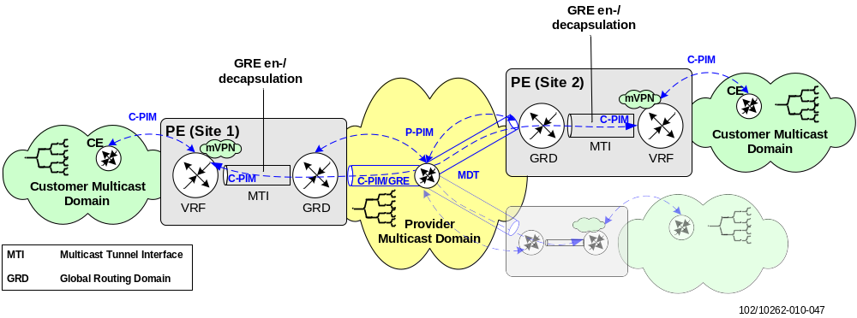
Figure 47 Multicast Tunnel Interface
Before the customer multicast routing information (e.g. C-PIM Join/Prune messages) can be propagated by P-PIM along the MDT, the packets have to be GRE encapsulated when entering the provider’s GRD via the MTI and de-capsulated when leaving the GRD into the corresponding VRF. For the transport across the MDT, the GRE encapsulated packets carry the P-multicast group address of the mVPN as destination and the MTI address as source address.
The MTI is treated by C-PIM like a normal LAN interface, so most standard PIM procedures will apply to the MTI: the interface must be configured for PIM multicast routing, it will be added to the outgoing interface list (olist) for customer multicast routing entries (C-S, C-G) or (C-*, C-G) originating from the mVPN, etc. However, the MTI is not visible in the unicast routing table of the associated VRF.
Because of this the normal Reverse Path Forwarding (RPF) procedure, that checks whether an interface on which multicast packets are received points back to the customer multicast source (on the shortest IGP path) in the unicast routing table, cannot be performed for the MTI.
Thus, the RPF procedure for mVPNs is modified so that the RPF interface is set to the MTI of the mVPN when the customer multicast sources were learned by Multiprotocol BGP.
Determination of the RPF neighbor and PIM adjacencies across the MTI is also slightly different: if the RPF interface is set to the MTI, the RPF neighbor is typically set to the BGP next-hop address of the PE router announcing the customer multicast source and the same address must also appear as neighbor in the C-PIM adjacency table. This is because an RPF neighbor must be an adjacent PIM neighbor.
Therefore the MTI IP address must be identical to the IP address used for the unicast MP-BGP peering between PE routers and C-PIM will use this address as source when sending e.g. Hellos across the MDT to form the neighbor adjacencies.
By default the PE router with the highest MTI IP address will become the designated router (DR) in the mVPN using normal PIM election rules: PIM Hellos are used to elect the DR for a multi-access network. Only the DR will send PIM Joins or Registers from receivers or sources to the customer Rendezvous Point (RP).
Moreover, if two mVPN PE routers were to send traffic from a customer source to different receivers for a certain multicast group, the PIM assert mechanism will be triggered to decide which PE router should be the forwarder, to prevent duplicate multicast traffic from traveling across the provider backbone.
- The IP address assigned to the MTI must be identical to the (loopback) address used for Multiprotocol BGP peering between PE routers to exchange unicast VPN prefixes in the mVPN.
- One unique MTI interface per VRF must be configured for access to the provider multicast domain and MDTs. Note, some implementations automatically create the MTI, deriving the IP properties from the loopback interface that is used for the unicast VPN BGP peering.
- (C-)PIM must be enabled on the MTI as well as on all VRF interfaces connecting multicast customers to the mVPN using the mode (ASM or SSM) required for the customer multicast domain. If sources or receivers are directly connected to the PE router, C-PIM must also be enabled on those VRF interfaces to allow election of the Designated Router (DR). Note that enabling PIM on an interface will also enable IGMP (with the router’s default IGMP version).
- (P-)PIM must be enabled on all backbone interfaces in the GRD. On PE routers it must also be enabled on the backbone loopback interface used for the VPN BGP peering. If (P-) PIM should operate in SSM mode the MDT group ranges that should operate in SSM mode must be specified. Note again that MP-BGP source auto-discovery is required for (P-) PIM-SSM.
- The mVPN must be associated with the MDT (that is the Default-MDT) by use of a unique P-multicast group address per mVPN which is configured in the respective VRF. In consequence, one VRF can only implement a single mVPN.
- The P-multicast group address for the MDT should be taken from the Administratively Scoped IP Multicast address range 239.192/16 (organization-local scope) for use in private domains as specified in [29] . See section 9.3 for IPv4 multicast addressing details.
As the P-multicast group address in the VRF is the only way to associate multicast packets traveling along the MDT with the correct mVPN (and MTI), more complex VPN topologies such as Extranet or overlapping VPNs in general cannot be created. For the same reason traffic from several mVPNs cannot be aggregated into a single MDT without extending PIM with mVPN specific information. The relation between mVPN/MTI and MDT is always a 1:1 or at most a 1:n relation. The latter comes into play when using Data-MDTs.
Two types of MDT can be used with draft-Rosen mVPNs in the provider multicast domain:
- Default-MDT
Used for low-bandwidth multicast services toward widely distributed receivers, as well as for sending C-PIM control traffic between PE routers. There is always a Default-MDT between PE routers for an mVPN
- Data-MDT
Used for high-bandwidth multicast services toward interested receivers (PE routers) in order to avoid flooding of multicast traffic to all PE routers in the multicast domain. Only multicast data traffic (no C-PIM control traffic) uses the Data-MDT. Data-MDTs are set up dynamically between certain PE routers
Whenever an mVPN on a PE router is created, the PE router immediately joins the Default-MDT for the configured P-multicast group address. Because of this the PE router always receives any multicast traffic sent over the Default-MDT, whether or not interested receivers are connected to the mVPN. This is suboptimal for high-bandwidth multicast services as traffic would be flooded to all PEs in the provider network.
To avoid this, Data-MDTs can be dynamically created if multicast traffic exceeds a certain bandwidth threshold on the Default-MDT. For the creation of Data-MDTs each VRF is configured with a set of Data-MDT group addresses.
Data-MDTs are created per (customer) multicast source exceeding the bandwidth threshold on the Default-MDT. It is the PE router where the multicast source is connected that monitors the bandwidth threshold and triggers the creation of the Data-MDTs. The creation of the Data-MDTs consists of two steps:
- Inform PE routers of the Data-MDT
The source PE router must inform the other PE routers in the mVPN that multicast traffic will be switched from the Default-MDT to a dedicated Data-MDT. The receiving PE routers will only join the Data-MDT if they have interested receivers, i.e. receivers that joined the multicast group to which the source is sending traffic. More specifically, there must be a source tree (i.e. (S, G) state) in the customer multicast routing table of the mVPN before the PE switches over to the Data-MDT
- Switch traffic from Default-MDT to Data-MDT
The source PE router will start sending multicast traffic on the Data-MDT by using one of the group addresses from the set of configured Data-MDT multicast group addresses as destination
To achieve the first step, a special kind of PIM-like control message called Data-MDT Join will be transmitted (GRE encapsulated) over the Default-MDT to all PE routers. The message contains as information the customer multicast source and group address as well as the Data-MDT group address (C-S, C-G, Data-MDT group) that the source PE router has picked from the configured Data-MDT address pool. Note that as the Data-MDT Join is sent across the Default-MDT and is evaluated by the C-PIM instance running in the VRF, this in turn triggers the P-PIM instance to join the announced Data-MDT group and to associate the mVPN with the new group address. As stated above, an (S, G) state must be present in the customer multicast routing table before the PE router can switch to the Data-MDT, meaning the customer should avoid using BiDir-PIM as well as setting the PIM-SM SPT threshold to infinity.
While the Default-MDT types can be set up using both PIM-SM modes, SSM or ASM, most Data-MDT deployments use PIM-SSM only (to avoid the initial detour through the P-RP). The source PE address is taken from the Data-MDT UDP signaling. The MTI will be used by both MDT types to send customer multicast traffic across the provider multicast domain.
The Data-MDT Join is sent at periodic intervals by the source PE. Once the injected multicast traffic falls below the configured threshold, the source PE stops sending the periodic Data-MDT Joins and the other PE routers will switch from the Data-MDT back to the Default-MDT after the expiry of a certain timeout period (3 min = 3 times the Data-MDT Join sending interval).
- Data-MDTs shall be used for all high-bandwidth multicast services such as IPTV to minimize the unnecessary flooding of traffic to dormant PE routers.
- The set of Data-MDT multicast group addresses should be unique per mVPN. When using P-PIM in SSM mode the Data-MDT addresses may be shared between different (source) PE routers per mVPN; otherwise with ASM they should be unique per (source) PE router.
- The P-multicast group address for the MDT should be taken from the Administratively Scoped IP Multicast address range 239.192/16 (organization-local scope) for use in private domains as specified in [29] . See section 9.3 for IPv4 multicast addressing details.
When the set of configured Data-MDT group addresses is too small, a group address may be reused by different sources injecting traffic into the same mVPN. As this could lead to suboptimal multicast routing the Data-MDT group address pool should be increased to avoid it. On the contrary, the more Data-MDTs are used, the more multicast routing states have to be maintained by the routers in the provider network.
Note that only PIM-SM (ASM mode) and Default-MDTs have been used for the provider tunnel setup in the verified draft-Rosen mVPN design in EIN, due to some specific vendor limitations as detailed below.
SmartEdge Specifics
The MTI is realized as an intercontext interface connecting to the local context with one end and the mVPN specific context (VRF) with the other end.
The intercontext interface in the mVPN must be associated with the Default-MDT group address. It must also be provided with an IP address matching the address of the loopback interface in the local context that is used for the VPN BGP peering.
As this loopback interface is also used to source multicast packets on the provider MDT it must be configured for GRE encapsulation using the command mdt encapsulation gre.
SmartEdge does not support PIM-SSM to set up the provider tunnels (MDTs), as the necessary MP-BGP extensions (MDT-SAFI or MCAST-VPN) are not implemented.
Data-MDTs are also not supported and thus high-bandwidth data would have to be transmitted over the Default-MDT. Due to this the use of mVPN technology for high-bandwidth multicast services such as IPTV is of limited use and not recommended.
In theory mVPNs may still be used for less bandwidth-demanding multicast services or for a very limited number of mVPNs that are not widely dispersed (from a network topology perspective), considering the necessary bandwidth provisioning aspects on the backbone links involved.
- Although the SmartEdge mVPN implementation has been verified to some extent with respect to its basic functionality and resilience, it shall only be deployed for demonstration and trial purposes.

MP-BGP + MPLS/P2MP LSPs Profile
In this profile Multiprotocol BGP (MP-BGP) is used in the control plane instead of PIM to communicate customer multicast routing information (i.e. C-PIM Join/Prune messages) between the mVPN PE routers. In principle the profile follows the same architecture and similar control plane procedures to those specified for the unicast BGP/MPLS IP VPNs in [38] . All mVPN PE routers are fully BGP-meshed with each other.
An mVPN according to [30] is defined by two sets of sites: a sender site set and a receiver site set. Only hosts in the receiver site set can receive traffic from the senders in the corresponding mVPN sender site set. A site can be in both the sender and the receiver site set. Whether a PE router belongs to a sender or receiver site set is determined by means of provisioning.
In the data plane MPLS encapsulation is used for the transport of customer multicast packets through the provider network. The respective provider multicast trees or tunnels are represented as P2MP LSPs. If available, mLDP [50] could be used as an alternative, depending on the multicast service specific aspects and requirements.
Note that even PIM + GRE could be used in the data plane. The difference from the PIM + GRE profile (i.e. draft-Rosen mVPNs) described before is that (apart from using GRE encapsulation instead of MPLS) PIM is used to instantiate the provider tunnels but not to communicate any customer multicast routing information between the mVPN sites. Combining MP-BGP in the control with PIM + GRE in the data plane might be an interesting option when migrating from the draft-Rosen PIM + GRE profile to an MP-BGP based one.
The MP-BGP control plane in this profile has to perform three essential tasks shown in the figure below. These will be detailed in the remainder of this section (however, details of the MPLS data plane set up using RSVP-TE signaled P2MP LSPs are out of scope):
- Exchange of customer multicast routing information between mVPN PE routers
- mVPN autodiscovery
- Distribution of provider tunnel information
To support the control plane operations for all above tasks, a new address family or NLRI called MCAST-VPN was added to MP-BGP using a SAFI value of 5. The related MCAST-VPN NLRI specific multicast extensions and encodings are defined in [29] .
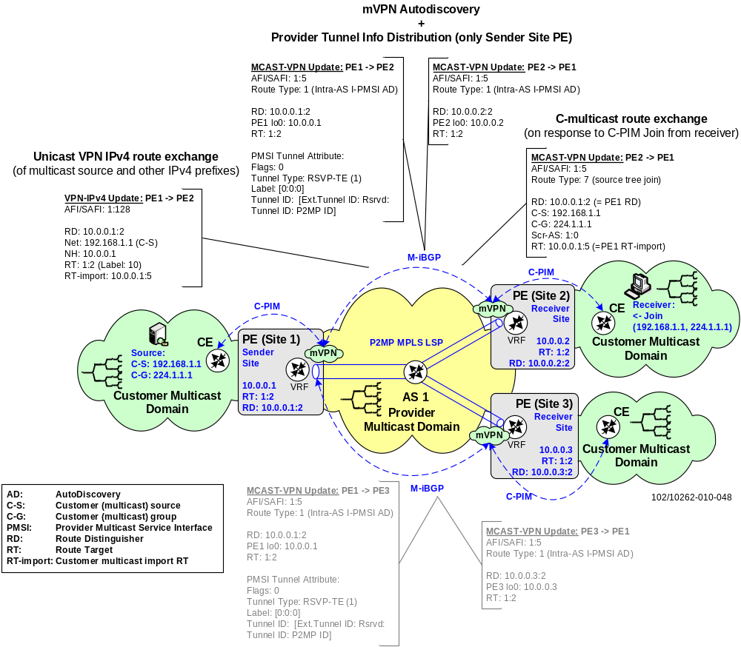
Figure 48 NGen multicast VPN (mVPN) concept – MP-BGP control plane view
PE – PE customer multicast route exchange:
Customer multicast routes exchanged between PE routers are either shared tree joins (C-*, C-G) or source tree joins (C-S, C-G) represented as MP-BGP MCAST-VPN route types 6 or 7. These route types are only meaningful to the PE routers connecting the customer multicast sources (C-S) or Rendezvous Points (Customer-RPs). Thus customer multicast routes will only be imported into the VRF tables of source or sender PE routers while being ignored by any of the other receiver PE site routers.
As with unicast Layer 3 VPNs, customer multicast routes advertised by MP-BGP are attached with a Route Distinguisher (RD) to guarantee uniqueness and a Route Target (RT) that controls the import of routes into the correct mVPN/VRF.
The RT attached to customer multicast routes is called the C-multicast Import RT and is unique across all VRFs and PEs. When a PIM Join is received from the customer, the receiving PE router sends a corresponding MP-BGP MCAST-VPN route with an attached C-multicast Import RT toward the source PE router to which the customer multicast source or Customer-RP is connected. It is this source PE router that is responsible for generating the C-multicast Import RT used by the receiver PE routers as export RT.
The source PE router is identified by receiver PE routers by doing a unicast route lookup for C-S or Customer-RP in the respective VRF. The source PE router communicates the C-multicast Import RT via MP-BGP to all receiver PE routers using the new VRF Route Import extended community attribute, when advertising the reachability to the connected sources C-S or Customer-RPs as unicast VPN-IP address; essentially the VRF Route Import extended community is attached to all VPN-IP routes announced by the source PE. So when the receiver PE performs the unicast route lookup to find the upstream PE router that announced C-S or Customer-RP reachability, it also finds the C-multicast Import RT that was attached by the source PE router as BGP attribute to the C-S or Customer-RP route.
Uniqueness of the RT value is guaranteed by the source PE router embedding its own IP address together with a locally generated number that is different per VRF.
Similar to the PIM + GRE profile, the RPF neighbor and interface has to be determined for each customer multicast routing entry generated inside the VRF. The RPF interface has to point to the respective provider tunnel across which the multicast traffic is transported, which is referred to by a tunnel identifier. The RPF neighbor is the corresponding upstream PE router that is determined from the advertised C-S or Customer-RP VPN-IP routes carrying the VRF Route Import extended community attribute. The procedure for this RPF neighbor determination is called Upstream Multicast Hop (UMH) selection and fully described in [30] .
mVPN auto discovery and provider tunnel information distribution:
For the set-up of the provider tunnels or PMSIs in the data plane it is necessary to:
- Discover the mVPN membership of PE routers, i.e. all the PEs to which the provider tunnels must be extended
- Communicate the mapping of mVPNs or certain (S, G) multicast flows to provider tunnels, the tunnel identifier and tunneling technology (tunnel type) used for transport such as P2MP mLDP LSPs
Because of the multicast dynamics, where receivers join and leave multicast groups at different sites at random, the mVPN membership discovery and mVPN to tunnel bindings must be performed in an automatic way. This is achieved via MP-BGP advertising so-called Auto-Discovery routes (A-D routes; route type 1 for intra-AS operation) using the MCAST-VPN NRLI. RTs are attached to A-D routes constraining these advertisements to the correct mVPNs.
The mVPN membership information in the advertised A-D routes is represented by the corresponding RTs while for the mVPN or multicast flow to tunnel mapping a so called PMSI tunnel attribute is attached to the A-D routes.
The provider tunnels can aggregate customer multicast traffic from multiple mVPNs or transport only certain (S, G) flows from a particular VPN. The latter is referred to as Selective-PMSI and the pendant to the Data-MDTs in the PIM + GRE profile.
If multiple mVPNs are aggregated to the same provider tunnel, an additional upstream-assigned VPN label must be included as part of the PMSI tunnel attribute. This allows the receiving PEs to map the MPLS encapsulated multicast traffic to the correct mVPN, as is the case with unicast VPNs. Otherwise no VPN label is needed. However, an MPLS transport label is always mandatory as only traffic arriving on an MPLS tunnel is mapped to an mVPN. In consequence the use of Penultimate Hop Popping (PHP) of the transport label is not allowed with MPLS encapsulated multicast traffic.
The generation of A-D route advertisements and information contained therein (PMSI tunnel attribute) depends on whether a PE router is connected to a site containing only multicast sources or receivers and on the technology (tunnel type) used to instantiate the provider tunnels, e.g. mLDP.
For example a PE router with connected multicast sources must always advertise A-D routes containing an PMSI attribute, while PE routers with connected multicast receivers may not except when RSVP-TE P2MP LSPs are used as tunneling technology. Then the receiver PE sites have to signal at least the mVPN membership information to the source PE site in order to enable the source PE router to set up the P2MP LSP tree to the correct receiver PE sites. The receiver PE routers will however never include the PMSI attribute in any advertised A-D route. With mLDP as tunneling technology the receiver sites do not need to advertise A-D routes as the P2MP tree is leaf-initiated from the receiver PE sites toward the source PE site.
On receipt of an A-D route with a matching RT value, the source PE router instantiates the provider tunnels toward the receiver PE routers. Receiver PE routers will create respective multicast forwarding states inside the VRF for traffic arriving over the tunnels; the latter is done under the assumption that customer multicast routing information (PIM Join) was already received by the receiver PE router.
This profile is not supported on SmartEdge.

mVPN Technology Comparison
The bullet lists given in this section outline some of the major Pros and Cons that are often brought forward by the advocates of the different mVPN technology camps (draft-Rosen vs. NGen mVPNs).
Draft-Rosen mVPNs (PIM + GRE profile)
Pros:
- The mVPN concept and architecture is well documented and understood
- There are many deployments that are also inter-operable between different router vendors
Cons:
- Two different control and data plane mechanisms must be maintained for VPNs: BGP and MPLS to realize unicast BGP/MPLS L3 VPNs, and PIM and GRE/IP to realize multicast VPNs. To be precise, BGP is also needed for the mVPN operation in order to determine the RPF neighbor.
- PIM adjacencies are set up between all PE routers participating in a certain mVPN, i.e. a PIM adjacency is maintained per mVPN per PE. In addition to the PIM adjacencies that a PE router has to maintain toward the CEs this could impose a scalability issue in large backbone networks. If no refresh reduction mechanisms are implemented periodic Join/Prune messages must be sent between PE routers to maintain the C-PIM soft-state
- Multicast routing state has to be maintained by P routers in the provider network as those are involved in setting up the provider MDTs
- In contrast to MPLS LSPs, traffic engineering with PIM/GRE multicast forwarding in the data plane can hardly be achieved. Traffic always flows along the “reverse” shortest path (RPF) toward the source.
- Without additional resilience related features, the convergence of the provider MDTs is steered by the convergence of the IGP and PIM protocols. This could be in the range of several seconds
- Inter-AS mVPN scenarios require the PEs (ASBRs) in different provider ASs to maintain a direct PIM peering with each other
NGen mVPNs MP-BGP + MPLS/P2MP LSPs profile
Pros:
- The multicasting control plane is completely decoupled from the forwarding plane. Thus a range of tunneling technologies can be used for the multicast data transport
- In the provider network the protocols and concepts known from unicast BGP/MPLS IP VPNs are re-used to implement multicast VPNs
- The use of P2MP LSPs allows for traffic engineering based on constraints or bandwidth of the provider’s multicast distribution tree and also fast failover due to the available fast reroute mechanisms
- Support for different VPN topologies (Intranet, Extranet, hub-and-spoke, inter-AS)
- No PIM multicast routing state needs to be maintained by P-routers in the provider network
- BGP is TCP based while PIM is a UDP based protocol. As such it provides better reliability in the case of packet loss (i.e. no PIM Join/Prune latency in the event of C-PIM packet losses).
- BGP adjacencies only need to be maintained per PE (independent of the number of mVPNs) and not per mVPN per PE as with PIM
- The same DiffServ mechanism as for unicast BGP/MPLS VPNs can be reused, i.e. DiffServ tunneling or pipe model based on the MPLS EXP field. With draft-Rosen IP DSCP based classification is required and the customer DiffServ domain basically leaks into the provider domain
Cons:
- There are hardly any deployments of this mVPN model
- The exchange of a potentially large number of C-multicast routes via BGP could impact other BGP users and the related convergence (i.e. impact on unicast BGP/MPLS VPN route dissemination)
- Two multicast control mechanisms are needed, PIM on the customer and BGP on the provider site. To bridge the concepts of both on the PE routers requires a considerable amount of understanding of both mechanisms

Anycast-RP setup in mVPNs

PIM + GRE Profile
In the original draft-Rosen mVPN profile two types of RPs are differentiated due to the hierarchical PIM approach:
- Customer-RP
The Customer-RP is responsible for the initial (shared tree) set up of multicast flows between sources and receivers in the customer multicast domain
- Provider-RP (P-RP)
The P-RP is responsible for the initial (shared tree) set up of multicast flows between sources and receivers in the provider multicast domain. In the provider multicast domain the sources and receivers are the PE routers configured with mVPNs
The Customer-RP function is typically located on a PIM router that is under the administration and control of the customer in the respective multicast domain. With this at most the configuration of the Customer-RP IP addresses needs to be performed by the provider on the respective mVPN PE routers if the Static RP provisioning model is deployed.
Theoretically the Customer-RP function could also be placed on the PE router residing in the customer multicast domain by providing the corresponding mVPN service. This is called the co-located PE/RP model and requires the PE router to process PIM Register messages and potentially also to act as MSDP peer if inter-domain multicast routing is handled via the PE router. Passing the Customer-RP control over to the provider is certainly not preferred by customers that have existing multicast network deployments.
Depending on the Customer-RP placement it can happen that multicast traffic crosses the service provider network twice: Once from the source to the Customer-RP located in a certain mVPN site and then to interested receivers located in yet another mVPN site. As said before, this (i.e. the RP placement) is not regarded as detrimental even in mVPN scenarios as this only occurs until the last-hop multicast router connecting the interested receivers switches from the shared tree to the source tree.
Two loopback interfaces with their corresponding addresses need to be configured on the Anycast-RP routers in the local context. One interface and address is used as the shared Anycast-RP address referenced by all PIM routers while the other is for the internal active source information exchange. PIM-SM and IGP routing must be enabled for both loopback interfaces.
The Anycast-RP set and shared Anycast-RP address is configured as follows:
context local
pim anycast-rp <shared RP lo addr.> <internal lo addr. of 1st RP>
pim anycast-rp <shared RP lo addr.> <internal lo addr. of 2nd RP>
pim rp-address <shared RP lo addr.>

MP-BGP + MPLS/P2MP LSPs Profile
In this profile the provider core is PIM free and thus only the Customer-RP function is needed as described for the PIM + GRE profile.
The IETF standard for BGP based mVPNs [30] provide an option to avoid the exchange of customer shared tree states or (C-*, C-G) routing information between PE routers. Instead only customer (C-S, C-G) states are transferred so that the PE routers behave as if only PIM-SSM is used in the connected customer multicast domains.
The basic idea behind this approach is that an mVPN can be perceived as a collection of PIM-SM ASM multicast domains that are interconnected across the provider network. In contrast to the PIM + GRE profile, the use of MP-BGP forms a kind of border between the C-PIM instances running in the VRFs on the interconnected mVPN PE routers. The C-PIM adjacencies are not extended across the provider network and set up between the PE routers in different mVPN sites as this would result by default in having only a single multicast domain including all customer mVPN PE sites. With MP-BGP only the customer mVPN sites connected to the same PE including the PE router itself build the multicast domain.
The exchange of active multicast source information between the different PIM-SM ASM domains is typically done using MSDP. If the PE routers exchange this information about active sources (per multicast group) among each other in a similar way, then they can build source based trees (SPTs) back to the PE routers in other sites.
In consequence, whenever a PE router receives a shared tree (C-*, C-G) Join from a connected CE router, it switches the multicast flow directly to the SPT across the provider backbone for any source sending traffic to ‘C-G’. The appeal of this is that the traditional SPT switchover initiated by the customer leaf-router is local to the site and has no impact on the provider network (i.e. no BGP signaling required) as the SPT already begins at the PE router hosting the connected customer site and multicast domain. Moreover, BGP does not have to deal with the signaling and procedures related to the SPT switchover and pruning of the shared tree.
To support the exchange of active source information between PE routers, a new route type called Source Active autodiscovery route that is carried in the MCAST-VPN NRLI was introduced in MP-BGP.
The PE routers know about active sources either by deploying the Customer-RP function on the PE router (i.e. the co-located PE/RP model) or by using MSDP between the Customer-RP and the PE router connecting the multicast domain where the Customer-RP resides. In the latter case the PE router is just made source aware for the purpose of distributing the Source Active autodiscovery routes via MP-BGP, but it does not host any Customer-RP functions.
As the Source Active autodiscovery routes do not carry any information about the site where a source is located (this is known to the PE router since the source IP information is exchanged via unicast VPN-IP routes), the Customer-RP and source are not required to be located at the same site.
This profile and BGP based Source Active discovery mechanisms are not supported by SmartEdge.

Multicast IP Addressing
The multicast IPv4 address range assigned by IANA consists of the old class D network address space 224.0.0.0/8.
The IP address range in subnet 224.0.0.0/24 is reserved for use by network protocols on a local network segment such as OSPF, PIM, etc. These IP addresses have link-local scope and are never forwarded by routers.
For other network protocols and multicast applications IANA has reserved the 224.0.1.0/24 address range (Internetwork control block [35]). These addresses are not of link-local scope and thus can be forwarded by multicast routers.
Due to the limited multicast address space the 239.0.0.0/8 sub-network is reserved as administratively scoped multicast addresses [29] for use in private multicast domains. This address range consists of two well-known scopes:
- IPv4 local scope 239.255.0.0/16 with possible expansions
This is the smaller scope (aka site local scope) to be used within an enterprise or organization. This should be used by multicast applications within a site, for example spanning one or several buildings.
- IPv4 organizational scope 239.192.0.0/16 with possible expansions
This address space is to be used in an enterprise or organization for inter-site multicast applications that run regionally or globally in the enterprise network. The mVPN MDT or PMSI group addresses are an example of such inter-site multicast applications
- As those administratively scoped addresses can be re-used in different multicast domains, forwarding or leakage into and out of the private multicast domain must be prevented by establishing scope boundaries.
This is performed by applying multicast filters (ACLs) on the interfaces of the domain border routers that, for example, deny the forwarding of multicast traffic for multicast groups used inside the private domain. Implementing scope boundaries is also beneficial for security reasons.
On Ethernet segments there is a 32:1 overlap of IP multicast to Ethernet MAC addresses. Thus the simultaneous use of addresses in the following ranges [224-239].0.0/23 and [224-239].128.0/23 should be avoided in Ethernet Layer 2 networks (even though the ambiguity will be sorted out when processing the frame on Layer 3).
Other important reserved multicast address spaces are:
- GLOP address space 233/8 [35]
This statically assigned multicast address space is to be used by multicast content providers (publishers and ISPs) or anyone that wishes to source content on the Internet. The 2nd and 3rd octets of the 233/8 address range are to be set to the Autonomous System number of the content provider. The 4th octet is a locally assigned number that can be used to source the multicast traffic. However, with only 256 multicast addresses available to each autonomous system, GLOP is not adequate for large-scale broadcasters.
- PIM-SSM Inter-domain address space 232/8 [44]
This address space is to be used by source-specific (one-to-many) multicast services and protocols. PIM, RPs and DR routers in a multicast domain adhering to this address space must be instructed to block shared tree joins (*, G), reject PIM registers or avoid forwarding multicast traffic across the shared tree to this address range.
- Service providers offering one-to-many (SSM) or many-to-many (ASM) multicast services to customers within their private multicast domain shall use the administratively scoped address range 239/8 considering the respective scoping (local or organizational).
- Service providers offering public one-to-many multicast services shall use the PIM-SSM address space 232/8. For public many-to-many applications the GLOP address space 233/8 shall be used following the IANA assignment rules.
The use of and request for public multicast addresses in the 224.0.1.0/24 and 224.0.2.0 – 224.0.255.255 (Ad-hoc block [35]) should be avoided.
A comprehensive overview and guideline on IP multicast addressing is given in [51].
Scope boundaries are applied by configuring ACLs listing the multicast groups for which traffic is allowed to traverse across interfaces at domain borders. The ACLs are applied to interfaces via the ip multicast boundary ACL command.

Resilience in Multicast Networks
Resilience can mean a lot of things but this section only covers aspects specific to IP multicast control and forwarding. Hardware redundancy in each node, for instance, is not covered in this section. Multicast networks can be split into different areas in which different mechanisms are applied for resilience.
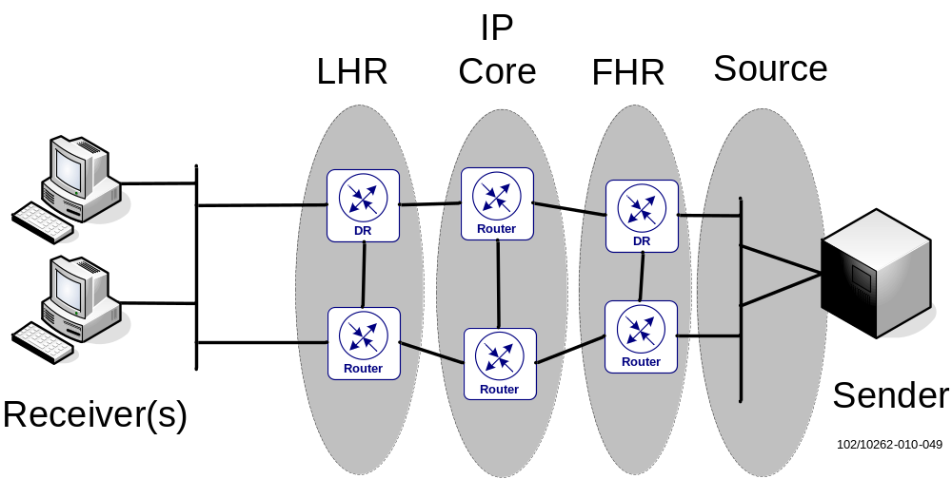
Figure 49 Different areas in a multicast network where resilience can be applied in different ways. Resilient RP set up is not shown here
- Resilient sources – Sources can be multi-homed i.e. having dual interfaces to redundant routers
- Resilient First Hop Routers – Since both FHRs announce the source IP address into the IGP, the PIM Join message from an LHR will be routed to the closest FHR. If an active FHR goes down, the multicast trees have to re-converge to new paths and this will give some outages. PIM convergence time is around a minimum of 200 ms for initial detection and then between 500 up to 4000 tree converges per second.
In an evenly distributed network, dual FHRs would also give some load-sharing over both FHRs for a specific source.
- Resilient RPs – redundant RPs using the Anycast-RP setup described in section [6] are recommended.
- Resilient IP Core – the same applies here as for the FHR case i.e. in the event of link or node failure the IP Core routers (PIM) have to reconverge the multicast trees. Another option for fast failover could be to use RSVP-TE P2MP LSPs with FRR. As RSVP-TE P2MP LSPs are signaled from the headend, headend/FHR failures are not covered by FRR
- Resilient Last Hop Routers – Receivers can have multiple LHRs for redundancy. If the receiver’s DR goes down, the second router on the LAN will be designated and send a PIM Join to the upstream router. A special case of LHR upstream link-protection (RPF interface protection) is SEOS PIM Dual Join mechanism; see below for details.
SEOS PIM Dual Join can protect the LHR’s upstream interface by adding a secondary RPF interface. A PIM Dual Join router will send one PIM Join out of the primary RPF interface and one PIM Join out of the secondary RPF interface. The router will therefore receive two identical streams and drop the stream received on the secondary RPF interface. In the event of a link or BFD failure on the primary RPF interface, the secondary RPF interface will be chosen and the second stream forwarded.
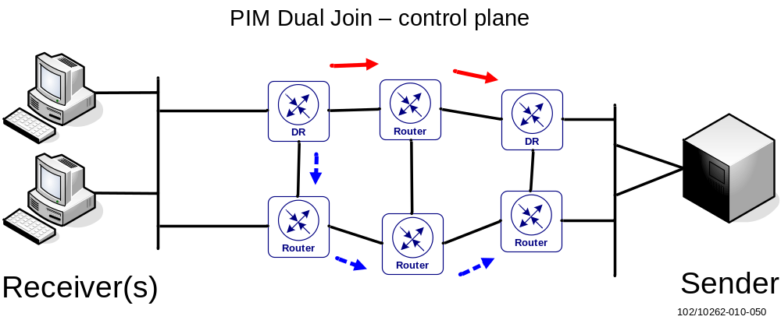
Figure 50 Two PIM Joins are sent by a PIM Dual Join Router toward the FHRs. Red arrows denote a PIM Join being sent out of the primary RPF interface while the blue, dotted arrows denote the secondary PIM Join.
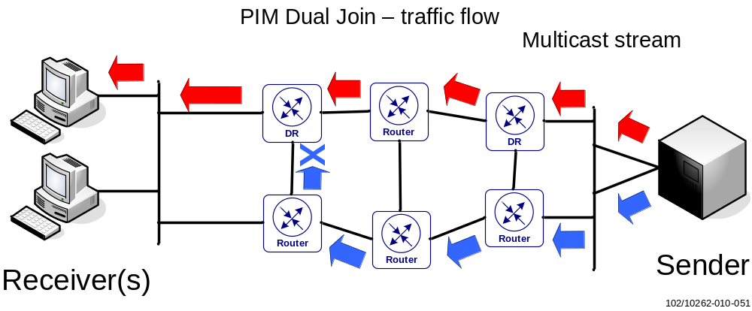
Figure 51 Two identical streams, red and blue, are received by the PIM Dual Join router and the stream (blue) arriving at the secondary RPF interface will be dropped.
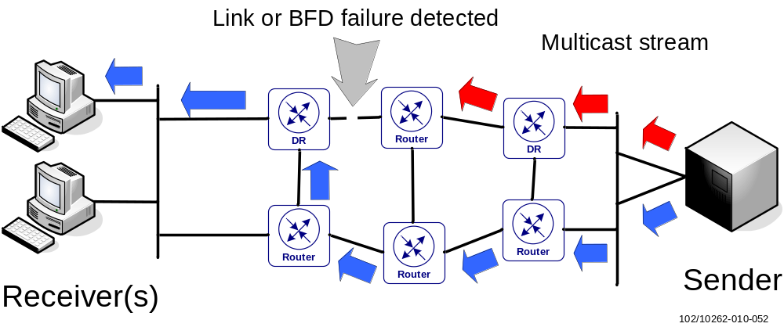
Figure 52 A link or BFD failure occurs on the primary RPF interface and the LHR will immediately start forwarding the second stream (blue)

IP Multicast Security
Attacks by Sources
- ASM – unwanted sources can attack groups on source first-hop routers and RPs. Multicast control traffic (PIM) between first-hop router and RP is unicast hence an attacker can be anywhere. Hosts should not be allowed to run PIM outside the PIM domain.
- SSM – no attack by unwanted sources since traffic will stop at first-hop router
Attacks by receivers
- Attack against content – receive content unauthorized
- Attack against bandwidth – Overload network bandwidth by subscribing to many streams, thus potentially affecting other receivers
- Attack against routers and switches – overload multicast state tables which then could affect convergence times
Bullets 2 and 3 can be stopped by filtering and protecting the control plane at the receiver side.

IGMP Security
Good: IGMPv2/v3 are normally running as link local multicast address, 224.0.0.1 (all-systems multicast), 224.0.0.2 (all-routers multicast) or 224.0.0.22 (IGPMv3 multicast) with an IP time-to-live of 1 meaning that IGMP messages will not be routed.
Bad: IGMP membership queries can be forged by a host on the LAN and this could trigger a response storm from other hosts on the same LAN. L2-per-port control is required to filter these.
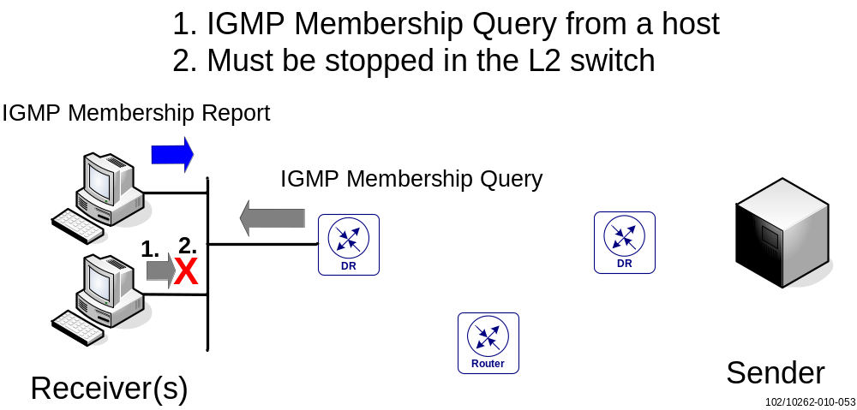
Figure 53 IGMP Membership queries from hosts must be filtered by the L2 switch. Only routers should be allowed.

PIM Security
PIM multicast packets
PIM multicast packets like Hello, Join/Prune, Assert, Bootstrap, DF-elect are all link local multicast to All-PIM-Routers (224.0.0.13) with a TTL=1 which means attacks must originate on the same subnet. PIM control traffic should be filtered and denied from users.
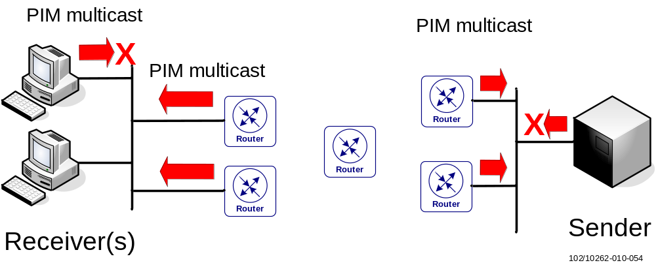
Figure 54 PIM multicast packets must originate on the same subnet and can be quite easily stopped from hosts. For instance, filtering per port in the L2 switch
PIM unicast packets
PIM unicast control packets are valid only for PIM-SM in the following scenarios:
- PIM Register; where unicast traffic is sent from DR to RP
- PIM Register-Stop; where unicast traffic is sent from RP to DR
- PIM Candidate-RP (C-RP) advertisement: Unicast from C-RP to BSR
PIM-SM unicast can be attacked from anywhere and PIM control traffic should be filtered and denied from users. To further reduce the risk of attacks on PIM Register traffic, the DR can also be configured to be RP and run MSDP toward the “real” RP if necessary.
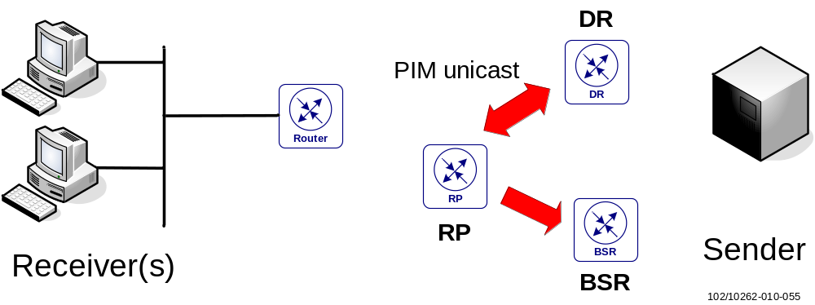
Figure 55 PIM unicast packets whereabouts in a PIM-SM scenario

QoS Implementation
Multicast packets are treated with the same DiffServ based QoS mechanism as unicast packets in the EIN Core Transport Network. As multicast packets are IP packets it just has to be assured that all multicast clients injecting traffic have their DSCPs set correctly in the IP packet header. Otherwise, Layer 3 ACLs need to be provided on the switch or router interfaces to mark or re-mark packets correctly.
When deploying draft-Rosen mVPNs using GRE encapsulation in the data plane the classification of packets in the provider network is IP DSCP based. It is MPLS Traffic Class/EXP based for NGen mVPNs using MPLS encapsulation in the data plane.
In consequence, for draft-Rosen mVPNs (or in general for any mVPN technology using IP based encapsulations like GRE or IP-IP in the data plane) knowledge about the customer’s DiffServ domain has to be maintained inside the provider network. No DiffServ tunneling (use of pipe models) as with MPLS encapsulation is possible.
With GRE encapsulation in the data plane the customer’s QoS information encoded in the Traffic Class bits is automatically copied into the GRE IP header when encapsulating the customer IP packets for transport across the provider network. This, together with an IP DSCP based classification and queuing mechanism on all provider core routers, will ensure QoS for multicast data transport.
- Enable IP DSCP based classification on all provider core router interfaces when using mVPN technologies with IP based encapsulations such as GRE (or IP-IP) in the data plane.
PIM and IGMP query related control plane traffic generated by the routers is handled as Network Control traffic.

References
EIN Product Documents
- EIN – Release Notes, Transport Limitations
1/109 47-IPM 101 41/3 Uen
- EIN – Design Overview
5/102 62-IPM 101 41/3 Uen
- EIN – Abbreviation List
0033-IPM 101 41/3 Uen
- EIN - Transport Technology
101/102 62-IPM 101 41/3 Uen
- EIN - Network Resilience and Scalability
103/102 62-IPM 101 41/3 Uen
- EIN - Transport Network Elements
104/102 62-IPM 101 41/3 Uen
- EIN - IP Addressing
106/102 62-IPM 101 41/3 Uen
- EIN - UNI between Transport and Application Modules
110/102 62-IPM 101 41/3 Uen
- EIN - Converged Aggregation and Access
111/102 62-IPM 101 41/3 Uen
- EIN - QoS Fundamentals
117/102 62-IPM 101 41/3 Uen
- EIN - QoS Transport Network Reference Design
138/102 62-IPM 101 41/3
- EIN – Generic IPsec Design
258/102 62-IPM 101 41/3 Uen
- EIN - External PDN Connectivity
131/102 62-IPM 101 41/3 Uen
- EIN - Core Site Infrastructure
201/102 62-IPM 101 41/3 Uen
- EIN - Connectivity to IPX/GRX Networks
207/102 62-IPM 101 41/3 Uen
- EIN - PS Connectivity to Corporate Networks
213/102 62-IPM 101 41/3 Uen
- EIN – PS Core Network
211/102 62-IPM 101 41/3 Uen
- IMS IP Connectivity, Infrastructure Connectivity Guidelines
238/102 62-IPM 101 41/3 Uen
- EIN - Internet and Security Gateway Functions
202/102 62-IPM 101 41/3 Uen
- EIN - O&M Performance Indicator 124/102 62 - IPM 101 41/3 Uen
- EIN -Transport Network Dimensioning 132/192 02 - IPM 101 41/3 Uen
- EIN - HLD: SSR BVI Solution with External Loopback Cable, 249/102 62-IPM 101 41/3
- EIN - Signaling Network 203/102 62-IPM 101 41/1 Uen
Other Ericsson Business Solutions or Product Documents
- IPRN Quickstudy Report: IP Transport Requirements, IPREFERENCENW-09:0099 Uen
- Previous MPBN Solution, IPM 101 20/16 Uen
- Ericsson SSR 8000, Bridging, EN/LZN 783 0024/2 R6
Standardization
- IEEE Std 802.1AX-2008 IEEE Standard for Local and Metropolitan Area Networks — Link Aggregation
- Recommendations on Route-flap dampening, RIPE Routing Working Group
http://www.ripe.net/docs/ripe-378.html
- Administratively Scoped IP Multicast, RFC 2365,
http://www.ietf.org/rfc/rfc2365.txt?number=2365
- Multicast in MPLS/BGP IP VPNs, draft-ietf-l3vpn-2547bis-mcast,
http://tools.ietf.org/html/draft-ietf-l3vpn-2547bis-mcast
- BGP encodings and Procedures for Multicast in MPLS/BGP IP VPNs,
draft-ietf-l3vpn-2547bis-mcast-bgp,
http://tools.ietf.org/html/draft-ietf-l3vpn-2547bis-mcast-bgp
- Requirements for Traffic Engineering Over MPLS, RFC 2702
http://www.ietf.org/rfc/rfc2702.txt?number=2702
- RSVP Refresh Overhead Reduction Extensions, RFC 2961,
http://www.ietf.org/rfc/rfc2961.txt?number=2961
- Carrying Label Information in BGP-4, RFC 3107,
http://www.ietf.org/rfc/rfc3107.txt?number=3107
- RSVP-TE: Extensions to RSVP for LSP Tunnels, RFC 3029,
http://www.ietf.org/rfc/rfc3029.txt?number=3029
- Requirements for Pseudo-Wire Emulation Edge-to-Edge (PWE3), RFC 3916,
http://www.ietf.org/rfc/rfc3916.txt?number=3916
- Fast Reroute Extensions to RSVP-TE for LSP Tunnels, RFC 4090, http://www.ietf.org/rfc/rfc4090.txt?number=4090
- Provider Provisioned Virtual Private Network (VPN) Terminology, RFC 4026,
http://www.ietf.org/rfc/rfc4026.txt?number=4026
- Requirements for Inter-Area MPLS Traffic Engineering, RFC 4105, http://www.ietf.org/rfc/rfc4105.txt?number=4105
- Protocol Extensions for Support of DiffServ-aware MPLS Traffic Engineering, RFC 4124,
http://www.ietf.org/rfc/rfc4124.txt?number=4124
- A Border Gateway Protocol 4 (BGP-4), RFC 4271,
http://www.ietf.org/rfc/rfc4271.txt?number=4271
- Security Architecture for the Internet Protocol, RFC 4301,
http://www.ietf.org/rfc/rfc4301.txt?number=4301
- BGP/MPLS IP VPNs, RFC 4364,
http://www.ietf.org/rfc/rfc4364.txt?number=4364
- Source-Specific Protocol Independent Multicast in 232/8, RFC 4608,
http://www.ietf.org/rfc/rfc4608.txt?number=4608
- Framework for Layer 2 Virtual Private Networks (L2VPNs), RFC 4664,
http://www.ietf.org/rfc/rfc4664.txt?number=4664
- Graceful Restart Mechanism for BGP, RFC4724
http://www.ietf.org/rfc/rfc4724.txt?number=4724
- Extensions to GMPLS Resource Reservation Protocol (RSVP) Graceful Restart, RFC 5063,
http://www.ietf.org/rfc/rfc5063.txt?number=5063
- Label Distribution Protocol Extensions for Point-to-Multipoint and Multipoint-to-Multipoint Label Switched Paths, RFC 6388,
http://www.ietf.org/rfc/rfc6388.txt?number=6388
- MVPN Profiles using PIM Control Plane, draft-rosen-l3vpn-mvpn-profiles,
http://tools.ietf.org/html/draft-rosen-l3vpn-mvpn-profiles
- Label Distribution Protocol Extensions for Point-to-Multipoint and Multipoint-to-Multipoint Label Switched Paths, draft-ietf-mpls-ldp-p2mp,
http://tools.ietf.org/html/draft-ietf-mpls-ldp-p2mp
- Guidelines for Enterprise IP Multicast Address Allocation, Cisco WhitePaper,
http://www.cisco.com/en/US/tech/tk828/technologies_white_paper09186a00802d4643.shtml#wp1002488
- OSPF and IS-IS: Choosing an IGP for Large-Scale Networks, Doyle J., Addison-Wesley Professional, Nov. 2005
- RFC 4762, Virtual Private LAN Service (VPLS) Using Label Distribution Protocol (LDP) Signaling
- Framework for Layer 2 Virtual Private Networks (L2VPNs), RFC 4664
- Pseudowire Setup and Maintenance Using the Label Distribution Protocol (LDP), RFC 4447
- LDP Specification, RFC 3036
- OSPF Version 2, RFC 2328,
http://www.ietf.org/rfc/rfc2328.txt?number=2328
- Assigned Numbers, RFC 1700,
http://www.ietf.org/rfc/rfc1700.txt?number=1700
- LDP IGP Synchronization, RFC 5443,
http://www.ietf.org/rfc/rfc5443.txt?number=5443
- Extensions to Resource Reservation Protocol - Traffic Engineering (RSVP-TE) for Point-to-Multipoint TE Label Switched Paths (LSPs), RFC 4875
http://www.ietf.org/rfc/rfc4875.txt?number=4875
External IPv6 Part
- Internet Protocol, Version 6 (IPv6) Specification, RFC 2460, http://www.rfc-editor.org/rfc/rfc2460.txt
- Neighbor Discovery for IP Version 6 (IPv6), RFC 2461 http://www.ietf.org/rfc/rfc2461.txt
- Authentication/Confidentiality for OSPFv3, RFC 4552,
http://tools.ietf.org/html/rfc4552
- Using a Link State Advertisement (LSA) Options Bit to Prevent Looping in BGP/MPLS IP VPNs, RFC 4576, http://www.ietf.org/rfc/rfc4576.txt?number=4576
- BGP-MPLS IP VPN Extension for IPv6 VPN, RFC 4659,
http://www.ietf.org/rfc/rfc4659.txt?number=4659
- Special-Use IPv6 Addresses, RFC 5156, http://www.rfc-editor.org/rfc/rfc5156.txt
- M-ISIS: Multi Topology (MT) Routing in Intermediate System to Intermediate Systems (IS-ISs), RFC 5120, http://tools.ietf.org/html//rfc5120
- OSPF for IPv6, RFC 5340, http://www.ietf.org/rfc/rfc5340.txt?number=5340
- Support of Address Families in OSPFv3, RFC 5838, http://www.ietf.org/rfc/rfc5838.txt?number=5838
- Supporting Authentication Trailer for OSPFv3, RFC 6506,
http://tools.ietf.org/html/rfc6506

Annex

VPN/VRF Names used in EIN Core Transport Network

Table 4 BGP/MPLS VPN Overview
VPN/VRF Name | Purpose | Client Network / Nodes | VLANs / Logical ports associated with the VRF | Routing Protocols
Media_CN | Supports inter-site transport of the PS/CS core and access network traffic (i.e. Gn, S5, Nb, IuCS, Iur, IuPS, A and Gb), as well as routing towards connected core/access nodes and PS roaming networks  Also supports IMS Media traffic; this VPN is called  InterM&G Media VPN in [18] | - SGSN-MMEs  - EPGs  - IPI Firewalls  - MSC/UDB nodes  - M-MGws  - IMS module  - iDNS  - RNCs  - BSCs | - PS_Core_<n>  - PS_Core_GGSN<x>_<n>  - PS_GRX  - PS_Core_Int_SR  - Media_CS  - Media_CS_BSC  - ext_media (IMS module)  - PS_DNS  - Media_CS_RNC<x>  - Media_CS_BSC,<x>  - Media_PS_RNC<x>  - Media_PS_BSC<x>  - Media_Iu_SGSN_<n>  - Media_PS  - Media_Gb_SGSN_<n>  - Media_Gb_Int_SR  - Media_Iu_Int_SR  x ∈[1..N]  n ∈[1..2] | - OSPF (to SGSN-MME/EPG)  - Static (to IPI Fw, IMS module, BSCs),  - Direct (to rest)
Media_CN_Roaming | Supports inter-site transport of PS roaming networks | -EPGs | - PS_Core_Roaming<x>_n  - PS_Core_Roaming_Int_SR  x ∈[1..N]  n ∈[1..2] | - OSPF(to EPG)
Sig_CN | Provides inter-site transport for signaling traffic (SS7oIP and SIP) and routing thereof to connected radio access, core network and Charging nodes  Also supports IMS Signaling traffic; this VPN is called InterSCMG Signaling VPN in [18] | - RNCs  - M-MGws  - MSC nodes  - SGSN-MMEs  - EPGs  - Charging Firewall  - IMS module  - IP-STP  - SAPC  - SAPC-FE  - HLR  - HLR-FE  - HSS  - HSS/SLF-FE  - SASN  - UPG  - EIR-FE | - SS7_RNC<x>_<n>  - SS7_<n>  - SS7_SGSN_<n>  - SS7_Iu_SGSN_<n>  - SCTP<n>  - SIG_EXT (charging)  - ext_sig (IMS module)  - SS7_BC  - SIP_BC  - DNS_BC  - CS_DNS  - SS7_EXT_<n>  - SS7_SGW_<n>  - SIP  - SIP_SBG  - PS_Gx_GGSN<x>_<n>  - sig_cn_tl<n>  - SASN_control  - sig_cn<n>  x ∈[1..N]  n ∈[1..2] | - OSPF (to SGSN-MME, EPG, SAPC, SAPC-FE, HSS, HSS/SLF-FE)  - Static (to MSC-S BC, Charging Fw, IMS module, SASN, UPG, EIR-FE)  - Direct (to rest)
Sig_DMZ | Provides inter-site transport of DNS traffic as well as routing thereof between external DNS servers and the EIN eDNS server to support PS roaming | - External Core DNS (eDNS)  - IPI Firewall (eDNS link) | - eDNS | - Direct (to eDNS)  - Static (to IPI Firewall)
Ext_IPI | Provides inter-site transport of PS roaming traffic to the correct GSN nodes in a EIN site and routing thereof to directly connected roaming partners (PLMNs) or a GRX (global roaming exchange) network. External DNS traffic from roaming networks towards the EIN eDNS is routed towards the IPI firewall. | - IPI Firewalls  - Roaming Networks | - IPI,  - Interfaces to GRX or peering partners  - SS7_SEC_<n>  - NNI_SEC_<n>  n ∈[1..N] | - Static (to IPI Firewalls)  - eBGP (to GRX/Roaming partners)
toExt_closed_n  n ∈[1..N] | Support for the Direct Corporate Access solution. These VPNs carry user traffic between EPGs and the external corporate networks. There is one VPN per corporation. | - EPGs  - Corporate Networks | - Gi_GGSN<x>_Corp<y>_<n>  -  x ∈[1..N]  y ∈[1..N]  n ∈[1..2] | - OSPF (to EPG)  - Static or eBGP (to Corporate Network)
toExt_closed_L2TP | Support for L2TP based Corporate Access solution. This VPN carries user traffic between EPGs and the external corporate networks. All corporations share the same VPN. | - EPGs  - Corporate Networks | - Gi_GGSN<x>_L2TP_<n>  x ∈[1..N]  n ∈[1..2] | - OSPF (to EPG)  - Static or eBGP (to Corporate Network)
OM_RAN | Provides inter-site transport for Radio Access O&M and NTP traffic and routing thereof to the connected radio access nodes and towards the NOC. | - RNCs  - BSCs  - NTP server  - OMLICH Firewall | - OM_RNC  - OM_BSC  - OM_NOC_RAN  - NTP_RAN | - Direct (RNC)  - Static (to rest)
OM_CN | Provides inter-site transport for Core Network node O&M and NTP traffic and routing thereof to the connected CN nodes and towards the NOC.  Also supports IMS OM traffic; this VPN is called InterSCMG O&M VPN in [19] | - SGSN-MMEs  - EPGs  - MSC/UDB nodes  - M-MGws  - NTP server  - iDNS/eDNS  -Terminal Server  - OMLICH Firewall  - Charging Firewall  - IMS module  - UDC nodes  - SAPC  - SASN  - UPG  - EIR-FE | - OM_Core_<n>  - OM_Core_ GGSN<x>_<n>  - OM_CN  - OM_TS  - OM_NOC_CN  - OM_CN_Int_SR  - OM_EXT (charging)  - ext_om (IMS Module)  - OM_UDC  - PG  - OM_BSC<n>  - om_cn_tl<n>  - om_cn_sc  - om_cn  x ∈[1..N]  n ∈[1..2] | - OSPF (to SGSN-MME, EPG, SAPC. SAPC-FE, HSS, HSS/SLF-FE)  - Direct (to MSC-S BC)  - Static/Direct (to rest)
Sig_Data_Sync | Provides the transport for UDC traffic between CUDB front-ends and the CUDB system as well as CUDB system internal traffic between CUDB nodes | - HLR-FE  - HSS/SLF-FE  -SAPC-FE  - CUDB nodes  - UPG  - EIR-FE | - CUDB_FE  - CUDB_FE<n>  - CUDB_SITE  n ∈[1/4] | - OSPF to HSS/SLF-FE and SAPC-FE  - Direct/Static (to rest)
Sig_Radius | Provides the transport for authentication signaling between RADIUS and  EPG in OBR  configurations | - EPGs  - Radius | Radius_GGSN<x>_<n>  x ∈[1..N]  y ∈[1..N]  n ∈[1..2] | - OSPF (to EPG)  - Static/Direct (to Radius)
toExt_open | Provides Internet / Service Network access from PS core nodes towards the Site Router. Internet access is routed from toExt_open to ext_inet optionally including NAT functionality using A10 AX or the Gi Firewall  MS traffic could also be routed to the IMS module; this VPN is called Mobile Access VPN in [18] | - EPGs  - A10 AX  - Gi Firewall  - Service Network  - IMS module | - Gi_IAC_ GGSN<x>_<n>  - Gi_Inet_NAT_Int  - Gi_Inet_FW_Int  - Interfaces to Service Network  - ext_maccess (to IMS module)  x ∈[1..N]  n ∈[1..2] | - OSPF (to EPG,  to AX if using Active/Active mode in [19] )  - Static (to AX if using Active/Passive mode in [19] [19] , Gi Fw, IMS module)  - Static or eBGP (to Service Network)
toext_open_SASN | Provides Internet / Service Network access between EPG and Cluster Switches. | - SASN | - SASN_user | - Static routes towards Cluster Switches and OSPF towards EPG
toExt_open_DMZ | Provides Internet connectivity to operator’s external-facing servers. | - External-facing servers  - Gi Firewall | - Interfaces to external-facing servers  - Gi_Inet_FW_DMZ | - Direct (to external-facing servers)  - Static (to Gi Firewall)
ext_inet | Provides Internet connectivity and support for the indirect (IPsec) based Corporate Access solution.  Also supports IMS Residential & Internet traffic this VPN is called  Residential & Internet VPN in [18] | - EPGs  - A10 AX  - Gi Firewall  - Corporate Nw  - Internet  - IMS module  - SASN | - Gi_Inet_<n>  - Gi_Inet_NAT_Ext  - Gi_Inet_FW_Ext  - Interfaces to Corporate Network and Internet ISP  ext_resint (to IMS module)  ext_resint_fw (to IMS module)  - SASN_internet  n ∈[1..2] | - eBGP (to EPG)  - Static (to AX)  - Static (to Gi Firewall)  - Static or eBGP (to Corporate Network and Internet)  - Static (to IMS module)
CH | Provides inter-site transport for charging traffic charging nodes | - Charging or OMLICH Firewall | - CH  - CH_EXT | - Static
[GRD] | The Generic Routing Domain (GRD) provides internal IGP, MPLS and BGP routing and connectivity and is also used to transport O&M and NTP traffic for the EIN infrastructure and backbone nodes | - All co-located Firewalls and Switches  - Console Management Server | - BB_Int_SR  - OM_SIBB  - OM_NOC_SIBB  - OM_CMS | - Direct  - Static  - IS-IS (or OSPF)  - BGP  - LDP (or RSVP)
NNI_x | IMS NNI traffic | - IMS module | ext_nni_x  ext_nni_x_fw | - Static (to IMS module)
ran | Provides connectivity between the eNodeBs (over the X2 interface) on one hand and the SGSN-MME (over the S1-MME) and the SGW (over the S1-U) on the other hand | eNodeB  SGSN-MME  EPG | S1_MME_1  S1_MME_2  S1_U<n>_1  S1_U<n>_2  RAN_Int_SR | - OSPF
media_wifi | Provides connectivity between the Access Controller (AC) and the Border Network Gateway (BNG) | BNG  AC | Media_WiFi_BNGnn  Media_WiFi_Acnn_1  Media_WiFi_Acnn_2 | - Static  - Direct

IPv6 Routing workaround without OSPFv3 DN-bit
This section explains the work-around for CE-PE connectivity using OSPFv3 in an EIN Core Transport Network, where the DN-bit/domain-ID is not supported on PE (in current SEOS release).
- Route-tag is used to prevent the routing loop between CE and PE
- Increasing the SPF delay on one of the site routers, to avoid the routing flapping and loop when both PE routers receive a new VPNv6 route and advertise it to each other via OSPFv3
Routing:
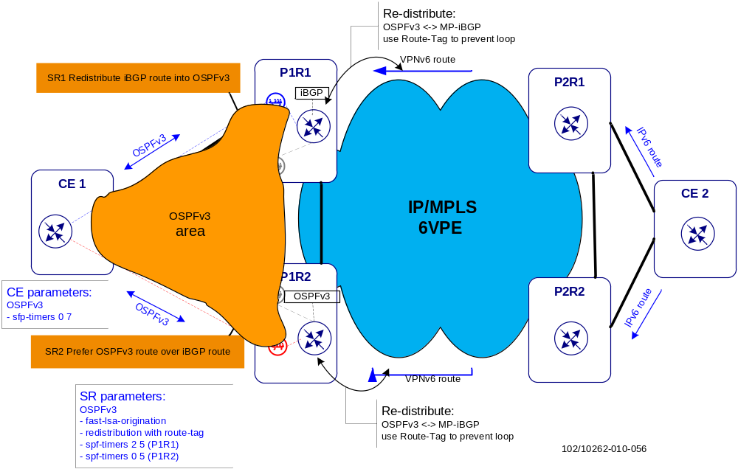
Figure 56 IPv6 routing for CE-PE OSPFv3 connectivity
Referring to Figure 56, if only Route-tag is configured on the P1 site routers with same SPF timers, when a new VPNv6 route arrives at PE routers simultaneously:
- When CE2 advertises an IPv6 route to the P2 site routers, P1 routers receive this BGP VPNv6 route via MP-iBGP and install it to their RIB
- P1R1 and P1R2 then redistribute this route to the OSPFv3 (It will not be redistributed to BGP due to the existence of Route-tag). After receiving OSPFv3 route from each other, they withdraw this iBGP route from the RIB as both of them prefer OSPFv3 route over iBGP route. This results in a loop between the two routers as each router is using its OSPFv3 neighbor as the next hop
- When P1R1 and P1R2 get this OSPFv3 route, they stop redistributing the iBGP route to the OSPFv3 and advertising this OSPFv3 route
- P1R1 and P1R2 withdraw the OSPFv3 route learned from each other, and use their iBGP route as described in step 1. Each PE router goes to endless routing flapping between OSPFv3 and iBGP route
Therefore, an asymmetric SPF timer on the PE routers is needed to avoid simultaneous OSPFv3 convergence. With higher SPF delay on the P1R1, in step 2 P1R1 does not update the OSPFv3 database after it receives the OSPFv3 route from P1R2, then P1R2 does not send the OSPFv3 route to P1R1 any more as it knows this route comes from P1R1. After the SPF delay timer expires, CE-PE routing becomes stable as shown in Figure 56. P1R1 uses the iBGP route and P1R2 uses the OSPFv3 route learned from P1R1.
To reach fast convergence in OSPFv3, on CE a higher SPF hold timer (such as 7 seconds) than PE would be needed; this has been proved in the verification.
An example of routing-tag and OSPFv3 SPF timer configurations on P1R1 is shown below:

router ospf3 10
spf-timers 2 5
router-id 192.168.21.5
area 0.0.0.1
interface fa1/2.10
interface fa1/3.10
redistribute static
redistribute bgp 64512 tag 666
!
route-map no-loop deny 10
match tag 666
route-map no-loop permit 20
!
router bgp vpn
address-family ipv4 unicast
export route-target 64512:10
import route-target 64512:10
redistribute connected
redistribute static
redistribute ospf 1
address-family ipv6 unicast
export route-target 64512:10
import route-target 64512:10
redistribute connected
redistribute static
redistribute ospf3 10 route-map no-loop
On P1R2 the routing-tag configuration is the same but the SPF timer is different:
!
router ospf3 10
spf-timers 0 5
Introduction of the asymmetric SPF delay prevents route flapping and loops, however this brings the following drawbacks:
- Brings in 2 seconds delay in OSPFv3 convergence
- Leads to asymmetric routing on the two PE routers; load balancing for outgoing traffic to remote site is not possible as only the PE router with higher SPF delay carries the outgoing traffic (P1 is considered as local site while P2 is remote site in this example)
Traffic flows:
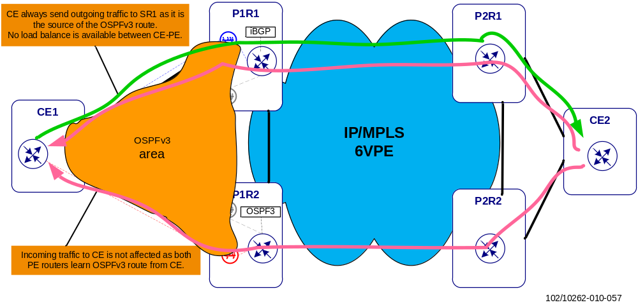
Figure 57 Traffic flows in CE-PE OSPFv3 connectivity
According to this solution, the traffic flows in this network are shown in Figure 57. Incoming traffic from a remote site is not affected as both PE routers learn the route via CE1; outgoing traffic to a remote site is sent to P1R1 because it advertises that IPv6 route to both CE1 and P1R2 via OSPFv3.
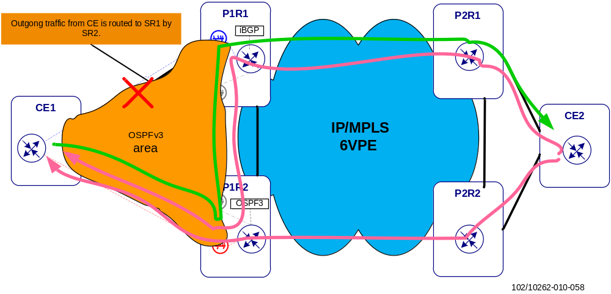
Figure 58 Traffic flows in CE-PE OSPFv3 connectivity, CE- PE link down
When the link between CE1 and P1R1 goes down, traffic flows in the network change as in Figure 58. All the traffic flows between CE1 and P1R1 are re-routed to the P1R2.

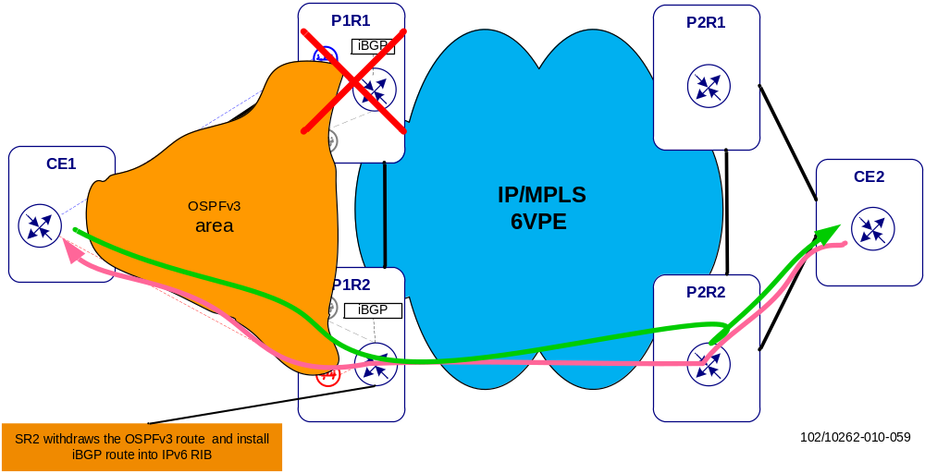
Figure 59 Traffic flows in CE-PE OSPFv3 connectivity, PE router failure
When the P1R1 which is advertising the OSPFv3 route goes down, traffic flows in the network change as in Figure 59. P1R2 withdraws the OSPFv3 route from P1R1 and installs the iBGP route in RIB instead. All the traffic is routed by P1R2.

It is also possible that some traffic does not traverse the core network, for example injected ingress enterprise or residential traffic traverse aggregation network only. However, this scenario is not part of this document.
The transport optimization comes through the statistical multiplexing gain provided by P-routers when dealing with highly varying mobile broadband traffic patterns between multiple edge (PE) sites: P-routers can flexibly/dynamically switch packets between different sites resulting in a better overall link utilization. Other optimization techniques that could for example be provided directly through the optical transport layer (OTN switching, router bypass) are not addressed in EIN Core Transport Network.
Unless the optical transport layer is OTN (ITU-T G.709) based requiring a certain optical framing structure.
with electrical GE the backbone recovery times for link breaks are close to or slightly above 2s
MP-BGP is backward compatible, which means that the routers running MP-BGP are able to establish neighbor with BGP routers that do not support MP-BGP.
Static LSPs can be configured at the site routers. Although they are not considered as an operational transport option they provide a means for network testing with minimal interference.
There exist extensions of the Border Gateway Protocol that can be used to manage an MPLS path.
Easier to maintain an IPv6 design using global IPv6 addresses compared to only auto-generated link-local addresses, since these link-local addresses can be hardware dependent (read using Ethernet MAC). When hardware is changed, so will the link-local addresses.
In IETF the term VPWS has replaced Virtual Leased Line (VLL) services. See [38]. In SSR documentation mainly the term VLL is used.
A (provider) multicast domain is represented by a set of multicast-enabled VRFs that can send multicast traffic to each other.
The standardization work also describes the possible use of unicast PE-PE tunnels with their respective encapsulation methods instead of using multicast trees.
The mVPN standards [48] and [29] nowadays promote the use of the “BGP Connector” or “VRF Route Import Extended Community” attributes to achieve this in a more generic and flexible way as the RPF neighbor might not always be an adjacent PIM neighbor with certain inters-AS MDT scenarios. Those attributes are carried within the MDT-SAFI or MCAST-VPN (Intra-AS I-PMSI A-D route type) NRLIs.
The Data-MDT Join is a UDP encapsulated packet addressed to the ALL-PIM-ROUTERS group address (224.0.0.13).
One exception is if the PE router is the RP or is on the path between the RP and the source since the routers between the RP and the source will always have an (S, G) state
Uniqueness is required to avoid the unnecessary creation of multicast routing states (inside VRFs) and provider tunnels as well as suboptimal multicast routing through the provider network.
Aggregation is not possible in the draft-Rosen mVPN model
According to information from Cisco
This name is used in the definition of the VRF at each PE router; as a convention, VRF names are written with lower case letters.
The <xyz>_Int_SR VLANs in this table need to be defined on the link between both site routers to prevent backdoor routing or to improve OSPF convergence in certain failure cases.
External DNS Server refers to the PLMN DNS that is reachable from external networks. For further information please refer to [23]
Note, the GRD is not a Layer 3 VPN. It represents the master routing instance and is just listed here for completeness. IP routing and forwarding will be used instead of MPLS.
This VLAN carries the MPLS backbone traffic on the GE link between two site routers.

