BUBBLE SORT ALGORITHM

Expected Output
See output image below.
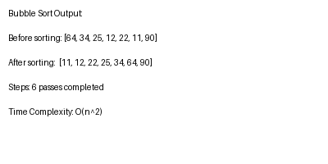
Figure 1: Output of Bubble Sort Program

