API Rate Limit

Design Doc

|  |  |  |
| --- | --- | --- |
| Date | version | Author |
| 2019/07/30 | 1.0 | Rahul Ranjan |

**High Level Design:**

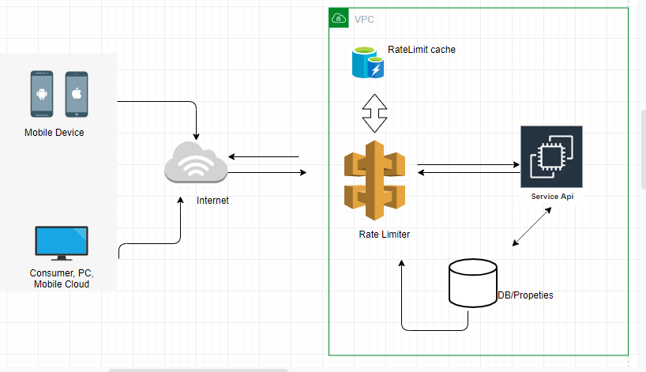

**Low Level Design:**

* **RateLimiter.java**

1. capacity
2. lastRefillTimeStamp
3. availableTokens

* **RateLimiterInterceptor.java**

It acts as gateway between user and service api

* **InMemoryCache.java**

To store the user rate limit count for specific api

* **Service API**

Dummy api to show the use cases