**Sachin Mishra**

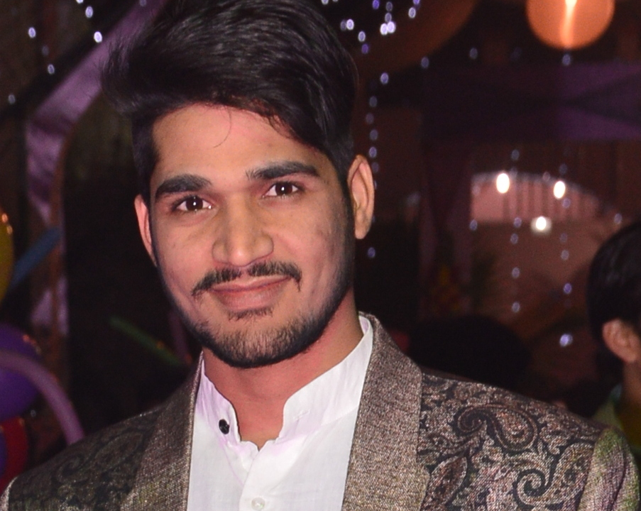

**Paste Your Photograph Here**

C 2 118New Ashok Nagar Delhi

**Mob**: 09532555562, 7007759795

**E-Mail:** [mishrasachin366@gmail.com](mailto:mishrasachin366@gmail.com)

Career Objective:

To obtain a position of Software Developer at any company where I may be able to employ my skillsin developing specified software applications in order to meet customers’ specifications.

Technical Proficiencies:

Language :Core PHP, CakePHP, Hadoop ecosystem

Database : MySQL Server

Web Technologies : HTML-5, CSS, JavaScript, Bootstrap

Tools : PHP Strom, Postman, FileZilla, Gitlab, Github

Api : Google, Facebook

Professional Experience:

**Company Name : Vega6 Wabware Technologies pvt**

**Duration :** 11-jan-2017 to 31-Jan-2018

**Role :** Software Developer

**Responsibilities :** Backend Developer, GUI

**Company Name : SMsquare infosolutions**

**Duration :** 11-jan-2017 to 31-Jan-2018

**Role :** Software Developer

**Responsibilities :** Backend Developer, GUI

**Company Name : GL Bajaj (glbitm)**

**Duration :** 18-july-2016 to 31-Dec-2016

**Role :** Lab Tech

**Responsibilities :** Provide IT support

**Company Name : Aegis**

**Duration :** 06-Aug-2015 to 10-Mar-2016

**Role :** IT Support

**Responsibilities :** Provide IT support

**Projects Undertaken:**

**Name of project : MareketPlace**

**Technologies** **:** CakePhp, ajax, Html, Css

**Database :** MySQL Server

**Role Category :** Backend Developer

**Role :** Software Developer

**Project Detail :** In the **MarketPlace** project The Seller add product and shows description and add product price and decide the cashback balance. And user shows the shop and purchase the product.

**Project link :** [**http://marketplace.vineasx.com**](http://marketplace.vineasx.com/)

**Name of project : HelpNeos**

**Technologies** **:** CakePhp, Ffmpeg, ajax, Html, Css

**Database :** MySQL Server

**Role Category :** Backend Developer

**Role :** Software Developer

**Project Detail : HelpNeos** lets you create attention-grabbing training, tutorial, presentation or marketing videos with just a few push of a button, without any creative ability, or any technical skills.

**Project link :** [**http://app.helpneos.com**](http://app.helpneos.com/)

**Name of project : HomeShopRest API**

**Technologies** **:** CakePHP

**Database :** MySQL Server

**Role Category :** Programming

**Project Detail :** I have created Rest API **HomeShop,** These Rest API’s will help Android App to connect with DB.

**Name of project : HomeShop**

**Technologies** **:** CakePHP, Css, Html, JavaScript

**Database :** MySQL Server

**Role Category :** Programming & Design

**Role :** Software Developer

**Project Detail : Homeshop**is India's leading search and comparison website that helps users find what they need at lowest prices.Homeshop empowers the users with maximum information about the products to provide a convenient experience. It has detailed product specifications, features, reviews & ratings, photos and videos to enable online shoppers take informed buying decisions.  
This Project is based on REST API’s that gives data about products.

**Project link : http://homeshop.knowyourmates.com**

**Name of project : Halim Muslim English School**

**Technologies** **:** Html, Css, JavaScript

**Role Category :** Programming & Design

**Role :** Software Developer

**Project Detail :** In the **Halim Muslim English School** website shows details of Fee Structure, Academics, Prospectus, Gallery, School Rule and Contacts details .

**Project link :** [**http://hmes.in**](http://hmes.in/)

**Name of project : Knowyourmates:The test of compatibility**

**Technologies** **:** CakePHP, CSS, HTML, JavaScript

**Database :** MySQL Server

**Role Category :** Programming & Design

**Role :** Software Developer

**Project Detail : Compatibility Test** is a web portal in which any user can challenge any other user to test how much the other person knows the challenger. All the questions will be optional and we can also give feature of creating his own questions and answers for challenging other person.

**Blog** is also implementedwhich is a personal online journal that is frequently updated and intended for general public consumption. This feature is managed by Admin as well as the site users.

**Project link :** [**http://www.knowyourmates.com**](http://knowyourmates.com/)

**Name of project : Appointmentmanagement system Rest API**

**Technologies** **:**CorePHP

**Database :** MySQL Server

**Role Category :**Programming

**Project Detail :** These Rest API’s will help Android App to connect with DB and Fix Appointment of the user with its current Latitude and Longitude. Also help App Admin to manage its appointment on the basis of priority.

**Name of project : smsquareinfosolutions**

**Technologies** **:** CorePhp, JavaScript, Html

**Database :** MySQL Server

**Role Category :** Programming & Design

**Role :** Software Developer

**Project Detail : SMsquare Infosolutions** is a fast growing Web development and Mobile Software firm providing comprehensive Offshore Software Development Services.

**Project link :** [**http://smsquareinfosolutions.com**](http://smsquareinfosolutions.com/)

**Professional Qualification:**

* **Bachelor of Computer Application (2011-14) f**rom **CSJM** University, Kanpur

**Educational Qualification:**

* **Intermediate with Science stream from U.P. Board in 2011**
* **Matriculation with Science stream from U.P. Board in 2008**

**TECHNICAL Certifications:**

* Certification on **Apache Hadoop Developer** from Ducat**,** Noida
* Certification on **Coral Draw** from Softech**,** Farrukhabad.

**Strengths:**

* Punctuality and Sincerity
* Team Work
* Can do attitude
* Ability to grasp the new skills quickly
* Positive Thinking and Logical Thinking
* Excellent knowledge of Core subjects

**Personal Details:**

* Father’s Name : Late Mr. Ajay Kumar Mishra
* Date of Birth : 15-July-1993
* Marital Status : unmarried
* Languages Knows : English,Hindi
* Hobbies :  Listening Music, Playing Chess

**References:**

* Rajeev Kumar Shukla (Development Project Manager)

Mob: 9811017262

Email: [rajeev3176@hotmail.com](mailto:rajeev3176@hotmail.com)

**Declaration:**

I hereby declare that the particulars, written above, are true to the best of my knowledge and belief.

Date: 03/07/2018 (Sachin Mishra)

Place:Delhi