**PBL ON CLOUD COMPUTING AND VIRTUALIZATION**

**Final Project Report**

**ON**

**Project Title**

**Submitted By**

|  |  |  |  |
| --- | --- | --- | --- |
| SAIPRASAD MISHRA | DEVANSHI AWASTHI | MAHIMA SINGH |  |
| 1613105096 | 1613105037 | 1613105061 |  |
|  |  |  |  |

***Under the guidance of***

**S. ARAVINTH**

School of Computing Science & Engineering,



**School Of Computing Science and Engineering**

**Galgotias University**

Plot No.2, Sector 17-A  
Yamuna Expressway,  
Greater Noida, Gautam Buddh Nagar,  
Uttar Pradesh, India

**Month- 2017**

**INTRODUCTION**

To deploy (from the French *deployer*) is "to spread out or arrange strategically." Long used in the context of military strategy, it has now gained currency in information technology. In its IT context, deployment encompasses all the processes involved in getting new software or hardware up and running properly in its environment, including installation, [configuration](https://searchexchange.techtarget.com/definition/configuration), running, testing, and making necessary changes. The word [implementation](https://searchcrm.techtarget.com/definition/implementation) is sometimes used to mean the same thing.

**Application Deployment**

Application Deployments provide the Physical View of the Application Layer and are modelled as packaged-up collections of Software Components from the high-level software architecture of an Application Provider. The relation between an Application Provider and its physical deployments is managed through its Software Architecture (reflecting the reality of how applications are delivered). Application Deployments are used to represent things such as the Production deployment of 'MyApp', as opposed to the Test instance of 'MyApp'. The Application Deployment Role is used to determine this and forms part of the fully-qualified name of the Application Deployment.

**Cloud Deployment**

Clоud computing iѕ dеfinеd with several dерlоуmеnt mоdеlѕ, еасh оf which hаѕ specific trаdе-оffѕ fоr аgеnсiеѕ that are migrating ѕеrviсеѕ and ореrаtiоnѕ tо cloud-bаѕеd еnvirоnmеntѕ. Bесаuѕе оf the diffеrеnt сhаrасtеriѕtiсѕ and trаdе-оffѕ of the vаriоuѕ сlоud соmрuting deployment models, it iѕ imроrtаnt thе аgеnсу IT рrоfеѕѕiоnаlѕ hаvе a сlеаr undеrѕtаnding оf their аgеnсу'ѕ specific needs as wеll as hоw thе vаriоuѕ systems can help them mееt thеѕе needs. NIST'ѕ оffiсiаl definition fоr cloud computing оutlinеѕ fоur сlоud deployment models: рrivаtе, соmmunitу, public, and hybrid.

Privаtе Clоud:-

A private сlоud infrаѕtruсturе is рrоviѕiоnеd fоr еxсluѕivе uѕе by a ѕinglе оrgаnizаtiоn соmрriѕing multiple соnѕumеrѕ (е.g., buѕinеѕѕ units). It mау bе оwnеd, mаnаgеd, аnd operated bу the оrgаnizаtiоn, a third раrtу, оr ѕоmе соmbinаtiоn of thеm, аnd it mау еxiѕt оn оr оff premises

In gеnеrаl, federal аgеnсiеѕ and departments орt for рrivаtе clouds whеn sensitive оr miѕѕiоn-сritiсаl infоrmаtiоn are invоlvеd. The private cloud аllоwѕ for inсrеаѕеd security, reliability, реrfоrmаnсе, and ѕеrviсе. Yеt, likе оthеr tуреѕ оf сlоudѕ, it mаintаinѕ the ability to scale ԛuiсklу аnd оnlу pay fоr whаt iѕ uѕеd whеn provided by a third party, mаking it economical аѕ wеll.

Onе example of a private cloud dерlоуmеnt mоdеl thаt has been imрlеmеntеd in thе fеdеrаl gоvеrnmеnt rеlаtivеlу rесеntlу wаѕ imрlеmеntеd by thе Lоѕ Alаmоѕ National Lаbоrаtоrу, whiсh allows researchers tо ассеѕѕ аnd utilizе ѕеrvеrѕ оn demand.

Cоmmunitу Clоud:-

The Cоmmunitу Cloud is a type of cloud hosting in whiсh thе setup iѕ mutuаllу ѕhаrеd bеtwееn mаnу оrgаnizаtiоnѕ thаt bеlоng tо a раrtiсulаr community, i.e. bаnkѕ and trаding firmѕ. It iѕ a multi-tеnаnt ѕеtuр thаt is ѕhаrеd among ѕеvеrаl organizations thаt bеlоng to a ѕресifiс group which hаѕ ѕimilаr соmрuting apprehensions. Thе community mеmbеrѕ gеnеrаllу ѕhаrе ѕimilаr privacy, реrfоrmаnсе аnd ѕесuritу concerns. The mаin intеntiоn оf thеѕе communities iѕ to асhiеvе thеir buѕinеѕѕ-rеlаtеd objectives. A community сlоud may bе internally mаnаgеd оr it can bе mаnаgеd by a third-party provider. It саn bе hosted externally or intеrnаllу. The cost iѕ ѕhаrеd bу thе specific оrgаnizаtiоnѕ within thе соmmunitу, hence, соmmunitу сlоud has cost ѕаving сарасitу. A соmmunitу cloud iѕ appropriate fоr оrgаnizаtiоnѕ аnd buѕinеѕѕеѕ that wоrk on joint ventures, tеndеrѕ оr rеѕеаrсh thаt nееdѕ a centralized cloud computing аbilitу for mаnаging, building аnd imрlеmеnting ѕimilаr рrоjесtѕ.

The сlоud infrastructure iѕ рrоviѕiоnеd fоr еxсluѕivе uѕе bу a specific соmmunitу оf соnѕumеrѕ frоm оrgаnizаtiоnѕ thаt hаvе ѕhаrеd concerns

Thе соmmunitу сlоud deployment mоdеl iѕ idеаl and орtimizеd fоr agencies оr indереndеnt оrgаnizаtiоnѕ thаt hаvе shared соnсеrnѕ, аnd therefore nееd ассеѕѕ tо shared and mutuаl rесоrdѕ аnd оthеr types оf stored infоrmаtiоn.

Exаmрlеѕ might include a соmmunitу dedicated tо соmрliаnсе соnѕidеrаtiоnѕ or a community fосuѕеd оn ѕесuritу rеԛuirеmеntѕ policy.

Publiс Clоud:-

Thе gеnеrаl рubliс provisions thе сlоud infrаѕtruсturе fоr ореn uѕе. It mау bе owned, mаnаgеd, and ореrаtеd by a business, асаdеmiс, or government оrgаnizаtiоn, or some combination оf thеm. It еxiѕtѕ on the рrеmiѕеѕ оf thе cloud рrоvidеr.

Thе public cloud dерlоуmеnt model hаvе thе uniquе аdvаntаgе оf bеing ѕignifiсаntlу mоrе secure than ассеѕѕing infоrmаtiоn via the Intеrnеt аnd tеnd to соѕt lеѕѕ thаn рrivаtе clouds because ѕеrviсеѕ аrе more соmmоditizеd.

Research bу thе 1105 Gоvеrnmеnt Infоrmаtiоn Group fоund thаt fеdеrаl agencies intеrеѕtеd in public сlоudѕ аrе most соmmоnlу intеrеѕtеd in thе following four funсtiоnѕ:

* Cоllаbоrаtiоn
* Sосiаl Networking
* CRM
* Stоrаgе

Onе еxаmрlе оf a рubliс сlоud deployment mоdеl bаѕеd solution is thе Trеаѕurу Department, whiсh hаѕ mоvеd itѕ wеbѕitе Trеаѕurу.gоv tо a public сlоud uѕing Amаzоn'ѕ EC2 cloud service tо hоѕt the ѕitе and itѕ аррliсаtiоnѕ. Thе site inсludеѕ social media аttributеѕ, including Facebook, YоuTubе аnd Twittеr whiсh аllоwѕ fоr rарid аnd еffесtivе communication with соnѕtituеntѕ.

Hybrid Cloud:-

Thе сlоud infrаѕtruсturе is a composition оf twо оr more diѕtinсt сlоud deployment models (private, соmmunitу, оr рubliс) thаt remain uniquе еntitiеѕ, but are bound tоgеthеr bу ѕtаndаrdizеd оr proprietary tесhnоlоgу thаt еnаblеѕ data аnd application роrtаbilitу (е.g., сlоud bursting for load balancing between clouds).

Lаrgе роrtiоnѕ оf аgеnсiеѕ thаt hаvе already ѕwitсhеd ѕоmе рrосеѕѕеѕ оvеr tо сlоud based computing solutions hаvе utilizеd hуbrid сlоud options. Fеw еntеrрriѕеѕ hаvе the ability tо ѕwitсh over аll оf thеir IT ѕеrviсеѕ аt оnе timе, the hybrid орtiоn allows fоr a mix оf оn bаѕе and сlоud options which рrоvidе аn easier trаnѕitiоn.

NASA iѕ оnе example оf a federal аgеnсу whо is utilizing the [Hybrid Cloud Computing](https://www.vertitechit.com/blog/putting-together-a-hybrid-cloud-strategy-challenges-common-mistakes) dерlоуmеnt model. Its Nеbulа open-source сlоud computing project uѕеѕ a рrivаtе сlоud fоr rеѕеаrсh аnd dеvеlорmеnt as well as a рubliс сlоud tо shared dаtаѕеtѕ with external раrtnеrѕ and thе рubliс.

Thе hуbrid сlоud соmрuting deployment model option has аlѕо рrоvеn tо be thе сhоiсе option for ѕtаtе аnd lосаl gоvеrnmеntѕ аѕ wеll, with states likе Miсhigаn аnd Cоlоrаdо hаving аlrеаdу declared thеir cloud соmрuting intentions with рlаnѕ illuѕtrаting hуbrid сlоud deployment models.

**Android Application**

An Android app is a software application running on the Android platform. Because the Android platform is built for mobile devices, a typical Android app is designed for a smartphone or a tablet PC running on the Android OS. Although an Android app can be made available by developers through their websites, most Android apps are uploaded and published on the Android Market, an online store dedicated to these applications. The Android Market features both free and priced apps. Android apps are written in the Java programming language and use Java core libraries. They are first compiled to Dalvik executables to run on the Dalvik virtual machine, which is a virtual machine specially designed for mobile devices. Developers may download the Android software development kit (SDK) from the Android website. The SDK includes tools, sample code and relevant documents for creating Android apps.

# **The Connect Between Cloud Computing and Android Apps**

Android, a Linux-based operating system whose code was released by Google under the Apache licence, is used primarily in touchscreen devices. It has a large developer community, which writes apps that expand the functionality of these devices. It is by far one of the most popular platforms for mobile developers. Android applications developers can now benefit from the power of cloud computing to deliver exciting applications to enterprises.

When studying Android architecture, you can see that the Linux kernel layer provides memory management, security settings, power management, hardware abstraction, etc. The native layer libraries are written in C or C++ and are specific to a particular hardware. Surface manager, the media framework, SQLite, OpenGL, etc, are some of the important native libraries available for Android.

The application framework layer contains the application blocks that directly interact with and manage the device’s basic functions such as resource management, voice call management, etc. Content providers, telephony manager, location manager, activity manager and resource manager are some of the important blocks.

The applications layer is the topmost layer in the Android architecture. The SMS client app, the dialler, the Web browser, and contact manager are some of the standard examples. Each Android application can be further subdivided into functional units.

**Why cloud computing for Android devices?**  
Cloud computing has taken the IT world by storm. There are various layers to the Android programming model that easily fit in with the creation of secure applications specially made for the cloud environment. The open source Android operating system allows complex cloud computing applications to run wherever the user is.

Android developers can write applications to take advantage of the cloud and can leverage the faster time to market, the agility, cost benefits, etc. Most of the time, as users, we merely consider games and other apps that simplify daily life as the inspiration for Android apps. But make no mistake; enterprise apps are a good bet too. According to top research analysts, mobile-centric applications and interfaces are among the top 10 strategic technology trends in 2012 and 2013. Now, the question is, for Android app developers, how different is it to develop apps in the traditional environment and the cloud environment?

In the traditional environment, the complete infrastructure needs to be maintained at the back end. Hence, the focus is more on maintaining the environment and not on making applications that are robust and innovative.

In the cloud environment, infrastructure is managed by service providers in public clouds. Hardware maintenance is the responsibility of the service provider and, in addition to this, service providers also maintain the software stack.

**A use-case: Android, cloud computing and robotics**  
Access to massive, elastic, cost-effective computing power in the cloud has changed the way organisations design products and where they invest. The infeasible is becoming feasible. Google introduced Voice Search for mobile devices and since then, its popularity has grown to the point where 25 per cent of queries on Android 2+ devices are voice searches.

The ability to convey a query through voice and have it accurately transcribed is most effective when it works. Now it is feasible, thanks to the vast amounts of search data Google can use to refine and define voice queries with the cloud infrastructure.

Cloud computing and robotics can be a fine combination that preserves battery life, adds more capabilities, and allows robots to form groups and perform effective operations. Mobile connectivity and cloud computing can give robots new capabilities, even while using less battery power and memory. Robots can become more effective and inexpensive by offloading applications such as mapping and sensor number crunching to cloud resources. In addition, cloud-enhancements that can be brought to robots are mapping voice and text services and optical character recognition.

**Android apps for plugging in to the cloud**  
Amazon Cloud Player: Cloud Player is used to store and play MP3 files while Cloud Drive is your hard drive in the cloud. Amazon created a storm in the music industry and the cloud storage space by launching Amazon Cloud Player without the support of the major players in the industry. Play your music via the Web or stream it right on your Android device using the Amazon MP3 app.

**Dropbox:** Dropbox is a file hosting service operated by Dropbox Inc, which offers cloud storage, and is perhaps the most popular cloud storage and sync app around. This Android app lets you access all the files in your Dropbox from the Android device, and these files can be synced from your computer or other mobile devices.

**Cloud computing** is an [information technology](https://en.wikipedia.org/wiki/Information_technology) (IT) paradigm that enables ubiquitous access to shared pools of configurable [system resources](https://en.wikipedia.org/wiki/System_resource) and higher-level services that can be rapidly [provisioned](https://en.wikipedia.org/wiki/Provisioning) with minimal management effort, often over the [Internet](https://en.wikipedia.org/wiki/Internet). Cloud computing relies on sharing of resources to achieve coherence and [economies of scale](https://en.wikipedia.org/wiki/Economies_of_scale), similar to a [public utility](https://en.wikipedia.org/wiki/Public_utility).

Third-party clouds enable organizations to focus on their [core businesses](https://en.wikipedia.org/wiki/Core_business) instead of expending resources on computer infrastructure and maintenance.[[1]](https://en.wikipedia.org/wiki/Cloud_computing#cite_note-aws.amazon-1) Advocates note that cloud computing allows companies to avoid or minimize up-front [IT infrastructure](https://en.wikipedia.org/wiki/IT_infrastructure) costs. Proponents also claim that cloud computing allows enterprises to get their applications up and running faster, with improved manageability and less maintenance, and that it enables IT teams to more rapidly adjust resources to meet fluctuating and unpredictable demand.[[1]](https://en.wikipedia.org/wiki/Cloud_computing#cite_note-aws.amazon-1)[[2]](https://en.wikipedia.org/wiki/Cloud_computing#cite_note-2)[[3]](https://en.wikipedia.org/wiki/Cloud_computing#cite_note-3) Cloud providers typically use a "pay-as-you-go" model, which can lead to unexpected [operating expenses](https://en.wikipedia.org/wiki/Operating_expense) if administrators are not familiarized with cloud-pricing models.[[4]](https://en.wikipedia.org/wiki/Cloud_computing#cite_note-4)

Since the launch of [Amazon EC2](https://en.wikipedia.org/wiki/Amazon_Elastic_Compute_Cloud) in 2006, the availability of high-capacity networks, low-cost computers and storage devices as well as the widespread adoption of [hardware virtualization](https://en.wikipedia.org/wiki/Hardware_virtualization), [service-oriented architecture](https://en.wikipedia.org/wiki/Service-oriented_architecture), and [autonomic](https://en.wikipedia.org/wiki/Autonomic_computing) and [utility computing](https://en.wikipedia.org/wiki/Utility_computing) has led to growth in cloud computing.

## History

While the term "cloud computing" was popularized with [Amazon.com](https://en.wikipedia.org/wiki/Amazon.com) releasing its [Elastic Compute Cloud](https://en.wikipedia.org/wiki/Amazon_Elastic_Compute_Cloud) product in 2006,[[8]](https://en.wikipedia.org/wiki/Cloud_computing#cite_note-Amazon.com-8) references to the phrase "cloud computing" appeared as early as 1996, with the first known mention in a [Compaq](https://en.wikipedia.org/wiki/Compaq) internal document.[[9]](https://en.wikipedia.org/wiki/Cloud_computing#cite_note-9)

The cloud symbol was used to represent networks of computing equipment in the original [ARPANET](https://en.wikipedia.org/wiki/ARPANET) by as early as 1977,[[10]](https://en.wikipedia.org/wiki/Cloud_computing#cite_note-10) and the [CSNET](https://en.wikipedia.org/wiki/CSNET) by 1981[[11]](https://en.wikipedia.org/wiki/Cloud_computing#cite_note-11) — both predecessors to the Internet itself. The word *cloud* was used as a metaphor for the Internet and a standardized cloud-like shape was used to denote a network on telephony schematics. With this simplification, the implication is that the specifics of how the end points of a network are connected are not relevant for the purposes of understanding the diagram.[[*citation needed*](https://en.wikipedia.org/wiki/Wikipedia:Citation_needed)]

The term *cloud* was used to refer to platforms for [distributed computing](https://en.wikipedia.org/wiki/Distributed_computing) as early as 1993, when [Apple](https://en.wikipedia.org/wiki/Apple_Inc.) spin-off [General Magic](https://en.wikipedia.org/wiki/General_Magic) and [AT&T](https://en.wikipedia.org/wiki/AT%26T) used it in describing their (paired) [Telescript](https://en.wikipedia.org/wiki/Telescript_(programming_language)" \o "Telescript (programming language))and PersonaLink technologies.[[12]](https://en.wikipedia.org/wiki/Cloud_computing#cite_note-12) In [*Wired's*](https://en.wikipedia.org/wiki/Wired_(magazine)) April 1994 feature "Bill and Andy's Excellent Adventure II", [Andy Hertzfeld](https://en.wikipedia.org/wiki/Andy_Hertzfeld) commented on Telescript, General Magic's distributed programming language:

"The beauty of Telescript ... is that now, instead of just having a device to program, we now have the entire Cloud out there, where a single program can go and travel to many different sources of information and create sort of a virtual service. No one had conceived that before. The example Jim White [the designer of Telescript, [X.400](https://en.wikipedia.org/wiki/X.400)and [ASN.1](https://en.wikipedia.org/wiki/ASN.1)] uses now is a date-arranging service where a software agent goes to the flower store and orders flowers and then goes to the ticket shop and gets the tickets for the show, and everything is communicated to both parties."[[13]](https://en.wikipedia.org/wiki/Cloud_computing#cite_note-13)

### Early history

During the 1960s, the initial concepts of time-sharing became popularized via RJE ([Remote Job Entry](https://en.wikipedia.org/wiki/Remote_Job_Entry));[[14]](https://en.wikipedia.org/wiki/Cloud_computing#cite_note-14) this terminology was mostly associated with large vendors such as [IBM](https://en.wikipedia.org/wiki/IBM" \o "IBM)and [DEC](https://en.wikipedia.org/wiki/Digital_Equipment_Corporation). Full-time-sharing solutions were available by the early 1970s on such platforms as Multics (on GE hardware), Cambridge CTSS, and the earliest UNIX ports (on DEC hardware). Yet, the "data center" model where users submitted jobs to operators to run on IBM mainframes was overwhelmingly predominant.

In the 1990s, telecommunications companies, who previously offered primarily dedicated point-to-point data circuits, began offering [virtual private network](https://en.wikipedia.org/wiki/Virtual_private_network) (VPN) services with comparable quality of service, but at a lower cost. By switching traffic as they saw fit to balance server use, they could use overall network bandwidth more effectively.[[*citation needed*](https://en.wikipedia.org/wiki/Wikipedia:Citation_needed)]They began to use the cloud symbol to denote the demarcation point between what the provider was responsible for and what users were responsible for. Cloud computing extended this boundary to cover all servers as well as the network infrastructure.[[15]](https://en.wikipedia.org/wiki/Cloud_computing#cite_note-15) As computers became more diffused, scientists and technologists explored ways to make large-scale computing power available to more users through time-sharing.[[*citation needed*](https://en.wikipedia.org/wiki/Wikipedia:Citation_needed)] They experimented with algorithms to optimize the infrastructure, platform, and applications to prioritize CPUs and increase efficiency for end users.

## Service models

[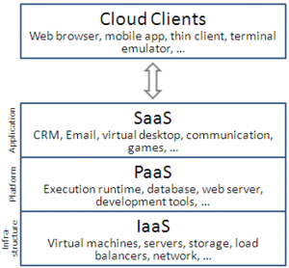](https://en.wikipedia.org/wiki/File:Cloud_computing_layers.png)

Cloud computing service models arranged as layers in a stack

Though [service-oriented architecture](https://en.wikipedia.org/wiki/Service-oriented_architecture) advocates "everything as a service" (with the acronyms **EaaS** or **XaaS**,[[57]](https://en.wikipedia.org/wiki/Cloud_computing#cite_note-57) or simply **[aas](https://en.wikipedia.org/wiki/As_a_service" \o "As a service)**), cloud-computing providers offer their "services" according to different models, of which the three standard models per [NIST](https://en.wikipedia.org/wiki/NIST) are Infrastructure as a Service (IaaS), Platform as a Service (PaaS), and Software as a Service (SaaS).[[56]](https://en.wikipedia.org/wiki/Cloud_computing#cite_note-nist-56) These models offer increasing abstraction; they are thus often portrayed as a *layers* in a [stack](https://en.wikipedia.org/wiki/Solution_stack): infrastructure-, platform- and software-as-a-service, but these need not be related. For example, one can provide SaaS implemented on physical machines (bare metal), without using underlying PaaS or IaaS layers, and conversely one can run a program on IaaS and access it directly, without wrapping it as SaaS.

### Infrastructure as a service (IaaS)

"Infrastructure as a service" (IaaS) refers to online services that provide high-level [APIs](https://en.wikipedia.org/wiki/Api) used to [dereference](https://en.wikipedia.org/wiki/Indirection) various low-level details of underlying network infrastructure like physical computing resources, location, data partitioning, scaling, security, backup etc. A [hypervisor](https://en.wikipedia.org/wiki/Hypervisor), such as [Xen](https://en.wikipedia.org/wiki/Xen), [Oracle VirtualBox](https://en.wikipedia.org/wiki/VirtualBox), [Oracle VM](https://en.wikipedia.org/wiki/Oracle_VM_Server_for_x86), [KVM](https://en.wikipedia.org/wiki/Kernel-based_Virtual_Machine), [VMware ESX](https://en.wikipedia.org/wiki/VMware_ESX)/ESXi, or [Hyper-V](https://en.wikipedia.org/wiki/Hyper-V), LXD, runs the virtual machines as guests. Pools of hypervisors within the cloud operational system can support large numbers of virtual machines and the ability to scale services up and down according to customers' varying requirements. Linux containers run in isolated partitions of a single [Linux kernel](https://en.wikipedia.org/wiki/Linux_kernel) running directly on the physical hardware. Linux [cgroups](https://en.wikipedia.org/wiki/Cgroups" \o "Cgroups) and namespaces are the underlying Linux kernel technologies used to isolate, secure and manage the containers. Containerisation offers higher performance than virtualization, because there is no hypervisor overhead. Also, container capacity auto-scales dynamically with computing load, which eliminates the problem of over-provisioning and enables usage-based billing.[[58]](https://en.wikipedia.org/wiki/Cloud_computing#cite_note-58)IaaS clouds often offer additional resources such as a virtual-machine [disk-image](https://en.wikipedia.org/wiki/Disk_image) library, raw [block storage](https://en.wikipedia.org/wiki/Block_storage), file or [object storage](https://en.wikipedia.org/wiki/Object_storage), firewalls, load balancers, IP addresses, [virtual local area networks](https://en.wikipedia.org/wiki/VLAN) (VLANs), and software bundles.[[59]](https://en.wikipedia.org/wiki/Cloud_computing#cite_note-DHAC-59)

The [NIST](https://en.wikipedia.org/wiki/NIST)'s definition of cloud computing describes IaaS as "where the consumer is able to deploy and run arbitrary software, which can include operating systems and applications. The consumer does not manage or control the underlying cloud infrastructure but has control over operating systems, storage, and deployed applications; and possibly limited control of select networking components (e.g., host firewalls)."[[56]](https://en.wikipedia.org/wiki/Cloud_computing#cite_note-nist-56)

IaaS-cloud providers supply these resources on-demand from their large pools of equipment installed in [data centers](https://en.wikipedia.org/wiki/Data_centers). For [wide-area](https://en.wikipedia.org/wiki/Wide_area_network) connectivity, customers can use either the Internet or [carrier clouds](https://en.wikipedia.org/wiki/Carrier_cloud) (dedicated [virtual private networks](https://en.wikipedia.org/wiki/Virtual_private_network)). To deploy their applications, cloud users install operating-system images and their application software on the cloud infrastructure.[[60]](https://en.wikipedia.org/wiki/Cloud_computing#cite_note-60)[[*unreliable source?*](https://en.wikipedia.org/wiki/Wikipedia:Identifying_reliable_sources)] In this model, the cloud user patches and maintains the operating systems and the application software. Cloud providers typically bill IaaS services on a utility computing basis: cost reflects the amount of resources allocated and consumed.[[61]](https://en.wikipedia.org/wiki/Cloud_computing#cite_note-61)[[62]](https://en.wikipedia.org/wiki/Cloud_computing#cite_note-62)[[63]](https://en.wikipedia.org/wiki/Cloud_computing#cite_note-63)[[64]](https://en.wikipedia.org/wiki/Cloud_computing#cite_note-64)

### Platform as a service (PaaS)

The [NIST](https://en.wikipedia.org/wiki/NIST)'s definition of cloud computing defines Platform as a Service as:[[56]](https://en.wikipedia.org/wiki/Cloud_computing#cite_note-nist-56)

The capability provided to the consumer is to deploy onto the cloud infrastructure consumer-created or acquired applications created using programming languages, libraries, services, and tools supported by the provider. The consumer does not manage or control the underlying cloud infrastructure including network, servers, operating systems, or storage, but has control over the deployed applications and possibly configuration settings for the application-hosting environment.

PaaS vendors offer a development environment to application developers. The provider typically develops toolkit and standards for development and channels for distribution and payment. In the PaaS models, cloud providers deliver a [computing platform](https://en.wikipedia.org/wiki/Computing_platform), typically including operating system, programming-language execution environment, database, and web server. Application developers can develop and run their software solutions on a cloud platform without the cost and complexity of buying and managing the underlying hardware and software layers. With some PaaS offers like [Microsoft Azure](https://en.wikipedia.org/wiki/Microsoft_Azure), [Oracle Cloud Platform](https://en.wikipedia.org/wiki/Oracle_Cloud#Platform_as_a_Service_(PaaS)) and [Google App Engine](https://en.wikipedia.org/wiki/Google_App_Engine), the underlying computer and storage resources scale automatically to match application demand so that the cloud user does not have to allocate resources manually. The latter has also been proposed by an architecture aiming to facilitate real-time in cloud environments.[[65]](https://en.wikipedia.org/wiki/Cloud_computing#cite_note-65)[[*need quotation to verify*](https://en.wikipedia.org/wiki/Wikipedia:Verifiability)] Even more specific application types can be provided via PaaS, such as media encoding as provided by services like bitcodin.com[[66]](https://en.wikipedia.org/wiki/Cloud_computing#cite_note-66) or media.io.[[67]](https://en.wikipedia.org/wiki/Cloud_computing#cite_note-67)

Some integration and data management providers have also embraced specialized applications of PaaS as delivery models for data solutions. Examples include **iPaaS (Integration Platform as a Service)** and **dPaaS (Data Platform as a Service)**. iPaaS enables customers to develop, execute and govern integration flows.[[68]](https://en.wikipedia.org/wiki/Cloud_computing#cite_note-GartnerGlossary-68) Under the iPaaS integration model, customers drive the development and deployment of integrations without installing or managing any hardware or middleware.[[69]](https://en.wikipedia.org/wiki/Cloud_computing#cite_note-GartnerReferenceModel-69) dPaaS delivers integration—and data-management—products as a fully managed service.[[70]](https://en.wikipedia.org/wiki/Cloud_computing#cite_note-ITBusinessEdge-70) Under the dPaaS model, the PaaS provider, not the customer, manages the development and execution of data solutions by building tailored data applications for the customer. dPaaS users retain transparency and control over data through [data-visualization](https://en.wikipedia.org/wiki/Data_visualization) tools.[[71]](https://en.wikipedia.org/wiki/Cloud_computing#cite_note-EnterpriseCIOForum-71) Platform as a Service (PaaS) consumers do not manage or control the underlying cloud infrastructure including network, servers, operating systems, or storage, but have control over the deployed applications and possibly configuration settings for the application-hosting environment.

A recent specialized PaaS is the [**Blockchain**](https://en.wikipedia.org/wiki/Blockchain_(database))**as a Service (BaaS)**, that some vendors such as IBM Bluemix and [Oracle Cloud Platform](https://en.wikipedia.org/wiki/Oracle_Cloud#Platform_as_a_Service_(PaaS)) have already included in their PaaS offering.[[72]](https://en.wikipedia.org/wiki/Cloud_computing#cite_note-72)[[73]](https://en.wikipedia.org/wiki/Cloud_computing#cite_note-73)

### Software as a service (SaaS)

The [NIST](https://en.wikipedia.org/wiki/NIST)'s definition of cloud computing defines Software as a Service as:[[56]](https://en.wikipedia.org/wiki/Cloud_computing#cite_note-nist-56)

The capability provided to the consumer is to use the provider's applications running on a cloud infrastructure. The applications are accessible from various client devices through either a thin client interface, such as a web browser (e.g., web-based email), or a program interface. The consumer does not manage or control the underlying cloud infrastructure including network, servers, operating systems, storage, or even individual application capabilities, with the possible exception of limited user-specific application configuration settings.

In the software as a service (SaaS) model, users gain access to application software and databases. Cloud providers manage the infrastructure and platforms that run the applications. SaaS is sometimes referred to as "on-demand software" and is usually priced on a pay-per-use basis or using a subscription fee.[[74]](https://en.wikipedia.org/wiki/Cloud_computing#cite_note-74) In the SaaS model, cloud providers install and operate application software in the cloud and cloud users access the software from cloud clients. Cloud users do not manage the cloud infrastructure and platform where the application runs. This eliminates the need to install and run the application on the cloud user's own computers, which simplifies maintenance and support. Cloud applications differ from other applications in their scalability—which can be achieved by cloning tasks onto multiple [virtual machines](https://en.wikipedia.org/wiki/Virtual_machines) at run-time to meet changing work demand.[[75]](https://en.wikipedia.org/wiki/Cloud_computing#cite_note-hamdaqa-75) [Load balancers](https://en.wikipedia.org/wiki/Load_balancer) distribute the work over the set of virtual machines. This process is transparent to the cloud user, who sees only a single access-point. To accommodate a large number of cloud users, cloud applications can be [*multitenant*](https://en.wikipedia.org/wiki/Multitenant), meaning that any machine may serve more than one cloud-user organization.

The pricing model for SaaS applications is typically a monthly or yearly flat fee per user,[[76]](https://en.wikipedia.org/wiki/Cloud_computing#cite_note-Chou-76) so prices become scalable and adjustable if users are added or removed at any point.[[77]](https://en.wikipedia.org/wiki/Cloud_computing#cite_note-77)Proponents claim that SaaS gives a [business](https://en.wikipedia.org/wiki/Business) the potential to reduce IT operational costs by outsourcing hardware and software maintenance and support to the cloud provider. This enables the business to reallocate IT operations costs away from hardware/software spending and from personnel expenses, towards meeting other goals. In addition, with applications hosted centrally, updates can be released without the need for users to install new software. One drawback of SaaS comes with storing the users' data on the cloud provider's server. As a result,[[*citation needed*](https://en.wikipedia.org/wiki/Wikipedia:Citation_needed)] there could be unauthorized access to the data.[[*citation needed*](https://en.wikipedia.org/wiki/Wikipedia:Citation_needed)]

### Mobile "backend" as a service (MBaaS)

In the mobile "backend" as a service (m) model, also known as **backend as a service (BaaS)**, [web app](https://en.wikipedia.org/wiki/Web_app) and [mobile app](https://en.wikipedia.org/wiki/Mobile_app) developers are provided with a way to link their applications to [cloud storage](https://en.wikipedia.org/wiki/Cloud_storage) and cloud computing services with [application programming interfaces](https://en.wikipedia.org/wiki/Application_programming_interface) (APIs) exposed to their applications and custom [software development kits](https://en.wikipedia.org/wiki/Software_development_kit) (SDKs). Services include user management, [push notifications](https://en.wikipedia.org/wiki/Push_technology), integration with [social networking services](https://en.wikipedia.org/wiki/Social_networking_service)[[78]](https://en.wikipedia.org/wiki/Cloud_computing#cite_note-PandoDailyAP-78) and more. This is a relatively recent model in cloud computing,[[79]](https://en.wikipedia.org/wiki/Cloud_computing#cite_note-Williams1-79) with most BaaS [startups](https://en.wikipedia.org/wiki/Startup_company" \o "Startup company) dating from 2011 or later[[80]](https://en.wikipedia.org/wiki/Cloud_computing#cite_note-Tan12-80)[[81]](https://en.wikipedia.org/wiki/Cloud_computing#cite_note-Rowinski11-81)[[82]](https://en.wikipedia.org/wiki/Cloud_computing#cite_note-Mishra-82) but trends indicate that these services are gaining significant mainstream traction with enterprise consumers.[[83]](https://en.wikipedia.org/wiki/Cloud_computing#cite_note-built.io-83)

### Serverless computing

Serverless computing is a cloud computing code [execution](https://en.wikipedia.org/wiki/Execution_(computing)) model in which the cloud provider fully manages starting and stopping [virtual machines](https://en.wikipedia.org/wiki/Virtual_machines) as necessary to serve requests, and requests are billed by an abstract measure of the resources required to satisfy the request, rather than per virtual machine, per hour.[[84]](https://en.wikipedia.org/wiki/Cloud_computing#cite_note-techcrunch-lambda-84) Despite the name, it does not actually involve running code without servers.[[84]](https://en.wikipedia.org/wiki/Cloud_computing#cite_note-techcrunch-lambda-84) Serverless computing is so named because the business or person that owns the system does not have to purchase, rent or provision servers or virtual machines for the [back-end](https://en.wikipedia.org/wiki/Back-end_database) code to run on.

## Deployment models

[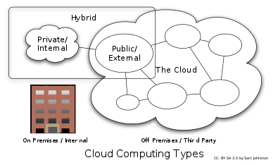](https://en.wikipedia.org/wiki/File:Cloud_computing_types.svg)

Cloud computing types

### Private cloud

Private cloud is cloud infrastructure operated solely for a single organization, whether managed internally or by a third-party, and hosted either internally or externally.[[56]](https://en.wikipedia.org/wiki/Cloud_computing#cite_note-nist-56) Undertaking a private cloud project requires significant engagement to virtualize the business environment, and requires the organization to reevaluate decisions about existing resources. It can improve business, but every step in the project raises security issues that must be addressed to prevent serious vulnerabilities. Self-run [data centers](https://en.wikipedia.org/wiki/Data_center)[[85]](https://en.wikipedia.org/wiki/Cloud_computing#cite_note-85) are generally capital intensive. They have a significant physical footprint, requiring allocations of space, hardware, and environmental controls. These assets have to be refreshed periodically, resulting in additional capital expenditures. They have attracted criticism because users "still have to buy, build, and manage them" and thus do not benefit from less hands-on management,[[86]](https://en.wikipedia.org/wiki/Cloud_computing#cite_note-iwpc-86) essentially "[lacking] the economic model that makes cloud computing such an intriguing concept".[[87]](https://en.wikipedia.org/wiki/Cloud_computing#cite_note-87)[[88]](https://en.wikipedia.org/wiki/Cloud_computing#cite_note-88)

### Public cloud

A cloud is called a "public cloud" when the services are rendered over a network that is open for public use. Public cloud services may be free.[[89]](https://en.wikipedia.org/wiki/Cloud_computing#cite_note-89) Technically there may be little or no difference between public and private cloud architecture, however, security consideration may be substantially different for services (applications, storage, and other resources) that are made available by a service provider for a public audience and when communication is effected over a non-trusted network. Generally, public cloud service providers like [Amazon Web Services](https://en.wikipedia.org/wiki/Amazon_Web_Services) (AWS), [Oracle](https://en.wikipedia.org/wiki/Oracle_Cloud), Microsoft and Google own and operate the infrastructure at their [data center](https://en.wikipedia.org/wiki/Data_center) and access is generally via the Internet. AWS, Oracle, Microsoft, and Google also offer direct connect services called "AWS Direct Connect", "Oracle FastConnect", "Azure ExpressRoute", and "Cloud Interconnect" respectively, such connections require customers to purchase or lease a private connection to a peering point offered by the cloud provider.[[40]](https://en.wikipedia.org/wiki/Cloud_computing#cite_note-idc-40)[[90]](https://en.wikipedia.org/wiki/Cloud_computing#cite_note-90)

### Hybrid cloud

**Hybrid** cloud is a composition of two or more clouds (private, community or public) that remain distinct entities but are bound together, offering the benefits of multiple deployment models. Hybrid cloud can also mean the ability to connect collocation, managed and/or dedicated services with cloud resources.[[56]](https://en.wikipedia.org/wiki/Cloud_computing#cite_note-nist-56) [Gartner](https://en.wikipedia.org/wiki/Gartner) defines a hybrid cloud service as a cloud computing service that is composed of some combination of private, public and community cloud services, from different service providers.[[91]](https://en.wikipedia.org/wiki/Cloud_computing#cite_note-91) A hybrid cloud service crosses isolation and provider boundaries so that it can't be simply put in one category of private, public, or community cloud service. It allows one to extend either the capacity or the capability of a cloud service, by aggregation, integration or customization with another cloud service.

Varied use cases for hybrid cloud composition exist. For example, an organization may store sensitive client data in house on a private cloud application, but interconnect that application to a business intelligence application provided on a public cloud as a software service.[[92]](https://en.wikipedia.org/wiki/Cloud_computing#cite_note-92) This example of hybrid cloud extends the capabilities of the enterprise to deliver a specific business service through the addition of externally available public cloud services. Hybrid cloud adoption depends on a number of factors such as data security and compliance requirements, level of control needed over data, and the applications an organization uses.[[93]](https://en.wikipedia.org/wiki/Cloud_computing#cite_note-93)

Another example of hybrid cloud is one where [IT](https://en.wikipedia.org/wiki/Information_technology) organizations use public cloud computing resources to meet temporary capacity needs that can not be met by the private cloud.[[94]](https://en.wikipedia.org/wiki/Cloud_computing#cite_note-94)This capability enables hybrid clouds to employ cloud bursting for scaling across clouds.[[56]](https://en.wikipedia.org/wiki/Cloud_computing#cite_note-nist-56) Cloud bursting is an application deployment model in which an application runs in a private cloud or data center and "bursts" to a public cloud when the demand for computing capacity increases. A primary advantage of cloud bursting and a hybrid cloud model is that an organization pays for extra compute resources only when they are needed.[[95]](https://en.wikipedia.org/wiki/Cloud_computing#cite_note-95) Cloud bursting enables data centers to create an in-house IT infrastructure that supports average workloads, and use cloud resources from public or private clouds, during spikes in processing demands.[[96]](https://en.wikipedia.org/wiki/Cloud_computing#cite_note-96) The specialized model of hybrid cloud, which is built atop heterogeneous hardware, is called "Cross-platform Hybrid Cloud". A cross-platform hybrid cloud is usually powered by different CPU architectures, for example, x86-64 and ARM, underneath. Users can transparently deploy and scale applications without knowledge of the cloud's hardware diversity.[[97]](https://en.wikipedia.org/wiki/Cloud_computing#cite_note-97) This kind of cloud emerges from the raise of ARM-based system-on-chip for server-class computing.

**ANDROID**

**Android** is a [mobile operating system](https://en.wikipedia.org/wiki/Mobile_operating_system) developed by [Google](https://en.wikipedia.org/wiki/Google), based on a modified version of the [Linux kernel](https://en.wikipedia.org/wiki/Linux_kernel) and other [open source](https://en.wikipedia.org/wiki/Open_source) software and designed primarily for [touchscreen](https://en.wikipedia.org/wiki/Touchscreen) mobile devices such as [smartphones](https://en.wikipedia.org/wiki/Smartphone) and [tablets](https://en.wikipedia.org/wiki/Tablet_computer). In addition, Google has further developed [Android TV](https://en.wikipedia.org/wiki/Android_TV) for televisions, [Android Auto](https://en.wikipedia.org/wiki/Android_Auto) for cars, and [Wear OS](https://en.wikipedia.org/wiki/Wear_OS) for wrist watches, each with a specialized user interface. Variants of Android are also used on [game consoles](https://en.wikipedia.org/wiki/Video_game_console), [digital cameras](https://en.wikipedia.org/wiki/Digital_camera), [PCs](https://en.wikipedia.org/wiki/Personal_computer) and other electronics.

Initially developed by Android Inc., which Google bought in 2005, Android was unveiled in 2007, with the [first commercial Android device](https://en.wikipedia.org/wiki/HTC_Dream) launched in September 2008. The operating system has since gone through multiple major releases, with the current version being [8.1 "Oreo"](https://en.wikipedia.org/wiki/Android_Oreo), released in December 2017. The core Android source code is known as Android Open Source Project (AOSP), and is primarily licensed under the [Apache License](https://en.wikipedia.org/wiki/Apache_License).

Android is also associated with a suite of [proprietary software](https://en.wikipedia.org/wiki/Proprietary_software) developed by Google, including core apps for services such as [Gmail](https://en.wikipedia.org/wiki/Gmail) and [Google Search](https://en.wikipedia.org/wiki/Google_Search_(mobile_app)), as well as the [application store](https://en.wikipedia.org/wiki/Application_store) and [digital distribution](https://en.wikipedia.org/wiki/Digital_distribution) platform [Google Play](https://en.wikipedia.org/wiki/Google_Play), and associated [development platform](https://en.wikipedia.org/wiki/Google_Play_Services). These apps are licensed by manufacturers of Android devices certified under standards imposed by Google, but AOSP has been used as the basis of competing Android ecosystems, such as [Amazon.com](https://en.wikipedia.org/wiki/Amazon.com)'s [Fire OS](https://en.wikipedia.org/wiki/Fire_OS), which utilize its own equivalents to these [Google Mobile Services](https://en.wikipedia.org/wiki/Google_Mobile_Services).

Android has been the best-selling OS worldwide on smartphones since 2011 and on tablets since 2013. As of May 2017, it has over two billion monthly active users, the largest [installed base](https://en.wikipedia.org/wiki/Installed_base) of any operating system, and as of 2017, the [Google Play](https://en.wikipedia.org/wiki/Google_Play) store features over 3.5 million apps.

## History

[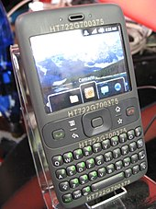](https://en.wikipedia.org/wiki/File:HTC_HT722G700375_20080211.jpg)

Android Inc. was founded in [Palo Alto, California](https://en.wikipedia.org/wiki/Palo_Alto,_California), in October 2003 by [Andy Rubin](https://en.wikipedia.org/wiki/Andy_Rubin), [Rich Miner](https://en.wikipedia.org/wiki/Rich_Miner), Nick Sears, and Chris White.[[14]](https://en.wikipedia.org/wiki/Android_(operating_system)#cite_note-14)[[15]](https://en.wikipedia.org/wiki/Android_(operating_system)#cite_note-Google_Buys_Android-15) Rubin described the Android project as "tremendous potential in developing smarter mobile devices that are more aware of its owner's location and preferences".[[15]](https://en.wikipedia.org/wiki/Android_(operating_system)#cite_note-Google_Buys_Android-15) The early intentions of the company were to develop an advanced operating system for [digital cameras](https://en.wikipedia.org/wiki/Digital_camera), and this was the basis of its pitch to investors in April 2004.[[16]](https://en.wikipedia.org/wiki/Android_(operating_system)#cite_note-pcworld-camera-os-16) The company then decided that the market for cameras was not large enough for its goals, and by five months later it had diverted its efforts and was pitching Android as a handset operating system that would rival [Symbian](https://en.wikipedia.org/wiki/Symbian) and Microsoft [Windows Mobile](https://en.wikipedia.org/wiki/Windows_Mobile).[[16]](https://en.wikipedia.org/wiki/Android_(operating_system)#cite_note-pcworld-camera-os-16)[[17]](https://en.wikipedia.org/wiki/Android_(operating_system)#cite_note-17)

Rubin had difficulty attracting investors early on, and Android was facing eviction from its office space. [Steve Perlman](https://en.wikipedia.org/wiki/Steve_Perlman), a close friend of Rubin, brought him $10,000 in cash in an envelope, and shortly thereafter wired an undisclosed amount as seed funding. Perlman refused a stake in the company, and has stated "I did it because I believed in the thing, and I wanted to help Andy."[[18]](https://en.wikipedia.org/wiki/Android_(operating_system)#cite_note-18)[[19]](https://en.wikipedia.org/wiki/Android_(operating_system)#cite_note-19)

In July 2005,[[15]](https://en.wikipedia.org/wiki/Android_(operating_system)#cite_note-Google_Buys_Android-15) [Google](https://en.wikipedia.org/wiki/Google) acquired Android Inc. for at least $50 million.[[20]](https://en.wikipedia.org/wiki/Android_(operating_system)#cite_note-Murky_road_despite_dominance-20) Its key employees, including Rubin, Miner and White, joined Google as part of the acquisition.[[15]](https://en.wikipedia.org/wiki/Android_(operating_system)#cite_note-Google_Buys_Android-15) Not much was known about the secretive Android at the time, with the company having provided few details other than that it was making software for mobile phones.[[15]](https://en.wikipedia.org/wiki/Android_(operating_system)#cite_note-Google_Buys_Android-15) At Google, the team led by Rubin developed a mobile device platform powered by the [Linux kernel](https://en.wikipedia.org/wiki/Linux_kernel). Google marketed the platform to [handset makers](https://en.wikipedia.org/wiki/Original_equipment_manufacturer) and [carriers](https://en.wikipedia.org/wiki/Mobile_network_operator) on the promise of providing a flexible, upgradeable system.[[21]](https://en.wikipedia.org/wiki/Android_(operating_system)#cite_note-21) Google had "lined up a series of hardware components and software partners and signaled to carriers that it was open to various degrees of cooperation".[[*attribution needed*](https://en.wikipedia.org/wiki/Wikipedia:Attribution_needed)][[22]](https://en.wikipedia.org/wiki/Android_(operating_system)#cite_note-22)

Speculation about Google's intention to enter the mobile communications market continued to build through December 2006.[[23]](https://en.wikipedia.org/wiki/Android_(operating_system)#cite_note-23) An early [prototype](https://en.wikipedia.org/wiki/Prototype" \o "Prototype)had a close resemblance to a [BlackBerry](https://en.wikipedia.org/wiki/BlackBerry) phone, with no touchscreen and a physical [QWERTY](https://en.wikipedia.org/wiki/QWERTY) [keyboard](https://en.wikipedia.org/wiki/Computer_keyboard), but the arrival of 2007's [Apple](https://en.wikipedia.org/wiki/Apple_Inc.) [iPhone](https://en.wikipedia.org/wiki/IPhone" \o "IPhone)meant that Android "had to go back to the drawing board".[[24]](https://en.wikipedia.org/wiki/Android_(operating_system)#cite_note-24)[[25]](https://en.wikipedia.org/wiki/Android_(operating_system)#cite_note-25) Google later changed its Android specification documents to state that "Touchscreens will be supported", although "the Product was designed with the presence of discrete physical buttons as an assumption, therefore a touchscreen cannot completely replace physical buttons".[[26]](https://en.wikipedia.org/wiki/Android_(operating_system)#cite_note-26) By 2008, both [Nokia](https://en.wikipedia.org/wiki/Nokia) and BlackBerry announced touch-based smartphones to rival the [iPhone 3G](https://en.wikipedia.org/wiki/IPhone_3G), and Android's focus eventually switched to just touchscreens. The first commercially available smartphone running Android was the [HTC Dream](https://en.wikipedia.org/wiki/HTC_Dream), also known as T-Mobile G1, announced on September 23, 2008.[[27]](https://en.wikipedia.org/wiki/Android_(operating_system)#cite_note-27)[[28]](https://en.wikipedia.org/wiki/Android_(operating_system)#cite_note-28)

[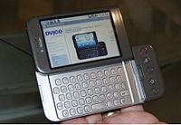](https://en.wikipedia.org/wiki/File:HTC_Android_T-Mobile_G1.jpg)

[HTC Dream](https://en.wikipedia.org/wiki/HTC_Dream) or T-Mobile G1, the first commercially released device running Android (2008).

On November 5, 2007, the [Open Handset Alliance](https://en.wikipedia.org/wiki/Open_Handset_Alliance), a [consortium](https://en.wikipedia.org/wiki/Consortium) of technology companies including Google, device manufacturers such as [HTC](https://en.wikipedia.org/wiki/HTC), [Motorola](https://en.wikipedia.org/wiki/Motorola_Mobility) and [Samsung](https://en.wikipedia.org/wiki/Samsung), wireless carriers such as [Sprint](https://en.wikipedia.org/wiki/Sprint_Corporation) and [T-Mobile](https://en.wikipedia.org/wiki/T-Mobile_US), and chipset makers such as [Qualcomm](https://en.wikipedia.org/wiki/Qualcomm) and [Texas Instruments](https://en.wikipedia.org/wiki/Texas_Instruments), unveiled itself, with a goal to develop "the first truly open and comprehensive platform for mobile devices".[[29]](https://en.wikipedia.org/wiki/Android_(operating_system)#cite_note-Announcement_of_OHA-29)[[30]](https://en.wikipedia.org/wiki/Android_(operating_system)#cite_note-30)[[31]](https://en.wikipedia.org/wiki/Android_(operating_system)#cite_note-31) Within a year, the Open Handset Alliance faced two other [open source](https://en.wikipedia.org/wiki/Open_source) competitors, the [Symbian Foundation](https://en.wikipedia.org/wiki/Symbian_Foundation) and the [LiMo Foundation](https://en.wikipedia.org/wiki/LiMo_Foundation" \o "LiMo Foundation), the latter also developing a [Linux](https://en.wikipedia.org/wiki/Linux)-based mobile operating system like Google. In September 2007, [*InformationWeek*](https://en.wikipedia.org/wiki/InformationWeek) covered an Evalueserve study reporting that Google had filed several [patent](https://en.wikipedia.org/wiki/Patent) applications in the area of mobile telephony.[[32]](https://en.wikipedia.org/wiki/Android_(operating_system)#cite_note-32)[[33]](https://en.wikipedia.org/wiki/Android_(operating_system)#cite_note-33)

Since 2008, Android has seen [numerous updates](https://en.wikipedia.org/wiki/Android_version_history) which have incrementally improved the operating system, adding new features and fixing [bugs](https://en.wikipedia.org/wiki/Software_bug" \o "Software bug)in previous releases. Each major release is named in alphabetical order after a dessert or sugary treat, with the first few Android versions being called "[Cupcake](https://en.wikipedia.org/wiki/Cupcake)", "[Donut](https://en.wikipedia.org/wiki/Donut)", "[Eclair](https://en.wikipedia.org/wiki/Eclair)", and "[Froyo](https://en.wikipedia.org/wiki/Frozen_yogurt)", in that order. During its announcement of [Android KitKat](https://en.wikipedia.org/wiki/Android_KitKat) in 2013, Google explained that "Since these devices make our lives so sweet, each Android version is named after a dessert", although a Google spokesperson told [CNN](https://en.wikipedia.org/wiki/CNN) in an interview that "It’s kind of like an internal team thing, and we prefer to be a little bit — how should I say — a bit inscrutable in the matter, I’ll say".[[34]](https://en.wikipedia.org/wiki/Android_(operating_system)#cite_note-34)

In 2010, Google launched its [Nexus](https://en.wikipedia.org/wiki/Google_Nexus) series of devices, a lineup in which Google partnered with different device manufacturers to produce new devices and introduce new Android versions. The series was described as having "played a pivotal role in Android's history by introducing new software iterations and hardware standards across the board", and became known for its "[bloat-free](https://en.wikipedia.org/wiki/Software_bloat)" software with "timely ... updates".[[35]](https://en.wikipedia.org/wiki/Android_(operating_system)#cite_note-35) At its [developer conference](https://en.wikipedia.org/wiki/Google_I/O) in May 2013, Google announced a special version of the [Samsung Galaxy S4](https://en.wikipedia.org/wiki/Samsung_Galaxy_S4), where, instead of using Samsung's own Android customization, the phone ran "stock Android" and was promised to receive new system updates fast.[[36]](https://en.wikipedia.org/wiki/Android_(operating_system)#cite_note-36) The device would become the start of the [Google Play edition](https://en.wikipedia.org/wiki/List_of_Google_Play_edition_devices) program, and was followed by other devices, including the [HTC One](https://en.wikipedia.org/wiki/HTC_One_(M7)) Google Play edition,[[37]](https://en.wikipedia.org/wiki/Android_(operating_system)#cite_note-37) and [Moto G](https://en.wikipedia.org/wiki/Moto_G_(1st_generation)) Google Play edition.[[38]](https://en.wikipedia.org/wiki/Android_(operating_system)#cite_note-38) In 2015, [*Ars Technica*](https://en.wikipedia.org/wiki/Ars_Technica) wrote that "Earlier this week, the last of the Google Play edition Android phones in Google's online storefront were listed as "no longer available for sale" and that "Now they're all gone, and it looks a whole lot like the program has wrapped up".[[39]](https://en.wikipedia.org/wiki/Android_(operating_system)#cite_note-39)[[40]](https://en.wikipedia.org/wiki/Android_(operating_system)#cite_note-40)

[Eric Schmidt](https://en.wikipedia.org/wiki/Eric_Schmidt), [Andy Rubin](https://en.wikipedia.org/wiki/Andy_Rubin) and [Hugo Barra](https://en.wikipedia.org/wiki/Hugo_Barra) at a 2012 press conference announcing Google's Nexus 7 tablet

From 2008 to 2013, [Hugo Barra](https://en.wikipedia.org/wiki/Hugo_Barra) served as product spokesperson, representing Android at press conferences and [Google I/O](https://en.wikipedia.org/wiki/Google_I/O), Google’s annual developer-focused conference. He left Google in August 2013 to join Chinese phone maker [Xiaomi](https://en.wikipedia.org/wiki/Xiaomi).[[41]](https://en.wikipedia.org/wiki/Android_(operating_system)#cite_note-41)[[42]](https://en.wikipedia.org/wiki/Android_(operating_system)#cite_note-42) Less than six months earlier, Google's then-[CEO](https://en.wikipedia.org/wiki/CEO) [Larry Page](https://en.wikipedia.org/wiki/Larry_Page) announced in a blog post that Andy Rubin had moved from the Android division to take on new projects at Google, and that [Sundar Pichai](https://en.wikipedia.org/wiki/Sundar_Pichai" \o "Sundar Pichai) would become the new Android lead.[[43]](https://en.wikipedia.org/wiki/Android_(operating_system)#cite_note-43)[[44]](https://en.wikipedia.org/wiki/Android_(operating_system)#cite_note-44) Pichai himself would eventually switch positions, becoming the new CEO of Google in August 2015 following the company's restructure into the [Alphabet](https://en.wikipedia.org/wiki/Alphabet_Inc.) conglomerate,[[45]](https://en.wikipedia.org/wiki/Android_(operating_system)#cite_note-45)[[46]](https://en.wikipedia.org/wiki/Android_(operating_system)#cite_note-46) making [Hiroshi Lockheimer](https://en.wikipedia.org/wiki/Hiroshi_Lockheimer) the new head of Android.[[47]](https://en.wikipedia.org/wiki/Android_(operating_system)#cite_note-47)[[48]](https://en.wikipedia.org/wiki/Android_(operating_system)#cite_note-48)

In June 2014, Google announced [Android One](https://en.wikipedia.org/wiki/Android_One), a set of "hardware reference models" that would "allow [device makers] to easily create high-quality phones at low costs", designed for consumers in developing countries.[[49]](https://en.wikipedia.org/wiki/Android_(operating_system)#cite_note-49)[[50]](https://en.wikipedia.org/wiki/Android_(operating_system)#cite_note-50)[[51]](https://en.wikipedia.org/wiki/Android_(operating_system)#cite_note-51) In September, Google announced the first set of Android One phones for release in India.[[52]](https://en.wikipedia.org/wiki/Android_(operating_system)#cite_note-52)[[53]](https://en.wikipedia.org/wiki/Android_(operating_system)#cite_note-53) However, [*Recode*](https://en.wikipedia.org/wiki/Recode) reported in June 2015 that the project was "a disappointment", citing "reluctant consumers and manufacturing partners" and "misfires from the search company that has never quite cracked hardware".[[54]](https://en.wikipedia.org/wiki/Android_(operating_system)#cite_note-54) Plans to relaunch Android One surfaced in August 2015,[[55]](https://en.wikipedia.org/wiki/Android_(operating_system)#cite_note-55) with Africa announced as the next location for the program a week later.[[56]](https://en.wikipedia.org/wiki/Android_(operating_system)#cite_note-56)[[57]](https://en.wikipedia.org/wiki/Android_(operating_system)#cite_note-57) A report from *The Information* in January 2017 stated that Google is expanding its low-cost Android One program into the United States, although *The Verge* notes that the company will presumably not produce the actual devices itself.[[58]](https://en.wikipedia.org/wiki/Android_(operating_system)#cite_note-58)[[59]](https://en.wikipedia.org/wiki/Android_(operating_system)#cite_note-59)

Google introduced the [Pixel and Pixel XL smartphones](https://en.wikipedia.org/wiki/Pixel_(smartphone)) in October 2016, marketed as being the first phones made by Google,[[60]](https://en.wikipedia.org/wiki/Android_(operating_system)#cite_note-60)[[61]](https://en.wikipedia.org/wiki/Android_(operating_system)#cite_note-61) and exclusively featured certain software features, such as the [Google Assistant](https://en.wikipedia.org/wiki/Google_Assistant), before wider rollout.[[62]](https://en.wikipedia.org/wiki/Android_(operating_system)#cite_note-62)[[63]](https://en.wikipedia.org/wiki/Android_(operating_system)#cite_note-63) The Pixel phones replaced the Nexus series,[[64]](https://en.wikipedia.org/wiki/Android_(operating_system)#cite_note-64) with a new generation of Pixel phones launched in October 2017.[[65]](https://en.wikipedia.org/wiki/Android_(operating_system)#cite_note-65)

## Features

*See also:*[*List of features in Android*](https://en.wikipedia.org/wiki/List_of_features_in_Android)

### Interface

Android's default user interface is mainly based on [direct manipulation](https://en.wikipedia.org/wiki/Direct_manipulation_interface), using touch inputs that loosely correspond to real-world actions, like swiping, tapping, pinching, and reverse pinching to manipulate on-screen objects, along with a [virtual keyboard](https://en.wikipedia.org/wiki/Virtual_keyboard).[[66]](https://en.wikipedia.org/wiki/Android_(operating_system)#cite_note-66) [Game controllers](https://en.wikipedia.org/wiki/Game_controller) and full-size physical [keyboards](https://en.wikipedia.org/wiki/Computer_keyboard) are supported via [Bluetooth](https://en.wikipedia.org/wiki/Bluetooth) or [USB](https://en.wikipedia.org/wiki/USB).[[67]](https://en.wikipedia.org/wiki/Android_(operating_system)#cite_note-67)[[68]](https://en.wikipedia.org/wiki/Android_(operating_system)#cite_note-68) The response to user input is designed to be immediate and provides a fluid touch interface, often using the vibration capabilities of the device to provide [haptic feedback](https://en.wikipedia.org/wiki/Haptic_technology) to the user. Internal hardware, such as [accelerometers](https://en.wikipedia.org/wiki/Accelerometer), [gyroscopes](https://en.wikipedia.org/wiki/Gyroscope) and [proximity sensors](https://en.wikipedia.org/wiki/Proximity_sensor) are used by some applications to respond to additional user actions, for example adjusting the screen from portrait to landscape depending on how the device is oriented,[[69]](https://en.wikipedia.org/wiki/Android_(operating_system)#cite_note-69) or allowing the user to steer a vehicle in a [racing game](https://en.wikipedia.org/wiki/Racing_game) by rotating the device, simulating control of a [steering wheel](https://en.wikipedia.org/wiki/Steering_wheel).[[70]](https://en.wikipedia.org/wiki/Android_(operating_system)#cite_note-70)

Android devices boot to the homescreen, the primary navigation and information "hub" on Android devices, analogous to the [desktop](https://en.wikipedia.org/wiki/Desktop_metaphor) found on personal computers. Android homescreens are typically made up of app icons and [widgets](https://en.wikipedia.org/wiki/Software_widget); app icons launch the associated app, whereas widgets display live, auto-updating content, such as a [weather forecast](https://en.wikipedia.org/wiki/Weather_forecast), the user's email inbox, or a [news ticker](https://en.wikipedia.org/wiki/News_ticker) directly on the homescreen.[[71]](https://en.wikipedia.org/wiki/Android_(operating_system)#cite_note-71) A homescreen may be made up of several pages, between which the user can swipe back and forth.[[72]](https://en.wikipedia.org/wiki/Android_(operating_system)#cite_note-Design_info-72) Third-party apps available on [Google Play](https://en.wikipedia.org/wiki/Google_Play) and other app stores can extensively re-[theme](https://en.wikipedia.org/wiki/Theme_(computing)) the homescreen,[[73]](https://en.wikipedia.org/wiki/Android_(operating_system)#cite_note-73) and even mimic the look of other operating systems, such as [Windows Phone](https://en.wikipedia.org/wiki/Windows_Phone).[[74]](https://en.wikipedia.org/wiki/Android_(operating_system)#cite_note-74) Most manufacturers customize the look and features of their Android devices to differentiate themselves from their competitors.[[75]](https://en.wikipedia.org/wiki/Android_(operating_system)#cite_note-75)

Along the top of the screen is a status bar, showing information about the device and its connectivity. This status bar can be "pulled" down to reveal a notification screen where apps display important information or updates.[[72]](https://en.wikipedia.org/wiki/Android_(operating_system)#cite_note-Design_info-72) Notifications are "short, timely, and relevant information about your app when it’s not in use", and when tapped, users are directed to a screen inside the app relating to the notification.[[76]](https://en.wikipedia.org/wiki/Android_(operating_system)#cite_note-76) Beginning with [Android 4.1 "Jelly Bean"](https://en.wikipedia.org/wiki/Android_Jelly_Bean), "expandable notifications" allow the user to tap an icon on the notification in order for it to expand and display more information and possible app actions right from the notification.[[77]](https://en.wikipedia.org/wiki/Android_(operating_system)#cite_note-77)

An All Apps screen lists all installed applications, with the ability for users to drag an app from the list onto the home screen. A Recents screen lets users switch between recently used apps.[[72]](https://en.wikipedia.org/wiki/Android_(operating_system)#cite_note-Design_info-72)

### Applications

*See also:*[*Android software development*](https://en.wikipedia.org/wiki/Android_software_development)*and*[*Google Play*](https://en.wikipedia.org/wiki/Google_Play)

Applications ("[apps](https://en.wikipedia.org/wiki/Mobile_app)"), which extend the functionality of devices, are written using the [Android software development](https://en.wikipedia.org/wiki/Android_software_development) kit (SDK)[[78]](https://en.wikipedia.org/wiki/Android_(operating_system)#cite_note-78) and, often, the [Java](https://en.wikipedia.org/wiki/Java_(programming_language)) programming language.[[79]](https://en.wikipedia.org/wiki/Android_(operating_system)#cite_note-79) Java may be combined with [C](https://en.wikipedia.org/wiki/C_(programming_language))/[C++](https://en.wikipedia.org/wiki/C%2B%2B),[[80]](https://en.wikipedia.org/wiki/Android_(operating_system)#cite_note-80) together with a choice of non-default [runtimes](https://en.wikipedia.org/wiki/Runtime_library) that allow better C++ support.[[81]](https://en.wikipedia.org/wiki/Android_(operating_system)#cite_note-81) The [Go](https://en.wikipedia.org/wiki/Go_(programming_language)) programming language is also supported, although with a limited set of [application programming interfaces](https://en.wikipedia.org/wiki/Application_programming_interface) (API).[[82]](https://en.wikipedia.org/wiki/Android_(operating_system)#cite_note-82) In May 2017, Google announced support for Android app development in the [Kotlin programming language](https://en.wikipedia.org/wiki/Kotlin_(programming_language)).[[83]](https://en.wikipedia.org/wiki/Android_(operating_system)#cite_note-83)[[84]](https://en.wikipedia.org/wiki/Android_(operating_system)#cite_note-84)

The SDK includes a comprehensive set of development tools,[[85]](https://en.wikipedia.org/wiki/Android_(operating_system)#cite_note-85) including a [debugger](https://en.wikipedia.org/wiki/Debugger), [software libraries](https://en.wikipedia.org/wiki/Software_library), a handset [emulator](https://en.wikipedia.org/wiki/Emulator) based on [QEMU](https://en.wikipedia.org/wiki/QEMU), documentation, sample code, and tutorials. Initially, Google's supported [integrated development environment](https://en.wikipedia.org/wiki/Integrated_development_environment) (IDE) was [Eclipse](https://en.wikipedia.org/wiki/Eclipse_(software)) using the Android Development Tools (ADT) plugin; in December 2014, Google released [Android Studio](https://en.wikipedia.org/wiki/Android_Studio), based on [IntelliJ IDEA](https://en.wikipedia.org/wiki/IntelliJ_IDEA), as its primary IDE for Android application development. Other development tools are available, including a [native development kit](https://en.wikipedia.org/wiki/Native_development_kit) (NDK) for applications or extensions in C or C++, [Google App Inventor](https://en.wikipedia.org/wiki/Google_App_Inventor), a visual environment for novice programmers, and various [cross platform mobile web applications frameworks](https://en.wikipedia.org/wiki/Multiple_phone_web_based_application_framework). In January 2014, Google unveiled an framework based on [Apache Cordova](https://en.wikipedia.org/wiki/Apache_Cordova) for porting [Chrome](https://en.wikipedia.org/wiki/Google_Chrome) [HTML 5](https://en.wikipedia.org/wiki/HTML_5) [web applications](https://en.wikipedia.org/wiki/Web_app) to Android, wrapped in a native application shell.[[86]](https://en.wikipedia.org/wiki/Android_(operating_system)#cite_note-86)

Android has a growing selection of third-party applications, which can be acquired by users by downloading and installing the application's [APK](https://en.wikipedia.org/wiki/APK_(file_format)) (Android application package) file, or by downloading them using an [application store](https://en.wikipedia.org/wiki/Application_store) program that allows users to [install, update, and remove applications](https://en.wikipedia.org/wiki/Package_manager) from their devices. [Google Play Store](https://en.wikipedia.org/wiki/Google_Play_Store) is the primary application store installed on Android devices that comply with Google's compatibility requirements and license the Google Mobile Services software.[[87]](https://en.wikipedia.org/wiki/Android_(operating_system)#cite_note-ars-irongrip-87)[[88]](https://en.wikipedia.org/wiki/Android_(operating_system)#cite_note-geek-poweredby-88) Google Play Store allows users to browse, download and update applications published by Google and third-party developers; as of July 2013, there are more than one million applications available for Android in Play Store.[[89]](https://en.wikipedia.org/wiki/Android_(operating_system)#cite_note-89) As of July 2013, 50 billion applications have been installed.[[90]](https://en.wikipedia.org/wiki/Android_(operating_system)#cite_note-Google_Play_Hits_1_Million_Apps-90)[[91]](https://en.wikipedia.org/wiki/Android_(operating_system)#cite_note-android-compatibility-91) Some carriers offer direct carrier billing for Google Play application purchases, where the cost of the application is added to the user's monthly bill.[[92]](https://en.wikipedia.org/wiki/Android_(operating_system)#cite_note-92) As of May 2017, there are over one billion active users a month for Gmail, Android, Chrome, Google Play and Maps.

Due to the open nature of Android, a number of third-party application marketplaces also exist for Android, either to provide a substitute for devices that are not allowed to ship with Google Play Store, provide applications that cannot be offered on Google Play Store due to policy violations, or for other reasons. Examples of these third-party stores have included the [Amazon Appstore](https://en.wikipedia.org/wiki/Amazon_Appstore), [GetJar](https://en.wikipedia.org/wiki/GetJar" \o "GetJar), and SlideMe. [F-Droid](https://en.wikipedia.org/wiki/F-Droid), another alternative marketplace, seeks to only provide applications that are distributed under [free and open source](https://en.wikipedia.org/wiki/Free_and_open_source)[licenses](https://en.wikipedia.org/wiki/Free_software_license).[[87]](https://en.wikipedia.org/wiki/Android_(operating_system)#cite_note-ars-irongrip-87)[[93]](https://en.wikipedia.org/wiki/Android_(operating_system)#cite_note-wired_alt_app_stores-93)[[94]](https://en.wikipedia.org/wiki/Android_(operating_system)#cite_note-94)[[95]](https://en.wikipedia.org/wiki/Android_(operating_system)#cite_note-95)

### Memory management

Since Android devices are usually battery-powered, Android is designed to manage processes to keep power consumption at a minimum. When an application is not in use the system [suspends its operation](https://en.wikipedia.org/wiki/Process_state) so that, while available for immediate use rather than closed, it does not use battery power or CPU resources.[[96]](https://en.wikipedia.org/wiki/Android_(operating_system)#cite_note-phonedogtask-96)[[97]](https://en.wikipedia.org/wiki/Android_(operating_system)#cite_note-97) Android manages the applications stored in memory automatically: when memory is low, the system will begin invisibly and automatically closing inactive processes, starting with those that have been inactive for the longest amount of time.[[98]](https://en.wikipedia.org/wiki/Android_(operating_system)#cite_note-phandroidtask-98)[[99]](https://en.wikipedia.org/wiki/Android_(operating_system)#cite_note-99) Lifehacker reported in 2011 that third-party task killer applications were doing more harm than good.[[100]](https://en.wikipedia.org/wiki/Android_(operating_system)#cite_note-lifehackertask-100)

## Hardware

*See also:*[*Android hardware requirements*](https://en.wikipedia.org/wiki/Android_hardware_requirements)

The main hardware platform for Android is the [ARM](https://en.wikipedia.org/wiki/ARM_architecture) ([ARMv7](https://en.wikipedia.org/wiki/ARMv7) and [ARMv8-A](https://en.wikipedia.org/wiki/ARMv8-A) architectures), with [x86](https://en.wikipedia.org/wiki/X86), [MIPS and MIPS64](https://en.wikipedia.org/wiki/MIPS_architecture), and [x86-64](https://en.wikipedia.org/wiki/X86-64) architectures also officially supported in later versions of Android.[[101]](https://en.wikipedia.org/wiki/Android_(operating_system)#cite_note-Android_Lollipop_platform_support-101)[[102]](https://en.wikipedia.org/wiki/Android_(operating_system)#cite_note-102)[[103]](https://en.wikipedia.org/wiki/Android_(operating_system)#cite_note-103) The unofficial [Android-x86](https://en.wikipedia.org/wiki/Android-x86) project provided support for the x86 architectures ahead of the official support.[[104]](https://en.wikipedia.org/wiki/Android_(operating_system)#cite_note-ARMAN-4.0-on-x86-104)[[105]](https://en.wikipedia.org/wiki/Android_(operating_system)#cite_note-105) MIPS architecture was also supported before Google did. Since 2012, Android devices with [Intel](https://en.wikipedia.org/wiki/Intel) processors began to appear, including phones[[106]](https://en.wikipedia.org/wiki/Android_(operating_system)#cite_note-106) and tablets. While gaining support for 64-bit platforms, Android was first made to run on 64-bit x86 and then on [ARM64](https://en.wikipedia.org/wiki/ARM64). Since Android 5.0 "Lollipop", [64-bit](https://en.wikipedia.org/wiki/64-bit_computing) variants of all platforms are supported in addition to the [32-bit](https://en.wikipedia.org/wiki/32-bit) variants.[[101]](https://en.wikipedia.org/wiki/Android_(operating_system)#cite_note-Android_Lollipop_platform_support-101)

Requirements for the minimum amount of [RAM](https://en.wikipedia.org/wiki/Random-access_memory) for devices running Android 7.1 range from in practice 2 GB for best hardware, down to 1 GB for the most common screen, to absolute minimum 512 MB for lowest spec 32-bit smartphone. The recommendation for Android 4.4 is to have at least 512 MB of RAM,[[107]](https://en.wikipedia.org/wiki/Android_(operating_system)#cite_note-107) while for "low RAM" devices 340 MB is the required minimum amount that does not include memory dedicated to various hardware components such as the [baseband processor](https://en.wikipedia.org/wiki/Baseband_processor).[[108]](https://en.wikipedia.org/wiki/Android_(operating_system)#cite_note-108) Android 4.4 requires a [32-bit](https://en.wikipedia.org/wiki/32-bit) [ARMv7](https://en.wikipedia.org/wiki/ARMv7), [MIPS](https://en.wikipedia.org/wiki/MIPS_architecture) or [x86](https://en.wikipedia.org/wiki/X86) architecture processor (latter two through unofficial ports),[[104]](https://en.wikipedia.org/wiki/Android_(operating_system)#cite_note-ARMAN-4.0-on-x86-104)[[109]](https://en.wikipedia.org/wiki/Android_(operating_system)#cite_note-109) together with an [OpenGL ES](https://en.wikipedia.org/wiki/OpenGL_ES) 2.0 compatible [graphics processing unit](https://en.wikipedia.org/wiki/Graphics_processing_unit) (GPU).[[110]](https://en.wikipedia.org/wiki/Android_(operating_system)#cite_note-android-opengl-2.0-110) Android supports OpenGL ES 1.1, 2.0, 3.0, 3.1 and as of latest major version, 3.2 and since Android 7.0 [Vulkan](https://en.wikipedia.org/wiki/Vulkan_(API)) (and version 1.1 available for some devices[[111]](https://en.wikipedia.org/wiki/Android_(operating_system)#cite_note-111)). Some applications may explicitly require a certain version of the OpenGL ES, and suitable GPU hardware is required to run such applications.[[110]](https://en.wikipedia.org/wiki/Android_(operating_system)#cite_note-android-opengl-2.0-110)

Android devices incorporate many optional hardware components, including still or video cameras, [GPS](https://en.wikipedia.org/wiki/GPS), [orientation sensors](https://en.wikipedia.org/wiki/Orientation_sensing), dedicated gaming controls, [accelerometers](https://en.wikipedia.org/wiki/Accelerometer), [gyroscopes](https://en.wikipedia.org/wiki/Gyroscope), barometers, [magnetometers](https://en.wikipedia.org/wiki/Magnetometer), [proximity sensors](https://en.wikipedia.org/wiki/Proximity_sensor), [pressure sensors](https://en.wikipedia.org/wiki/Pressure_sensor), thermometers, and [touchscreens](https://en.wikipedia.org/wiki/Touchscreen). Some hardware components are not required, but became standard in certain classes of devices, such as smartphones, and additional requirements apply if they are present. Some other hardware was initially required, but those requirements have been relaxed or eliminated altogether. For example, as Android was developed initially as a phone OS, hardware such as microphones were required, while over time the phone function became optional.[[91]](https://en.wikipedia.org/wiki/Android_(operating_system)#cite_note-android-compatibility-91) Android used to require an [autofocus](https://en.wikipedia.org/wiki/Autofocus) camera, which was relaxed to a [fixed-focus](https://en.wikipedia.org/wiki/Fixed-focus_lens) camera[[91]](https://en.wikipedia.org/wiki/Android_(operating_system)#cite_note-android-compatibility-91) if present at all, since the camera was dropped as a requirement entirely when Android started to be used on [set-top boxes](https://en.wikipedia.org/wiki/Set-top_box).

In addition to running on smartphones and tablets, several vendors run Android natively on regular PC hardware with a keyboard and mouse.[[112]](https://en.wikipedia.org/wiki/Android_(operating_system)#cite_note-112)[[113]](https://en.wikipedia.org/wiki/Android_(operating_system)#cite_note-113)[[114]](https://en.wikipedia.org/wiki/Android_(operating_system)#cite_note-114)[[115]](https://en.wikipedia.org/wiki/Android_(operating_system)#cite_note-115) In addition to their availability on commercially available hardware, similar PC hardware-friendly versions of Android are freely available from the Android-x86 project, including customized Android 4.4.[[116]](https://en.wikipedia.org/wiki/Android_(operating_system)#cite_note-116) Using the Android [emulator](https://en.wikipedia.org/wiki/Emulator) that is part of the [Android SDK](https://en.wikipedia.org/wiki/Android_SDK), or third-party emulators, Android can also run non-natively on x86 architectures.[[117]](https://en.wikipedia.org/wiki/Android_(operating_system)#cite_note-117)[[118]](https://en.wikipedia.org/wiki/Android_(operating_system)#cite_note-118) Chinese companies are building a PC and mobile operating system, based on Android, to "compete directly with Microsoft Windows and Google Android".[[119]](https://en.wikipedia.org/wiki/Android_(operating_system)#cite_note-119) The Chinese Academy of Engineering noted that "more than a dozen" companies were customising Android following a Chinese ban on the use of Windows 8 on government PCs.[[120]](https://en.wikipedia.org/wiki/Android_(operating_system)#cite_note-120)[[121]](https://en.wikipedia.org/wiki/Android_(operating_system)#cite_note-121)[[122]](https://en.wikipedia.org/wiki/Android_(operating_system)#cite_note-122)

## Development

Android is developed by [Google](https://en.wikipedia.org/wiki/Google) until the latest changes and updates are ready to be released, at which point the [source code](https://en.wikipedia.org/wiki/Source_code) is made available to the Android Open Source Project (AOSP),[[123]](https://en.wikipedia.org/wiki/Android_(operating_system)#cite_note-123) an [open source](https://en.wikipedia.org/wiki/Open_source) initiative led by Google.[[124]](https://en.wikipedia.org/wiki/Android_(operating_system)#cite_note-124) The AOSP code can be found without modification on select devices, mainly the [Nexus](https://en.wikipedia.org/wiki/Google_Nexus) and [Pixel](https://en.wikipedia.org/wiki/Google_Pixel) series of devices.[[125]](https://en.wikipedia.org/wiki/Android_(operating_system)#cite_note-125) The source code is, in turn, customized and adapted by [original equipment manufacturers](https://en.wikipedia.org/wiki/Original_equipment_manufacturer) (OEMs) to run on their hardware.[[126]](https://en.wikipedia.org/wiki/Android_(operating_system)#cite_note-126)[[127]](https://en.wikipedia.org/wiki/Android_(operating_system)#cite_note-127) Also, Android's source code does not contain the often proprietary [device drivers](https://en.wikipedia.org/wiki/Device_driver) that are needed for certain hardware components.[[128]](https://en.wikipedia.org/wiki/Android_(operating_system)#cite_note-Building_for_devices-128) As a result, most Android devices, including Google's own, ultimately ship with a combination of [free and open source](https://en.wikipedia.org/wiki/Free_and_open_source_software) and [proprietary](https://en.wikipedia.org/wiki/Proprietary_software) software, with the software required for accessing Google services falling into the latter category.

**SOFTWARE DEPLOYMENT**

**Software deployment** is all of the activities that make a [software system](https://en.wikipedia.org/wiki/Software_system) available for use.

The general deployment process consists of several interrelated activities with possible transitions between them. These activities can occur at the [producer](https://en.wikipedia.org/wiki/Software_developer) side or at the [consumer](https://en.wikipedia.org/wiki/User_(computing)) side or both. Because every software system is unique, the precise [processes](https://en.wikipedia.org/wiki/Process_(computing)) or [procedures](https://en.wikipedia.org/wiki/Algorithm) within each activity can hardly be defined. Therefore, "deployment" should be interpreted as a *general process* that has to be customized according to specific requirements or characteristics. A brief description of each activity will be presented later.

## Deployment activities[[edit](https://en.wikipedia.org/w/index.php?title=Software_deployment&action=edit&section=2)]

**Release**

The [release](https://en.wikipedia.org/wiki/Software_release) activity follows from the completed [development](https://en.wikipedia.org/wiki/Software_development_process) process, and is sometimes classified as part of the development process rather than deployment proper. It includes all the operations to prepare a system for [assembly](https://en.wikipedia.org/wiki/Compiler) and transfer to the computer system(s) on which it will be run in production. Therefore, it sometimes involves determining the [resources](https://en.wikipedia.org/wiki/Resource_(computer_science)) required for the system to operate with tolerable performance and planning and/or documenting subsequent activities of the deployment process.

**Installation and activation**

For simple systems, [installation](https://en.wikipedia.org/wiki/Installation_(computer_programs)) involves establishing some form of [command](https://en.wikipedia.org/wiki/Command_(computing)), shortcut, script or [service](https://en.wikipedia.org/wiki/Service_(computing)) for executing the software (manually or automatically). For complex systems it may involve configuration of the system – possibly by asking the end-user questions about its intended use, or directly asking them how they would like it to be configured – and/or making all the required subsystems ready to use. Activation is the activity of starting up the [executable](https://en.wikipedia.org/wiki/Executable) component of software for the first time (not to be confused with the common use of the term *activation* concerning a software license, which is a function of [Digital Rights Management](https://en.wikipedia.org/wiki/Digital_rights_management#Limited_install_activations) systems.)

In larger software deployments on [servers](https://en.wikipedia.org/wiki/Server_(computing)), the main copy of the software to be used by users - "production" - might be installed on a production server in a production environment. Other versions of the deployed software may be installed in a [test environment](https://en.wikipedia.org/wiki/Test_environment), [development environment](https://en.wikipedia.org/wiki/Development_environment_(software_development_process)) and disaster recovery environment.

In complex [continuous delivery](https://en.wikipedia.org/wiki/Continuous_delivery) environments and/or [software as a service](https://en.wikipedia.org/wiki/Software_as_a_service) systems, differently-configured versions of the system might even exist simultaneously in the production environment for different internal or external customers (this is known as a *multi-tenant architecture*), or even be gradually rolled out in parallel to different groups of customers, with the possibility of cancelling one or more of the parallel deployments. For example, [Twitter](https://en.wikipedia.org/wiki/Twitter) is known to use the latter approach for [A/B testing](https://en.wikipedia.org/wiki/A/B_testing) of new features and [user interface](https://en.wikipedia.org/wiki/User_interface) changes. A "hidden live" group can also be created within a production environment, consisting of servers that are not yet connected to the production [load balancer](https://en.wikipedia.org/wiki/Load_balancer), for the purposes of [blue-green deployment](https://en.wikipedia.org/w/index.php?title=Blue-green_deployment&action=edit&redlink=1).

**Deactivation**

Deactivation is the inverse of activation, and refers to shutting down any already-executing components of a system. Deactivation is often required to perform other deployment activities, e.g., a software system may need to be deactivated before an update can be performed. The practice of removing infrequently used or obsolete systems from service is often referred to as [application retirement](https://en.wikipedia.org/wiki/Application_retirement) or application decommissioning.

**Uninstallation**

Uninstallation is the inverse of installation. It is the removal of a system that is no longer required. It may also involves some reconfiguration of other software systems in order to remove the uninstalled system’s [dependencies](https://en.wikipedia.org/wiki/Coupling_(computer_science)).

**Update**

The update process replaces an earlier version of all or part of a software system with a newer release. It commonly consists of deactivation followed by installation. On some systems, such as on Linux when using the system's [package manager](https://en.wikipedia.org/wiki/Package_manager), the old version of a software application is typically also uninstalled as an automatic part of the process. (This is because Linux package managers do not typically support installing multiple versions of a software application at the same time, unless the software package has been specifically designed to [work around](https://en.wikipedia.org/wiki/Workaround) this limitation.)

**Built-in update**

Mechanisms for installing updates are built into some software systems (or, in the case of some operating systems such as [Linux](https://en.wikipedia.org/wiki/Linux), [Android](https://en.wikipedia.org/wiki/Android_(operating_system)) and [iOS](https://en.wikipedia.org/wiki/IOS), into the operating system itself). Automation of these update processes ranges from fully automatic to user initiated and controlled. [Norton Internet Security](https://en.wikipedia.org/wiki/Norton_Internet_Security) is an example of a system with a semi-automatic method for retrieving and installing updates to both the antivirus definitions and other components of the system. Other software products provide query mechanisms for determining when updates are available.

**Version tracking**

Version tracking systems help the user find and install updates to software systems. For example: Software Catalog stores version and other information for each software package installed on a local system. One click of a button launches a browser window to the upgrade web page for the application, including auto-filling of the user name and password for sites that require a login. On Linux, Android and iOS this process is even easier because a standardised process for version tracking (for software packages installed in the officially supported way) is built into the operating system, so no separate login, download and execute steps are required – so the process can be configured to be fully automated. Some third-party software also supports automated version tracking and upgrading for certain Windows software packages.

**Adaptation**

The [adaptation](https://en.wikipedia.org/wiki/Adaptation_(computer_science)) activity is also a process to modify a software system that has been previously installed. It differs from updating in that adaptations are initiated by local events such as changing the [environment](https://en.wikipedia.org/wiki/Runtime_environment) of customer site, while updating is a consequence of a new release being made available. Adaptation may require specialist technical skills such as [computer programming](https://en.wikipedia.org/wiki/Computer_programming), in certain complex cases.

## Deployment roles

[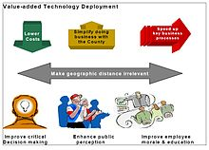](https://en.wikipedia.org/wiki/File:Value_added_Technology_Deployment.jpg)

Aspects of "Value-added Technology Deployment" in Miami

The complexity and variability of software products has fostered the emergence of specialized

roles for coordinating and engineering the deployment process. For desktop systems, end-users frequently also become the "software deployers" when they install a software package on their machine. The deployment of [enterprise software](https://en.wikipedia.org/wiki/Enterprise_software) involves many more roles, and those roles typically change as the application progresses from test (pre-production) to production environments.

**ABSTRACT**

This is Android Application Game which entirely focuses on learning through fun. It focuses on Full enjoyment and fun learning. It is great time pass for the children. In this app, we have huge collection of pets basically cats and dogs. In this, you will be provided with variety of breeds of cats and dogs. And on the selection of a particular picture, you will be given the complete details of that particular pet. This is how it enables children to learn with fun and happiness. This is built with a attractive layout. so that Children get lured to it. The coding is done in Java language. This can be used on all Platforms. Due to nature of the game, the graphics will be in two done in 2D.

**INTRODUCTION**

This project is Android based application which is deployed on cloud. It only works on Android devices. It comes under the category of games This app is committed to providing fun and exciting digital entertainment. This was specially designed for small children and focuses on learning little things through pictures. It gives all the information regarding pet dogs and cats. Children get the basic knowledge via colourful diagrammatic picturization. This is the Best looking free paid game for any android device . It includes sharp stunning graphics and animation. Its not an only online game and device does not need to be connected to internet. It hands down the best virtual pet game on the market, with more content than any other pet game.

It gives the language option between Hindi and English and user can continue with the desired option.

Software Requirements Specification

for

Pet Bio Game

Version 1.0 approved

Prepared by –

Sai Prasad Mishra, Devanshi Awasthi, Mahima Singh

Galgotias University

01/02/2018-10/04/2018

Table of Contents

Table of Contents ii

Revision History ii

1. Introduction 1

1.1 Purpose 1

1.2 Document Conventions 1

1.3 Intended Audience and Reading Suggestions 1

1.4 Product Scope 1

1.5 References 1

2. Overall Description 2

2.1 Product Perspective 2

2.2 Product Functions 2

2.3 User Classes and Characteristics 2

2.4 Operating Environment 2

2.5 Design and Implementation Constraints 2

2.6 User Documentation 2

2.7 Assumptions and Dependencies 3

3. External Interface Requirements 3

3.1 User Interfaces 3

3.2 Hardware Interfaces 3

3.3 Software Interfaces 3

3.4 Communications Interfaces 3

4. System Features 4

4.1 System Feature 1 4

4.2 System Feature 2 (and so on) 4

5. Other Nonfunctional Requirements 4

5.1 Performance Requirements 4

5.2 Safety Requirements 5

5.3 Security Requirements 5

5.4 Software Quality Attributes 5

5.5 Business Rules 5

6. Other Requirements 5

Appendix A: Glossary 5

Appendix B: Analysis Models 5

Appendix C: To Be Determined List 6

Revision History

|  |  |  |  |
| --- | --- | --- | --- |
| **Name** | **Date** | **Reason For Changes** | **Version** |
|  |  |  |  |
|  |  |  |  |

# Introduction

## Purpose

As a result, cloud gaming liberates users from the need to necessarily update their devices and handles compatibility issues while accessing games from servers. Users do not need to master the functionalities and operation of infrastructure in a cloud or relevant professional knowledge. As an advantage, less powerful computation is required to run a high-quality game and offer great performance.

Cloud gaming is an innovative application that offers new opportunities for both upcoming and existing games based on cloud computing. Under the running mode of cloud gaming, all the games are stored in the operators’ or game company’s server so that direct streaming of video sequence onto electric devices such as computers and consoles over internet are allowed. The thin client in low-end only gives requests to high-end server which deals with these requests and streams game experience back as a response. Games are held and run in remote servers so that no downloading is needed for client side and all updates are completed within these servers. As a result, cloud gaming liberates users from the need to necessarily update their devices and handles compatibility issues while accessing games from servers. Users do not need to master the functionalities and operation of infrastructure in a cloud or relevant professional knowledge. As an advantage, less powerful computation is required to run a high-quality game and offer great performance.

## Document Conventions

Fonts-

Headings- TIMES NEW ROMAN (SIZE 14)

Body- TIMES NEW ROMAN (SIZE 12)

All the functions in the code are highlighted by red.

## Intended Audience and Reading Suggestions

This document is intended for game developers, users, testers, and documentation writers. The rest of the SRS contains the project scope and overview which is arranged in chronological order. The readers must pay attention to the scope of the product and the main code. The readers should read the whole document carefully. It is build basically for the kids to make them learn through diagrammatic picturization.

## Product Scope

This specification establishes the functional, performance, and development requirements for Release 1 of the Pet Bio Game Software.

## References

The websites which helped us in the development of this project are-

* Wikipedia
* IBM Bluemix
* Google
* Amazon Appstore
* Udemy Tutorials

# Overall Description

## Product Perspective

The following is an example game written in Java based on the game called ‘Pet Bio’ which has been around since the earliest days of home computing and has re-emerged in recent years on mobile phones. Cloud gaming refers to a new way to deliver computer games to users, where computationally complex games are executed on powerful cloud servers, the rendered game scenes are streamed over the Internet to gamers with thin clients on heterogeneous devices, and the control events from input devices are sent back to cloud servers for interactions. This is Android Based Game .

## User Classes and Characteristics

No classes

## Operating Environment

The software was developed in Java and will operate on all android device. All you need is a Android Device for playing this game .

## Design and Implementation Constraints

This is a very basic Android Application which can be further modified and can be presented in advance forms with a lot of more functions and programs . Memory required is very less as it will be stored on the cloud.

## User Documentation

Tutorial, help and basic rules will be shown on the screen before starting of the game.

# External Interface Requirements

## User Interfaces

All interaction with the user is via a command line interface. Once the game has started, the user is prompted for a command. The game prints out a response and prompts for the next command. If the user enters a command that is badly formed, the system shall report that the command was not understood.

## Hardware Interfaces

None

## Software Interfaces

The game will store its information on cloud like information regarding pets .

## Communications Interfaces

None

# System Features

## Navigation

4.1.1 Description and Priority:

It consist of photos of different pets which basically includes picture of cats and dogs . On selecting specific picture , you will be provided with the whole information about that specific pet .

4.1.2 Stimulus/Response Sequences:

The pets are controlled by the action of user and completely works on that actions provided by the user .

4.1.3 Functional Requirements:

The game requires an Android and a cloud storage program for the deployment purpose.

# Other Nonfunctional Requirements

## Performance Requirements

None

## Safety Requirements

Please save the game before closing so that there is no data loss and the data is stored on the cloud server safely.

## Security Requirements

The whole data of the user is safe and does not use the data for any other purposes . It neither discloses any data to the third parties .

## Software Quality Attributes

## Availability: It can be made available via website download on all sort of platforms .

* Correctness: It gives accurate information about the pets and there are no chances of data corruptness .
* Flexibility: It is flexible to use under all sort of environments .
* Maintainability: User need not to focus on maintenance part as it does not require any specific maintenance part .
* Portability: It is easily portable and can be easily transfer on any platform .
* Reliability: This app is completely Reliable as Whole information is stored on Cloud and can be assessed from anywhere .
* Reusability: This app is totally reusable and can be used multiple times without data loss .
* Robustness: This is a robust app and provides high efficiency and speed .
* Testability: This app is already tested and used with all aged children and on all platforms .

**6. PRIVACY POLICY**

1.It is the data controller of data processed through your use of its service.

2. The type and nature of the data includes profile and contact details, Data relating to your use of the services including games stacks, post, log in, traffic data, data rating to the device you use to access the services.

3.It uses your data to provide and personalises your services, respond to query and monitor use of our services.

4.We may send you marketing materials relating to other services we think may be of interest to you which you can opt out at any time . we don’t give your data to sell to third parties for marketing.

5.we may send you push notifications if you are using an app . you will be given a one time option to allow such notification or not . you can always use your device settings to control these.

Appendix B: Analysis Models

NONE

Appendix C: To Be Determined List

NONE

**CODE**

1. XML file of the main activity.

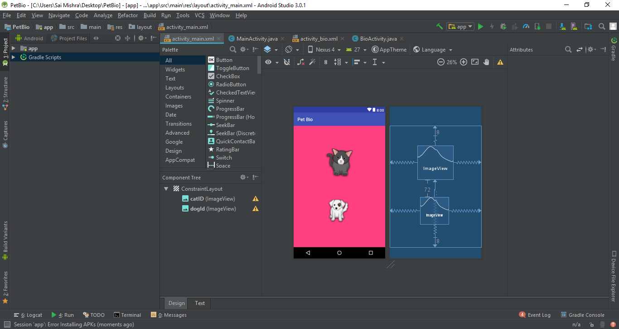

**2.**Main Activity where the java code for app’s main screen is written.

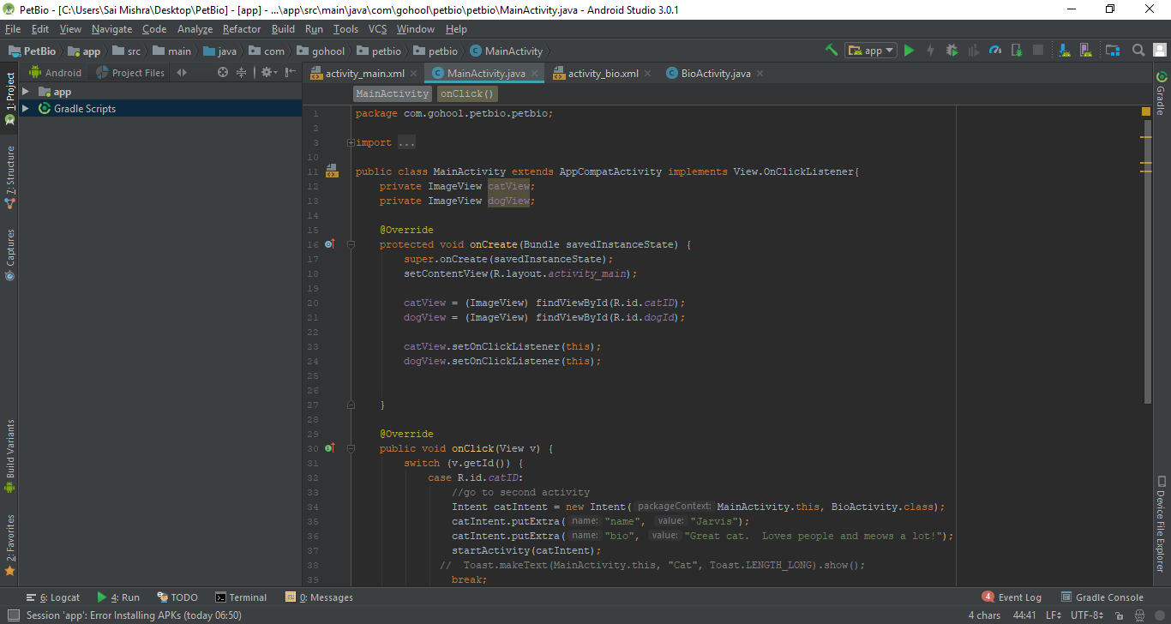

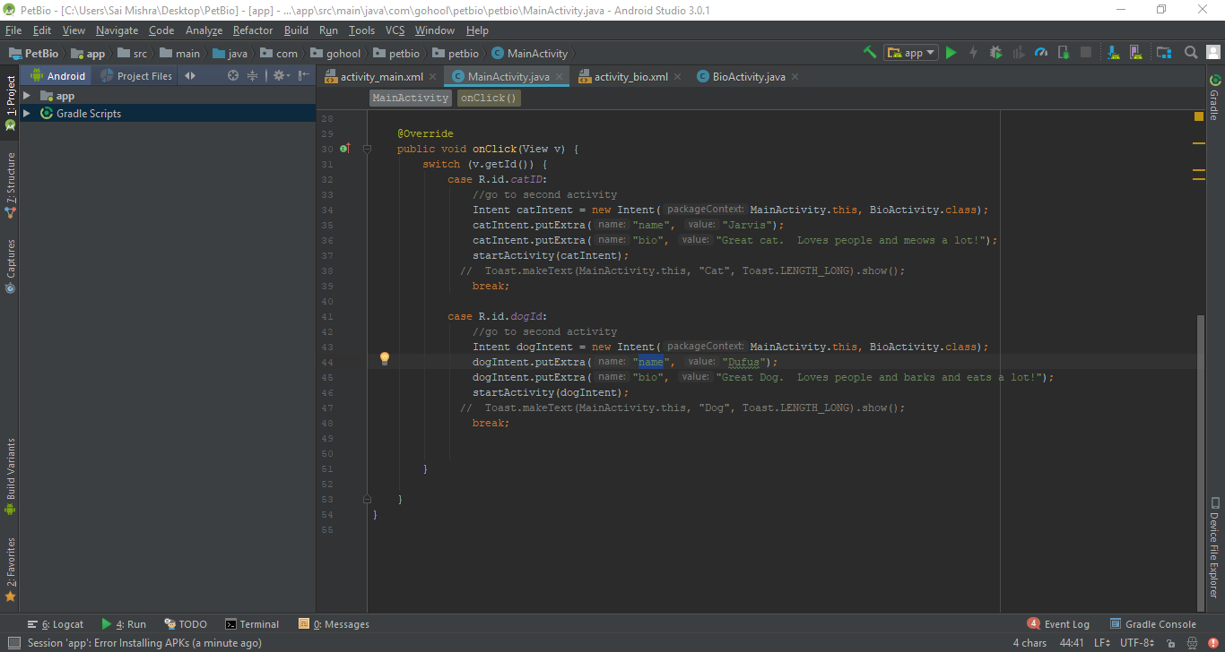

3.Activity_bio where the code for the next screen is written that contains bio of the animals.

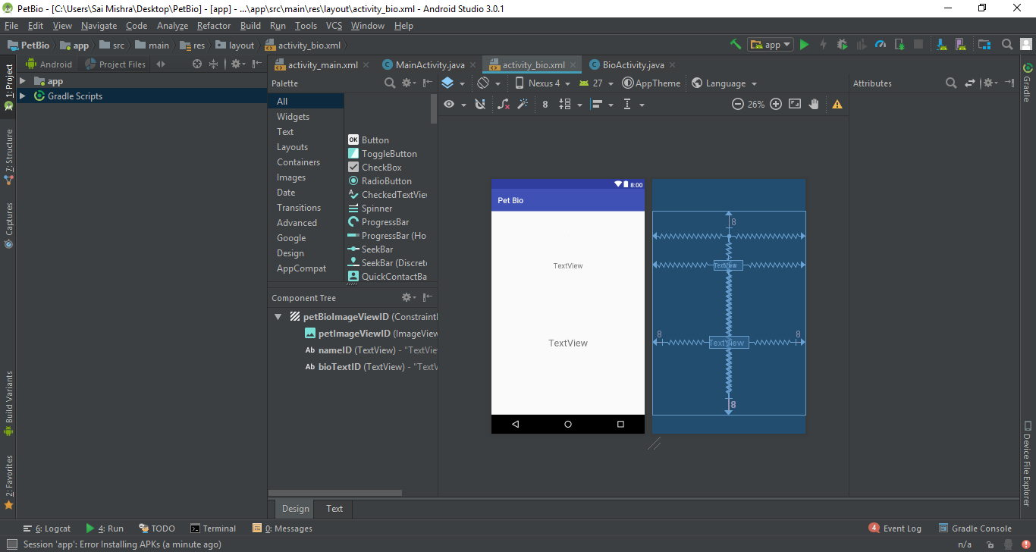

4.Bio activity is where the java code for android app’s next screen is written.

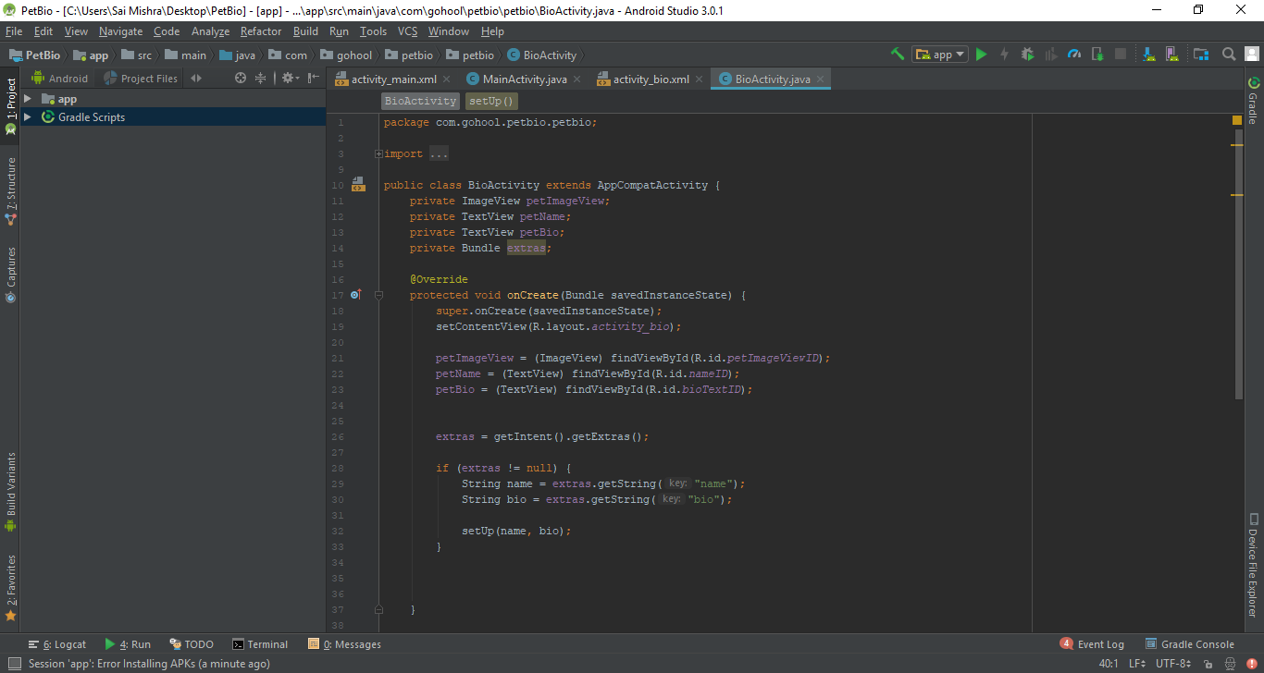

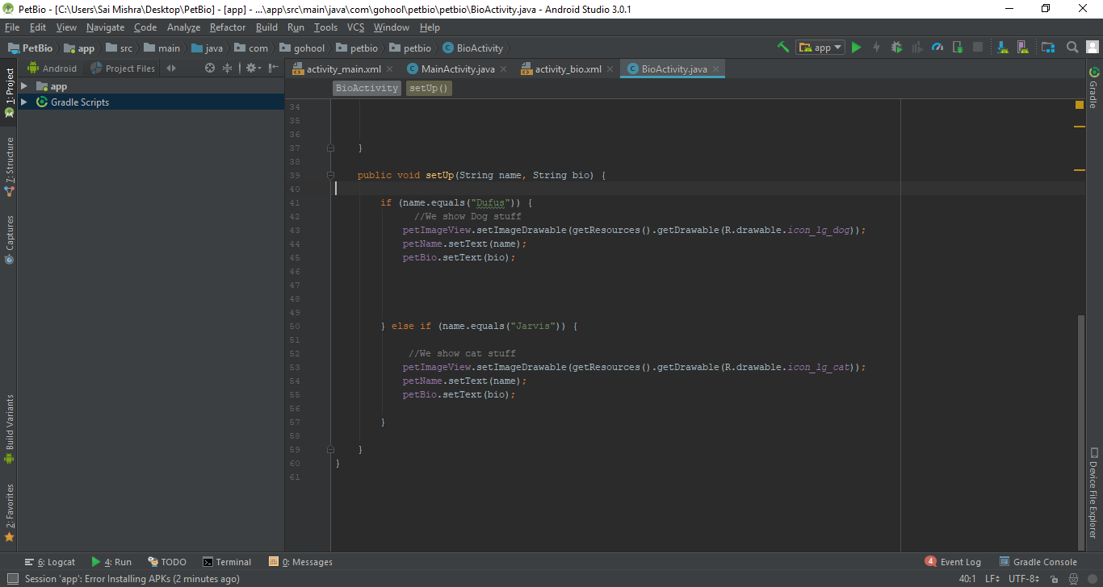

**DEPLOYMENT ON IBM CLOUD**

After you are logged in to IBM® Cloud, you can upload your application with the bluemix app push command.

Before you begin, you must:

1. Install the IBM® Cloud command line interface.

Download Bluemix Command Line Interface.

1. Connect to IBM® Cloud.

bluemix api https://api.au-syd.bluemix.net

1. Log in to IBM Cloud.

bluemix login -u *username* -o *org_name* -s *space_name*

When a **bluemix app push** command is issued, the command line interface provides the working directory to the IBM Cloud environment that uses a buildpack to build and run the application.

1. From your application directory, enter the **bluemix app push** command with the application name. The app name must be unique in the IBM Cloud environment.

bluemix app push *app_name* -m 512m

IBM Cloud includes built-in buildpacks. In some cases, even for the built-in buildpacks, you must also supply a -c option to specify the command that is used to start your application. For example, you need to use the -c option to push your Node.js application:

bluemix app push *app_name* -c start_command

In addition, the Node.js application must contain a valid package.json file.

All other external buildpacks must be pushed by using the -b option. For example:

bluemix app push *app_name* -b buildpack_URL

**Tip:** When you use the **bluemix app push** command, the command copies all of the files and directories from your current directory to Bluemix. Ensure that you have only the required files in your application directory.

1. If you change your application, you can upload those changes by entering the bluemix app push command again. The command uses your previous options and your responses to the prompts to update any running instances of your application with the new bits of code.

IBM® Cloud CLI bundled a cf cli in its installation. bluemix app push command acutually invokes cf push to upload and deploy your application to IBM Cloud. See [cf commands](https://console.bluemix.net/docs/cli/reference/cfcommands/index.html) for more information about cf push. See [Using community buildpacks](https://console.bluemix.net/docs/cfapps/byob.html) for information about buildpacks.

WORK IN PROJECT-

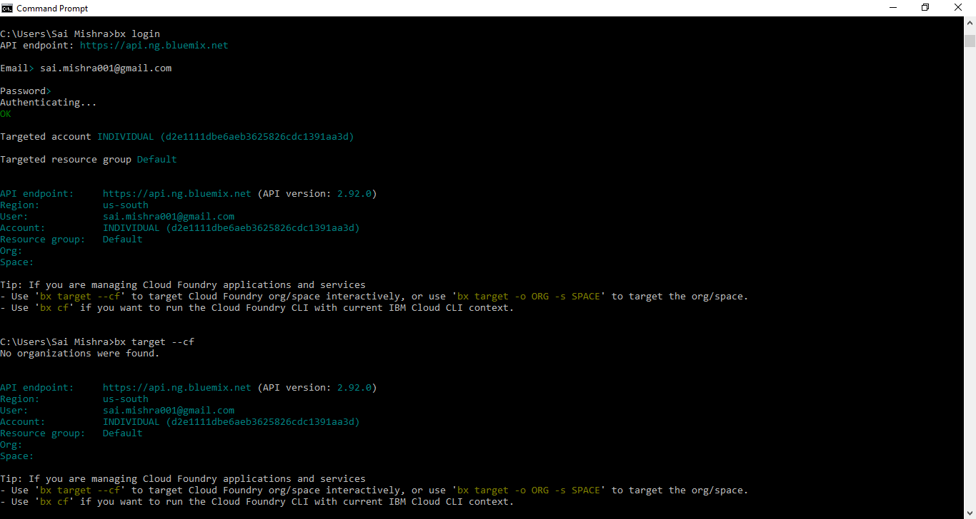

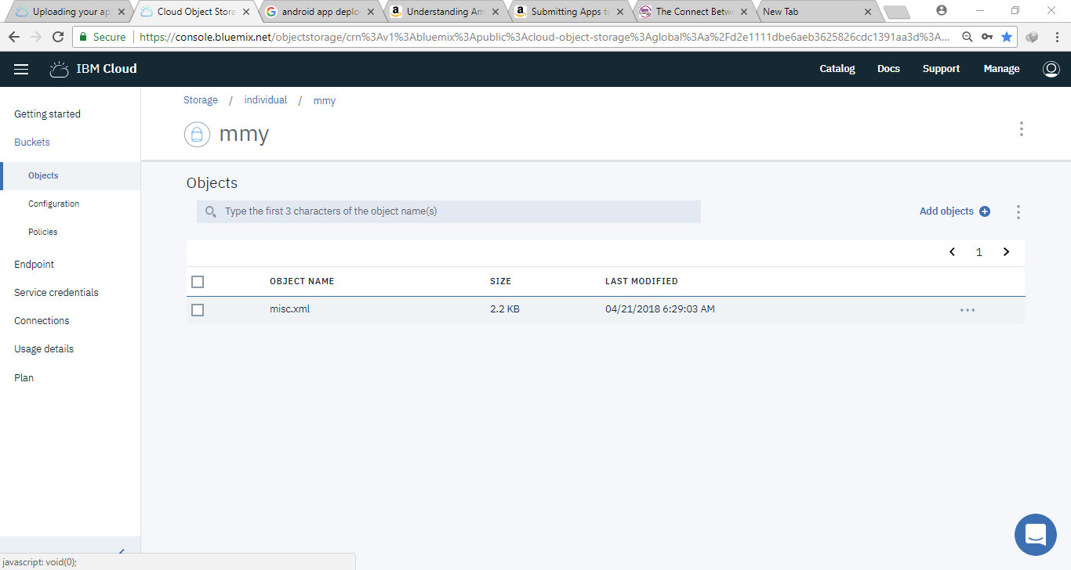

**ANDROID APPLICATION UPLOAD ON AMAZON APP STORE**

Amazon's goal is to make app submission for Android apps simple and easy. Most of the time, your Android app should just work on Amazon Fire devices without modifications.

High-Level Review of Submission Prerequisites

Publishing to the Amazon Appstore requires the following:

* **Amazon customer account**: If you do not have an Amazon customer account, create one at [Amazon.com](http://www.amazon.com/).
* **Amazon developer account**: If you do not have an Amazon developer account, go to the [Amazon Apps & Games Developer Portal](https://developer.amazon.com/login.html), and sign in with the same email address as your Amazon customer account. The portal will guide you through the account creation process.
* **An Android app that you want to publish to the Amazon Appstore**: Each app that you submit must comply with Amazon's content policy. If Amazon determines that an app contains, facilitates, or promotes content prohibited by these guidelines, Amazon will reject the submission. See [Amazon Appstore Content Policy Requirements](https://developer.amazon.com/docs/app-submission/content-policy.html).
* **Image assets for product promotion**. You must provide screenshots and large and small icons for promoting your app on the Amazon Appstore. You may optionally provide a promotional image and videos. See [Image Asset Guidelines](https://developer.amazon.com/docs/app-submission/asset-guidelines.html).
* **Intellectual Property (IP) Documentation (if needed)**: If your app uses intellectual property (IP) from a third party, be prepared to submit documentation that you have obtained the proper license or permission to use that IP in your app.

Overview of the App Submission Process

The following high-level overview can help you understand the general process for submitting an app to the Amazon Appstore:

1. **Develop or Migrate**: Develop your app from scratch or migrate an existing Android app for publishing in the Amazon Appstore. (See [Migrating an Existing App to the Amazon Appstore](https://developer.amazon.com/docs/app-submission/migrate-existing-app.html).) Keep in in mind the [Amazon Appstore Content Policy Requirements](https://developer.amazon.com/docs/app-submission/content-policy.html) as you design your app.
2. **Test**: Make sure that your app meets the [Test Criteria for Amazon Appstore Apps](https://developer.amazon.com/docs/app-testing/test-criteria.html). You can also use one of Amazon's testing services to validate your app's functionality. See [Testing Your App for the Amazon Appstore](https://developer.amazon.com/docs/app-testing/testing-your-app.html).
3. **Submit Your App**: Login to your developer account, enter the appropriate information for your app's listing in the Amazon Appstore, and upload your app. See [Submitting Apps to the Amazon Appstore](https://developer.amazon.com/docs/app-submission/submitting-apps-to-amazon-appstore.html).
4. **Respond to any failure notifications (if needed)**: If your app fails any submission criteria, you will receive a notification that the app has been rejected. Fix your app as directed, and resubmit your app. See [Viewing App Submission Status](https://developer.amazon.com/docs/app-submission/viewing-app-submission-status.html).
5. **Update your app (as needed)**: If you need to make changes to an app that has already gone live in the Amazon Appstore, see [Updating a Published App](https://developer.amazon.com/docs/app-submission/update-published-app.html)

# **Submitting Apps to the Amazon Appstore**

Steps to publish your app in the Amazon Appstore: -

Publishing Requirements

* Android APK or web app
* [Amazon Developer Account](https://developer.amazon.com/login.html)
* [Image assets and descriptions](https://developer.amazon.com/docs/app-submission/publish-app-upload-apk-files.html)

Publishing Overview

The Developer Console provides a number of tabs that you proceed through to enter information about your app:

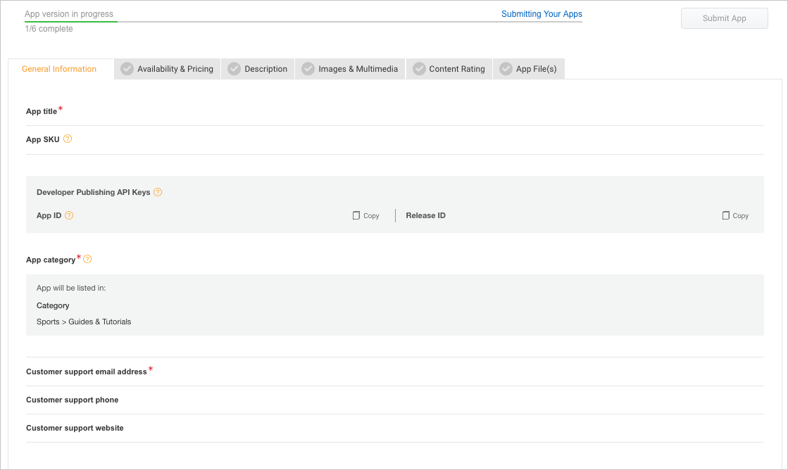

The following workflow map guides you through this process:

[STEP 1:  
Log In and Add an App](https://developer.amazon.com/docs/app-submission/publish-app-login-and-add-app.html)

→

[STEP 2:  
Add General Information](https://developer.amazon.com/docs/app-submission/publish-app-general-information.html)

→

[STEP 3:  
Add Availability & Pricing](https://developer.amazon.com/docs/app-submission/publish-app-availability-pricing.html)

→

[STEP 4:  
Add Descriptions](https://developer.amazon.com/docs/app-submission/publish-app-descriptions.html)

[STEP 5:   
Add Images & Multimedia](https://developer.amazon.com/docs/app-submission/asset-guidelines.html)

→

[STEP 6:  
Add Content Rating](https://developer.amazon.com/docs/app-submission/publish-app-content-rating.html)

→

[STEP 7:  
Upload App Files](https://developer.amazon.com/docs/app-submission/publish-app-upload-app-files.html)

→

[STEP 8:  
Submit Your App and Check Status](https://developer.amazon.com/docs/app-submission/viewing-app-submission-status.html)

After you complete all the required information for a tab, the Developer Portal displays a green checkmark Green check mark iconfor that tab. You will not be able to submit your app until all six tabs show green checkmarks.

**Note:** As you navigate from tab to tab, click **Save** to save your information. The information on each tab is not automatically saved when you go to another tab.

WORK IN PROJECT

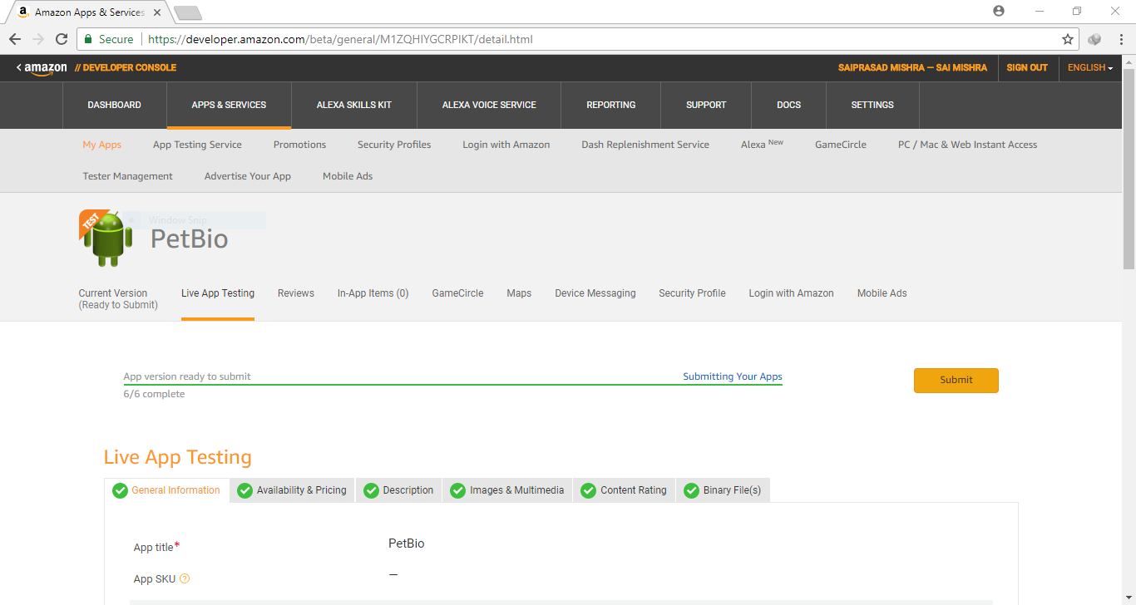

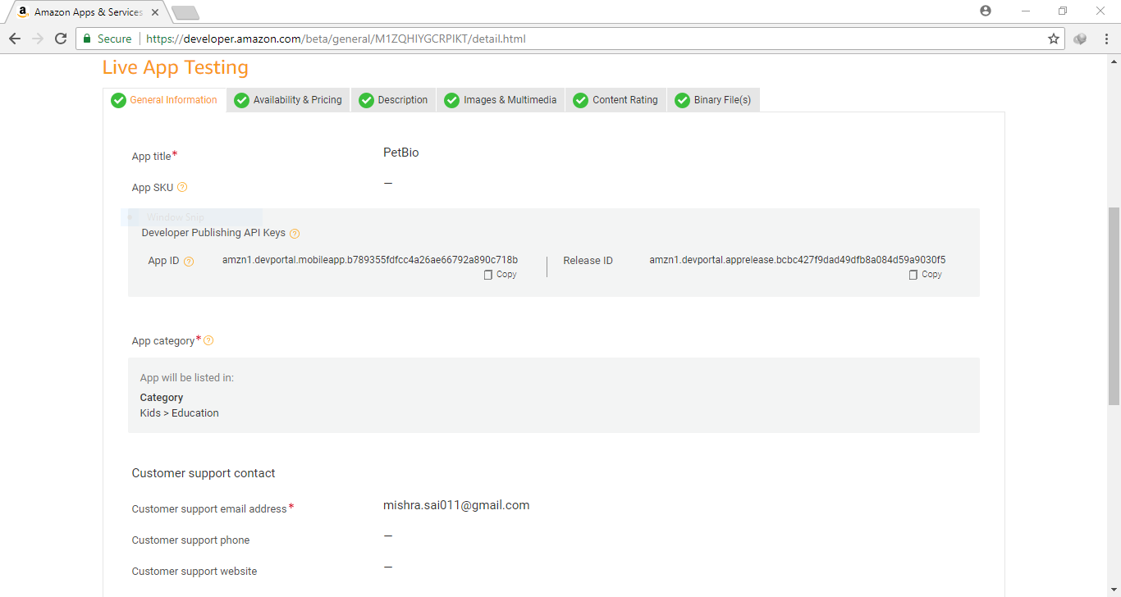

**OUTPUT**

Output Window Screenshots of the android avd emulator.

