**ANDROID APPLICATION UPLOAD ON AMAZON APP STORE**

Amazon's goal is to make app submission for Android apps simple and easy. Most of the time, your Android app should just work on Amazon Fire devices without modifications.

High-Level Review of Submission Prerequisites

Publishing to the Amazon Appstore requires the following:

* **Amazon customer account**: If you do not have an Amazon customer account, create one at [Amazon.com](http://www.amazon.com/).
* **Amazon developer account**: If you do not have an Amazon developer account, go to the [Amazon Apps & Games Developer Portal](https://developer.amazon.com/login.html), and sign in with the same email address as your Amazon customer account. The portal will guide you through the account creation process.
* **An Android app that you want to publish to the Amazon Appstore**: Each app that you submit must comply with Amazon's content policy. If Amazon determines that an app contains, facilitates, or promotes content prohibited by these guidelines, Amazon will reject the submission. See [Amazon Appstore Content Policy Requirements](https://developer.amazon.com/docs/app-submission/content-policy.html).
* **Image assets for product promotion**. You must provide screenshots and large and small icons for promoting your app on the Amazon Appstore. You may optionally provide a promotional image and videos. See [Image Asset Guidelines](https://developer.amazon.com/docs/app-submission/asset-guidelines.html).
* **Intellectual Property (IP) Documentation (if needed)**: If your app uses intellectual property (IP) from a third party, be prepared to submit documentation that you have obtained the proper license or permission to use that IP in your app.

Overview of the App Submission Process

The following high-level overview can help you understand the general process for submitting an app to the Amazon Appstore:

1. **Develop or Migrate**: Develop your app from scratch or migrate an existing Android app for publishing in the Amazon Appstore. (See [Migrating an Existing App to the Amazon Appstore](https://developer.amazon.com/docs/app-submission/migrate-existing-app.html).) Keep in in mind the [Amazon Appstore Content Policy Requirements](https://developer.amazon.com/docs/app-submission/content-policy.html) as you design your app.
2. **Test**: Make sure that your app meets the [Test Criteria for Amazon Appstore Apps](https://developer.amazon.com/docs/app-testing/test-criteria.html). You can also use one of Amazon's testing services to validate your app's functionality. See [Testing Your App for the Amazon Appstore](https://developer.amazon.com/docs/app-testing/testing-your-app.html).
3. **Submit Your App**: Login to your developer account, enter the appropriate information for your app's listing in the Amazon Appstore, and upload your app. See [Submitting Apps to the Amazon Appstore](https://developer.amazon.com/docs/app-submission/submitting-apps-to-amazon-appstore.html).
4. **Respond to any failure notifications (if needed)**: If your app fails any submission criteria, you will receive a notification that the app has been rejected. Fix your app as directed, and resubmit your app. See [Viewing App Submission Status](https://developer.amazon.com/docs/app-submission/viewing-app-submission-status.html).
5. **Update your app (as needed)**: If you need to make changes to an app that has already gone live in the Amazon Appstore, see [Updating a Published App](https://developer.amazon.com/docs/app-submission/update-published-app.html)

# **Submitting Apps to the Amazon Appstore**

Steps to publish your app in the Amazon Appstore: -

Publishing Requirements

* Android APK or web app
* [Amazon Developer Account](https://developer.amazon.com/login.html)
* [Image assets and descriptions](https://developer.amazon.com/docs/app-submission/publish-app-upload-apk-files.html)

Publishing Overview

The Developer Console provides a number of tabs that you proceed through to enter information about your app:

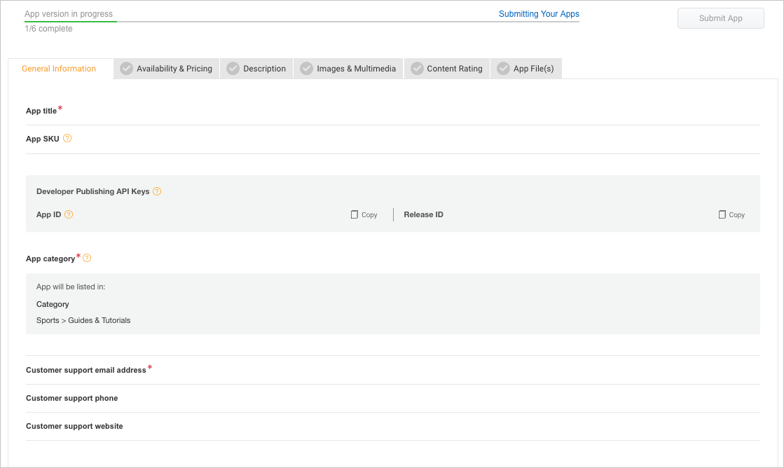

The following workflow map guides you through this process:

[STEP 1:  
Log In and Add an App](https://developer.amazon.com/docs/app-submission/publish-app-login-and-add-app.html)

→

[STEP 2:  
Add General Information](https://developer.amazon.com/docs/app-submission/publish-app-general-information.html)

→

[STEP 3:  
Add Availability & Pricing](https://developer.amazon.com/docs/app-submission/publish-app-availability-pricing.html)

→

[STEP 4:  
Add Descriptions](https://developer.amazon.com/docs/app-submission/publish-app-descriptions.html)

[STEP 5:   
Add Images & Multimedia](https://developer.amazon.com/docs/app-submission/asset-guidelines.html)

→

[STEP 6:  
Add Content Rating](https://developer.amazon.com/docs/app-submission/publish-app-content-rating.html)

→

[STEP 7:  
Upload App Files](https://developer.amazon.com/docs/app-submission/publish-app-upload-app-files.html)

→

[STEP 8:  
Submit Your App and Check Status](https://developer.amazon.com/docs/app-submission/viewing-app-submission-status.html)

After you complete all the required information for a tab, the Developer Portal displays a green checkmark Green check mark iconfor that tab. You will not be able to submit your app until all six tabs show green checkmarks.

**Note:** As you navigate from tab to tab, click **Save** to save your information. The information on each tab is not automatically saved when you go to another tab.

WORK IN PROJECT

