**Project Title**

**Hotel Management System**

**Abstract:-**

The client uses MS Excel, and maintains their records, however it is not possible them to share the data from multiple system in multi user environment, there is lot of duplicate work, and chance of mistake. When the records are changed they need to update each and every excel file. There is no option to find and print previous saved records. There is no security; anybody can access any report and sensitive data, also no reports to summary report. This Hotel Management System is used to overcome the entire problem which they are facing currently, and making complete atomization of manual system to computerized system.

**Introduction**

The theme of our Project is **Hotel Management System**. This Project is a fine thought to make the complex procedure of the Hotel management system to an easy manner which is systematic, modular designed, selective menu based user display. The modular design and constructed system is very much user oriented in which user can easily understand the tools and can do edit of his own choice. The system is not any tough more and does not possesses many applications but it is made by focusing on the maintaining records employee’s actions in a computerized system rather than time taking and cumbersome manual system.

The project is a software application that can be easily handled by minimum educated and simple computer knowledge person without any option of error.

Two kinds of users can handle the system.

1. Online Users

2. Administrator or Hotel Management.

The Online users are the customers or the staff who can see the news and updates of the Hotel and the Administrator are responsible for updating the Hotel details on computer. The Administrator is the authorized user who has power to change or edit the updates as well as the Password. In case of the forgetting of password there is provision to password recovery and Logout and Login in the system.

The Purpose of the whole process is to ease the daily or regular activities of the Hotel Management into an automatic computerized retrievable process. The daily activities includes the Room activities, Entering details of the new customer check in, To allocate a room as per the customer need and interest, Recording the checkout time and details, Releasing or Empty of room and to record the process in a computer system for future.

Due to time constraint and the minimum resources, the system is not made for the high level use. But the Management system can use the application in a very easy and minimum effort.

The application of the Hotel Management System bears the following functions to use by the Administrator.

1. Room status
2. New Room inauguration
3. Allocated Room Modification
4. Details for the Customer Check in and Check out
5. New Customer Admission
6. Allocation of Room as per the Customer Interest
7. Statement and Transactions of the Customer
8. Total Customers Present In The Hotel
9. Separate Customer Report.

**Problem Statement**

Tourist information centers spend a lot of their time calling hotels to check for availability. Also, many smaller hotels suffer from not being able to advertise their availability to tourist information centers. The Aptos Chamber of Commerce, a tourist information center in Santa Cruz County, currently has no automated system for managing information about hotel availability and must call each hotel individually. They would like a more efficient system to route tourists to local hotels with availability while saving valuable time that could be invested in other community services.

**Problem Solution**

The process of finding hotel availability could be automated to save time for both the tourist information center staff and the hotel staff. We propose a system that allows hotel staff to add listings to a central database via a website. The tourist information center staff could then open an application to access the database, and retrieve information about the number of rooms available and their prices.

**Scope**

We will do so by meeting the following milestones:

• User-level requirements overview.

• Implementation of the central database.

• Implementation of the website accessed by hotels.

• Implementation of the application accessed by the tourist information center.

**Input / Output**

* All the fields such as hotel, services, bookings are validated and doesn’t take invalid values.
* Each form of hotel, rooms customers, cannot accept blank value fields.
* Avoiding errors and data.
* Controlling amount input.
* Integration of all the modules/forms in the system.
* Preparationof the test cases.
* Preparation of possible test data with all validation checks.
* Actual testing done manually.
* Recording of all the reproduced errors.
* Modification done for the errors found during testing.
* Prepared the test results scripts after rectification of the errors.
* Functionality of the entire module/forms.
* Validations for the user input.

**Modules and their Interaction(UML)**

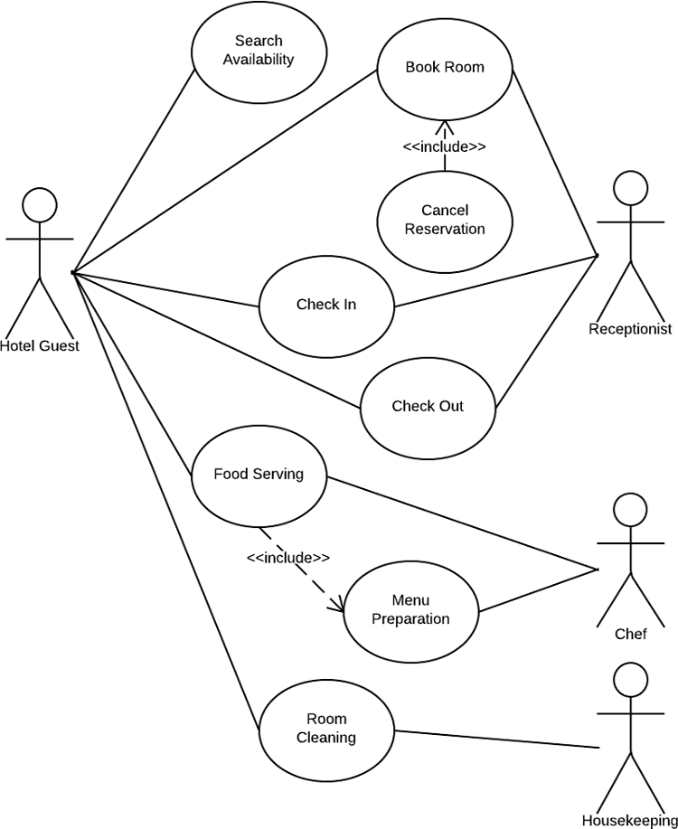

**Algorithm**

**Algorithm for form Load**

Step1: Start the application

Step2: Wait until the program loads

Step3: This form automatically closes.

**Algorithm for Login**

Step1: Start

Step2:  Select User Name

Step3:  Enter password

Step4:  Click on Login button

If (User ID) and (Password) is Valid then

Unload the user form from memory and

Load and show MDI Main form.

Else

Display the message “Username and Password doesn’t match”

Go to Step2

Step5:  Stop

**Algorithm for Adding New User**

Step1:  Start

Step2:  Go to system > manage user

Step3: Enter the administrative password to carry out the operation.

Step4: Click on Add New User and a field appears,

Step5:  Enter new User name, Password, Confirm Password.

Step6:  Click on save button for adding user and cancel button for cancelling operation.

Step7:  If all condition remains true then print message “Username Added”.

Step8: End

**Algorithm for Editing User’s record**

Step1: Start

Step2: Go to system > manage user

Step3: Enter the administrative password to carry out the operation

Step4: Click on update user and a field appears,

Step5: Choose the user name you want to edit and Click on save button for adding user and cancel button for cancelling operation

Step6: if the User ID after editing is found on the database then print the message “User already exists”

Else save the record on the database with message

Step7: End

**Algorithm for Deleting User’s record**

Step1:  Start

Step2:  Click on the user’s record from the list whom you want to Delete

Step3:  Click on the Delete button then print the message “Do you really want to delete this user”

Step4:  If click on yes the user will be deleted

 If click on no the operation will be cancelled

Step6: End

**Algorithm for Adding New Room Reservation**

Step1: Start

Step2: Go to New Room Reservation

Step3: Click on New Button of the form

Step4: Fill all the given fields,

Step5: Click on Save button to save record or Cancel button to cancel the operation

Step6: If clicked Save

Print the message “Record Saved successfully”. And it saves the record to the database

Else program terminates to main form.

Step8:  Stop.

**Algorithm for Delete Record**

Step1: Start

Step2: Go to Customer > New Room Reservation

Step3: Click on Delete Button of the form

Step4: Enter the Reservation Number which you want to delete.

Step5: click on Ok button to delete record or Cancel button to cancel the operation

Step6: If clicked Ok

Print the message “Record Deleted successfully”. And it deletes the record from the database

Else program terminates to main form.

Step7:  Stop.

**Algorithm for Print Record**

Step1: Start

Step2: Click on Report >Print or Open the Room Reservation form and click Print.

Step3: The system calls the print function and starts printing if the printer is installed.

Step4: Stop

**Algorithm for Backup**

Step1: Start.

Step2: Open Main form >Tools >Database Backup.

Step3: The form opens and asks the user to give the path.

Step4: Click on Ok to create backup orCancel to cancel operation.

If Ok button is the program creates a backup in the specified path.

Else the program terminates to the previous form.

Step5: Stop.

**References**

**Website Referred:**

* [www.google.com](http://www.google.com)
* [www.codeproject.com](http://www.codeproject.com)
* [www.freevbcode.com](http://www.freevbcode.com)
* [www.vbsources.com](http://www.vbsources.com)

**Books:**

* Introduction to Java Programing- Y.Daniel Liang.
* Understanding Object-oriented Programming with Java-Timothy Budd.