Module 5-Frontend-HTML5

Theory Assignment
- Difference b/w HTML & HTML5?

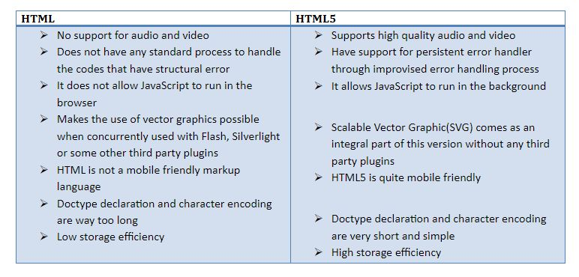

- What are the additional tags used in HTML5?
- Semantic Structural Tags:

- <header>: Represents the introductory content or a group of navigational links for a section or document.

- <footer>: Defines a footer for a document or a section, typically containing information about the author, copyright data, or links to related documents.

- <nav>: Represents a section of a page that contains navigation links.

- <main>: Specifies the main content of a document, unique to that document.

- <section>: Defines a self-contained section of content within a document.

- <article>: Represents a self-contained piece of content, such as a blog post or a news story.

- <aside>: Defines content that is tangentially related to the content around it, like a sidebar.

- Multimedia Tags:

- <audio>: Used to embed sound content into a document.

- <video>: Used to embed video content into a document.

- <source>: Specifies multiple media resources for <video> and <audio> tags.

