**PREDICTING STOCK MARKET MOVEMENT BY ANALYZING SENTIMENT IN NEWS HEADLINES**

### A Major Project Report Submitted in Partial Fulfillment for the Award of the Degree of Bachelor of Technology in Computer Science and Engineering/Information Technology

### *Submitted to*

### 

**Dr. A.P.J. ABDUL KALAM TECHNICAL UNIVERSITY, LUCKNOW**

### *Submitted by:*

### Siddhant Mishra (2000100100174)

### Saumya Pandey (2000100100158)

### Ritika Singh (2000100100146)

**UNDER THE SUPERVISION OF**

Mr. Rajeev Dixit

Assistant Professor



**DEPARTMENT OF COMPUTER SCIENCE AND ENGINEERING**

**UNITED COLLEGE OF ENGINEERING AND RESEARCH, PRAYAGRAJ**

**MAY 2024**

## **CANDIDATE’S** **DECLARATION**

We hereby certify that the project entitled “Predicting stock market movements by analyzing sentiment in news headlines.” submitted by us in partial fulfillment of the requirement for the award of the degree of B. Tech (Computer Science & Engineering) submitted to Dr. A.P.J. Abdul Kalam Technical University, Lucknow, at United College of Engineering and Research, Prayagraj is an authentic record of our own work carried out during a period from June 2023 to May 2024 under the guidance of Mr. Rajeev Dixit (Assistant Professor, Department of Computer Science & Engineering). The matter presented in this project has not formed the basis for the award of any other degree, diploma, fellowship, or any other similar title.

**Siddhant Mishra**

(2000100100174)

**Saumya Pandey**

(2000100100158)

**Ritika Singh**

( 2000100100146)

### Place: Prayagraj

### Date:

# **CERTIFICATE**

This is to certify that the project is titled “Predicting stock market movement by analyzing sentiment in news headlines.” is the bona fide work carried out by Siddhant Mishra (2000100100174) ,Saumya Pandey (2000100100158) and Ritika Singh (2000100100146) in partial fulfillment of the requirement for the award of the degree of the B. Tech. (Computer Science & Engineering) submitted to Dr. A.P.J Abdul Kalam Technical University, Lucknow at United College of Engineering and Research, Prayagraj is an authentic record of their own work carried out during a period from June, 2023 to May, 2024 under the guidance of Mr. Rajeev Dixit (Assistant Professor, Department of Computer Science & Engineering). The Major Project Viva-Voce Examination has been held on __________________.

### Signature of the Guide _________________________________

### [Mr. Rajeev Dixit]

### Signature of Project Coordinator ________________________

### [Mr. Shyam Bahadur Verma]

### 

### Signature of the Head of Department _____________________

### [Dr. Vijay Kumar Dwivedi]

### Place: Prayagraj

### Date:

# **ABSTRACT**

This final-year project report delves into the intricacies of predicting stock market movement by analyzing sentiment in news headlines. It marks the culmination of a journey that began with sourcing a dataset from Kaggle, meticulously followed by rigorous data cleaning and training procedures to ensure the data's readiness for analysis.

Our project aims to help people predict stock market movements using sentiment analysis in the news.

This involves using natural language processing (NLP) techniques to analyze the sentiment of news (positive, negative, or neutral) related to the stock market in general.

By gauging the sentiment expressed in these news headlines, we aim to develop a predictive model that can potentially provide insights into future movements.

The idea is to make a model using Python, Machine Learning (Natural Language Processing ) and other methodologies.

Unravel Sentiment-stock Relationship: The project uncovers insights into the relationship between news sentiment and stock market movements. This could include identifying periods when sentiment strongly affects price movements and periods when it doesn't.

Visualization of Results: Demonstrate the model's performance on the basis of sentiment. These visualizations can help convey the effectiveness of the model to stakeholders.

Our report dives deep into the methodology behind our project, shedding light on the hurdles we encountered and the strategies we employed to surmount them. Moreover, we meticulously dissect the performance of our model, showcasing its accuracy.

**ACKNOWLEDGEMENT**

We express our sincere gratitude to Dr. A.P.J. Abdul Kalam Technical University, Lucknow, for giving us the opportunity to work on the major project during our final year of B.Tech. (CSE), which is an important aspect in the field of engineering.

We would like to thank Prof. H.P. Shukla, Principal, and Dr. Vijay Kumar Dwivedi, Head of Department, CSE, at the United College of Engineering and Research, Prayagraj, for their kind support.

We also owe our sincerest gratitude to Mr. Rajeev Dixit for his valuable advice and healthy criticism throughout our project, which helped us immensely to complete our work successfully.

We would also like to thank everyone who has knowingly and unknowingly helped us throughout our work. Last but not least, a word of thanks to the authors of all those books and papers that we have consulted during our project work as well as for preparing the report.

**List of Figures**

| **S. No** | **Figure Caption** | **Page No.** |
| --- | --- | --- |
| 0 | Gantt Chart | 7 |
| 1.1 | Framework for Predicting Stock Movement | 13 |
| 1.2 | How Machine Learning Works | 16 |
| 1.3 | LSTM Model | 17 |
| 2.1 | Flow Chart | 30 |
| 2.2 | LSTM layers Flow Chart | 31 |
| 2.3 | 0-Level Data Flow Diagram | 31 |
| 2.4 | 1-Level Data Flow Diagram | 32 |
| 2.5 | 2-level Data Flow Diagram | 32 |
| 3.5 | Testing (Fig 3.5.1, 3.5.2 and 3.5.3) | 39,40 |
| 4.1 | Output | 42 |
| 7.1 | Plagiarism Report | 50 |

**Gantt Chart**

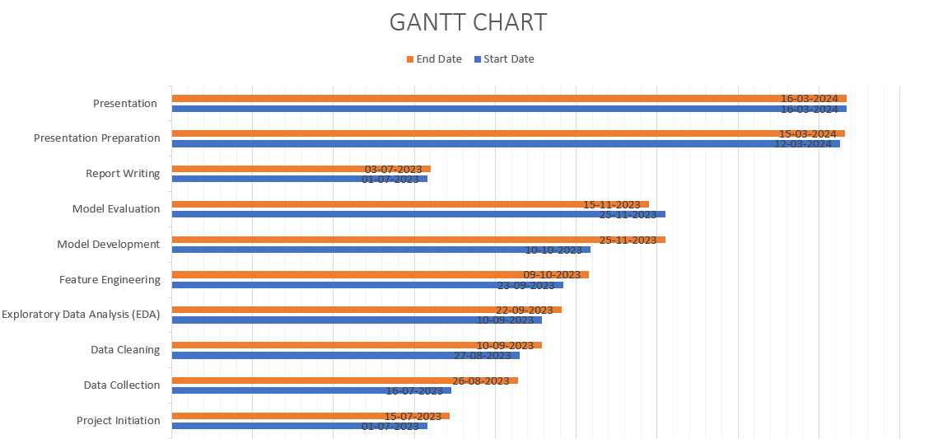

**Fig.0 Gantt Chart**

**CONTENTS**

**TITLE PAGE i**

**Declaration ii**

CERTIFICATE iii

ABSTRACT iv

ACKNOWLEDGEMENT v

List of Figures vi

Gantt Chart vii

**Content** viii

**CHAPTER 1 - Introduction:**

1.1 Problem Definition 10

1.2 Project Overview/Specifications 11

1.3 Hardware Specification 18

1.4 Software Specification 19

**CHAPTER 2 - LITERATURE REVIEW:** 20

2.1 EXISTING SYSTEM 22

2.2 PROPOSED SYSTEM 22

2.3 FEASIBILITY STUDY 23

**CHAPTER 3 -** **SYSTEM ANALYSIS & DESIGN:**

3.1 Requirement Specification 26

3.2 Diagrams 29

1. Flow Chart 29
2. LSTM Layers Flow Chart 30
3. 0-Level Data Flow Diagram 30
4. 1-Level Data Flow Diagram 31
5. 2- Level Data Flow Diagram 31

3.3 Design and Test Steps / Criteria 32

3.4 Algorithms 34

1. Data Processing Algorithm 34
2. Long Term Short Memory Algorithm 35
3. Optimization Algorithm 37
4. Regularization Algorithm 37

3.5 Testing Process (Test Cases to be included) 38

**CHAPTER 4 -RESULT/OUTPUT** 40

**CHAPTER 5 -** **CONCLUSION/RECOMMENDATION** 42

**CHAPTER 6 -** **REFERENCES** 45

**CHAPTER 7 -Appendices** 46

**Plagiarism Report** 49

**CHAPTER I**

**INTRODUCTION**

**1.1 Problem Definition:**

The objective of this project is to empower investors with a tool that leverages sentiment analysis of financial news headlines to predict stock market movements. In today's dynamic and interconnected financial landscape, where news spreads rapidly and influences market sentiment, it's crucial for investors to have access to tools that can analyze and interpret the vast amount of textual data available. By harnessing the power of natural language processing (NLP) techniques, we aim to extract valuable insights from news headlines and integrate them into a machine learning model for predicting stock price movements.

The challenge at hand is multifaceted. Firstly, we need to preprocess the textual data effectively to remove noise, handle outliers, and extract relevant information. This involves techniques such as tokenization, removing stop words, stemming, and possibly entity recognition to identify key entities such as company names and financial indicators. Additionally, we must address the inherent ambiguity and subjectivity present in natural language, ensuring that our sentiment analysis accurately captures the nuanced emotions expressed in financial news.

Next, we need to design an appropriate deep learning architecture that can effectively learn from the sequential nature of textual data. LSTM (Long Short-Term Memory) networks, known for their ability to capture long-range dependencies in sequential data, are a natural choice for modeling textual data. However, we must carefully tune the architecture and hyperparameters to avoid overfitting and underfitting.

Training the model on historical data poses its own set of challenges. We need to curate a comprehensive dataset of financial news headlines. This dataset should span a significant time period and cover diverse market conditions to ensure the model learns robust patterns and trends. Furthermore, we must consider the impact of external factors such as macroeconomic indicators, geopolitical events, and market sentiment.

Finally, evaluating the model's performance requires careful consideration. Traditional metrics may not be sufficient in this context, as predicting stock market movements is inherently challenging and subject to noise. Instead, we may employ metrics such as accuracy to assess the model's ability to correctly predict upward and downward movements in stock prices.

By successfully addressing these challenges, our ultimate goal is to build a reliable predictive tool that can assist investors in making more informed decisions. By integrating sentiment analysis of financial news headlines into their trading strategies, investors can gain valuable insights into market sentiment.

**1.2 Project Overview:**

This project endeavors to harness the power of sentiment analysis techniques applied to a diverse array of textual data sources for news headlines to predict the movements of the stock market. In today's data-rich environment, where information flows incessantly from various channels, deciphering the sentiment embedded within textual data holds immense potential for uncovering valuable insights into market dynamics.

At the core of this initiative lies the quantification of sentiment polarity and strength within the collected textual data. By employing natural language processing (NLP) techniques, we aim to extract nuanced sentiments expressed in news articles, social media conversations, and financial reports. This involves not only identifying positive, negative, and neutral sentiments but also gauging the intensity and context of the emotions conveyed, allowing for a more nuanced understanding of market sentiment.

Through meticulous analysis of sentiment trends over time, we seek to unveil patterns and correlations between sentiment dynamics and stock market movements. By leveraging advanced machine learning algorithms, including but not limited to deep learning models such as recurrent neural networks (RNNs) and transformers, we aim to develop predictive models that can seamlessly integrate sentiment signals. These models will be trained on vast datasets spanning diverse market conditions, ensuring robustness and adaptability across different market scenarios.

The predictive models generated through this project will not only forecast future stock price trajectories but also provide insights into the underlying drivers of market sentiment. By discerning the collective mood of market participants reflected in textual data, investors and traders can gain a deeper understanding of market dynamics and anticipate potential shifts in sentiment. Armed with these insights, they can make more informed decisions, whether it's identifying investment opportunities, managing risks, or optimizing trading strategies.

Moreover, this endeavor aims to democratize access to market sentiment analysis, making it accessible to a broader audience of investors and traders. Through a user-friendly interface and interactive visualization tools, we aim to empower individuals with actionable insights derived from sentiment analysis, enabling them to navigate the complexities of the stock market with greater confidence and precision.

In summary, this project represents a convergence of technologies, including NLP, machine learning, and data analytics, to unlock the predictive power of sentiment analysis in forecasting stock price movements. By bridging the gap between textual data and market dynamics, we aspire to revolutionize decision-making in the realm of financial markets, ushering in a new era of data-driven insights and informed investment strategies.

**1.2.1 What are Stocks**

Stocks, often referred to as equities or shares, are foundational instruments in the realm of finance, embodying ownership stakes in companies and granting shareholders rights to a portion of the company's assets and profits. Traded on various stock exchanges globally, their values are subject to the ebb and flow of market forces, shaped by a myriad of factors spanning from macroeconomic trends to individual investor sentiments.

The allure of investing in stocks lies in the potential for two primary forms of returns: capital appreciation and dividend income.

Capital appreciation occurs when the market value of a stock increases over time, allowing investors to profit from the spread between their purchase and sale prices.

Dividend income, on the other hand, represents a share of the company's profits distributed periodically to shareholders, providing a steady stream of income irrespective of stock price fluctuations.

However, the pursuit of these returns is not without its perils. Investing in stocks carries inherent risks, ranging from market volatility and economic downturns to company-specific challenges and unforeseen events. The possibility of losing the principal investment looms over every stock transaction, underscoring the importance of prudent risk management and informed decision-making.

Despite these risks, stocks remain indispensable components of financial markets, serving as vital conduits for capital allocation, wealth creation, and economic growth. They offer investors a diverse array of opportunities to participate in the success stories of companies across various industries and sectors, from technology and healthcare to finance and consumer goods.

Moreover, stocks play a pivotal role in fostering innovation, entrepreneurship, and corporate governance. By providing companies with access to capital, stocks enable them to finance expansion initiatives, research and development endeavors, and strategic acquisitions. Additionally, the presence of shareholders incentivizes management teams to act in the best interests of the company and its stakeholders, promoting transparency, accountability, and long-term value creation.

In essence, stocks represent more than mere financial instruments; they embody the aspirations, achievements, and aspirations of businesses and investors alike, weaving together the fabric of the global economy and shaping the trajectory of financial markets for generations to come.

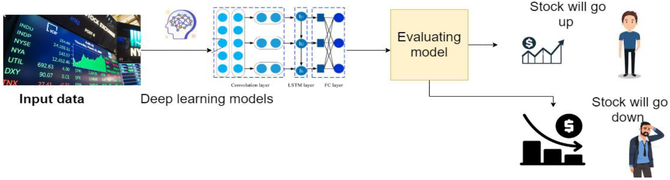

**Fig1.1 Framework for Predicting Stock Movement**

The value of stocks in the real world is determined by a complex interplay of market dynamics, investor sentiment, and fundamental factors like company performance and economic conditions.

Stock prices fluctuate based on factors such as revenue growth, GDP growth, and industry trends, influenced by news events and market sentiment. Understanding these dynamics is crucial for investors navigating the financial markets.

Overall, stocks are a key component of the financial markets, providing investors with opportunities to participate in the growth and profitability of companies across various sectors and industries.

**1.2.2 Types of Stocks**

Stocks can be classified into various types based on different criteria. Here are some common types of stocks:

1. **Common Stock**: represents ownership in a company with voting rights at shareholders' meetings. Owners of common stock are entitled to a share of the company's profits, typically through dividends, and may benefit from capital appreciation if the stock price increases.
2. **Preferred Stock:** This class of stock typically offers investors higher priority for dividends and assets than common stockholders. Preferred shareholders often receive fixed dividends but usually do not have voting rights in company decisions.
3. **Blue-Chip Stocks:** These are shares of well-established companies with a reputation for stable earnings and reliable performance. Blue-chip stocks are often considered less risky than others and are favored by conservative investors seeking long-term growth and income.
4. **Growth Stocks:** Growth stocks belong to companies expected to grow at a faster rate than the overall market. While they may not offer dividends, investors are attracted to them for their potential for significant capital appreciation over time.
5. **Value Stocks:** Value stocks are those believed to be trading at a lower price relative to their intrinsic value. Investors in value stocks typically seek companies that are undervalued by the market and have strong fundamentals, such as low price-to-earnings ratios or high dividend yields.
6. **Income Stocks:** Income stocks are shares of companies that consistently pay dividends to their shareholders. These stocks are often favored by income-oriented investors seeking regular cash flow from their investments.
7. **Small-Cap, Mid-Cap, and Large-Cap Stocks**: These classifications are based on the market capitalization of the issuing company.

Small-cap stocks represent smaller companies with market capitalizations typically below $2 billion. Mid-cap stocks are those of medium-sized companies, usually valued between $2 billion and $10 billion.

Large-cap stocks belong to well-established companies with market capitalizations typically exceeding $10 billion. Each category presents different levels of risk and growth potential for investors.

**1.2.3 Ways of Stock Trading**

Two of the most common trading types in the Indian stock market are:

1. **Intraday:** This strategy involves buying and selling shares on the same trading day. Intraday traders aim to capitalize on short-term price movements, often leveraging technical analysis and market trends to make quick buying and selling decisions. One of the key features of intraday trading is that positions are not held overnight, meaning there is no transfer of shares to the investor's Demat account. Instead, trades are settled on the same day, and any profits or losses are realized by the end of the trading session. It's essential for intraday traders to monitor market movements closely and adhere to strict risk management practices to mitigate potential losses. Additionally, if a position is not closed before the market closes or expires, brokers may automatically square it off, usually incurring a fee.
2. **Delivery:** Unlike intraday trading, delivery trading involves purchasing stocks with the intention of holding them for an extended period, ranging from days to years. When investors buy stocks in delivery trades, the shares are transferred to their Demat accounts and remain in their possession until they choose to sell them. This approach is typically favored by long-term investors who seek to profit from the potential appreciation of stock prices over time or who prioritize receiving dividends from their investments. Delivery trading allows investors to take advantage of fundamental analysis and company performance metrics to make informed investment decisions. Unlike intraday trading, there is no pressure to close positions within the same trading day, providing investors with greater flexibility and a reduced trading frequency.

**1.2.4 Machine Learning**

Machine learning, a branch of artificial intelligence, revolutionizes the way computers process information and make decisions by enabling them to learn from data without explicit programming. Through the analysis of vast datasets, machine learning algorithms identify patterns, correlations, and insights that humans may overlook, thereby facilitating predictions and informed decision-making.

Supervised learning, a fundamental approach in machine learning, involves training models on labeled datasets, where the correct output is provided for each input. These models learn to generalize from the provided examples, enabling them to make predictions or classifications based on new, unseen data.

Conversely, unsupervised learning algorithms work with unlabeled data, aiming to identify inherent structures or patterns without predefined categories. This type of learning is particularly useful for tasks such as clustering.

Reinforcement learning introduces a dynamic element to machine learning, wherein agents learn through trial and error by interacting with an environment. Through a process of exploration and exploitation, these agents optimize their actions to maximize cumulative rewards, making reinforcement learning suitable for tasks like game playing, robotics, and autonomous systems.

The versatility of machine learning extends across various industries and domains, with applications ranging from healthcare to finance, marketing, and beyond. For instance, in healthcare, machine learning algorithms analyze medical records and imaging data to assist in disease diagnosis and treatment planning. In finance, these algorithms facilitate fraud detection, risk assessment, and algorithmic trading. Marketing benefits from machine learning through personalized recommendations, targeted advertising, and customer segmentation.

In essence, machine learning reshapes data analysis, decision-making, and problem-solving paradigms, empowering computers to tackle intricate tasks that were once considered beyond their capabilities. As the field continues to evolve, its potential for driving innovation and addressing societal challenges remains boundless.

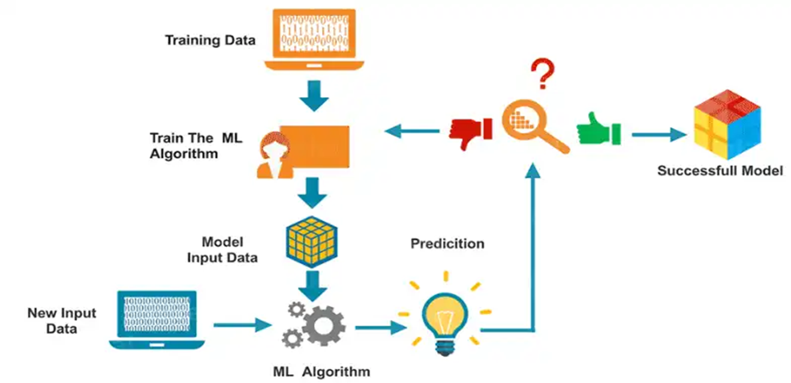

**Fig 1.2 How Machine Learning Works**

**1.2.5 Long Short Term Memory (LSTM)**

LSTM, or Long Short-Term Memory, represents a specialized architecture within recurrent neural networks (RNNs). Unlike traditional RNNs, LSTM networks excel at capturing long-range dependencies and maintaining information over extended time intervals. This capability is crucial for understanding sequential data, such as text, where context plays a significant role.

The essence of LSTM lies in its unique structure, consisting of different layers designed to regulate the flow of information. These layers include the input gate, forget gate, output gate, and memory cell, each serving a distinct purpose in managing the flow of information through the network.

By strategically controlling the flow of information, LSTM networks can selectively retain or discard information from previous time steps, allowing them to effectively capture patterns and dependencies in sequential data. This ability makes LSTMs particularly well-suited for tasks such as natural language processing, time series prediction, and speech recognition, where understanding long-range dependencies is critical for achieving high performance.

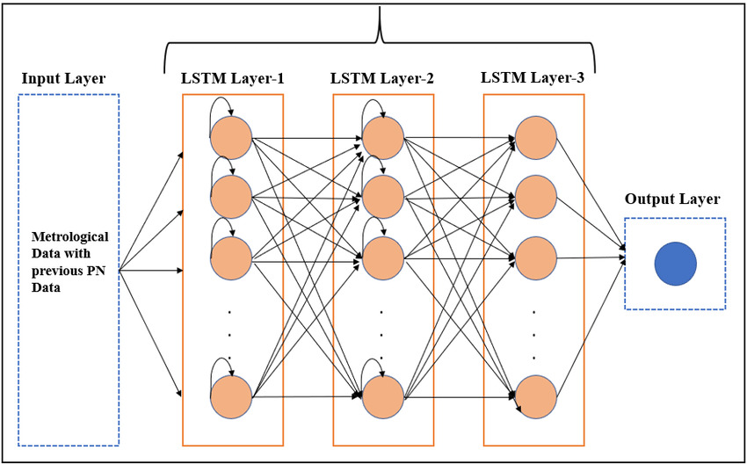

**Fig 1.3 LSTM Model**

**1.3 Hardware Specifications**

**Processor:** Intel Core i5-10300H ( 2.50 GHz ) with Nvidia GeForce GTX 1650

**Installed RAM:** 8.00 GB (5.88 GB usable)

**System Type:** 64-bit operating system, x64-based processor

**Operating System:** Windows 11 Home Single Language, Version 23H2, OS build 22631.3527

**Experience:** Windows Feature Experience Pack

**1.4 Software Specifications**

**1.4.1 Dataset Platform:**

**Kaggle**: Utilized for accessing and sourcing datasets relevant to the project's objectives.

**1.4.2 Machine Learning Development Platform:**

**Google Colab**: Employed for testing and executing machine learning code. It provides a cloud-based environment with GPU support, facilitating efficient model training and experimentation.

**1.4.3 Application to process dataset files:**

**Google Sheets/Excel:** Google Sheets is a web-based application that enables users to create, update, and modify datasets in CSV (comma separated Values) files and share the data online in real time.

**1.4.4 Integrated Development Environment (IDE) for Frontend Development:**

**Visual Studio Code (VSCode)**: Utilized for creating the form interface using HTML, CSS, and JavaScript. VSCode offers a lightweight yet powerful environment with robust features for web development.

**1.4.5 Web Browsers:**

**Chrome and Brave**: Used to visualize and use our machine learning model. Both Chrome and Brave are modern web browsers known for their speed, security, and compatibility with web technologies.

**CHAPTER II**

**LITERATURE SURVEY**

Financial markets are renowned for their inherent volatility, which presents investors with a significant degree of uncertainty and risk. In response to this challenge, this paper introduces a novel approach by leveraging Long Short-Term Memory (LSTM) and sentiment analysis models to predict the impact of news headlines on market movements.

The proposed methodology harnesses the power of LSTM networks, a specialized architecture within recurrent neural networks (RNNs), renowned for their ability to capture long-range dependencies in sequential data. By employing LSTM, the model can effectively process and analyze historical data, enabling it to discern intricate patterns and relationships that influence market dynamics.

Through the synergistic combination of LSTM and sentiment analysis, this approach offers a robust methodology for forecasting market behavior, enabling investors to make more informed decisions.

| **S.No.** | **Research Paper** | **Methodology** | **Author** | **Result** |
| --- | --- | --- | --- | --- |
| 1. | Forecasting Stock Market Movement Direction Using  Sentiment Analysis and Support Vector Machine | Support Vector  Machine and user-  generated Internet  content (e.g.,  tweets) | Ren, Wu, and Liu (2018) | Achieved up to 89.93%  accuracy in forecasting the  movement direction after  introducing sentiment  variables. |
| 2. | Analysis of Stock Price Prediction Using ML Techniques | LSTM | S. Sabarinath (IJRASET) | LSTM model with 87% |
| 3. | Stock Trend Prediction System using News Sentiment Analysis | Random forest, Naive Bayes and SVM | Kalyani Joshi | 95.8% for SVM Model |
| 4. | Stock Price Movement Based On News Headline | CountVectorizer and Random Forest | Ronil Patil | 85.1% |
| 5. | Analyzing Stock Price News Sentiment with Machine Learning | Natural Language Toolkit | [Sahaj Godhani](https://sahajgodhani777.medium.com/?source=post_page-----1d94fb680b3d--------------------------------) | Sentiment Prediction model using NLTK |
| 6. | Sentiment Analysis for Stock Price Prediction | Random Forest | James Briggs | 91% accuracy |
| 7. | Stock Sentiment Analysis | LSTM | Krish C Naik | 84.13% |
| 8. | Stock market prediction using machine learning classifiers and social media news | Machine Learning,  Deep Learning,  Feature Selection,  Spam Tweet  Reduction,  Ensemble  Classifiers. | Khan et al. (2020) | The study achieved prediction  accuracies up to 80.53% with  social media data and 75.16%  with financial news. |

These are the list of papers we referenced and comparative summary of Machine Learning and Sentiment Analysis in financial market prediction literature

**2.1 Existing System:**

Predicting stock market movements using sentiment analysis on news headlines is not only a fascinating area of research but also one that holds immense practical significance in financial markets. The ability to gauge market sentiment from textual data and use it to forecast stock market fluctuations can provide investors and traders with a valuable edge in decision-making.

Historically, traditional statistical methods relied heavily on manual analysis or rule-based systems to interpret sentiment from news headlines.

However, these approaches were often limited in scalability and struggled to capture the nuances of sentiment accurately. With the advent of machine learning, particularly supervised learning models like Random Forest, sentiment analysis has seen significant advancements. These models can effectively classify news headlines into positive, negative, or neutral sentiments by learning from labeled data, thus offering more scalable and accurate solutions.

Despite these advancements, challenges persist in accurately predicting stock market movements using sentiment analysis. Issues such as data quality, including noise or bias in news data, pose significant hurdles. Additionally, the inherent unpredictability of financial markets adds another layer of complexity to the task.

Looking forward, future research directions may involve exploring more advanced deep learning techniques, such as attention mechanisms and reinforcement learning, to further enhance the accuracy of sentiment analysis. Moreover, integrating external factors like market indicators, economic data, and geopolitical events could provide additional context and improve the predictive capabilities of models.

Given the interdisciplinary nature of this field, collaborations between experts in finance, natural language processing, and machine learning will be essential.

**2.2 Proposed System:**

To extend the application potential of our existing system, we aim to leverage its capabilities for analyzing sentiment within news articles, a critical factor influencing stock market trends.

Our proposed system for predicting stock market movements through sentiment analysis of news headlines represents a significant advancement over current methodologies. It not only addresses the limitations of existing approaches but also integrates recent advancements in machine learning and natural language processing.

At the core of our proposed system lies the utilization of advanced sentiment analysis techniques and sophisticated learning architectures, notably Long Short-Term Memory (LSTM). These models excel at capturing the nuanced linguistic subtleties present in news headlines. By harnessing such capabilities, our system endeavors to discern subtle sentiment patterns more accurately, thereby enhancing its efficacy.

Crucially, our system prioritizes model interpretability, ensuring that users can comprehend the underlying rationale behind predictions. This transparency empowers users to make well-informed decisions based on the insights provided by the model, thereby enhancing its practical utility.

In essence, our proposed system offers a comprehensive and adaptable approach to stock market prediction. Through the integration of advanced sentiment analysis techniques and the incorporation of diverse data sources, it aims to furnish actionable insights that facilitate informed decision-making in financial markets.

Moreover, our system's versatility enables seamless extension into the analysis of specific factors such as company performance, economic indicators, and political developments. By incorporating additional contextual elements, the system can provide a more holistic understanding of the multifaceted factors influencing stock market dynamics, thereby enriching its predictive capabilities and value proposition for stakeholders.

**2.3 Feasibility Study**

**2.3.1 Technical Feasibility**

The technical feasibility of implementing the proposed project on Predicting stock market movement by analyzing sentiment in news headlines using Long Short-Term Memory (LSTM) is deeply rooted in the availability of robust and well-established technologies. The project's foundation rests upon mature machine learning libraries such as Pandas, TextBlob, NLTK (Natural Language Toolkit), Keras, and Scikit-learn, all of which are readily accessible within the Python ecosystem. These libraries offer a rich set of tools and functionalities for data preprocessing, sentiment analysis, and LSTM model development, making the implementation process not only feasible but also highly efficient.

The choice of Python as the primary programming language further enhances the project's technical feasibility. Python is renowned for its simplicity, versatility, and extensive library support, making it a preferred language for data science and machine learning tasks. Moreover, the availability of comprehensive documentation, numerous tutorials, and vibrant online communities ensures that developers have access to ample resources and support to overcome any technical challenges encountered during implementation.

In addition to backend technologies, the project's frontend interface creation is facilitated by the use of HTML, CSS, and JavaScript. These web development technologies provide a flexible and intuitive platform for designing user-friendly interfaces that interact seamlessly with the underlying machine learning models. With a plethora of frontend frameworks and libraries available, developers have the freedom to choose the most suitable tools for crafting engaging and responsive user interfaces.

Overall, the technical feasibility of the proposed project is underpinned by the wealth of accessible resources, the maturity of the chosen technologies, and the robustness of the selected methodologies. By leveraging these tools effectively, the project stands poised to deliver valuable insights into anomaly detection through sentiment analysis, thereby contributing to advancements in the field of data-driven decision-making.

**2.3.2 Economic Feasibility**

Economic feasibility is a critical aspect to consider, particularly for us students who have limited financial resources. The project's viability is greatly enhanced by leveraging open-source tools and frameworks, which significantly reduce the cost of software licenses. By utilizing Python along with libraries like Pandas, TextBlob, NLTK, Keras, and Scikit-learn, all of which are open-source projects, the need for expensive proprietary software is eliminated, making the project economically feasible for students. This accessibility to free and open tools ensures that financial constraints do not impede the project's development and implementation.

Moreover, the availability of Kaggle datasets for training the machine learning model further minimizes costs associated with data acquisition. Kaggle provides a vast repository of high-quality datasets across various domains, allowing students to access relevant data without incurring additional expenses. This accessibility to data facilitates robust model training and validation processes without the need for costly data procurement.

Overall, the project maintains a high level of economic feasibility by capitalizing on open-source resources and minimizing expenses related to software licenses and data acquisition. This affordability makes the project accessible to students with budget constraints, enabling them to pursue innovative research and gain valuable experience in data science and machine learning fields without financial barriers.

**2.3.3 Operational Feasibility**

Operational feasibility evaluates how well a project aligns with existing operational processes and workflows, especially within the financial sector. The proposed system, which centers on sentiment analysis of news headlines, integrates seamlessly with industry practices and standards. Leveraging machine learning techniques, the system provides a scalable and efficient solution for predicting stock movements, addressing a critical need within the financial sector. Consequently, from an operational standpoint, the project exhibits high feasibility and compatibility with industry requirements.

Moreover, the proposed system offers several operational advantages. Firstly, it automates the process of analyzing news sentiment, reducing manual effort and potential errors associated with human interpretation. This automation streamlines workflow processes, enabling financial professionals to focus on higher-value tasks such as strategic decision-making.

Secondly, the scalability of the system allows it to accommodate varying volumes of news data, ensuring robust performance even during periods of heightened market activity. This scalability is essential for handling the dynamic and unpredictable nature of financial markets, where large volumes of news can impact stock movements within short timeframes.

Furthermore, the system's ability to provide timely insights into market sentiment enhances decision-making agility. By promptly identifying sentiment trends in news headlines, financial professionals can adjust their investment strategies and risk management approaches in response to changing market conditions.

Overall, the proposed system meets operational feasibility requirements within the financial sector. Its seamless integration with industry practices, scalability, automation capabilities, and timely insights make it a valuable asset for financial institutions seeking to leverage technology for informed decision-making and risk management.

**CHAPTER III**

**SYSTEM ANALYSIS AND DESIGN**

**3.1 Requirement Specifications**

**3.1.1 Functional Requirements:**

**Data cleaning and normalization:**

* The system must preprocess the Kaggle dataset, handling missing values, outliers, and padding numerical features to ensure data quality.
* Preprocessing the text data, including tokenization, removing stopwords, and stemming.

**Handling User Input:**

* The system should handle the provided dataset without making any changes that are not defined by the user, except for the preprocessing.

**Building an LSTM model architecture for sentiment analysis:**

* Building an LSTM model architecture for sentiment analysis.
* Training the model on the preprocessed data.
* The system should load the pre-trained Long Short Term Memory model alongside the dataset to enable the classification of headlines for sentiment analysis.

**Result Display:**

* Evaluating the model's performance using accuracy, confusion matrix, and classification report.
* Visualizing the confusion matrix.

**3.1.2 Non-Functional Requirements:**

**Performance**:

* The system should efficiently process user input and deliver classification results promptly, ensuring a responsive user experience.

**Accuracy:**

* The machine learning model must exhibit high accuracy while minimizing false positives to enhance trust and reliability.

**Security:**

* Robust security measures should be implemented to safeguard user data ensuring confidentiality and integrity.

**Scalability:**

* The system must be designed to handle a growing volume of datasets without compromising performance or accuracy, ensuring scalability for future demands.

**Usability:**

* Interpretability should be easy, allowing users to input datasets effortlessly and comprehend classification results with clarity.

**Maintainability:**

* The system's codebase should be well-documented and modularly designed to facilitate future updates, enhancements, and maintenance tasks, ensuring long-term sustainability.

**3.1.3 Data Requirements:**

**Dataset:**

* Access to a comprehensive dataset containing News headlines related to the stock market for some given period of time with relevant features such as Date, Description, and Label is essential for training the machine learning model.

**Training Data:**

* A subset of the dataset will be utilized for training the machine learning model, while the remaining data will serve for testing and validation purposes to ensure model accuracy and generalization.

**Data Preprocessing:**

* Prior to model training, the system must perform rigorous data cleaning and normalization procedures to ensure the dataset's quality and consistency, thereby enhancing the effectiveness of the machine learning model.

**3.1.4 Technical Requirements:**

**Python**

* The code is written in Python, leveraging its ecosystem for data analysis, natural language processing, and machine learning.

**Pandas**

* Used for reading and manipulating the CSV data, as well as organizing it into DataFrames.

**TextBlob**

* Utilized for sentiment analysis and text processing tasks.

**NLTK (Natural Language Toolkit)**

* Provides tools and resources for text processing, including tokenization, stopwords removal, and stemming.

**Keras**

* A high-level neural networks API, used here for building and training the LSTM model.

**Scikit-learn**

* Provides utilities for preprocessing data, splitting datasets, and evaluating model performance.

**Matplotlib and Seaborn**

* Used for data visualization, including plotting confusion matrices and model architectures.

**Google Colab**

* The code is structured for execution in a Google Colab environment, which provides free access to GPUs for faster model training.

**3.2 Diagrams**

**3.2.1 Flow Chart**

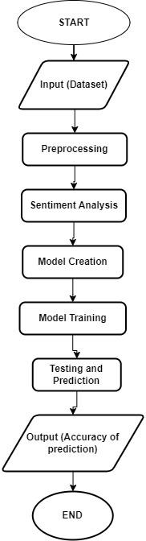

**Fig 2.1 Flow Chart**

**3.2.2 LSTM Layers**

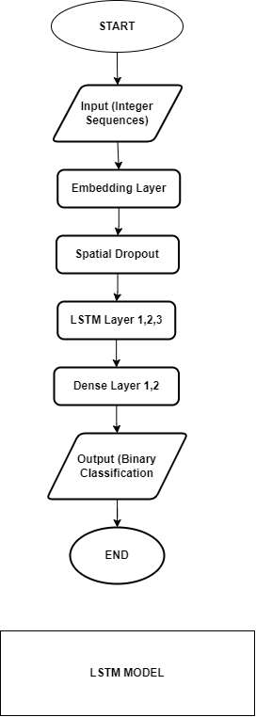

**Fig 2.2 LSTM Layers Flow Chart**

**3.2.3 0-Level DFD**

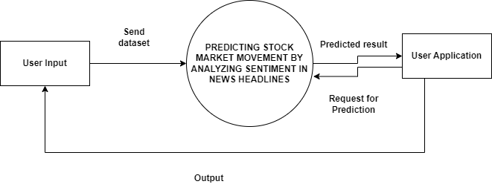

**Fig 2.3 Level - 0 DFD**

**3.2.4 1-Level DFD**

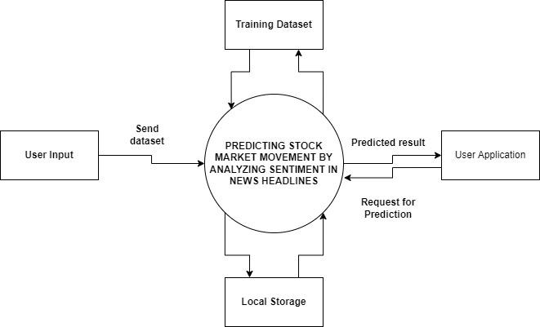

**Fig 2.4 LEVEL - 1 DFD**

**3.2.5 2-Level DFD**

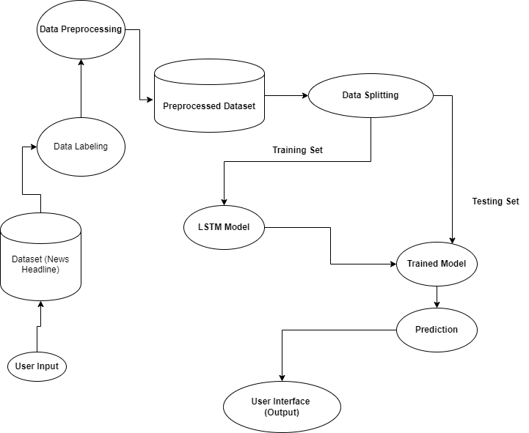

**Fig 2.5 Level - 2 DFD**

**3.3 Design and Test Steps**

**3.3.1 System Design:**

**Problem Definition:**

* Clearly define the problem statement, which is sentiment analysis of financial news data.
* Specify the goal of the analysis, such as predicting sentiment (positive, negative, or neutral) based on news descriptions.

**Data Collection and Understanding:**

* Identify sources for financial news data, such as Kaggle.
* Collect a diverse dataset of financial news articles along with their corresponding sentiment labels.
* Understand the structure of the data, including the format of news articles, sentiment labels.

**Data Preprocessing:**

* Clean the text data by removing any irrelevant information, such as special characters, HTML tags, or punctuation.
* Tokenize the text data by splitting it into individual words or tokens.
* Remove stop words (commonly occurring words that do not carry significant meaning) from the text.
* Apply stemming or lemmatization to reduce words to their base forms.

**Model Selection and Architecture:**

* Choose an appropriate machine learning model for sentiment analysis.
* Such as LSTM (Long Short-Term Memory), which are well-suited for sequential data like text.
* Design the architecture of the model, including the number of layers, type of activation functions, and regularization techniques.

**Model Training:**

* Split the dataset into training, validation, and testing sets.
* Train the sentiment analysis model on the training data using appropriate optimization algorithms and loss functions.
* Monitor the model's performance.

**Model Evaluation:**

* Evaluate the trained model's performance on the testing set using metrics such as accuracy and confusion matrix.
* Analyze the model's predictions using confusion matrices to understand its strengths and weaknesses.

**Model Deployment:**

* Deploy the trained sentiment analysis model in a production environment, such as a web application.
* Monitor the model's performance over time and consider retraining it periodically with new data to maintain accuracy.

**3.3.2 Testing Steps:**

**Data Preparation:**

* Prepare a separate testing dataset that was not used during model training or validation.

**Data Preprocessing:**

* Preprocess the testing data using the same techniques applied during training, including cleaning, tokenization, stop word removal, and stemming or lemmatization.

**Feature Engineering:**

* Convert the preprocessed testing data into numerical features using the same techniques applied during training, such as word embeddings.

**Model Evaluation:**

* Use the trained sentiment analysis model to make predictions on the testing dataset.
* Evaluate the model's performance using standard evaluation metrics such as accuracy.
* Analyze the confusion matrix to understand the distribution of true positive, true negative, false positive, and false negative predictions.

**Error Analysis:**

* Examine misclassified examples to identify patterns or trends in prediction errors.
* Determine whether certain types of news articles are more challenging for the model to classify accurately.

**Performance Comparison:**

* Compare the performance of the sentiment analysis model with baseline models or existing systems to assess its effectiveness and potential improvements.

**Usability Testing:**

* Gather feedback from users to evaluate the system's ease of use and intuitiveness. Identify any usability issues and make necessary improvements to enhance the user experience, such as improving form layout or adding tooltips for clarity.

**Maintainability Testing:**

* Assess the system's maintainability by reviewing its codebase, documentation, and modularity. Ensure that the system is well-documented and structured to facilitate future updates and maintenance tasks, allowing for seamless integration of new features or enhancements.

**3.4 Algorithms**

**3.4.1 Data Preprocessing Algorithms:**

1. Utilize Pandas to read the CSV file containing financial news data.
2. Define a function (analyze_sentiment) to analyze the sentiment of each news description using TextBlob.
3. Calculate the polarity of the text using TextBlob's sentiment analysis, where the polarity ranges from -1 (very negative) to 1 (very positive).
4. Assign a label of 1 for positive or neutral sentiment and 0 for negative sentiment.
5. Remove punctuations and other unnecessary characters.
6. Tokenize each text description using NLTK's word_tokenize function.
7. Remove stopwords using NLTK's stopwords corpus.
8. Apply stemming to reduce words to their root or base form using NLTK's Porter Stemmer.
9. Tokenize the preprocessed text data into sequences of integers using Keras' Tokenizer.
10. Pad the sequences to ensure uniform length using Keras' pad_sequences.
11. Split the preprocessed data into training and testing sets using sklearn's train_test_split function.

**Pseudo Code:**

def analyze_sentiment(description):

blob = TextBlob(description)

sentiment_score = blob.sentiment.polarity

if sentiment_score >= 0:

return 1 # Positive or neutral sentiment

else:

return 0 # Negative sentiment

def add_sentiment_label(df):

df['Label'] = df['Description'].apply(analyze_sentiment)

return df[['Date', 'Label', 'Description']]

def preprocess_text(text):

tokens = word_tokenize(text)

stop_words = set(stopwords.words('english'))

filtered_tokens = [word for word in tokens if word.lower() not in stop_words]

stemmer = PorterStemmer()

stemmed_tokens = [stemmer.stem(token) for token in filtered_tokens]

processed_text = ' '.join(stemmed_tokens)

return processed_text

X_processed = df['Combined'].apply(preprocess_text)

X_train, X_test, y_train, y_test = train_test_split(X_padded, df['Label'], test_size=0.2, random_state=42)

**3.4.2 Long Term Short Memory Algorithm:**

* Model Definition:

1. We have defined a Sequential model, indicating that layers will be added sequentially.
2. The first layer is an Embedding layer, which is commonly used for processing text data. It converts integer indices into dense vectors of fixed size.
3. A SpatialDropout1D layer follows the Embedding layer. Spatial dropout randomly sets input features to zero, which helps prevent overfitting.
4. Next, we have added three LSTM layers with decreasing number of units (neurons) and increasing dropout rates.
5. The LSTM layers are recurrent neural network layers particularly suited for sequence data.
6. After the LSTM layers, we have added a Dense layer with 32 units and ReLU activation function, followed by a Dropout layer with a dropout rate of 0.5 to further prevent overfitting.
7. Finally, there's a Dense layer with 1 unit and sigmoid activation function, which outputs the probability of the input belonging to the positive class in a binary classification problem.

* Model Compilation:

1. We have compiled the model using the Adam optimizer and specified accuracy as the metric to monitor during training.

* Training:

1. The model is trained using the fit method on the training data X_train and y_train.
2. With the number of epochs to 20 and the batch size to 64.
3. Validation data is specified using the validation_split argument, which splits a fraction of the training data as validation data.
4. Early stopping is implemented with a patience of 10 epochs to monitor the validation loss and stop training if it doesn't improve for 10 consecutive epochs.

**Pseudo Code:**

model = Sequential()

model.add(Embedding(input_dim=len(tokenizer.word_index)+1, output_dim=128, input_length=X_padded.shape[1]))

model.add(SpatialDropout1D(0.2))

model.add(LSTM(64, dropout=0.2, recurrent_dropout=0.2, kernel_regularizer='l2', return_sequences=True))

model.add(LSTM(32, dropout=0.2, recurrent_dropout=0.2, kernel_regularizer='l2', return_sequences=True))

model.add(LSTM(16, dropout=0.2, recurrent_dropout=0.2, kernel_regularizer='l2'))

model.add(Dense(32, activation='relu', kernel_regularizer='l2'))

model.add(Dropout(0.5))

model.add(Dense(1, activation='sigmoid'))

optimizer = Adam(learning_rate=0.0001)

model.compile(loss='binary_crossentropy', optimizer=optimizer, metrics=['accuracy'])

early_stopping = EarlyStopping(monitor='val_loss', patience=10, restore_best_weights=True)

history = model.fit(X_train, y_train, epochs=20, batch_size=64, validation_split=0.1, callbacks=[early_stopping])

**3.4.3 Optimization Algorithm:**

* Adam Optimizer:

1. The Adam optimizer is used for training the neural network model. Adam is an adaptive learning rate optimization algorithm that combines the advantages of both adaptive methods and stochastic gradient descent (SGD), making it efficient for training deep neural networks.

**Pseudo Code:**

from keras.optimizers import Adam

# Initialize Adam optimizer with specific learning rate

optimizer = Adam(learning_rate=0.0001)

**3.4.4 Regularization Algorithm:**

* L2 Regularization:

1. It is applied to the LSTM layers to prevent overfitting this adds a term to the loss function based on the squared magnitude of the weights, discouraging overly complex models.

**Code:**

model.add(LSTM(64, dropout=0.2, recurrent_dropout=0.2, kernel_regularizer='l2', return_sequences=True))

model.add(LSTM(32, dropout=0.2, recurrent_dropout=0.2, kernel_regularizer='l2', return_sequences=True))

model.add(Dense(32, activation='relu', kernel_regularizer='l2'))

**3.5 Testing Process:**

**Test Case 1: Loading Model**

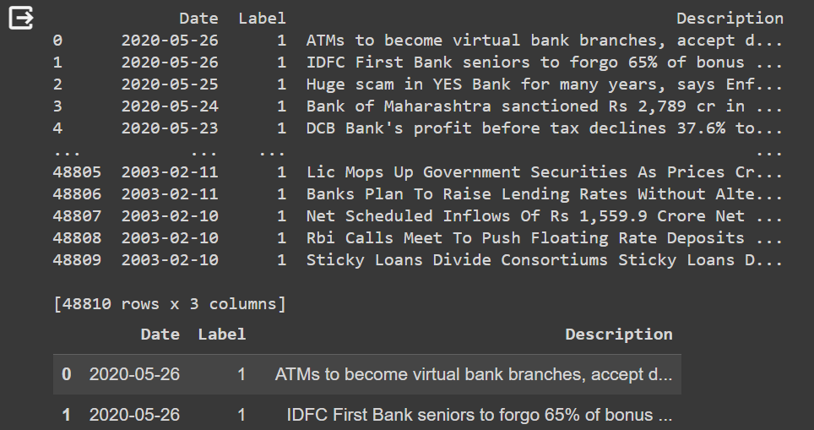

Fig 3.5.1: Dataset loads successfully without any errors.

**Test Case 2: Training Test**

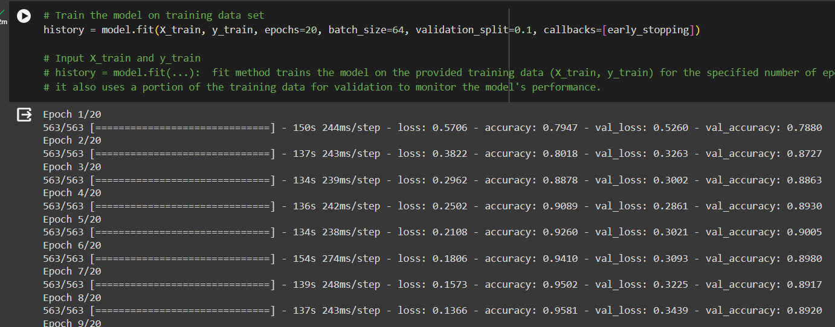

Fig 3.5.2: Model loads successfully and trains on data set without any errors

**Test Case 3: Prediction Test**

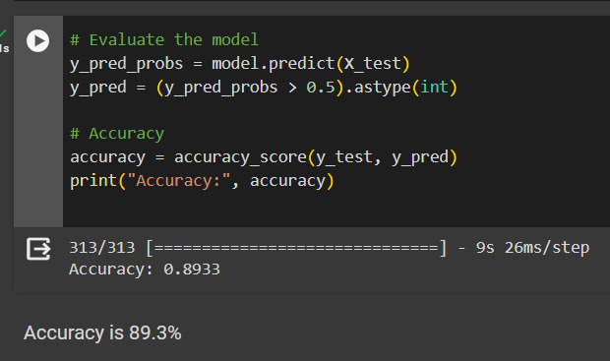

Fig 3.5.3:Model successfully predicts with an accuracy of 78.9%

**CHAPTER-IV**

**RESULT**

**Key Points**

* The project utilizes the LSTM algorithm, a type of recurrent neural network (RNN), to predict stock market movements based on sentiment analysis of news headlines. LSTM is particularly suited for sequence prediction tasks like this, as it can capture dependencies and patterns in sequential data over time.
* Before feeding the data into the LSTM model, the input dataset undergoes labeling and preprocessing. Labeling involves assigning sentiment labels to each news headline, indicating whether it expresses positive, negative, or neutral sentiment. Preprocessing involves tasks like tokenization, removing stopwords, stemming, and converting text data into numerical sequences that the model can understand.
* The trained LSTM model, along with the preprocessed dataset, is loaded into memory. This step ensures that the model is ready to receive input data and make predictions.
* Once the input data is received from the user, it is passed to the trained machine learning model. The model then analyzes the attributes of the input data, such as sentiment scores derived from the news headlines.
* The LSTM model analyzes the sentiment scores and other attributes of the input data to make predictions on stock market movements. These predictions indicate whether the market is expected to go up, down, or remain neutral based on the sentiment expressed in the news headlines. By leveraging the sentiment analysis of news headlines, the model provides insights into potential market trends and helps investors make informed decisions.

**OUTPUT**



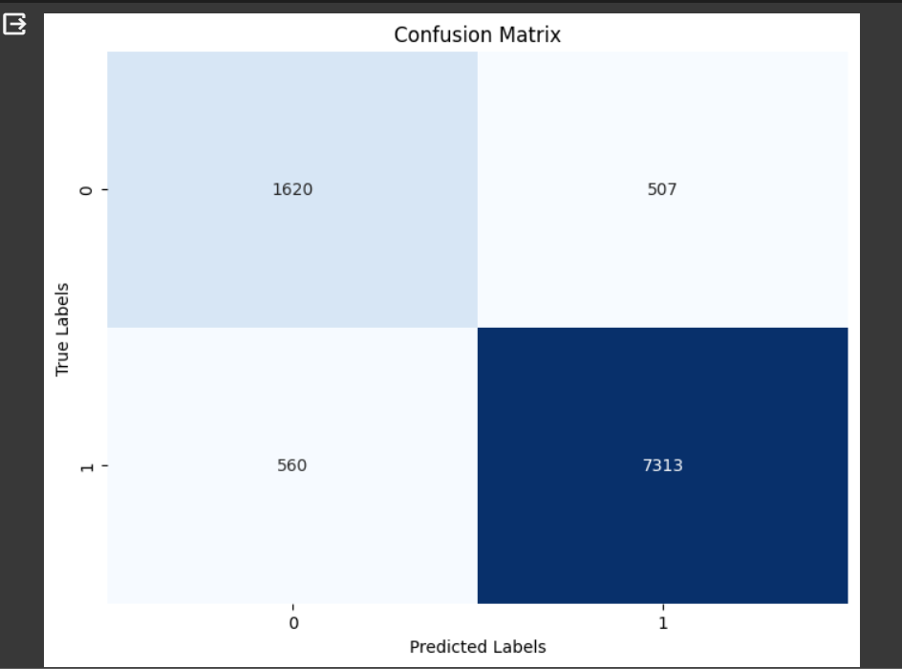

**CHAPTER-V**

**CONCLUSION**

In conclusion, the fusion of sentiment analysis and machine learning techniques to predict stock market movements signifies a pivotal moment in the evolution of investment strategies. Through the utilization of Long Short Term Memory (LSTM) algorithms, we've unlocked the potential to extract nuanced insights from the vast expanse of news headlines, empowering stakeholders to make more informed and proactive decisions in the dynamic world of finance.

Our journey towards this achievement has been characterized by meticulous data labeling, preprocessing, and model training. These efforts have culminated in the creation of a robust framework capable of discerning subtle sentiment patterns embedded within news articles. The foundation we've established, reinforced by LSTM's adeptness at capturing dependencies, underscores our commitment to precision and reliability in forecasting market trends.

In essence, our endeavor transcends mere technical achievement; but it embodies a pattern shift in the approach to financial analysis and decision-making. By harmonizing the art of sentiment analysis with the science of machine learning, we've forged a tool offering a beacon of clarity amidst the turbulence of market volatility.

As we continue to push the boundaries of innovation and exploration, our commitment to empowering individuals and organizations remains unwavering. Together, we embark on a journey of discovery, fueled by curiosity, driven by data, and guided by the relentless pursuit of excellence.

**Recommendations and Future Scope**

As we gaze towards the horizon, we envision a landscape brimming with opportunities for further refinement and expansion. Integrating additional data sources, such as social media sentiment and real-time market news, holds immense potential for enhancing the predictive capabilities of our model. Furthermore, the incorporation of advanced feature engineering techniques and ensemble learning methods could propel our predictions to unprecedented levels of accuracy and granularity.

There are numerous avenues for enhancing and extending the capabilities of the current model:

1. Incorporating Additional Features: Beyond sentiment analysis, integrating other pertinent features such as market indicators, company financial data, or economic indicators could significantly enhance prediction accuracy. By incorporating a broader range of data sources, the model can capture more comprehensive insights into market dynamics.

2. Deep Reinforcement Learning: Introducing reinforcement learning techniques would allow the model to learn and adapt its strategies based on feedback from market movements over time. This adaptive learning approach could lead to more dynamic and responsive predictions, particularly in rapidly changing market conditions.

3. Attention Mechanisms: Implementing attention mechanisms within the LSTM model could enable it to focus on the most relevant parts of news headlines, thereby potentially improving prediction accuracy. By prioritizing key information within the text, attention mechanisms can enhance the model's ability to extract meaningful signals from noisy data.

4. Time-Series Analysis: Extending the model to analyze time-series data would enable it to capture temporal dependencies and patterns in both news sentiment and stock market movements. By considering the sequential nature of data, the model can better understand how sentiment evolves over time and its impact on market trends.

5. Ensemble Methods: Combining multiple models, such as LSTM with other machine learning algorithms like Random Forest or Gradient Boosting could create an ensemble model that leverages the strengths of each individual model. Ensemble methods have the potential to improve prediction accuracy and robustness by aggregating diverse perspectives.

6. Real-Time Prediction: Developing the capability to make real-time predictions by continuously updating the model with the latest news headlines and market data is crucial. By leveraging streaming data sources and implementing efficient updating mechanisms, the model can provide timely insights for investors and traders.

7. Interpretability: Enhancing model interpretability by providing insights into which features or news sentiments are most influential in driving the predictions is essential. Transparent and interpretable models instill confidence in users and facilitate more informed decision-making.

8. Deployment and Integration: Deploying the model as part of a trading strategy or investment platform and integrating it with existing financial systems would facilitate seamless adoption by users. By embedding the model within familiar interfaces and workflows, it becomes more accessible and actionable for investors and traders.

9. Robustness and Generalization: Continuously evaluating and improving the model's robustness and generalization ability across different market conditions and time periods is crucial. Stress-testing the model under various scenarios and incorporating feedback loops for continuous improvement ensures its effectiveness and reliability in diverse contexts.

By pursuing these avenues for enhancement and extension, the predictive model can evolve into a sophisticated tool for providing invaluable insights and support in navigating the complexities of the stock market.

**CHAPTER-VI**

**REFERENCES**

# Sentiment Analysis for Stock Price Prediction By [James Briggs](https://jamescalam.medium.com/?source=post_page-----bed40c65d178--------------------------------) published on [Towards Data Science](https://towardsdatascience.com/?source=post_page-----bed40c65d178--------------------------------)

* [**Stock-Sentiment-Analysis**](https://github.com/krishnaik06/Stock-Sentiment-Analysis) by [**krishnaik06**](https://github.com/krishnaik06)
* Kaggle datasets <https://www.kaggle.com/datasets/>

# [Analysis of Stock Price Prediction Using ML Techniques](https://issuu.com/ijraset/docs/analysis_of_stock_price_prediction_using_ml_techni/s/24117758) by [IJRASET](https://issuu.com/ijraset) (International Journal for Research in Applied Science and Engineering Technology)

* B. Johan, H. Mao, X. Zeng, Twitter mood predicts the stock market. J. Comput. Sci. **2**(1), 1–8 (2011)
* Keras documentation <https://keras.io/api/models/>
* Forecasting Stock Market Movement Direction Using Sentiment Analysis and Support Vector

Machine by Ren, Wu, and Liu (2018)

* Stock Sentiment Analysis by Krish C Naik
* Analysis of Stock Price Prediction Using ML Techniques by S. Sabarinath (IJRASET)

**CHAPTER - VII**

**Appendices**

**A. Dataset Description**

The dataset used in this project consists of financial news headlines along with their corresponding dates. Each entry in the dataset represents a single news headline and its publication date. The dataset was collected from various sources and covers a wide range of financial news topics.

Key Features:

- Date: The publication date of the news headline.

- Description: The text content of the news headline.

Source:

The dataset was sourced from multiple financial news websites, aggregators, and databases. Due to the sensitive nature of financial data, the specific sources are not disclosed to maintain confidentiality and data integrity.

Summary Statistics:

- Total number of entries: 48,810

- Date range: From February 10, 2003, to May 26, 2020

**B. Libraries used**

1. pandas: Used for data manipulation and analysis, particularly for handling structured data like CSV files.

2. TextBlob: A library for processing textual data, providing simple API for tasks like sentiment analysis, part-of-speech tagging, and noun phrase extraction.

3. nltk (Natural Language Toolkit): A library for natural language processing (NLP) tasks, providing modules for tokenization, stemming, stopwords removal, and other text processing tasks.

4. keras: An open-source neural network library written in Python, capable of running on top of other deep learning frameworks like TensorFlow and Theano. It provides a high-level API for building and training neural networks.

5. scikit-learn: A machine learning library for Python, providing simple and efficient tools for data mining and data analysis. It includes various tools for classification, regression, clustering, dimensionality reduction, and preprocessing.

6. matplotlib: A plotting library for creating static, animated, and interactive visualizations in Python. It is commonly used for data visualization tasks.

7. seaborn: A data visualization library based on matplotlib, providing a high-level interface for drawing attractive and informative statistical graphics.

These libraries are commonly used in Python for tasks related to data preprocessing, machine learning, and data visualization, particularly in the context of natural language processing (NLP) and deep learning.

**C. Model Training**

The sentiment analysis model was trained on the preprocessed dataset using the following training parameters:

- Epochs: 20

- Batch Size: 64

- Validation Split: 0.1 (10% of training data used for validation)

- Callbacks: EarlyStopping callback with a patience of 10 epochs to monitor validation loss and restore the best weights.

During training, the model's performance was monitored on both training and validation sets to ensure generalization and prevent overfitting. The training process involved optimizing the model's parameters to minimize the binary cross-entropy loss function using the Adam optimizer.

**D. Model Evaluation**

After training, the sentiment analysis model was evaluated on a separate test dataset to assess its performance. The evaluation metrics used included:

1. Accuracy: The proportion of correctly predicted labels out of all predictions made.

2. Confusion Matrix: A tabular representation of true positive, false positive, true negative, and false negative predictions.

3. Classification Report: Providing precision, recall, F1-score, and support for each class, along with macro and weighted averages.

These evaluation metrics helped assess the model's ability to classify news headlines into positive and negative sentiment categories effectively.

**E. Visualization**

Visualization techniques were employed to analyze the model's performance and understand its behavior.

Confusion Matrix Heatmap: Visual representation of the confusion matrix using a heatmap to identify patterns of correct and incorrect predictions.

These visualizations aided in interpreting the model's results and understanding its underlying structure and functionality.

**Plagiarism Report**

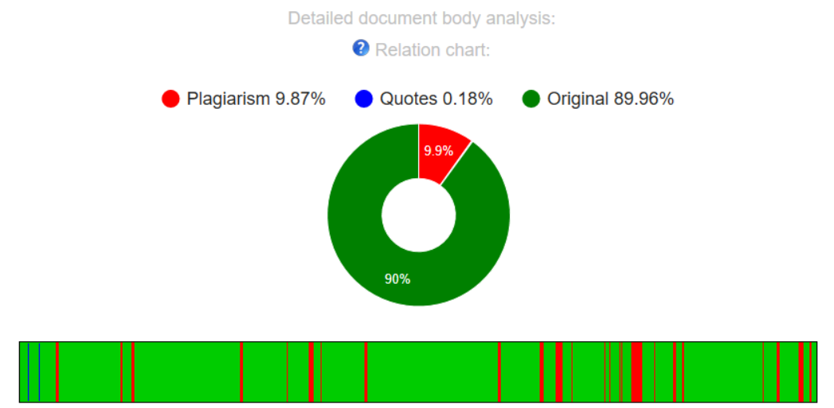

Fig 7.1 Plagiarism Report