File Index:
Category 1.Team4_The_Zen_Of_Five_01.DataCleaning.ipynb
Category 2. Team4_The_Zen_Of_Five_02.Descriptive.ipynb
Category 3.Team4_The_Zen_Of_Five_03.Prescriptive.ipynb
Category 4.Team4_The_Zen_Of_Five_04.Predictive.ipynb
Category 5. Team4_The_Zen_Of_Five_05.Dashboard.py
This is the plotly/stream lit dashboard. Please run from local command prompt.
Seven Raw source file used in the data cleaning file.
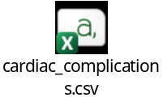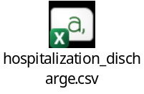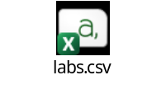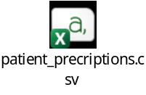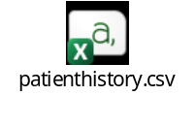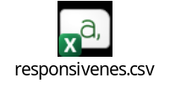
Final file used in all the Jupyter notebook
Team4.The_Zen_Of_Five_Cleaned_Data.csv
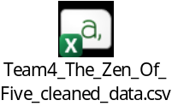
Helpful Insights: Needed for All the rules, the expectations and examples needed to do the hackathon.
1.Organisers Launching and Induction PowerPoint Presentation.
2.github.com/Numpyninja2025/Python_Hackathon-Reference Document.
3.numpyninja #blogs.

