This Python program uses the Open AI API to evaluate restaurants menus for risk of specific allergens. Details can be found in my medium blog at [My first Generative AI project: Evaluating restaurant menus for allergen safety | by Mishti | Jan, 2024 | Medium](https://medium.com/@mishti27/food-safety-algorithm-part-2-developing-the-program-49b750410fb9).

**Installation and use**

1) Your Python project folder should look like this.

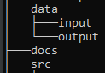

2) Download the following files and place them in the src folder:

* foodAllergyRiskEvalFunctions.py
* foodAllergyRiskEvalMain.py
* menuData_format.JSON
* menu_analysis_response_format.JSON

3) In the file foodAllergyRiskEvalMain.py, set the following:

* Your Open AI API key.
* Your base directory (your Python project folder)

4) In the data\input folder, place your menu data files. These can be text dumps of restaurant website menus, or files created by a screen scrapers.

5) Go back to foodAllergyRiskEvalMain.py and set the following:

* The allergens of interest.
* The menu data file name.

6) Execute the program. The output should look like this:

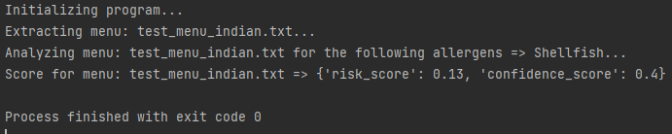

**Potential improvements**

* Loop thru multiple menu files in the data\input folder.
* Alternatively, read HTTP data from a list of restaurant websites returned by a search.
* Graphical user interface that presents scoring and ranking of multiple restaurants.