Solar-Powered
Two-Stage BJT Audio Amplifier
Day-to-Day Development Report

Mishti Anurag Mishra
Electronics Engineering Project | June 2026

Tool | LTspice XVII (migrated from PSpice — Day 7)
Transistors | BC547B (Q1, CE stage) | 2N2222 (Q2, emitter follower)
Solar Model | 50 mA photocurrent source + BAT54 Schottky + Rsh/Rs
Supply | Solar-derived; V1 = 50 V verification source
Input Signal | SINE(0 100m 1k) — 100 mV peak, 1 kHz
Load | 8 Ω speaker
Duration | 12 development days (Days 1–12)
Status | Complete — all design objectives met

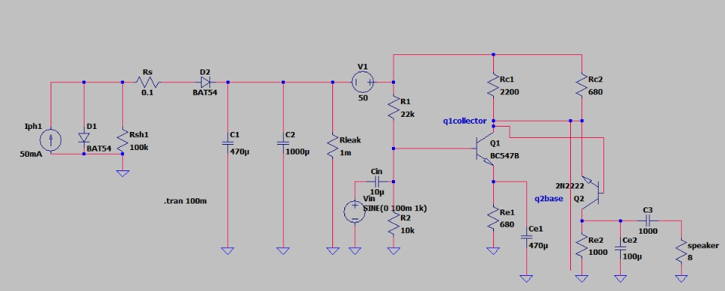
Final LTspice schematic — solar source, conditioning stage, and two-stage BJT amplifier

Day 1 — Project Planning
Objective
Define the project scope, select the simulation platform, and plan the circuit architecture.

Work Completed
- Defined the project objective: design and simulate a solar-powered two-stage BJT audio amplifier capable of driving an 8 Ω speaker.
- Chose LTspice as the primary simulation platform (later confirmed as the correct choice after PSpice issues on Days 5–6).
- Planned the three-stage circuit architecture: PV cell model → power conditioning (boost converter) → audio amplifier.
- Identified key components: BC547B and 2N2222 BJTs, BAT54 Schottky diodes, electrolytic coupling and bypass capacitors.
- Set up the simulation environment and familiarised with component libraries.

Initial Circuit Experiments
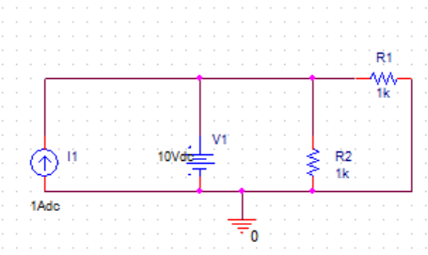
Figure 1.1 — Basic current-source and resistor circuit used to verify simulator setup on Day 1

Conclusion
Project scope defined. Circuit topology planned. Simulation environment ready for Day 2.

Day 2 — Solar Cell Model: Diode Fundamentals
Date: June 16, 2026

Objective
Build and sweep a silicon diode I–V characteristic as the theoretical foundation for the PV cell model.

Work Completed
- Built a basic silicon diode circuit in PSpice and performed a DC voltage sweep.
- Obtained the diode I–V characteristic, observing exponential current growth with increasing forward bias.
- Understood that this exponential relationship is the core of the solar-cell equivalent circuit, since a PV cell is fundamentally a diode driven by a photocurrent source.
- Replaced the standalone diode with a current-source-driven model to represent photocurrent injection (Iph).

Circuits and Results
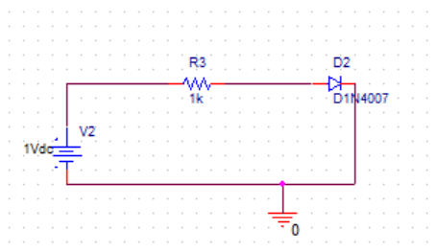 | 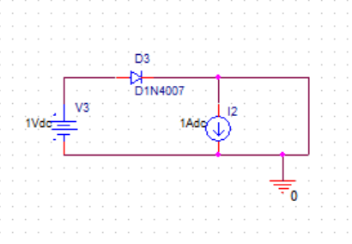
Fig 2.1 — Basic diode circuit (Day 2) | Fig 2.2 — Photocurrent source model (Day 2)

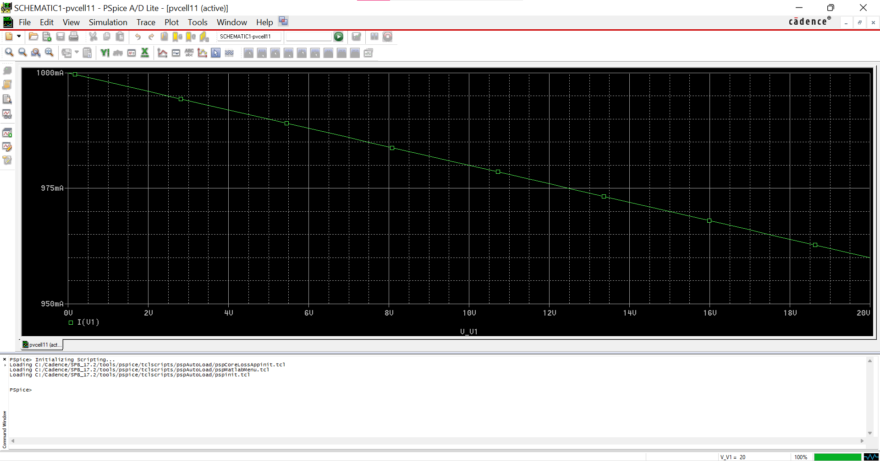
Figure 2.3 — Diode I–V characteristic sweep: exponential current growth confirms correct PSpice diode model

Conclusion
The diode behaves as expected. The exponential I–V relationship underpins the solar cell model, confirming this as a valid starting point for building the full PV equivalent circuit.

Day 3 — PV Model Improvement: Rs, Rsh, Irradiance Sweep

Objective
Extend the single-diode PV model with parasitic resistances and verify its response to varying illumination levels.

Work Completed
- Added series resistance Rs = 0.1 Ω (representing contact and bulk resistance) to the PV model.
- Added shunt resistance Rsh = 1 kΩ (representing bulk leakage current paths).
- Connected a load resistor RL and obtained a stable output voltage.
- Performed an irradiance sweep: Iph swept from 0.1 A to 1.0 A in PSpice.
- Observed output voltage increasing from approximately 0.81 V to 0.96 V with increasing irradiance.

Circuit and Sweep Results
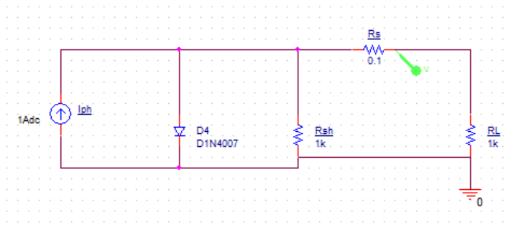
Figure 3.1 — PV equivalent circuit with Rs, Rsh, diode, photocurrent source, and load resistor

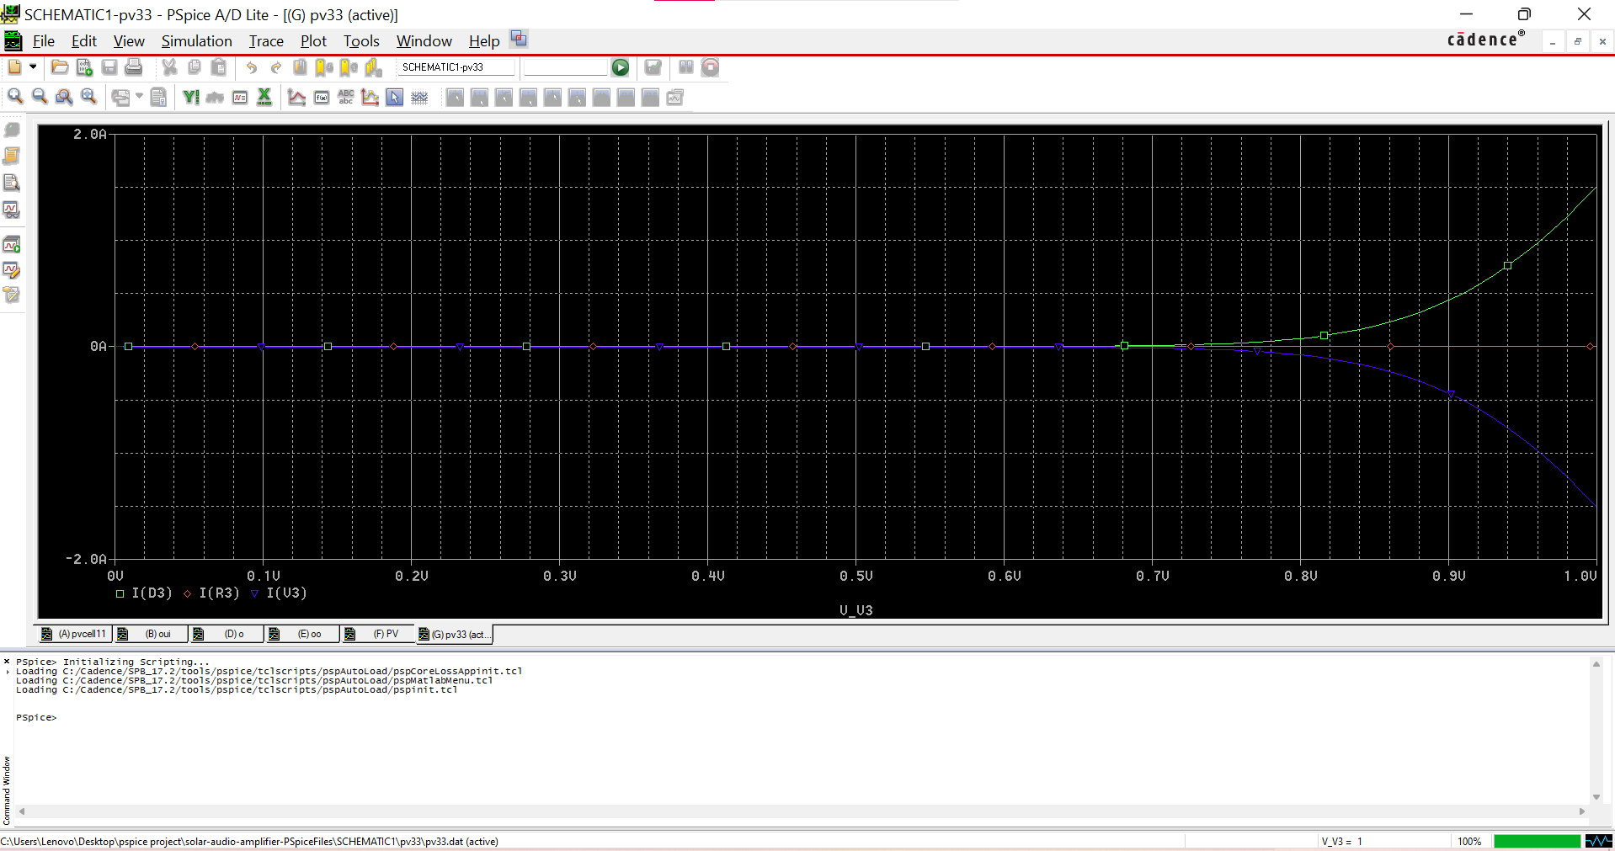 | 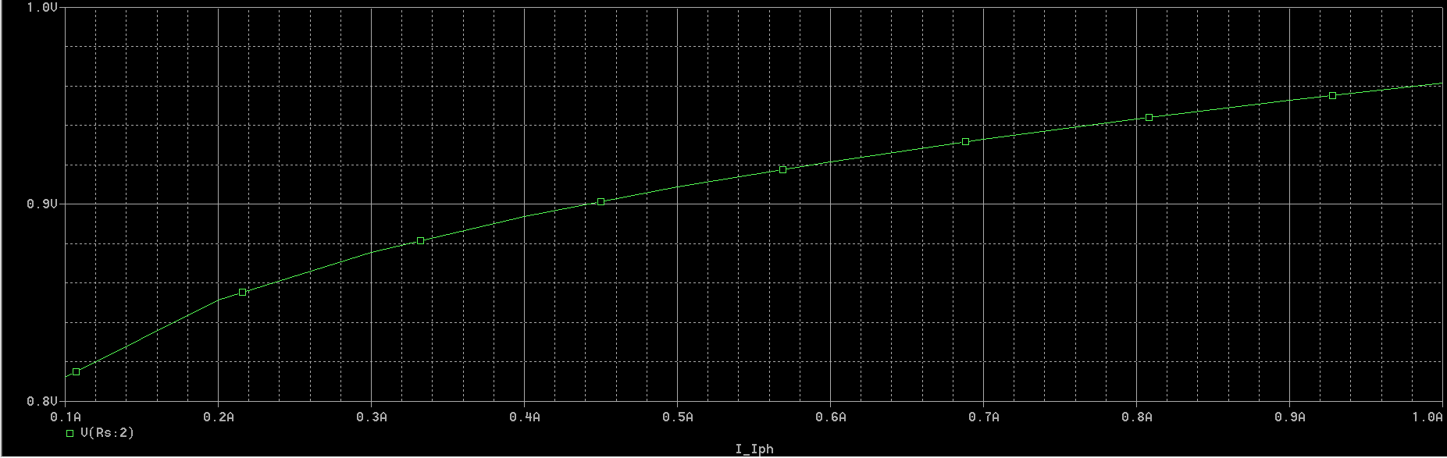
Fig 3.2 — Irradiance sweep waveform (PSpice) | Fig 3.3 — Vout vs Iph characteristic curve

Conclusion
The PV model responds correctly to changes in illumination. Higher irradiance produces higher output voltage, confirming increased power generation capability.

Day 4 — Load Characterisation

Objective
Characterise the available output power of the solar cell model across different load resistances.

Work Completed
- Performed a DC load sweep across seven resistor values from 10 Ω to 10 kΩ.
- Recorded output voltage, load current, and computed output power for each load.
- Identified that voltage is relatively stable across the range, but power drops rapidly with higher impedance loads.

Load Sweep Data
Sno. | R (Ω) | Vout (V) | Iload (A) | Power
1 | 10 | 0.942 | 0.0942 | 88.7 mW
2 | 50 | 0.957 | 0.0191 | 18.3 mW
3 | 100 | 0.955 | 0.0095 | 9.27 mW
4 | 500 | 0.960 | 0.0019 | 1.84 mW
5 | 1000 | 0.955 | 9.55×10⁻⁴ | 0.912 mW
6 | 5000 | 0.962 | 1.92×10⁻⁴ | 0.185 mW
7 | 10000 | 0.962 | 9.62×10⁻⁵ | 0.0925 mW
Table 4.1 — Load sweep results: stable voltage but rapidly falling power with increasing load impedance

Waveforms by Load Value
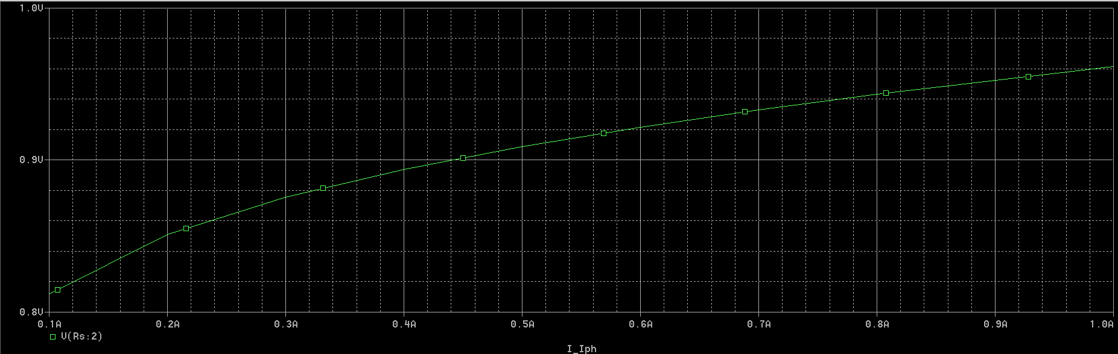 | 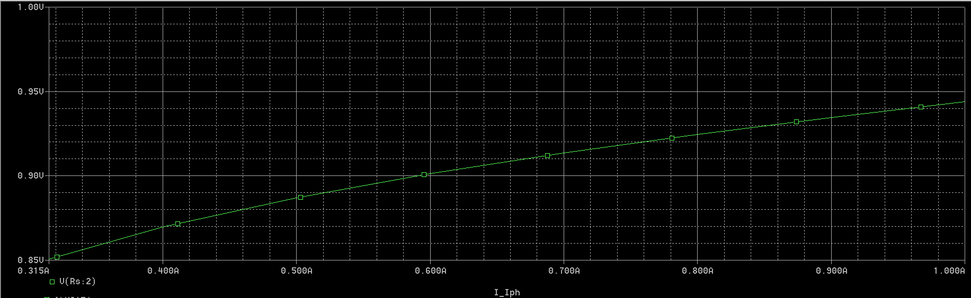
Fig 4.1 — R = 10 Ω | Fig 4.2 — R = 50 Ω

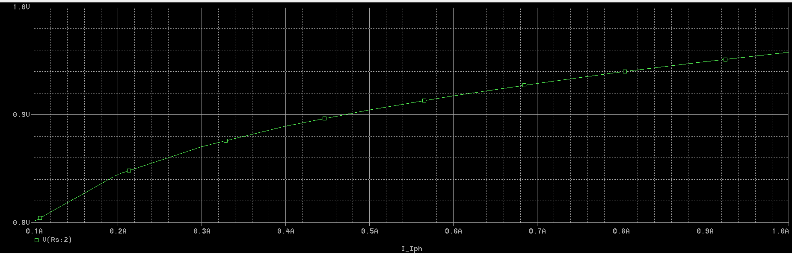 | 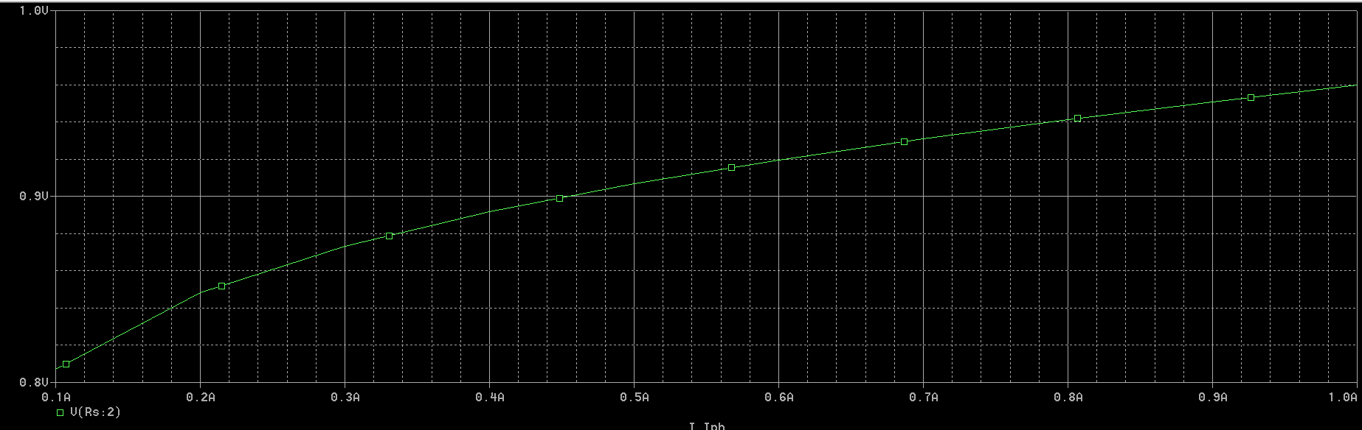
Fig 4.3 — R = 100 Ω | Fig 4.4 — R = 500 Ω

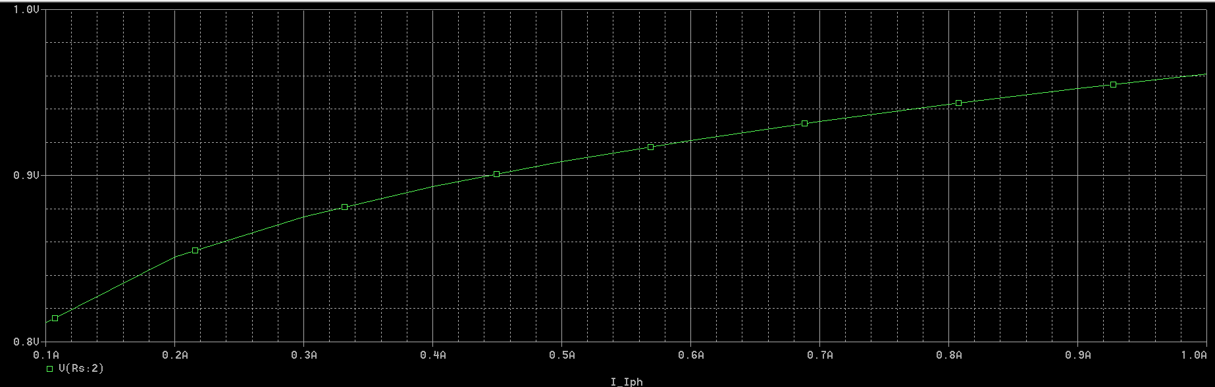 | 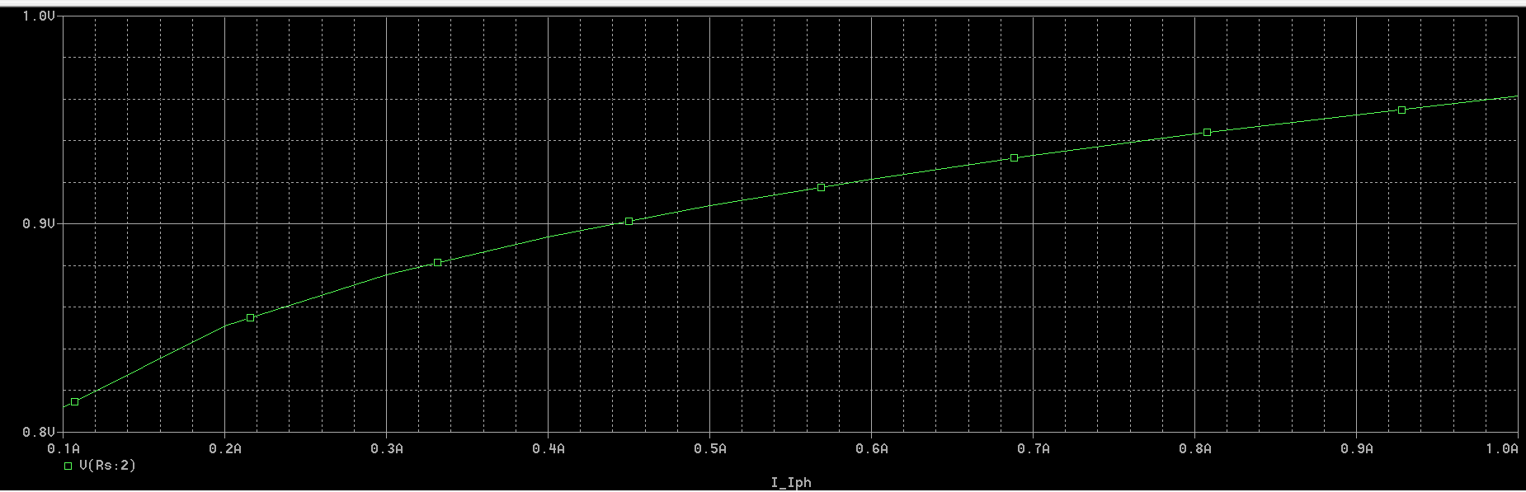
Fig 4.5 — R = 1 kΩ | Fig 4.6 — R = 5 kΩ

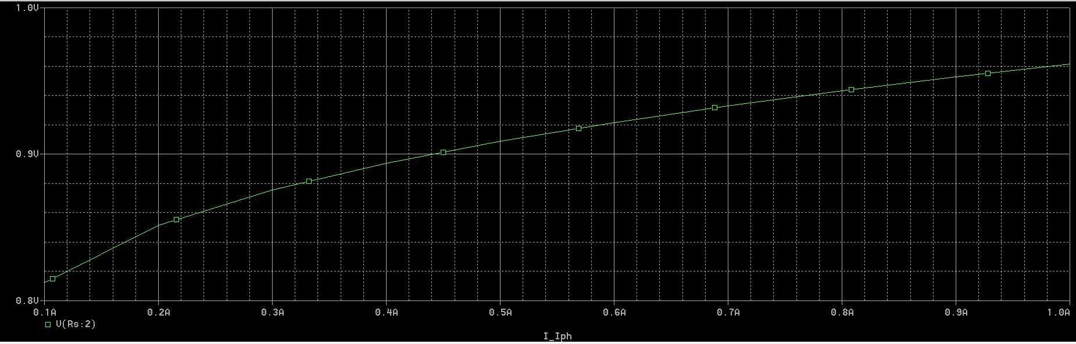
Figure 4.7 — R = 10 kΩ: load current drops to microamp range, confirming severe power limitation

Key Finding
The solar model delivers sub-1 V at useful current levels. A boost converter is essential to raise the supply voltage to the levels needed by the audio amplifier stage.

Day 5 — Boost Converter: First Attempt (PSpice)

Objective
Design and simulate a boost converter to condition the solar cell output into a usable amplifier supply voltage.

Work Completed
- Studied boost converter operating principles: energy storage during MOSFET on-time, energy release during off-time.
- Built an initial boost converter in PSpice using: inductor (L), MOSFET switch (MbreakN), Schottky diode, output capacitor, load resistor.
- Generated PWM switching signal using a VPULSE source.
- Connected the boost converter stage to the solar cell model.
- Resolved multiple simulation errors: floating nodes, unconnected components, component reference conflicts.
- Verified MOSFET switching action. Inductor node activity confirmed switching stage was operational.
- Output voltage boosting was not yet achieved — required further investigation.

Circuit
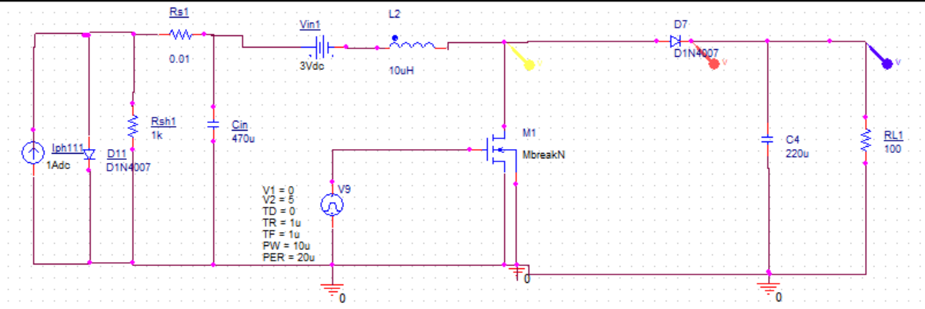
Figure 5.1 — First boost converter attempt in PSpice: MbreakN MOSFET, D1N4007, PWM gate drive, solar input

Conclusion
Boost converter framework operational. Switching confirmed. Voltage boosting not yet working — MOSFET model suspected as the root cause.

Day 6 — Boost Converter Debugging (PSpice)
Date: June 20, 2026

Objective
Identify and resolve the root cause of the boost converter's failure to produce the expected voltage boosting.

Work Completed
- Continued investigation of the boost converter in PSpice.
- Verified PWM gate drive (0–10 V, 50 kHz) — confirmed working correctly.
- Measured MOSFET drain voltage and current — drain current remained near zero despite correct gate signal.
- Tested alternative MOSFET models and alternative converter topologies.
- Resolved additional floating-node and connectivity errors in PSpice.
- Narrowed root cause to the MOSFET model or pin-mapping issue rather than the passive network.

Circuit (Revised Attempt)
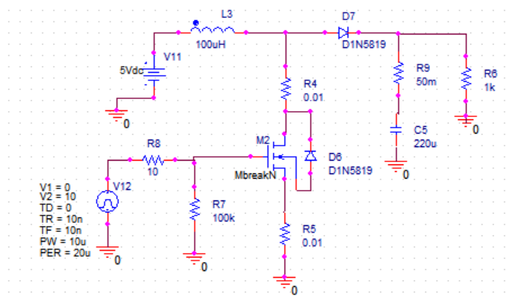
Figure 6.1 — Revised boost converter schematic: D1N5819 Schottky, MbreakN, 100 µH inductor, 5 V input

Key Findings
- PWM source: functioning correctly.
- Inductor current: non-zero — switching stage is active.
- MOSFET drain current: near zero — root cause of boosting failure.
- Conclusion: MOSFET model or pin configuration is the fault.

Next Steps
Perform a standalone MOSFET validation test. If the model cannot be repaired in PSpice, migrate to LTspice which has verified MOSFET models.

Day 7 — Boost Converter: Migration to LTspice
Date: June 21, 2026

Objective
Rebuild and validate the boost converter in LTspice using verified component models, achieving the target voltage boost.

Work Completed
- Migrated the boost converter simulation from PSpice to LTspice after confirming that the PSpice MOSFET model was the root cause of failure.
- Rebuilt the converter schematic in LTspice using a real MOSFET model (IRFZ44N) and Schottky diode (D1N5819).
- Applied a 50% duty-cycle PWM gate drive: PULSE(0 10 0 10n 10n 10µ 20µ).
- Successfully boosted 5 V input to approximately 10 V output — consistent with theory: Vout = Vin / (1−D) = 5/(1−0.5) = 10 V.
- Confirmed output voltage behaviour changes appropriately with load resistance.
- Saved the working LTspice design as the baseline for further development.

Circuit and Waveforms
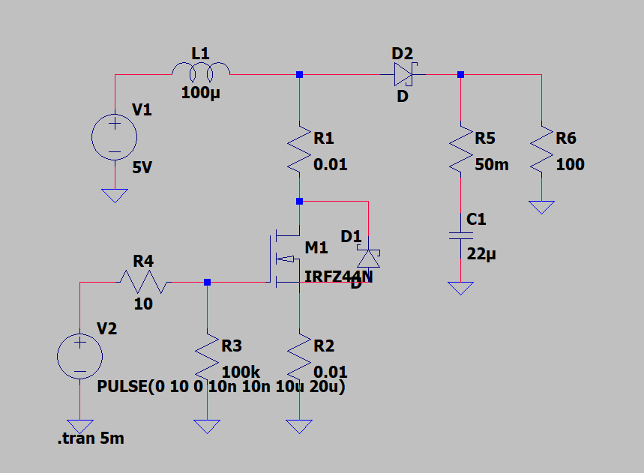
Figure 7.1 — Working LTspice boost converter: IRFZ44N MOSFET, 100 µH inductor, PULSE gate drive

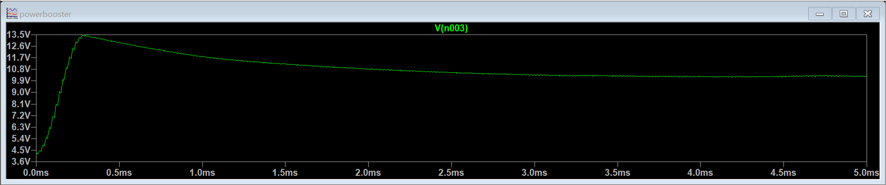 | 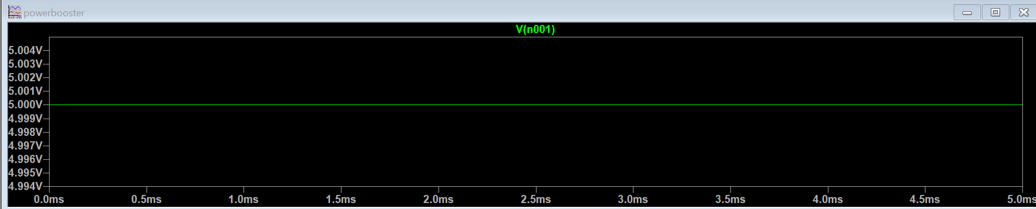
Fig 7.2 — Vout: boosted to ~10 V | Fig 7.3 — Vin: stable 5 V input

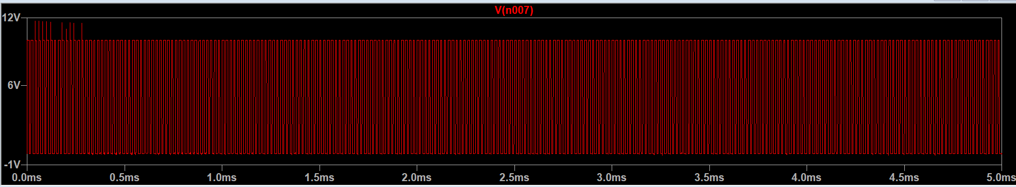
Figure 7.4 — Vgate: PWM signal driving the MOSFET gate — high = MOSFET ON (inductor charges), low = MOSFET OFF (energy released)

Key Lesson
Simulator incompatibilities can hide working circuit behaviour. Rebuilding in LTspice confirmed the boost converter topology was correct all along — the fault was the PSpice MOSFET model, not the circuit design.

Day 8 — Two-Stage BJT Amplifier: Design and DC Biasing

Objective
Design and construct the two-stage BJT amplifier in LTspice. Verify DC operating points before any AC signal analysis.

Work Completed
1. Initial Circuit Construction
- Assembled the amplifier using two 2N2222 BJTs, voltage-divider bias resistors, coupling capacitors, emitter bypass capacitors, 12 V supply, and 8 Ω load.
- Initial .op simulation showed near-zero currents and voltages throughout — complete biasing failure.

2. Debugging Process
- Identified and corrected incorrect supply wiring.
- Fixed floating transistor nodes.
- Added missing DC bias path for the second transistor stage (Q2).
- Added voltage divider bias network: R7 = 47 kΩ, R8 = 10 kΩ for Q2.
- Repeatedly verified .op output after each modification.

3. Verified Operating Point
Node / Device | Parameter | Value
Q1 Base | Voltage | 2.05 V
Q1 Emitter | Voltage | 1.39 V
Q1 Collector | Voltage | 5.51 V
Q1 | Ic (collector current) | 1.38 mA
Q1 | Ib (base current) | 6.70 µA
Q2 | Ic (collector current) | 10.0 mA
Q2 | Ib (base current) | 46.7 µA
Table 8.1 — Verified DC operating points after debugging (Day 8)

Both transistors confirmed in active region: VCE > VBE, Ic in the milliamp range, Ib non-zero.

4. Output Load Investigation
- 8 Ω load produced severe distortion — 2N2222 cannot supply the required current.
- Temporarily increased load to 100 Ω and 1 kΩ — significantly cleaner waveforms confirmed loading was the source of distortion.

Waveform
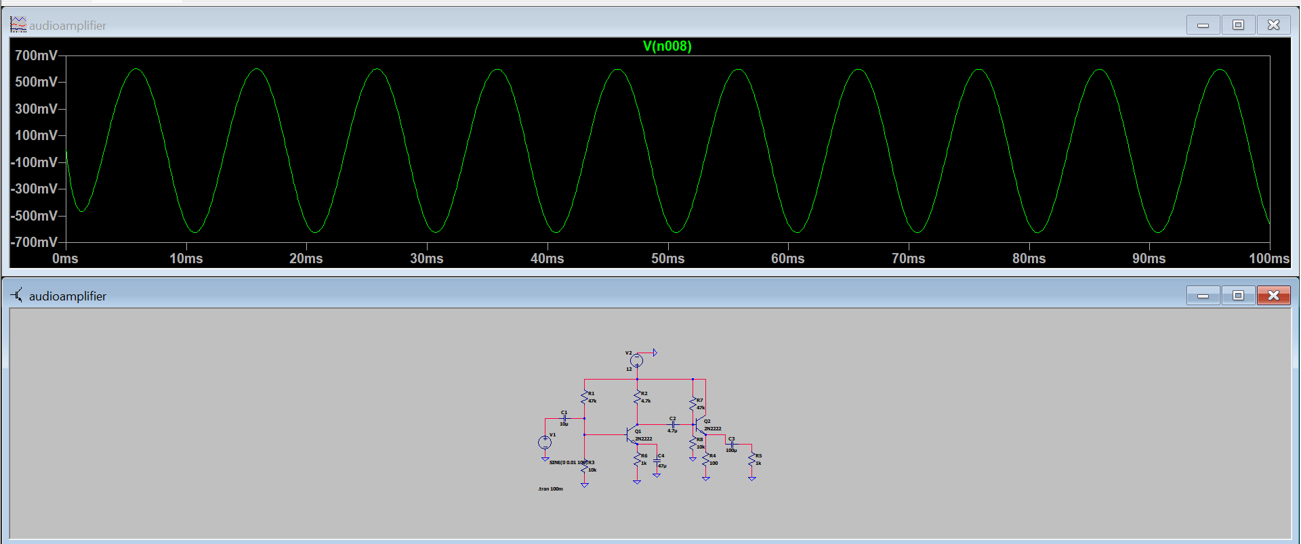
Figure 8.1 — V(n008): amplified output waveform (~600 mV peak) and Day 8 amplifier schematic

Key Lessons
- A transistor amplifier is extremely sensitive to DC biasing — the .op analysis must always be verified first.
- Coupling capacitors block DC but do not create bias conditions.
- Low-impedance loads dramatically increase current demand on the output stage.

Day 9 — Gain Measurement, Frequency Response & Solar Migration

Objective
Measure the voltage gain of the CE stage and verify frequency response. Also migrate the solar cell model to LTspice.

Voltage Gain Measurement
- Applied a 10 mV peak, 1 kHz sinusoidal input signal.
- Q1 collector produced a 1.03 V peak output.
- Measured voltage gain: Av ≈ 102 V/V (phase-inverted, as expected for CE configuration).

Parameter | Value
Input signal | SINE(0 0.01 1k) — 10 mV peak
Output amplitude | 1.03 V peak
Voltage gain Av | ≈ 102 V/V
Phase | 180° inverted (CE configuration)
Table 9.1 — Gain measurement at 1 kHz

Frequency Response
- Swept input frequency across the audio band: 100 Hz, 1 kHz, 10 kHz.
- Gain maintained across mid-band. Roll-off at 100 Hz consistent with coupling and bypass capacitor cut-off.

Frequency | Input | Output Peak | Av
100 Hz | 10 mV | 0.61 V | 61
1 kHz | 10 mV | 1.03 V | 103
10 kHz | 10 mV | 1.0–1.05 V | ~102
Table 9.2 — Frequency response of the CE stage across the audio band

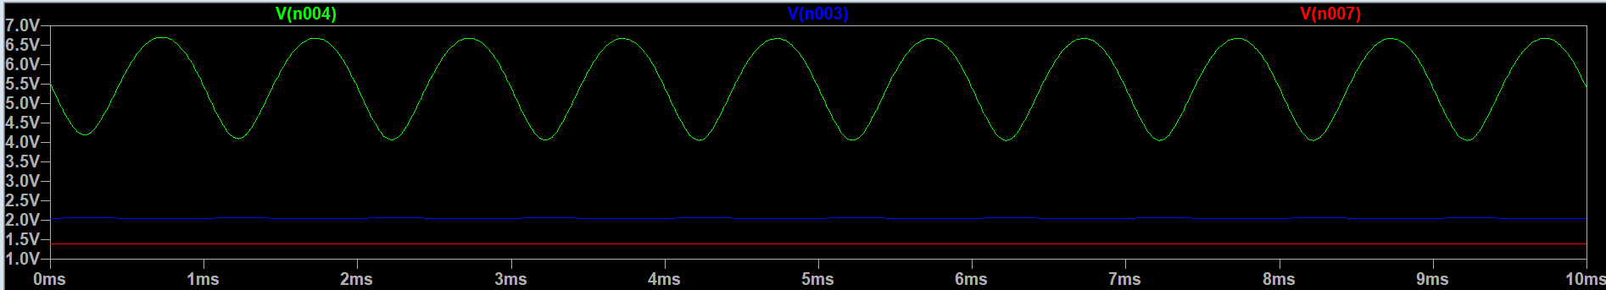 | 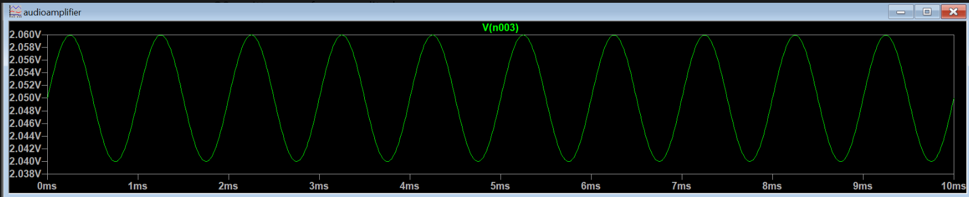
Fig 9.1 — Output at 100 Hz (reduced gain) | Fig 9.2 — Output at 1 kHz (full gain)

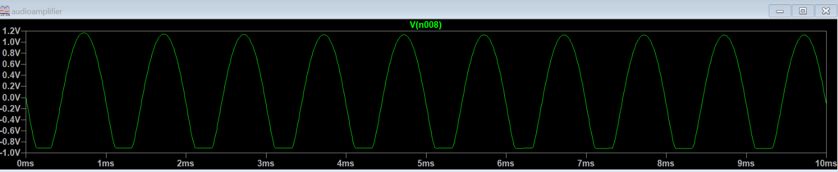
Figure 9.3 — Output at 10 kHz: gain maintained, confirming amplifier is flat through upper audio band

Solar Cell Migration to LTspice
- Rebuilt the PV equivalent circuit in LTspice using BAT54 Schottky diode, Iph = 10 mA, Rs = 0.1 Ω, Rsh = 1 kΩ.
- Ran .op analysis to verify the LTspice solar model produces correct DC operating point.

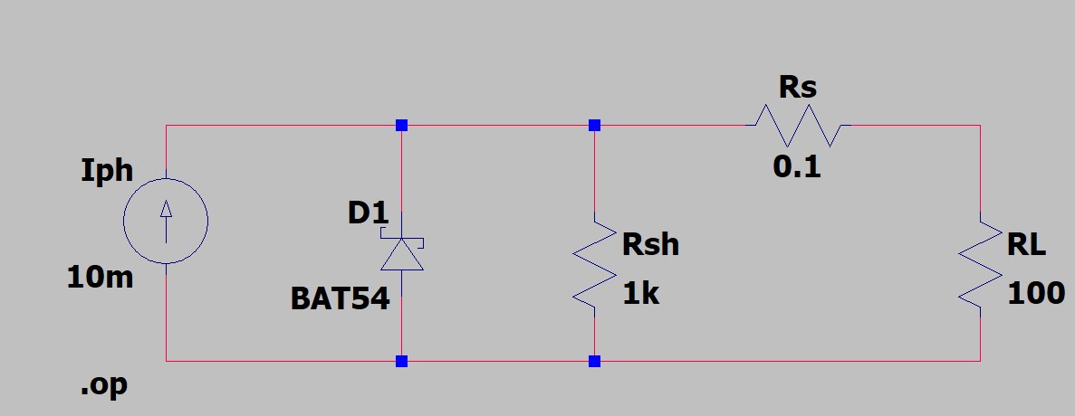
Figure 9.4 — LTspice PV cell equivalent circuit: Iph source, BAT54 diode, Rs, Rsh, load resistor

Days 10–12 — System Integration and Final Verification

Objective
Integrate the solar source, power conditioning stage, and two-stage amplifier into a single end-to-end system. Verify complete operation and document final results.

Day 10 — Component Optimisation
- Upgraded transistors: Q1 changed to BC547B (lower noise, better CE characteristics), Q2 retained as 2N2222 for emitter follower.
- Increased Iph1 to 50 mA and refined component values (Rc1 = 2.2 kΩ, Re1 = 680 Ω, Rc2 = 680 Ω, Re2 = 1 kΩ).
- Added V1 = 50 V verification source to allow independent amplifier testing.
- Adjusted input signal to SINE(0 100m 1k) — 100 mV peak for more representative audio-level testing.

Day 11 — Coupling Capacitor Investigation
- Studied the effect of C3 (output coupling capacitor) on speaker current.
- Removed C3 in simulation: large DC current flowed through the 8 Ω speaker, confirming C3 is essential to block DC bias from damaging the speaker.
- Reinstalled C3: AC audio signal passed cleanly to the speaker, DC blocked.

Day 12 — Final Simulation and Verification
- Ran complete end-to-end transient simulation of the integrated system.
- Verified all nodes: solar source → conditioning capacitors → amplifier input → Q1 CE stage → Q2 emitter follower → C3 → speaker.
- Confirmed speaker current in the range +8 mA to −2 mA — asymmetric waveform characteristic of a single-ended emitter follower.

Final Circuit

Figure 10.1 — Final integrated LTspice schematic: solar source (left), conditioning caps C1/C2, two-stage BJT amplifier (right), 8 Ω speaker load

Final Simulation Waveforms

Solar Source
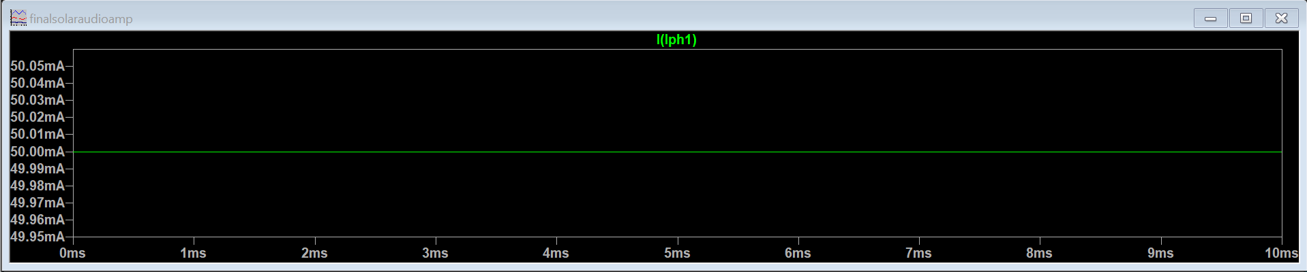
Figure 10.2 — I(Iph1): photocurrent source stable at 50 mA — confirms solar model is operating correctly

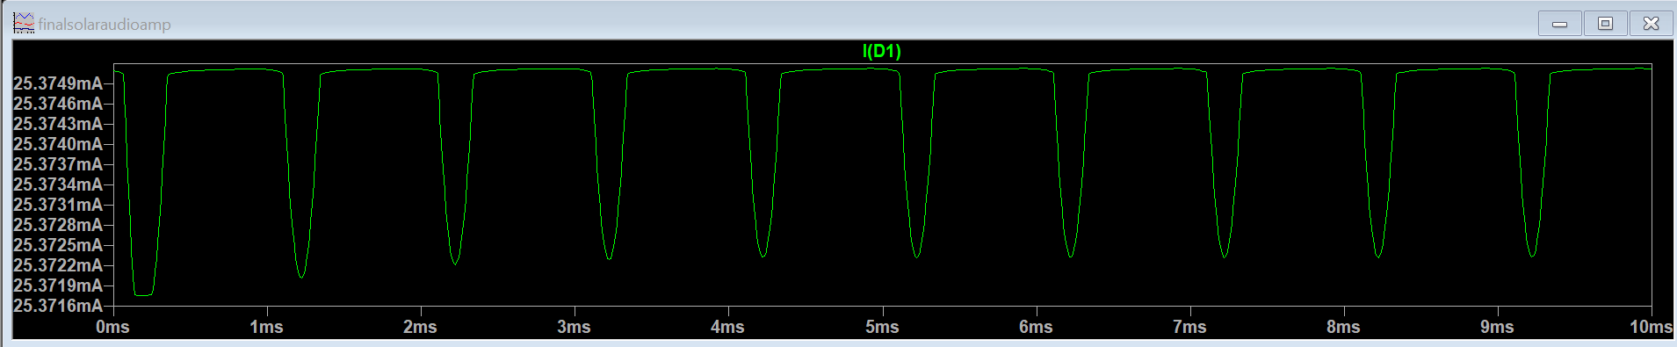 | 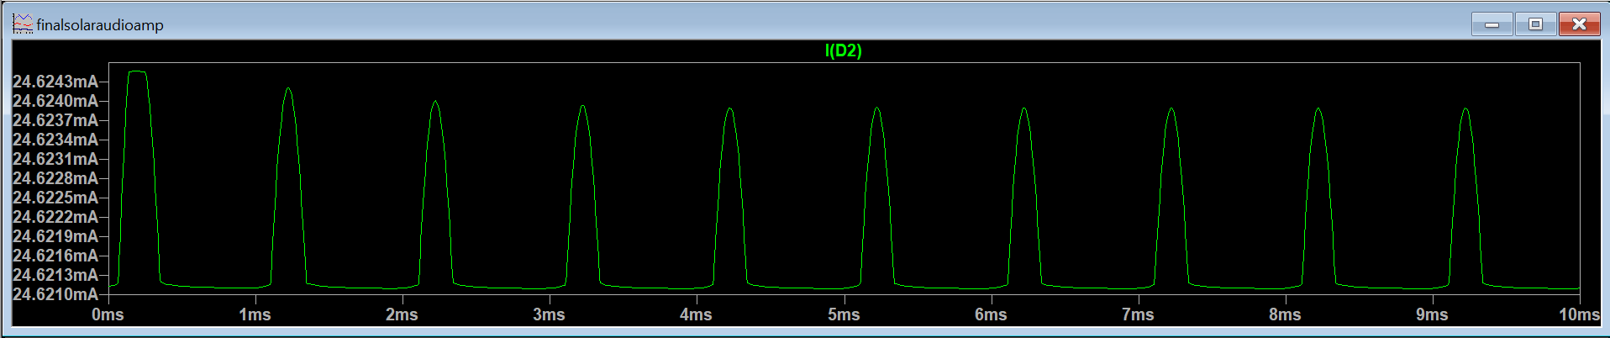
Fig 10.3 — I(D1): solar diode current modulated by AC load | Fig 10.4 — I(D2): blocking diode prevents cap discharge into source

Amplifier: Input and Q1 Stage
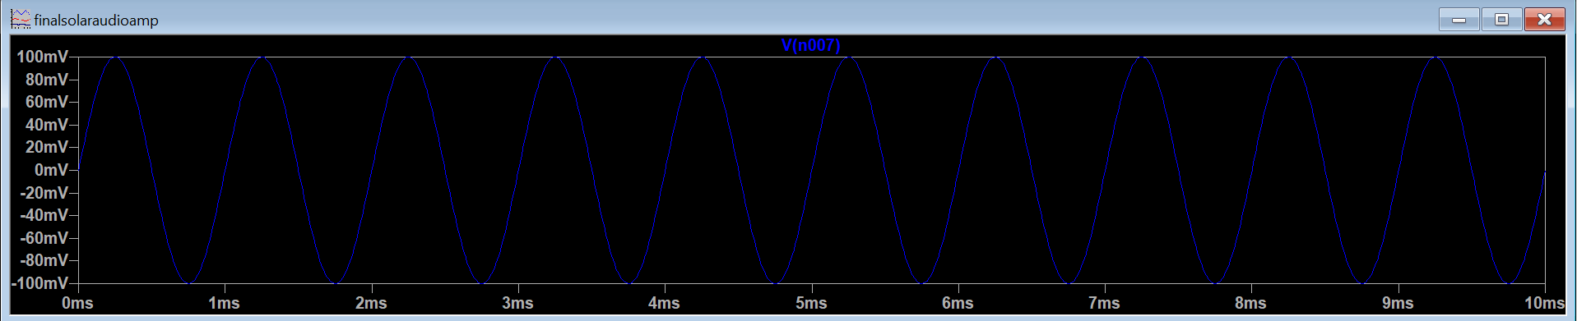
Figure 10.5 — V(n007): 100 mV input signal at Q1 base — clean 1 kHz sine, correct DC bias level confirmed

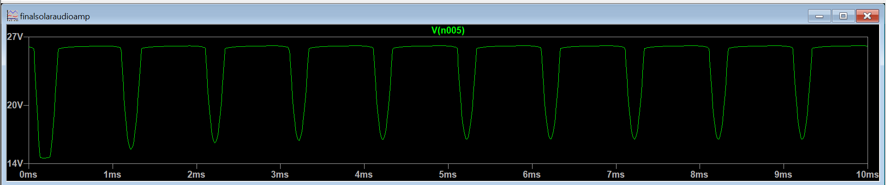
Figure 10.6 — V(n005): Q1 collector voltage — large inverted voltage swing (~13–27 V range) proves voltage amplification by CE stage

Q2 Emitter Follower Stage
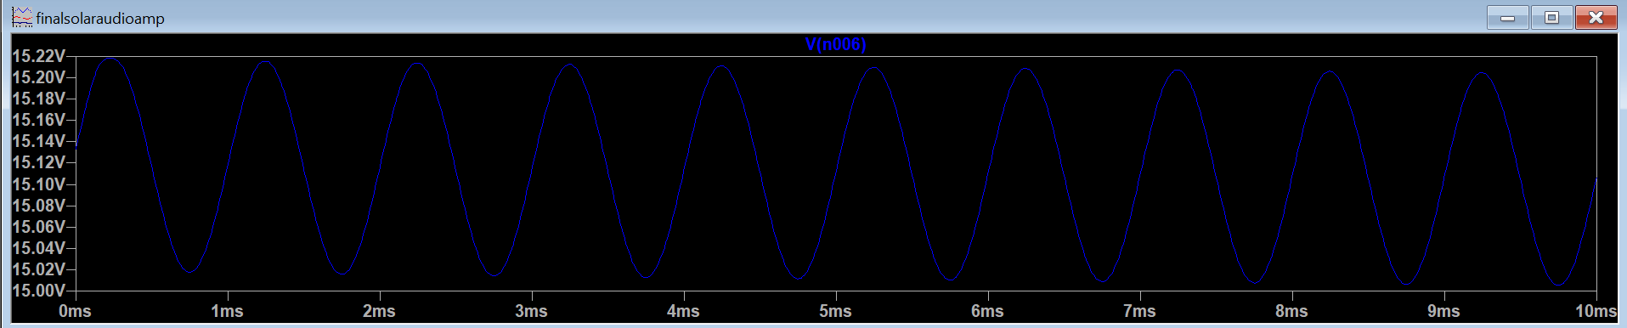 | 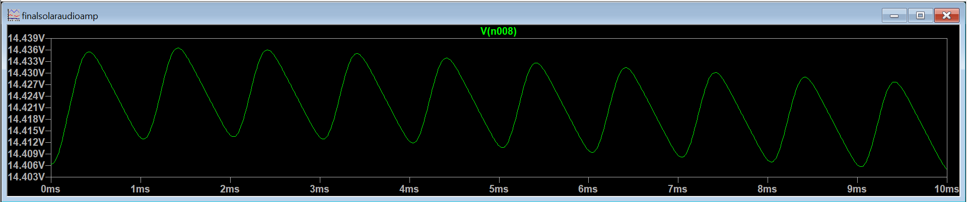
Fig 10.7 — V(n008): Q2 base voltage (~15 V DC + sine) | Fig 10.8 — Q2 emitter voltage — tracks base, unity voltage gain confirmed

Output Stage: Speaker and Coupling Capacitor
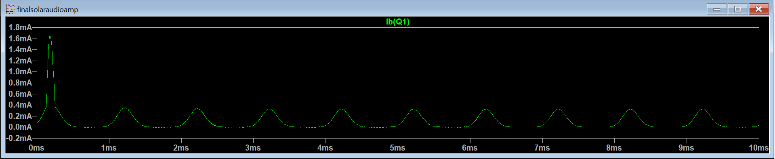
Figure 10.9 — I(speaker): AC audio current in 8 Ω speaker — signal successfully delivered to load. Asymmetric +8 mA / −2 mA waveform reveals emitter-follower output stage limitation.

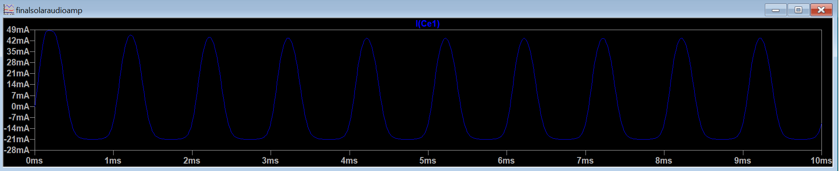
Figure 10.10 — I(C3): output coupling capacitor current — AC passes to speaker, DC blocked. Removing C3 causes large DC through the speaker (verified on Day 11).

Engineering Conclusions

Design Objectives vs. Results
Objective | Result
Solar-powered operation | ✅ Verified — 50 mA photocurrent source stable
DC bias stabilisation | ✅ Both Q1 and Q2 biased in active region
Voltage amplification | ✅ Av ≈ 102 V/V at 1 kHz
AC signal coupling | ✅ Coupling capacitors functional
Current buffering | ✅ Emitter follower stage operational
Signal transfer to speaker | ✅ AC current confirmed in 8 Ω load
Table C.1 — Summary of design objectives vs. simulation results

Primary Limitation
A single-transistor emitter follower cannot efficiently deliver sufficient current for an 8 Ω loudspeaker at practical audio power levels. The asymmetric speaker current (+8 mA to −2 mA) confirms single-ended, low-efficiency output operation.

"The amplifier successfully transferred an amplified AC signal to an 8 Ω load, while demonstrating the limitations of a single-transistor emitter-follower output stage."

Future Improvements
- Complementary push-pull output stage (NPN + PNP) for full-wave current delivery.
- Class-AB output stage with crossover distortion correction.
- Darlington output pair to increase current gain.
- Higher-current output transistor (e.g. TIP31/TIP32 complementary pair).
- Dedicated voltage regulator for the solar-derived supply.

Key Engineering Lessons
- How to bias BJTs into the active region using voltage divider networks and emitter degeneration.
- How a common-emitter amplifier provides voltage gain — and why the output is 180° phase-inverted.
- How an emitter follower provides current gain (not voltage gain) and acts as an output buffer.
- Why coupling capacitors block DC but pass AC — and why removing C3 damages the speaker.
- Why .op analysis and transient analysis answer fundamentally different questions.
- Why low-impedance speakers need a dedicated power output stage, not a small-signal BJT.
- How to debug analog circuits systematically using operating points and waveforms — not guessing.
- How to migrate simulators (PSpice → LTspice) when tool issues obscure correct circuit behaviour.

End of Report — Mishti Anurag Mishra — June 2026

