Strategic Data Collection and Preprocessing Blueprint
  - Public logistics data, Python pipelines, and a reproducible cleaning workflow
Meghana Krishnakumar Nair
31 October 2026
Week 1 task submission · virtual internship
Repository: github.com/mishtiiikrishnaa/virtualinternship1

Contents
Executive summary 3
1. Scope, objectives and success criteria 3
1.1 The problem this report addresses 3
1.2 Objectives 3
1.3 Success criteria 4
1.4 What is out of scope 4
2. What logistics data actually looks like 4
2.1 The five families 4
2.2 The defects that recur 5
2.3 Why the grain matters more than the columns 5
3. Public data sources and selection criteria 5
3.1 The register 5
3.2 Five gates 6
3.3 Why not simply scrape 6
4. Legal, ethical and licensing considerations 6
4.1 Open is not the same as unrestricted 6
4.2 What the project does about it 7
4.3 Ethics beyond compliance 7
5. Collection architecture 8
5.1 Six stages, one direction 8
5.2 Idempotence and replay 9
5.3 Tooling at the right size 9
6. Profiling before preprocessing 9
6.1 The questions profiling must answer 9
6.2 Implementation 10
6.3 Reading the profile like an analyst 10
7. Preprocessing with pandas and NumPy 10
7.1 Ingestion with explicit dtypes 10
7.2 Dates 11
7.3 Numbers, units and money 11
7.4 Deduplication and grain 11
7.5 Feature derivation 12
7.6 Performance notes 12
8. Handling missing data 13
8.1 Classify before imputing 13
8.2 The rules applied 14
8.3 Choosing the method 14
8.4 Reporting missingness 14
9. Inconsistent data, entity resolution and normalisation 14
9.1 Controlled vocabularies 14
9.2 Fuzzy matching and its limits 15
9.3 Geospatial normalisation 15
9.4 Normalisation of measures 15
9.5 Encoding and categories 15
10. Validation and quality gates 15
10.1 Declarative checks 15
10.2 Critical versus warning 16
10.3 The checks that earn their keep 16
10.4 Beyond the checks 16
11. Reproducibility and documentation 16
11.1 The repository is the method 16
11.2 What gets recorded 17
11.3 Pinning and provenance 17
11.4 Documentation that survives handover 17
12. Reference implementation: what the pipeline actually did 17
12.1 Inputs and outputs 17
12.2 What the output looks like 18
12.3 What the run does not prove 18
13. Feasibility, risks and mitigations 18
13.1 Feasibility within an internship 18
13.2 Risk register 19
13.3 The risk that matters most 19
14. Plan for weeks 2–4 19
14.1 Week 2 — exploratory analysis and visualisation 19
14.2 Week 3 — predictive modelling and forecasting 19
14.3 Week 4 — decision support 20
14.4 Acceptance criteria per week 20
15. Conclusion 20
References 20
Appendix A. Cleaning log excerpt 21
Appendix B. Transform example 22

Executive summary
This report sets out a strategy for identifying, collecting and cleaning publicly available logistics data with Python. It is written as an operating plan rather than a literature review: every stage names the tool that does the work, the failure it is designed to catch, and the artefact it leaves behind for a reviewer.
The argument runs in four movements. First, logistics data is not one dataset but a family of them — freight flow estimates, customs records, vessel positions, port statistics and carrier transactions — and each family fails in a different way. Second, the useful public sources are identifiable and can be reached through documented bulk downloads and APIs, but their licences differ sharply, and a plan that ignores licensing produces a pipeline nobody can publish. Third, cleaning is not a single pass but a sequence of bounded transforms, each of which logs what it changed; the discipline of logging is what separates a reusable pipeline from a one-off notebook. Fourth, missing and inconsistent data are classification problems before they are imputation problems, and the correct answer is frequently “flag it and move on” rather than “fill it with the mean”.
The strategy is demonstrated rather than asserted. A reference implementation accompanies this document: a seeded extract deliberately containing the defects seen in real freight feeds, a cleaning module of eight stages, thirteen validation checks of which nine are fatal, nineteen unit tests, and a regenerated data-quality report. On that extract the pipeline removes 180 rows of duplication, rejects 86 implausible weights, converts four currencies to a pinned USD snapshot, imputes 9.1 per cent of weights and 5.2 per cent of costs with explicit flags, and publishes 4,200 typed rows with a checksum traceable to the source file.
The deliverable is therefore three things at once: a plan, a set of diagrams describing the workflow, and a working codebase that runs the plan and prints the evidence.

1. Scope, objectives and success criteria

1.1 The problem this report addresses
Logistics analytics fails in a characteristic way. The models are rarely the weak point; the data underneath them is. A shipment record may carry a weight in pounds in one system and kilograms in another, a country written four different ways, a delivery timestamp that precedes its despatch timestamp, and a freight cost stored as the string €1,240.50. Any of these is survivable in isolation. Together they make the difference between a dashboard that a planner trusts and one that is quietly ignored.
The task set for week 1 is to design a strategy for gathering and preprocessing publicly available logistics data, and to document it precisely enough that another analyst could execute it. The deliverable is a Word document; the supporting repository is where the strategy is proved to be executable.

1.2 Objectives
Five objectives structure the work:
- Identify the families of public logistics data, their publishers, their grain and their access routes.
- Specify a collection architecture that is repeatable: scheduled pulls, immutable landing, recorded provenance.
- Define a preprocessing pipeline in Python, naming libraries and functions rather than gesturing at “using pandas”.
- Set rules for missing and inconsistent values that are defensible under review, including when not to impute.
- Document the whole thing so that the cleaning is reproducible and the decisions are auditable.

1.3 Success criteria
A blueprint is only useful if it can fail. The following criteria make failure visible:
criterion | test
Reproducibility | a clean checkout plus a fixed seed reproduces the published table and its checksum
Traceability | every published row can be traced to a source extract, a run timestamp and a code version
Transparency | every transform that changes a value appears in a machine-readable log with a row count
Safety | no critical validation failure reaches the curated layer; the run exits non-zero instead
Portability | the same pipeline accepts a real FAF extract without structural rewrite
These are deliberately stricter than “the document is well formatted”. A strategy that cannot be run is a hypothesis, and the evaluation criteria for this task reward depth of technical detail, so the criteria above are the ones the remainder of the report is measured against.

1.4 What is out of scope
Two capabilities are excluded on purpose. Geospatial enrichment — joining port polygons, computing great-circle distances, snapping coordinates to road networks — requires a reference dataset and a spatial index, and half-building it would misrepresent the effort involved. Time-zone-correct timestamps require origin and destination zone rules; the synthetic extract uses naive dates and the decision log records the deferral. Neither is required by the tasks that follow, so both are recorded as deferred in section 14 rather than faked here.

2. What logistics data actually looks like

2.1 The five families
Public logistics data falls into five families, and the family determines the defects you will spend your time on.
Freight flow estimates. The US Freight Analysis Framework is the canonical example: tonnage and value between origin–destination pairs, by commodity and mode, estimated rather than observed [1]. Because it is modelled, its “missingness” is structural — regions below a reporting threshold are pooled — and its uncertainty is documented in a user guide rather than in the rows.
Customs and trade records. UN Comtrade and national trade statistics give value and quantity by commodity and partner country [2]. These are administrative: commodity codes follow the Harmonized System and change revision, so a time series stitched across revisions will show a fake jump unless concordance tables are applied.
Movement and telemetry. AIS vessel positions, ADS-B flight states and port call records describe where things physically are [3]. They are high-volume, irregularly sampled, and identified by opaque keys (MMSI, ICAO address) that must be joined to reference tables before they mean anything.
Operational transactions. Carrier invoices, waybills and warehouse movements are the data most analysts actually want and the data least likely to be public. Commercial extracts are licensed, expensive, and frequently anonymised to the point where lane-level analysis is impossible.
Reference and context data. Country codes, UN/LOCODE port codes, currency tables, road networks and port boundaries. These are the join keys that make the other four families usable, and they are the ones most often neglected until a merge silently drops 12 per cent of rows.

2.2 The defects that recur
Across all five families, the same defects recur, and the strategy is organised around them:
- Unit drift — kilograms and pounds, tonnes and short tons, cubic metres and cubic feet, all in the same column.
- Vocabulary drift — Air, AIR, air freight and AWB describing one mode; U.S.A., USA, US and United States describing one country.
- Temporal ambiguity — 04/03/2025 is two different days depending on who typed it; timestamps without offsets across multiple zones.
- Coded nulls — 999999, -1, n/a and the empty string all meaning “unknown”, none of them recognisable as null to a naive reader.
- Grain violations — several rows per shipment because the feed emits a row per status change; a “duplicate” is often the current state of the world.
- Free-text locations — Rotterdam 3011, ROTTERDAM, Rotterdam, Netherlands as three distinct values in a city column.
Recognising these as a fixed catalogue rather than a series of surprises is what allows the preprocessing design to be systematic. Each defect maps to one stage of the pipeline, and each stage maps to a test.

2.3 Why the grain matters more than the columns
The single most consequential decision in any logistics dataset is the grain: what does one row represent? A shipment, a consignment, a waybill line, a pallet, a status event? A dataset that claims to be shipment-level but is actually event-level will produce plausible-looking but wrong aggregates, and no amount of cleaning will fix it. The strategy therefore asserts the grain explicitly in the schema contract (grain: one row per shipment_id), tests it after deduplication, and records in the data dictionary what a duplicate meant before it was collapsed.

3. Public data sources and selection criteria

3.1 The register
Rather than a list of links, the project keeps a register (docs/sources.md) recording what each dataset contains, how it is reached, and what prevents naive use. The shortlist below is the part of that register that matters for a first implementation.
dataset | grain | access | decisive consideration
BTS Freight Analysis Framework (FAF5.7.1 / FAF6) [1] | O–D flows by mode and commodity, 132 zones | bulk CSV/ZIP, tabulation tool | documented methodology, versioned releases, public domain
UN Comtrade [2] | country–commodity–partner values | REST API, free tier | rate limits; HS revision changes break naive time series
IMF PortWatch [3] | daily port calls and transit activity | hosted layers, downloadable files | model-based, not a census; attribution required
BTS Border Crossing/Entry [4] | monthly counts per port, mode, direction | bulk download | clean and small; good first ingestion exercise
Eurostat freight transport [5] | tonnes-km by mode and region | bulk + SDMX API | free reuse with attribution; no shipment keys
OpenStreetMap [6] | roads, ports, terminals, boundaries | planet file, Overpass, Geofabrik | ODbL share-alike constrains derived databases
ECB reference rates [7] | daily bilateral FX | API, CSV | required for any multi-currency cost field

3.2 Five gates
Each candidate was assessed against five gates, in this order:
- Grain and key. Is there a defensible primary key, stated by the publisher rather than inferred? FAF has an O–D–commodity–mode key and a documented zone system; a Kaggle upload with an unnamed index does not.
- Licence. May a derived table be redistributed? This eliminates several attractive commercial freight datasets immediately.
- Stability. Is there a version number or dated release, so a figure quoted in a report can be tied to a specific extract? FAF’s versioned releases (5.7.1 for 2018–2024; FAF6 for the 2022 benchmark) satisfy this [1]. An undated dashboard does not.
- Documentation. Does a codebook exist for the categorical fields? Without one, “mode = 4” is uninterpretable and any cleaning is guesswork.
- Defect plausibility. Does the data contain the mess this task is about? A perfectly tidy dataset teaches nothing about handling imperfection.
FAF passes all five and becomes the reference dataset for weeks 2–4. PortWatch and Comtrade are the next additions. The popular Kaggle supply-chain datasets fail gates 1 and 4: their grain is ambiguous and their provenance undocumented, which is why pipeline development here runs on a synthetic extract whose defects are known and seeded.

3.3 Why not simply scrape
Scraping port dashboards is technically trivial and strategically poor. It produces an unversioned artefact, breaks without warning when a layout changes, may breach the site’s terms, and cannot be reproduced by a reviewer. Where a publisher offers no machine-readable interface, the honest options are to transcribe a single figure with a citation, or to approach the publisher. Neither belongs in an automated pipeline, and treating them as if they did is how data teams end up defending numbers they cannot regenerate.

4. Legal, ethical and licensing considerations

4.1 Open is not the same as unrestricted
Public availability and permission to reuse are different things. Three distinctions matter in practice.
Licence type. Public domain (US federal works such as BTS datasets) allows redistribution with citation. Permissive attribution licences (CC BY 4.0, used by much World Bank material) allow reuse provided attribution is preserved. Share-alike licences (ODbL for OpenStreetMap) impose a reciprocal obligation on derived databases, which can affect a product built on a geocoded table. Research-only terms (OpenSky) forbid commercial use outright. A pipeline that mixes all four into one table inherits the strictest obligation in the mix, and the register records that per source rather than per project.
Personal and commercial data. Shipment-level data frequently contains consignee names, addresses, contact details and negotiated rates. Even where analytics does not need them, their presence makes the dataset personal data under GDPR and equivalent regimes. The strategy is to minimise at ingestion: select the columns required, hash or drop direct identifiers, and never carry a field “because it might be interesting”. Negotiated rates are commercially confidential for the carrier even when they are technically obtainable, which is a stronger constraint than the licence.
Terms of service. API terms commonly cap request rates, require a user agent, forbid redistribution of raw responses and require attribution. These are engineering requirements, not paperwork: a retry loop without backoff will get a key suspended, and a cached raw response that is republished may breach the terms even if the derived aggregate is fine.

4.2 What the project does about it
Four concrete controls are applied:
- A licence column in the source register, reviewed before a dataset is added.
- Raw responses stored locally and never committed when their terms forbid redistribution; only derived aggregates are published.
- A synthetic extract for development, so the public repository carries no third-party data at all.
- Attribution written into the data dictionary and the report, naming the version of the dataset used, because “BTS FAF” without a version is not a citation.

4.3 Ethics beyond compliance
Two further questions are worth asking of any logistics dataset. First, does the analysis make claims about identifiable firms that the data cannot support? A carrier ranked poorly on a noisy delay metric is a reputational act, not a statistical one. Second, does aggregation hide a harmful pattern? Port-level throughput hides the labour and emissions distribution beneath it. Neither question has a technical fix, but both belong in the documentation, and neither is answered by a licence.

5. Collection architecture
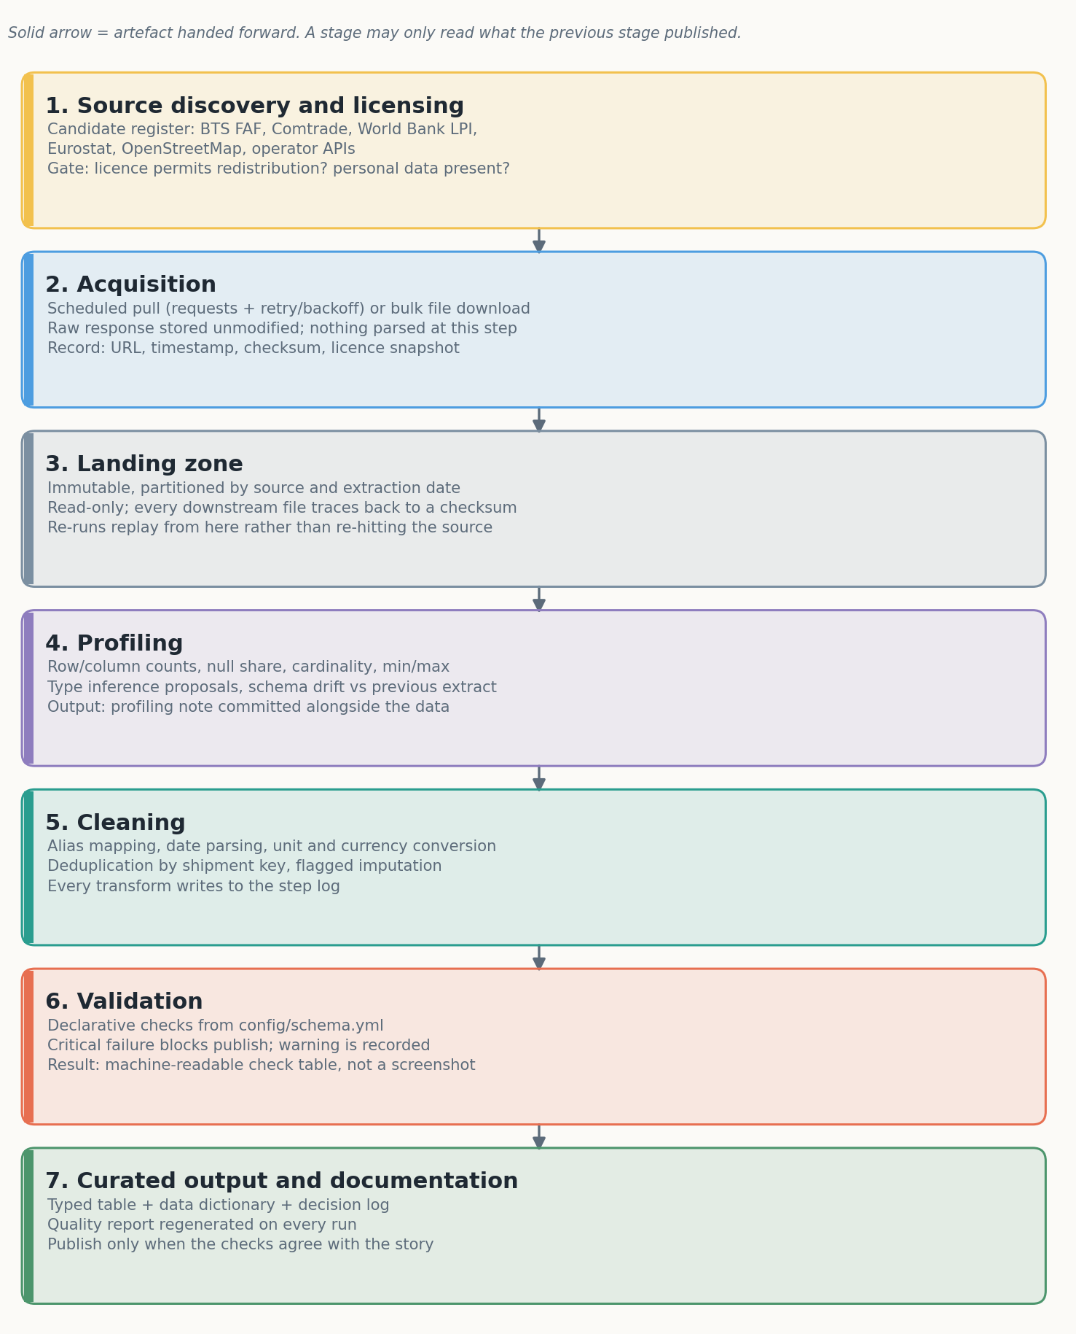
Figure 1. End-to-end workflow from source discovery to published table. Each stage publishes an artefact that the next stage reads; the raw layer is never overwritten.

5.1 Six stages, one direction
The workflow has a single direction of travel and a hard rule: a stage may read only what the previous stage published. This removes the most common cause of irreproducible analysis, which is a script that reads a file someone edited by hand three weeks ago.
Discovery and licensing produces a register entry, not code.
Acquisition fetches and stores the response byte-for-byte, with the URL, timestamp, HTTP status and a licence snapshot. For an API, that means a requests.Session with retry and exponential backoff, an explicit user agent, and pagination driven by the response rather than by a guessed page count. For a bulk file, it means a download that verifies content length and records a checksum.
Landing is immutable storage partitioned by source and extraction date. Nothing is edited in place; a correction is a new partition.
Profiling computes row and column counts, null shares, cardinality, and min/max for every column, then compares the result against the previous extract. Schema drift — a new column, a dtype change, a category that has appeared — is caught here, before it reaches a transform.
Cleaning applies the bounded transforms described in section 7 and writes a step log.
Validation and publication run the checks in section 10 and write the curated table only if the critical ones pass.

5.2 Idempotence and replay
Every stage is a pure function of its inputs plus a configuration file. Running the pipeline twice on the same extract produces the same bytes out, which is demonstrable with a checksum rather than a promise. When a rule changes, the pipeline re-derives from the raw layer rather than patching the curated table. This costs compute time and buys the ability to answer “what changed, and when, and why” without archaeology.

5.3 Tooling at the right size
The reference implementation uses a plain Python entry point, a YAML schema contract and pytest. That is deliberate. An orchestrator such as Airflow, Dagster or Prefect is justified when there are dependencies between tasks, retries across systems and a scheduler to operate; none of those exist yet. The migration path is cheap — each stage is already a function with explicit inputs and outputs, which is exactly what an orchestrated task needs to be.
Storage follows the same logic: CSV on disk for the reference run, Parquet via pyarrow once the extract exceeds memory, and a table format (Delta or Iceberg) only when concurrent writers appear. Choosing the durable option before the problem exists is how a four-week internship acquires a three-month platform.

6. Profiling before preprocessing

6.1 The questions profiling must answer
Profiling is not a formality before cleaning; it is what tells you which cleaning is required. The profile answers seven questions:
- How many rows and columns arrived, and does that match what the publisher documented?
- What share of each column is null, and is the null rate stable across sources and months?
- How many distinct values does each categorical column have, and does that cardinality match the codebook?
- What are the min, max and quantiles of each numeric column, and do the extremes suggest sentinels?
- Which columns are unique, and does the claimed key actually hold?
- Which columns look like dates or numbers but arrived as text?
- What changed since the last extract?

6.2 Implementation
In pandas, the cheap profile is a small set of aggregations rather than a profiling library: df.isna().mean() for null shares, df.nunique(dropna=True) for cardinality, df.describe(include="all") for ranges, and df.duplicated(subset=keys).sum() for key violations. The reference implementation wraps these in ingest.profile() and writes the result into the run report, so the profile is versioned alongside the data rather than living in a notebook output cell.
For deeper work, ydata-profiling produces an HTML report quickly and pandera or great_expectations formalise the expectations. The trade-off is that generated HTML reports are hard to diff, so the strategy keeps a small, diffable summary as the committed artefact and treats the HTML as a convenience.

6.3 Reading the profile like an analyst
A profile is only useful if it is read with suspicion. A 0 per cent null rate in a weight column is not good news; it usually means the nulls were coded as zero. A maximum weight of 999,999 is a sentinel. A country column with 47 distinct values where the codebook lists 12 is a vocabulary problem, not a geography problem. The reference extract shows all three, which is why the cleaning stage treats sentinels and vocabulary drift as first-class steps rather than edge cases.

7. Preprocessing with pandas and NumPy
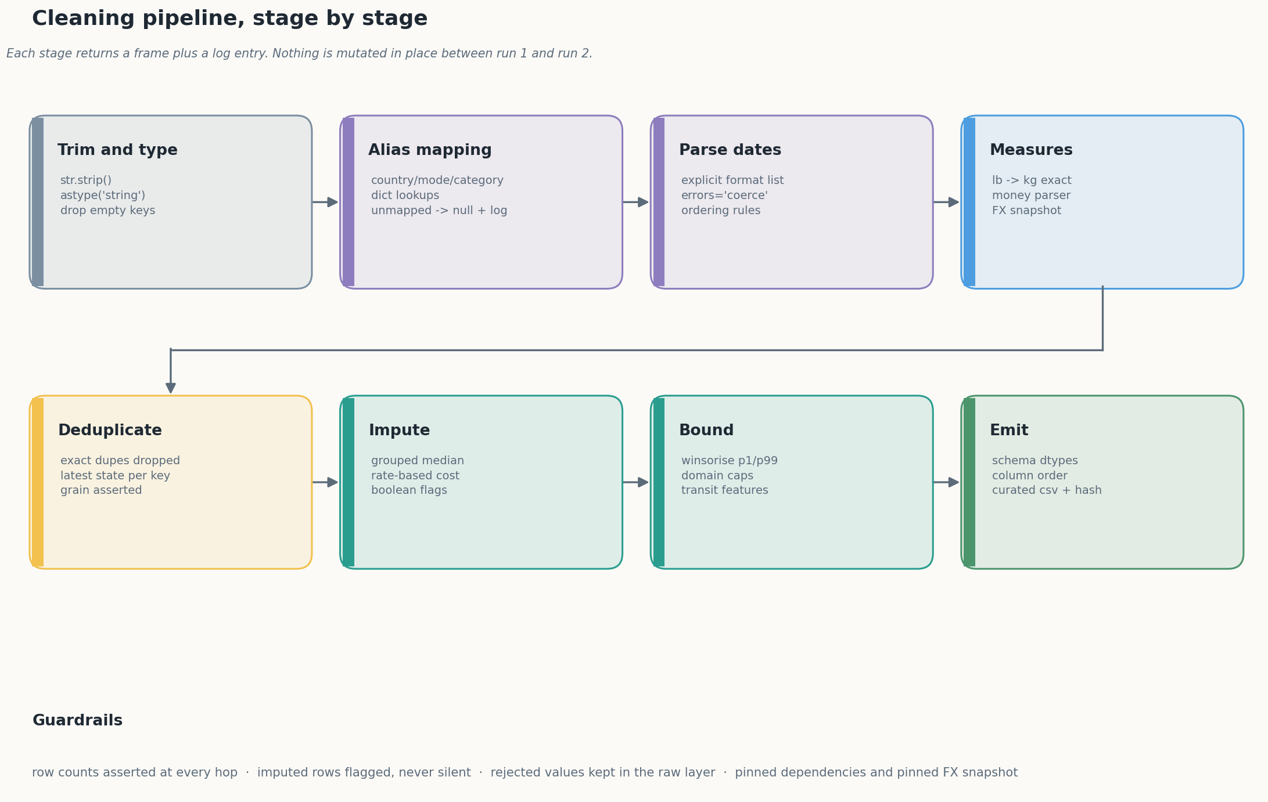
Figure 2. The eight cleaning stages applied to the shipment table. Each stage returns a frame plus a log entry recording what changed and how many rows it touched.

7.1 Ingestion with explicit dtypes
The first decision is to read everything as text and parse deliberately:
frame = pd.read_csv(path, dtype=str, keep_default_na=True,
na_values=["", "NA", "N/A", "null", "-"])
Automatic inference is convenient and occasionally destructive. A consignment identifier of 00123 becomes 123; a numeric-looking code becomes an integer; a mixed date column becomes object and every downstream comparison silently fails. Reading as text costs one extra cast per column and removes an entire class of bug. Once parsed, columns receive explicit types — string rather than object, category for controlled vocabularies, Int64 and Float64 where nulls must survive, and datetime64[ns] for dates.
The distinction between np.nan and pd.NA matters here. NumPy’s float NaN propagates through arithmetic but cannot exist in an integer column; pandas’ nullable dtypes preserve missingness in integers and booleans. Mixing the two produces the familiar FutureWarning: Downcasting object dtype arrays, which is a symptom rather than a nuisance.

7.2 Dates
Date parsing is where naive pipelines break. The rule applied here is an explicit list of formats, tried in order, with the first success winning:
for fmt in ("%Y-%m-%d", "%d/%m/%Y", "%B %d, %Y", "%Y/%m/%d", "%d-%m-%Y"):
pending = out.isna() & source.notna()
if not pending.any():
break
out.loc[pending] = pd.to_datetime(source[pending], format=fmt, errors="coerce")
This is slower than format="mixed" and considerably safer: 04/03/2025 is unambiguous within a file because the format is asserted, not inferred. Rows that match no format become NaT and are counted, never defaulted to today — a rule that prevents the single most damaging silent error in operational reporting, where a failed parse becomes a shipment dated to the run date.

7.3 Numbers, units and money
Weights arrive with a companion unit column that is itself inconsistent (kg, KG, Kilograms, lb, lbs). The transform normalises the unit to a key, looks up a factor, multiplies, and rejects anything implausible:
kg = frame["weight_value"].map(_numeric) * frame["weight_unit"].map(_UNIT_TO_KG)
kg = kg.mask((kg > 250_000) | (kg <= 0))
The pound factor is the exact international value, 0.45359237, not 0.45. A 0.8 per cent error per row is invisible in a sample and material in annual tonnage.
Money is harder because the currency may be in the amount, in a separate column, or both, and the amount may carry a symbol, a thousands separator and a parenthesised negative. The parser strips formatting, resolves decimal commas versus thousands commas by comparing the last occurrence of each, and recovers the sign from the string rather than assuming a numeric prefix works:
negative = "-" in raw or (raw.startswith("(") and raw.endswith(")"))
cleaned = re.sub(r"[^0-9.,]", "", raw)
Conversion uses a pinned FX table, recorded in the decision log. Live rates make yesterday’s report irreproducible; a pinned table makes the figure stable and the assumption visible. A production job stores the daily rate series and versions it, which is the same idea with more honesty about drift.

7.4 Deduplication and grain
Deduplication is two operations, not one. Byte-identical rows are dropped first, then conflicting rows sharing a shipment key are resolved by keeping the latest state. Keeping the “most complete” row sounds smarter and biases towards whichever field was edited by hand; keeping the last row reflects how the source system actually emits records.
frame = frame.drop_duplicates()
frame = frame.drop_duplicates(subset=["shipment_id"], keep="last")
On the reference extract this removes 122 identical rows and collapses 58 conflicting keys, taking 4,380 landed rows to 4,200 published ones. The grain is then asserted before anything else runs.

7.5 Feature derivation
Two features are derived rather than cleaned: transit time and lateness. Transit is the difference between despatch and delivery in days, nulled where negative. Lateness compares transit against a promised window taken, in the absence of contract data, as the ninetieth percentile of observed transit for that mode — stated explicitly because a p90 promise trivially produces a ten per cent late rate by construction, and an unstated assumption of that kind is how a metric becomes a myth.

7.6 Performance notes
The reference extract is small enough that any approach works. At the scale of a real feed — tens of millions of rows — three changes matter: use dtype_backend="pyarrow" when reading to cut memory and speed up string operations, prefer CategoricalDtype for mode, carrier and country so grouping does not hash strings repeatedly, and avoid apply on rows entirely. Vectorised groupby().transform() computes the grouped medians used for imputation in one pass; a row-wise apply would be two orders of magnitude slower and is the single most common cause of a pipeline that “works” but cannot be scheduled.

8. Handling missing data
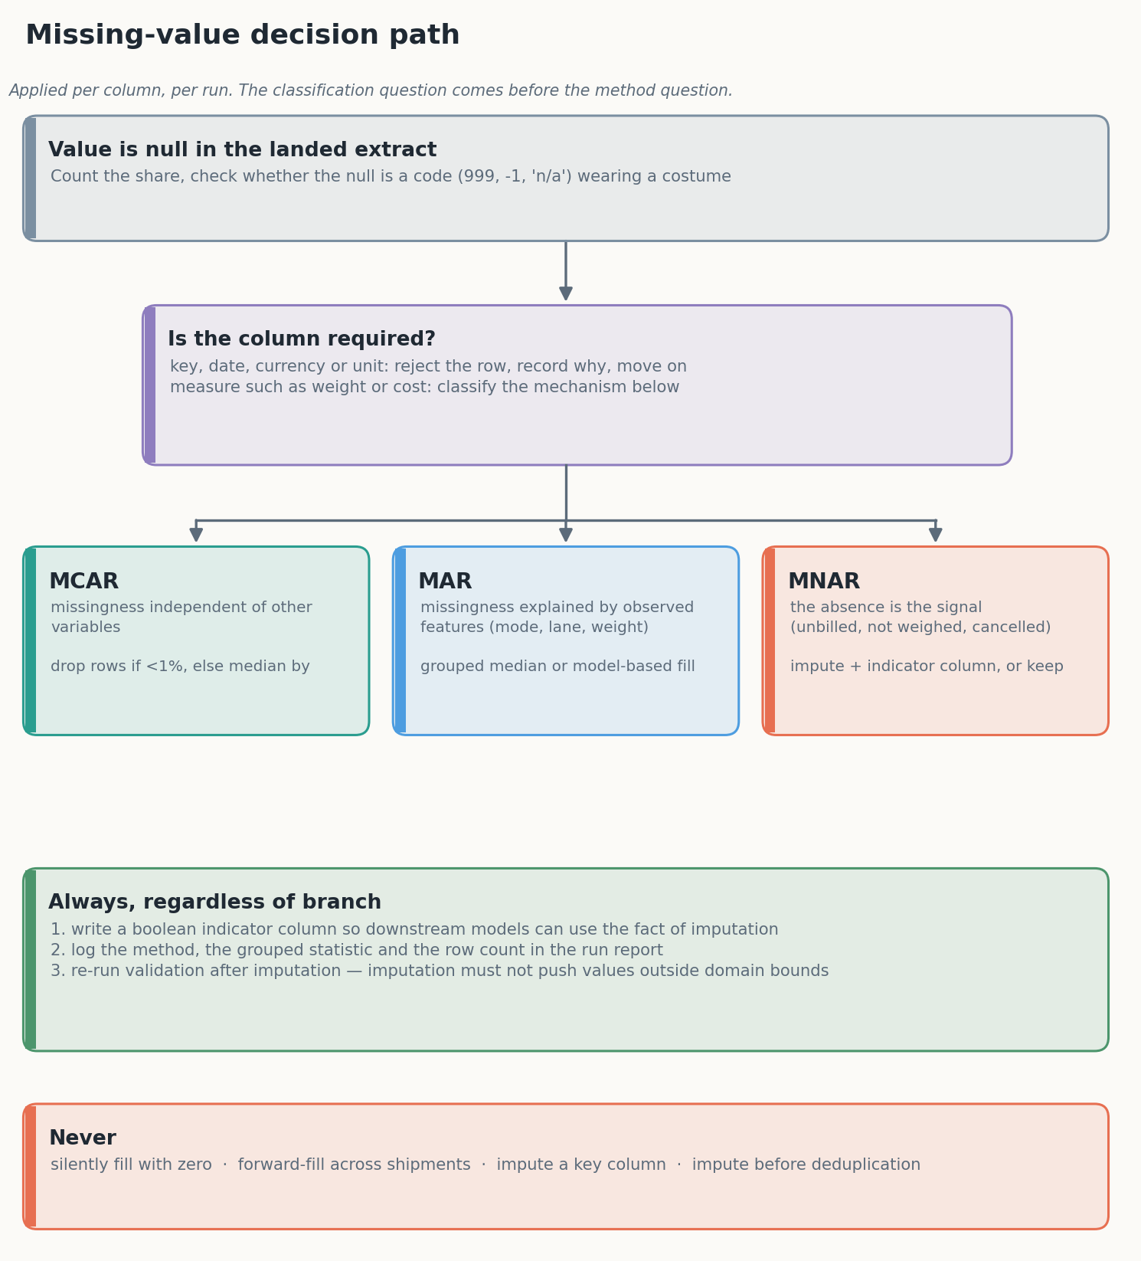
Figure 3. The missing-value decision path applied per column. Classification precedes method; the indicator column is mandatory regardless of branch.

8.1 Classify before imputing
Missing data is conventionally classified into three mechanisms: missing completely at random (MCAR), missing at random in the sense that the probability depends on observed variables (MAR), and missing not at random, where the absence itself carries information (MNAR) [8][9]. The classification is not academic. Under MCAR a complete-case analysis is unbiased; under MAR a model-based or grouped imputation is defensible; under MNAR every simple imputation produces a biased estimate, and the honest response is to model the missingness explicitly or to keep it.
In logistics, most operational missingness is MNAR or MAR, rarely MCAR. A weight of null on a consignment that was never weighed is MNAR: the absence correlates with the process, and filling it with a median asserts an observation that was never made. A null cost on an unbilled shipment is the same problem wearing a different hat. A null carrier because the carrier field is populated only for contracted lanes is MAR, conditional on lane type.

8.2 The rules applied
The strategy applies five rules, in order:
- Detect coded nulls first. A weight of zero, a cost of -1 and a category of n/a are nulls in disguise. The reference pipeline rejects 86 weights that are zero or above 250,000 kg before any imputation runs.
- Never impute a key or a date used for ordering. A shipment with no despatch date is rejected, not invented.
- Impute measures with grouped statistics. Weight is imputed from the median within mode × category, falling back to mode, then to the global median. Median rather than mean because weights are log-normal and a single mis-scaled pallet moves a mean substantially.
- Flag every imputed value. A boolean weight_imputed column is written before the fill, so the fact of imputation survives into the model, where it is often predictive in its own right.
- Re-validate after imputation. An imputed value must not fall outside the domain bounds; if it does, the grouping is wrong and the run should say so.

8.3 Choosing the method
method | assumption | strength | risk | used here
drop rows | MCAR, small share | unbiased, simple | loses whole records | no (rejects only key fields)
global median | MCAR | trivial, stable | ignores structure | fallback only
grouped median | MAR on the grouping | cheap, robust | thin cells mislead | yes, mode × category
rate-based estimate | cost ∝ billed weight | uses a real relationship | needs a reliable weight | yes, for cost
regression / KNN | MAR, linear or local structure | uses more signal | overfits, uninterpretable | deferred
multiple imputation | MAR, correct model | propagates uncertainty | expensive, needs expertise | deferred, not needed here
keep as null | MNAR | makes no false claim | downstream must handle nulls | yes, delivery date
The pipeline deliberately mixes methods: median for weight, a rate model for cost, and outright preservation for delivery dates. A single imputation strategy applied to every column is a sign that the classification step was skipped.

8.4 Reporting missingness
Every run writes the imputation share per column into the quality report. In the reference run 9.1 per cent of weights and 5.2 per cent of costs are imputed. Nine per cent is tolerable for a descriptive aggregate and marginal for a cost model; stating the number is what allows that judgement to be made by the reader rather than buried in a notebook.

9. Inconsistent data, entity resolution and normalisation

9.1 Controlled vocabularies
The cheapest fix for inconsistency is a dictionary, and the cheapest way to make that dictionary maintainable is to normalise the key before lookup: strip whitespace, lower-case, delete dots, replace remaining punctuation with spaces, collapse runs. Deleting dots rather than replacing them matters — U.S.A. must match USA, while U.A.E. must not become u a e. The reference implementation’s first version got this wrong, validation caught 112 unmapped origin countries, and the fix is now covered by a test. That sequence — defect, loud failure, test — is the workflow the report is recommending.
Unmapped values are set to null and logged, never passed through. A pass-through turns a typo into a new country and a new line in every downstream aggregate; a null fails validation and gets fixed.

9.2 Fuzzy matching and its limits
Exact dictionaries handle spelling variants known in advance. They do not handle Shenzen for Shenzhen or Nhava Shiva for Nhava Sheva. For these, rapidfuzz provides a scored nearest match:
from rapidfuzz import process, fuzz
match, score, _ = process.extractOne(value, choices, scorer=fuzz.WRatio)
The rule is to accept automatically above a high threshold (typically 92), queue between 85 and 92 for human review, and leave below 85 unmatched. The review queue is a real artefact with a named owner, not a comment in a notebook. The failure mode to avoid is silent auto-acceptance at 80, which merges distinct ports with similar names — a mistake that is expensive and hard to detect downstream because the output looks plausible.

9.3 Geospatial normalisation
City names are not keys. The defensible approach is to resolve free text to a canonical place with a coordinate and a code, in this order: an exact match on UN/LOCODE [10], then a gazetteer match within the known country, then a geocoder with a confidence threshold, then manual review. Coordinates allow distance computation in a projected CRS (EPSG:3857 or a local UTM zone) rather than degrees, and sjoin_nearest in geopandas resolves ambiguous names by proximity. Where a port boundary is the question, an sjoin against the port polygon is authoritative in a way that a name match never is. This is scoped out of the reference implementation, but the decision log records it as deferred rather than done.

9.4 Normalisation of measures
Three normalisations matter for comparability. Unit normalisation to a single base unit per dimension, applied at ingestion rather than at analysis time. Currency normalisation to one reporting currency with the rate and date recorded. Time normalisation to UTC for storage and to local time for presentation, never the reverse. Each is a small transform and each is a prerequisite for a correct aggregate.

9.5 Encoding and categories
Categorical columns are stored as CategoricalDtype with an explicit, ordered set of categories. This has three benefits: memory, a guaranteed vocabulary (the category set is part of the contract), and a cheap way to detect drift when a new value appears. One-hot encoding is done at model time, not storage time, because a stored encoding freezes the schema and breaks the moment a new mode appears.

10. Validation and quality gates

10.1 Declarative checks
Validation is defined in config/schema.yml and executed by src/validate.py, so that a change in expectations is a reviewable diff rather than an edit buried in a notebook. The reference implementation runs thirteen checks:
group | checks | severity
identity | unique shipment_id | critical
completeness | nine key columns populated | critical
vocabulary | country, mode, category within allowed sets | critical
domain | weight > 0, cost ≥ 0, despatch ≥ order | critical
consistency | transit days ≥ 0 | warning
distribution | cost per kg plausible | warning
imputation | share of imputed weights ≤ 15% | warning
volume | row count within the expected band | warning

10.2 Critical versus warning
The split is a design decision, not a taxonomy exercise. A critical failure stops publication and returns a non-zero exit code, so a scheduled run fails where people notice — in the scheduler, in CI, in the alert. A warning is recorded, published and reviewed. Pipelines that treat every anomaly as fatal are abandoned within a month; pipelines that treat none as fatal are trusted for exactly as long as it takes for a wrong number to reach a steering committee.

10.3 The checks that earn their keep
Three checks have already paid for themselves on a 4,200-row extract. The vocabulary check caught the dotted-abbreviation mapping bug. The imputation-share check prevents a slow drift where a source change causes half a column to be filled with medians while every aggregate continues to look reasonable. The cost-per-kilogram check is the domain guard: a median of $0.91 per kilogram is plausible for a mixed air and ocean book, whereas a median of $0.0009 would indicate a currency inversion that no schema check would catch.

10.4 Beyond the checks
Schema validation (pandera, great_expectations) formalises these rules and generates reports; pytest covers the transforms themselves, including property-based tests with hypothesis for invariants such as “converting to kilograms is monotonic”. The reference implementation uses nineteen explicit unit tests rather than a framework, because at this scale an added dependency costs more than it saves, and because a test named test_dotted_abbreviations_survive_punctuation_stripping documents the failure better than a schema line ever will.

11. Reproducibility and documentation

11.1 The repository is the method
Documentation that describes a process is weaker than a repository that runs it. The structure below is chosen so that a reviewer can move from claim to evidence in one step:
config/schema.yml contract: dtypes, allowed values, bounds, FX assumption
data/raw/ immutable landing, checksum recorded
data/processed/ curated output, regenerated, git-ignored
docs/sources.md source register with licence notes
docs/data_dictionary.md every column and the rule behind it
docs/decision_log.md 18 decisions, rejected alternatives, rationale
src/ingest.py provenance and profiling
src/clean.py eight bounded transforms plus a step log
src/validate.py thirteen checks, two severities
src/run_pipeline.py one entry point, non-zero exit on critical failure
tests/test_clean.py nineteen unit tests
reports/ quality report, regenerated on every run

11.2 What gets recorded
Every run writes: the source filename, its SHA-256, its byte size, the row count before cleaning, the row count after, the checksum of the published table, a table of every transform with the rows it touched, and the result of every check. That is the minimum set that answers “which input, which code, which rules, which output” without reconstructing a session from memory.

11.3 Pinning and provenance
Dependencies are pinned exactly in requirements.txt. The random seed is a module constant. The FX table is pinned with a comment stating why. The data hash is recorded next to the report it produced. Together these make a claim like “median freight cost was $209.36” checkable months later, which is the only version of reproducibility worth the name.
For larger projects the same ideas scale with DVC or lakeFS for data versioning, a lockfile plus container image for the environment, and a CHANGELOG.md for the table’s semantic version. The principles do not change with scale; only the tooling does.

11.4 Documentation that survives handover
Three documents carry the reasoning: the data dictionary (what each column means, including what null means), the decision log (what was chosen, what was rejected, why), and the quality report (what the last run found). A fourth — the source register — carries the licensing position. Prose that describes the code rather than the decisions becomes stale within a sprint and is worse than nothing, because it is trusted.
Writing these is not overhead on the analysis; it is the difference between an analysis that can be defended in a review and one that has to be redone by whoever inherits it. The habit also has a private benefit: the decision log is where the reasoning that was too fuzzy to put in a commit message finally gets written down, and writing it is usually how the remaining ambiguity is discovered.

12. Reference implementation: what the pipeline actually did

12.1 Inputs and outputs
The numbers below come from reports/data_quality_report.md, generated by the run that produced the committed figures. They are not estimates.
stage | rows
landed extract | 4,380
byte-identical duplicates removed | −122
conflicting shipment keys collapsed by latest state | −58
published | 4,200

cleaning action | rows affected
whitespace trimmed across keys, cities, carriers | 4,380
implausible weights rejected (0 kg or > 250,000 kg) | 86
negative costs retained as credits, then clipped at zero | 43
weights imputed (mode × category median, flagged) | 382 (9.1%)
costs imputed (median USD/kg by mode, flagged) | 220 (5.2%)
dates with despatch before order nulled | 0
weights winsorised at p0.1 / p99.9 | 10
costs winsorised at p1 / p99 | 84

12.2 What the output looks like
mode | rows | median weight (kg) | median freight cost (USD) | median transit (days) | share late
Air | 1,492 | 182.5 | 905.07 | 3 | 0.0%
Ocean | 1,180 | 185.2 | 77.26 | 28 | 6.1%
Rail | 617 | 176.1 | 121.42 | 11 | 0.0%
Road | 911 | 180.7 | 171.14 | 5 | 0.0%
Two features of that table are worth stating rather than smoothing over. Weights are almost identical across modes, because the extract was generated with one weight distribution and the mode only affects the unit mix; a real book would show air consignments markedly lighter than ocean ones, and the absence of that pattern is a property of the synthetic data, not a finding about freight. Lateness appears only for ocean, because integer transit days coarsen the p90 so that for short-haul modes the promise lands on the maximum observed value and nothing can exceed it. That is a limitation of the p90 promise with coarse integer data, and it is precisely the kind of artefact a reviewer should be told about rather than left to discover.
Currency resolution shows the point of parsing the amount rather than trusting the column: of 4,200 rows, 2,542 resolve to USD, 903 to EUR, 441 to GBP and 314 to INR, with the code printed in the amount overriding the separate column on the rows where the two disagreed.

12.3 What the run does not prove
Three things are honestly absent. The data is synthetic, so no conclusion about real freight markets follows from it. The delay metric uses a p90 promise, so its 1.7 per cent late share is a property of that definition rather than a finding. And geospatial enrichment and time-zone handling are scoped out. A report that lists its own gaps is more useful than one that leaves the reader to discover them.

13. Feasibility, risks and mitigations

13.1 Feasibility within an internship
The scope is deliberately sized to be deliverable: a documented strategy, three diagrams, a working pipeline on a controlled extract, and a plan for swapping in a real public dataset. Nothing in the reference implementation requires paid infrastructure. The only external dependency that costs money is a commercial freight dataset, and the strategy does not need one to be credible.

13.2 Risk register
risk | likelihood | impact | mitigation
real dataset fails to arrive or is licensed restrictively | medium | high | FAF is public and versioned; the pipeline is dataset-agnostic behind the schema
source schema drifts mid-project | high | medium | schema contract plus a profiling diff per run
imputation choices criticised as arbitrary | medium | medium | documented classification, flagged values, alternatives listed in section 8.3
geocoding API limits or costs | medium | low | batch, cache, and resolve against UN/LOCODE first
over-engineering beyond the internship window | medium | medium | explicit out-of-scope list; plain Python entry point instead of an orchestrator
ambiguous day/month dates corrupting a time series | high | high | explicit format list, no inference, counted failures

13.3 The risk that matters most
The dominant risk is not technical. It is producing a document that describes an impressive pipeline while the code diverges from it. The mitigation is structural: the numbers in section 12 are read from a generated report, the diagrams are drawn by code, and the decision log is written as changes are made. A reviewer who runs two commands can reproduce the claims, and that is the property that makes the work defensible.

14. Plan for weeks 2–4
The programme sets three further tasks, and the week 1 output is built to feed all three rather than to stand alone. The plan below states what each week consumes from this one.

14.1 Week 2 — exploratory analysis and visualisation
The cleaned table is the input, which is exactly why the grain, types and flags matter. Week 2 works in four passes: univariate distributions for weight, cost, transit and quantity; lane-level comparison across the eight countries and four modes; outlier and concentration analysis, since freight volumes are famously heavy-tailed; and a time dimension, because despatch dates span a year and seasonality is the obvious hypothesis. Figures are produced with matplotlib and seaborn, with plotly reserved for anything interactive, and every figure carries an interpretation rather than a caption. Two variables from week 1’s quality report become analysis variables in their own right: the imputation flags, to test whether filled rows behave differently, and the currency column, to check that conversion has not introduced a mode-level artefact.

14.2 Week 3 — predictive modelling and forecasting
The obvious target is transit time or, as a classification problem, late delivery. Features come from the contract: mode, lane, carrier, category, weight, quantity, month. The modelling plan is deliberately boring — a mean baseline, then linear regression, then a gradient-boosted tree — with a time-based split so that the model never sees the future, and a documented leakage review, because the two most tempting features (delay days and delivery date) are both consequences of the target. Evaluation uses MAE and RMSE on the regression, a confusion matrix and precision-recall on the classification, and a residual analysis by mode. The p90 lateness definition from week 1 has to be either defended or replaced by then; an arbitrarily defined label produces a model that predicts the definition rather than the world.

14.3 Week 4 — decision support
The final task is integration, not new analysis: one document that carries the preprocessing decisions, the exploratory findings and the model results into a set of operational recommendations, each tied to the evidence behind it. The week 1 artefacts make that easier than it sounds, because the decision log already records why each cleaning rule exists and the quality report already quantifies what was imputed. The risk register extends to the recommendations themselves, and the appendix carries the code that produced each figure.

14.4 Acceptance criteria per week
Week 2 passes when every figure in the report can be regenerated from a committed script and each one carries an interpretation. Week 3 passes when a time-based split, a stated baseline and a leakage review are all present, and when the reported metric is the one the split actually measures. Week 4 passes when a reader who has not seen the code can trace each recommendation back to a number in weeks 1–3.

15. Conclusion
The strategy in this report rests on a small number of positions that do most of the work. Raw data is immutable and everything downstream is derived from it. Types are asserted rather than inferred, and dates are parsed against an explicit list. Values are coerced or rejected, never guessed. Missingness is classified before it is imputed, and every imputation is flagged. Validation gates publication, with a severity split that stops the pipeline for real problems and records the rest. Documentation is generated from the run, not written alongside it.
None of these positions is novel, and that is the point: logistics data is messy in predictable ways, and the value of a blueprint lies in applying predictable discipline to it. The reference implementation shows what that looks like at a small scale — 4,200 rows, thirteen checks, nineteen tests, one generated report — and the plan for weeks 2–4 reuses it for exploration, prediction and decision support without changing the shape of the argument.
What the work demonstrates, finally, is a habit rather than a technique. A pipeline that logs what it changed, fails when it should, and can be re-run by someone else is worth more than a clever transform nobody can reproduce.

References
- US Bureau of Transportation Statistics. Freight Analysis Framework (FAF5 and FAF6). https://www.bts.gov/faf — data and documentation, accessed October 2026.
- United Nations Statistics Division. UN Comtrade Database and API. https://comtradeplus.un.org
- International Monetary Fund. PortWatch: daily port activity data. https://portwatch.imf.org
- US Bureau of Transportation Statistics. Border Crossing/Entry Data. https://www.bts.gov/browse-statistical-products-and-data/border-crossing-data
- Eurostat. Freight transport statistics. https://ec.europa.eu/eurostat/web/transport/data/database
- OpenStreetMap contributors. OpenStreetMap, ODbL 1.0. https://www.openstreetmap.org
- European Central Bank. Euro foreign exchange reference rates. https://www.ecb.europa.eu/stats/policy_and_exchange_rates/euro_reference_exchange_rates
- Little, R. J. A. and Rubin, D. B. (2019). Statistical Analysis with Missing Data, 3rd edn. Wiley.
- Rubin, D. B. (1976). Inference and missing data. Biometrika, 63(3), 581–592.
- UNECE. UN/LOCODE code list for trade and transport locations. https://unece.org/trade/cefact/unlocode-code-list-country-and-territory
- McKinney, W. (2010). Data structures for statistical computing in Python. Proceedings of the 9th Python in Science Conference, 56–61.
- Harris, C. R. et al. (2020). Array programming with NumPy. Nature, 585, 357–362.
- Gebru, T. et al. (2021). Datasheets for Datasets. Communications of the ACM, 64(12), 86–92.
- Wilkinson, M. D. et al. (2016). The FAIR Guiding Principles for scientific data management and stewardship. Scientific Data, 3, 160018.
- Sandve, G. K. et al. (2013). Ten simple rules for reproducible computational research. PLoS Computational Biology, 9(10), e1003285.
- Sculley, D. et al. (2015). Hidden technical debt in machine learning systems. Advances in Neural Information Processing Systems, 28.

Appendix A. Cleaning log excerpt
Produced by src/run_pipeline.py; excerpted from reports/data_quality_report.md, which carries the full table.
step | detail | rows affected
unmapped origin_country | left null for manual review: P.R. China | 113
reject implausible weight | sentinel values above 250,000 kg and non-positive weights set to null | 86
negative freight cost | kept as credit notes, excluded from cost aggregates | 43
deduplicate | 122 byte-identical rows removed, 58 conflicting shipment keys resolved by latest state | 180
impute weight | grouped median (mode × category → mode → global 181.9 kg), flag added | 382
impute cost | mode-level median USD per kg applied to missing costs, flag added | 220
winsorise freight_cost_usd | clipped to p1 = 3.99 / p99 = 6,131.60 | 84
emit curated table | 4,200 rows, 20 columns | 4,200

A.1 How to read the log
Three things in that table are worth reading closely. The unmapped country row records a failure, not a success: 113 rows carried P.R. China, which the alias table did not recognise until the key-dot rule was fixed. That the run now maps it is a consequence of this log entry existing, which is the argument for logging unmapped values rather than dropping them quietly.
The deduplication row separates two different phenomena in one line: 122 rows were byte-identical, which is a transport artefact, while 58 shared a shipment key with a different body, which is a genuine state change. Collapsing both into “180 duplicates removed” without the split would hide that distinction and make the choice of keep="last" impossible to audit.
The winsorisation bounds are reported with the values used, not just the percentiles. A reader can therefore see that p1 of $3.99 is a plausible freight minimum and not an artefact of a currency parse, which is precisely the question a reviewer should be asking about a clipped cost column.

A.2 What is absent from the log
No row appears for “date ordering” or “reject quantity” with a non-zero count, because the seeded extract contained none. A log that only lists positive findings flatters the run; a log that also records zero is a stronger claim. The report keeps those rows in the full table for exactly that reason.

Appendix B. Transform example
The following is the actual imputation function, abridged only by removing docstrings. It illustrates the pattern applied throughout: group, estimate, flag, log.
def impute_weight(frame, log):
kg = frame["weight_kg"]
by_cell = (
frame.groupby(["mode", "product_category"], observed=True)["weight_kg"]
.transform("median")
)
by_mode = frame.groupby("mode", observed=True)["weight_kg"].transform("median")
global_median = kg.median()
filled = kg.fillna(by_cell).fillna(by_mode).fillna(global_median)
log.add(
"impute weight",
f"grouped median -> global {global_median:,.1f} kg",
int(kg.isna().sum()),
)
return filled
Three details worth noting. The grouping uses observed=True so that unused categories do not create empty groups. The fallback chain is explicit, so it is obvious what happens when a cell is empty. And the log entry records the statistic used, not merely that something happened — a log that says “imputed weight” without the value is a receipt, not evidence.
The complementary check is what stops the imputation from silently degrading the dataset. The validation module treats the imputation share as a warning with a threshold, so a source change that pushes it from nine per cent to forty per cent fails loudly without stopping a legitimate run:
imputed = float(frame["weight_imputed"].mean())
checks.append(
Check(
"imputation share",
imputed <= 0.15,
"warning",
f"{imputed:.2%} of weights imputed",
)
)
Together the two snippets show the pattern that the whole pipeline follows: estimate with the smallest defensible model, record what was estimated, then assert that the volume of estimation stayed within a tolerance somebody chose in advance. The tolerance is the part teams skip, and it is the part that turns a cleaning script into a monitored process.

