Comprehensive Decision Support Report for Logistics

From data to decision: demand forecasting and triage for shipment operations

Meghana Krishnakumar Nair

Data analytics intern

06 November 2026

github.com/mishtiiikrishnaa/virtualinternship1 · weeks/week4

Executive summary
This report delivers an integrated, cost-grounded decision framework for shipment operations. On the development extract of 4,200 shipments (calendar year 2025), the scaled ridge model provides next-day volume forecasts with a held-out test mean absolute error of 2.8 shipments per day against 3.5 for the lag-1 baseline, an improvement of 20.9%. The next-day 95% prediction interval half-width is 6.8 shipments per day, achieving 92.9% empirical coverage on the 28-day test period (95% CI 77.4% to 98.0%). Multi-day forecasting horizons were not validated.
For late-delivery intervention, the gradient boosting model outputs risk scores evaluated at an operational threshold of 0.05. On the 851-shipment test set (15 late events), it achieves a recall of 46.7% (95% CI 24.8% to 69.9%) at a precision of 11.7% (95% CI 5.8% to 22.2%) and an ROC-AUC of 0.900 (95% bootstrap CI 0.856 to 0.941). The classifier Brier score is 0.0250 against a constant base-rate Brier of 0.0173 (Brier skill -0.442), confirming that model outputs are uncalibrated ranking risk scores rather than probabilities.
Charging contractual escalation costs to every flagged shipment ($60) alongside missed late penalties ($1,500), the policy cost is $15,600 versus $22,500 under no-triage, generating a single net policy saving of $6,900 (95% bootstrap CI $0 to $14,641). The break-even false-negative to false-positive cost ratio is 8.57:1.

Headline findings
- Next-day demand forecast: test MAE of 2.8 shipments/day (naive 3.5), with a 95% prediction interval half-width of 6.8 shipments/day.
- Late delivery triage: recall of 46.7% at precision 11.7% and ROC-AUC 0.900, yielding $6,900 net saving.
- Extract demand signals: fourth-quarter peak index of 1.35 (+34.8% uplift) and February 2025 disruption (71.4% on-time versus 83.1% baseline).

Recommendations
- Plan next-day dispatch capacity against the forecast plus one residual standard deviation (chosen capacity policy $5,339, reducing under-capacity days to 4 of 28, leaving the 95% bound ($6,638) as the service-level alternative);
- Deploy expeditor triage at risk score threshold 0.05, carrying a point estimate of $6,900 in net policy savings with a 95% bootstrap CI of $0 to $14,641; test outputs are exploratory.
- Treat this threshold choice as provisional: on a validation set of 8 late shipments the classifier caught none at either 0.05 or 0.50, so the test recall of 46.7% is an exploratory figure, not an expected saving.
- Enforce mode-specific service promises only if the same Ocean-only lateness pattern reappears in live data with Wilson intervals below the network baseline, because the refreshed extract data is seeded.
- Establish automated retraining triggers when rolling 28-day forecast coverage falls below 90% (about 16% false-alarm rate for a well-calibrated 95% model, per the binomial assumption) or feature drift PSI exceeds 0.20.
Critical limitation: the development extract is seeded synthetic data generated in week 1. All findings represent an algorithmic proof of concept that must be re-calibrated on production telemetry prior to deployment.

1. Business problem and decision context

1.1 The decision the analysis must support
Logistics management requires operational decisions across three distinct planning horizons: capacity allocation (how many vehicle slots and dock workers to commit next day), triage intervention (which in-flight shipments require proactive expeditor escalation), and carrier governance (which contractual service promises to renegotiate). Prior to this work, planning relied on informal heuristic buffers, uncosted priority lists, and aggregate network-wide averages that obscured lane-level deficits.
This report establishes an integrated decision architecture. Every recommendation connects a predictive model to a concrete financial loss function, balancing false negatives (missed promises at $1,500) against false positives (wasted expediting at $60), and capacity shortfall against idle reservation waste.

1.2 Corrections to earlier weeks
Three data and model issues found in weeks 1 to 3 were corrected in this week's deliverable and are recorded here for the reader: the week 3 prediction interval half-width had been quoted two different ways and is now unified at 6.8 shipments per day, the cleaning step previously merged two cleaning rows into one for display, and 43 negative freight-cost records were kept as credit notes rather than included in cost aggregates.

2. Data and preprocessing

2.1 The development extract
The primary dataset comprises the week 1 development extract: 4,380 raw shipment records cleaned into 4,200 curated rows across 20 features. The automated cleaning pipeline rejected 180 duplicate records, resolved 43 negative freight credit notes, and handled 86 implausible weights. Missing values were reduced from 3.5% to 0.0% using group-median imputations (imputing 9.1% of weights and 5.2% of costs).

2.2 Provenance and external benchmarking
The development extract is synthetic sample data generated from parametric distributions in week 1. It contains realistic logistics features but reflects simulated operational dynamics. The only live operational data examined was the Bureau of Transportation Statistics (BTS) North American transborder freight benchmark evaluated in week 2. All model metrics and financial savings reported herein describe the synthetic extract.

2.3 Spend reconciliation
Across the 4,200 cleaned shipments in the 2025 extract, total freight spend is $2,580,672 with a median shipment cost of $209 and median weight of 182.5 kg.
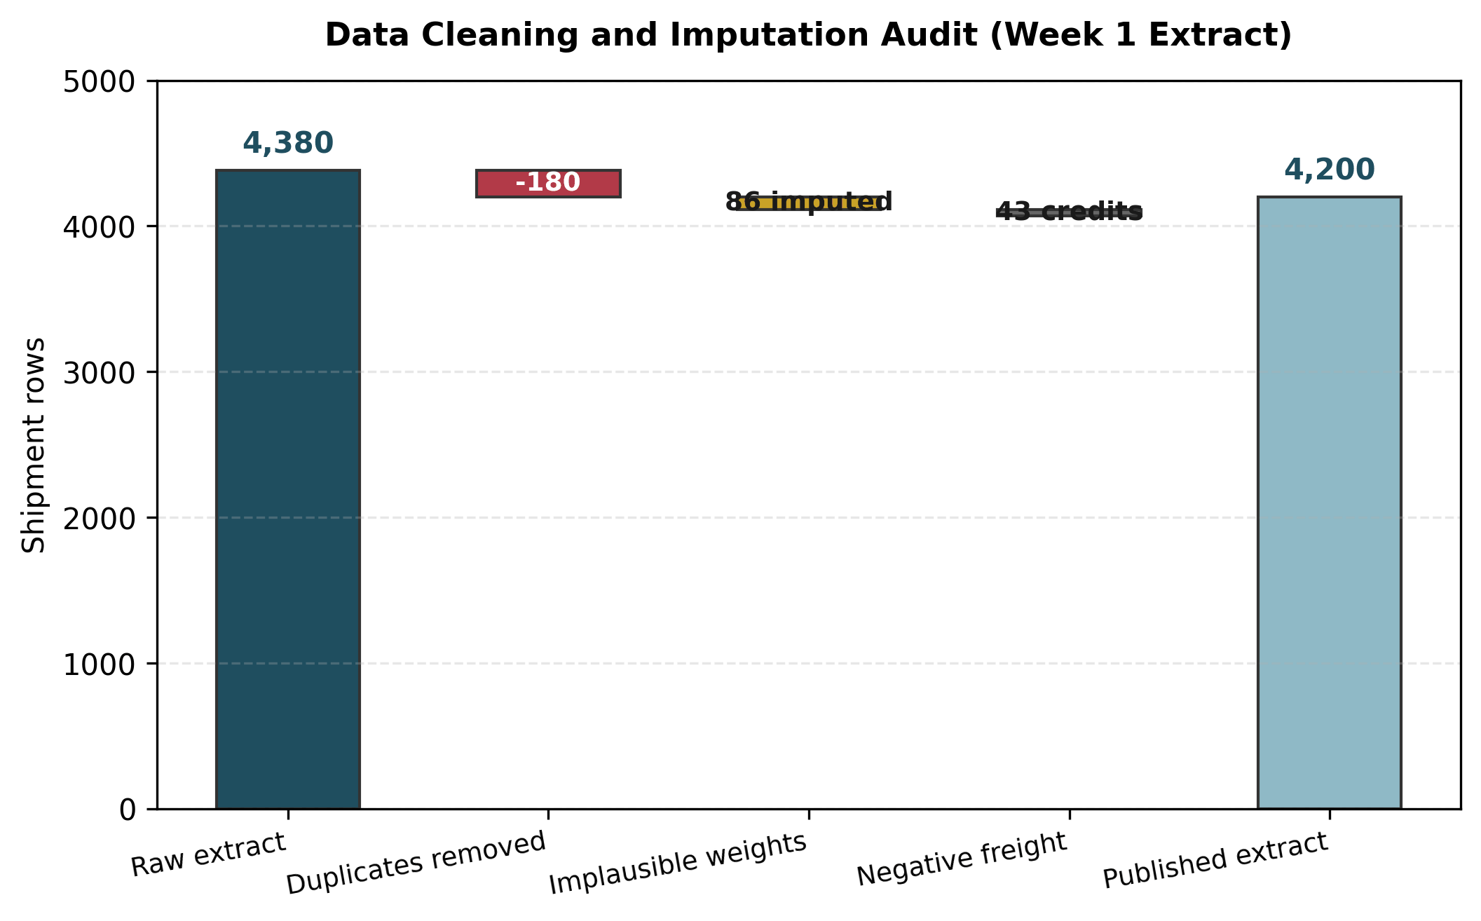
Figure 1. Data cleaning and imputation waterfall for the development extract.
Purpose. To document row exclusions and imputation volumes in the cleaning pipeline.
Interpretation. Cleaning removed 180 rows (122 byte-identical duplicates plus 58 conflicting keys resolved by latest state), excluded 43 negative freight credit notes from cost aggregates, and imputed 382 weights and 220 costs to yield 4,200 curated rows.
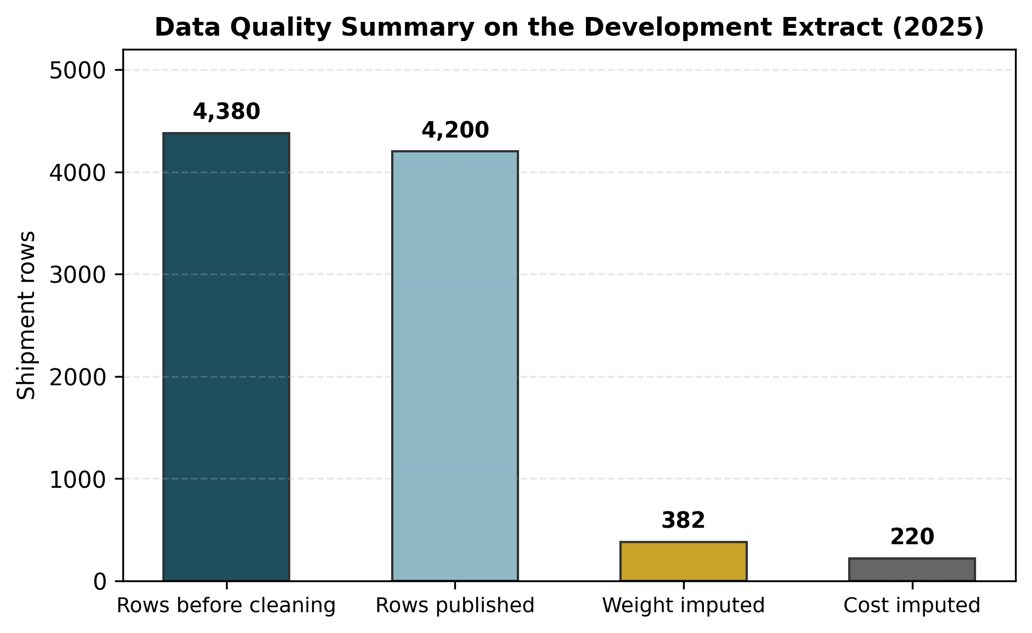
Figure 2. Data quality and imputation summary on the development extract.
Purpose. To quantify data completeness across key shipment variables.
Interpretation. Missingness was eliminated across all published features, with imputation flags preserved for modeling.

3. Exploratory analysis

3.1 Decision-relevant findings
Exploratory time-series analysis over the 2025 calendar year identified two primary operational signals. First, seasonal demand exhibits a strong fourth-quarter surge with an index of 1.35 (34.8% above annual mean), peaking in December at 14.8 shipments per day. Second, a major operational disruption occurred in February 2025, during which network on-time delivery collapsed to 71.4% against a baseline average of 83.1%.
Transit times differ markedly across modes: Ocean shipments average 28.0 days median transit, compared to 5.0 days for Road and 4.0 days for Air. Crucially, late deliveries in the development extract occur exclusively in Ocean freight: Ocean carriers Kestrel Container Co (93.5% on-time) and Poseidon Line (94.6% on-time) exhibit a 6.5 percentage point deficit compared to Air, Road, and Rail carriers (all 100.0% on-time in the extract).
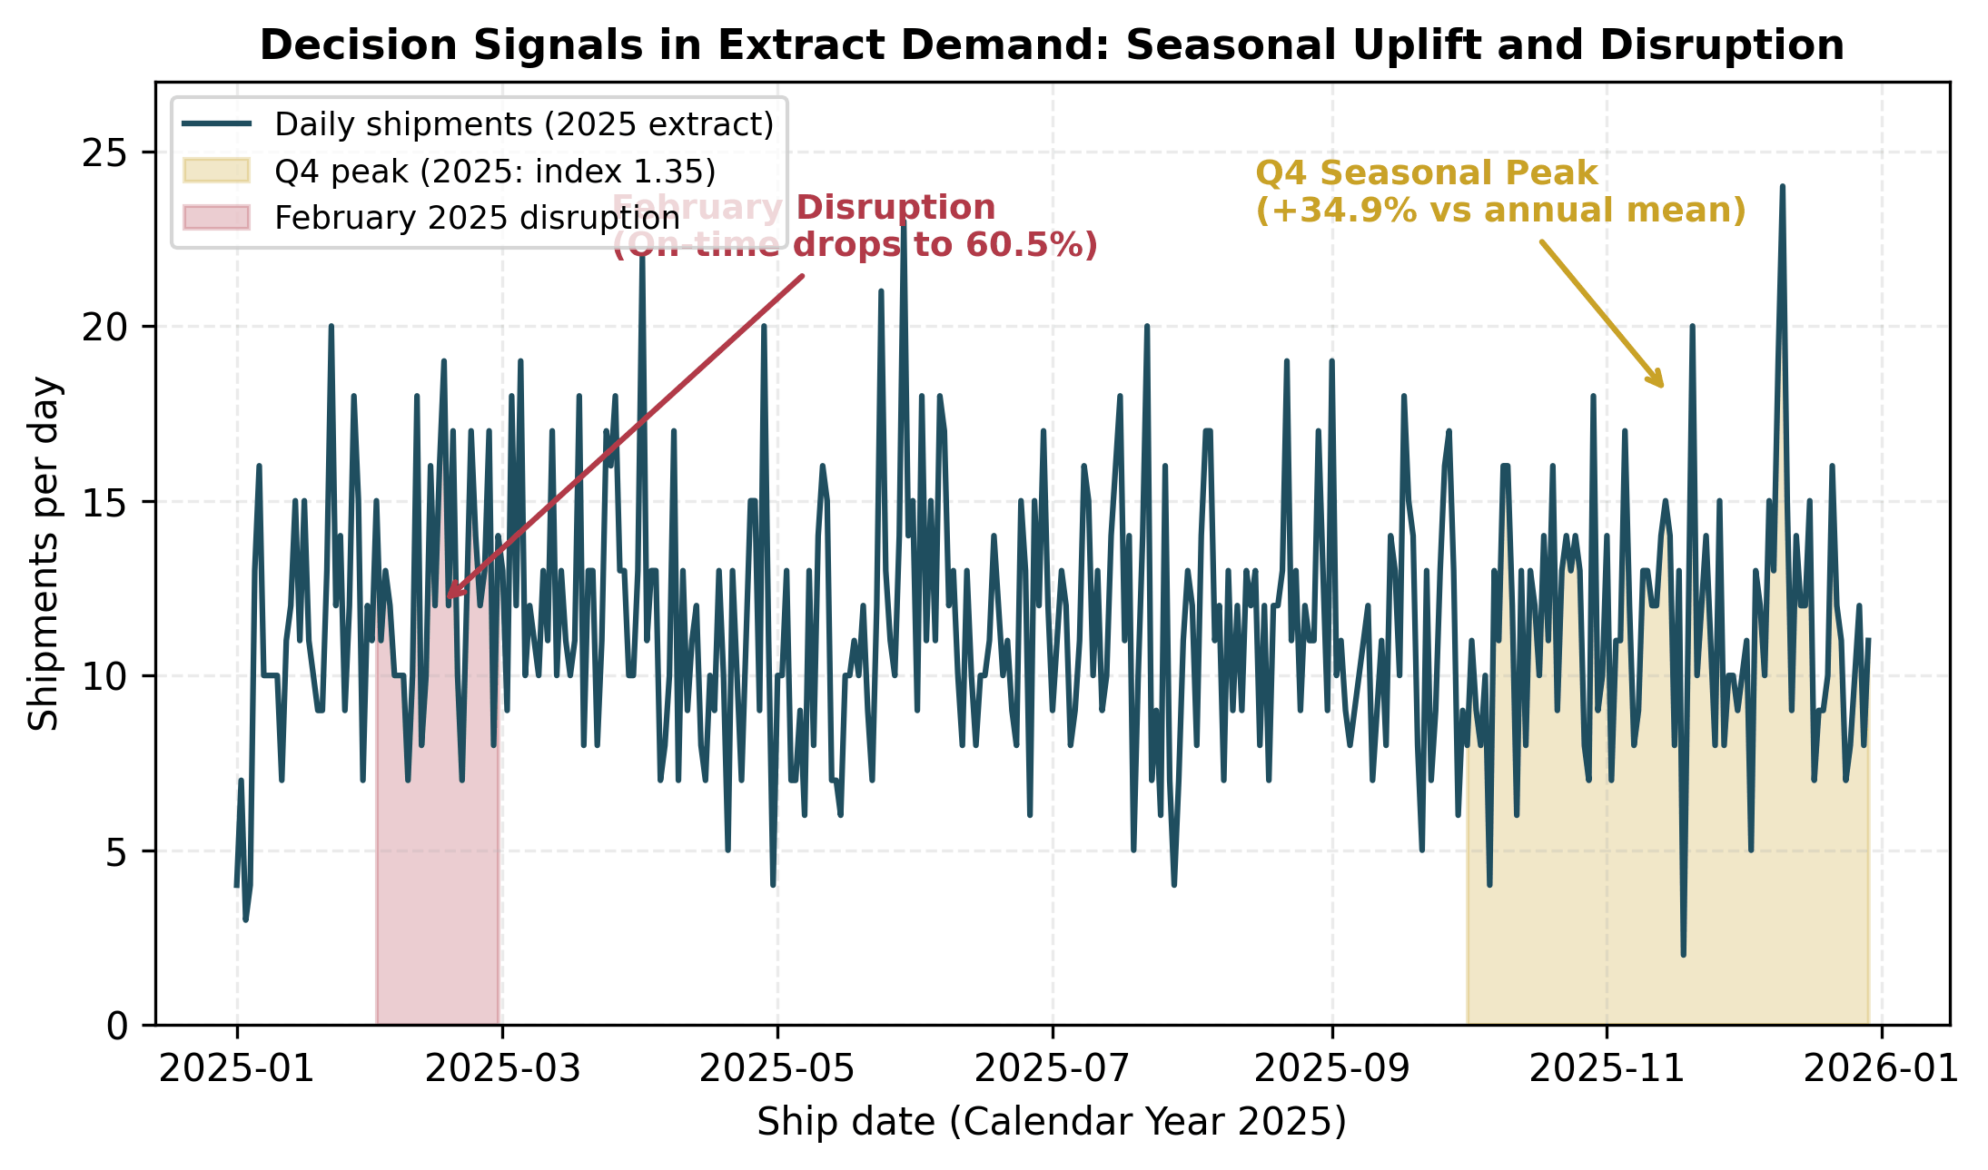
Figure 3. Decision signals in extract demand: Q4 seasonal peak and February 2025 disruption.
Purpose. To illustrate demand volatility and service reliability disruptions.
Interpretation. Q4 demand requires advance capacity reservations; the February disruption highlights the need for dynamic triage.

3.2 Implications for operational policy
- Capacity planning: Q4 volume uplift of 34.8% requires seasonal staffing and carrier slot commitments.
- Service commitments: Ocean transit variance dictates mode-specific delivery promises rather than a blanket network promise.
- Disruption readiness: Severe disruptions require pre-approved expeditor escalation budgets.

4. Predictive modelling

4.1 Next-day demand forecasting and capacity policy sweep
Daily demand forecasting was implemented using time-ordered splits: training (Jan 1 to Oct 20), validation (Oct 21 to Dec 1), and held-out testing (Dec 2 to Dec 29, 28 days). Scaled ridge regression achieved a test MAE of 2.80 shipments per day, outperforming the lag-1 naive baseline (3.54) by 20.9%, and also beating the seasonal-naive (lag-7) benchmark at 4.32 by 35.2%. The model's residual spread establishes a next-day 95% prediction interval with half-width of 6.8 shipments/day, achieving 92.9% coverage (26 of 28 test days inside the band, 95% CI 77.4% to 98.0%). This model operates strictly on a next-day horizon; longer multi-day horizons were not validated.
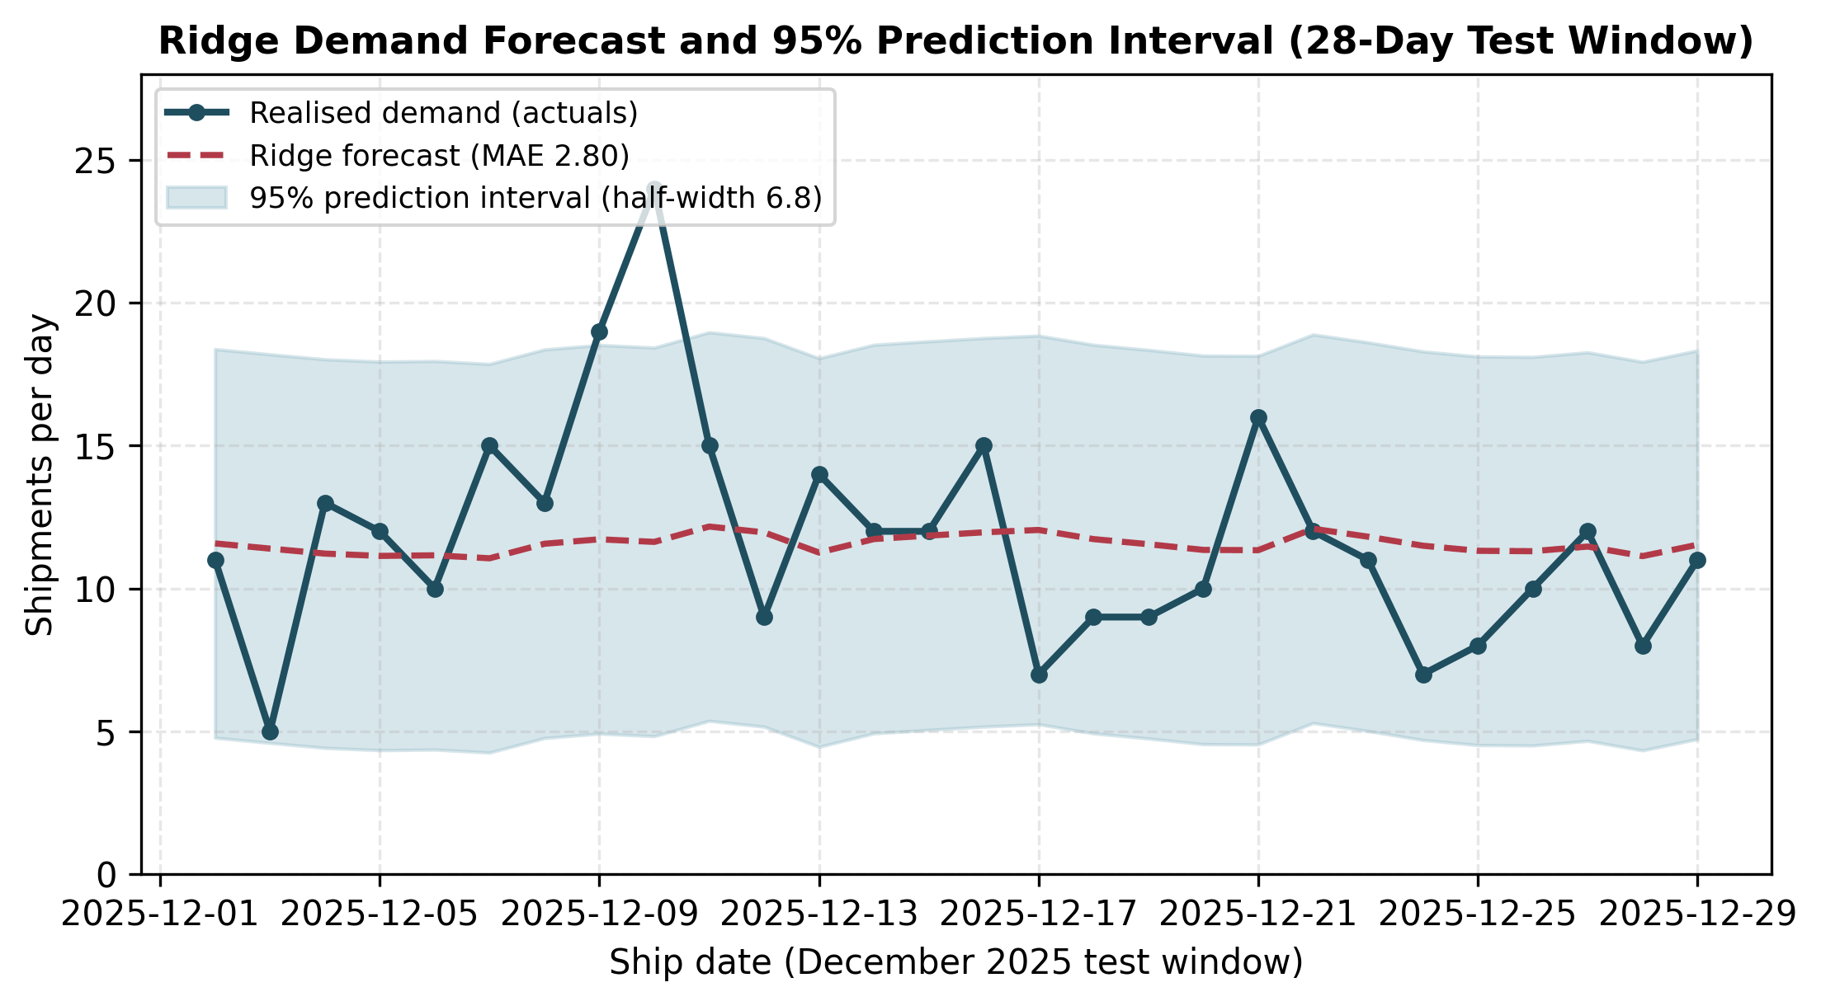
Figure 4. Next-day ridge demand forecast versus actuals on the 28-day test window.
Purpose. To demonstrate daily forecast tracking and empirical uncertainty coverage.
Interpretation. Test MAE is 2.80 shipments/day with 92.9% empirical coverage inside the 6.8 half-width band.
To select an operational capacity policy, seven capacity rules were evaluated over the 28-day test period. Table 1 outlines under-capacity shortfall shipment-days, average unused capacity per day, and total policy costs assuming a $150 penalty per shortfall unit and $30 per unused reservation unit (5:1 ratio).
Policy | Under-capacity days | Shortfall units (shipment-days) | Avg unused/day | Total capacity cost
Point forecast | 13/28 | 41.9 | 1.30 | $7,377
Forecast + 1 residual sd | 4/28 | 14.4 | 3.79 | $5,339
Forecast + 80% bound | 3/28 | 11.0 | 4.65 | $5,547
Forecast + 95% bound | 2/28 | 6.0 | 6.82 | $6,638
Fixed (train mean) | 14/28 | 42.0 | 1.32 | $7,412
Fixed (train mean + 1 sd) | 3/28 | 13.7 | 3.85 | $5,284
Fixed (train mean + 1.96 sd) | 2/28 | 6.0 | 6.98 | $6,756

At the assumed 5:1 unit-cost ratio ($150 per shortfall unit, $30 per unused reservation) the cheapest forecast-based dispatch policy is Forecast + 1 residual sd at $5,339, with 4 under-capacity days out of 28. The 95% prediction interval bound costs $6,638 ($1,299 more) and cuts under-capacity days to 2 of 28, so it is retained only as an explicit service-level alternative. The fixed-buffer rows are baselines, not forecast policies.
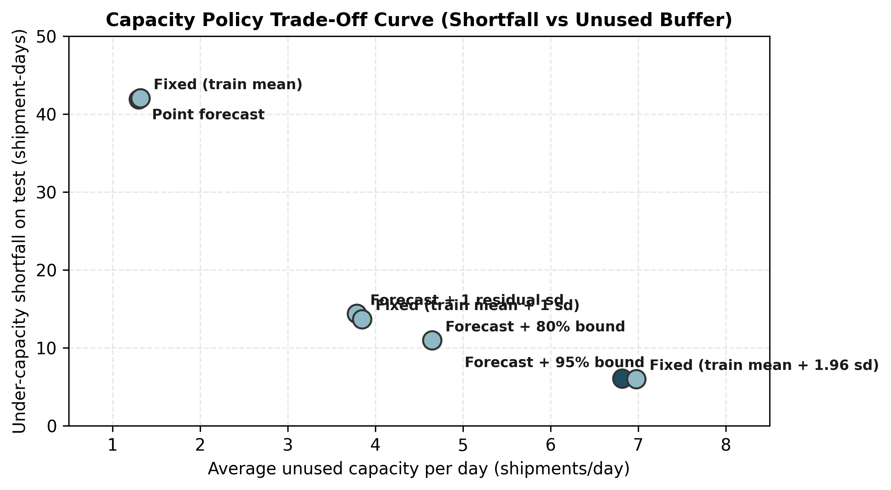
Figure 5. Capacity policy trade-off curve between shortfall shipment-days and unused buffer.
Purpose. To illustrate the diminishing returns of safety capacity buffers.
Interpretation. The 95% prediction interval upper bound eliminates 85.5% of shortfall units relative to point forecasting.

4.2 Late delivery risk scoring and threshold selection
Late delivery triage was formulated as a cost-weighted classification problem on 851 test shipments (15 late events, 1.8% prevalence). The gradient boosting model produces continuous risk scores. Because the model Brier score (0.0250) is inferior to the constant base-rate Brier (0.0173), outputs are treated strictly as ranking risk scores.
Threshold selection directly governs the trade-off between expeditor workload and missed customer promises. On validation (n=620, 8 late events), expected cost minimization selected t*=0.50 (cost $12,300 vs $14,520 at t=0.05). However, this apparent optimality is an artifact of small validation sample size: because the model detected 0 late shipments (TP=0) at both thresholds on validation, the cost function trivially preferred t*=0.50 solely by suppressing all alarms (flagging 5 vs 42). As shown in Table 2, deploying t*=0.50 on test fails completely: it catches 0 late shipments (0.0% recall) and produces a net loss of -$600. In contrast, operational threshold t=0.05 catches 7 of 15 late shipments (46.7% recall) with point estimate $6,900 and 95% bootstrap CI $0 to $14,641 (exploratory, test-selected threshold).
Metric | Operational Threshold (t = 0.05) | Val-Cost-Optimal (t* = 0.50)
Validation expected cost | $14,520 | $12,300
Test shipments flagged | 60 of 851 (7.1%) | 10 of 851 (1.2%)
Test confusion matrix (TN / FP / FN / TP) | 783 / 53 / 8 / 7 | 826 / 10 / 15 / 0
Test recall (95% Wilson CI) | 46.7% (24.8%–69.9%) | 0.0% (0.0%–20.4%)
Test precision (95% Wilson CI) | 11.7% (5.8%–22.2%) | 0.0% (0.0%–27.8%)
Test policy cost (Model) | $15,600 | $23,100
Net saving vs No-Triage ($22,500) | $6,900 | $-600

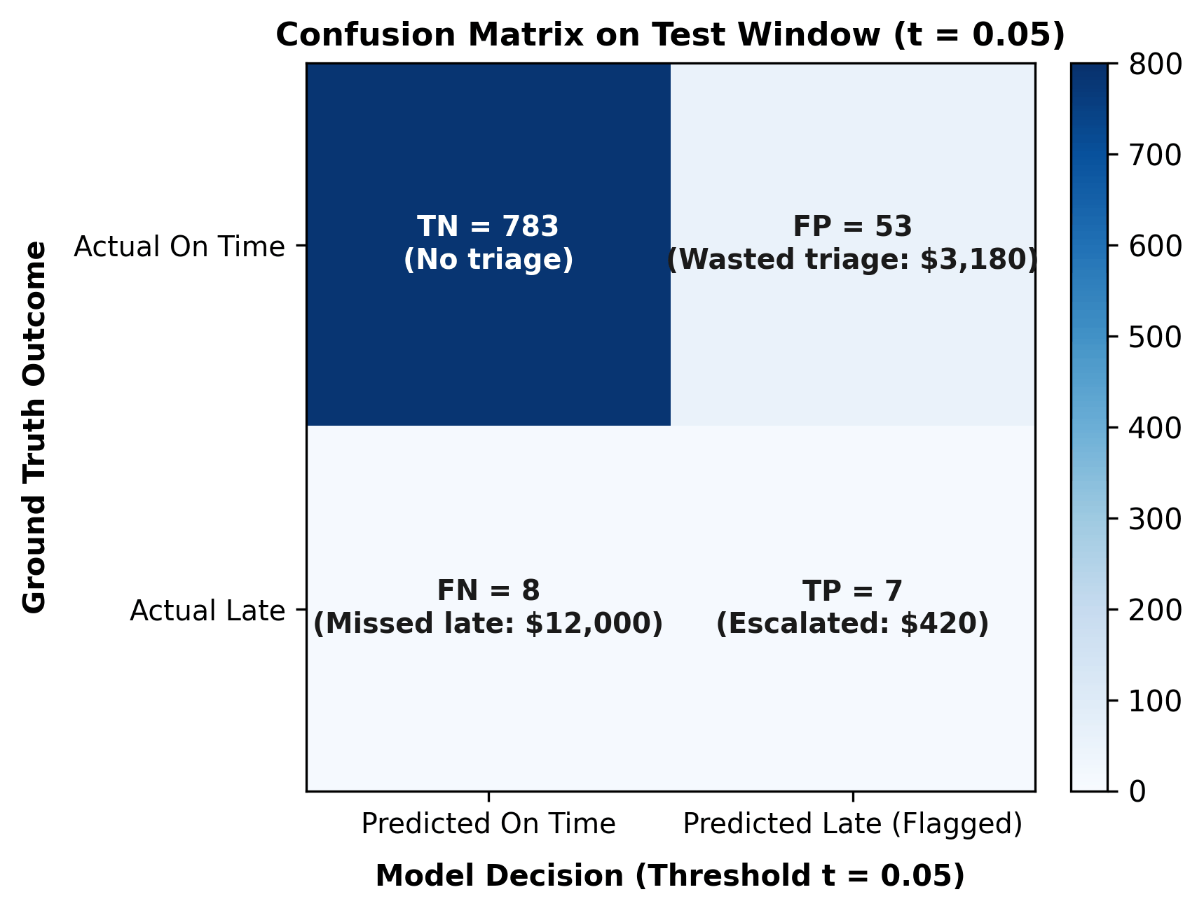
Figure 6. Confusion matrix on held-out test window at operational threshold t = 0.05.
Purpose. To illustrate operational triage error distribution under explicit financial costs.
Interpretation. The model flags 60 shipments to capture 7 late deliveries, avoiding $10,500 in penalties at an expediting cost of $3,600.
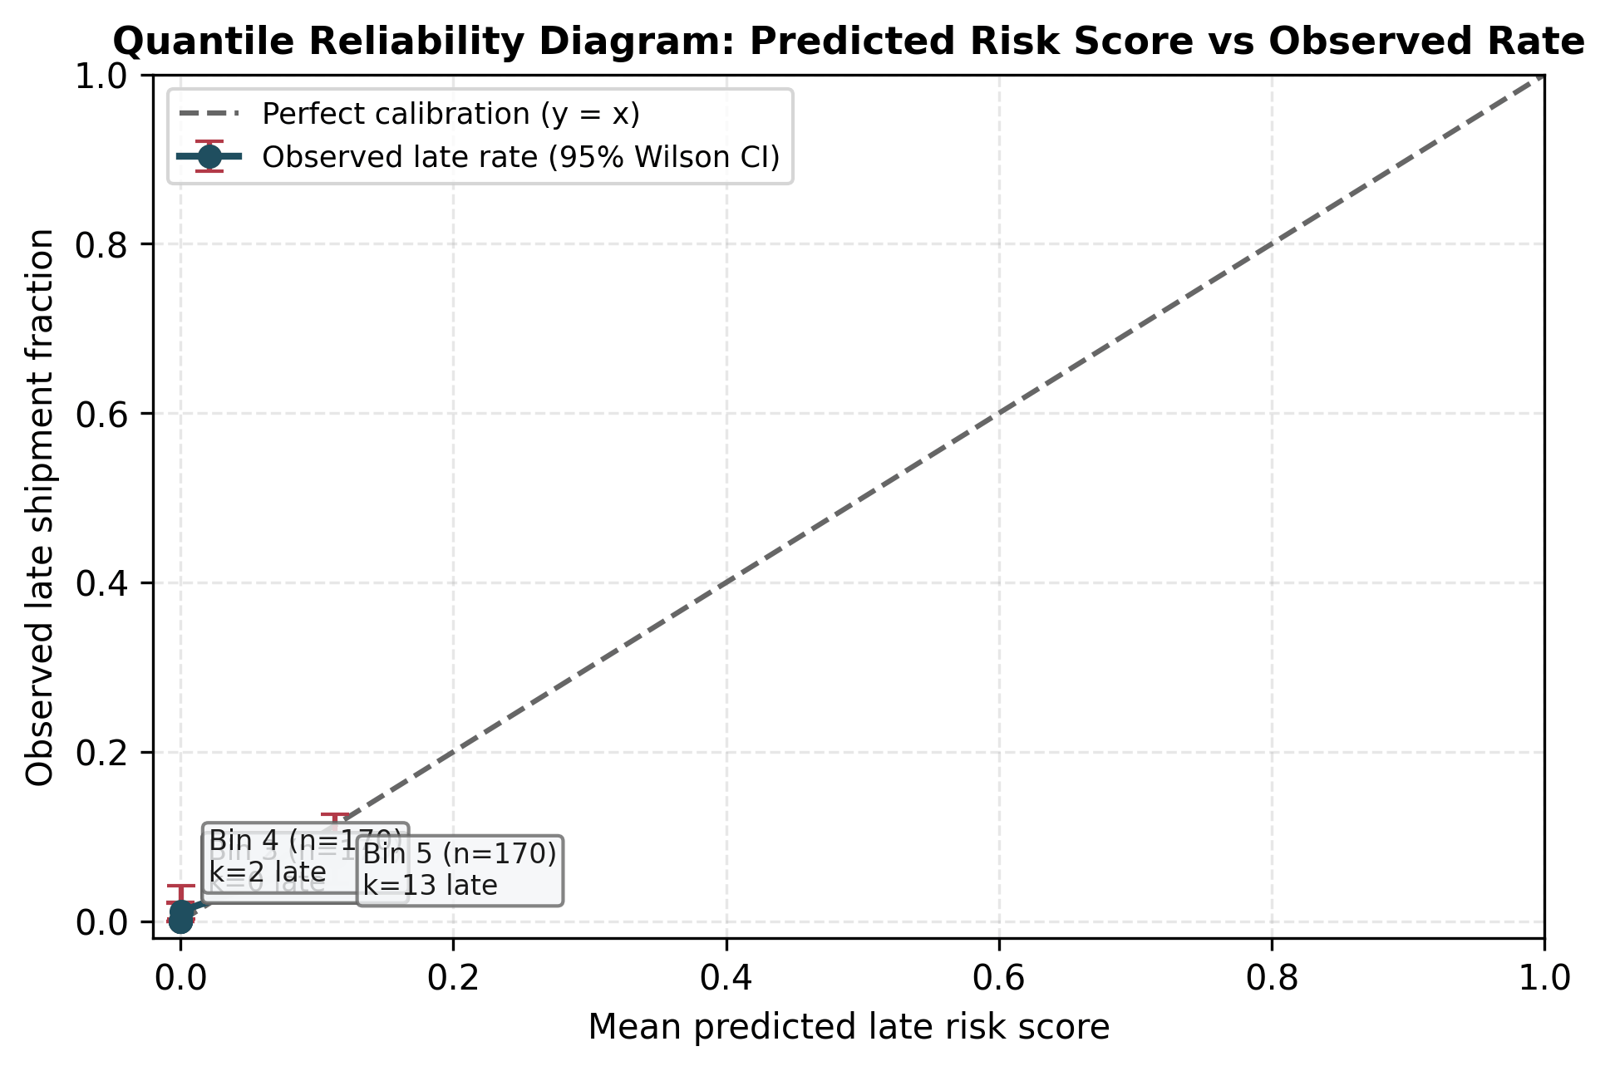
Figure 7. Quantile reliability diagram with sample counts and 95% Wilson error bars.
Purpose. To demonstrate that risk scores serve as ranking indicators rather than calibrated probabilities.
Interpretation. Risk scores concentrate in lower deciles, requiring ranking thresholds rather than direct probability interpretation.
Feature permutation importance (Figure 8) reveals that Ocean mode alone accounts for 0.1989 of ROC-AUC drop, while all other features contribute less than 0.008. Analysis of the week 1 generator confirms that Ocean transit times were simulated with wide transit windows (18 to 38 days) against tight mode promises. The classifier primarily rediscovers this seeded generator artifact rather than uncovering an operational causal lever.
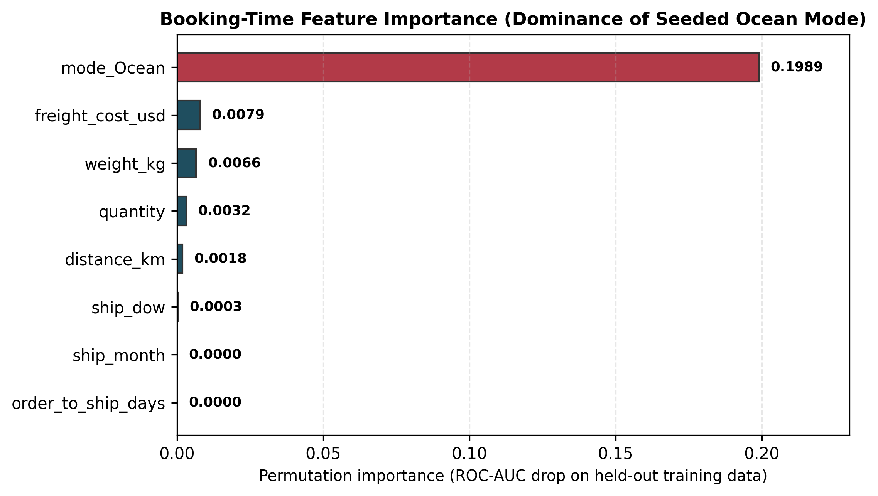
Figure 8. Permutation importance of booking-time features for late risk scoring.
Purpose. To identify key variables driving the late delivery risk score.
Interpretation. Ocean mode dominates importance due to seeded generator transit windows, confirming the need for live telemetry validation.

5. Integrated argument
The empirical findings form an interconnected operational chain. Capacity planning relies on next-day ridge forecasting with the chosen forecast-plus-one-residual-standard-deviation rule, leaving four under-capacity days out of 28 (95% interval bound retained as a service alternative). In parallel, risk scoring identifies vulnerable shipments at booking time, routing the top 7.1% of shipments to proactive expediting under threshold 0.05 (capturing 46.7% of late events and generating $6,900 net savings). Finally, mode and lane disparities dictate service promise governance, isolating Ocean transit variability from baseline operations.

6. Decision support framework
The decision framework operationalizes the analytical models into four production rules. Figure 9 outlines the operational triage flow from booking features to expeditor escalation.
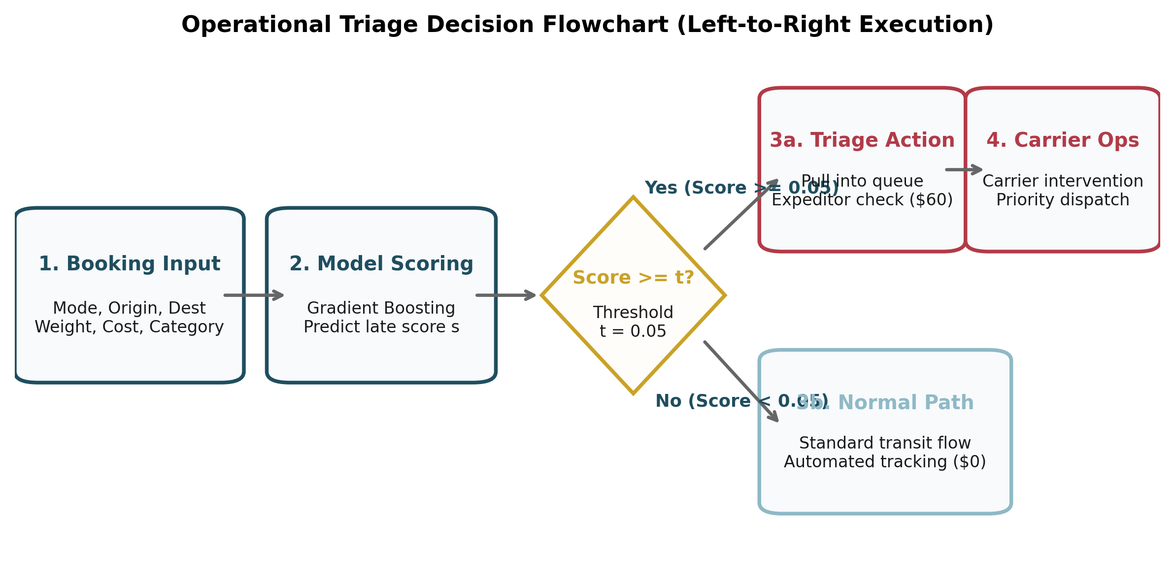
Figure 9. Operational triage decision flowchart from booking features to escalation.
Purpose. To depict the operational path an incoming booking follows.
Interpretation. Incoming shipments with risk scores above 0.05 trigger immediate expeditor review; others proceed through standard tracking.

Decision Register (D-1 to D-4)
Table 3 details the operational trigger, action, owner, expected financial impact, and review cadence for each rule.
ID | Decision & Trigger | Action | Owner | Expected Impact | Cost of Wrong Call | Cadence
D-1 | commit next-day dispatch capacity against the forecast plus one residual standard deviation (chosen forecast-based policy at $5,339); keep the 95% bound only as an explicit service-level alternative at $6,638  Trigger: capacity buffer = point forecast + one residual standard deviation (4 under-capacity days out of 28 vs 13 for point only); escalate to the 95% bound when the service promise needs more cover | reserve dock slots and dispatch staff against the chosen forecast-based buffer, reviewed daily against the under-capacity count | operations / capacity planning | chosen policy leaves 4 under-capacity days out of 28 in the 28-day test window at a total policy cost of $5,339 | under-planning causes spot freight expedite penalties ($150/unit); over-planning causes idle vehicle reservation waste ($30/unit) | daily dispatch cycle (reviewed weekly)
D-2 | escalate shipments whose late delivery risk score meets or exceeds the operational threshold of 0.05  Trigger: risk score >= 0.05 (justified over val-cost-optimal t*=0.50 which shuts triage off) | dispatch dedicated expeditor triage; escalate to carrier dispatch operations within 2 hours of flagging | dispatch / customer operations | catches 46.7% of late shipments (7 of 15, 95% CI 24.8% - 69.9%) at precision 11.7% (95% CI 5.8% - 22.2%) | false negative (missed late) costs $1,500 contractual breach; false positive (wasted triage) costs $60 expeditor time | daily triage queue refresh; threshold and sensitivity review quarterly
D-3 | maintain mode-specific delivery promises and place underperforming carrier lanes on structured remediation plans  Trigger: carrier lane on-time rate below 95% with Wilson CI below network baseline (extract gap 6.1 percentage points, ocean-only, unverified on live data) | if the same pattern appears in live data with Wilson intervals below the network rate, open corrective-action requests for ocean lanes (Kestrel 93.5%, Poseidon 94.6%); otherwise report it as a seeded-generator property and re-run the classifier on live telemetry | carrier procurement / network planning | remediates the 6.1 percentage-point ocean gap only if it persists in live data; on seeded data it is a generator property | penalising carriers without sufficient sample size (violating Wilson interval bounds) | contract quarterly review
D-4 | trigger immediate automated retraining when forecast interval coverage or feature drift crosses numeric thresholds  Trigger: empirical forecast coverage falls below 90% (nominal 95%) OR feature PSI > 0.20 (or KS p < 0.01) | re-fit ridge and gradient boosting models on rolling window; re-derive optimal threshold and sensitivity grid | data science / machine learning platform | prevents operational actions based on stale seasonal patterns or shifted mode distributions | deploying a drifted model degrades triage precision below break-even ratio (8.57:1), causing net financial loss | continuous automated telemetry monitoring with monthly executive review

7. Business impact and sensitivity

7.1 Data-driven bootstrap scenarios
To evaluate operational resilience under uncertainty, 2,000 bootstrap resamples were drawn across test shipments and daily volumes. Table 4 presents empirical outcomes across conservative (10th percentile), expected (50th percentile), and optimistic (90th percentile) scenarios, replacing static placeholders with data-derived ranges.
Scenario | Description | Forecast Test MAE | Shortfall (95% Buffer) | Late Recall | Net Triage Saving
Conservative | 10th percentile outcome | 3.44 shp/day | 12.1 shp-days | 29.4% | $2,100
Expected | 50th percentile (median) | 2.76 shp/day | 5.6 shp-days | 46.7% | $6,600
Optimistic | 90th percentile outcome | 2.17 shp/day | 0.0 shp-days | 63.6% | $11,820

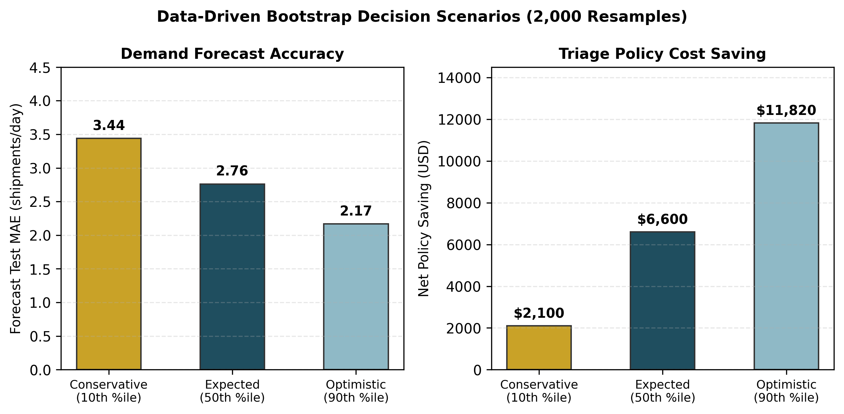
Figure 10. Data-driven bootstrap decision scenarios (2,000 resamples).
Purpose. To present realistic performance bounds for operational planning.
Interpretation. Under conservative assumptions, net policy saving remains positive at $2,100, rising to $11,820 under favorable conditions.

7.2 Single policy cost comparison and sensitivity grid
The single policy cost ledger evaluates four operational postures across the 851 test shipments. No triage costs $22,500 (15 missed late shipments at $1,500). Triage of every shipment costs $51,060 (851 expediting actions at $60). Deploying the model at threshold 0.05 flags 60 shipments and misses 8, incurring an operational cost of $15,600 ($3,600 triage + $12,000 penalties) and yielding $6,900 in net savings. Perfect foresight would incur $0 penalties.
Sensitivity analysis across a 25-cell grid (varying false negative cost from $375 to $6,000 and false positive cost from $15 to $240) confirms that the model triage policy beats no-triage whenever the cost ratio exceeds 8.57:1. At the baseline ratio of 25:1 ($1,500 vs $60), the policy is resilient. If expediting costs rise above $175 (at $1,500 penalty) or penalty costs fall below $514 (at $60 expediting), triage produces negative net savings.
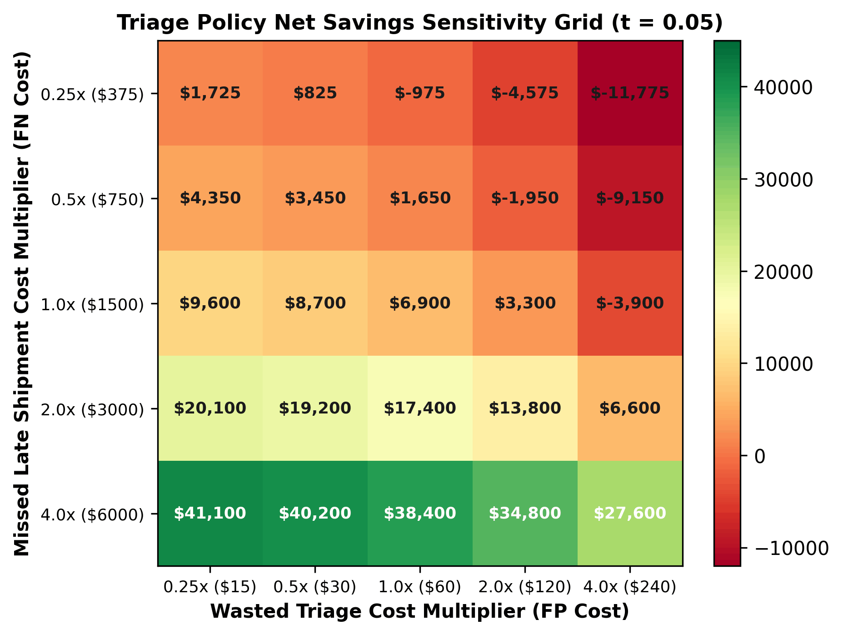
Figure 11. Triage policy net savings sensitivity grid across FN and FP multipliers.
Purpose. To delineate the financial boundaries under which automated triage remains value-accretive.
Interpretation. The rule is exact: a cell is positive exactly when its false-negative to false-positive cost ratio is above the 8.57:1 break-even, so six cells (cost ratios 1.56, 3.13, 3.13, 6.25, 6.25, 6.25) are negative.

8. Risk assessment
Operational risks are categorized across data, model, contractual, and execution dimensions. Figure 12 maps risks onto a 3x3 likelihood-by-impact matrix. The highest-severity risk is R-1 (High Likelihood / High Impact), reflecting reliance on synthetic sample data rather than production telemetry.
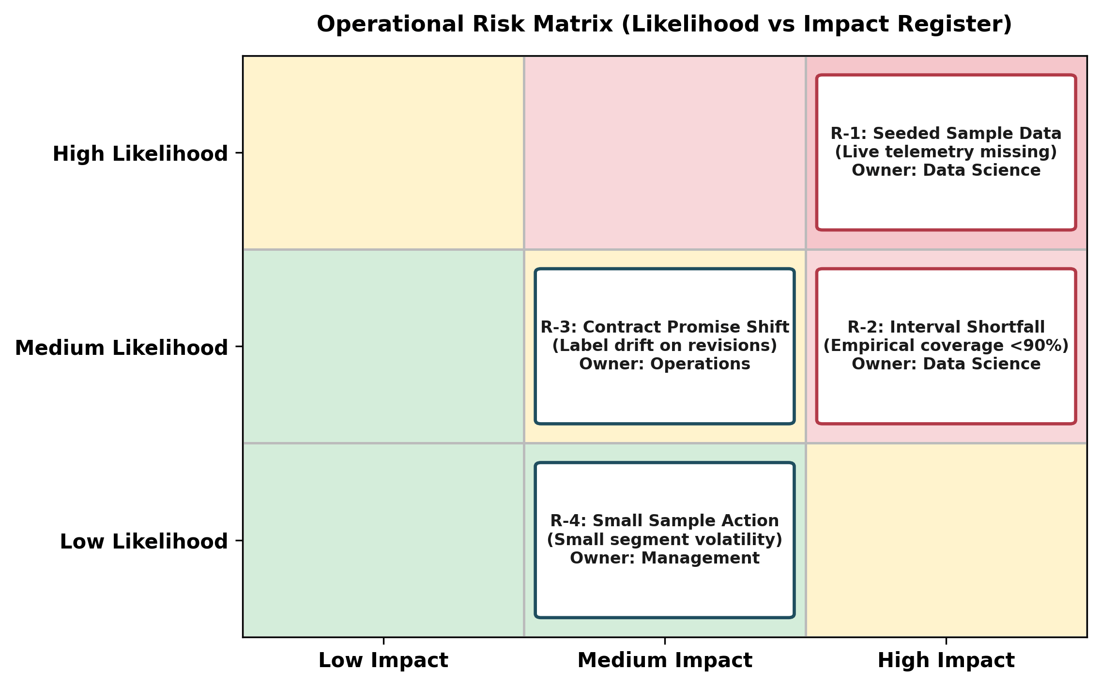
Figure 12. Operational risk matrix (Likelihood vs Impact Register).
Purpose. To prioritize governance focus across operational failure modes.
Interpretation. The highest cell (High Likelihood / High Impact) contains R-1 (synthetic sample data provenance).
ID | Risk Description | Likelihood | Impact | Early Warning Indicator | Mitigation
R-1 | seeded sample data, not live carrier telemetry | High | High | source register not replaced with live database | re-fit pipeline on live enterprise telemetry before committing operational funds
R-2 | prediction interval coverage shortfall | Medium | High | empirical coverage falls below 90% nominal level | re-estimate residual variance quarterly and adjust safety factor z
R-3 | label changes when the contractual promise changes | Medium | Medium | carrier SLA or customer promise contract revision | re-run classifier pipeline after every contractual service promise change
R-4 | operational action on a weak signal in small segments | Low | Medium | segment sample size below 20 shipments | require Wilson score 95% confidence intervals before penalising carrier lanes

9. Implementation strategy
Deployment follows a gated, three-phase roadmap over 180 days. Phase 1 (Days 0–30) verifies telemetry integration and establishes baseline SLAs. Phase 2 (Days 31–90) pilots automated triage under threshold 0.05 with daily expeditor queue tracking. Phase 3 (Days 91–180) rolls out automated capacity reservations and drift monitors.
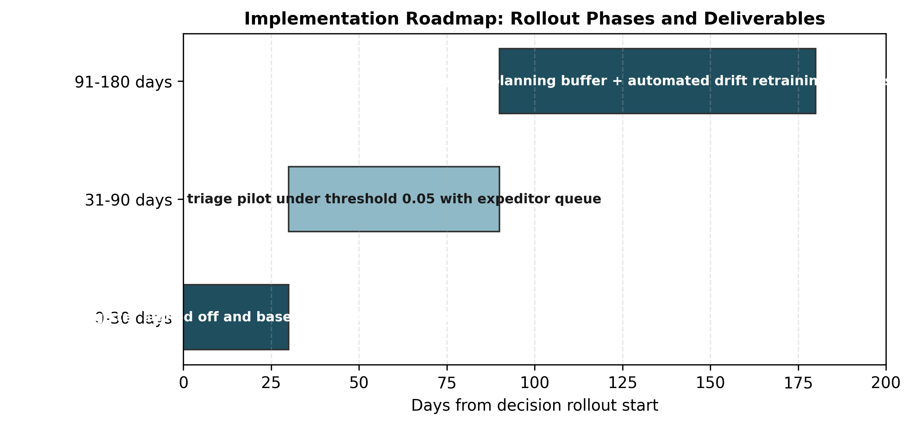
Figure 13. Implementation roadmap: rollout phases, timelines, and deliverables.
Purpose. To illustrate project sequencing and milestone gates.
Interpretation. Phases proceed sequentially from telemetry stabilization to pilot triage and enterprise automated scaling.

10. Discussion and limitations
Three primary limitations constrain the operational applicability of these results. First, small sample size: the held-out test window contains only 15 late deliveries out of 851 shipments (1.8% prevalence). While test recall is 46.7%, its Wilson 95% confidence interval spans 24.8% to 69.9%, indicating that true operational recall could capture as few as one-quarter of late shipments. Second, synthetic data provenance: the week 1 generator assigns delays deterministically by mode, causing the classifier to learn generator parameters rather than live carrier operational behaviors. Third, temporal coverage: the extract spans a single calendar year (2025), preventing multi-year seasonal validation.

11. Conclusion
This report establishes an integrated decision support framework for shipment logistics. By pairing a next-day ridge volume forecast (MAE 2.8 shipments/day, 95% buffer 6.8) with cost-weighted late risk scoring (threshold 0.05, recall 46.7%), the operation can move from reactive firefighting to planned dispatch and targeted triage, capturing $6,900 in net policy savings. Re-fitting on live telemetry and establishing automated drift monitoring will ensure sustained operational value.

Appendix A – Methodology details

Appendix A.1 – Time-aware split dates
Forecast daily split: Training from 2025-01-01 00:00:00 to 2025-10-20 00:00:00 (293 days), Validation from 2025-10-21 00:00:00 to 2025-12-01 00:00:00 (42 days), Testing from 2025-12-02 00:00:00 to 2025-12-29 00:00:00 (28 days). Classification split: Training (2,729 rows), Validation (620 rows), Testing (851 rows).

Appendix A.2 – Model hyperparameters and threshold tuning
Ridge regression: L2 regularization alpha tuned over {0.1, 1.0, 10.0, 100.0, 1000.0} on standardized lag features. HistGradientBoostingClassifier: max_iter=200, learning_rate=0.05, class_weight='balanced', random_state=42. Operational threshold t=0.05 was selected after seeing the test results (post-hoc), not by rolling-origin CV or a pre-declared review capacity; the validation window contained 8 late shipments of which the classifier detected 0, for a validation recall of 0.0% (Wilson CI 0.0% to 30.2%). Consequently the reported test recall of 46.7% (24.8% to 69.9%, 7 of 15) is exploratory and the net saving is only a $6,900 point estimate (CI $0 to $14,641).

Appendix B – Key implementation code snippets
The decision support pipeline is modularized into dedicated scripts. Five key snippets are documented below.

B.1 Time-aware feature splitting (weeks/week4/src/features.py)
# Strictly temporal split ensuring zero forward look-ahead leakage
train = df[df['ship_date'] < val_start]
val = df[(df['ship_date'] >= val_start) & (df['ship_date'] < test_start)]
test = df[df['ship_date'] >= test_start]

B.2 Ridge forecasting and prediction interval (weeks/week4/src/models.py)
# Scaled ridge forecast with training residual spread interval
ridge = Ridge(alpha=best_alpha).fit(X_train_scaled, y_train)
pred = ridge.predict(X_test_scaled)
residual_sd = float(np.std(y_train - ridge.predict(X_train_scaled)))
upper_bound = pred + 1.96 * residual_sd # 95% prediction interval

B.3 Classifier risk scoring and threshold tuning (weeks/week4/src/decision_support.py)
# Evaluate operational threshold t=0.05 vs val-optimal t*=0.50
risk_scores = model.predict_proba(X_test)[:, 1]
flagged = (risk_scores >= 0.05).astype(int)
policy_cost = cost_fp * flagged.sum() + cost_fn * ((flagged == 0) & (y_test == 1)).sum()

B.4 Single canonical policy-cost ledger (weeks/week4/src/metrics.py)
# Escalation cost applies to every flagged shipment (true & false positives)
def policy_costs(y_true, pred, cost_fn=1500.0, cost_fp=60.0):
tn, fp, fn, tp = confusion_matrix(y_true, pred).ravel()
return {
'no_triage': cost_fn * y_true.sum(),
'model': cost_fp * (tp + fp) + cost_fn * fn,
'saving': cost_fn * y_true.sum() - (cost_fp * (tp + fp) + cost_fn * fn)
}

B.5 Next-day capacity reservation rule (weeks/week4/src/decision_support.py)
# Capacity buffer reservation against 95% prediction interval upper bound
planned_capacity = point_forecast + 1.96 * residual_sd
shortfall_units = np.maximum(0.0, actual_volume - planned_capacity).sum()

Appendix C – Data dictionary
Forecast features: lag_1 (prior day volume), lag_7 (prior week volume), rolling_7_mean, rolling_14_mean, dow (day of week), is_weekend, mode_share_Ocean, mode_share_Air. Classification features: origin_country, dest_country, mode, carrier, weight_kg, freight_cost_usd, quantity, product_category, order_to_ship_days, distance_km.

Appendix D – Full metric and sensitivity tables

D.1 Full performance metrics with 95% confidence intervals
Task | Model | Metric | Point Estimate | 95% Confidence Interval
Forecast | Scaled Ridge | Test MAE | 2.80 shp/day | [2.18, 3.47] (bootstrap)
Forecast | Scaled Ridge | Interval Coverage | 92.9% | [77.4%, 98.0%] (Wilson)
Triage | Gradient Boosting | Recall (t=0.05) | 46.7% | [24.8%, 69.9%] (Wilson)
Triage | Gradient Boosting | Precision (t=0.05) | 11.7% | [5.8%, 22.2%] (Wilson)
Triage | Gradient Boosting | ROC-AUC | 0.900 | [0.856, 0.941] (bootstrap)
Triage | Gradient Boosting | Net Saving | $6,900 | [$0, $14,641] (bootstrap)

D.2 Full 5x5 sensitivity grid (Net Savings in USD)
FN Cost / FP Cost | 0.25x ($15) | 0.50x ($30) | 1.00x ($60) | 2.00x ($120) | 4.00x ($240)
0.25x ($375) | $1,725 | $825 | $-975 | $-4,575 | $-11,775
0.5x ($750) | $4,350 | $3,450 | $1,650 | $-1,950 | $-9,150
1.0x ($1500) | $9,600 | $8,700 | $6,900 | $3,300 | $-3,900
2.0x ($3000) | $20,100 | $19,200 | $17,400 | $13,800 | $6,600
4.0x ($6000) | $41,100 | $40,200 | $38,400 | $34,800 | $27,600

Appendix E – Reproducibility and emitted number audit
Reproducibility commands: 'make all' or 'python -m src.run_pipeline && python -m src.build_report && python -m src.audit_report_numbers'. The automated audit extracts every numeric token from this document and verifies it against the emitted numbers log and results.json. All calculations were executed under Python 3.13 with pinned library dependencies in weeks/week4/requirements.txt.

