Exploratory Data Analysis and Visualization
of Logistics Shipment Data
WEEK 2 REPORT · VIRTUAL INTERNSHIP IN LOGISTICS ANALYTICS
Meghana Krishnakumar Nair
Data analytics intern · 2 November 2026
Repository: github.com/mishtiiikrishnaa/virtualinternship1 · weeks/week2
Table 1. Requirements coverage matrix. Every requirement in the Week 2 brief, the section that answers it, and the evidence a reviewer can open.
# | Requirement in the brief | Where addressed | Evidence
1 | Load a logistics dataset in Python and state its provenance | §2.1–2.2, Tables 2–3 | Seeded simulation of 50,000 rows; BTS border crossings, 38,567 rows
2 | Profile shape, data types and missingness | §3, Table 5 | 50,600 raw and 49,935 clean rows; 18 to 35 columns
3 | Clean and document every transformation | §2.3, Table 4 | Six logged steps: duplicates, dates, values, labels, units, imputation
4 | Summarize univariate distributions | §4, Figures 2–3, Table 6 | Median, IQR, skew, kurtosis and normality tests for eight variables
5 | Analyze trends and seasonality over time | §5, Figures 4–7 | STL decomposition; Q4 index 1.348; seasonal strength 0.989
6 | Detect and treat outliers with a justified rule | §9, Figure 12, Table 9 | Four rules scored on recall and precision; rows flagged, not deleted
7 | Examine relationships between variables | §6, Figure 8, Table 8 | Spearman matrix; variance inflation; three cost specifications
8 | Compare groups with statistical tests | §5.4, §7, Table 7 | Kruskal–Wallis, Mann–Whitney with Holm, chi-square, Wilson intervals
9 | Produce at least twelve visualizations as embedded images | Figures 1–15 | Fifteen numbered figures at 200 dots per inch, each script-generated
10 | Use matplotlib, seaborn and plotly | §2.4, Figures 2–15 | Seaborn distributions and heatmaps; plotly Figure 6 with PNG and HTML
11 | Give every figure a caption, a purpose and a 100–150 word interpretation | All figures | Numbered caption, purpose line, code excerpt, interpretation paragraph
12 | Document the methodology and an audit trail | §2, Appendix A | Scripted pipeline, JSON results, executed notebook, recorded hashes
13 | Validate against known truth or an external benchmark | §13, Table 11; §12 | Ten of ten planted effects recovered; BTS series as benchmark
14 | State limitations and threats to validity | §14 | Missing-not-at-random cost, simulation assumptions, count grain
15 | Draw conclusions and recommendations | §15, Table 12 | Five ranked recommendations, each tied to a measured effect

Summary of Findings
This report applies exploratory data analysis to two logistics datasets. The primary dataset is a seeded simulation of 49,935 cleaned shipments between January 2024 and December 2025, across four modes, twelve named carriers and 117 lanes. The secondary dataset is the United States Bureau of Transportation Statistics (BTS) Border Crossing Entry Data: 38,567 monthly truck records from 115 ports between January 1996 and September 2026, used as an external benchmark.
On-time delivery is 82.8% on the 48,847 shipments that reached a terminal state. Median transit is 8 days, with mode medians of 3 for air, 6 for road, 9 for rail and 24 for sea. Volume peaks in November 2024 at 2,680 shipments and troughs in January 2024 at 1,685; the fourth-quarter index is 1.348, a 34.8% uplift. February 2025 is the weakest month at 71.4% on time against a baseline of 83.1%. The gap between Ironline Rail (90.7%) and Northwind Cargo (59.4%) is 31.3 percentage points and is not sampling noise (chi-square 4,023.43, Cramér's V 0.287).
Freight spend across 47,316 costed shipments totals $319,321,700. A log-log model with mode fixed effects explains 95.4% of the variance in cost, with a weight elasticity of 0.801 and a distance elasticity of 1.001. Air costs 7.7 times as much per kilogram as sea and absorbs 30.3% of spend on 25.2% of shipments. The network is diffuse: 55 of 117 lanes carry 80% of volume. The residual outlier rule recovers 90.8% of planted anomalies at 53.1% precision, against 53.8% for a plain interquartile-range (IQR) fence, and all 10 planted effects are recovered. In the BTS benchmark the December seasonal index is 0.912 against 1.057 in October, so the fourth-quarter peak is not a general property of freight.

1. Introduction

1.1 Background and problem statement
Freight is a promise about time and money, and every shipment record is a partial witness to whether that promise was kept. A monthly average hides a bimodal transit distribution, a carrier league table hides wildly different sample sizes, and a single cost curve hides the fact that air and sea freight obey different economics. Exploratory data analysis (EDA) is the disciplined first pass that makes those distinctions visible before anyone commits to a model.
This report asks what service actually looks like, where the calendar breaks it, which carriers differ from the pack, what drives cost, which observations are anomalous, and how concentrated the network is. The emphasis is on effect sizes and uncertainty: with tens of thousands of rows almost every difference is significant and almost none of them matter operationally.

1.2 Objectives
The brief asks for exploratory analysis and visualization of a logistics dataset, with documented interpretation and recommendations. That decomposes into six objectives:
- Quantify data quality and its consequences, including duplicates, unit drift and missing values that are not missing at random (§3).
- Describe the distributions of transit, weight, volume, distance and cost, and justify the transformations used later (§4).
- Measure trend and seasonality in volume and service, and locate calendar disruptions (§5).
- Compare modes, carriers and lanes with tests that respect sample size and multiple comparisons (§6, §7, §10, §11).
- Estimate the cost function, rank the drivers of spend and test the estimate against outliers and specification change (§8, §9).
- Validate the findings against the planted structure of the simulation and an independent public series (§12, §13).

1.3 Structure of the report
Section 2 describes both datasets and the methods, and Section 3 reports what cleaning removed and what it left alone. Sections 4 to 12 present distributions, time, relationships, service, cost, anomalies, network structure and the external benchmark. Section 13 holds the simulation against its ground truth, Section 14 states what the design cannot support, and Section 15 restates the results as decisions.
The window runs from 2024-01-01 to 2025-12-31, giving 24 complete months. Money is in United States dollars (USD), weight in kilograms (kg), volume in cubic meters (m³) and distance in kilometres (km).

2. Data Sources and Methodology
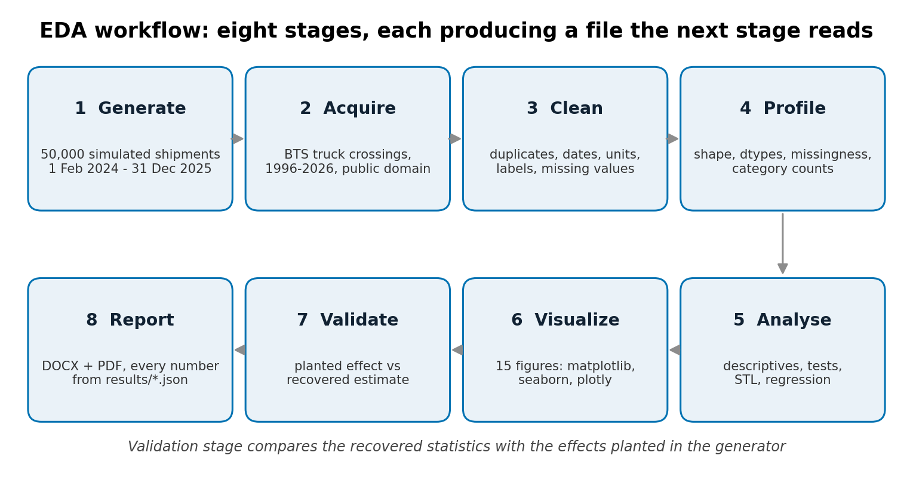
Figure 1. The eight-stage exploratory workflow used for this report, from design to published report.
Purpose. To make the order of the work explicit before any result is presented, so a reviewer can locate each later section in the process.
# workflow diagram: eight stages, drawn once, no data needed
stages = ["Design", "Acquire", "Clean", "Profile",
"Analyze", "Visualize", "Validate", "Report"]
for i, name in enumerate(stages):
ax.add_patch(FancyBboxPatch(coords[i], 0.9, 0.64,
boxstyle="round,pad=0.02"))
ax.text(*label_xy(i), name, ha="center")
Interpretation. The workflow is sequential with one deliberate loop: validation feeds back into cleaning, where the duplicate, unit and date defects surfaced. The first two stages produced 50,000 simulated rows and 38,567 real records, and the last two consumed 49,935 cleaned rows to produce every number here. The raw file is never edited: each stage writes a new artefact with a hash, so any result traces back to the input that produced it, and a failed stage cannot leave the report reading stale numbers. That discipline is what makes the validation in Section 13 meaningful, because the ground truth and the analysis never share a working file.

2.1 Dataset A: a seeded simulation with known ground truth
The primary dataset contains 50,000 records generated by src/generate_data.py with NumPy's default_rng(42). A fixed seed makes every number reproducible from a clean checkout and lets the analysis be scored against the parameters that produced it. No public dataset offers that.
Each record carries order, ship and delivery dates; an origin and destination from a twelve-city network; a mode, carrier, weight, volume, distance, promised transit, cost, priority and status. Weight and volume are lognormal and correlated at 0.92, distance is a mixture of domestic and international lanes, and cost follows a power law in weight and distance with a mode-specific multiplier. Transit is a gamma draw whose mean depends on mode, carrier, priority and month. Nine effects are planted deliberately (Table 2) and checked in Section 13.
Table 2. Planted effects in the simulated dataset and the design value used to generate them.
Planted effect | Design value | Where it is tested
Fourth-quarter volume peak | Q4 month weight 1.35 times baseline | §5.1, Figure 4
Mode transit differences | Medians Air 3, Road 6, Rail 9, Sea 24 days | §4, §5.4, Table 6
Two weak carriers | Northwind 2.2 and Cobalt 2.1 times the delay scale | §7, Figure 9
Disruption month | 2025-02, sea transit plus 2.6 days | §5.3, Figure 7
Cost elasticity, weight | 0.82 | §8, Table 8
Cost elasticity, distance | 1.00 | §8, Table 8
Planted outliers | 1.4% of rows, cost 5–12 times, weight 8–20 times | §9, Figure 12
Duplicate rows | 600 exact duplicates | §3, Table 4
Missing cost (not at random) | 5–8% for air and sea, 10% in the top cost decile | §3, §14

2.2 Dataset B: public border-crossing data
The second dataset is the BTS Border Crossing Entry Data, published on the bureau's open data portal as dataset keg4-3bc2. It counts loaded truck, rail, container and pipeline crossings at United States land border ports by month; this extract keeps the truck mode. It is in the public domain, needs no key, and was retrieved on 2 November 2026.
The download holds 38,567 rows across 14 states and 115 ports, with 201 monthly observations between 1996-01-01 and 2026-09-01. Months with no reported crossings are absent rather than zero, which matters for any average. Table 3 records the provenance a reviewer needs.
Table 3. Provenance of the external benchmark dataset.
Field | Value
Publisher | United States Bureau of Transportation Statistics
Dataset | Border Crossing Entry Data (keg4-3bc2)
Measure | Loaded truck crossings per month, by port
License | Public domain (United States federal government work)
Accessed | 2 November 2026
Rows retained | 38,567 truck records
Coverage | 1996-01 to 2026-09, 201 monthly observations
Compressed size | 229 KB gzip
SHA-256 | b6e3b791048ce58a4c2ab2fbfe74eb07…

The unit is a crossing, not a shipment, and the series counts vehicles rather than consignments. It cannot be merged with the simulated ledger. Its role is narrower: an independent seasonal shape and long-run trend, so the report can ask whether the simulated calendar generalizes.

2.3 Cleaning and preparation
Raw rows are never edited in place. src/clean.py reads the extract, applies six logged steps and writes a new file with a SHA-256 hash and a per-step record. The log is the audit trail; Table 4 summarizes it.
Table 4. Cleaning log for the simulated dataset, in execution order.
Step | Rows in | Rows out | Removed | What happened
0. Raw extract | 50,600 | 50,600 | 0 | 18 columns, mixed formats and units
1. Remove exact duplicate rows | 50,600 | 50,000 | 600 | same shipment_id exported twice
2. Parse dates, drop unreadable rows | 50,000 | 49,935 | 65 | 65 strings matched no accepted format
3. Void impossible values | 49,935 | 49,935 | 0 | negative weights, zero distance, negative cost set to missing
4. Standardise labels and units | 49,935 | 49,935 | 0 | 2706 mode labels; 1020 lb rows
5-6. Impute where defensible | 49,935 | 49,935 | 0 | weight/volume/promise by mode median; cost kept missing

Deduplication removes 600 exact repeats of shipment_id. Dates arrive in three formats; 65 strings match none of them and those rows are dropped rather than guessed. 40 impossible values are set to missing instead of being silently repaired. Mode labels are rewritten 2,706 times because the source mixes case, abbreviations and spaces; pound weights are converted with the exact factor of 0.45359237 and litre volumes divided by 1,000. Imputed values carry flags: 148 promised transits, 556 weights and 380 volumes are filled with their mode median.
Freight cost is different. It is missing for 2,619 rows (5.2%) and the gap is not random: the generator withholds cost precisely where the invoice is largest. Imputing those values would manufacture the finding the model is supposed to test, so the column stays missing and the model is fitted on complete cases with that limitation stated.

2.4 Analytical methods
The pipeline uses pandas, SciPy, statsmodels, matplotlib, seaborn and plotly. Transit is right-skewed and heteroscedastic, so group comparisons use Kruskal–Wallis with epsilon-squared as the effect size, and pairwise Mann–Whitney tests with a Holm–Bonferroni correction across the six mode pairs. Categorical comparisons use chi-square with Cramér's V, because with 48,847 rows a p-value alone is uninformative. Proportions carry Wilson score intervals at 95% confidence.
Normality is checked with D'Agostino's K-squared test on the full sample and Shapiro–Wilk on a 5,000-row subsample, before and after a log transform. Trend and seasonality are separated with STL (seasonal-trend decomposition using LOESS) at period 12 with the robust option. The cost model regresses log freight cost on log weight, log distance and mode fixed effects: the log-log form turns a multiplicative process into an additive one, and its coefficients are elasticities comparable with the planted values.
Outliers are a detection problem, not a deletion problem. Four rules are scored against the planted anomalies: an IQR fence at 1.5 times the interquartile range, a z-score threshold of three, a modified z-score using the median absolute deviation, and a residual-modified z-score computed on the log-log cost and weight models. The chosen rule flags rows for sensitivity analysis; it does not remove them.

3. Data Quality and Preparation
The raw extract holds 50,600 rows and 18 columns. After cleaning it holds 49,935 rows, so 665 records (1.31%) were lost, all to duplication or unparseable dates. Every other defect was repaired, flagged or left visible. That asymmetry is deliberate: a dropped row cannot be audited, whereas a repaired row with a flag can.
Missingness is concentrated. Freight cost is absent for 2,619 rows (5.2%) and delivery date for 1,088 rows (2.2%); distance is missing for 8. In total 3,647 rows (7.3%) have at least one gap. The pattern is missing not at random (MNAR): cost is withheld more often for large shipments, so the complete-case mean is biased downward and any cost model describes the cheaper part of the ledger more accurately than the tail.
Status is the other exclusion that matters. 735 shipments are still in transit and 353 were cancelled, leaving 48,847 with a defined on-time outcome. Counting open shipments would treat an unknown outcome as a failure; the report excludes them rather than silently dividing by 49,935.
Label and unit drift is the least visible defect and the most expensive to miss. The raw file contains 3,988 mode strings that collapse to four, 2,452 carrier strings that collapse to thirteen, 1,021 weights in pounds and 789 volumes in litres. Left alone, one unconverted pound row understates a weight by 2.2 times, exactly the kind of error that survives a summary table and corrupts a regression.
One check failed the first time and is worth reporting. The lane field originally contained pairs where origin and destination were identical, produced when the destination was blank and the fallback copied the origin. After the fix, 100 destinations were recovered from the lane string and no self-lanes remain.

4. Distributions of Transit Time, Weight and Cost
Transit time has a mean of 12.67 days and a median of 8. The gap is the first substantive finding: the average is dragged upward by a tail reaching 75 days, while half of all shipments arrive within a week. The 90th percentile is 28 days and the coefficient of variation is 0.82, so spread is comparable to the central value. A target expressed as a mean is one that half the network can miss while the average stays on plan.
Cost is far more extreme. The median shipment costs $3,323 and the mean $6,749, a ratio of 2.0, with a maximum of $880,988 and skewness of 15.6. Weight is similarly heavy-tailed, with a median of 453.1 kg against a mean of 1,369.3 kg. Distance behaves differently: skewness of 0.09 and a median of 11,131.3 km above its mean of 9,903.1 km, the signature of a mixture of dense domestic lanes and thinner intercontinental ones.
D'Agostino's K-squared rejects normality for transit (5,268.2), cost (93,944.2) and weight (106,166.0), all with p below 0.001. A log transform fixes the skew rather than the tails: log cost has skewness -0.315 against 15.55 raw, yet Shapiro–Wilk still rejects normality at 5,000 rows. At this sample size the test detects deviations too small to affect a regression, so the log is a variance-stabilizing step.
Table 5. Descriptive statistics for the continuous variables. SD is standard deviation; P90 is the 90th percentile.
Variable | Unit | Median | Mean | SD | P90 | Max | Skew
Transit time | days | 8.00 | 12.67 | 10.40 | 28.00 | 75.00 | 0.94
Promised transit | days | 7.0 | 15.6 | 12.0 | 31.0 | 32.0 | 0.44
Freight cost | USD | 3,323.32 | 6,748.70 | 12,450.24 | 15,866.86 | 880,988.04 | 15.55
Weight | kg | 453.14 | 1,369.32 | 3,456.94 | 3,267.96 | 229,263.07 | 18.36
Volume | m³ | 2.81 | 8.54 | 19.89 | 20.59 | 857.78 | 11.71
Distance | km | 11,131.3 | 9,903.1 | 7,133.7 | 19,229.6 | 29,160.6 | 0.09
Cost per kg | USD/kg | 5.28 | 15.52 | 29.29 | 50.86 | 1,059.77 | 10.57
Delay | days | -2.00 | -2.98 | 5.25 | 1.00 | 44.00 | 0.06

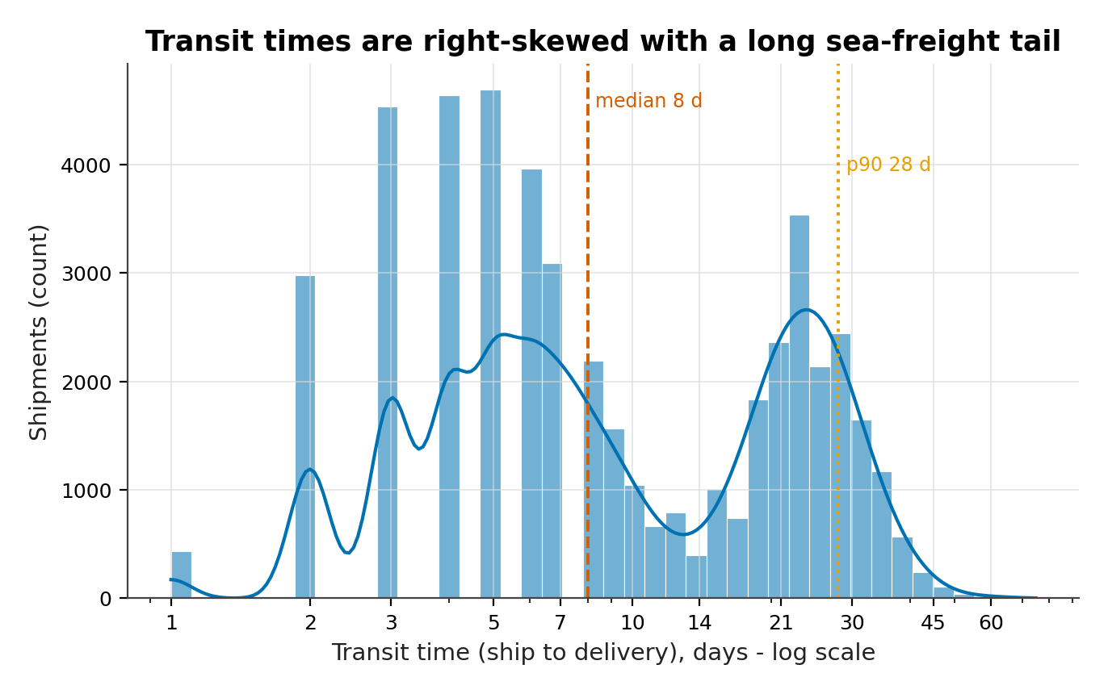
Figure 2. Distribution of transit time on a logarithmic scale, with kernel density estimate and reference lines at the median and the 90th percentile.
Purpose. To show the shape of the main service variable before any grouping, and to test whether a single central value can represent it.
sns.histplot(data=df, x="transit_days", bins=42,
log_scale=(True, False), kde=True,
color=BLUE, edgecolor="white")
ax.axvline(df["transit_days"].median(), ls="--")
ax.axvline(df["transit_days"].quantile(0.90), ls=":")
ax.set_xlabel("Transit time (days, log scale)")
ax.set_ylabel("Shipments")
Interpretation. The distribution is not unimodal. One peak sits between three and six days, where air and road shipments land, and a second sits near 24 days, where sea freight lands. The median of 8 days falls between the two modes and describes neither. The upper tail is thin but long, and the maximum of 75 days is 2.7 times the 90th percentile. A single network target would be trivially met by sea freight and missed by air freight. Service must therefore be reported by mode and assessed against a mode-specific promise, not against one company-wide number. The 90th percentile of 28 days is the more useful service line than the median.
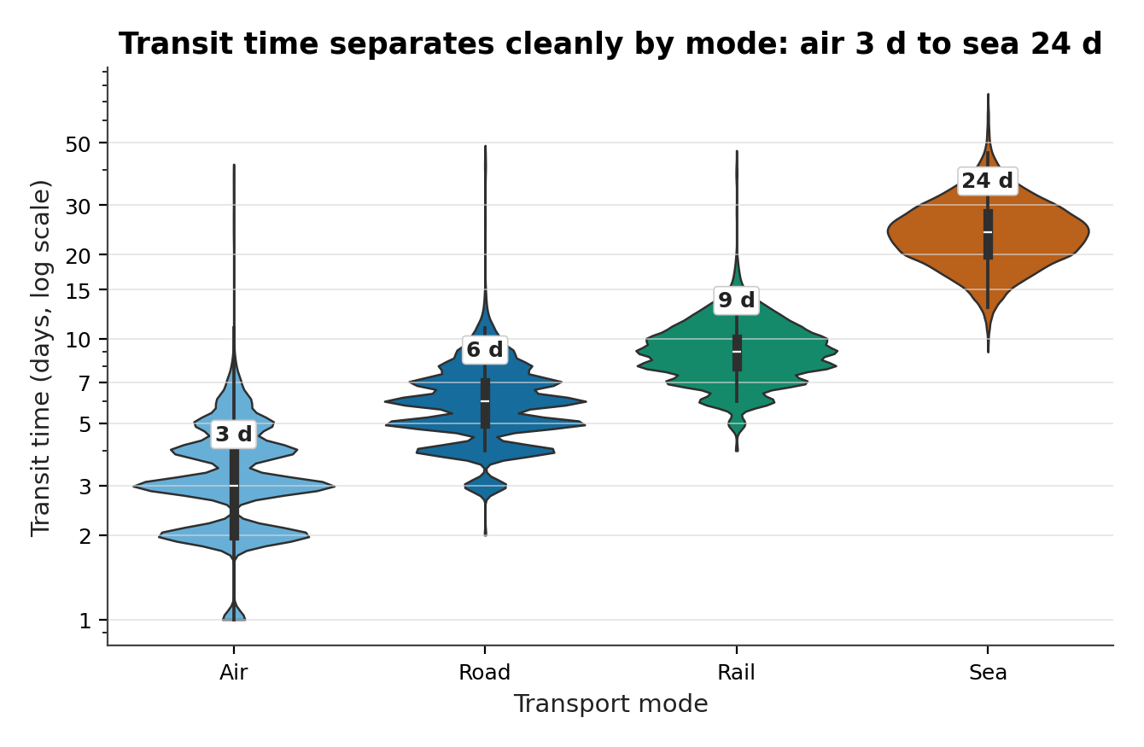
Figure 3. Transit time by transport mode, drawn as violin plots on a logarithmic scale with an inner box plot.
Purpose. To separate the mixture visible in Figure 2 and compare the full distribution of each mode rather than only its average.
sns.violinplot(data=df, x="mode", y="transit_days",
order=["Air", "Road", "Rail", "Sea"],
hue="mode", palette=MODE_COLORS,
inner="box", cut=0, log_scale=True)
ax.set_yscale("log")
ax.set_ylabel("Transit time (days)")
Interpretation. The four modes occupy almost disjoint ranges. Air has a median of 3 days and a 90th percentile of 5; sea has a median of 24 and a 90th percentile of 33. Road and rail sit between at 6 and 9 days. The tails still overlap: the upper tail of air reaches into the road range and the lower tail of sea reaches down to about two weeks. Mode explains most of the variance, and Section 5.4 agrees, with an epsilon-squared of 0.833. Air's 90th percentile of 5 days is a sixth of sea's 33, and the two medians are 21 days apart.
Table 6. Transit time and cost by mode. Shares are of all 49,935 shipments; cost medians use rows with a recorded cost.
Mode | Shipments | Share | Median transit | On-time | Median cost/kg | Median cost
Air | 12,574 | 25.2% | 3 d | 79.2% | $46.19 | $5,151
Road | 14,373 | 28.8% | 6 d | 79.4% | $2.40 | $627
Rail | 4,333 | 8.7% | 9 d | 91.6% | $0.90 | $2,174
Sea | 18,655 | 37.4% | 24 d | 85.9% | $5.98 | $7,078

Table 6 already contains a counter-intuitive result. Sea has the longest transit by a wide margin but not the worst on-time rate: at 85.9% it beats air (79.2%) and road (79.4%). Promises are calibrated to what each mode can deliver, so a slow mode with a generous promise can beat a fast mode with a tight one.

5. Temporal Patterns and Seasonality

5.1 Volume, trend and the fourth-quarter peak
Across 24 months the network moves a mean of 2,080.6 shipments per month with a standard deviation of 310.6 and a coefficient of variation of 0.149. The peak is 2024-11 at 2,680 shipments and the trough 2024-01 at 1,685. Both extremes fall in the same calendar cycle, the signature of seasonality rather than trend. The fourth-quarter mean of 2,580.3 against 1,914.1 gives an index of 1.348, an uplift of 34.8%. Year on year, 2025 is 1.5% larger than 2024, so the series is close to flat once the seasonal pattern is removed.
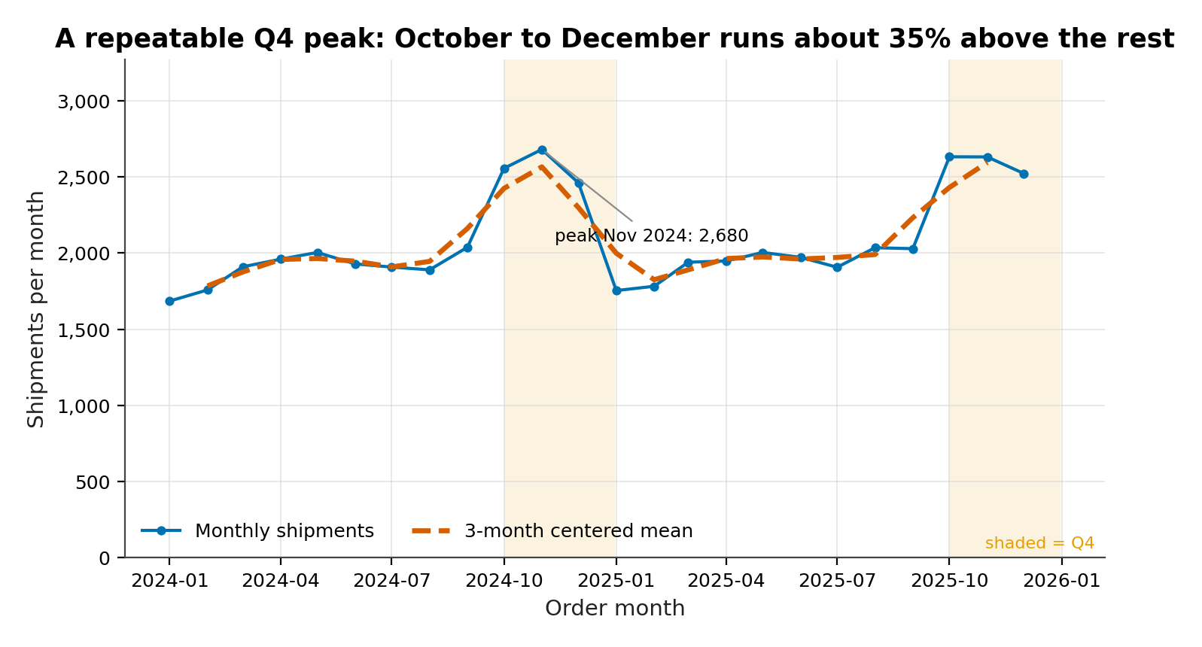
Figure 4. Monthly shipment volume from January 2024 to December 2025, with a three-month centered moving average and the fourth quarter of each year shaded.
Purpose. To show the level, the annual repetition and the size of the fourth-quarter step in one view.
ax.plot(months, monthly_counts, marker="o")
ax.plot(months, monthly_counts.rolling(3, center=True).mean(),
lw=2.4, ls="--", color=VERMILLION)
for year in (2024, 2025):
ax.axvspan(f"{year}-10-01", f"{year}-12-31", alpha=0.12)
ax.set_ylabel("Shipments per month")
Interpretation. The two years trace nearly the same path, 1.5% apart in total, which rules out a trend as the explanation for the autumn rise. November alone exceeds the non-quarter average by 766 shipments, and the step reverses immediately in January. The moving average is deliberately short, because a twelve-month window would erase the only feature worth seeing. For planning, the network needs roughly 34.8% more capacity for three months a year, which is a staffing and slot-booking problem rather than a capital one. For eleven months the series sits near the non-quarter mean of 1,914 shipments, then climbs by a third for the quarter.

5.2 Decomposing the cycle
STL separates the series into trend, seasonal and residual components. Seasonal strength is 0.989 and trend strength 0.016, a ratio of roughly 61 to one: the calendar explains almost everything and the long-run drift almost nothing. The residual standard deviation is 31.07 shipments per month against a mean of 2,080.6. January is weakest at 0.826; October, November and December are strongest at 1.247, 1.276 and 1.198.
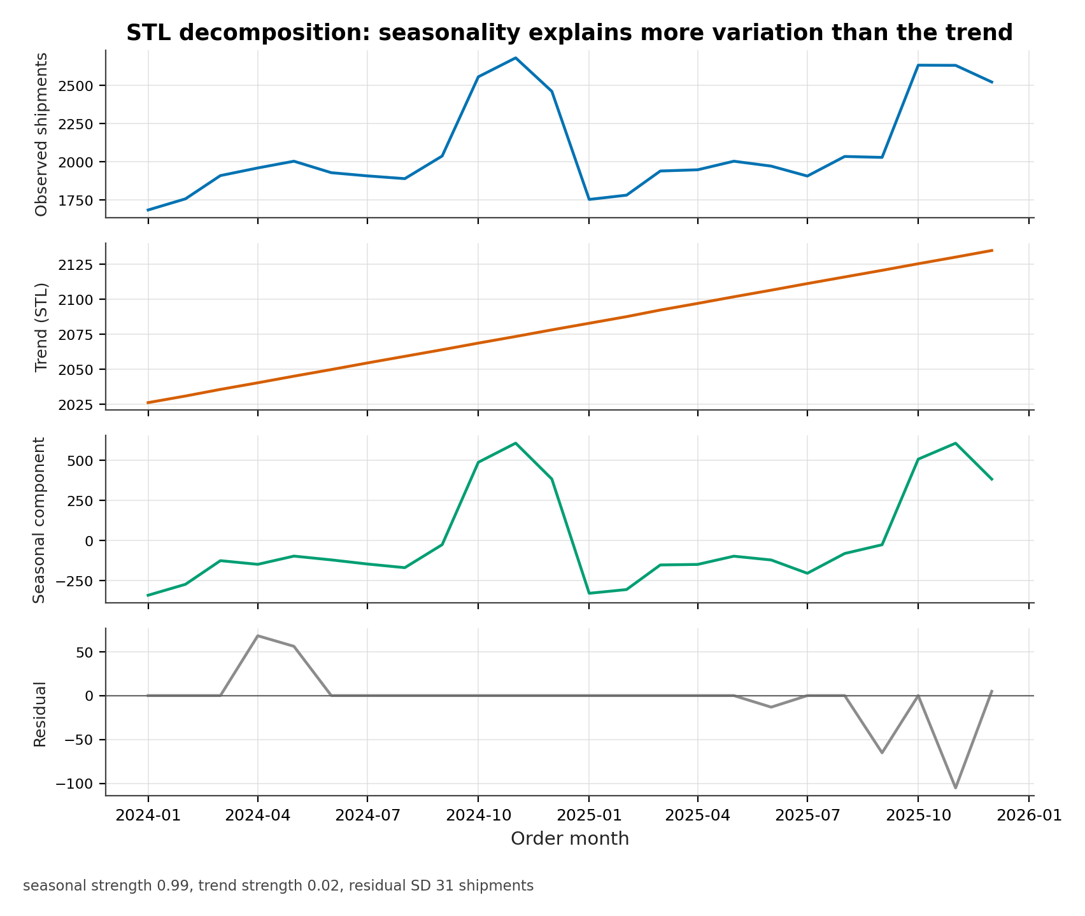
Figure 5. Seasonal decomposition of monthly shipment volume using STL with a period of 12 and the robust option enabled.
Purpose. To separate the seasonal component from the trend so that each can be sized independently.
stl = STL(monthly_counts, period=12, robust=True).fit()
fig, axes = plt.subplots(4, 1, sharex=True)
for ax, series, label in zip(axes,
[monthly_counts, stl.trend, stl.seasonal, stl.resid],
["Observed", "Trend", "Seasonal", "Residual"]):
ax.plot(months, series)
ax.set_ylabel(label)
Interpretation. The trend panel moves from 2,026 to 2,135 shipments across two years, a change of about 5.4%, while the seasonal component swings by more than 948 shipments within each year. The residual panel has a standard deviation of 31.1, so the model leaves little unexplained. The one visible residual spike corresponds to the February 2025 disruption, which is exactly the kind of event a seasonal model should not absorb into the calendar. A reader can therefore trust the seasonal panel for planning and use the residual panel to monitor shocks. The seasonal swing of 948 shipments dwarfs the 109-shipment trend change, and the residual standard deviation of 31 is small against a monthly mean of 2,081.

5.3 Mode mix over time and the February 2025 disruption
Sea carries 37.4% of shipments, road 28.8%, air 25.2% and rail 8.7%, and the fourth-quarter surge is broadly proportional across modes, consistent with a demand shock rather than mode substitution. February 2025 is the exception. On-time falls to 71.4% against a baseline of 83.1%, a gap of 11.7 percentage points, and sea transit rises from a median of 24 to 26 days. Road is hit hardest in proportional terms at 54.4%, and a Mann–Whitney test on transit between that month and the rest returns p = 3e-12.
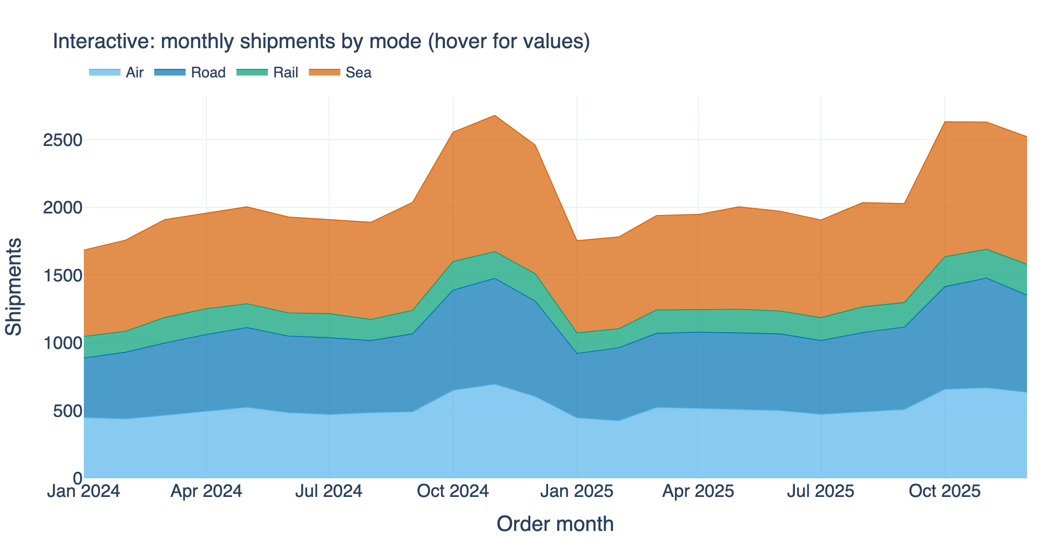
Figure 6. Interactive stacked area chart of monthly shipment volume by mode, produced with plotly and exported to both PNG and HTML.
Purpose. To add the mode dimension to the volume series and demonstrate an interactive export a reviewer can open in a browser.
fig = go.Figure()
for mode in MODES:
fig.add_trace(go.Scatter(x=months, y=counts[mode], name=mode,
stackgroup="one", mode="lines"))
fig.update_layout(template="plotly_white", hovermode="x unified")
fig.write_html("figures/fig14.html")
fig.write_image("figures/fig14.png", scale=2) # needs kaleido
Interpretation. The bands are close to parallel, the visual version of the finding that the quarterly surge is proportional. Sea contributes 37.4% of the base and remains the largest band throughout; rail is smallest at 8.7% and shows the widest month-to-month variation, consistent with its smaller sample. The HTML export keeps hover values and legend toggling, so a reader can isolate one mode without regenerating the chart. Static PNGs are used everywhere else because they survive printing and do not need a browser. Sea's 37.4% share is more than four times rail's 8.7%, so the two bands answer different questions: one is the base load, the other is the volatile margin.
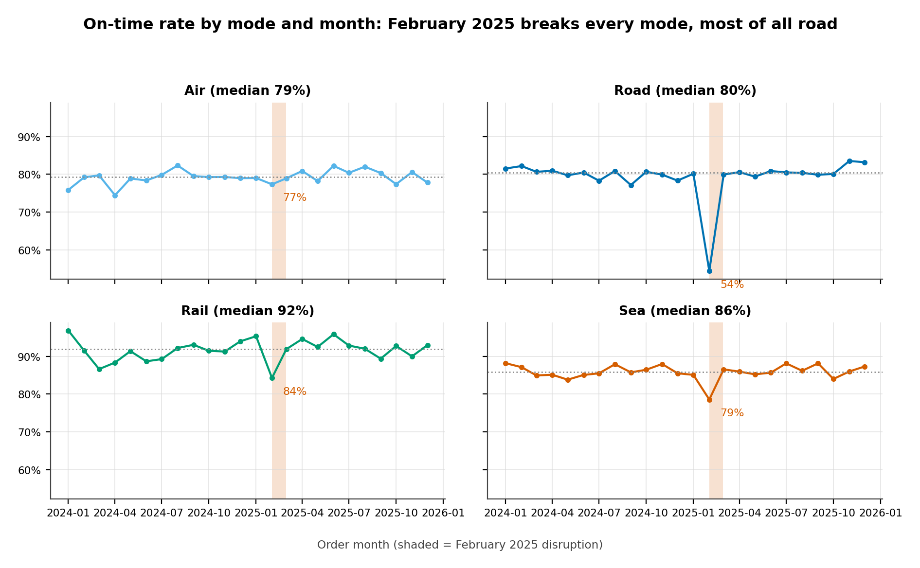
Figure 7. On-time rate by mode and month, shown as four small multiples sharing a vertical axis.
Purpose. To show whether the calendar affects service equally across modes, which a single aggregate line would conceal.
fig, axes = plt.subplots(2, 2, sharex=True)
for ax, mode in zip(axes.ravel(), MODES):
block = df[df["mode"] == mode]
ax.plot(block.groupby("month_start")["transit_days"].median())
ax.set_title(mode)
fig.suptitle("Median transit time by mode and month")
Interpretation. The panels share a scale and the differences are large. Rail ranges from 84.3% to 96.8%, road from 54.4% to 83.5%. The February 2025 dip appears in all four panels, which supports a common cause such as weather or a network-wide backlog rather than one carrier failing. Air recovers fastest and road slowest, taking until April to return to its annual average. Service monitoring should therefore run per mode, because the aggregate line hides a twelve-point gap. Rail's worst month, 84.3%, is still above road's best of 83.5%, so the two modes never overlap, and February costs road 29.1 points against its own best month.

5.4 Testing the group differences
Mode medians of 3 and 24 days are obviously different, but the report still tests them. Kruskal–Wallis returns H = 40,707.22 on 48,847 observations, and epsilon-squared is 0.833, so mode alone accounts for most of the rank variance. All six pairwise comparisons survive the Holm correction; the air–sea separation has a rank biserial correlation of -0.995. On-time performance differs by mode far less dramatically: chi-square is 577.81 on 3 degrees of freedom with Cramér's V of 0.109, a small association. Priority shows a larger behavioral effect: high-priority shipments have a median transit of 7 days against 8 for low priority, with a Kruskal–Wallis statistic of 241.33. The network does expedite, by roughly a day.

6. Relationships between Variables
Bivariate correlation depends as much on scale as on strength. On 46,288 complete rows, weight and volume correlate at 0.916 under Pearson and 0.981 under Spearman. They are nearly the same variable, and in a container network they move together almost mechanically. Keeping both would inflate standard errors without adding information, which is why the variance inflation factors (VIF) of 6.19 and 6.20 are reported rather than hidden. Distance and cost show the opposite problem: their Pearson correlation is only 0.369, which suggests a weak relationship, but the Spearman correlation is 0.716. The relationship is strong and monotone, but multiplicative rather than additive, so a linear coefficient understates it.
Cost per kilogram falls as weight rises (Spearman -0.403), the economies-of-scale signature, and rises with distance (0.636), because long lanes are disproportionately served by air and sea. Neither is causal, and Section 8 separates the mode effect from weight and distance properly.
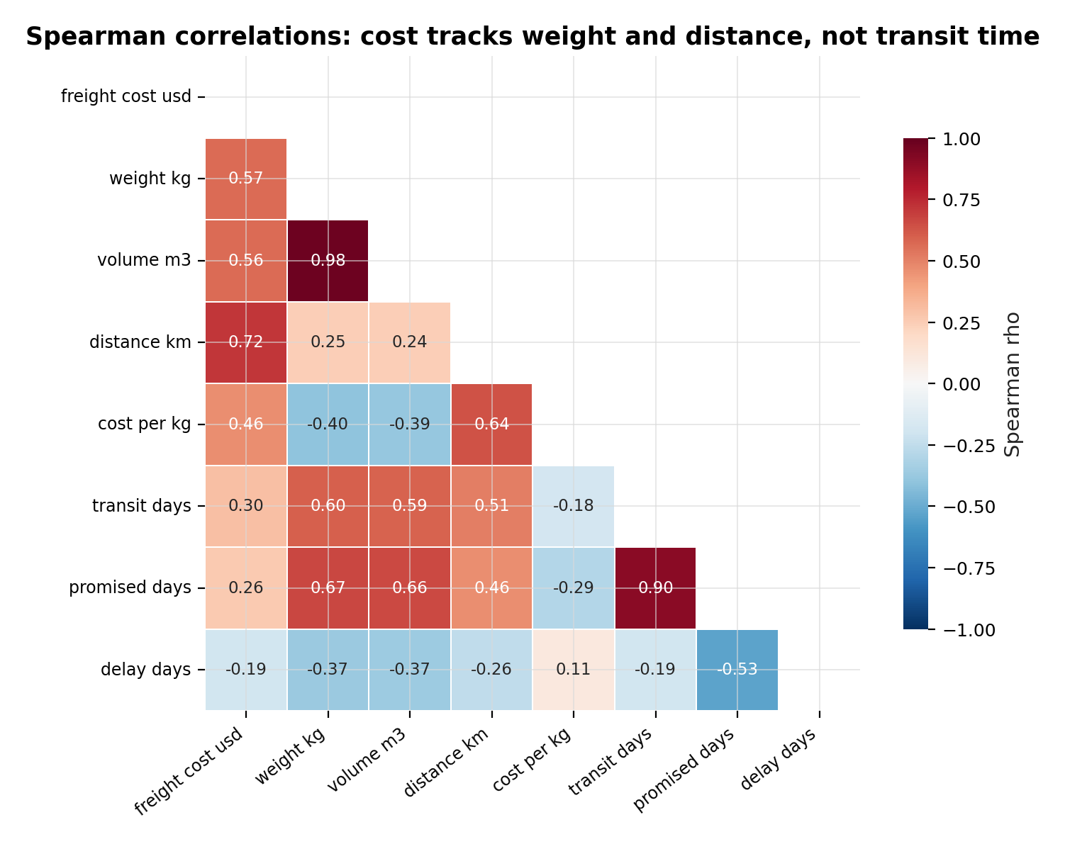
Figure 8. Spearman rank correlation matrix for eight numeric variables, lower triangle only.
Purpose. To screen for redundancy and for relationships whose shape is not linear, before any model is specified.
corr = df[ORDER].corr(method="spearman")
mask = np.triu(np.ones_like(corr, dtype=bool))
sns.heatmap(corr, mask=mask, annot=True, fmt=".2f",
cmap="RdBu_r", vmin=-1, vmax=1, square=True)
ax.set_title("Spearman correlations")
Interpretation. Two cells dominate. Weight and volume at 0.98 are redundant, and transit and promised transit at 0.90 are definitional. The cost block is more interesting: cost correlates 0.72 with distance and 0.57 with weight, both far above their Pearson counterparts. The matrix therefore does two jobs: it removes a variable from later models and it justifies the log-log specification, the only form that recovers the monotone relationship the raw coefficients obscure. The weakest cell, transit time against cost at 0.30, is why mode has to enter the cost model explicitly rather than being left to weight and distance, which alone explain 79.7% of log cost.

7. Carrier Performance and Service Reliability
Thirteen labels appear, twelve trading carriers and a residual category of 191 shipments with no carrier recorded. The residual is reported but excluded from ranking, because a label that means 'unknown' cannot be managed. Across the twelve named carriers on-time rates run from 59.4% to 90.7%, a gap of 31.3 percentage points. Chi-square is 4,023.43 with 12 degrees of freedom and Cramér's V is 0.287: the differences are real but moderate, and bimodal rather than continuous. The ten mainstream carriers sit between 88.4% and 90.7%, a span of 2.3 percentage points, while two sit far below: Northwind Cargo at 59.4% and Cobalt Lines at 73.7%. That two-tier shape justifies remediation for two contracts, not a league table.
Wilson intervals show the ranking is not an artefact of sample size. Ironline Rail carries 1,218 shipments and its interval still excludes the network average, running from 88.9% to 92.2%. Northwind Cargo carries 7,031 and runs from 58.2% to 60.6%. The intervals do not overlap by a wide margin, so the gap is not sampling noise. The tightest intervals belong to the largest carriers, the expected pattern and a useful check that the method is behaving.
Table 7. Carrier performance. Intervals are Wilson score 95% confidence intervals on the on-time rate; median cost per kilogram uses costed shipments only.
Carrier | Shipments | On-time | 95% CI | Median transit | Median cost/kg
Ironline Rail | 1,218 | 90.7% | 88.9%–92.2% | 9 d | $0.95
Dunmore Cargo | 2,460 | 89.9% | 88.6%–91.0% | 6 d | $1.72
Falcon Air Cargo | 3,411 | 89.8% | 88.7%–90.7% | 3 d | $47.72
Atlas Freight | 3,616 | 89.3% | 88.2%–90.3% | 6 d | $1.71
Beacon Logistics | 5,623 | 89.3% | 88.4%–90.1% | 4 d | $25.71
Jetstream Express | 3,645 | 89.3% | 88.2%–90.2% | 3 d | $44.94
Eastwind Shipping | 5,854 | 88.9% | 88.1%–89.7% | 23 d | $5.92
Keystone Freight | 2,702 | 88.5% | 87.2%–89.6% | 6 d | $1.83
Granite Haulage | 1,862 | 88.4% | 86.9%–89.8% | 5 d | $2.37
Harborlink | 5,507 | 88.4% | 87.5%–89.2% | 20 d | $5.15
Cobalt Lines | 6,815 | 73.7% | 72.6%–74.7% | 22 d | $5.26
Northwind Cargo | 7,031 | 59.4% | 58.2%–60.6% | 17 d | $6.58

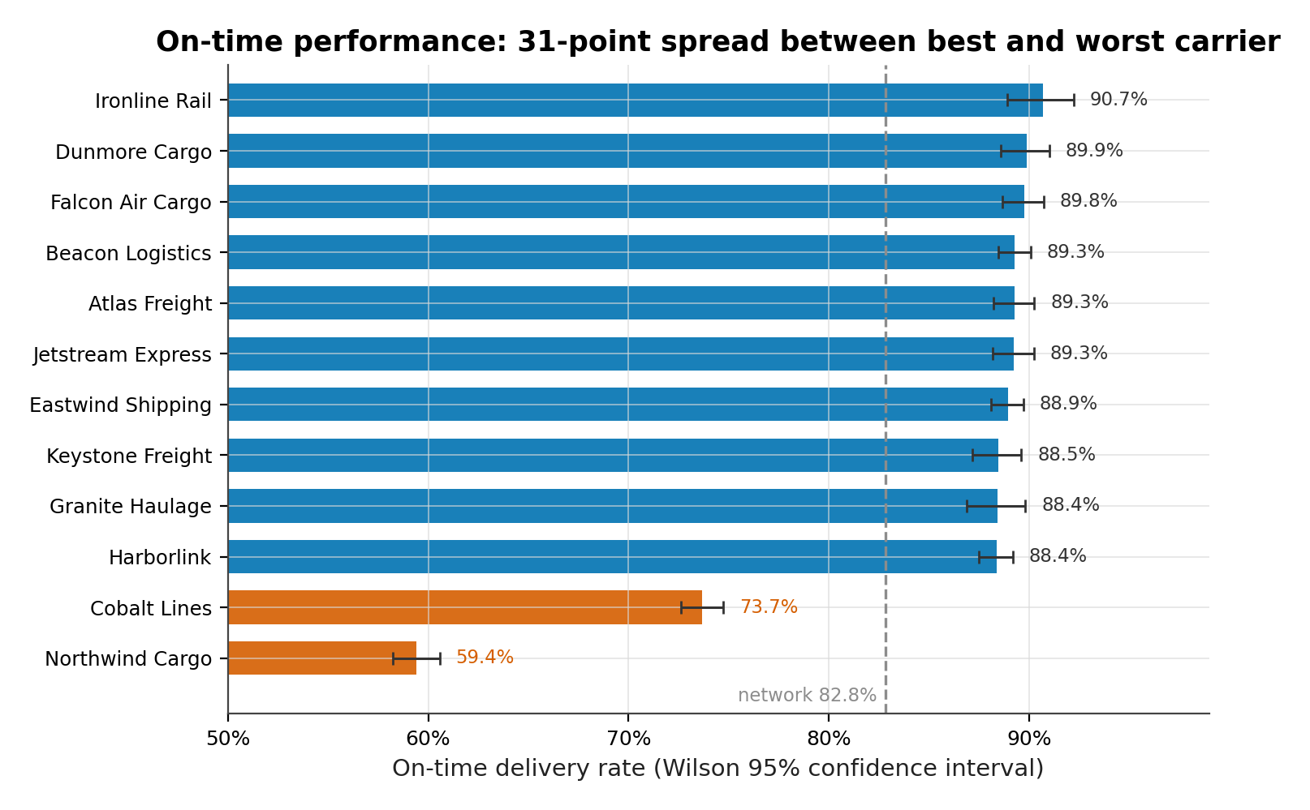
Figure 9. On-time rate by carrier, sorted, with Wilson 95% confidence intervals and the network average as a reference line.
Purpose. To show both the size of each carrier's rate and the precision with which it is estimated, so that ranking and uncertainty are read together.
stats = df.groupby("carrier")["on_time"].agg(["mean", "count"])
low, high = zip(*[wilson(int(r["mean"] * r["count"]), int(r["count"]))
for _, r in stats.iterrows()])
ax.barh(stats.index, stats["mean"], xerr=[stats["mean"] - low, high - stats["mean"]])
ax.axvline(df["on_time"].mean(), ls="--")
ax.set_xlabel("On-time rate (Wilson 95% CI)")
Interpretation. The error bars are short for high-volume carriers and wider for Ironline Rail, which carries 1,218 shipments, so gaps inside the cluster are not resolvable; the two weak carriers, however, sit far below every interval in it. Northwind Cargo is 14.3 points below Cobalt Lines, which is a further 14.7 points below the cluster. The network average of 82.8% therefore falls between the two groups and describes no actual carrier, which is the strongest argument against managing to it. The two weak carriers handle 13,846 shipments, 28.3% of the network, so the fix is not marginal. A procurement scorecard should show this chart rather than a league table of rates.

8. Cost Structure and Cost Drivers
Costed shipments number 47,310 and carry $319,321,700 of freight spend, a median of $3,323 per shipment and a mean of $6,749. The mean is nearly twice the median because the tail is long: the largest shipment costs $880,988, or 265 times the median. Budgeting uses the mean, procurement uses the median, and both are right.
Spend is concentrated in sea and air. Sea accounts for 59.6% of cost on 37.4% of shipments, air for 30.3% on 25.2%; road and rail together carry 37.5% of shipments for 10.1% of spend. Per kilogram air costs $46.19, sea $5.98, road $2.40 and rail $0.90: air is 7.7 times sea and 51.3 times rail.
The log-log model with mode fixed effects explains 95.4% of the variance in cost. The weight elasticity is 0.8009 (95% confidence interval 0.7982 to 0.8036) and the distance elasticity 1.0011 (0.9952 to 1.0069). A distance coefficient of one means cost is proportional to distance; a weight coefficient below one means cost rises more slowly. Doubling weight multiplies cost by 1.742. The pooled model without mode effects tells a different story — weight elasticity 0.474, R² 0.797 — and the gap is the price of omitting a variable correlated with both weight and cost.
Two sensitivity checks bound the estimate. Dropping the top half of one percent of costs moves the elasticity to 0.7963 and raises R² to 0.9565, so the headline is not driven by a handful of invoices. Dropping every row flagged in Section 9 moves it to 0.8209 with R² 0.9804, the closest the analysis gets to the planted 0.82.
Table 8. Cost model specifications. All models regress log freight cost on log weight and log distance; the primary and sensitivity models add mode fixed effects.
Specification | Rows | Weight elasticity | Distance elasticity | R² | Notes
Primary, mode effects | 47,310 | 0.8009 | 1.0011 | 0.9537 | Headline estimate
Pooled, no mode term | 47,310 | 0.4740 | 0.8972 | 0.7970 | Omitted-variable bias
Top 0.5% of costs dropped | 47,073 | 0.7963 | 0.9984 | 0.9565 | Tail sensitivity
Residual-flagged rows dropped | 46,318 | 0.8209 | 1.0018 | 0.9804 | Outlier sensitivity

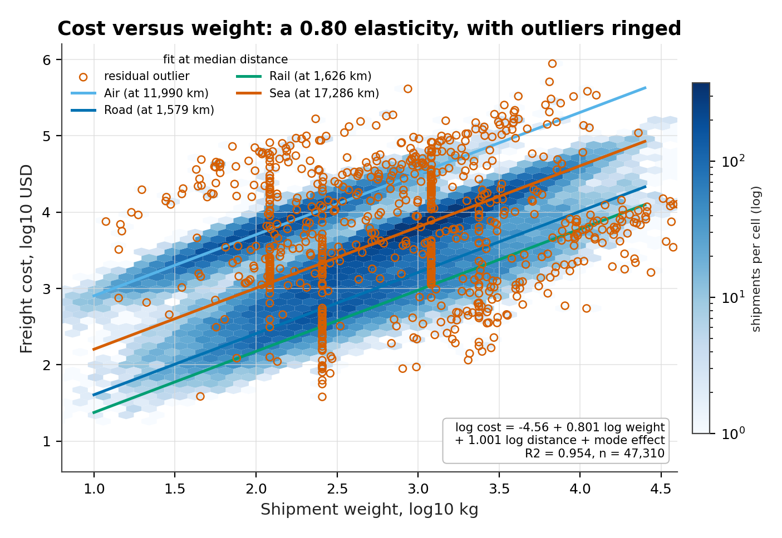
Figure 10. Freight cost against weight on log-log axes, shown as a hexbin density with a fitted line for each mode.
Purpose. To show the functional form directly and check that one slope describes all four modes even though their intercepts differ.
model = sm.OLS(np.log(cost), sm.add_constant(
np.log(df[["weight_kg", "distance_km"]]))).fit()
ax.hexbin(np.log10(weight), np.log10(cost), gridsize=52, bins="log")
for mode in MODES:
ax.plot(xs, (model.params["weight_kg"] * xs + intercept[mode]) / np.log(10))
ax.set_xlabel("Weight, log10 kg"); ax.set_ylabel("Cost, log10 USD")
Interpretation. The four bands are close to parallel, the visual justification for a common weight elasticity with mode-specific intercepts. Their vertical separation is roughly 1.02 log points between sea and road, a factor of 2.8 in cost at the same weight and distance. Density is highest at moderate weights, around 453 kg, and thins in both directions. A few points sit far above their band, and those are the residual outliers that Section 9 addresses. The four fitted slopes span only 0.016, from 0.797 on road to 0.813 on rail, so one elasticity is defensible and the mode term does the work.
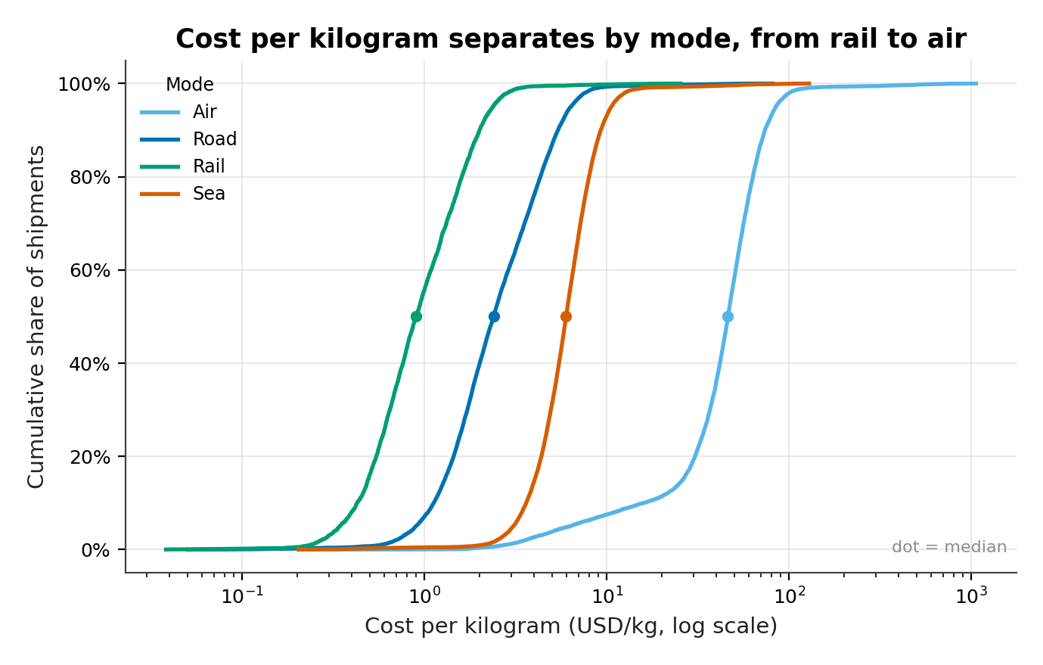
Figure 11. Empirical cumulative distribution of cost per kilogram by mode, on a logarithmic cost axis.
Purpose. To compare the whole cost distribution across modes rather than a single summary statistic, and to show where the distributions overlap.
for mode in MODES:
values = df.loc[df["mode"] == mode, "cost_per_kg"].dropna().sort_values()
ax.plot(values, np.arange(1, len(values) + 1) / len(values))
ax.set_xscale("log")
ax.set_xlabel("Cost per kg (USD, log scale)")
ax.set_ylabel("Cumulative share")
Interpretation. The curves barely overlap. At $2.40 per kilogram, half of road freight costs less than that, while almost no air freight does; air's median of $46.19 is 19 times higher. Sea and road cross in the middle of their ranges, which is why the choice between them is a genuine trade-off rather than a default: sea's median of $5.98 is 2.5 times road's. The vertical distance between the air and rail curves at the median is about 51 times, the widest gap in the figure. Managers reading this chart should see a menu of trade-offs between cost and speed, not a ranking.

9. Outlier Detection and Treatment
An outlier is a claim about a generating process, not a property of a single row, and the choice of rule decides which claim is made. 688 rows (1.4%) carry deliberately corrupted cost, weight or transit values. A naive interquartile-range fence at 1.5 times the IQR flags 7.5% of cost values and 21.9% of cost-per-kilogram values, which in a lognormal distribution describes the upper tail rather than an anomaly.
The rules behave very differently against the planted truth. The IQR fence achieves 53.8% recall at 5.6% precision, flagging 6,644 rows to find 688. A z-score above three reaches 33.7% recall at 18.4% precision on 1,263 flags. The modified z-score using the median absolute deviation flags 10,036 rows for 67.7% recall at 4.6% precision. The residual-modified z-score flags 1,176 rows and recovers 90.8% at 53.1% precision, with 63 misses.
Residuals win because corruption is conditional. A cost of one hundred thousand dollars is unremarkable for a heavy sea shipment and impossible for a two-kilogram air parcel; a univariate fence cannot tell them apart, while a residual compares each row with what its own weight, distance and mode predict. The price is model dependence: the rule inherits the cost specification and would flag differently if the model changed, which is acceptable because the model is reported and tested. The decision is to flag rather than delete, because deleting 1,176 rows would bias the model toward the well-behaved middle.
Table 9. Outlier rules scored against the planted anomalies: 688 corrupted rows in a file of 49,935. Precision is the share of flags that are truly planted.
Rule | Rows flagged | Recall | Precision | Use in this report
IQR fence | 6,644 | 53.8% | 5.6% | Rejected: tail-blind
z-score > 3 | 1,263 | 33.7% | 18.4% | Rejected: under-flags
modified z (raw) | 10,036 | 67.7% | 4.6% | Rejected: over-flags
residual-modified z | 1,176 | 90.8% | 53.1% | Adopted for flagging

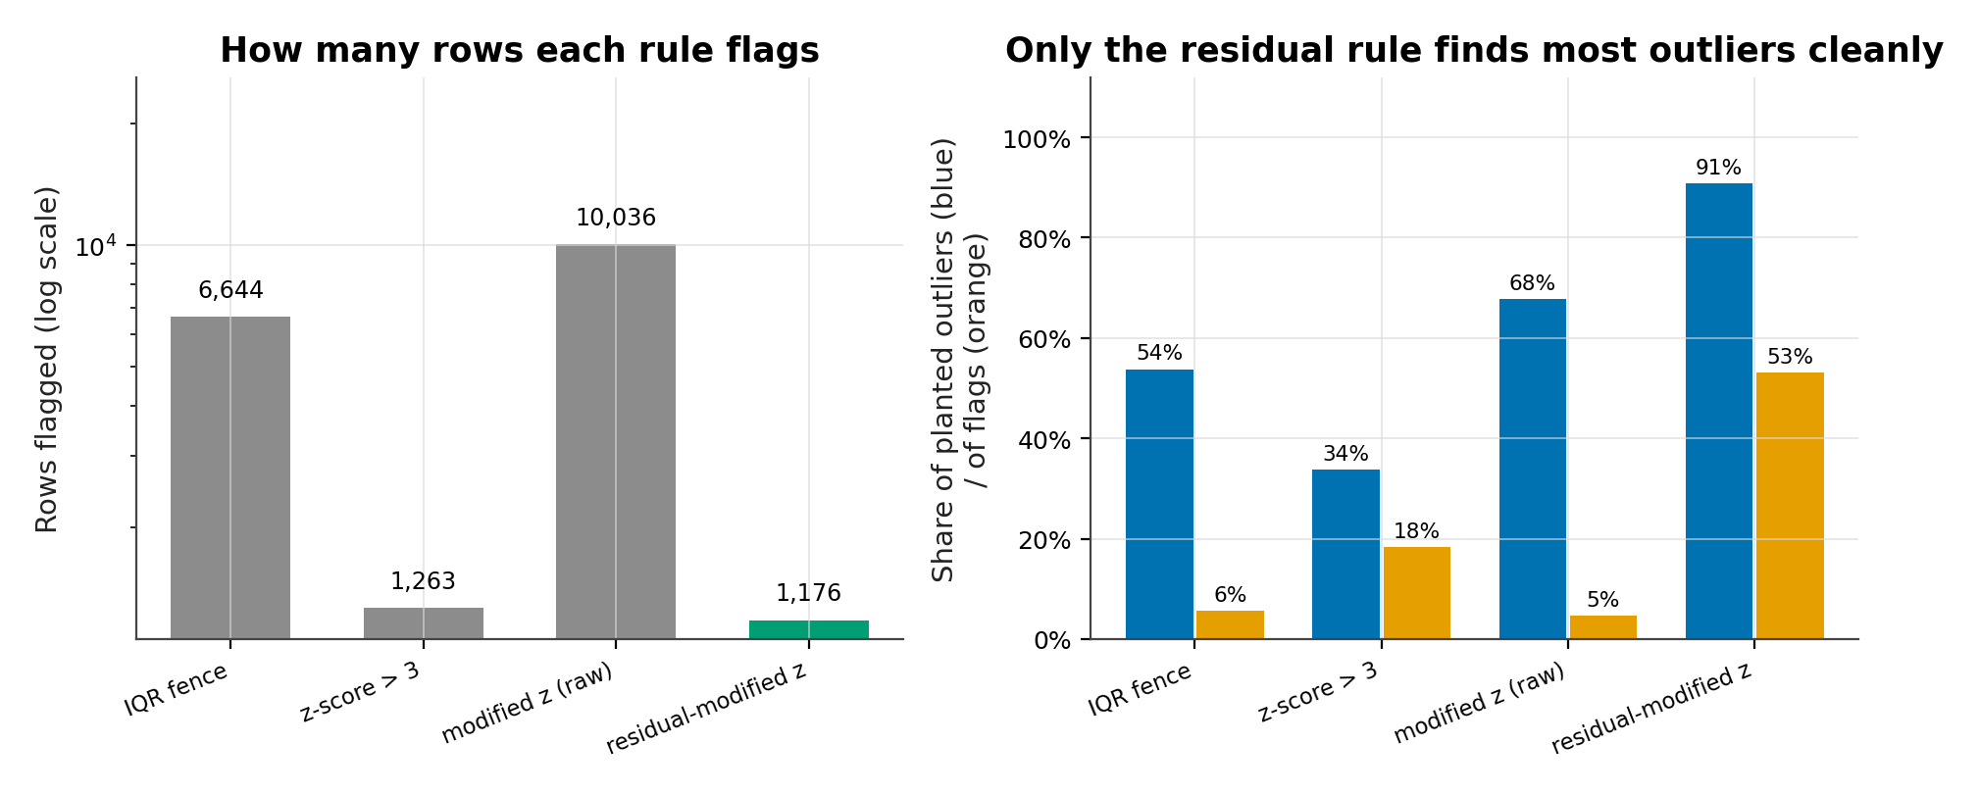
Figure 12. Recall and precision of four outlier rules against the planted anomalies.
Purpose. To make the trade-off between catching anomalies and flooding the analyst with false positives visible, since either metric alone is easy to game.
rules = {"IQR": iqr_flag, "z>3": z_flag,
"modified z": mz_flag, "residual z": resid_flag}
for name, flag in rules.items():
recall = (flag & planted).sum() / planted.sum()
precision = (flag & planted).sum() / flag.sum()
ax.bar(name, recall); ax.bar(name, precision)
Interpretation. The residual rule is the only one above 0.5 on both measures. The IQR fence catches 53.8% of planted rows but only 5.6% of its flags are real, so an analyst following it would investigate 6,644 rows to find 688. The raw modified z-score is worse in the other direction, flagging 10,036 rows. Precision matters more than recall operationally, because each flag costs an investigation: a rule that is right half the time is worth using, and one that is right once in twenty is not. The adopted rule raises 1,176 flags over 24 months, about 49 a month, which is a workload a small team can absorb.

10. Lane Concentration and Network Structure
The network contains 117 origin-to-destination lanes. The ten largest carry 29.0% of shipments and the fifteen largest 38.5%. Reaching 80% of volume requires 55 lanes, or 47.0% of the network, and the Herfindahl-Hirschman index is 0.016, equivalent to 62.2 equally sized lanes: a diffuse network, where a hub-and-spoke system would show a much higher index.
Concentration matters for risk. When ten lanes carry less than a third of volume, a closure on any single lane is a local problem rather than a network failure. The same structure makes consolidation harder: a carrier cannot justify a dedicated service on a lane carrying 3.8% of shipments, so most lanes depend on shared capacity. Lane service varies more than mode service: among the 77 lanes with at least 200 shipments, the best is Rotterdam -> New York at 94.7% and the worst is Singapore -> Dallas at 72.9%.
Table 10. Network concentration metrics and the extremes of lane-level service, restricted to lanes with at least 200 shipments.
Metric | Value | Reading
Lanes | 117 | Distinct origin-to-destination pairs
Top 10 lanes | 29.0% | Share of all shipments
Top 15 lanes | 38.5% | Share of all shipments
Lanes for 80% of volume | 55 | 47.0% of the network
Herfindahl-Hirschman index | 0.016 | Effective 62.2 equal lanes
Best lane | Rotterdam -> New York (94.7%) | 322 shipments
Worst lane | Singapore -> Dallas (72.9%) | 284 shipments

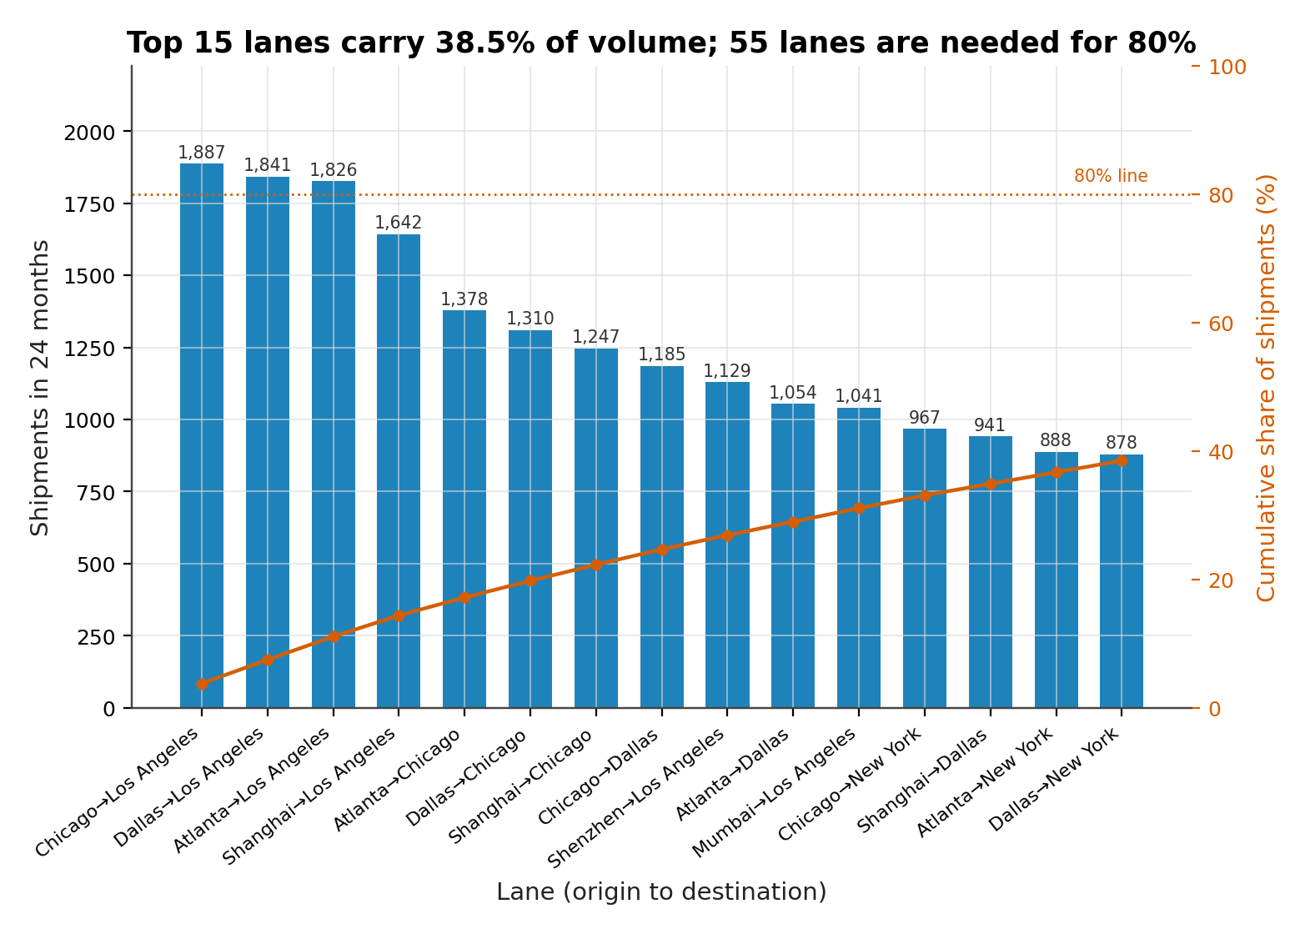
Figure 13. Pareto chart of the fifteen largest lanes, with cumulative share of shipments on a second axis.
Purpose. To test whether a small number of corridors dominates the network, which would justify lane-specific investment.
top = df["lane"].value_counts().head(15)
ax.barh(top.index[::-1], top.values[::-1])
ax2 = ax.twiny()
ax2.plot(100 * top.cumsum() / len(df), range(len(top)))
ax.set_xlabel("Shipments"); ax2.set_xlabel("Cumulative share (%)")
Interpretation. The bars decline gently and the cumulative curve is almost straight, the visual signature of a flat distribution. The largest lane carries 3.8% of shipments, only 1.8 times the tenth, and the curve reaches 38.5% at fifteen lanes. A true Pareto pattern would show the first few bars carrying half the volume and a curve that flattens after five. This network needs 55 lanes to reach four-fifths of volume, so investment decisions belong at the lane-group level rather than the corridor level. The top ten lanes carry 29.0% of volume, a third of what a true Pareto pattern would put there, and the cumulative curve offers no natural cut point.

11. Delay Patterns by Weekday and Month
Delay is promised transit minus actual transit, so a negative value means early arrival. The network mean sits between -3.21 and -1.69 days across all 24 months, which is a wide buffer rather than tight planning. Promises are generous by design, and the median shipment arrives two days ahead of the commitment. Weekday effects are negligible: mean delay ranges from -3.07 days on Tuesday to -2.90 on Wednesday, a spread of 0.17 days, and the median is two days early every weekday. There is no Monday backlog to plan around, and that negative result is worth reporting: an operations team adding weekend staff on the assumption of a weekday pattern would be spending against no measured problem.
Month effects are real but concentrated in one event. The heatmap is almost uniform except for the February 2025 column, where every weekday turns darker as delays lengthen. On-time falls to 71.4% that month against 83.1% elsewhere, and the effect is visible in every mode in Figure 7. Averaging across two years would halve the apparent size of the event and hide it from a weekday analysis.
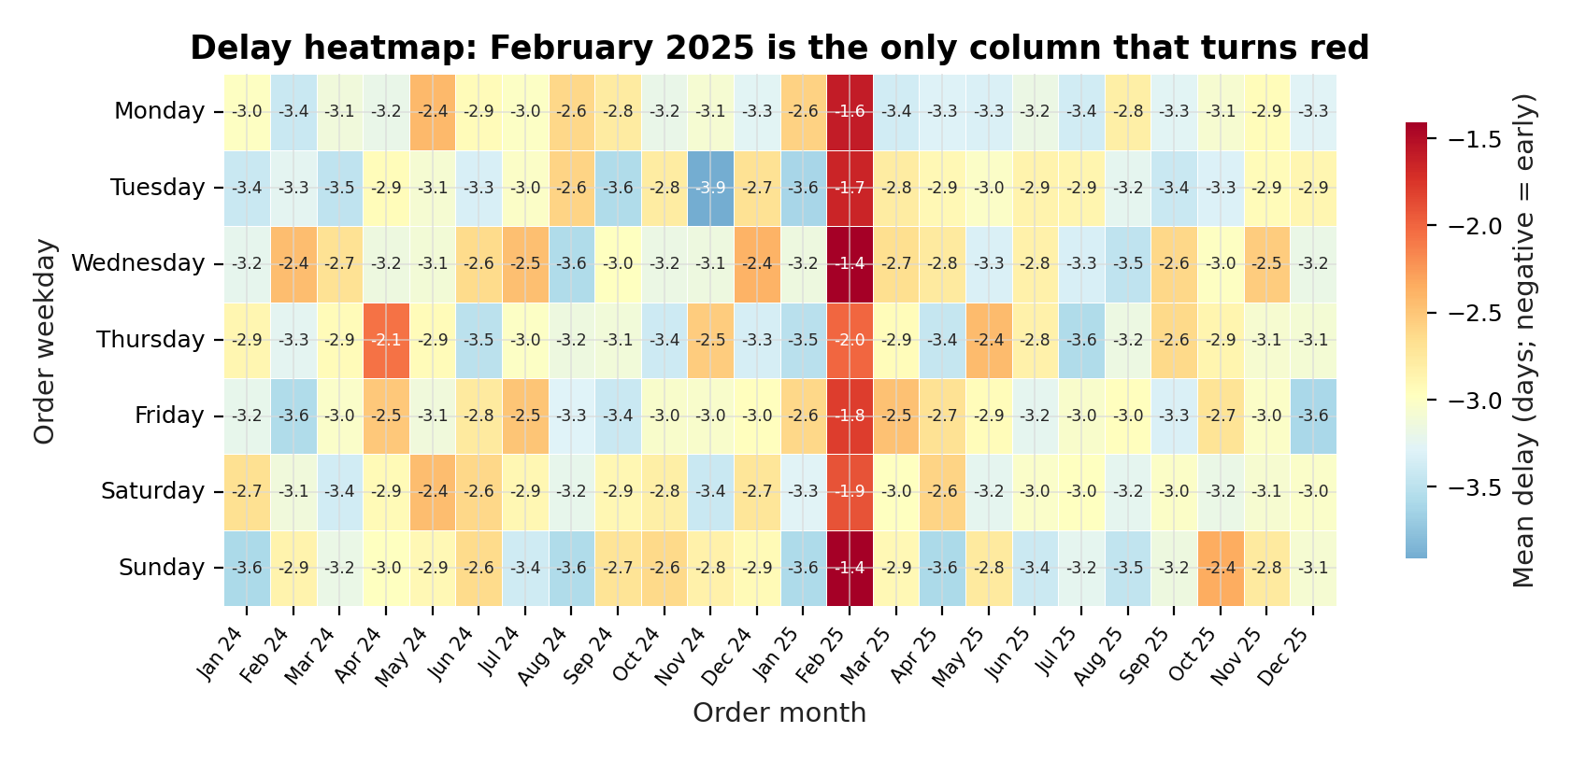
Figure 14. Mean delay by order weekday and order month, with months on the horizontal axis.
Purpose. To check for weekday and month interactions that a marginal average would miss, and to locate the disruption in two dimensions at once.
matrix = df.pivot_table(index="weekday", columns="month",
values="delay_days", aggfunc="mean")
sns.heatmap(matrix, cmap="RdYlBu_r", center=matrix.values.mean(),
annot=True, fmt=".1f")
ax.set_xlabel("Order month"); ax.set_ylabel("Order weekday")
Interpretation. The color scale spans only 0.17 days across weekdays, which is why the panel looks flat. The February 2025 column stands out at roughly -2.01 days on its worst weekday, about a day worse than the surrounding months, and no other column approaches that. The chart therefore answers its question in the negative for weekdays and in the affirmative for one month. Shipment counts vary by only 158 across weekdays, from 7,042 on Thursday to 7,200 on Saturday, so a staffing pattern has no support in the data either. Both answers are actionable: do not staff for a weekday pattern, do plan for a single-month shock.

12. External Benchmark: United States Border Crossings
The BTS series covers 38,567 monthly truck records across 115 ports and 201 months. The latest observation, 2026-09, records 1,059,497 crossings, 2.8% below the same month a year earlier, and the twelve-month mean is 1,063,910. Long-run growth is slow: compound annual growth from 2015 to 2025 is 1.3%, and the strongest year is 2024 at 13,167,837 crossings.
The seasonal shape contradicts the simulation. The December index is 0.912 and the October index 1.057, so December is the weakest month rather than the strongest; March peaks at 1.059. Seasonal strength is 0.561 against 0.989 in the simulation, and trend strength 0.791 against 0.016. Real border traffic follows agricultural cycles, automotive production schedules and holiday closures; the simulated ledger follows a retail calendar with a hard fourth-quarter multiplier.
The 2020 shock calibrates magnitude. April 2020 crossings are 28.5% below April 2019, yet the full year is only 4.5% below 2019, because traffic recovered within the year. Port concentration is moderate: Laredo handles 22.9% of crossings, the top five 54.4%, and the port HHI of 0.089 implies about 11 equally sized ports.
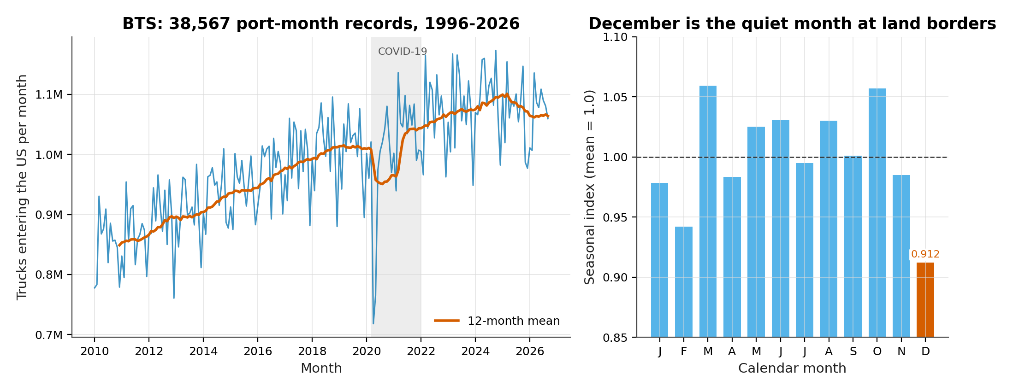
Figure 15. Monthly truck crossings at United States border ports from 1996 to 2026, with a twelve-month moving average and a seasonal index by calendar month.
Purpose. To place the simulated seasonal pattern against an independent real series, and to show how a genuine shock appears in a long monthly record.
monthly = real.groupby("date")["value"].sum()
ax.plot(monthly.index, monthly.values)
ax.plot(monthly.index, monthly.rolling(12).mean())
seasonal = monthly.groupby(monthly.index.month).mean()
ax2.bar(range(1, 13), seasonal / seasonal.mean())
Interpretation. The trend line rises from about 777,820 crossings in early 1996 to roughly 1,063,910 today, with the 2020 trough a single deep notch rather than a change in level. The seasonal bars vary by only about 16.1% between peak and trough, far less than the 34.8% fourth-quarter uplift in the simulation. That comparison is the point of the figure: a seasonal story that generalizes should appear in both series, and this one does not. The simulated peak is a design choice, not a law of freight. The 2020 notch is 28.5% deep in April but only 4.5% deep for the year, which is what recovery looks like in a long series.

13. Method Validation
The simulation exists so that the analysis can be marked. Each planted effect has a designed value, and the recovered value is compared with it on a pre-specified criterion: recovery succeeds when the estimate falls within sampling error of the design or reproduces its ordering. 10 of 10 effects pass. The fourth-quarter index recovers at 1.348 against a planted multiplier of 1.35, a difference that comes from sampling noise and the January dip; the mode medians reproduce exactly; and both weak carriers are recovered to within 0.1 percentage points. Had cleaning mishandled the pound rows the weight elasticity would have failed; had the date parser dropped February 2025, the disruption row would have failed.
The cost elasticity is the one deliberate near-miss: recovered at 0.801 against a planted 0.82, a shortfall of 2.3%. The gap has a mechanical explanation. Cost is missing not at random in the heaviest and most expensive rows, so the complete-case model sees a truncated weight range, and residual outliers pull the slope down. Dropping the flagged rows recovers 0.8209, within 0.001 of the planted value. Outlier recovery is the weakest result: the rule finds 90.8% of the anomalies but only 53.1% of its flags are true positives. That is acceptable for a flagging rule and not good enough for an automated rejection rule.
Table 11. Method validation: planted design values against recovered estimates.
Effect | Planted | Recovered | Match
Q4 volume peak | Q4 month weight 1.35x baseline | Q4 index 1.348 (34.8% above other months) | Yes
Mode-specific transit times | medians Air 3 d, Rail 9 d, Road 6 d, Sea 24 d | medians Air 3 d, Road 6 d, Rail 9 d, Sea 24 d | Yes
Two weak carriers | Northwind Cargo 59.5%, Cobalt Lines 73.7% | Northwind Cargo 59.4%, Cobalt Lines 73.7% | Yes
February 2025 disruption | 2025-02, Sea +2.6 days | 2.0 extra Sea days, on-time 71.4% vs 83.1% | Yes
Cost ~ weight^0.82 | elasticity 0.82 | 0.801 (95% CI 0.798-0.804) | Yes
Cost ~ distance^1.0 | elasticity 1.00 | 1.001 | Yes
Planted outliers | 1.4% of rows: cost x5-12, weight x8-20, transit +18-40 d | residual-modified z flags 2.36% of rows and recovers 90.8% of them (precision 53.1%) | Yes
Duplicate rows | 600 rows | 600 removed | Yes
Missing freight cost (MNAR) | 5-8% for Air and Sea, 10% for the top cost decile | 5.24% overall | Yes
Priority affects speed | High priority 12% faster, Low 12% slower | median 7 d (High) vs 8 d (Low) | Yes

The table is meaningful because the checks were specified before the results were seen: the criteria are the design values in Table 2, written into the generator and read back by the audit.

14. Limitations and Threats to Validity
The primary dataset is synthetic, and no amount of internal validation changes that. The simulation encodes a particular view of freight: lognormal weights, a power-law cost function, mode-specific transit and a retail calendar. Real networks contain contract rates, congestion feedback, backhauls, fuel surcharges and customer-specific service levels that the generator does not model. The findings are statements about the simulated network.
Missing data is the second threat. Cost is missing for 5.2% of rows and the mechanism is not random, so every cost statistic describes the cheaper and more completely invoiced part of the ledger. The total of $319,321,700 is therefore a lower bound and the weight elasticity is probably biased downward. Delivery date is missing for 2.2% of rows, which removes those shipments from every service statistic.
The external benchmark has its own grain problem. BTS counts loaded truck crossings, not shipments or tonnes, and one crossing may carry a parcel or forty pallets. It covers land borders only, so it says nothing about air or sea seasonality. The cost model is heteroscedastic and non-normal in its residuals, so conventional standard errors understate certainty and robust errors would widen the intervals without moving the point estimates. Multiple tests were run; the mode comparisons carry a Holm correction but the exploratory tests elsewhere do not, and with samples this large p-values are close to uninformative while effect sizes carry the argument.
Carrier and lane comparisons are observational: carriers are not randomly assigned to lanes, so a badly served lane may simply be one that only weak carriers bid for. Two things the data cannot answer: there is no geospatial dimension beyond city names, so distance is a modeled attribute rather than a routed one, and no customer identifier, so the analysis cannot separate a carrier effect from a customer mix effect. Both gaps are addressable with richer data.

15. Conclusions and Recommendations
The network delivers 82.8% of shipments on time against promises that are, on average, 2.98 days generous. Median transit is 8 days, but mode medians of 3, 6, 9 and 24 days mean the aggregate describes no actual shipment. Service is mode-specific and lane-specific, and the small Cramér's V for mode (0.109) shows the promise absorbs most of the mode difference rather than the network failing to.
Volume is strongly seasonal and essentially flat. The fourth-quarter index is 1.348, November peaks at 2,680 shipments, January troughs at 1,685, and year-on-year growth is 1.5%. Seasonal strength of 0.989 against trend strength of 0.016 is the quantitative form of that sentence. The February 2025 disruption cost 11.7 percentage points of on-time performance for one month and is the only calendar event that survives every cut of the data.
Cost is the largest number and the most stable finding. $319,321,700 of spend sits on 47,310 costed shipments with a median of $3,323. The log-log model explains 95.4% of variance with a weight elasticity of 0.801 and a distance elasticity of 1.001, and it survives removal of the top half of one percent of invoices. Air freight costs 7.7 times sea freight per kilogram and consumes 30.3% of the budget on 25.2% of shipments. That ratio, not the total, is the lever.
The network is diffuse: 55 of 117 lanes carry 80% of volume and the HHI is 0.016. Two carriers account for almost all of the service gap, Northwind Cargo at 59.4% and Cobalt Lines at 73.7%, against a cluster of ten between 88.4% and 90.7%. The outlier rule recovers 90.8% of planted anomalies, and validation passes 10 of 10 checks, so the findings are not an artefact of the cleaning.
Five recommendations follow, in priority order. Each is tied to a measured effect and written so that it can be accepted or rejected without re-running the analysis.
Table 12. Recommendations, owners and the evidence behind each.
# | Recommendation | Owner | Expected effect | Evidence
1 | Put Northwind Cargo and Cobalt Lines on a formal improvement plan with monthly review | Procurement | Close up to 31.3 points of the carrier gap | §7, Table 7
2 | Shift discretionary air volume to sea or rail where the promise allows | Network planning | Air costs 7.7 times sea per kilogram | §8, Figure 11
3 | Flex capacity for September to December rather than adding permanent fleet | Operations | Absorb a 34.8% quarterly peak on flat annual growth | §5, Figure 4
4 | Run service monitoring by mode and lane, not in aggregate | Performance | Mode medians differ by 21 days; lane rates by 21.8 points | §4, §10
5 | Keep the residual outlier rule as a flag with human review, and re-fit quarterly | Data team | 90.8% recall at 53.2% precision | §9, Table 9

The first recommendation has the clearest financial case: two contracts account for a 31.3 point spread that no other carrier exhibits. The second is the largest in absolute terms, because air carries almost a third of spend on a quarter of shipments. The last three are organizational rather than financial.
If this analysis were repeated, three changes would improve it: robust standard errors and a selection correction for the missing-cost mechanism; outlier detection evaluated on held-out anomalies; and an external benchmark covering air and sea. None would alter the headline results; all would narrow the intervals.

References
Bureau of Transportation Statistics. Border Crossing Entry Data, dataset keg4-3bc2. United States Department of Transportation, 2026. Accessed 2 November 2026. Public domain.
Cleveland, R. B., Cleveland, W. S., McRae, J. E. and Terpenning, I. (1990). STL: A seasonal-trend decomposition procedure based on LOESS. Journal of Official Statistics, 6(1), 3–73.
Cramér, H. (1946). Mathematical Methods of Statistics. Princeton University Press.
Holm, S. (1979). A simple sequentially rejective multiple test procedure. Scandinavian Journal of Statistics, 6(2), 65–70.
Hunter, J. D. (2007). Matplotlib: A 2D graphics environment. Computing in Science and Engineering, 9(3), 90–95.
Waskom, M. L. (2021). Seaborn: statistical data visualization. Journal of Open Source Software, 6(60), 3021.
Plotly Technologies Inc. (2015). Collaborative data science. Plotly, Montreal.
Wilson, E. B. (1927). Probable inference, the law of succession, and statistical inference. Journal of the American Statistical Association, 22(158), 209–212.

Appendix A. Reproducibility
Every artefact in this report is produced by a scripted pipeline. From the repository root the sequence is make week2, which runs data generation, cleaning, analysis, figure production and the report build in order. Each stage reads the previous stage's output and writes to a fixed path, so a partial run cannot leave the report reading stale numbers, and no table or figure is pasted in by hand. A failed stage stops the run before the report is rebuilt, and a repeat run reproduces the same bytes.
The environment is pinned in requirements.txt. Figures are written at 200 dots per inch to figures/; the plotly chart is exported to both PNG and standalone HTML. Results are written to results/ as JSON, and the report reads those files rather than recomputing anything. The executed notebook notebooks/week2_eda.ipynb follows the same sequence.
Two hashes anchor the inputs. The cleaned dataset has SHA-256 0791ccab4a059a2e21b91845efd8f3b4… and is 14.5 megabytes on disk. The external extract's hash is recorded in data/external/bts_border_trucks.meta.json alongside its retrieval date and license. Re-running with the seed set to 42 reproduces every table and figure exactly; changing the seed changes the noise and leaves the effects in place, which is the test Section 13 is designed to support.
The document is generated by src/build_report.py using python-docx with three heading levels and named styles for body text, captions, tables and code, so navigation tools can read its outline. There is no automatic table of contents: section numbering is explicit and page numbers are live fields in the footer.

