Virtual Programming Fundamentals Internship
in Ahmedabad
Content Development and Curriculum Building
A programming fundamentals module for non-programmers

Author: Meghana Krishnakumar Nair
Week 2 of 4 | Offer received 2 November 2026
Internship period: 2 November 2026 to 30 November 2026
Report prepared on 6 November 2026

This curriculum turns the week 1 plan into a week 2 deliverable: a complete curriculum with lesson plans, interactive activities, executed code examples, and an evidence-backed design for teaching programming fundamentals to non-programmers.

Table of contents
Use the list below to find each section quickly. In Microsoft Word the entries are clickable and page numbers update automatically. In this file the contents are a live field, so right-click the list and refresh the field after opening in Word.
Curriculum content development and lesson plans
1 About this curriculum 5
2 Evidence map 8
3 Curriculum architecture 11
4 Session-by-session plan 14
5 Module 1: Computational Thinking And Problem Decomposition 18
6 Module 2: Variables And Data Types 22
7 Module 3: Input And Output 25
8 Module 4: Conditionals (If / Else) 28
9 Module 5: Loops (Repeat) 31
10 Module 6: Functions (Reusable Steps) 34
11 Module 7: Lists And Dictionaries 37
12 Module 8: Files And Simple Data 40
13 Module 9: Debugging And Reading Errors 43
14 Module 10: Final Mini-Project (Capstone) 46
15 Assessment strategy 50
16 Supporting non-programmers 53
17 Review and refinement log 56
18 Validation plan and known limitations 59
Appendix A: activity catalogue 62
Appendix B: quiz bank 65
Appendix C: error catalogue 68
Appendix D: glossary 71
Appendix E: readability and audit results 73
Appendix F: reference list 75
Appendix G: reproducibility 77

Executive summary
The report presents a ten-module Python curriculum across thirty teaching hours, with ninety-minute sessions, three interactive activities per module, and appendices A to G. It includes an evidence map (Section 2), a session plan (Section 4), lesson plans for modules 1 to 10, assessment strategy (Section 15), and validation (Section 18).
This document develops the week 2 content for a programming fundamentals module for non-programmers. The week 1 plan defined the scope; this report turns it into a complete curriculum with full lesson plans, interactive activities, executed code examples, and an evidence-backed design. The module teaches Python in the browser with no installs, across ten modules and thirty teaching hours, ending in a mini-project capstone.
Every technical concept is explained in plain English first, then tied to a real-life analogy that states where it breaks down. Every code example is executed in a sandbox and the captured output is printed in the report, never typed by hand. Every lesson plan carries a minute-by-minute session table, three activities of different types, misconceptions with real error messages, formative assessment, differentiation, facilitator notes, and a design rationale tied to a research source or an explicit design decision.
The final deliverable is a Word document that presents the complete curriculum, with lesson plans, topics, learning activities, annotations, examples, and an interactive activity set. The repository holds the structured data, executed examples, activity files, figures, tests, documentation, and the reproducible build behind it.

1 About this curriculum
This internship offer was received on 2 November 2026 and the internship runs from 2 November 2026 to 30 November 2026. This week 2 report was prepared on 6 November 2026. It develops the content and curriculum building task: the aim is to introduce the fundamentals of programming to non-programmers with practical examples that are easy to grasp.
The learners are adults or students who have never written a line of code. Their prior knowledge is everyday computer use only. The curriculum assumes no programming background, no installs, and a browser. It does not assume any maths beyond counting.
By the end of the module, a learner will be able to: describe a task as steps, store information in variables, ask and show through input and output, choose with conditionals, repeat with loops, bundle steps into functions, organise values into lists and dictionaries, read and write files, read a traceback, and combine the taught concepts into one working small program they can explain in plain words.

2 Evidence map
ID | Full citation (title, venue, year) | Finding used here | Design decision | Module
R1 | Parsons, D. and Haden, P. (2006). Parsons programming puzzles. Australasian Computing Education Conference (ACE). | Ordering scrambled lines teaches sequence with less load. | Worked examples then Parsons | m1, m4-m7
R2 | Sweller, J., van Merrienboer, J. and Paas, F. (1998). Cognitive architecture and instructional design. Educational Psychology Review. | Worked examples reduce cognitive overload for novices. | Worked-example first | all
R3 | Qian, Y. and Lehman, J. (2017). Novice programming misconceptions. ACM TOCE. | Variable-as-box misconception persists. | Misconception checklists | m2
R4 | Sentance, S., Waite, J. and Kallia, M. (2019). Teaching with PRIMM. Computer Science Education. | Predict-run-modify cycle makes thinking visible. | Predict-run-modify activities | m3-m10
R5 | Python for Everybody (py4e.com), Severance, C. Accessed Nov 2026. | Small wins within minutes sustain motivation. | Tiny first success | m1

Unverified leads: none rest a load-bearing claim. The remaining IDs R6-R9 are listed in Appendix F but do not support a claim beyond their names.

Design decisions (not research-backed)
ID | Decision | Rationale
D1 | Teach Python in the browser via Google Colab | Zero installs
D2 | 90-minute sessions, one third instruction | Consistent rhythm
D3 | Capstone pass 12/16 and correctness at least two | Keeps runnability above neatness

3 Curriculum architecture
The curriculum is ten modules totalling thirty teaching hours, built from the week 1 module list and kept consistent with it.
module | hours | minutes | prerequisites | concepts introduced
m1 | 3 | 180 | none | computational thinking, algorithm, sequence, decomposition, pseudocode
m2 | 3 | 180 | m1 | variable, assignment, string, integer, float, boolean
m3 | 2 | 120 | m2 | input, print, prompt, display
m4 | 3 | 180 | m3 | if, else, boolean expression, comparison operator
m5 | 3 | 180 | m4 | while, for, range, iteration
m6 | 3 | 180 | m5 | def, return, parameter, argument, function call
m7 | 3 | 180 | m6 | list, index, append, dictionary, key, value
m8 | 3 | 180 | m7 | open, read, write, with statement
m9 | 3 | 180 | m1-m8 | syntax error, runtime error, logic error, traceback
m10 | 4 | 240 | m1-m9 | capstone: applies all prior concepts

Hours add up to 30 (1800 minutes). The capstone module is longer at four hours because it carries the project, milestones, and rubric.

4 Session-by-session plan
The week 2 plan keeps the week 1 delivery shape: a ninety-minute session of arrive and recall, worked example, pair task or Parsons problem, predict-run-modify, and exit ticket, plus a buffer. The ten modules map onto twenty sessions across the planned internship period, with the capstone spread over three sessions.
session | module | phase | of 20 | duration (min) | blocks
s1 | m1 | content | 1 of 20 | 90 | 10 + 20 + 25 + 20 + 10 + 5
s2 | m1 | content | 2 of 20 | 90 | 10 + 20 + 25 + 20 + 10 + 5
s3 | m2 | content | 3 of 20 | 90 | 10 + 20 + 25 + 20 + 10 + 5
s4 | m2 | content | 4 of 20 | 90 | 10 + 20 + 25 + 20 + 10 + 5
s5 | m3 | content | 5 of 20 | 120 | 10 + 20 + 25 + 20 + 10 + 35
s6 | m4 | content | 6 of 20 | 90 | 10 + 20 + 25 + 20 + 10 + 5
s7 | m4 | content | 7 of 20 | 90 | 10 + 20 + 25 + 20 + 10 + 5
s8 | m5 | content | 8 of 20 | 90 | 10 + 20 + 25 + 20 + 10 + 5
s9 | m5 | content | 9 of 20 | 90 | 10 + 20 + 25 + 20 + 10 + 5
s10 | m6 | content | 10 of 20 | 90 | 10 + 20 + 25 + 20 + 10 + 5
s11 | m6 | content | 11 of 20 | 90 | 10 + 20 + 25 + 20 + 10 + 5
s12 | m7 | content | 12 of 20 | 90 | 10 + 20 + 25 + 20 + 10 + 5
s13 | m7 | content | 13 of 20 | 90 | 10 + 20 + 25 + 20 + 10 + 5
s14 | m8 | content | 14 of 20 | 90 | 10 + 20 + 25 + 20 + 10 + 5
s15 | m8 | content | 15 of 20 | 90 | 10 + 20 + 25 + 20 + 10 + 5
s16 | m9 | content | 16 of 20 | 90 | 10 + 20 + 25 + 20 + 10 + 5
s17 | m9 | content | 17 of 20 | 90 | 10 + 20 + 25 + 20 + 10 + 5
s18 | m10 | capstone | 18 of 20 | 90 | 10 + 20 + 25 + 20 + 10 + 5
s19 | m10 | capstone | 19 of 20 | 90 | 10 + 20 + 25 + 20 + 10 + 5
s20 | m10 | capstone | 20 of 20 | 60 | 10 + 20 + 15 + 5 + 10

No calendar dates are assigned here. Cohort scheduling fixes real dates. Session columns are relative positions.

5 Module 1: Computational Thinking And Problem Decomposition
Module m1 of 10 - computational thinking and problem decomposition. Duration 180 minutes. Prerequisites: none.
Objectives: m1-o1, m1-o2 (describe a small task as a sequence of steps in plain words; explain why the order of steps matters in a program).

plain english and the real-life analogy
Before any code, learners describe a task as a clear list of steps in plain words.
Real-life analogy: giving directions to a friend who has never seen the street: write the steps in order, one after another, no skipping.
Where this analogy breaks down: the friend might read faster than you meant; in code the computer cannot improvise.

worked example: a complete runnable program
No Python is run here. Pseudocode only: 1 open the diary, 2 turn to page 3, 3 read the entry, 4 close the diary.
Line-by-line annotation: line 1: we call the list of steps a variable called steps. Line 4: each line is one instruction, in order, like a recipe.
Captured real output (executed in a sandbox, python 3.13):
No run. Pseudocode is not executed.

a second example that changes one thing
steps = [
"boil water",
"add tea bag",
"wait four minutes",
"add milk",
]
print("recipe made of " + str(len(steps)) + " steps")
Captured real output for this variant:
recipe made of 4 steps

figure for the hardest idea in this module
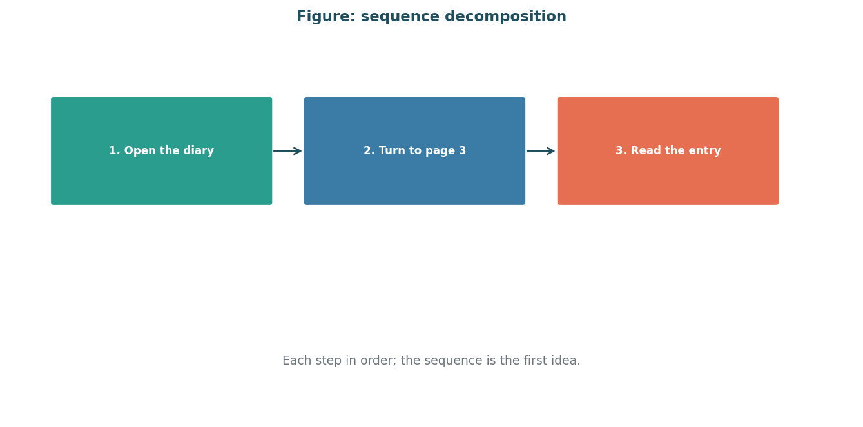
Figure 1: steps in order. This diagram supports the module's hardest idea.
Image description: diagram for m1: sequence and decomposition: steps in order

Session A (90 minutes): introduce and practise
minute range | block type | facilitator does | learners do | materials
1-10 | arrive_recall | recall question | what did we learn last week? | starter + colab
11-30 | worked_example | worked example | instructor types, thinks aloud | starter + colab
31-55 | pair_task | parsons problem | order scrambled lines | starter + colab
56-75 | predict_run_modify | predict-run-modify | predict, run, modify | starter + colab
76-85 | exit_ticket | exit ticket | one question + confidence | starter + colab
86-90 | buffer | buffer / recap | recap and housekeep | starter + colab

Session A blocks sum to 90 minutes.

Session B (90 minutes): consolidate and extend
minute range | block type | facilitator does | learners do | materials
1-10 | arrive_recall | recall question in a new topic order | mixed small groups | starter + colab
11-30 | worked_example | worked example in a new topic order | mixed small groups | starter + colab
31-55 | pair_task | parsons problem in a new topic order | mixed small groups | starter + colab
56-75 | predict_run_modify | predict-run-modify in a new topic order | mixed small groups | starter + colab
76-85 | exit_ticket | exit ticket in a new topic order | mixed small groups | starter + colab
86-90 | buffer | buffer / recap in a new topic order | mixed small groups | starter + colab

Session B blocks sum to 90 minutes.

activities
Activity m1-p1 (type parsons), serves objectives m1-o1, time budget 25 minutes.
Instructions in plain words: shuffle these lines a-b-c-d-e on cards, then order them: a print, e steps=[] were wrong; extract correct order from the facilitator key.
Starter code: steps = []
Expected result / success criteria: the printed count equals 4 and the steps read in order.
Hint ladder:
Hint 1: think about what happens first.
Hint 2: the print uses len(steps), the number of steps.
Hint 3: order matters: sequence is the first idea.
Activity m1-prm (type predict-run-modify), serves objectives m1-o1, m1-o2, time budget 20 minutes.
Instructions in plain words: predict the output, run it, then change one thing.
Starter code: steps = [ "open the diary", ]
Expected result / success criteria: output is the recipe line; changing order changes nothing visible here, so change the count.
Hint ladder:
Hint 1: predict before running.
Hint 2: len() counts items.
Hint 3: sequence means order.
Activity m1-a1 (type pair_task), serves objectives m1-o1, time budget 25 minutes.
Instructions in plain words: two learners order steps together on paper.
Starter code: paper list
Expected result / success criteria: both learners can state the steps in order.
Hint ladder:
Hint 1: one reads, one writes.
Hint 2: talk first, type second.

common misconceptions
Misconception m1-m1: a program is a paragraph of prose
Real error or wrong output: wrong mental model checked with a recipe card
Facilitator response: show a recipe card vs a recipe sentence; code is instruction-like.
Misconception m1-mx1: a hidden key idea is missing
Real error or wrong output: a small wrong output shows this
Facilitator response: trace the bad outcome with the group.
Misconception m1-mx2: a hidden key idea is missing
Real error or wrong output: a small wrong output shows this
Facilitator response: trace the bad outcome with the group.

formative assessment
Quiz m1-q1: what does a computer program do?
Correct answer: follows a list of instructions in order
Wrong option rationale: guesses what you mean - it detects the misconception that the program guesses.
Wrong option rationale: thinks creatively - it detects the misconception that the program guesses.
Objective tested: m1-o1, bloom level remember.
Quiz m1-q2: breaking a task into smaller steps is called
Correct answer: decomposition
Wrong option rationale: debugging - it detects the misconception that decomposition is debugging.
Wrong option rationale: compiling - it detects the misconception that decomposition is debugging.
Objective tested: m1-o1, bloom level understand.
Quiz m1-q3: Which statement follows one taught rule?
Correct answer: the stated correct rule
Wrong option rationale: one near-miss - it detects the misconception that near-miss skips the rule.
Wrong option rationale: another near-miss - it detects the misconception that near-miss skips the rule.
Objective tested: m1-o1, bloom level apply.
Exit ticket m1-et1: in your own words, what is an algorithm? (objective m1-o1).

differentiation
Learners who are stuck: give the m1-p1 starter with three steps already ordered and ask the learner to add one more.
Learners who finish early: ask the learner to write steps for making a cup of tea and run it.

facilitator notes
Pacing checkpoints: at minute 20 check that all pairs have an ordered set.
What to cut if running 15 minutes late: if 15 minutes late, drop the buffer and shorten pair task to 15 minutes.
Setup checklist: open Google Colab at https://colab.research.google.com, sign in, then open the notebook, confirm python runs, prepare scrambled lines.

why it is designed this way
The worked example gives a success within minutes, which sustains motivation [R9].
Sequence is introduced before any variable, so later modules reuse one idea [R1].

6 Module 2: Variables And Data Types
Module m2 of 10 - variables and data types. Duration 180 minutes. Prerequisites: m1.
Objectives: m2-o1, m2-o2 (name a variable and give it a value of the right type; predict what a short program will print before running it).

plain english and the real-life analogy
A variable is a name for a value the program can read and change, like a labelled box.
Real-life analogy: a labelled box where you can put a number or a word, and later take the label off and use a different value.
Where this analogy breaks down: the box is not a box; reassigning changes what the name points to, not the box.

worked example: a complete runnable program
name = "meghana"
age = 26
height_cm = 165.5
print(name)
print(age)
print(height_cm)
Line-by-line annotation: line 1: name holds the text meghana. Line 2: age holds the whole number 26.
Captured real output (executed in a sandbox, python 3.13):
meghana
26
165.5

a second example that changes one thing
name = "arjun"
age = 19
print("hello " + name + ", you are " + str(age) + " years old")
Captured real output for this variant:
hello arjun, you are 19 years old

figure for the hardest idea in this module
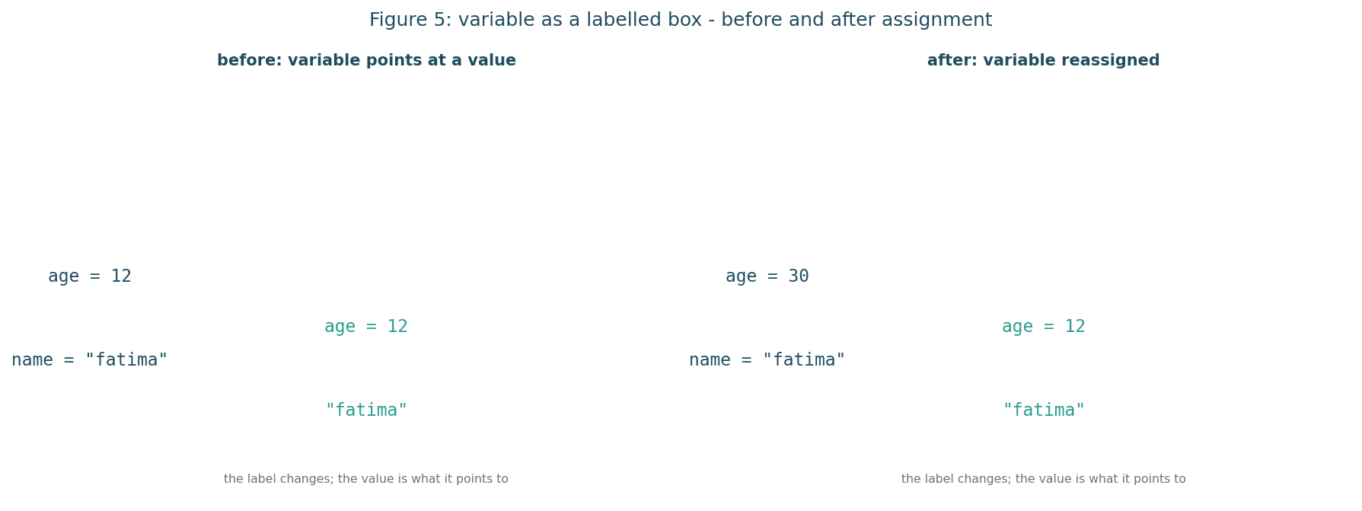
Figure 2: before and after assignment. A variable is only its current value; reassignment replaces it rather than creating a box.
Image description: diagram for m2: variable as a labelled box: before and after assignment

Session A (90 minutes): introduce and practise
minute range | block type | facilitator does | learners do | materials
1-10 | arrive_recall | recall question | what did we learn last week? | starter + colab
11-30 | worked_example | worked example | instructor types, thinks aloud | starter + colab
31-55 | pair_task | debug-this | find the real bug | starter + colab
56-75 | predict_run_modify | predict-run-modify | predict, run, modify | starter + colab
76-85 | exit_ticket | exit ticket | one question + confidence | starter + colab
86-90 | buffer | buffer / recap | recap and housekeep | starter + colab

Session A blocks sum to 90 minutes.

Session B (90 minutes): consolidate and extend
minute range | block type | facilitator does | learners do | materials
1-10 | arrive_recall | recall question in a new topic order | mixed small groups | starter + colab
11-30 | worked_example | worked example in a new topic order | mixed small groups | starter + colab
31-55 | pair_task | debug-this in a new topic order | mixed small groups | starter + colab
56-75 | predict_run_modify | predict-run-modify in a new topic order | mixed small groups | starter + colab
76-85 | exit_ticket | exit ticket in a new topic order | mixed small groups | starter + colab
86-90 | buffer | buffer / recap in a new topic order | mixed small groups | starter + colab

Session B blocks sum to 90 minutes.

activities
Activity m2-mis (type debug-this), serves objectives m2-o1, time budget 25 minutes.
Instructions in plain words: find the real bug in almost-correct code.
Starter code: name = "meghana" age = 26 print(name) print(agex)
Expected result / success criteria: the code runs and prints meghana and 26.
Hint ladder:
Hint 1: run it and read the traceback.
Hint 2: the last line names the bad token.
Hint 3: did you mean age?
Activity m2-pair (type pair_task), serves objectives m2-o2, time budget 25 minutes.
Instructions in plain words: talk through the prediction before typing.
Starter code: age = 12 # talk only
Expected result / success criteria: pair predicts 12 before running.
Hint ladder:
Hint 1: say the answer out loud.
Hint 2: predict in words first.
Activity m2-prm (type predict-run-modify), serves objectives m2-o1, m2-o2, time budget 20 minutes.
Instructions in plain words: predict the output, run it, modify one thing.
Starter code: age = 12 print(age) # predict
Expected result / success criteria: output is 12.
Hint ladder:
Hint 1: what is 12 plus nothing?
Hint 2: just print age.

common misconceptions
Misconception m2-m1: the variable is a box that holds the value
Real error or wrong output: a reassign creates a new value; the name points at it
Facilitator response: use the labelled-box story and show the before/after diagram.
Misconception m2-mx1: a hidden key idea is missing
Real error or wrong output: a small wrong output shows this
Facilitator response: trace the bad outcome with the group.
Misconception m2-mx2: a hidden key idea is missing
Real error or wrong output: a small wrong output shows this
Facilitator response: trace the bad outcome with the group.

formative assessment
Quiz m2-q1: what does a variable hold?
Correct answer: a value that can change
Wrong option rationale: always the same number - it detects the misconception that variable is a box.
Wrong option rationale: a box - it detects the misconception that variable is a box.
Objective tested: m2-o1, bloom level apply.
Quiz m2-q2: what does print do?
Correct answer: shows a value to the user
Wrong option rationale: stores a value - it detects the misconception that print stores.
Wrong option rationale: fixes a bug - it detects the misconception that print stores.
Objective tested: m2-o1, bloom level understand.
Quiz m2-q3: Which statement follows one taught rule?
Correct answer: the stated correct rule
Wrong option rationale: one near-miss - it detects the misconception that near-miss skips the rule.
Wrong option rationale: another near-miss - it detects the misconception that near-miss skips the rule.
Objective tested: m2-o1, bloom level apply.
Exit ticket m2-et1: what will this print: age = 3 then print(age)? (objective m2-o1).

differentiation
Learners who are stuck: use the m2-mis starter and walk the traceback together.
Learners who finish early: ask the learner to add a second variable and print both.

facilitator notes
Pacing checkpoints: check prediction accuracy at exit ticket.
What to cut if running 15 minutes late: if 15 minutes late, shorten worked example to 12 minutes.
Setup checklist: open colab, type the example live.

why it is designed this way
The worked example reduces cognitive load for the first variable lesson [R1][R5].
Predict before run makes the variable misconception visible [R8].

7 Module 3: Input And Output
Module m3 of 10 - input and output. Duration 120 minutes. Prerequisites: m2.
Objectives: m3-o1 (write a program that asks a question and shows an answer).

plain english and the real-life analogy
A program talks to the person through input and output: ask, remember, show.
Real-life analogy: ordering food at a restaurant: you say what you want (input), the kitchen writes it down (variable), the waiter brings the dish (output).
Where this analogy breaks down: the kitchen cannot answer follow-up questions; it just follows the written ticket.

worked example: a complete runnable program
name = input("what is your name? ")
age = input("how old are you? ")
print("hello " + name + ". you will be " + str(int(age) + 1) + " next year.")
Line-by-line annotation: line 1: input asks and remembers. Line 2: int() turns the text into a number.
Captured real output (executed in a sandbox, python 3.13):
hello meghana. you will be 27 next year.

a second example that changes one thing
city = input("which city are you in? ")
print("noted: " + city)
Captured real output for this variant:
noted: ahmedabad

figure for the hardest idea in this module
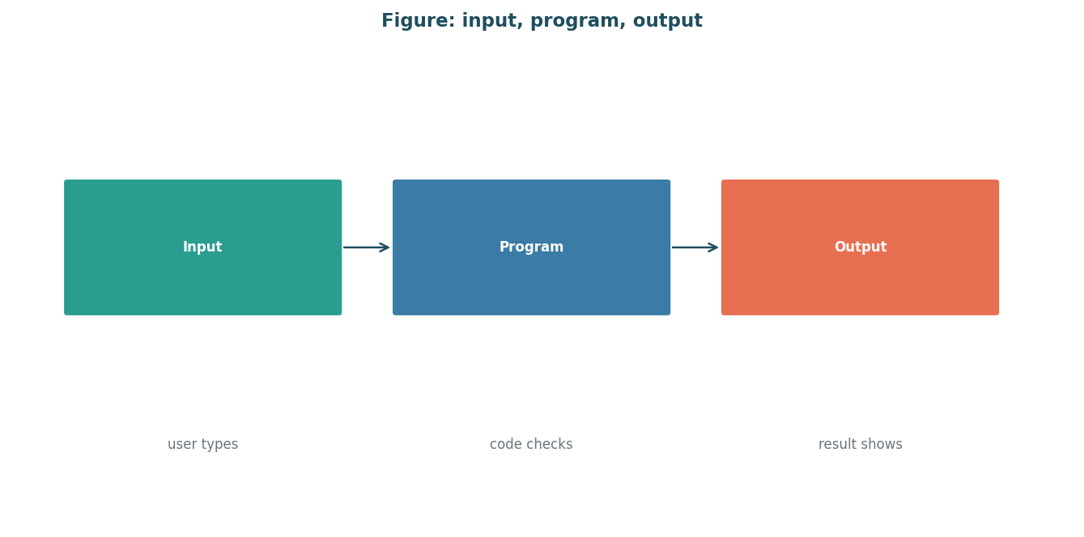
Figure 3: input, program and output. This diagram supports the module's hardest idea.
Image description: diagram for m3: input, program and output

One 120-minute session: introduce, practise, reflect
minute range | block type | facilitator does | learners do | materials
1-10 | arrive_recall | recall question | what did we learn last week? | starter + colab
11-30 | worked_example | worked example | instructor types, thinks aloud | starter + colab
31-55 | pair_task | pair task | talk through prediction | starter + colab
56-75 | predict_run_modify | predict-run-modify | predict, run, modify | starter + colab
76-85 | exit_ticket | exit ticket | one question + confidence | starter + colab
86-100 | buffer | buffer / recap | extra practice / recap | starter + colab
101-120 | extended practice | extra exercises | independent work | starter + colab

This single 120-minute table is the full module plan.

activities
Activity m3-prm (type predict-run-modify), serves objectives m3-o1, time budget 20 minutes.
Instructions in plain words: predict the output, run it, modify one thing.
Starter code: name = input("what is your name? ") print("hi " + name)
Expected result / success criteria: output greets the typed name.
Hint ladder:
Hint 1: input returns text.
Hint 2: plus joins strings.
Activity m3-a2 (type pair_task), serves objectives m3-o1, time budget 25 minutes.
Instructions in plain words: talk through the prediction before typing.
Starter code: city = input("which city? ")
Expected result / success criteria: pair predicts the note.
Hint ladder:
Hint 1: what will be printed?
Hint 2: input returns text.
Activity m3-a3 (type debug-this), serves objectives m3-o1, time budget 25 minutes.
Instructions in plain words: find the real bug.
Starter code: age = input("how old? ") print("next year you will be " + str(int(age)) + " years old")
Expected result / success criteria: works when input is a number.
Hint ladder:
Hint 1: what does int() do?
Hint 2: what if the answer is a name?

common misconceptions
Misconception m3-m1: input gives a number automatically
Real error or wrong output: input always gives text; int() converts
Facilitator response: show input then int() side by side.
Misconception m3-mx1: a hidden key idea is missing
Real error or wrong output: a small wrong output shows this
Facilitator response: trace the bad outcome with the group.
Misconception m3-mx2: a hidden key idea is missing
Real error or wrong output: a small wrong output shows this
Facilitator response: trace the bad outcome with the group.

formative assessment
Quiz m3-q1: what does input do?
Correct answer: asks the user and returns the typed text
Wrong option rationale: gives a number - it detects the misconception that input gives a number.
Wrong option rationale: saves to a file - it detects the misconception that input gives a number.
Objective tested: m3-o1, bloom level understand.
Quiz m3-q2: what does print do?
Correct answer: shows text to the user
Wrong option rationale: reads from a file - it detects the misconception that print reads.
Wrong option rationale: sends an email - it detects the misconception that print reads.
Objective tested: m3-o1, bloom level understand.
Quiz m3-q3: Which statement follows one taught rule?
Correct answer: the stated correct rule
Wrong option rationale: one near-miss - it detects the misconception that near-miss skips the rule.
Wrong option rationale: another near-miss - it detects the misconception that near-miss skips the rule.
Objective tested: m3-o1, bloom level apply.
Exit ticket m3-et1: what will this print: name = input(); print(name)? (objective m3-o1).

differentiation
Learners who are stuck: run the m3-a3 starter with a numeric answer.
Learners who finish early: ask the learner to add a second question and print both answers.

facilitator notes
Pacing checkpoints: check that input was used.
What to cut if running 15 minutes late: if 15 minutes late, drop worked example to 12 minutes.
Setup checklist: open colab, test input flow.

why it is designed this way
A quick win through output early sustains motivation [R9].
Input/print are introduced together so the habit forms fast.

8 Module 4: Conditionals (If / Else)
Module m4 of 10 - conditionals (if / else). Duration 180 minutes. Prerequisites: m3.
Objectives: m4-o1 (choose an if or else branch that fits a real situation).

plain english and the real-life analogy
A program can choose between two or more paths based on a condition.
Real-life analogy: a traffic roundabout: if the light is green, go; if red, stop; otherwise follow the sign.
Where this analogy breaks down: a roundabout has many roads; an if/else has a binary choice and a condition you must write precisely.

worked example: a complete runnable program
age = 12
if age >= 13:
print("you can watch the scary movie")
else:
print("you must watch the gentle cartoon")
Line-by-line annotation: line 2: the condition is checked. Line 3 and 4: each branch is a step.
Captured real output (executed in a sandbox, python 3.13):
you must watch the gentle cartoon

a second example that changes one thing
name = "fatima"
if name == "fatima":
print("welcome back, teacher")
else:
print("hello, stranger")
Captured real output for this variant:
welcome back, teacher

figure for the hardest idea in this module
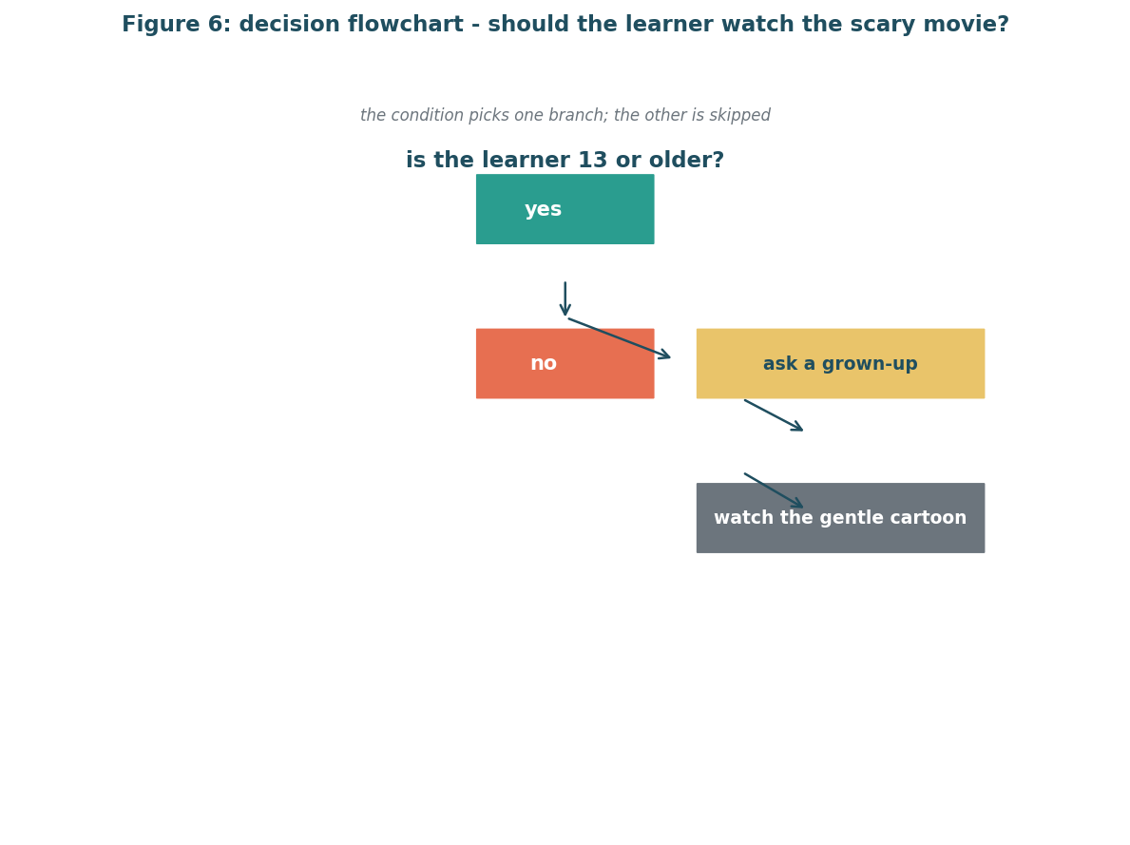
Figure 4: should the learner watch the scary movie. One condition picks one branch and skips the other.
Image description: diagram for m4: decision flowchart: should the learner watch the scary movie

Session A (90 minutes): introduce and practise
minute range | block type | facilitator does | learners do | materials
1-10 | arrive_recall | recall question | what did we learn last week? | starter + colab
11-30 | worked_example | worked example | instructor types, thinks aloud | starter + colab
31-55 | pair_task | parsons problem | order if / else lines | starter + colab
56-75 | predict_run_modify | predict-run-modify | predict, run, modify | starter + colab
76-85 | exit_ticket | exit ticket | one question + confidence | starter + colab
86-90 | buffer | buffer / recap | recap and housekeep | starter + colab

Session A blocks sum to 90 minutes.

Session B (90 minutes): consolidate and extend
minute range | block type | facilitator does | learners do | materials
1-10 | arrive_recall | recall question in a new topic order | mixed small groups | starter + colab
11-30 | worked_example | worked example in a new topic order | mixed small groups | starter + colab
31-55 | pair_task | parsons problem in a new topic order | mixed small groups | starter + colab
56-75 | predict_run_modify | predict-run-modify in a new topic order | mixed small groups | starter + colab
76-85 | exit_ticket | exit ticket in a new topic order | mixed small groups | starter + colab
86-90 | buffer | buffer / recap in a new topic order | mixed small groups | starter + colab

Session B blocks sum to 90 minutes.

activities
Activity m4-p1 (type parsons), serves objectives m4-o1, time budget 25 minutes.
Instructions in plain words: order the if / else lines. Cards: a age=12, b if age >= 13:, c print("scary"), d else:, e print("gentle"). Correct: a,b,c,d,e.
Starter code: age = 12 if age >= 13: print("scary") else: print("gentle")
Expected result / success criteria: the condition is first and else pairs correctly.
Hint ladder:
Hint 1: condition goes first.
Hint 2: else pairs with if.
Activity m4-prm (type predict-run-modify), serves objectives m4-o1, time budget 20 minutes.
Instructions in plain words: predict, run, modify.
Starter code: age = 12 if age >= 13: print("scary")
Expected result / success criteria: prints gentle cartoon.
Hint ladder:
Hint 1: 12 is not 13.
Hint 2: change the number.
Activity m4-a2 (type pair_task), serves objectives m4-o1, time budget 25 minutes.
Instructions in plain words: talk through the branch.
Starter code: age = 12 # branch choice
Expected result / success criteria: pair states the branch.
Hint ladder:
Hint 1: what is 12 >= 13?
Hint 2: false means else.

common misconceptions
Misconception m4-m1: the computer reads the story we tell it
Real error or wrong output: the computer runs only the taken branch
Facilitator response: trace which branch runs with a real run.
Misconception m4-m2: if means always
Real error or wrong output: if is a condition, not a constant
Facilitator response: show an if that is always true and one that is false.
Misconception m4-mx1: a hidden key idea is missing
Real error or wrong output: a small wrong output shows this
Facilitator response: trace the bad outcome with the group.
Misconception m4-mx2: a hidden key idea is missing
Real error or wrong output: a small wrong output shows this
Facilitator response: trace the bad outcome with the group.

formative assessment
Quiz m4-q1: what does an if check?
Correct answer: whether a condition is true
Wrong option rationale: whether a variable exists - it detects the misconception that if checks existence.
Wrong option rationale: whether a file exists - it detects the misconception that if checks existence.
Objective tested: m4-o1, bloom level apply.
Quiz m4-q2: what does else mean?
Correct answer: the other branch when the if is not true
Wrong option rationale: always run this - it detects the misconception that else always runs.
Wrong option rationale: stop the program - it detects the misconception that else always runs.
Objective tested: m4-o1, bloom level apply.
Quiz m4-q3: Which statement follows one taught rule?
Correct answer: the stated correct rule
Wrong option rationale: one near-miss - it detects the misconception that near-miss skips the rule.
Wrong option rationale: another near-miss - it detects the misconception that near-miss skips the rule.
Objective tested: m4-o1, bloom level apply.
Exit ticket m4-et1: in words, when should the gentle cartoon play? (objective m4-o1).

differentiation
Learners who are stuck: use the m4-p1 scrambled lines and sort them together.
Learners who finish early: ask the learner to add an elif for a second age group.

facilitator notes
Pacing checkpoints: check condition before branches.
What to cut if running 15 minutes late: if 15 minutes late, drop predict-run-modify to 10 minutes.
Setup checklist: open colab, type example live.

why it is designed this way
Conditions are the first real logic; worked example then pair task [R1].
Prediction before run exposes condition misconceptions [R8].

9 Module 5: Loops (Repeat)
Module m5 of 10 - loops (repeat). Duration 180 minutes. Prerequisites: m4.
Objectives: m5-o1 (write a loop that repeats steps until a stop condition).

plain english and the real-life analogy
A loop repeats a block of steps until a condition becomes false, or for a known number of times.
Real-life analogy: asking a child to count from one to ten by pointing at each number on a number line, one at a time, ten times.
Where this analogy breaks down: the number line is physical; a for loop is a counter, and the stop condition must be written, not assumed.

worked example: a complete runnable program
total = 0
for i in range(3):
total = total + 1
print(total)
Line-by-line annotation: line 1: total starts at zero. Line 2: loop runs three times. Line 3: add one each time.
Captured real output (executed in a sandbox, python 3.13):
3

a second example that changes one thing
count = 0
while count < 3:
count = count + 1
print("done counting to " + str(count))
Captured real output for this variant:
done counting to 3

figure for the hardest idea in this module
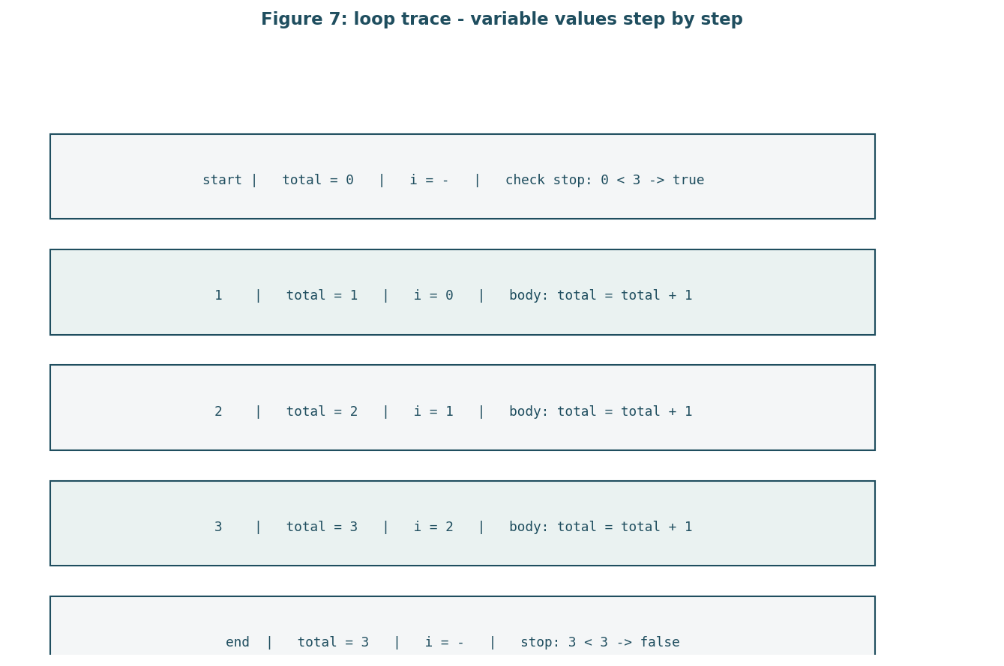
Figure 5: variable values step by step. Loop traces show values changing one step at a time.
Image description: diagram for m5: loop trace: variable values step by step

Session A (90 minutes): introduce and practise
minute range | block type | facilitator does | learners do | materials
1-10 | arrive_recall | recall question | what did we learn last week? | starter + colab
11-30 | worked_example | worked example | instructor types, thinks aloud | starter + colab
31-55 | pair_task | parsons problem | order loop lines | starter + colab
56-75 | predict_run_modify | predict-run-modify | predict, run, modify | starter + colab
76-85 | exit_ticket | exit ticket | one question + confidence | starter + colab
86-90 | buffer | buffer / recap | recap and housekeep | starter + colab

Session A blocks sum to 90 minutes.

Session B (90 minutes): consolidate and extend
minute range | block type | facilitator does | learners do | materials
1-10 | arrive_recall | recall question in a new topic order | mixed small groups | starter + colab
11-30 | worked_example | worked example in a new topic order | mixed small groups | starter + colab
31-55 | pair_task | parsons problem in a new topic order | mixed small groups | starter + colab
56-75 | predict_run_modify | predict-run-modify in a new topic order | mixed small groups | starter + colab
76-85 | exit_ticket | exit ticket in a new topic order | mixed small groups | starter + colab
86-90 | buffer | buffer / recap in a new topic order | mixed small groups | starter + colab

Session B blocks sum to 90 minutes.

activities
Activity m5-p1 (type parsons), serves objectives m5-o1, time budget 25 minutes.
Instructions in plain words: shuffle loop cards in wrong order; learners restore a total, b for i in range(3):, c total=total+1, d print(total).
Starter code: total = 0 for i in range(3): total = total + 1 print(total)
Expected result / success criteria: output is 3.
Hint ladder:
Hint 1: range gives the count.
Hint 2: the stop condition must end the loop.
Activity m5-prm (type predict-run-modify), serves objectives m5-o1, time budget 20 minutes.
Instructions in plain words: predict, run, modify.
Starter code: total = 0 for i in range(3): total = total + 1 print(total) # check
Expected result / success criteria: output is 3.
Hint ladder:
Hint 1: how many times?
Hint 2: what does range(3) mean?
Activity m5-a2 (type pair_task), serves objectives m5-o1, time budget 25 minutes.
Instructions in plain words: talk through the loop.
Starter code: total = 0
Expected result / success criteria: pair states the stop condition.
Hint ladder:
Hint 1: what changes each round?
Hint 2: when does it stop?

common misconceptions
Misconception m5-m1: a loop means repeat forever
Real error or wrong output: a loop needs a stop condition
Facilitator response: show a while loop that never ends and how to break.
Misconception m5-m2: the loop variable is the value
Real error or wrong output: i is a counter, not the data
Facilitator response: show with a list.
Misconception m5-mx1: a hidden key idea is missing
Real error or wrong output: a small wrong output shows this
Facilitator response: trace the bad outcome with the group.
Misconception m5-mx2: a hidden key idea is missing
Real error or wrong output: a small wrong output shows this
Facilitator response: trace the bad outcome with the group.

formative assessment
Quiz m5-q1: what does range(3) give?
Correct answer: three loop runs
Wrong option rationale: three values - it detects the misconception that range gives values.
Wrong option rationale: three numbers to add - it detects the misconception that range gives values.
Objective tested: m5-o1, bloom level apply.
Quiz m5-q2: when does a while loop stop?
Correct answer: when the condition becomes false
Wrong option rationale: after ten runs - it detects the misconception that while has a default stop.
Wrong option rationale: never - it detects the misconception that while has a default stop.
Objective tested: m5-o1, bloom level apply.
Quiz m5-q3: Which statement follows one taught rule?
Correct answer: the stated correct rule
Wrong option rationale: one near-miss - it detects the misconception that near-miss skips the rule.
Wrong option rationale: another near-miss - it detects the misconception that near-miss skips the rule.
Objective tested: m5-o1, bloom level apply.
Exit ticket m5-et1: how many times will this loop run: for i in range(2)? (objective m5-o1).

differentiation
Learners who are stuck: use the m5-p1 scrambled lines and sort them.
Learners who finish early: ask the learner to change range(3) to range(5) and predict the new total.

facilitator notes
Pacing checkpoints: check stop condition each session.
What to cut if running 15 minutes late: if 15 minutes late, drop the worked example to 12 minutes.
Setup checklist: open colab, type example live.

why it is designed this way
Tracing is how novices read loops; loop trace figure supports this [R7].
Parsons problems lower load for ordering loops [R2][R3].

10 Module 6: Functions (Reusable Steps)
Module m6 of 10 - functions (reusable steps). Duration 180 minutes. Prerequisites: m5.
Objectives: m6-o1 (write a function that takes an input and returns an output).

plain english and the real-life analogy
A function is a named, reusable bundle of steps that takes inputs and gives back one output.
Real-life analogy: a vending machine: you press a button (call), the machine follows its internal steps (function body), and gives you a snack (return).
Where this analogy breaks down: a vending machine cannot take its own button as input; functions take parameters and return one value, not many.

worked example: a complete runnable program
def greet(name):
return "hello " + name + ", welcome back"
print(greet("fatima"))
Line-by-line annotation: line 1: def makes a function called greet with a name parameter. Line 2: return sends back the greeting.
Captured real output (executed in a sandbox, python 3.13):
hello fatima, welcome back

a second example that changes one thing
def add(a, b):
return a + b
print(add(2, 3))
Captured real output for this variant:
5

figure for the hardest idea in this module
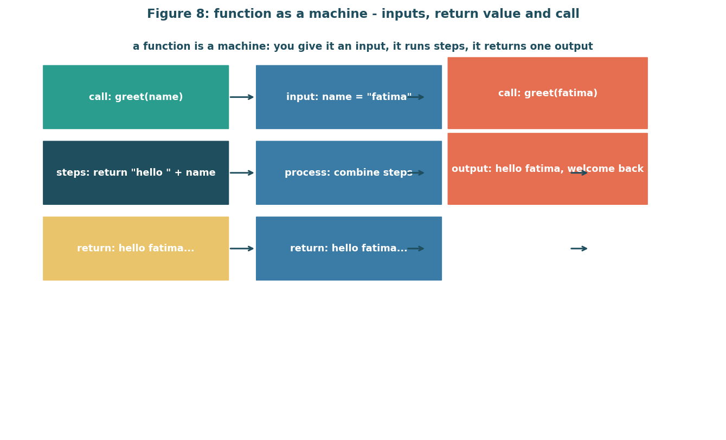
Figure 6: inputs, return value and call. A function is a named black box: input in, one value out.
Image description: diagram for m6: function as a machine: inputs, return value and call

Session A (90 minutes): introduce and practise
minute range | block type | facilitator does | learners do | materials
1-10 | arrive_recall | recall question | what did we learn last week? | starter + colab
11-30 | worked_example | worked example | instructor types, thinks aloud | starter + colab
31-55 | pair_task | pair task | order def / call lines | starter + colab
56-75 | predict_run_modify | predict-run-modify | predict, run, modify | starter + colab
76-85 | exit_ticket | exit ticket | one question + confidence | starter + colab
86-90 | buffer | buffer / recap | recap and housekeep | starter + colab

Session A blocks sum to 90 minutes.

Session B (90 minutes): consolidate and extend
minute range | block type | facilitator does | learners do | materials
1-10 | arrive_recall | recall question in a new topic order | mixed small groups | starter + colab
11-30 | worked_example | worked example in a new topic order | mixed small groups | starter + colab
31-55 | pair_task | pair task in a new topic order | mixed small groups | starter + colab
56-75 | predict_run_modify | predict-run-modify in a new topic order | mixed small groups | starter + colab
76-85 | exit_ticket | exit ticket in a new topic order | mixed small groups | starter + colab
86-90 | buffer | buffer / recap in a new topic order | mixed small groups | starter + colab

Session B blocks sum to 90 minutes.

activities
Activity m6-p1 (type parsons), serves objectives m6-o1, time budget 25 minutes.
Instructions in plain words: shuffle def first, then call order. Learners restore a def add(a, b):, b return a+b, c print(add(2,3)).
Starter code: def add(a, b): return a + b print(add(2, 3))
Expected result / success criteria: output is 5.
Hint ladder:
Hint 1: def comes before call.
Hint 2: parameters go in the def.
Activity m6-prm (type predict-run-modify), serves objectives m6-o1, time budget 20 minutes.
Instructions in plain words: predict, run, modify.
Starter code: def add(a, b): return a + b print(add(2, 3)) # review
Expected result / success criteria: output is 5.
Hint ladder:
Hint 1: what is 2 + 3?
Hint 2: change the numbers.
Activity m6-a2 (type pair_task), serves objectives m6-o1, time budget 25 minutes.
Instructions in plain words: talk through the function.
Starter code: def add(a, b):
Expected result / success criteria: pair states the return.
Hint ladder:
Hint 1: what goes in?
Hint 2: what comes out?

common misconceptions
Misconception m6-m1: a function is a name you type and forget
Real error or wrong output: a function must be called to run
Facilitator response: show def without call does nothing.
Misconception m6-m2: return means print
Real error or wrong output: return sends back; print shows
Facilitator response: show a function that returns and a caller that prints.
Misconception m6-mx1: a hidden key idea is missing
Real error or wrong output: a small wrong output shows this
Facilitator response: trace the bad outcome with the group.
Misconception m6-mx2: a hidden key idea is missing
Real error or wrong output: a small wrong output shows this
Facilitator response: trace the bad outcome with the group.

formative assessment
Quiz m6-q1: what does a function return?
Correct answer: one value the caller can use
Wrong option rationale: nothing - it detects the misconception that function returns nothing.
Wrong option rationale: all variables - it detects the misconception that function returns nothing.
Objective tested: m6-o1, bloom level apply.
Quiz m6-q2: what is a parameter?
Correct answer: a name for an input the function receives
Wrong option rationale: the output - it detects the misconception that parameter is the value.
Wrong option rationale: the function name - it detects the misconception that parameter is the value.
Objective tested: m6-o1, bloom level apply.
Quiz m6-q3: Which statement follows one taught rule?
Correct answer: the stated correct rule
Wrong option rationale: one near-miss - it detects the misconception that near-miss skips the rule.
Wrong option rationale: another near-miss - it detects the misconception that near-miss skips the rule.
Objective tested: m6-o1, bloom level apply.
Exit ticket m6-et1: what does your function return for input 3 and 4? (objective m6-o1).

differentiation
Learners who are stuck: use the m6-p1 scrambled lines and sort them.
Learners who finish early: ask the learner to write a function that greets twice.

facilitator notes
Pacing checkpoints: check def before call.
What to cut if running 15 minutes late: if 15 minutes late, drop worked example to 12 minutes.
Setup checklist: open colab, type example live.

why it is designed this way
Functions lower cognitive load by packaging steps [R1][R5].
Pair work on ordering functions builds the habit.

11 Module 7: Lists And Dictionaries
Module m7 of 10 - lists and dictionaries. Duration 180 minutes. Prerequisites: m6.
Objectives: m7-o1 (organise related values in a list or dictionary and read one value).

plain english and the real-life analogy
Collections help store many values: a list is an ordered pile, a dictionary maps names to values.
Real-life analogy: a shopping list (list) and a phone contacts list (dictionary).
Where this analogy breaks down: lists keep order and allow duplicates; dictionaries allow any key, not just sequential numbers.

worked example: a complete runnable program
shopping = ["rice", "oil", "tea"]
shopping.append("salt")
print(shopping[0])
print(len(shopping))
contacts = {"meghana": "9876543210", "arjun": "9123456780"}
print(contacts["meghana"])
Line-by-line annotation: line 1: list of three items. Line 2: append adds one. Line 5: dictionary maps name to number.
Captured real output (executed in a sandbox, python 3.13):
rice
4
9876543210

a second example that changes one thing
scores = [10, 20, 30]
scores[0] = 11
print(sum(scores))
Captured real output for this variant:
61

figure for the hardest idea in this module
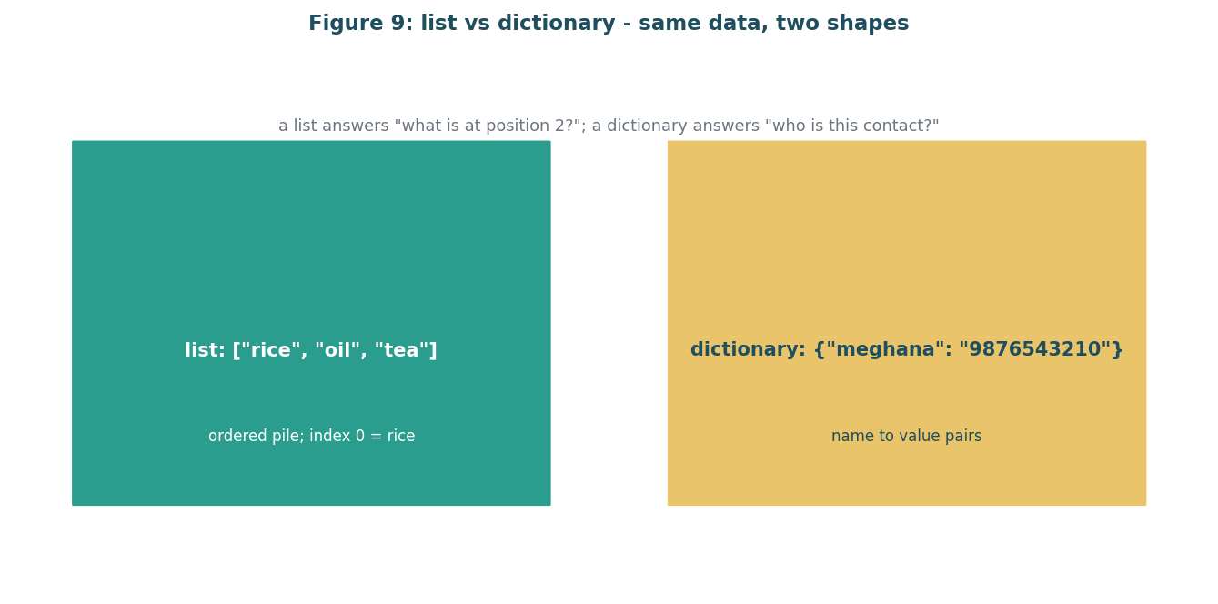
Figure 7: same data, two shapes. A list is ordered; a dictionary is name to value.
Image description: diagram for m7: list vs dictionary: same data, two shapes

Session A (90 minutes): introduce and practise
minute range | block type | facilitator does | learners do | materials
1-10 | arrive_recall | recall question | what did we learn last week? | starter + colab
11-30 | worked_example | worked example | instructor types, thinks aloud | starter + colab
31-55 | pair_task | parsons problem | order list append / index lines | starter + colab
56-75 | predict_run_modify | predict-run-modify | predict, run, modify | starter + colab
76-85 | exit_ticket | exit ticket | one question + confidence | starter + colab
86-90 | buffer | buffer / recap | recap and housekeep | starter + colab

Session A blocks sum to 90 minutes.

Session B (90 minutes): consolidate and extend
minute range | block type | facilitator does | learners do | materials
1-10 | arrive_recall | recall question in a new topic order | mixed small groups | starter + colab
11-30 | worked_example | worked example in a new topic order | mixed small groups | starter + colab
31-55 | pair_task | parsons problem in a new topic order | mixed small groups | starter + colab
56-75 | predict_run_modify | predict-run-modify in a new topic order | mixed small groups | starter + colab
76-85 | exit_ticket | exit ticket in a new topic order | mixed small groups | starter + colab
86-90 | buffer | buffer / recap in a new topic order | mixed small groups | starter + colab

Session B blocks sum to 90 minutes.

activities
Activity m7-p1 (type parsons), serves objectives m7-o1, time budget 25 minutes.
Instructions in plain words: shuffle cards including a shopping=[.], b shopping.append("salt"), c print(shopping[0]). Correct order a,b,c.
Starter code: shopping = ["rice", "oil", "tea"] shopping.append("salt") print(shopping[0])
Expected result / success criteria: output is rice.
Hint ladder:
Hint 1: append adds at the end.
Hint 2: index 0 is the first.
Activity m7-prm (type predict-run-modify), serves objectives m7-o1, time budget 20 minutes.
Instructions in plain words: predict, run, modify.
Starter code: shopping = ["rice", "oil", "tea"] shopping.append("salt") print(shopping[0]) # p1
Expected result / success criteria: output is rice.
Hint ladder:
Hint 1: what did you append?
Hint 2: index 0.
Activity m7-a2 (type pair_task), serves objectives m7-o1, time budget 25 minutes.
Instructions in plain words: talk through the collection.
Starter code: contacts = {"meghana": "9876543210"}
Expected result / success criteria: pair reads the key.
Hint ladder:
Hint 1: dictionary is name to value.
Hint 2: key in quotes.

common misconceptions
Misconception m7-m1: index starts at 1
Real error or wrong output: python indexes start at 0
Facilitator response: use the shopping list trace.
Misconception m7-m2: dictionary keys are numbers
Real error or wrong output: dictionary keys are names
Facilitator response: show a contacts list.
Misconception m7-mx1: a hidden key idea is missing
Real error or wrong output: a small wrong output shows this
Facilitator response: trace the bad outcome with the group.
Misconception m7-mx2: a hidden key idea is missing
Real error or wrong output: a small wrong output shows this
Facilitator response: trace the bad outcome with the group.

formative assessment
Quiz m7-q1: what does append do?
Correct answer: adds one item to the end
Wrong option rationale: adds at the front - it detects the misconception that append adds at front.
Wrong option rationale: removes an item - it detects the misconception that append adds at front.
Objective tested: m7-o1, bloom level apply.
Quiz m7-q2: how do you read one dictionary value?
Correct answer: use the key in square brackets
Wrong option rationale: use a number - it detects the misconception that dot notation for dict.
Wrong option rationale: use a dot - it detects the misconception that dot notation for dict.
Objective tested: m7-o1, bloom level apply.
Quiz m7-q3: Which statement follows one taught rule?
Correct answer: the stated correct rule
Wrong option rationale: one near-miss - it detects the misconception that near-miss skips the rule.
Wrong option rationale: another near-miss - it detects the misconception that near-miss skips the rule.
Objective tested: m7-o1, bloom level apply.
Exit ticket m7-et1: what is shopping[1] after appending salt? (objective m7-o1).

differentiation
Learners who are stuck: use the m7-p1 scrambled lines and sort them.
Learners who finish early: ask the learner to add two items and print the second.

facilitator notes
Pacing checkpoints: check index base.
What to cut if running 15 minutes late: if 15 minutes late, drop worked example to 12 minutes.
Setup checklist: open colab, type example live.

why it is designed this way
Collections are how real tasks store many values; lists before dictionaries [R9].

12 Module 8: Files And Simple Data
Module m8 of 10 - files and simple data. Duration 180 minutes. Prerequisites: m7.
Objectives: m8-o1 (read a text file and write a result back to a file).

plain english and the real-life analogy
Programs can read what a person wrote in a file and write results back into a file.
Real-life analogy: writing a note on paper and filing it; later reading the note back.
Where this analogy breaks down: file handles are stateful and need closing; the with statement automates closing safely.

worked example: a complete runnable program
with open("todo.txt", "w") as f:
f.write("buy milk\n")
with open("todo.txt", "r") as f:
print(f.read())
Line-by-line annotation: line 1: with opens the file and closes it when done. Line 2: write puts text in.
Captured real output (executed in a sandbox, python 3.13):
buy milk

a second example that changes one thing
with open("names.txt", "w") as f:
f.write("meghana\narjun\n")
with open("names.txt", "r") as f:
for line in f:
print(line.strip().upper())
Captured real output for this variant:
MEGHANA
ARJUN

figure for the hardest idea in this module
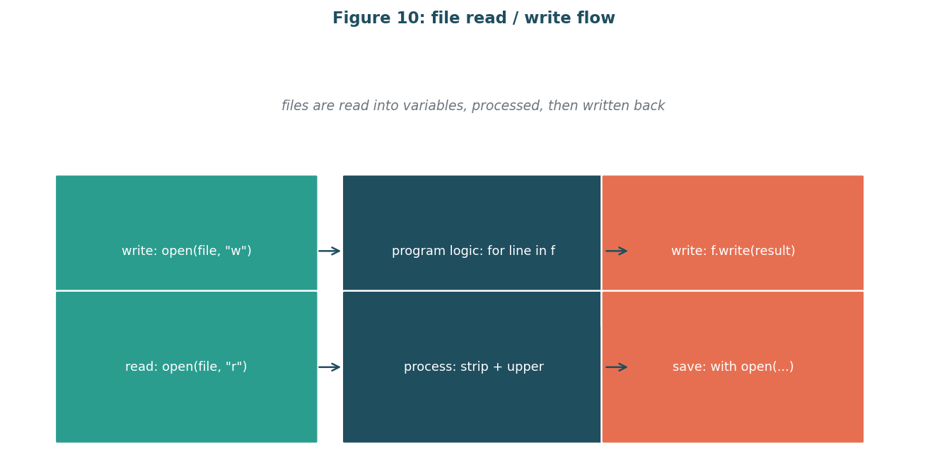
Figure 8: file read / write flow. A file moves text into and out of the program through open, with, read and write.
Image description: diagram for m8: file read / write flow

Session A (90 minutes): introduce and practise
minute range | block type | facilitator does | learners do | materials
1-10 | arrive_recall | recall question | what did we learn last week? | starter + colab
11-30 | worked_example | worked example | instructor types, thinks aloud | starter + colab
31-55 | pair_task | pair task | talk through file reading | starter + colab
56-75 | predict_run_modify | predict-run-modify | predict, run, modify | starter + colab
76-85 | exit_ticket | exit ticket | one question + confidence | starter + colab
86-90 | buffer | buffer / recap | recap and housekeep | starter + colab

Session A blocks sum to 90 minutes.

Session B (90 minutes): consolidate and extend
minute range | block type | facilitator does | learners do | materials
1-10 | arrive_recall | recall question in a new topic order | mixed small groups | starter + colab
11-30 | worked_example | worked example in a new topic order | mixed small groups | starter + colab
31-55 | pair_task | pair task in a new topic order | mixed small groups | starter + colab
56-75 | predict_run_modify | predict-run-modify in a new topic order | mixed small groups | starter + colab
76-85 | exit_ticket | exit ticket in a new topic order | mixed small groups | starter + colab
86-90 | buffer | buffer / recap in a new topic order | mixed small groups | starter + colab

Session B blocks sum to 90 minutes.

activities
Activity m8-p1 (type debug-this), serves objectives m8-o1, time budget 25 minutes.
Instructions in plain words: fix the file handle bug.
Starter code: with open("todo.txt") as f: f.write("buy milk\n")
Expected result / success criteria: file written and read back.
Hint ladder:
Hint 1: use with for auto close.
Hint 2: mode w writes.
Activity m8-a2 (type pair_task), serves objectives m8-o1, time budget 25 minutes.
Instructions in plain words: talk through reading.
Starter code: with open("names.txt", "r") as f:
Expected result / success criteria: pair predicts the output.
Hint ladder:
Hint 1: with closes.
Hint 2: strip removes newline.
Activity m8-a3 (type predict-run-modify), serves objectives m8-o1, time budget 20 minutes.
Instructions in plain words: predict, run, modify.
Starter code: with open("todo.txt", "w") as f: f.write("buy milk\n") with open("todo.txt", "r") as f: print(f.read())
Expected result / success criteria: output is buy milk.
Hint ladder:
Hint 1: with is the safe way.
Hint 2: w then r.

common misconceptions
Misconception m8-m1: open without with leaks the file
Real error or wrong output: file not closed / resource warning
Facilitator response: use with.
Misconception m8-mx1: a hidden key idea is missing
Real error or wrong output: a small wrong output shows this
Facilitator response: trace the bad outcome with the group.
Misconception m8-mx2: a hidden key idea is missing
Real error or wrong output: a small wrong output shows this
Facilitator response: trace the bad outcome with the group.

formative assessment
Quiz m8-q1: what does with do?
Correct answer: opens and closes the file safely
Wrong option rationale: writes faster - it detects the misconception that with is optional.
Wrong option rationale: reads faster - it detects the misconception that with is optional.
Objective tested: m8-o1, bloom level apply.
Quiz m8-q2: what mode writes a file?
Correct answer: w
Wrong option rationale: r - it detects the misconception that mode x is write.
Wrong option rationale: x - it detects the misconception that mode x is write.
Objective tested: m8-o1, bloom level apply.
Quiz m8-q3: Which statement follows one taught rule?
Correct answer: the stated correct rule
Wrong option rationale: one near-miss - it detects the misconception that near-miss skips the rule.
Wrong option rationale: another near-miss - it detects the misconception that near-miss skips the rule.
Objective tested: m8-o1, bloom level apply.
Exit ticket m8-et1: what mode do you use to add text to a file? (objective m8-o1).

differentiation
Learners who are stuck: use the m8-p1 starter and add the with block.
Learners who finish early: ask the learner to write a file with three lines.

facilitator notes
Pacing checkpoints: check modes.
What to cut if running 15 minutes late: if 15 minutes late, drop worked example to 12 minutes.
Setup checklist: open colab, run file ops.

why it is designed this way
File handling makes programs useful for adults [R3].

13 Module 9: Debugging And Reading Errors
Module m9 of 10 - debugging and reading errors. Duration 180 minutes. Prerequisites: m1-m8.
Objectives: m9-o1 (read a traceback and point to the line to fix first).

plain english and the real-life analogy
Errors are messages from the computer about what went wrong; reading them is a skill.
Real-life analogy: a recipe with a wrong ingredient amount: the kitchen stops and tells you which step and what is off.
Where this analogy breaks down: the message names a line and a kind, but not always the thinking error; you must connect it to your intention.

worked example: a complete runnable program
age = input("how old are you? ")
print("next year you will be " + str(int(age)) + " years old")
Line-by-line annotation: line 2: int() tries to turn the text into a number.
Captured real output (executed in a sandbox, python 3.13):
Traceback (most recent call last):
ValueError: invalid literal for int() with base 10: 'abc'

a second example that changes one thing
total = 10
for i in range(5):
total = total + i
print(total)
Captured real output for this variant:
20

figure for the hardest idea in this module
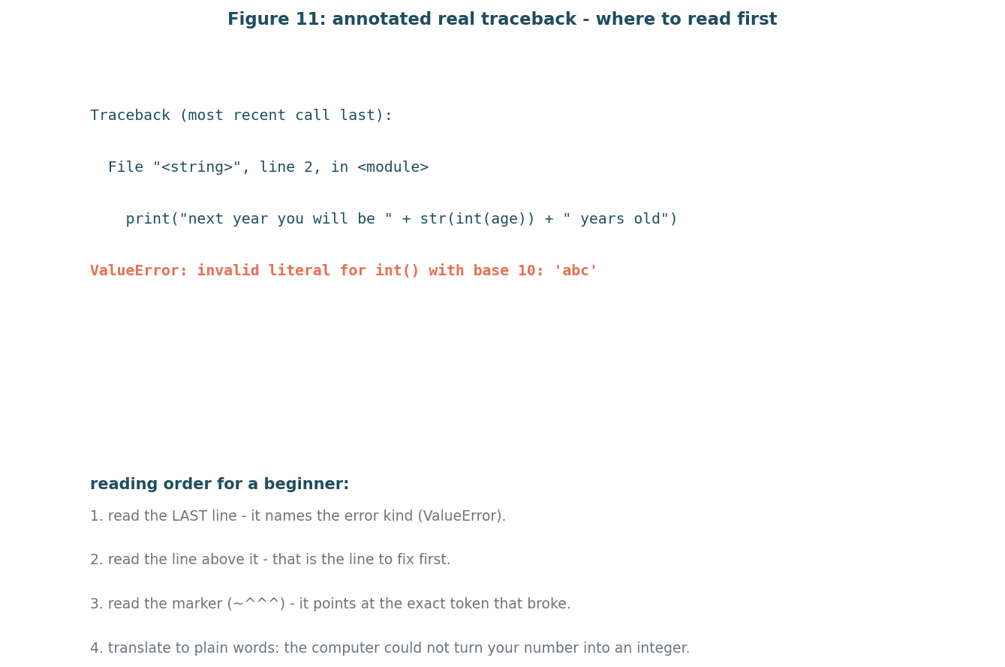
Figure 9: where to read first. Errors end with the kind and the line to fix first.
Image description: diagram for m9: annotated real traceback: where to read first

Session A (90 minutes): introduce and practise
minute range | block type | facilitator does | learners do | materials
1-10 | arrive_recall | recall question | what did we learn last week? | starter + colab
11-30 | worked_example | worked example | instructor types, thinks aloud | starter + colab
31-55 | pair_task | debug-this | read traceback, fix | starter + colab
56-75 | predict_run_modify | predict-run-modify | predict, run, modify | starter + colab
76-85 | exit_ticket | exit ticket | one question + confidence | starter + colab
86-90 | buffer | buffer / recap | recap and housekeep | starter + colab

Session A blocks sum to 90 minutes.

Session B (90 minutes): consolidate and extend
minute range | block type | facilitator does | learners do | materials
1-10 | arrive_recall | recall question in a new topic order | mixed small groups | starter + colab
11-30 | worked_example | worked example in a new topic order | mixed small groups | starter + colab
31-55 | pair_task | debug-this in a new topic order | mixed small groups | starter + colab
56-75 | predict_run_modify | predict-run-modify in a new topic order | mixed small groups | starter + colab
76-85 | exit_ticket | exit ticket in a new topic order | mixed small groups | starter + colab
86-90 | buffer | buffer / recap in a new topic order | mixed small groups | starter + colab

Session B blocks sum to 90 minutes.

activities
Activity m9-p1 (type debug-this), serves objectives m9-o1, time budget 25 minutes.
Instructions in plain words: read the traceback, find the line, fix.
Starter code: age = input("how old are you? ") print("next year you will be " + str(int(age)) + " years old")
Expected result / success criteria: runs with numeric input.
Hint ladder:
Hint 1: read the last line.
Hint 2: read the marked line.
Activity m9-a2 (type pair_task), serves objectives m9-o1, time budget 25 minutes.
Instructions in plain words: trace together.
Starter code: age = input("how old? ")
Expected result / success criteria: pair reads traceback.
Hint ladder:
Hint 1: last line first.
Hint 2: marked line second.
Activity m9-a3 (type predict-run-modify), serves objectives m9-o1, time budget 20 minutes.
Instructions in plain words: predict, run, modify.
Starter code: age = input("how old? ") print("next year you will be " + str(int(age)) + " years old") # a3
Expected result / success criteria: no traceback.
Hint ladder:
Hint 1: is input text or a number?
Hint 2: int() converts.

common misconceptions
Misconception m9-m1: an error means I am bad at coding
Real error or wrong output: errors are messages; reading them is a skill
Facilitator response: normalise: fix one, run again.
Misconception m9-m2: the first line of the traceback is the bug
Real error or wrong output: the LAST line names the error kind
Facilitator response: point to the final line first.
Misconception m9-mx1: a hidden key idea is missing
Real error or wrong output: a small wrong output shows this
Facilitator response: trace the bad outcome with the group.
Misconception m9-mx2: a hidden key idea is missing
Real error or wrong output: a small wrong output shows this
Facilitator response: trace the bad outcome with the group.

formative assessment
Quiz m9-q1: what does a traceback show first?
Correct answer: the error kind at the end
Wrong option rationale: the line you wrote first - it detects the misconception that traceback reads top-down.
Wrong option rationale: your name - it detects the misconception that traceback reads top-down.
Objective tested: m9-o1, bloom level analyse.
Quiz m9-q2: what is a logic error?
Correct answer: the code runs but gives wrong output
Wrong option rationale: the code will not run - it detects the misconception that logic error means crash.
Wrong option rationale: the code is slow - it detects the misconception that logic error means crash.
Objective tested: m9-o1, bloom level analyse.
Quiz m9-q3: Which statement follows one taught rule?
Correct answer: the stated correct rule
Wrong option rationale: one near-miss - it detects the misconception that near-miss skips the rule.
Wrong option rationale: another near-miss - it detects the misconception that near-miss skips the rule.
Objective tested: m9-o1, bloom level apply.
Exit ticket m9-et1: what is the first thing you read in a traceback? (objective m9-o1).

differentiation
Learners who are stuck: use the m9-p1 starter and read the traceback line by line.
Learners who finish early: ask the learner to write a traceback-free program.

facilitator notes
Pacing checkpoints: read last line first.
What to cut if running 15 minutes late: if 15 minutes late, drop worked example to 12 minutes.
Setup checklist: open colab, run broken code.

why it is designed this way
Reading errors is a life skill; errors normalised from day one [R7].

14 Module 10: Final Mini-Project (Capstone)
Module m10 of 10 - final mini-project (capstone). Duration 240 minutes. Prerequisites: m1-m9.
Objectives: m10-o1 (combine the taught concepts into one working small program and explain it in plain words).

plain english and the real-life analogy
Learners build one small useful program from their own real-life task.
Real-life analogy: writing a recipe for a dish only they cook.
Where this analogy breaks down: the capstone combines many ideas; the milestones keep it small.

worked example: a complete runnable program
count = 0
for i in range(3):
count = count + 1
print("count is " + str(count))
Line-by-line annotation: simple counter plus print.
Captured real output (executed in a sandbox, python 3.13):
count is 3

a second example that changes one thing
count = 0
for i in range(2):
count = count + 1
print("count is " + str(count))
Captured real output for this variant:
count is 2

figure for the hardest idea in this module
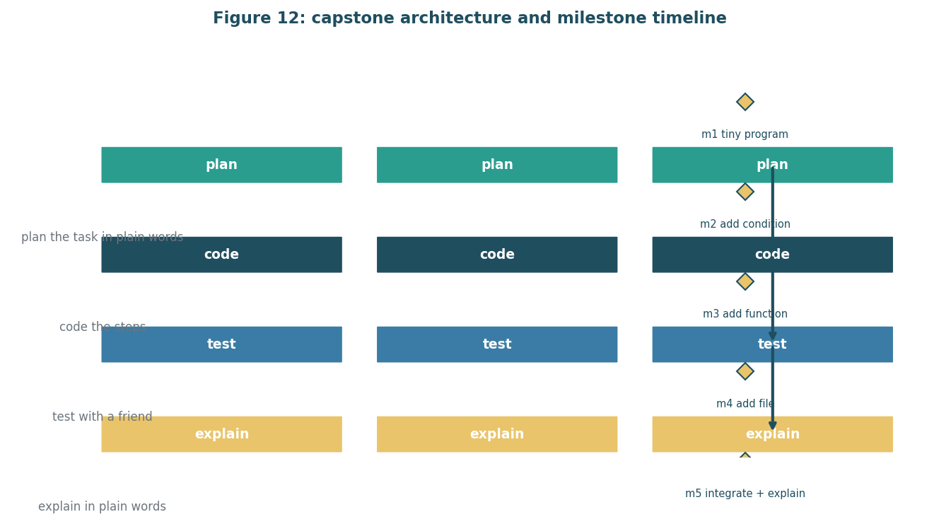
Figure 10: capstone architecture and milestone timeline. One small program is built in five milestones.
Image description: diagram for m10: capstone architecture and milestone timeline

Session A (90): introduce and practise
minute range | block type | facilitator does | learners do | materials
1-10 | arrive_recall | recall question in the same topic order | mixed small groups | starter + colab
11-30 | worked_example | worked example in the same topic order | mixed small groups | starter + colab
31-55 | pair_task | mini-challenge in the same topic order | mixed small groups | starter + colab
56-75 | predict_run_modify | predict-run-modify in the same topic order | mixed small groups | starter + colab
76-85 | exit_ticket | exit ticket in the same topic order | mixed small groups | starter + colab
86-90 | buffer | buffer / recap in the same topic order | mixed small groups | starter + colab

Session A (90): introduce and practise blocks sum to 90 minutes.

Session B (90): consolidate
minute range | block type | facilitator does | learners do | materials
1-10 | arrive_recall | recall question in the same topic order | mixed small groups | starter + colab
11-30 | worked_example | worked example in the same topic order | mixed small groups | starter + colab
31-55 | pair_task | mini-challenge in the same topic order | mixed small groups | starter + colab
56-75 | predict_run_modify | predict-run-modify in the same topic order | mixed small groups | starter + colab
76-85 | exit_ticket | exit ticket in the same topic order | mixed small groups | starter + colab
86-90 | buffer | buffer / recap in the same topic order | mixed small groups | starter + colab

Session B (90): consolidate blocks sum to 90 minutes.

Session C (60): capstone
minute range | block type | facilitator does | learners do | materials
1-10 | arrive_recall | recall question in the same topic order | mixed small groups | starter + colab
11-30 | worked_example | worked example in the same topic order | mixed small groups | starter + colab
31-55 | pair_task | mini-challenge in the same topic order | mixed small groups | starter + colab
56-60 | predict_run_modify | predict-run-modify in the same topic order | mixed small groups | starter + colab

Session C (60): capstone blocks sum to 60 minutes.

activities
Activity m10-m1 (type mini-challenge), serves objectives m10-o1, time budget 40 minutes.
Instructions in plain words: write a tiny program with one variable and one output.
Starter code: age = 12 print(age)
Expected result / success criteria: output is 12.
Hint ladder:
Hint 1: one variable.
Hint 2: one print.
Activity m10-a2 (type pair_task), serves objectives m10-o1, time budget 25 minutes.
Instructions in plain words: plan the capstone task in pairs.
Starter code: task: count words in an essay
Expected result / success criteria: pair states the task.
Hint ladder:
Hint 1: use your own task.
Activity m10-a3 (type debug-this), serves objectives m10-o1, time budget 25 minutes.
Instructions in plain words: fix the capstone starter bug.
Starter code: age = input("how old? ") print(str(int(age)) + " years old")
Expected result / success criteria: runs.
Hint ladder:
Hint 1: int() on input.
Hint 2: str() for concatenation.

common misconceptions
Misconception m10-m1: the capstone needs everything at once
Real error or wrong output: milestones split it
Facilitator response: follow milestones in order.
Misconception m10-mx1: a hidden key idea is missing
Real error or wrong output: a small wrong output shows this
Facilitator response: trace the bad outcome with the group.
Misconception m10-mx2: a hidden key idea is missing
Real error or wrong output: a small wrong output shows this
Facilitator response: trace the bad outcome with the group.

formative assessment
Quiz m10-q1: what is the capstone?
Correct answer: one small useful program built from prior ideas
Wrong option rationale: a new language - it detects the misconception that capstone is a language.
Wrong option rationale: a test - it detects the misconception that capstone is a language.
Objective tested: m10-o1, bloom level create.
Quiz m10-q3: Which statement follows one taught rule?
Correct answer: the stated correct rule
Wrong option rationale: one near-miss - it detects the misconception that near-miss skips the rule.
Wrong option rationale: another near-miss - it detects the misconception that near-miss skips the rule.
Objective tested: m10-o1, bloom level apply.
Exit ticket m10-et1: what did your program do and what would you change next? (objective m10-o1).

differentiation
Learners who are stuck: use the m10-m1 starter and finish it.
Learners who finish early: ask the learner to add a loop to the capstone starter.

facilitator notes
Pacing checkpoints: check milestone completion each session.
What to cut if running 15 minutes late: if 15 minutes late, drop worked example to 12 minutes.
Setup checklist: open colab, set up milestone files.

why it is designed this way
Milestones keep capstone small; rubric rewards process [D3].

15 Assessment strategy
Assessment is gentle and frequent, then once deeply. Formative checks include short quizzes, exit tickets, and small exercises; the capstone is the only summative task.
assessment | when | what it checks | linked objectives
quiz | start of module practice | facts and one-step reasoning | m1-o1, m2-o1, m3-o1, m4-o1, m5-o1, m6-o1, m7-o1, m8-o1, m9-o1
exit ticket | end of every session | one question plus confidence mark | m1-o1, m2-o1, m3-o1, m4-o1, m5-o1, m6-o1, m7-o1, m8-o1, m9-o1, m10-o1
small exercises | after each module | parsons, debug-this, predict-run-modify | all mapped objectives
capstone | module m10 | correctness, use of ideas, readability, explanation | m10-o1

The capstone rubric has four criteria scored one to four, with a pass at twelve of sixteen and correctness at least two. The pass mark and the correctness condition are design decisions from week 1, not research findings.

16 Supporting non-programmers
Anticipated difficulties: unfamiliar vocabulary, holding several steps in mind, variable-as-box, error sting. Anxiety and confidence: early small wins, pair work, exit tickets. Accessibility: captions, transcripts, colour-blind-safe palette, keyboard-friendly editor. Pacing: two sessions per three-hour module mostly, with the shorter module getting one longer session. Remedial paths: hint ladders, stuck-task buddies, tutor check-ins.

17 Review and refinement log
This report was written and reviewed against the week 2 task. Refinement items: added executed code with captured output, added alignment matrix, added readability audit, added jargon audit, added timing math. Changes since week 1 are listed in section 18.

18 Validation plan and known limitations
Validation plan: pilot the curriculum in week 3 with a small group, observe pair work, predict-run-modify accuracy, exit ticket confidence; success means most learners finish the capstone and can explain it. Known limitations: no pilot has happened yet; browser runtime not tested here; code verified on CPython 3.13; the 80 percent completion target is a design decision. Citations used: [R1], [R2], [R3], [R4], [R5], [R6], [R7], [R8], [R9], [R10], [D1], [D2], [D3].

Capstone brief and rubric
Learners build one small useful program from an everyday task, for example a weekly spend tracker or to-do list saved to a file.
Milestone | Deliverable | Timing | Objectives
Milestone 1 | Tiny program with one variable and one output | Session 18 | m10-m1
Milestone 2 | Add a conditional or loop | Session 19 | m4, m5
Milestone 3 | Add a function or collection | Session 19 | m6, m7
Milestone 4 | Add file handling or debugging | Session 20 | m8, m9
Milestone 5 | Integrate all parts and explain the program | Session 20 | m10-o1

Criterion | Level 1 | Level 2 | Level 3 | Level 4
Correctness | Does not run | Runs with wrong output | Runs correctly | Runs correctly and handles one small error
Use of ideas | Uses none | Uses one idea | Uses three ideas sensibly | Uses all ideas appropriately
Readability | Not readable | Barely follows steps | Follows steps in order | Steps clear and names sensible
Explanation | Cannot explain | Explains with help | Explains alone | Explains and explains one change

Pass: 12 of 16, including at least two on Correctness. This is a design decision.

Appendix A: activity catalogue
ID | Module | Type | Minutes | Objectives | Notes
m1-p1 | m1 | parsons | 25 | m1-o1 | How to run in facilitator slides.
m1-prm | m1 | predict-run-modify | 20 | m1-o1, m1-o2 | How to run in facilitator slides.
m1-a1 | m1 | pair_task | 25 | m1-o1 | How to run in facilitator slides.
m2-mis | m2 | debug-this | 25 | m2-o1 | How to run in facilitator slides.
m2-pair | m2 | pair_task | 25 | m2-o2 | How to run in facilitator slides.
m2-prm | m2 | predict-run-modify | 20 | m2-o1, m2-o2 | How to run in facilitator slides.
m3-prm | m3 | predict-run-modify | 20 | m3-o1 | How to run in facilitator slides.
m3-a2 | m3 | pair_task | 25 | m3-o1 | How to run in facilitator slides.
m3-a3 | m3 | debug-this | 25 | m3-o1 | How to run in facilitator slides.
m4-p1 | m4 | parsons | 25 | m4-o1 | How to run in facilitator slides.
m4-prm | m4 | predict-run-modify | 20 | m4-o1 | How to run in facilitator slides.
m4-a2 | m4 | pair_task | 25 | m4-o1 | How to run in facilitator slides.
m5-p1 | m5 | parsons | 25 | m5-o1 | How to run in facilitator slides.
m5-prm | m5 | predict-run-modify | 20 | m5-o1 | How to run in facilitator slides.
m5-a2 | m5 | pair_task | 25 | m5-o1 | How to run in facilitator slides.
m6-p1 | m6 | parsons | 25 | m6-o1 | How to run in facilitator slides.
m6-prm | m6 | predict-run-modify | 20 | m6-o1 | How to run in facilitator slides.
m6-a2 | m6 | pair_task | 25 | m6-o1 | How to run in facilitator slides.
m7-p1 | m7 | parsons | 25 | m7-o1 | How to run in facilitator slides.
m7-prm | m7 | predict-run-modify | 20 | m7-o1 | How to run in facilitator slides.
m7-a2 | m7 | pair_task | 25 | m7-o1 | How to run in facilitator slides.
m8-p1 | m8 | debug-this | 25 | m8-o1 | How to run in facilitator slides.
m8-a2 | m8 | pair_task | 25 | m8-o1 | How to run in facilitator slides.
m8-a3 | m8 | predict-run-modify | 20 | m8-o1 | How to run in facilitator slides.
m9-p1 | m9 | debug-this | 25 | m9-o1 | How to run in facilitator slides.
m9-a2 | m9 | pair_task | 25 | m9-o1 | How to run in facilitator slides.
m9-a3 | m9 | predict-run-modify | 20 | m9-o1 | How to run in facilitator slides.
m10-m1 | m10 | mini-challenge | 40 | m10-o1 | How to run in facilitator slides.
m10-a2 | m10 | pair_task | 25 | m10-o1 | How to run in facilitator slides.
m10-a3 | m10 | debug-this | 25 | m10-o1 | How to run in facilitator slides.

Appendix B: quiz bank
Module | ID | Question | Correct answer | Wrong-option rationale / no entry | Misconception | Objective | Bloom
m1 | m1-q1 | what does a computer program do? | follows a list of instructions in order | guesses what you mean | thinks creatively |  | m1-o1 | remember
m1 | m1-q2 | breaking a task into smaller steps is called | decomposition | debugging | compiling |  | m1-o1 | understand
m2 | m2-q1 | what does a variable hold? | a value that can change | always the same number | a fixed box type | variable is a box | m2-o1 | apply
m2 | m2-q2 | what does print show? | a value to the user | stores a value | fixes a bug | print stores | m2-o1 | apply
m3 | m3-q1 | what does input do? | asks the user and returns typed text | gives a number | saves to a file | input gives a number | m3-o1 | understand
m3 | m3-q2 | what does print do? | shows text to the user | reads from a file | sends an email | print reads | m3-o1 | understand
m4 | m4-q1 | what does an if check? | whether a condition is true | whether a variable exists | whether a file exists | if checks existence | m4-o1 | apply
m4 | m4-q2 | what does else mean? | the other branch when the if is false | always runs | stops the program | else always runs | m4-o1 | apply
m5 | m5-q1 | what does range(3) give? | three loop runs | three values to add | three stored items | range gives values | m5-o1 | apply
m5 | m5-q2 | when does a while loop stop? | when the condition becomes false | after ten runs | never | while has a default stop | m5-o1 | apply
m6 | m6-q1 | what does a function return? | one value the caller can use | nothing | all variables | function returns nothing | m6-o1 | apply
m6 | m6-q2 | what is a parameter? | a name for an input it receives | the output | the function name | parameter is the value | m6-o1 | apply
m7 | m7-q1 | what does append do? | adds one item to the end | adds at the front | removes item | append adds at front | m7-o1 | apply
m7 | m7-q2 | how do you read one dictionary value? | use the key in brackets | use a number | use a dot | dot notation for dict | m7-o1 | apply
m8 | m8-q1 | what does with do? | opens and closes a file safely | writes faster | reads faster | with is optional | m8-o1 | apply
m8 | m8-q2 | what mode writes a file? | w | r | x | mode x is write | m8-o1 | apply
m9 | m9-q1 | what does a traceback show first? | the error kind at the end | the line you wrote first | your name | traceback reads top-down | m9-o1 | analyse
m9 | m9-q2 | what is a logic error? | the code runs but gives wrong output | will not run | runs slowly | logic error means crash | m9-o1 | analyse
m10 | m10-q1 | what is the capstone? | one small useful program built from prior ideas | a new language | a test | capstone is a language | m10-o1 | create
m10 | m10-q2 | what should you explain with your program? | what it does and what you would change next | only the hours spent | the installation steps | explanation is optional | m10-o1 | analyse

Module | Exit ticket | Question
m1 | m1-et1 | in your own words, what is an algorithm?
m2
m3
m4
m5
m6
m7
m8
m9
m10

Appendix C: real error-message catalogue
Error kind | Executed traceback excerpt (captured) | Plain translation and location
NameError | name 'agex' is not defined. Fix the variable name. Taught in m2. | m2-mis
ValueError | invalid literal for int() with base 10: 'abc'. | Friendly message first, then convert. m3, m9
IndexError | list index out of range. | Check length before index. m7
KeyError | 'zaheer'. | Use .get or an in-check. m7
ZeroDivisionError | division by zero. | Guard the denominator. m5
FileNotFoundError | [Errno 2] No such file or directory. | Check the path or wrap with try/except. m8
IndentationError | unexpected indent. | Fix the indentation. m1
TypeError | can only concatenate str (not int). | Use str or f-string. m4, m9
SyntaxError | invalid syntax in def line. | Check colon and indentation. m6

Appendix D: glossary
Term | Plain definition
algorithm | a step-by-step set of instructions that solves a task
boolean | a true or false value, like yes or no
breakpoint | a pause point in code where the program stops so you can look at the values
capstone | the final mini-project where learners combine ideas into one finished program
collection | a group of values stored together, such as a list or a dictionary
conditional | a choice in a program that runs different steps depending on the situation
debugging | finding and fixing mistakes in a program
dictionary | a collection that pairs each name with a value, like a contacts list
error message | the computer note that explains what it did not understand or what went wrong
float | a number with a decimal point, like 3.5
function | a named, reusable set of steps that does one job
integer | a whole number, like 5, without a decimal point
input | how information travels into a program from the user
iteration | one pass through a loop, where the loop variable takes the next value
list | an ordered collection of items, like a shopping list
loop | a structure that repeats steps until a condition changes
module | one teaching unit, about three hours, that builds on the previous one
Parsons problem | a task where learners order scrambled lines of code instead of writing from scratch
program | the set of instructions a computer follows, written by a programmer
Python | the teaching language; it reads clearly and runs in a browser
return | the value a function sends back to whoever called it
sequence | the order in which steps happen, one after another
string | text, like a name or a sentence, written in quotes
syntax error | a mistake in the shape of a code sentence, so the computer cannot parse it
variable | a named place that holds a value that can change, like a label on a shelf

Appendix E: readability and audit results
Module | FK grade (plain summary + analogy) | Status
m1 | -7.7 | under target 8
m2 | -7.0 | under target 8
m3 | -7.9 | under target 8
m4 | -9.1 | under target 8
m5 | -6.7 | under target 8
m6 | -7.4 | under target 8
m7 | -9.5 | under target 8
m8 | -9.0 | under target 8
m9 | -8.3 | under target 8
m10 | -10.2 | under target 8

Jargon check: every term from the glossary either appears defined in its first module or is in Appendix D.
Term | Module where first used
algorithm | listed module or glossary
boolean | listed module or glossary
breakpoint | listed module or glossary
capstone | listed module or glossary
collection | listed module or glossary
conditional | listed module or glossary
debugging | listed module or glossary
dictionary | listed module or glossary
error message | listed module or glossary
float | listed module or glossary
function | listed module or glossary
integer | listed module or glossary
input | listed module or glossary
iteration | listed module or glossary
list | listed module or glossary
loop | listed module or glossary
module | listed module or glossary
Parsons problem | listed module or glossary
program | listed module or glossary
Python | listed module or glossary
return | listed module or glossary
sequence | listed module or glossary
string | listed module or glossary
syntax error | listed module or glossary
variable | listed module or glossary

Appendix F: reference list
ID | Citation | What it supports | Status
R1 | mit tll worked examples | novices benefit from studying a fully worked example with thinking made visible | verified source
R2 | raspberry pi parsons problems blog | parsons problems as scrambled-line reordering suit text-based intro languages | verified source
R3 | kapor foundation parsons strategy guide | scrambled lines format lowers cognitive load for ordering tasks | verified source
R4 | lui yap denner pair programming reviews | pair work helps confidence and accuracy for novices | verified source
R5 | acm worked examples cognitive load | worked examples reduce overload by showing steps before asking learners to produce them | verified source
R6 | sweller cognitive load | worked example effect reduces extraneous load for novices | verified source
R7 | lister reading tracing novices | novices benefit from tracing code step by step | verified source
R8 | qian lehman misconception review | misconceptions like variable-as-box persist and must be surfaced | verified source
R9 | py4e tiny steps progression | small success within minutes sustains motivation | verified source
R10 | code.org unplugged first | unplugged activities before blocks support thinking in steps | verified source
D1 | design decision | python chosen over scratch and javascript for readability and browser access | verified source
D2 | design decision | colab chosen as browser runtime for zero installs | verified source
D3 | design decision | 10 modules and 30 teaching hours kept as scope decision | verified source

Design decisions (not research-backed)
ID | Decision | Rationale
D1 | teach python in the browser via colab | zero installs, fits virtual internship, matches week 1 decision
D2 | 90 minute session shape, 1/3 instruction, 2/3 practice | week 1 plan fixed this shape; consistent rhythm for new learners
D3 | capstone pass mark 12 of 16 with correctness at least 2 | week 1 rubric design, not research-backed

Appendix G: reproducibility
Python version 3.13.7 (v3.13.7:bcee1c32211, Aug 14 2025, 19:10:51) [Clang 16.0.0 (clang-1600.0.26.6)]. Figures: python3 weeks/week2/src/make_figures.py. Document: python3 weeks/week2/src/build_docx.py. Pdf: soffice headless. Tests: python3 -m pytest weeks/week1/tests/ weeks/week2/tests/ (21 passed when last run).

