Exercise 1:

<html>
<head>
<title> "My First HTML Page"</title>
<h1> My name is Roshini P</h1>
<p>About my hobbies I like to listen to music learn the lyrics of the song <br> Surfing on internet like to learn new technologies and reading books</p>
<hr>
<br>
</head>
</html>

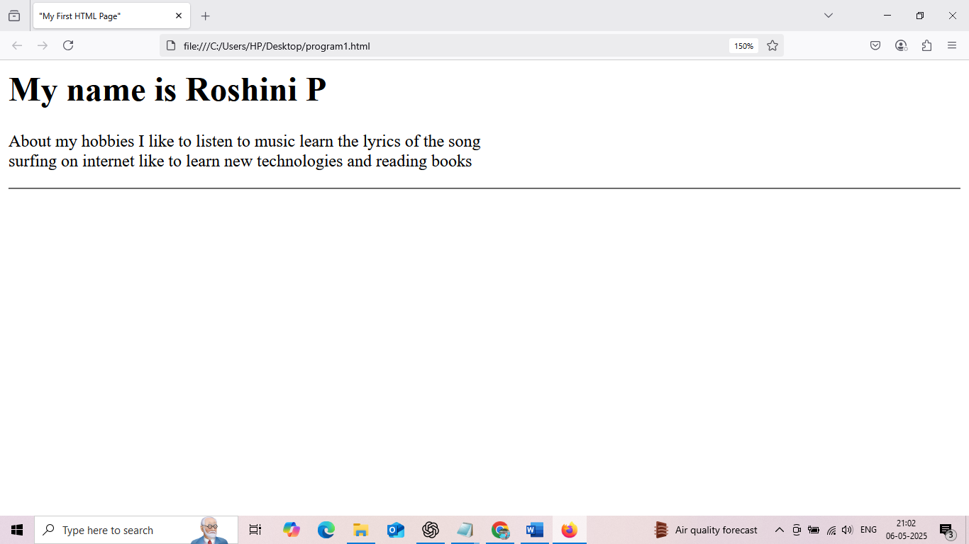

Exercise 2:
<html>
<head>
<title> Lists and Links</title>
</head>
<body>
<h4>My favourite fruits</h4>
<ul>
<li>Mango</li>
<li>Orange</li>
<li>Banana</li>
</ul>
<h4>Top 3 Movies</h4>
<ol>
<li>The Dark Knight</li>
<li>3 Idiots</li>
<li>PK</li>
</ol>
<a href="https://www.google.com" target="_blank">My favourite website</a>
</body>
</html>

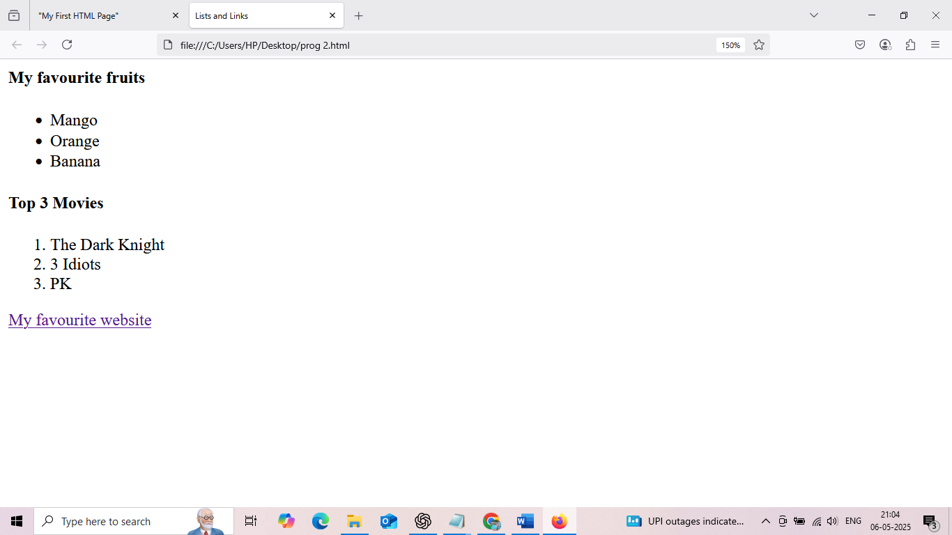



Exercise 3:
<html>
<head>
<title>Adding images and tables</title>
</head>
<body>
<h3>Adding image</h3>
<img src="C:/Users/HP/Desktop/picture/scene.jpg" alt="scene"></img>
<h3>Student tables</h3>
<table>
<tr>
<th>Student Name</th>
<th>Age</th>
<th>Favorite Subject</th>
</tr>
<tr>
<td>Dravid</td>
<td>12</td>
<td>Math</td>
</tr>
<tr>
<td>Elly</td>
<td>15</td>
<td>Physics</td>
</tr>
<tr>
<td>Navya</td>
<td>18</td>
<td>computer Science</td>
</tr>
</body>
</html>

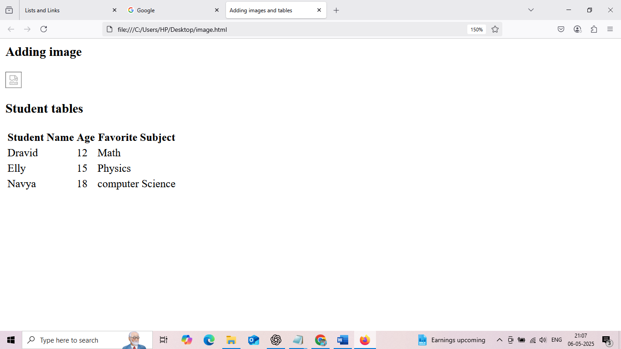

Exercise 4:
<html>
<head>
<title> Intro to css</title>
<style>
h3 {
background-color: lightblue;
color: darkblue;
font-size: 30px;
}
p {
font-family: Arial,sans-serif;
text-align: justify;
}
table, th,td {
border: 1px solid black;
border-collapse: collapse;
padding: 8px;
}
</style>
</head>
<body>
<h3>Welcome to css styling</h3>
<p>
CSS is used to style and layout web pages. <br> It allows to apply colors,fonts,spacing and positioning to HTML elements<br> Using internal css, we can define styles directly within the HTMl document.
</p>
</body>
</html>
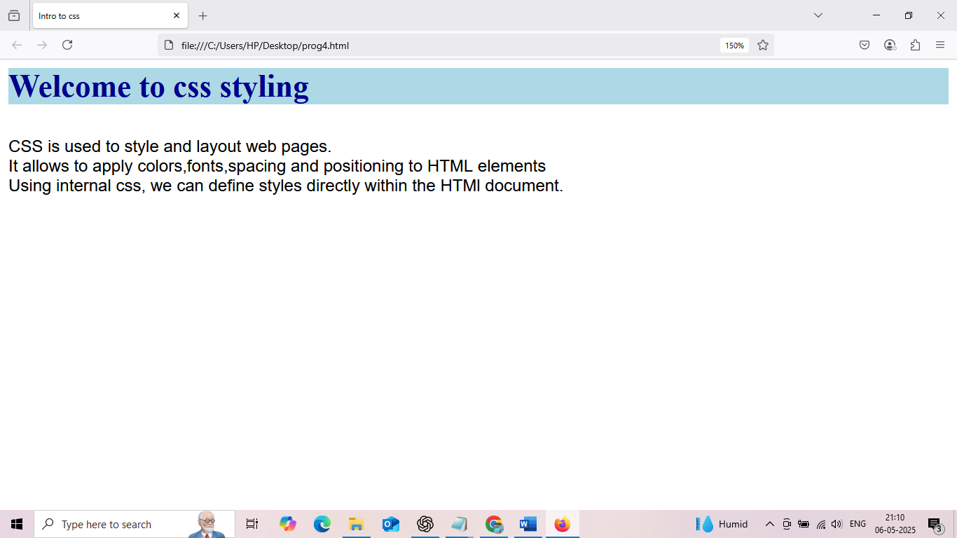
Exercise 5:
<html>
<head>
<title> div styling </title>
<style>
#intro {
border: 2px solid black;
padding : 15px;
margin-bottom: 20px;
}
.highlight{
background-color: orange;
padding: 10px;
}
</style>
</head>
<body>
<div id="intro">
<h3>Introduction</h3>
<p>This is introduction section styled with a border and padding.</p>
</div>
<div class="highlight">
<h2>Highlight section</h2>
<p>This is has blue background with is sed as highlight.</p>
</div>
</body>
</html>

