Bring Your Own Device: The Facts and the Future

Internal Use Only

**11 April 2013** ID:G00250384

**Analyst(s):**David A. Willis

**VIEW SUMMARY**

Bring-your-own-device strategies are the most radical change to the economics and the culture of client computing in business in decades. The benefits include creating new mobile workforce opportunities, increasing employee satisfaction, and reducing or avoiding costs.

http://imagesrv.gartner.com/reprints/images/bottom.gif

Overview

Impacts

* "Bring your own device" (BYOD) drives innovation for CIOs and the business by increasing the number of mobile application users in the workforce.
* BYOD improves employee satisfaction, resulting in a favorable perception of CIOs and their organizations.
* CIOs can use BYOD as a cost reduction and avoidance mechanism.
* BYOD increases risks and changes expectations for CIOs.

Recommendations

* Look for opportunities throughout the entire workforce where mobility could drive substantial innovation.
* Assess where your organization sits versus others in your industry. Even if you don't plan to embrace BYOD, you need to set expectations for your leadership.
* Decide on how many forms of BYOD you will support.
* Determine when, how, and how much you will subsidize business use of personal devices.
* Establish clear policies for BYOD qualification, service expectations and the employee's assumed risk.
* Invest in technologies to separate enterprise and personal applications and data.
* Establish user self-support and third-party support options.
* Specify what platforms will be supported and how.

Analysis

In just a few years' time, BYOD programs have gone from being a rarity to being common in business and government. Initially these programs evolved as a way to provide the employee a choice of devices which had been formerly unavailable or limited by the business, such as an iPad, iPhone or Android device. Some employees would like to carry a single device for work and personal use rather than two functionally equivalent devices. Based on Gartner inquiries with early adopters, employees' satisfaction with their employer and with their IT department consistently improves when BYOD programs are introduced. But this wave has only just begun, and attitudes may change as employers get more aggressive with the policy.

According to CIOs, enterprises that offer only corporate-liable programs will become the exception soon. As shown in Figure 1, 38% of companies expect to stop providing devices to workers by 2016 (see "Hunting and Harvesting in a Digital World: The 2013 CIO Agenda"). We estimate that only 15% of companies will never provide any BYOD option, and the remaining 40% of companies will offer both styles of programs.

**Figure 1.** When Organizations Will Cease to Provide Personal Devices

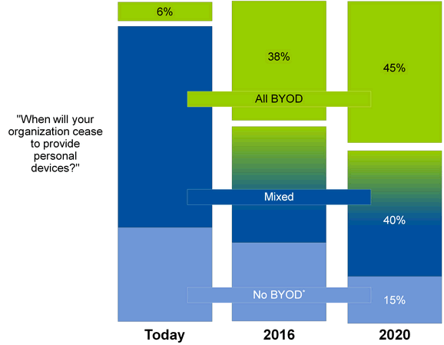

*Gartner analyst estimates; N = 2,053 worldwide

Source: Gartner (April 2013)

[**Return to Top**](http://www.gartner.com/technology/reprints.do?id=1-1HN6L5B&ct=130726&st=sb)

Gartner defines a BYOD strategy as "an alternative strategy that allows employees, business partners and other users to use a personally selected and purchased client device to execute enterprise applications and access data. It typically spans smartphones and tablets, but the strategy may also be used for PCs. It may or may not include a subsidy."

**Figure 2.** Top Impacts and Recommendations for BYOD Strategy

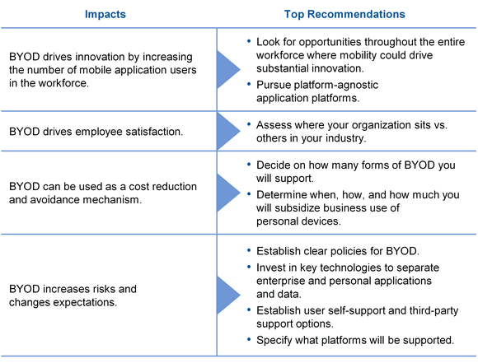

Source: Gartner (April 2013)

[**Return to Top**](http://www.gartner.com/technology/reprints.do?id=1-1HN6L5B&ct=130726&st=sb)

Impacts and Recommendations

"Bring your own device" (BYOD) drives innovation for CIOs and the business by increasing the number of mobile application users in the workforce

Pervasive mobile computing will soon be normal in the workplace. In the first wave of mobile workforce enablement, mobile phones provided communication in the field. Next, mobile email added asynchronous communications, limited file sharing, simple collaboration and basic workflow. High costs limited mobile penetration in the workforce.

The third wave of mobile workforce enablement will be the largest and most impactful: Mobile applications in all of their variety, for the entire population of workers, will be a game changer. Higher rates of computing in the workforce have often led to dramatic productivity improvements and created great potential for innovation. Mobile computing accelerates that trend.

For an example, a beverage manufacturer provided applications on consumer devices for low-cost hourly workers to travel behind trucks and set up displays, keeping the drivers on their routes and serving more retailers. Innovations like this are being launched by leading organizations every day.

But there has long been one major barrier to mobile adoption: Companies struggle to absorb all the costs. At an average of well over $600 per employee per year, an organization simply can't afford it. What if instead the employee's own device could be used to run business applications?

Consumer adoption of mobile devices has become mainstream worldwide. In developed markets, over half of the eligible workforce and two-thirds of households already have a smartphone that can run apps and has a capable browser. Many employees are already way ahead of their employers, so to some extent, policies are simply catching up to reality. Already, over 60% of workers report using a personal device at least once a day in their work; 44% use a personal smartphone in their job (see "User Survey Analysis: Is Bring Your Own Device Job Essential or a Personal Preference?").

Another factor is the movement toward contract personnel, temporary and seasonal workers, co-employed workers, and other nontraditional relationships. Many of these workers consider themselves "free agents" in charge of their own technology solutions.

In short, technology has become democratized.

But consumer adoption and the democratization of IT are only part of the story, and several other factors have to be considered. BYOD is coming into the workplace at the same time that organizations are looking to expand their use of mobility, which is now the No. 2 technology initiative for CIOs in 2013 (behind analytics and business intelligence, a capability which is itself going increasingly mobile). Leading organizations see great potential in expanding the number of workers that have access to applications via mobile devices, extending well beyond the traditional executive and management ranks and into hourly personnel.

Rolling out applications throughout the workforce presents a myriad of new opportunities beyond traditional mobile email and communications. Applications such as time sheets, punch lists, site check-in/check-out, and employee self-service HR applications are just a few examples. Expanding access and driving innovation will ultimately be the legacy of the BYOD phenomenon — much like departmental and personal computing introduced process improvements where old host-based data processing systems could simply not function.

We project that the number of workers having mobile access to applications will soon double, due to the shift deeper into the workforce and the push to go beyond voice and email.

Workforce enablement starts to look like consumer mobile. Organizations pursuing mobile BYOD face the same application challenges that companies pursuing consumers have: the fragmentation of mobile platforms, spanning at least three major ecosystems (iOS, Android and Windows), presenting a myriad of application architecture choices (native, HTML5, hybrid, traditional Web, and so forth). See "Mobile Applications: Native, Cross-Compiled, Custom Container, Hybrid, or Web" for more on this topic.

*Recommendation:*

Look for opportunities throughout the entire workforce where mobility could drive substantial innovation. Map out the new process improvements and innovations your organization could see if every worker had access to mobile applications. Look well beyond email and into practical applications like scheduling, time sheets, approval processes, HR forms, remote training, and collaboration.

Pursue platform-agnostic application platforms. The more you fully embrace BYOD, the more diverse your mix of mobile endpoints will be. This diversity will only increase over time. Choose a best-fit application architecture that reduces your dependency on a specific target device: Build traditional Web applications, mobile Web applications or hybrid apps. Use native platforms to build resident mobile applications only when truly necessary.

[**Return to Top**](http://www.gartner.com/technology/reprints.do?id=1-1HN6L5B&ct=130726&st=sb)

BYOD improves employee satisfaction, resulting in a favorable perception of CIOs and their organizations

There are many drivers for BYOD, most notably employee satisfaction. In data collected in Gartner inquiries, we have seen substantial improvement in the way the enterprise and its IT organization are perceived when BYOD is introduced. A CIO of a large petroleum company remarked that "no matter how much we spend on the back office, our executives still tell us that letting them use their personal iPads is the best thing we've done for them in years."

This extends to IT itself. According to a September 2012 Gartner study of BYOD adoption (n = 453), most IT leaders have a positive view of BYOD, and they see it as inevitable. Only 10% do not like the idea of BYOD at all (see Figure 3).

**Figure 3.** How Employees Perceive BYOD

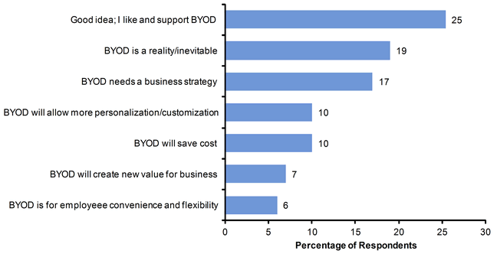

N = 374

Source: Gartner (April 2013)

[**Return to Top**](http://www.gartner.com/technology/reprints.do?id=1-1HN6L5B&ct=130726&st=sb)

However, satisfaction with the state of current policies is middling at best (see Figure 4).

**Figure 4.** Satisfaction With Current BYOD Policies

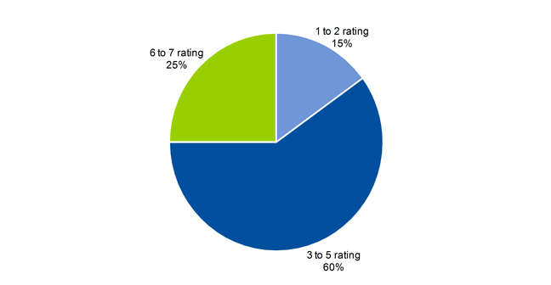

Ratings are on a scale of 1 to 7, where 1 = low and 7 = high; N = 453

Source: Gartner (April 2013)

[**Return to Top**](http://www.gartner.com/technology/reprints.do?id=1-1HN6L5B&ct=130726&st=sb)

Only one-quarter of leaders rate their own policies highly. We believe this is due to a lack of clear direction in the organization and a failure to keep up with current trends in mobile policies. Policy is often unevenly applied, and employees are often unaware of the policy. In many organizations, policies are openly violated (see Figure 5).

**Figure 5.** How Well Organizations Address BYOD

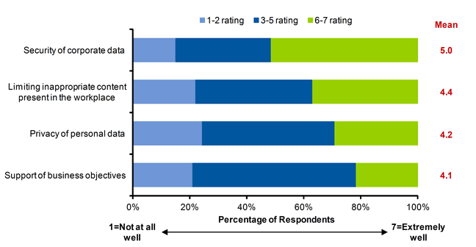

N = 453

Source: Gartner (April 2013)

[**Return to Top**](http://www.gartner.com/technology/reprints.do?id=1-1HN6L5B&ct=130726&st=sb)

The business case needs to be better evaluated. Most leaders do not understand the benefits, and only 22% believe they have made a strong business case. There are several reasons for this uncertainty: Like other elements of the Nexus of Forces (cloud, mobile, social and information), mobile initiatives are often exploratory and may not have a clearly defined and quantifiable goal, making IT planners uncomfortable. While there are many mobile applications with a provable return on investment, stumbling onto a breakthrough does not seem like the right strategy. Leading organizations have a set of well-defined processes that can benefit from mobility (such as sales force enablement and field service) and also are running more exploratory pilots that focus on "softer" benefits like employee satisfaction, or on productivity, a common goal but one that is notoriously difficult to measure.

While BYOD is occurring in companies and governments of all sizes, BYOD is most prevalent in midsize and large organizations ($500 million to $5 billion in revenue, with 2,500 to 5,000 employees). BYOD also permits smaller companies to go mobile without a huge device and service investment. In some cases, the low-cost consumer apps or the mobile clients of existing server apps can add significant value without significant cost.

Adoption varies widely across the globe. Companies in the United States are twice as likely to allow BYOD as those in Europe, where BYOD has the lowest adoption of all the regions. In contrast, employees in India, China and Brazil are most likely to be using a personal device, typically a standard mobile phone, at work. Figure 6 shows the distribution of responses to the question, "For each of the following devices you personally own, how often do you use each for work purposes?"

**Figure 6.** BYOD Adoption

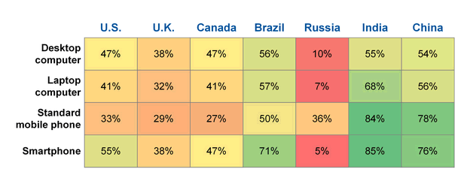

Source: Gartner (April 2013)

[**Return to Top**](http://www.gartner.com/technology/reprints.do?id=1-1HN6L5B&ct=130726&st=sb)

*Recommendations:*

Assess where your organization sits versus others in your industry. Even if you are with one of the relatively few organizations that will not permit BYOD, it is important to know what the rest of your industry is doing, and set expectations in the workplace. See the Types of Programs by Technology section below. It's also notable that completely banning personal devices in the workplace has historically led to "stealth" IT rather than full compliance.

If you are offering BYOD, take advantage of the opportunity to show the rest of the organizations the benefits it will bring to them and to their business.

[**Return to Top**](http://www.gartner.com/technology/reprints.do?id=1-1HN6L5B&ct=130726&st=sb)

CIOs can use BYOD as a cost reduction and avoidance mechanism

While a well-managed BYOD program can occasionally save money, other goals tend to eclipse cost savings. Workers with an essential need to use a mobile device in their business expect to be compensated for its use, just as companies typically reimburse for the incremental cost of mileage and travel expenses that are incurred in the course of business. But unlike mileage, there are currently no officially settled-upon rates that all companies follow for device usage. Today, roughly one half of BYOD programs provide a partial reimbursement, typically for the service plan only, while less than 2% of companies pay the full cost of a personal device — whether it is a smartphone, tablet or PC. The remainder do not subsidize.

The subsidized amount also varies widely throughout the world. In the United States, employees who receive a subsidy for smartphone usage typically receive $30 to $40 for voice, data and text, which works out to roughly 50% to 60% of a consumer's bill (see Figure 7).

**Figure 7.** U.S. Worker Subsidies for BYOD Smartphones

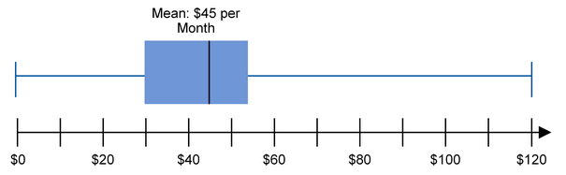

Note: U.S. worker subsidies for BYOD smartphone voice/data/text plans, excluding international travel.

Source: Gartner (April 2013)

[**Return to Top**](http://www.gartner.com/technology/reprints.do?id=1-1HN6L5B&ct=130726&st=sb)

Gartner recommends that employers do not subsidize the smartphone device itself (except where labor laws require it), but instead merely the service plan, and recommends that companies move cautiously in allowing internationally traveling workers into the program.

Coupling the effect of mass market adoption (more users will have personal mobile) with the steady declines in carrier fees, employers will gradually reduce their subsidies. A $45 average reimbursement today is likely to be under $30 in two years, a 30% decline. And as the number of workers using mobile devices expands, those who receive no subsidy whatsoever will grow. For every worker currently under a corporate-liable plan, we could easily see two additional mobile workers.

No mobile worker is free. It is easy to see the costs associated with these programs: more employees and more devices mean more security and management tool costs, more application licenses, more potential problems for an overtaxed help desk to deal with, and more confusion.

Even if your organization provides no subsidy whatsoever, you will still incur overhead costs for each mobile worker — including software (for example, mobile device management, containerization, secure content sharing and data protection), infrastructure, and support service overheads. These costs can easily exceed $100 per worker per year today. We expect the costs per worker to increase to an average of $300 by 2016, largely due to license fees for mobile apps. These app costs may be mitigated by heavier use of Web/HTML5-delivered applications rather than platform-specific or hybrid apps.

Costs are often more than justified if the organization has an aggressive mobile workforce strategy. Enterprises have the option to pocket the savings from reducing enterprise-liable employees, or alternatively to invest in broadening the mobile workforce. In one example observed with a manufacturing client, cutting the number of qualified fully-paid corporate-liable employees in half and subsidizing the remaining workers with a $30 per month stipend resulted in a 24% annual savings after overhead cost. That savings is then being kept in the program in order to fund a set of mobile workers that formerly did not qualify for the program (and who receive no subsidy). Even with the overhead costs, the company can now support 2,000 new users for every 1,000 that it supported prior to the program.

How you subsidize the use of a personal device is critical, and it can dramatically change the economics of BYOD. Whether you reimburse via expense reporting, provide a stipend, or provide an unspecified "device allowance" on an individual's paycheck can mean that the amount is considered taxable — which could imply an additional 30% to 40% cost uplift (thus the savings in the above example would get quickly washed away). There are thousands of tax jurisdictions worldwide, and so this is a particularly thorny challenge for multinational organizations, often forcing qualification, subsidy rates and usage terms to be localized. This task must not be completed by IT alone — involve your HR and legal departments in the policy.

In general, the higher the subsidy, the higher the uptake for the program. With an average reimbursement rate, and where no attractive fully paid enterprise-liable option is available, roughly 40% of the enterprise-liable population will move to BYOD. Increase the subsidy, and more workers opt in. The subsidy can also be used to encourage users to choose a device that is more enterprise-friendly and more supported. In other words, a user on a preferred platform may receive a higher amount than one whose platform is more difficult to support.

[**Return to Top**](http://www.gartner.com/technology/reprints.do?id=1-1HN6L5B&ct=130726&st=sb)

**Types of Programs: By Technology**

Gartner observes four common BYOD programs based on the technology being used:

1. Tablets (offered by 54% of enterprises on average, only 16% of which provide any sort of subsidy). See Figure 8. Most organizations are allowing the device in their operations; relatively few are actually reimbursing for usage.
2. Smartphones (offered by 34% of companies, over half of which subsidize). See Figure 9. For smartphones, companies in retail, services, health and finance are more likely to have a BYOD program. Companies in services, media, and healthcare are more likely to reimburse for usage. In all instances, partial reimbursement, rather than full reimbursement, is the norm.
3. PC programs (14% allow casual usage of a secondary PC, but under 2% of companies subsidize).
4. "Bring any technology" programs providing general allowances, stipends or reimbursements for any technology, at the user's and department's discretion. This approach is very rare, involving less than 0.5% of all organizations.

**Figure 8.** Tablet BYOD Adoption by Industry

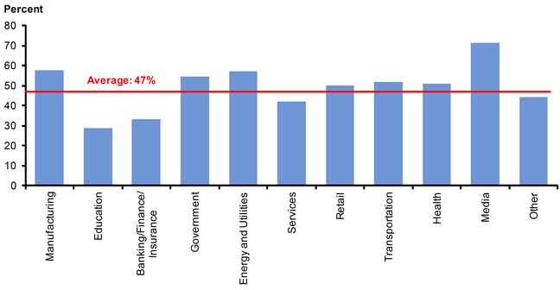

Source: Gartner (April 2013)

**Figure 9.** Smartphone BYOD Adoption by Industry

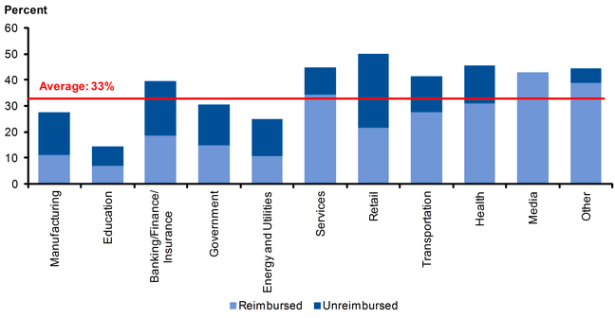

Source: Gartner (April 2013)

**Types of Programs: By Economic Model**

* **Employee-responsible models**. In this approach, the organization transfers full responsibility for the device to the individual. The enterprise subsidizes work use via stipend, salary increase or reimbursement.
* **Hybrid responsibility models.** There are various approaches with shared responsibility for ownership, payment and support. The most common model allows an enterprise-supplied device to be used for personal applications. Another hybrid approach takes an employee's personally owned smartphone and puts it under the business's carrier contract. In a slight variation to this approach, the individual is offered the option to purchase discounted personal service under the enterprise contract, which may offer split billing of the employer's and worker's portion.
* **Secondary-device models.** In this approach the personal device is used as an unsubsidized supplement to an official enterprise device (for example, for Web access to email).

*Recommendations:*

Decide on how many forms of BYOD you will support. Determine the device scope: Will the BYOD program support tablets, smartphones, PCs or a combination? Is it merely for a secondary device, or is it for the user's primary device? Consider a mix of enterprise-liable, bring-your-own and hybrid models.

Determine when, how, and how much you will subsidize business use of personal devices. Working with HR, your legal department and your corporate risk organization, understand the tax, privacy, legal liability and labor relations impacts of the program. Determine who qualifies for a usage subsidy and how it will be paid (allowance, stipend, voucher or reimbursement program).

[**Return to Top**](http://www.gartner.com/technology/reprints.do?id=1-1HN6L5B&ct=130726&st=sb)

BYOD increases risks and changes expectations for CIOs

Unsurprisingly, security is the top concern for BYOD. After decades of owning the device that a business user would use and centering much of its security protections around control over the endpoint, the new BYOD model makes the business more like a cloud service provider. Security has to exist in the application, in data controls and in add-on capabilities like containerization or virtualization.

The risks of data leakage on mobile platforms are particularly acute and are now a bigger problem than malware. Mobile devices like the iPad or iPhone are designed to share data in the cloud and have no general-purpose file system for applications to share, increasing the potential for data to be easily duplicated between applications and moved between applications and the cloud.

In general, IT is catching up to the phenomenon of BYOD. Over half of organizations rate themselves highly in security of corporate data for enterprise-owned mobile devices. This new confidence in the security posture to support BYOD is a reflection of more-mature tools and processes that address a myriad of needs in the security area. Investments in mobile security technologies are growing rapidly — including mobile device management/mobile application management, enterprise file sharing systems, encryption/containerization, content protections and virtualization. Investing in these and related security, infrastructure and management technologies is essential.

Client feedback indicates that BYOD drives the total number of calls for endpoint support down, while introducing new types of help desk calls requiring additional skills from the mobile support teams.

As IT formally recognizes the use of personal devices, IT will be required to guide workers into making the right purchasing decisions when they walk into a store or shop online. Over 60% of professional workers state that they think about work usage when they make a purchase — and about half of those buyers consider work usage a top consideration.

*Recommendations:*

Establish clear policies for BYOD. It is essential that IT specify which platforms will be supported and how; what service levels a user should expect; what the user's own responsibilities and risks are; who qualifies; and that IT provides guidelines for employees purchasing a personal device for use at work, such as minimum requirements for operating systems. For details, see "Toolkit: BYOD Mobile Device Policy Template."

Invest in key technologies to separate enterprise and personal applications and data. Manage device policies with mobile device management systems, provide a convenient method of securely sharing documents and collaborating on mobile devices, and invest in on-device containerization and virtual desktop infrastructure as needed.

Establish user self-support and third-party support options. Retrain existing service desk staff, and augment the mobile support team as needed. Use internal wikis, user forums, email distribution lists, enterprise social networking and other collaboration tools for user self-support.

Specify what platforms will be supported. Let workers know what devices are appropriate, or not, in the workplace. Not all devices can be supported. Specify the widest range of operating system/mobile device families as is reasonably possible, rather than certifying specific products.

[**Return to Top**](http://www.gartner.com/technology/reprints.do?id=1-1HN6L5B&ct=130726&st=sb)

[](javascript:void('0');)

**DOWNLOAD ATTACHMENTS**

* [impactappraisal...](http://imagesrv.gartner.com/reprints/250300/250384/impactappraisalgraphic.png) (21KB)

**STRATEGIC PLANNING ASSUMPTIONS**

By 2015, the number of employees using mobile applications in the workplace will double.

By 2017, half of employers will require employees to supply their own device for work purposes.

By 2016, the average amount a qualified employee currently receives for the business use of a personal smartphone will be reduced by 30%.

By 2016, most employees using a personal device in business will receive no direct subsidy for its use.

By 2016, the typical organization will spend over $300 per year per employee on mobile applications, security, management and support.

**EVIDENCE**

The data used in this report was gathered from four key sources:

Research presentation for "Hunting and Harvesting in a Digital World: The 2013 CIO Agenda," showing CIOs' plans for rapid BYOD adoption (2,053 respondents, worldwide, 2H12)

Gartner Research Circle "Hot Topic" survey on BYOD (453 respondents, worldwide, September 2012), identifying the types of programs currently in place by vertical industry, major drivers for BYOD, and concerns of IT leadership.

Gartner consumer research study (3,807 workers in the United States, United Kingdom, Canada, Brazil, Russia, India and China, 2H12), highlighting employees' adoption of personal devices in business and how it affected their personal purchases.

Gartner inquiries (more than 100) as a source for typical reimbursement rates and methods of managing and securing BYOD.