Customer Touch
NKSOFT’S Vision and Go-to-Market Offerings

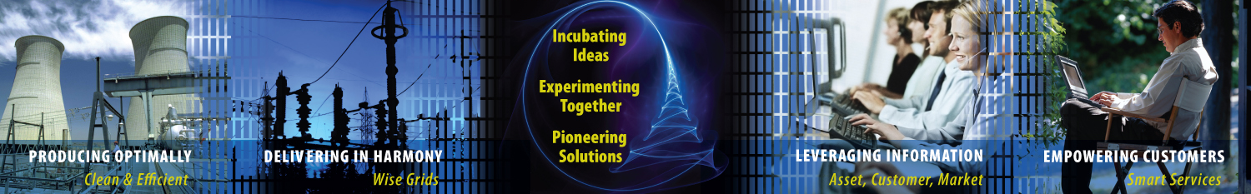

NKSOFT’S Vision of Customer Touch

Deregulation and competition has vastly opened up the market, pushing Utility companies to seek new ways to increase customer base, lower operational cost, enhance service quality, and adopt innovative low-cost options to serve customers. With the customer becoming the key focus of Utilities, there is a strong need, today, for an efficient CIS to take care of the entire lifecycle of customer management, yielding high returns on investments.

NKSOFT’S vision in the area of Customer Service is to co-create value with Utilities so that they can deliver better value to their customers through
- holistic view of customer data and analytics to design new offerings for their customers
- strategize customer retention policies
- formulate smart methods to improve realization and outstanding.
- enhance capability for energy trading and risk management

Co-creating Value with Customers: Investments in Innovation and R&D

NKSOFT is committed to create a strong infrastructure for co-creating value with customers. Key initiatives include:

Co-Innovation Network

We have developed Co-Innovation Network to bring an ecosystem perspective to innovation. We leverage shared synergies across the innovation ecosystem with entities such as alliances, start-ups, academic institutions, multilateral organizations, and key clients
to bring truly collaborative innovation for benefit of Utilities.

Utilities Innovation Lab
Our drive towards innovation has led us to create an “Innovation Framework”, to incubate ideas throughout the transformation journey of the Utilities. The framework focuses on three core areas to foster a culture of innovation: “Categorization” of innovation into manageable buckets with defined ownerships, a proposed “Lifecycle” with built in governance to foster ideation and a prescribed “Engagement Model” for the customer.

Our offerings in Customer Touch area cover the following
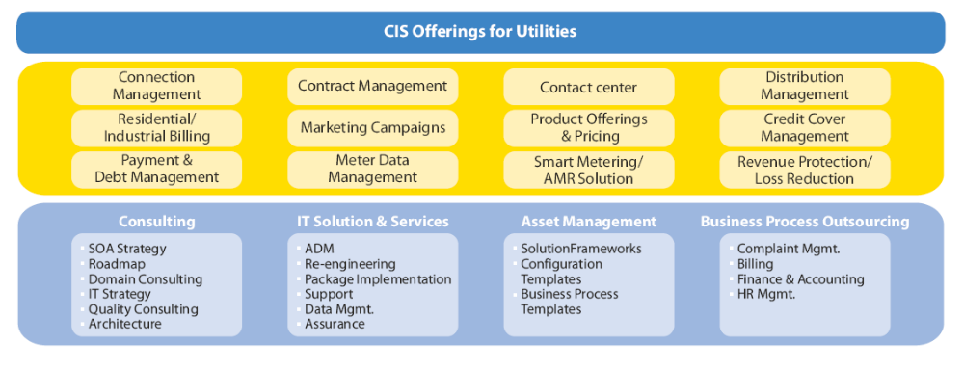

Some of the key assets conceptualized and developed in our Innovation Lab are listed below

Business Areas | NKSOFT Asset | Value derived
Meter Readings | - Service Mart for Automated Metering Infrastructure: a data extraction, transformation and integration framework built on Service Oriented Architecture  - Wireless Sensor Networks for automated Monitoring  - AMI through FTTx Network | Agility  Lower TCO  Flexibility  Technology excellence
Distribution Automation Design | - Experience and framework in MV feederline analysis both in MV and LV feeder line  - DA Framework | Agility  High Value DA  Engineering Planning
Billing Solution | - Framework for Oracle and SAP based billing solution for regulated and competitive market  - De-risked Transition Framework to support Billing Landscape  - Business Process exception management experience | Lower TCO  Flexibility  Customer Intimacy
Credit Collection and Payment Processing | - Template for implementing automated Dunning processes and workflows  - Experienced team to manage back office processes | Lower TCO  Improved Receivables
Customer Service Solution | - Collaborative Communications Solution  - Integration framework with Voice, Video and Chat  - Multi Channel Self Service Solutions(web 2.0)  - Customer Savings calculator | Reduced Customer Service time  Process Integration with agents  Reduced Street to Desk time

Some of the details of the above GTM Offerings are listed below

Customer Savings Calculator (CSC)

The CSC is applicable for the retail business for an electricity and gas provider. It aims to provide a quick calculation of savings for a prospective customer who would like to switch to the company’s product from a competitor product.

The CSC can be incorporated in a portal and can be accessed directly by the customer. Alternatively the Call Center Operative can make use of it to provide feedback to a customer when he or she calls.

The application has the prices of own products and competitor products available in the region. It takes the consumption or annual spend of the prospective customer and calculates the best possible option from the company’s product range provided that the customer can be served from the existing meter. It then calculates the savings that the customer will have if he/she changes to the option provided.

SmarterUtility – Electricity, Gas and Water Utilities
NKSOFT’S SmarterUtility offering is a conglomeration of its experience in utilities industry domain and leadership in process excellence that helps the enterprise in implementing effective Smart Grid solution to aid decision-making process. The SmarterUtility framework consists of an enterprise wide Logical Data Model (LDM), Analytical Templates (AT) and High-end Analytics (HA).

For Power Generation – Process Excellence supported by SmarterUtility:
- Plant Operational and Maintenance
  - Heat Rate Analysis
  - Outage Analysis
  - Auxiliary consumption
- Market opportunity analysis
- Vendor/supplier performance analysis
  - Fuel quality Analysis

For Power T&D – Analytics supported by SmarterUtility:
- Transmission element load analysis
  - Link wise load analysis
  - Distribution transformer load analysis
- Power quality and reliability analysis
  - Power Factor analysis
  - Outage Analysis- CAIDI

For Power Retail – Analytics supported by SmarterUtility:
- Consumer load profiling and segmentation
o Consumer Load Profile
  - Customer segmentation and Y-Y growth Analysis
  - Industrial Load Pattern Analysis
- Consumer loyalty analysis
  - Churn Analysis
- Revenue and profit
  - Profitability analysis

Tariff business process analysis

NKSOFT analyses the tariff in three-fold, namely:

- Study of existing business processes (As Is study)
- Recommendation of future business processes (To Be study)
- Identification of IT systems required to support the proposed business processes

The actual scope of work includes studying the long-term objectives of the policy makers, and associated legal and regulatory guidelines to assess the vision that underpinned the reforms that are will be put in place. This is important as it helps to crystallize the various processes through which tariff would be determined and obtain a detailed understanding of the data that would be necessary to support the same. Taking this exercise further, it becomes necessary to review the various issues that exist in terms of data quality, completeness and timeliness. The very extensive nature of the proposed reforms calls for a significant change in the mindset of existing organizations, thereby necessitating a close scrutiny of how things were being done vis-à-vis how they should be done.

Business Process Outsourcing

NKSOFT is the amongst the boutique BPO service provider servicing over 20 leading clients across 2 global delivery locations. NKSOFT’S BPO business unit currently employs 200+ associates across these centres, providing a range of multiple service offerings across focus verticals. NKSOFT brings significant differentiation in its offerings through its value extraction approaches: Task - level Automation, Work Flow/Process Engineering, and Infrastructure-IT-BPO bundled Services and Utility based Solutions.

NKSOFT strategy for BPO rests on three pillars as outlined below:
- Domain led Offerings: NKSOFT has over the years built intellectual property in the form of practices, platforms and tools which help NKSOFT deliver value added services to the customer and bring to them Global Standard / Best of the Breed processes within NKSOFT’S key focus areas.
NKSOFT has the following set of utility specific services to offer:

  - Pre ERP Implementation Services
    - Backlog Clearance Services – within fixed time span and with delivery milestones at fixed price.
    - Need based Ramp up capabilities for backfill to support back office operations and transition related services during ERP implementation.
  - Back office transaction processing support e.g. Metering, Billing, New connection, Customer Communication consolidation and document processing
  - Utilities Assessment Reporting Services
  - Billing and Debt collection Services
  - Health and Safety Services - administration and follow up
  - Work Order Management Services
  - Contact Centre and Complaint Management
  - Post Implementation Services
    - Ramp-up support to manage i. Productivity decrease due to new systems ii. Call Centre volume
    - Large volume of exception arising from Data Migration issues, Customer Set-up, Market Data exceptions - Ramp up support to manage

Smart Metering Empowerment
Wireless Sensor Networks for automated Monitoring
Wireless Sensor Networks (WSN) – A network of low complexity sensor nodes with integrated wireless communication capability. This enables autonomic management of data collection with minimum human intervention

Smart Metering Empowerment
Home Infotainment Platform (NKSOFT Set top box)
NKSOFT Set-Top-Box (STB) is a application consisting of embedded components that accepts video feed from any source (analog or digital) and provides an uplink for interactivity and other value added interactive video based services via broadband
Set Top Box as a Smart Meter Gateway using Zigbee Sensor Network
- Smart meters continuously measure and record the electricity, water, or gas consumption of individual households and allow for remote access to the consumption data (e.g. using Power Line, GSM or fixed data lines).

- A Set Top Box can be used as the home gateway for the smart meters by direct zigbee interface.

- This enables direct telemetric connect and disconnect capabilities and act as the local controller for devices.

- It can give rich media data representation for the common man’s understanding of his consumption for each device

- Enables better energy management system at home and leads to a greener future.

WEB 2.0 Initiatives
Service Offerings
- Enterprise 2.0 Consulting
- Experience on Rich Internet Apps
- Usability Consulting and Social Interaction Design
- Web Oriented Architectures and Mashup platforms
- Co-Creation frameworks
- Contextual Collaboration
- Enterprise Social Software
Tools & Accelerators
- RIA pattern library
- Social Q&A platforms
- Social Innovation Management platforms
- Collaboration tools for specific business processes
- Eclipse extensions for bringing advanced collaboration to the development environment
Relevant Developments
Just Ask: A Social Q&A platform for the enterprise. Allows users to Ask, Answer and Discover questions and answers in a social and participatory ecosystem.
Idefix: A Social Idea Nurturing platform for the enterprise that is centered around user generated content. Every idea is submitted and voted on by the community. It allows users to ideate and collaborate in a social and participatory ecosystem.
Quix: An Enterprise Microblogging platform that enables an informal, yet effective stream of knowledge bytes, ideas, questions, answers, announcements and even feelings/moods to be shared in an enterprise social web. Modeled after consumer internet platforms like Jaiku and Twitter, this has been designed keeping the enterprise in mind.
Pwrshr: An enterprise slide share platform that gives a social lease of life to the thousands of presentations that tend to contain the knowledge of an enterprise. The platform enables social interactions around presentations (comments, tags, annotations, votes, bookmarks)

