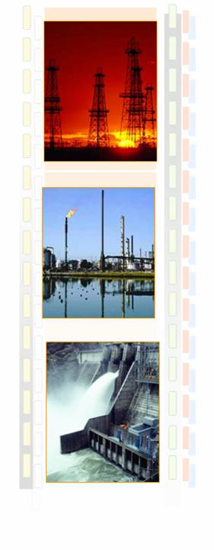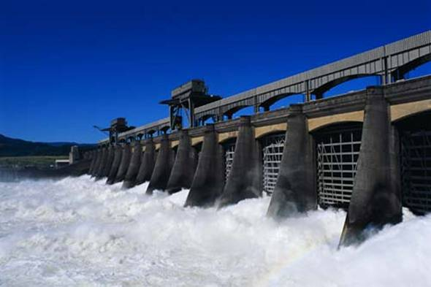

NKSOFT’s Utilities Industry Solution Unit
Offerings and Capabilities

NKSoft Consulting Services
June, 2014

Table of Content

1. Introduction 3
2. NKSOFT’ Capabilities and Offerings 6
3. EN’RGISE 30
4. Utilities Innovation Lab 32
5. SUAVE - SAP Utility Applications Value Enhancement 33

Introduction

The Utilities industry is currently evolving from a monopoly in a regulated utilities market to a competition-based energy and service industry. In political and economic terms, this process is seen as a positive development and reflects an international trend. The goal of incremental deregulation of the utilities market is to open up that market to competition, and thus benefit the consumer. Liberalization laws are advancing deregulation to varying degrees, depending on the political sphere of influence concerned. In future, therefore, the customer will be the focal point of the utilities market. He will be able to choose from a number of different suppliers (retailers) since, in a deregulated market, he can buy his supply services from different companies. The de-regulation breaks open the Generation and Production >> Transmission >> Distribution >> Customer service value added chain.

The consequence of the market opening out of the de-regulation process is:

- Unbundling of the value chain
- Complete redefinition of marketing, sales, billing, service processes for customers as a result of unbundling and competition.
- New offerings and distribution channels
- Considerable changes to technologies for measurement devices and meter readings
- New, complex data communication processes between companies, as a result of the defined market mechanisms: data mining, reconciliation and financial settlement
- Increased needs for data analysis and market information
- Restructuring of cost structures, management reporting and activity monitoring indicators
- Pressure on margins

The impact of this on the Information systems include

- IT Systems “unbundling” (Mainly out of business separation issues)
- CRM systems to support the marketing, sales, and service processes
- Updated billing system to support new forms of contracts, rates (products) billing and payment in a deregulated market
- A complete integration of Front Office CRM with Middle Office billing
- Powerful tools for data management for the definition of new contracts, reconciliation and settlement process,
- Asset optimization and control
- Optimization of IT costs, standardization / automation

Business Focus Areas and IT Application Architecture
The unbundling and de-regulation process has re-shaped the business focus areas across the utility value chain and impacted the IT application architecture view in a great detail. IT requirement of a generation company largely differs from that for a distribution or transmission company. Standard IT application architecture views for Generation / Production Company, Transmission Company and Distribution Company are depicted below:

Generation / Production

Business Focus Area
- Asset Operation and Maintenance
- Process Optimization
- Vendor Management
- Efficiency Modeling
- Plant Operations and Management
- Regulatory Compliance

Application Architecture

The IT application architecture for a generation / production company can be depicted in the following diagram. It also shows the other market participants who influence the business / IT operation of the generation company.

Tariff
Billing
Generation / Production
Project Management
Maintenance
Management
Material Management
Plant Automation
Process Optimization
Fuel Management
Demand Management
HRMS, Finance & Accounting
Vendor
Regulator
Transco
Trading
Co

Transmission

Business Focus Area

- Network Optimization and Control
- Network Asset Management
- Congestion Management
- Energy Management and Loss Reduction
- System Operation
- Wholesale Trading Management
- Mobile Workforce
- Real Time Systems and EMS
- GIS

Application Architecture

The standard IT application architecture view for a transmission company along with other external market participants is shown below:

Tariff
Billing
Project Management
System Analysis
Congestion Management
SCADA/GIS
Energy Accounting
Operation Management
Demand Management
HRMS, Finance & Accounting
Generator
Regulator
Customer Management
Trading Co.
Transmission
Disco.

Distribution

Business Focus Area

- Managing suppliers (Retailers), points of delivery, load profiles
- Managing grid customer contracts and supplier outline contracts
- Energy Settlement based on analytical or synthetic procedures
- Providing data for suppliers, settlement coordinators, and settlement area coordinators
- Billing, Customer Care and CRM
- Asset Management
- Work Management
- Network Management
- Mobile Workforce
- Connection Management

Application Architecture

The standard IT application architecture view for a distribution company along with other external market participants is shown below:
Tariff
Billing
Project Management
Outage Management
GIS
Energy Accounting
CRM
Operation Management
Demand Management
HRMS, Finance & Accounting
Transco & Trading Co
Regulator
Consumer
Trading Co
Distribution

NKSOFT’ Capabilities and Offerings

NKSOFT has been working in the Utilities sector from the early Nineties. It started providing offshore services to a number of companies in UK and USA. Utilities as a practice were formally launched in 2001. This brought together increased focus on combining domain and IT expertise within the group. It helped in increased appreciation of customer needs and fine tuning of the solutions. The domain team brought with it an expertise in consultancy on various areas of the business including strategy, planning and operations.
NKSOFT created the En’rgise Framework which was a combination of consulting and IT modules for Utility companies. Details on this framework have been provided in a later section of the document. In the past few years the Utility practice has evolved in terms of addressing increased number of areas of the customer business and building competence on a wide range of technologies.
Leveraging core strengths of NKSOFT, the practice is today a significant System Integrator, an implementation partner of choice for large transformation programs and a capable application and infrastructure support provider.
NKSOFT has conducted a number of assignments across the power and gas supply chain, from generation to retail. The solutions have included both operational and business processes. The figure below provides a view of the NKSOFT solutions for power and gas Utility companies.
After the recent transformation exercise within NKSOFT, we are now called the Utilities Industry Solution Unit (SOLUTIONS UNIT). You shall find this reference throughout the document to refer to Utilities in NKSOFT.
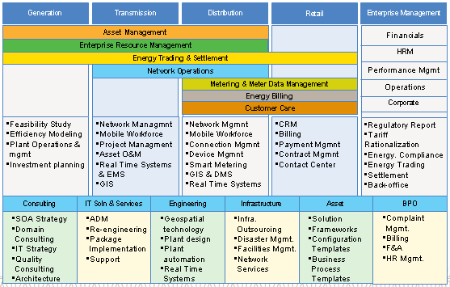
Business
Lifecycle
Key
Business
Process
Focus
Areas
Solution Offerings

Solution Spectrum in Power & Gas Utility

- Utility Focus Areas

Based on the industry trends and the requirements of the customers, we have selected certain key focus areas of business to create service offerings. These are:

- Customer Service
- Enterprise Asset Management & GIS
- Energy Trading and Risk Management
- Business Intelligence and Performance Management
- Advanced Metering Infrastructure
- Enterprise Solutions (ERP)

The SOLUTIONS UNIT leverages the strong capabilities of NKSOFT in providing outsourcing services for all three key areas

- Application support
- IT Infrastructure Services
- Business Process Outsourcing

In the sections that follow, the focus areas as mentioned above have been detailed along with some case studies of assignments that have been carried out.

2.1 Customer Service
Utility companies providing electricity, gas or water are today facing a new challenge in terms of retaining and acquiring customers. They usually had certainty in terms of retaining the set of customers in their areas, however the opening up of the market to competition has seriously reversed the situation and has forced the companies to look into ways of developing strategies to retain customers and also if possible to acquire more customers.

Lowering costs and improving reliability had always been a goal, however regulatory pressure to reduce downtime and in turn to maintain high level of customer satisfaction is becoming essential. This clearly shows that the erstwhile asset centric view of the Industry is changing and the customer centric view is gaining importance. IT has become a critical enabler to accomplish this.

The customer management space can be broadly divided into:
- Revenue Management
- Customer Services

Major IT applications in Revenue Management services include-
- Energy Billing in regulated environment
- Energy Billing in de-regulated environment
- Contract Management
- Payment Management
- Energy Accounting
- Metering Solution
- Demand Side Management

Major IT applications in Customer Services include-
- New Connection Services
- Contact Centre Solution
- Customer Information System (CIS)
- CRM solution

2.1.1 Business Overview of Customer Service

This section describes certain key important business areas within Customer Service followed by a few examples of NKSOFT experiences.

Complex Billing Solution

The core of the revenue management system is the billing solution. A billing system must take care of all the issues generated from the following entities:

- Regulators
- Market Participants
- Customers

NKSOFT has an in-depth understanding of complex billing processes which may come up due to the involvement of different market participants like generators, transmission companies, distributors, retailers, Meter Readers (Data Collectors), Meter Operators, Settlement agencies and so on. NKSOFT has successfully developed be-spoke billing solutions and also implemented product based solutions for regulated and de-regulated environments in India and abroad.

CRM Solution

CRM systems are created to achieve customer effectiveness — understanding each customer as much as possible to maximize customers' revenue potential across products, as well as understand what products and services they want and need. CRM systems should be integrated with Customer Information System (CIS) to ensure continued operational efficiency.

NKSOFT’ offerings in CIS & CRM area include Business Consultancy and IT package implementation in Oracle, SAP and Siebel CRM solution. NKSOFT offerings in this space also cover integration of CRM solutions with call center solution and outage management systems.

Call Center and Contact Center Solution

The basic function of the customer call center includes complaint handling and inquiry handling of the consumers. Traditional call center technology consists of automatic call distribution and IVR and some computer-telephony integration. In comparison, a contact center includes more-advanced self-service and Internet contact channels.

Experiences in Customer Service

Two representative cases have been provided here which cover the aspects of Customer Service described in the previous sections.

Selected Experience Profiles in Customer Service

Project Profile: DUoS and Associated Distribution System (DADS)

Client Overview: United Kingdom's first multi-utility group providing services in water, wastewater, electricity distribution, Gas Distribution and telecommunication.

Business Needs/Challenges:

The Project was initiated out of the business separation activity between the electricity distribution and supply business of United Utilities. The objective of the project was to consolidate the billing and associated functionality of distribution business so that United utilities can operate in competitive electricity market as a discrete business unit.

The challenges were:

- Accommodation of business change functionality in DADS application
- Analysis and development of complex billing and customer care functionality
- Fulfilment of Data exchange needs with different market participants in a de-regulated electricity market

Solutions Offered

NKSOFT has carried out an in depth analysis and implemented a be-spoke software solution covering the detailed business functions of revenue and customer care management covering New Connection, Disconnection & Re-connection, Contract Management & Tariff, Device Management (Metering), Meter Reading for Non-Half-Hourly & Half-Hourly meters, Billing, Bill Adjustment & Reconciliation, Debt & Payment Management, Revenue Protection Services & Trade Sale Management.
Complex billing requirement of DADS included handling of interval meter reading, estimation of missing period consumption through complex logic, reading & billing validation based on varied business rules and receive and generate data exchange files from other market participants.

Business Benefits

- Automation of end-to-end business functionality for electricity distribution business in the domain of customer management.
- Fulfilment of regulatory requirements and helped united utilities to operate as a discrete electricity distribution business unit.

Project Profile: Customer Services Transformation Programme (CSTP)

Client Overview: Southern Water is water Utility company providing water supply and wastewater treatment services across Kent, East and West of Sussex, Hampshire and the Isle of Wight in UK

Business Needs/Challenges

This programme aims to transform the customer services of SW by implementing SAP to improve business processes and benefit from SAP best practices in conducting utility business.

The challenges were:
- Fulfilment of regulatory (OFWAT) requirements
- Analysis and development of customer care functionality
- Reducing the lead time of Customer Service call
- Data Migration of over 6 million data
- Building interfaces with around 25 legacy applications

Solutions Offered

NKSOFT is engaged in the execution of the programme involving implementation of SAP IS-U, SAP-CRM, SAP-BW, SAP-XI and DMS as a unified solution in an Onsite-Offshore Model along with hardware and data centre setup. NKSOFT is also engaged in Programme Management, Business Process and Organisation Redesign, Change Management, Systems Integration, Data Migration and Interface Building. CRM will be covering Business functions like Activity Management, Complaint Management, Telephony Integration and entire Front office processes. Device Management will provide solution in the areas like Technical & Business Master Data, Meter Reading Management, Device Installation & Removal, Disconnection & Reconnection and Service Order Management. The whole program to be completed in less than a year’s time

Business Benefits

- Initiate a change in performance and culture, becoming more Customer Centric with enhanced front office capability thus reducing “Cost to Serve”
- Initiate and maximise “One Stop Resolution” of customer calls through increased competencies thus improving and simplifying business processes to reduce call duration
- Provide Operational Status / Issues to Front Office thus establishing a seamless integration with back office Providing Centralized Solution Help Desk

2.2 Enterprise Asset Management & GIS
Energy and utility companies depend on critical assets to drive their business. Utility organisation need to optimize shareholder value while at the same time meet stringent safety and regulatory requirements and fulfil customer demand for high reliability in an increasingly competitive market. Managers are recognizing that maximizing the value of asset investment is their key responsibility for the continuity of utility business through a seamless enterprise. They have a collection of strategic assets that can help them meet the challenges by waves of change brought on by deregulation, globalisation and restructuring. Environment has put assets on centre stage of business operations and adoption of EAM philosophy through asset management approaches makes it possible for managers to face the market competitiveness.

Business Overview of Utility Asset Management

The asset life cycle consists of Plan & Invest → Acquire → Operate & Maintain → Retire. In each stage there are key elements that are needed to be addresses for effective management of the asset. NKSOFT solutions cover the entire lifecycle of an asset from Planning to Retirement.

Plan & invest
Acquire
Operate &
Maintain
Retire

Reduce Operating Costs
Increase Productivity
Manage Regulatory, Health and Safety Issues
Improve reliability

Procurement
Strategies
Vendor Selection
Asset Cycle
Performance
Financial impact
Spend profile
Risk exposure

Investment Prioritization

Cost, Risk & Benefits capturing of various schemes
Vendor Management
Work & Asset Management
GIS Integration
RCM
Crew Management
Real time Asset Performance measurement

Enterprise Asset Management solution

It covers initiatives to grow the enterprise solution capabilities and rationalise the IS landscape around capital investment planning, programme and project planning, asset management and procurement, as well as collaboration tools for capital programme execution. Some of the areas covered by EAM would include:

- Asset Management (including Warranty Management)
- Work Management (including Preventive Maintenance, Job Plans)
- Service Management
- Inventory Management
- Procurement (including Materials Management)
- Health and Safety
- Financial Management
- Contracts Management
- Human Resources Management (used for Resource Scheduling and Dispatching, Timesheets and Payroll)
- Streetworks Management (Noticing)
- Capital Project Management
- Field Service Management (including mobile)

Mobile and wireless workforce management solution

The most prevalent mobile applications implemented in utilities are for business to employee activities. These projects range from supporting service people in the field to remote meter reading and sales force automation tools. Applications that are most frequently cited as being on the drawing board include location tracking of service workers, field service and field sales projects.

Sample EAM Case Studies:
Programme and Investment Management System (PIMS)

Client Overview: United Kingdom's first multi-utility group providing services in water, wastewater, electricity distribution, Gas Distribution and telecommunication.

Business Needs/Challenges:

The Project was initiated to meet shortfalls in project management functionality. Legacy systems were both costly and inefficient, and increased the danger associated with maintaining a number of data sources. The objective of the project was to standardize different approaches of the project managers by providing the business with a robust suite of tools for the effective management of capital investment to meet the shortfalls in both current needs and future expectations.

The challenges were:

- Tool to address the full and adequate functionality in project management
- Secure platform for regulatory reporting allowing the flexibility to meet changing regulatory demands within the current sectors, or in any other sectors
- Standard approach for project, programme and investment management

Solutions Offered:

NKSOFT carried out an in-depth analysis and implemented an enterprise-wide, centralized repository for all of UU’s Programme and Project information. Programme and Investment Management System (PIMS) project has been developed with the aim of providing an enterprise solution that supported delivery of AX4 and future capital plans. The Blueprint stage for the project was initiated to design the new business process framework. The project then moved into implementation of the Primavera project management suite of products, development of be-spoke modules and interfaces. Implementation is divided into three phases, first one to cover two water business areas, second one to cover the rest of the water areas and the third one to cover the electricity distribution business areas.

Business Benefits:

- Full and Adequate Functionality in Project and Programme Management
- Improved Project Timing Control, Project Resource Management and Risk Management
- Provision of Strong Project Cost Management and Reporting Capability
- Provide the Company with a Secure Platform for Enhanced Regulatory Reporting
- Removal of Ad-Hoc Project Management Systems

Front Office Solution for Scotia Gas Networks:
Client Overview:

Following the sale of the gas distribution networks by NG in UK, Scotia Gas Networks (SGN) the holding company of Scotland and Southern Gas Networks was formed. SGN is owned by a consortium made up of Scottish and Southern energy Plc (SSE), Borealis Infrastructure Management Inc and Ontario Teachers’ Pension Plan Board. SGN now operates two of the large Gas distribution networks in UK.

Business Needs:

Following the partial sale of the distribution network by NG and change in the UK gas distribution business, four players emerged. The sale necessitated that the new company formulates new processes around the front office solution. The business need is also to define new business processes, consolidate and transition all the existing information system supporting the critical front office operation. Phase 2 of the project involved implementation of the new systems replacing the existing legacy systems.

Issues/Challenges:

- Consolidation of Work and Asset repository into a common solution across processes
- Management of multiple vendors
- Data management and handling issues with existing data quality
- Working under extremely difficult timelines and dynamic environment
- Business expectation management

Solutions Offered:
NKSOFT solution was provided in two phases, phase 1 being the consultancy; in phase 2 NKSOFT was primarily involved in leading (a) System Implementation (b) System Integration (c) Program Management (d) Data Migration (e) Testing.
The solution provided involved implementation of (a) IBM’s Maximo (b) Syclo’s Maximo Mobile Works Manager (c) Click software’s ClickSchedule (d) Symology’s Insight (e) ESRI GIS Solution (f) Engineering products. Primarily covering areas of work and Asset management. The requirement was also to integrate with certain specific engineering products (Advantica) and external systems for smooth running of business.

Business Benefits:
- Consolidation of the number of systems into lesser number of logical manageable systems
- Improvements in processes with the help of implemented systems
- Provided a new set of systems configured with the capability to meet the changing business requirements in future and carry out business improvements from more reliable data.

2.2.2. Business overview of GIS
Large utility companies as yours aim at managing assets more effectively and strive for improving customer service levels. Geospatial Technology when implemented and integrated with your other business systems brings in numerous benefits including that of better, cost-effective data management, and operational efficiency. We at NKSOFT Consultancy Services (NKSOFT) help you accomplish these objectives & reap the benefits of Geospatial Technology by offering you turnkey services right from define to deploy and maintain. A well-engineered GIS system creates and maintains an easily accessible and up-to-date utility network data repository, and helps you maximize benefits. Being well integrated with other enterprise business systems, it also improves your RoI, reduces dependency on legacy systems, and helps you adopt advanced integration frameworks. The only pre-requisite: it has to be a well-crafted geospatial data model that reduces the efforts in reconstructing the location of all facilities to a new and consistent data model.

Our offerings in GIS
Experienced in enterprise GIS systems integration, design, development & implementation of GeoSpatial Technology integrated with diverse IT applications we offer business effectiveness improvement programs to meet your requirements. We provide customized GIS solutions, in sync with your organizational business processes, utilizing our cost effective onsite/offshore delivery model. Our offerings include:

Consulting: We understand the 'as is' and 'to be' situations, assess gaps and suggest roadmaps for future implementations. We help you connect business strategy and business process, illuminating how information technology and Geospatial Technology can advance both.

Design, development and implementation: We design complex data models for diverse business needs and implement enterprise-wide GIS solutions, globally.

Spatial data services: We can capture and migrate large graphical and non-graphical data to the target systems, and have developed multiple automated processes and tools to migrate enterprise databases in quick turnaround time, without affecting business. We also provide data management support in Onsite/offshore model.

Operation and maintenance support: We provide post implementation support to large IT and GIS systems, helping you cut down operational cost and delivery time. We also undertake product redesign, development, enhancements, testing, and maintenance, supporting products from our offshore development centers.

GIS integration with business systems: We integrate your GIS system with business and IT systems like CRM, ERP, Billing, SCADA, MIS, Asset Management, Mathematical Models, etc. We are backed by experience in integration methods and approaches including EAI, XMI, SOA, Web Methods, XML, CORBA, SAP XI, RFC and third party connectors.

Sample GIS case study

Project: Multi Utility Geographical Information System (MUGIS)

Client Overview: United Kingdom's first multi-utility group providing services in water, wastewater, electricity distribution, Gas Distribution and telecommunication.

Business Needs/Challenges

The MUGIS project was initiated to provide a common view and a single point of access to multi utility GIS data including water, waster water and electricity data. Apart from data viewing and querying facilities, the application was also required to serve spatial/geographic requirements of various departments

The challenges were:

- Legacy systems running on unsupported hardware
- Complex integration between applications. Integration included EAI as well as tightly coupled desktop integration

Solutions Offered

NKSOFT carried out an analysis and came up with a web-based solution available over the intranet, enabling easy access to internal users. Key functionalities of the system include seeding Address and Street Intersections, identifying locations on the map, batch printing of maps, drawing and analysing event and interruption boundaries, etc. GIS data displayed in MUGIS is sourced from the existing WaterGS and PowerGIS systems. Apart from storing Address seeds, Street Intersection seeds and Geographic Area boundaries, MUGIS also provides facilities to draw and spatially analyse Interruption and Event Boundaries, and produce Work Order plots. Other systems, instead of directly integrating with WaterGS and PowerGIS, interface with MUGIS for fulfilment of various geographic data requirements.

Business Benefits

- Attain fully integrated work management, customer management, address management and mapping systems
- Better customer calls handling.
2.3 Energy Trading & Risk Management (ETRM)

Increasing liquidity, rising energy price volatility together with introduction of the financial instruments in the energy market has resulted in a significant increase in the role of ETRM. Utilities today use ETRM as a mandatory solution rather than a tool for differentiation.

A typical ETRM solution has the following business modules

Master Contract

Trade

Transport

Actualization

Settlement

Risk Management

The Utilities SOLUTIONS UNIT has the following offering in the area of ETRM

- Business Process Consulting for Energy Trading & Risk Management
- ETRM product evaluation
- ETRM solution implementation & support
- Annual Revenue Requirement (ARR) & Tariff Restructuring and Revision

Experiences in ETRM Products

NKSOFT has resources trained in ETRM products from Allegro. Allegro is a leading US based ETRM solution provider focused on energy and commodity markets. Allegro is now in its eighth major software generation in 24 years. The Company continues to deliver on its strategic roadmap and generate consistent growth as a privately held, self-funded enterprise – another energy industry rarity.

Our experience with FPL Energy LLC – A risk management case study

- FPL Energy LLC – Background

FPL Energy is a leading clean energy provider with natural gas, wind, solar, hydroelectric and nuclear power plants in operation across USA. A subsidiary of FPL Group, Inc., FPL Energy is a competitive energy supplier with a presence in 25 states in the US. FPL Energy promotes the generation of clean energy through the use of clean-burning fuels and renewable resources.

Currently, the portfolio of facilities totals more than 15,500 net megawatts of generating capacity. FPL Energy owns and operates the Horse Hallow Wind Energy Centre in Texas, which is the largest wind turbine farm in the world.

- Current Engagement with FPL Energy LLC

In the energy sector, contracts for electricity and fuel are often long drawn contracts running into multiple years. Energy companies are therefore subjected to an inherent risk due to price variations, which need to be managed to optimize the value of power generation. FPL Energy carries out trading on financial derivative instruments (primarily spots, futures and options and forwards) to manage this risk and this trading activity is also subject to risk.
They currently have a system – predominantly batch oriented, to evaluate the risk on various trading positions held. The system produces the Value at Risk (VAR) and Mark To Market (MTM) Values which the Risk management team uses to devise appropriate mitigation strategies.

NKSOFT is entrusted with the work of enhancing the current system to overcome the various pitfalls and to also build new modules to improve the overall end-to-end risk management process.

The project is planned in two releases comprising of the following modules:

Release | Modules
Release-1 | FEA Options library
Release-1 | Realized P&L
Release-1 | Pricing module
Release-2 | Enhancements to VaR program
Release-2 | Development of EaR model
Release-2 | Real-time calculation of MTM
Release-2 | Integration of Spot and forward
Release-2 | Enhancements to VaR Summarize

The project started in April 08 and is expected to complete by March 09.

2.4 Business Intelligence and Performance Management

We have talked about the power industry in many countries having witnessed new regulatory environment and pressure for unbundling from vertically integrated monolithic structures into independent entities like generation, transmission, distribution, retail and trading.

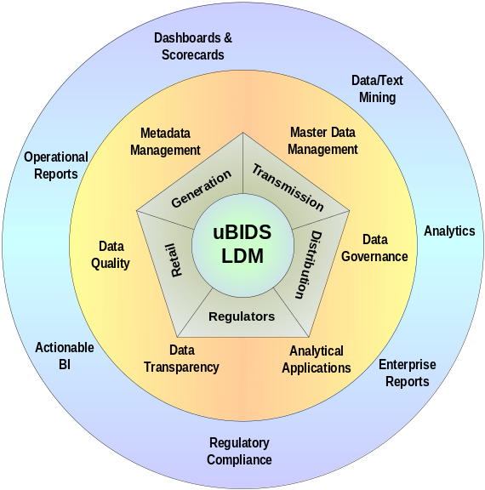
Like energy utilities, transformation is happening in water utilities towards adopting proactive measures to improve process and technology for water treatment, to minimize the supply interruption and to improve the consumer satisfaction.

Companies are looking at a variety of strategies – technological, financial, operational, and fiscal – to improve efficiency. SmarterUtility is a NKSOFT approach to address those challenges in utilities in terms of providing the right information at the right time to aid decision making.

SmarterUtility Framework for Power Utilities

The benefits of the SmarterUtility Framework are:

- Increase business competitiveness,
- Focus on market economy
- Energy conservation and loss reduction
- Technology alignment

For Power Generation – Analytics supported by SmarterUtility:

- Plant Operational and Maintenance
  - Heat Rate Analysis
  - Outage Analysis
  - Auxiliary consumption
- Market opportunity analysis
- Vendor/supplier performance analysis
  - Fuel quality Analysis

For Power T&D – Analytics supported by SmarterUtility:

- Transmission element load analysis
  - Link wise load analysis
  - Distribution transformer load analysis
- Power quality and reliability analysis
  - Power Factor analysis
  - Outage Analysis- CAIDI

For Power Retail – Analytics supported by SmarterUtility:

- Consumer load profiling and segmentation
  - Consumer Load Profile
  - Customer segmentation and Y-Y growth Analysis
  - Industrial Load Pattern Analysis
- Consumer loyalty analysis
  - Churn Analysis
- Revenue and profit
  - Profitability analysis

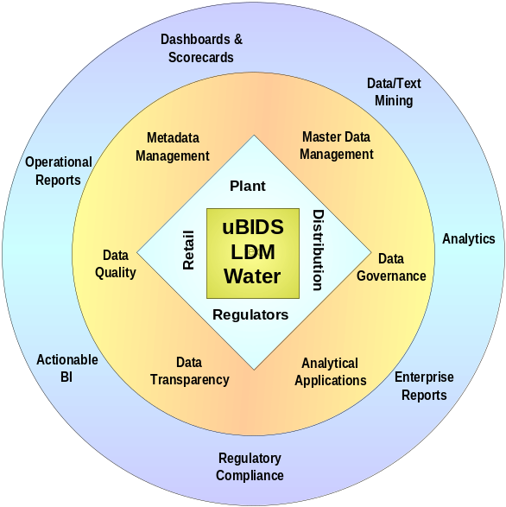
NKSOFT Solution Offering – SmarterUtility Framework for Water Utilities

SmarterUtility for water utilities (treatment plants, distribution and retail business) is an integral part of NKSOFT-BIPM Industry Solutions framework with an objective to create, enhance and support innovative business solutions for water utilities. The analytics provided by the framework is to improve individual process & sub process efficiency for water treatment plant and distribution network, and to improve customer satisfaction by complying with the OFWAT quality compliance, reduction of supply interruption, distribution network planning and fault management by leveraging the GIS capability and profit maximization by lowering UFW (Unaccounted For Water) and NRW (Non Revenue Water).

The Analytics supported by the SmarterUtility framework are:

- Cost of production
- Consumption Pattern
- Revenue and Profit
- Plant availability
- UFW (Unaccounted For Water)
- NRW (Non Revenue Water)
- Potable Water Quality
- SLA Compliance and Customer Satisfaction

BI Service Offering Areas

Consulting
1 | BIBP – BI Blue Print | The BI strategy, solution architecture, conceptual data model and the program definition including a program roadmap and detailed implementation methodology are delivered in the form of a BI Blueprint document.
2 | BIHC – BI Health Check | It is a structured approach for evaluation of customer’s BI Program keeping in mind objectives of all the stakeholders’ viz. Creator, Manager, Sponsor and finally the ultimate Consumer.

Implementation
1 | BIDSTM Methodology | It is a proven and successful methodology from NKSOFT to conceptualize and implement a BI solution for an enterprise, resulting in effective transformation of raw data into useful information and business knowledge.
2 | BICC – BI Competency Center | A BI competency Center (BICC) is the center that epitomizes the business and technical best practice of the organization. NKSOFT helps organizations by establishing BICC, involving Business and IT in collaborative environment.
3 | M2X – Migration Services | It provides a proven and successful methodology for migrating BI applications.
4 | U2X – Upgrade Services | The BIDSTM Upgrade methodology accelerates and simplifies transitions to new software releases. It comes up with a trusted Six - Phase upgrade process that minimizes risk and operational disruption while providing the most feasible approach.
5 | BIDM – BI Dashboard Management | NKSOFT has devised a delivery specific solution framework for BIDS™ Methodology catering to the requirements of digitization in an enterprise called KPI Radar framework.

Maintenance
1 | BI Maintenance | BIDS™ Maintenance Methodology provides a proven and successful methodology for supporting and maintaining BI applications. The goal is to establish a robust process that would ensure higher quality and standardization of processes thereby making efficient use of resources and time.

Solution Accelerators
1 | SmarterUtility – Electricity and Water Utilities | NKSOFT’ SmarterUtility offering is a conglomeration of its experience in utilities industry domain and leadership in BI space that will help the enterprise in implementing effective BI solution to aid decision-making process. The SmarterUtility framework consists of an enterprise wide Logical Data Model (LDM), Analytical Templates (AT) and High-end Analytics (HA).

Case Study – National Grid Transco

About NGT - National Grid Transco (NGT) was formed out of the merger of National Grid Group and Lattice Group. NGT is the largest utility in the UK. It ranks among the FTSE Top 20. It is a leading international energy delivery company with a turnover of £9bn and market capitalization around £15bn. NGT is responsible for balancing generation of power against demand.

Business Situation - New electricity trading arrangements (NETA) details the following:
- Changes the process of electricity trading, settlements and balancing mechanism.
- Power distributed over a wide geographical region but controlled centrally.
- Driven by the market needs for power and scheduling on the same to the second.
- System and Cost Imbalance is checked.

Key Achievements –

The NETA Economic Data warehouse (NED) was designed for
- Analysis of Operational and Commercial data
- Trending of Minutely data through time series
- On-Line Analytical Processing (OLAP) of aggregated data along Time and BM Units
- Standard and Ad-hoc Reporting & Trending

Case Study – United Utility Plc.

About UU – United Utility (UU) is engaged in managing and operating the regulated electricity distribution, water and waste water networks in the North-West of England. Its primary focus is to provide service to 7 million customers in the North-West of England. It is a member of the FTSE 100 group of leading UK listed companies and employs over 8,000 people in its core utility activities. The turnover of UU is approximately GBP 1318.2 million, profits of GBP 568.7 million.

Business Requirements –
- End to end Reporting solution to cater all the business needs
- ‘Performance Management Framework’ and align it to United Utilities Strategic objectives
- Provide process consultancy in categorizing reporting requirements in terms of real time and non real time reports and mapping those requirements in to operational, Regulatory and analytical requirements
- Dashboard Requirements
- Business Objects Universe Design and Report Development
- System administration and support of BO reports

Key Achievements –
- Requirement Engineering using ‘Top Down’ and ‘Bottoms Up’ approach
- Defining Performance Management Framework and align it to United Utilities Strategic objectives
- To provide multi utility dimension to most the requirements i.e. the same report can be utilized by electricity, water as well as wastewater business
- Handling Large volume of reports and user base
- Defining User Security Matrix
- Common Business Objects universe for electricity, water and wastewater
- BO reports development, support & enhancements

2.5 Advanced Metering Infrastructure

Utility enterprises today are embracing smart metering as a solution to reduce operational costs, increase customer retention, optimize load management and meet regulatory demands. The solution has evolved from traditional Automatic Meter Reading (AMR) solution and the technology today offers the potential to benefit energy stakeholders by providing solutions that help manage assets, load and design customer centric offerings.

We, at NKSoft Consultancy Services (NKSOFT) have created a Service Mart (SMart) for your smart meters that offers you the flexibility to select services to augment your existing meter data management system (MDMS) or transit in a phased manner to a new agile MDMS system through service oriented architecture.

NKSOFT' Metering SMart for Utilities allows you to choose from a range of pre-configured services that help you lower the overall cost to serve .The Metering services aggregates the power of time sliced meter data and delivers them as service packets based on your specific requirements. SMart is made up of innumerable fine grain services covering the entire range of functionalities impacted by metering system. These fine grain services are orchestrated through the workflow engine to create coarse grained services customised to the specific requirement of utilities.

For e.g. A billing system will get the billing determinants readily from this metering SMart. Similarly combinations of the granular meter data can be aggregated bottom up to a network asset and facilitate superior asset.

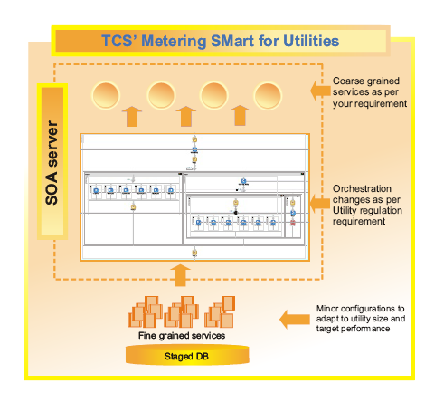

NKSOFT' Metering SMart for Utilities offers unique services which include:

- Conforms to Service Oriented Architecture (SOA), and can be consumed by other utility enterprise systems independent of realization platform

- Allows you to choose the services as per your priority process areas enabling staggered implementation, or to augment your existing meter data management system

- Equipped with ready interfaces for acquiring data from several sources like head-end AMI systems, GIS, SCADA, etc

- Provides services that can be configured based on the size and target performance of the utility

- Provides validation, editing, and estimation services that take care of cleansing the data, allowing meter data storage to be treated separately

- Can be fit into your utility eco-system irrespective of whether your utility has an application integration framework or not, or is in transition

- Ease of deployment through a scalable J2EE server, which enhances manageability, and eases dealing with security issues, along with web services standards.

Credentials on NKSOFT Smart Metering

Innovation labs

NKSOFT has set up two innovation labs in Peterborough and Kolkata to jointly develop a framework for Smart Metering, i.e. SMart (Services Mart) that can meet Utility industry requirements. The NKSOFT Kolkata Lab incubates the framework and is involved in actual development of the same. The Peterborough Lab facilitates the customer with optioning on off the shelf products in the area as well as look into the Smart framework.
NKSOFT Peterborough Lab is currently doing a PoC (Proof of Concept) to test out AMI business processes for a large Utility UK customer. Provision of PoC environment has helped reduce business risk for NKSOFT’s client. In the Labs there are other enterprise systems to test out the integration and create pilots to actually see how the smart metering solutions fit into the ecosystem.
Proof of Concepts
NKSOFT has also recently delivered a POC to a large multi utility company in middle east responsible for supplying power water and gas to approximately 0.5 million customers. The POC is to demonstrate a common Automated Metering Infrastructure in multi utility environment.
Product Expertise
NKSOFT had been a development partner for one of the leading MDMS (Meter Data Management System) product vendor based in North America. NKSOFT had also assisted them in functional testing and system engineering. This has provided rich experience and in-depth knowledge into leading product of the market.

NKSOFT also supports the application maintenance of the leading product in this field at Utilities in Ireland and UK.

2.6 Enterprise Solutions (ERP)

Enterprise Resource Planning (ERP) for Utilities is referred to as the back office systems. The functionalities typically covered are Finance, HR and Materials which are important support functions for any organisation.

NKSOFT has strong capabilities in most popular ERP packages, for Utilities these are commonly SAP and Oracle.

The key differentiators for this offering are:

- Leverage NKSOFT global competency centers for SAP and Oracle, provide best in class solutions
- Use domain expertise from the Utilities group to provide best practices in the processes being mapped
- Use large repository of NKSOFT templates, accelerators and tools for reducing implementation cycles

A case study on a large Oracle Applications implementation project for a group consisting of many companies is given below.

Balfour Beatty Utilities Limited (BBUL) is a leading solutions provider to major UK water, wastewater, gas, and civil engineering companies, for whom it operates term contracts.

Business Needs:

The company is committed to increasing customer satisfaction and growing shareholder value through lean, innovative, solutions-driven business processes.
- Reduce Costs by lowering the Travel Time between jobs
- Optimize the use of resources allocated by the Automatic Scheduling Process
- Prevent fines by the council
- Improve the Efficiency of Gangs
- Allocate Jobs based on Client Priority

Issues/Challenges:

- Reduce overhead, improve efficiency, and enhance service to customers by replacing the multiple technology platforms and applications used to handle client contracts with a single, automated work management solution
- Cut overhead through automation, enhance quality through best practice and raise productivity and performance
- Choose an implementation partner with the skills, experience, and resources to deliver against a challenging deadline

Solution Offered:

- Replaced disparate legacy financial, purchasing and project management applications with an integrated, automated work management solution built on Oracle E-Business Suite
- Used Oracle Project Costing and the work management application to gain a single, real-time view of the costs and status of each of the 25 customer contracts in progress
- Enforced use of authorized suppliers and negotiated discounts for bulk buying by using Oracle Procurement to manage spend

Business Benefits:
- Set to cut operating costs by £1.5 million (US$ 2.96 million) each year when all client contracts are managed by the solution
- Leveraged expertise of NKSoft Consultancy Services (Oracle Certified Advantage Partner) to build and enhance the solution which enabled BBUL to completely reengineer their processes and build an integrated, real-time business in just 18 months
- Benefited from the work management application to optimize the allocation of staff and contractor skills to each job and maximize the value of capital and equipment assets
- Leveraged Oracle Project Billing to provide customers with timely, accurate invoices and improve cash flow
- Cut monthly close times using Oracle Financials
- Benefited from improved efficiency to reduce exposure to Section 74 fines levied by the New Roads and Street Works Act for work overruns
- Successfully piloted the integrated work management solution on a major customer contract, cutting operating costs by 2.4%
- Solution to successfully manage all existing and new contracts
- Working with NKSOFT to enhance functionality by adding mobile job scheduling and work management capabilities
2.7 Strategic Outsourcing

NKSOFT Utilities SOLUTIONS UNIT provides full service play for outsourcing which covers Application Outsourcing, Infrastructure Services Outsourcing and Business Process Outsourcing.

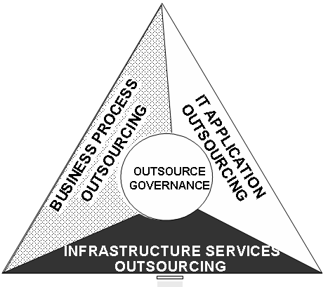

What we Offer?

- Overall Strategy and Roadmap for Outsourcing needs
- Bundled offerings in the areas of Applications, Infrastructure and Business Process
- Leverage of our vast knowledge built over last 4 decades – practices, platforms and tools

How will you benefit?

- Access to special expertise by partnering with Industry experts to increase innovation
- Increase the ability to focus on core competencies
- Improved operating performance, risk management and controls.
- Align IT with business Outcomes
- Speedier time to market
- Increased product and services value, customer satisfaction and Share holder value
- Reduce costs resulting into bottom-line performance improvements
- Predictable and sustainable IT costs year on year.

The services under strategic outsourcing are given in the figure below.

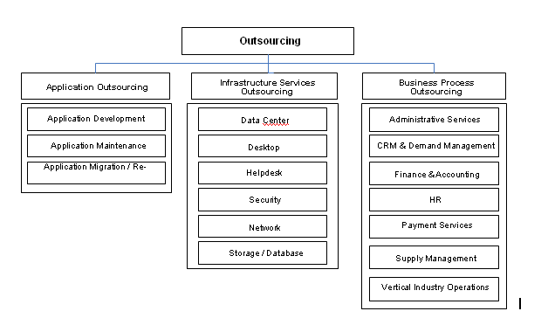

A case study on a large strategic outsourcing project for a Southern Water , providing water supply and wastewater treatment services across Kent, East and West of Sussex, Hampshire and the Isle of Wight in UK is given below.

Business Needs:

Guaranteed Service Scheme, which Capture Customer Correspondence information in Relational database from micro films & generate MIS Reports needs a Cost effective solution for conversion of data from micro films to DVD and data entry into database.

Business Solution Offered by NKSOFT:

- Analyse and generate reports on customer correspondence through
- Digitisation of Correspondence
- Classification for relevance to DG regulations
- Categorisation based on DG6 and DG7 categories
- Verification of records for adherence to DG norms
- Validation against customer’s Business Application data
- Billing Application
- Correspondence Management system
- Call Centre Applications
- Generation of correspondence analytics for payable calculation
- Auditable processes assuring traceability of deliverables at all stages
- Adherence to BS6000 Quality Standards satisfying Auditor’s requirements

Business Benefits:

- Development of an ASP based application for induction training automation and improving productivity
- Need base quick ramp-up of resources at offshore
- Exceeded the SLA commitment of 95% accuracy within the stipulated duration
- Analysis of 13 million images of correspondences related to 10 years complaints (DG7)
- Conclusively, suggest the client about the pay-out cases and non-payable cases
- Client’s compliance to UK OFWAT regulations was maintained – they could submit investigation results to OFWAT within 6 months of project inception
- Successfully audited by one of the top-5 audit companies – rigorous process audit and data audit were conducted
- ‘Zero backlog’ stage was achieved within the stipulated time-frame

EN’RGISE

The NKSOFT developed framework, EN’RGISE (ENterprise Related Generalized Information SystEm), is used to manage online business transactions of a Utility Organisation. NKSOFT provides the solution as a whole or modules can be implemented separately. These modules are easy to integrate with existing customer applications. EN’RGISE has a 3 tiered architecture based on the widely accepted J2EE architecture.

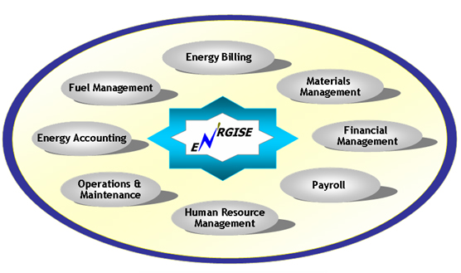

Product Features

- Complete range of back-office applications: From Finance and Materials Management to HR Management and Payroll, En’rgise can be easily customized to address specific requirements of customers.
- Unique set of Utility specific applications:

  - Fuel Management - Covering planning to payment cycle
  - Energy Accounting - Post-facto analysis, performance analysis and decision support
  - Investment Planning Optimization - Determination of optimum balance between repair and replacement
  - Billing - New connections, Tariff engine, Debt management

Moreover, En’rgise offers integration capabilities of smart metering with billing, fault and outage management and allied systems.

- Easily adaptable: To existing computing environment; scalable, modular, extensible, rule-based, and can be easily integrated and configured.

A pictorial representation of En’rgise functionality in detail is given in the diagram below.

ASSET MANAGEMENT
ENERGY BILLING

- Application Processing
- Customer Information Management
- Billing & Meter Inspection
- Collections & Remittances

ENERGY ACCOUNTING & AUDTIING

Accouting the energy inflow and outflow
- Feeder Wise
- Sub-station wise
- Distribution Transformer wise

FINANCIAL MANAGEMENT
- General Ledger Accounting
- Purchase Accounting, Funds Management
- Inventory Accounting
- Management Accounting

HUMAN RESOURCE MANAGEMENT
- Employee Information Management
- Manpower Planning, Allocation, Transfer
- Traning, Development,Industrial Relations
- Rules and Policies

FUEL MANAGEMENT
- Receipt & Consumption
- Fuel Billing & Valuation
- Claims Management
- Transit Losses,Reconciliation

MATERIALS MANAGEMENT
- Purchase Management
- Inventory Management
- Risk Management

OPERATIONS AND MAINTENANCE MANAGEMENT
- Equipment Information Management
- Maintenance Planning, Work Specification
- Document & Contracts Management
- Plant Performance Reports Generation

OPTIMIZER
- Data collection & database monitoring
- Statistical analysis & report generation
- Depriciation modelling
- Alarm and periodic report generation

BACK OFFICE SOLUTIONS
PAYROLL ADMINISTRATION
- Loan Information, Claims
- Advances & Settlements
- Savings & Income Tax
- Accounting Reports

SYSTEM ADMINISTRATION

- User
Maintenance
- Backup &
Recovery
- Archival
- Database
Administration
- Security
Management

CUSTOMER SERVICE

4. Utilities Innovation Lab

The Utilities Innovation Network (UIN) derives its methodology from the NKSOFT Co Innovation Network It brings together the Customer and NKSOFT to work together on an idea which can then be put to use in the customer business. UIN helps like a catalyst to identify from among the network partners, the organisations and individuals who need to work together to give shape to the idea.

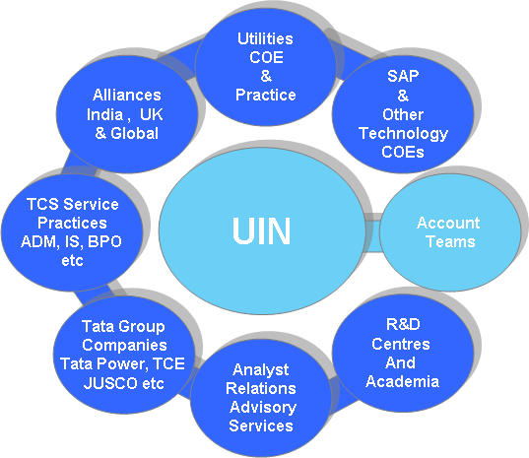

The Utilities Innovation Lab is a part of the UIN. The key activities of the lab are:

- Incubating Ideas
- Experimenting together
- Pioneering Solutions
- Delivering Certainty

The NKSOFT Innovation Lab @ Peterborough is an example of joint innovation between NKSOFT and National Grid. The lab jointly experiments on the possibilities of creating an IS environment for the SMART AMI solution. The NKSOFT lab provides the facilities for pilot development and testing.

5. SUAVE - SAP Utility Applications Value Enhancement

NKSOFT has developed a dedicated competency centre for SAP for Utilities. This group within the Utilities SOLUTIONS UNIT works in tandem the NKSOFT SAP Centre of Excellence. In addition to delivering solutions and services to SAP Utility Clients, they are also engaged in research and development of solutions incorporating the best practices.

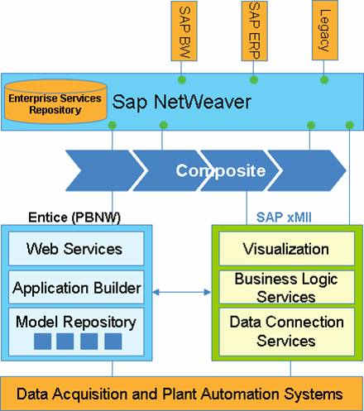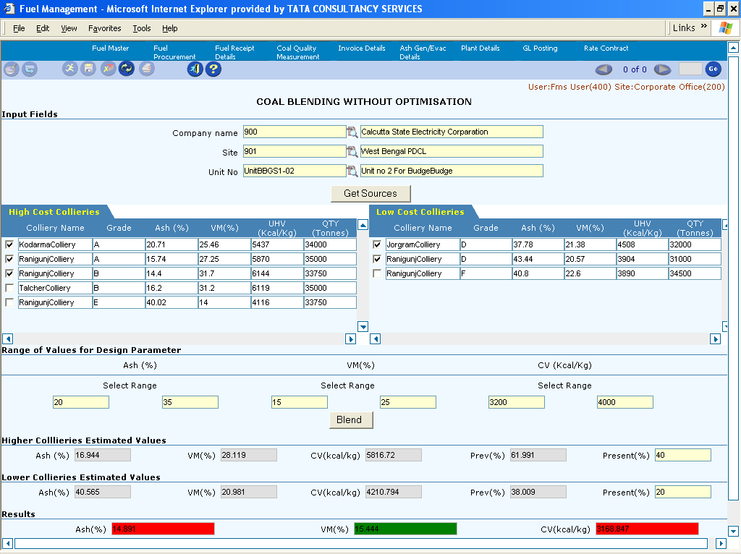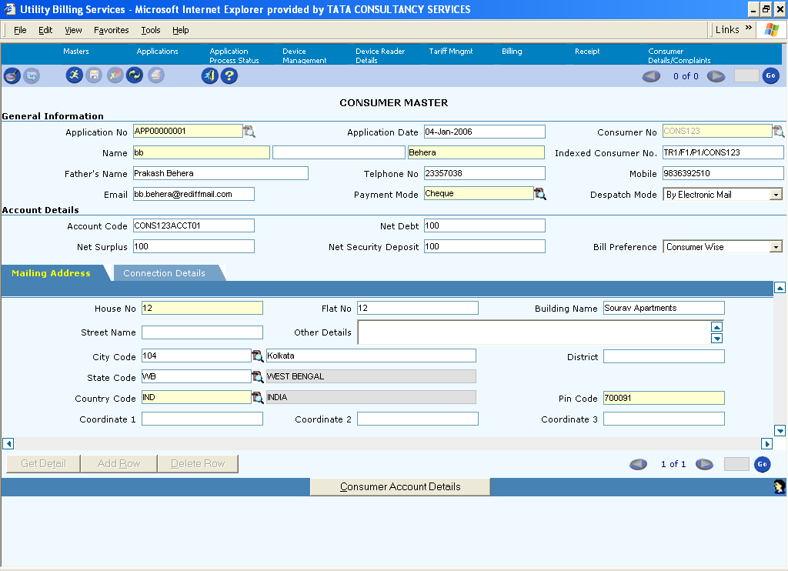
Current Initiatives:

Enterprise Asset Management Solution:

This solution has been developed using industry best practices and knowledge gained from assignments. It gives a SAP solution integrated with GIS, Mobile field force solution, projects and investment management solutions. This platform is used to work on customer specific enhancements.

IS-U Templates:

Templates for Water, Gas and Electricity have been developed and being maintained to capture typical scenarios in the areas of CRM and IS-U functionalities. This again serves as a platform to work on advanced processes necessary for clients

Composites for white spaces:

Composites will be built using XMII technology in SAP to address ‘white spaces’

Bolt on solutions with En’rgise

There are three specialised modules which are being integrated with SAP
- Energy Accounting System
- Fuel Management System
- Asset Optimizer

