NKSOFT Testing Process

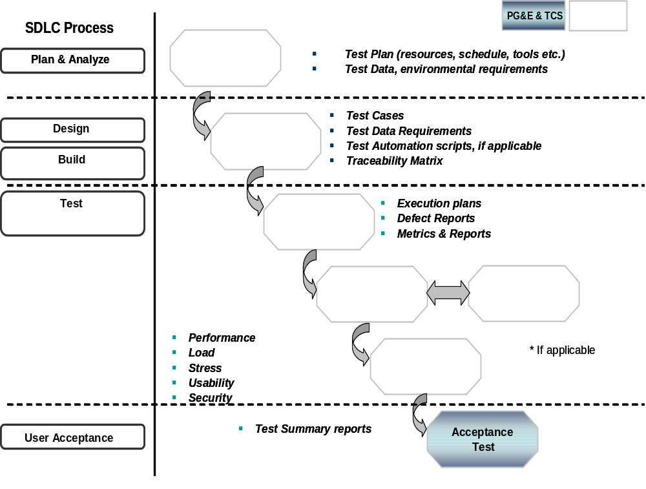
The following diagram depicts the overall Testing life cycle and the Testing process that is aligned with the SDLC as well as Project Delivery Methodology (PDM)
NKSoft

- The planning for testing will start at the requirements stage of SDLC. The requirements will be reviewed to understand the proposed change to the system and to define the necessary testing strategy.
  - The Test Strategy will be defined with the focus on finding the defects in the early stages/phases of testing to reduce cost, and to ensure that the later phases of testing to validate the functional aspects of the system run relatively smoothly. The strategy also will provide the basis for Test Planning.
- The Test Strategy will define the various high level test activities, test phases, exit/entry criteria between phases and the overall sign off criteria for the entire testing.
- The Test Planning phase will concentrate on defining the necessary resources, effort/schedule requirement and the cost involved for implementing the proposed Test Strategy.
- Test Design will comprise of Test Cases, Test Scripts and Test Data. At higher levels of functional testing, Test Cases will have to be clubbed together to form Business Scenarios/Test Scenarios. A set of business scenarios will be combined together to form Test Cycles. A Test Case reusable list will be prepared by identifying the test cases, which can be reused in current or future release. Similarly business critical scenarios will be identified during the test design stage for the subsequent smoke testing or random independent testing of applications.
- NKSOFT will use a traceability matrix to track requirements of test cases and defects. This can be effectively handled using test management tools (HP Quality Center) where there is mapping from requirements to test cases/scripts and test cases/scripts to defects detected and reported.
- In the Test Execution phase the system will run to check that it behaves as expected in the scenarios defined by the Test Cases and Test Scenarios. Any deviation from the expected behavior will be reported as a defect. Once the defect is fixed by the development team, the test cases will be run again, to make sure that the fix has resolved the problem.
  - NKSOFT will leverage its metrics management program for reporting test results and metrics to CLIENT. NKSOFT can provide dashboards to the various stakeholders regarding project status at any given point in time through effective usage of the test management tool (HO Quality Center)

Unit Testing

Name | Unit Testing
Objective | To perform white-box testing on individual systems/components in order to ensure code coverage.  This will be done in the development environment by the respective developers.
Inputs | - Compiled code/build  - Unit test cases  - Code reviews and walkthrough done | Outputs | - Defect Logs  - Test execution reports
Entry Criteria | - Code has compiled successfully  - All code review comments have been closed  - Unit test cases have been reviewed and are available | Exit Criteria | - Unit Test cases executed  - Defects logged  - Test results available

System Testing

Name | System Testing
Objective | To perform black-box testing on overall systems/components in order to ensure conformance to the functional requirements  This will be preferably done in a designated System testing environment by the testers – in case the same is not available, the development environment will have to be refreshed.
Inputs | - Unit tested build  - System test cases in HP Quality Center  - System test environment & data  - Automation scripts (if applicable) | Outputs | - Defect Logs in HP Quality Center  - Test execution reports
Entry Criteria | - Build has passed Unit Testing  - All unit test defects have been closed  - System testing environment is refreshed and available  - System test scenarios have been reviewed and are available | Exit Criteria | - System Test cases executed  - Defects logged  - Test results available

Integration Testing

Name | Integration Testing
Objective | To test end to end business processes on the integrated set of components/systems – by interfacing the portal with other set of interfacing systems  This has to be ideally tested in an environment where the multiple interfacing systems and the necessary data would be available.  In the absence of this, this testing would be executed in the designated System testing environment with interface stubs.
Inputs | - System tested components  - Integration test scenarios & cases  - End to end business scenarios  - Test environment and data  - Availability of external systems interfaces or stubs | Outputs | - Defect logs in HP QC  - Test execution reports
Entry Criteria | - Integration requirements have been completely defined  - Individual systems/components have undergone System Testing  - All interfacing components or stubs therof are available for testing.  - Availability of data and environment | Exit Criteria | - Integration test cases executed  - Defects logged  - Test results available

Performance Testing

Name | Performance Testing
Objective | To test the overall conformance of the system to identified non functional requirements (NFR) regarding the system performance in terms of responsiveness and performance workload requirements  To be ideally carried out in an environment that is a close replica of the production environment in terms of hardware and data. In the system test environment, NKSOFT would however employ its Emulator and Profiling tools to emulate production-like conditions for effective performance testing.
Inputs | - System tested components  - Performance Test environment  - Test data - adequate data for load testing  - Test scenarios are available  - Tool available and deployed  - Automation scripts ( if Tools like HP Load Runner is to be used) | Outputs | - Test results  - Trends  - Result analysis
Entry Criteria | - Build has passed System testing  - Appropriate environment and data are available  - Tools have been deployed. | Exit Criteria | - Defects logged  - Test results are available

NKSOFT would support CLIENT in the execution of User Acceptance Support.

Regression Testing

Name | Regression Testing
Objective | - For the initial portal build, the regression test suite will be progressively created and will be base lined with the base-lining of the portal development.  - Regression testing will be carried out once the build is base lined and has passed earlier rounds of ST and Integration testing  - One round of regression testing may be done following the completion of Wave 1 and Wave 2 of development and prior to release of the build for UAT
Inputs | - Regression test suite  - Test environment and data  - Test tools setup | Outputs | - Defect logs  - Test execution reports
Entry Criteria | - Build taken through system and integration testing  - Availability of data and environment  - Availability of tool | Exit Criteria | - Regression test suite executed  - Defects logged  - Test results available

Defect Management Process
The following table describes the activities to be carried out during the defect tracking and management. HP Quality Center (licenses available with CLIENT) will be used for the purpose of end to end defect management

Activity | Tasks
Defect Detection & Defect Logging | On identification of a defect, defect Information logged in the tool (HP QC) by the tester and passed on to the development team for investigation
Analyse & Set Priority/ Severity | Will be performed by the tester and reviewed by the Lead  - Analyse the defect  - Categorise the defect  - Assign severity and priority level  - Set defect status to Open
Defect Resolution  (development team) | - Causal analysis  - Assign to team member  - Fix and unit test
Re-Testing | - Re-Test the new build of the application after the defect fix is provided  - If a defect is resolved, change the defect status to Closed  - If the same defect is found again, assign it with status Reopen
Tracking & Monitoring | - Regular tracking of defects status in terms of closure and ageing by the Assurance team using the defect management tool

