# Log Analytics Platform

The Log Analytics Platform is an end-to-end monitoring system that collects, processes, stores, and visualizes application logs in real time. It uses Kafka for real-time log ingestion, Prometheus for metrics, and Grafana for powerful visualizations. This system helps developers monitor system health, track API performance, and detect issues early.

## 📌 Features

- **Request Count per Endpoint**

- **Response Time Trends**

- **Most Frequent Application Errors**

- **Live Log Feed (Streaming View)**

- Extensible: Add new metrics or dashboards easily

## 🧰 Tech Stack

| Component | Technology |

|------------------|--------------------|

| Containerization | Docker |

| Messaging | Apache Kafka |

| API | Flask / JSON-Server (mock) |

| Log Storage | PostgreSQL / Loki / Prometheus |

| Visualization | Grafana |

log-analytics-platform/

├── api/ # REST API with 5–10 endpoints

├── kafka-producer/ # Sends logs to Kafka

├── kafka-consumer/ # Consumes logs from Kafka, stores in DB

├── load-generator/ # Simulates API traffic

├── grafana/ # Dashboards & provisioning config

├── prometheus/ # Metric collection setup

├── log-viewer-cli/ # CLI tool to view logs

├── docker-compose.yml # Orchestrates all services

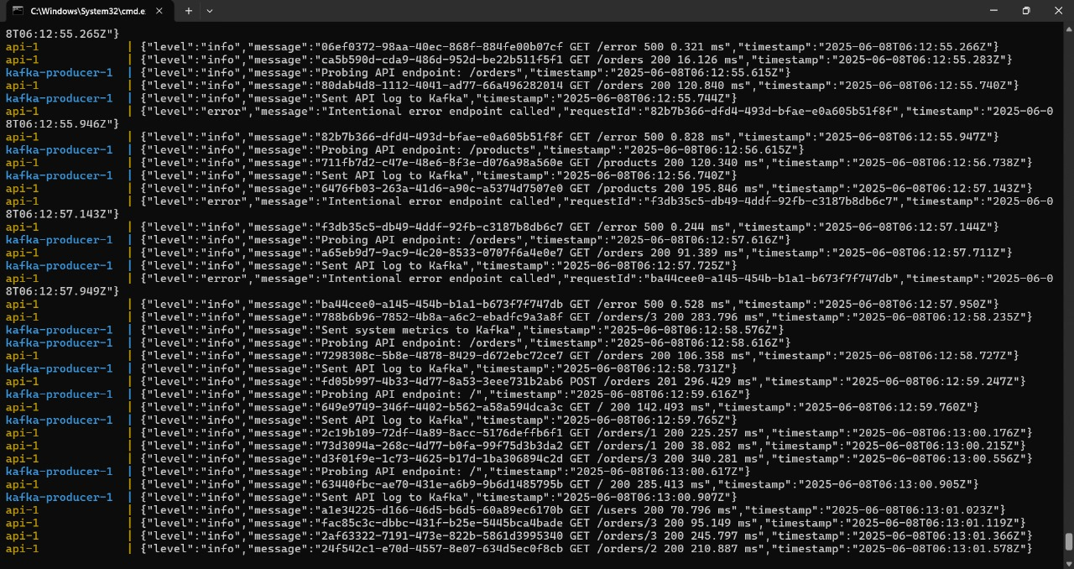

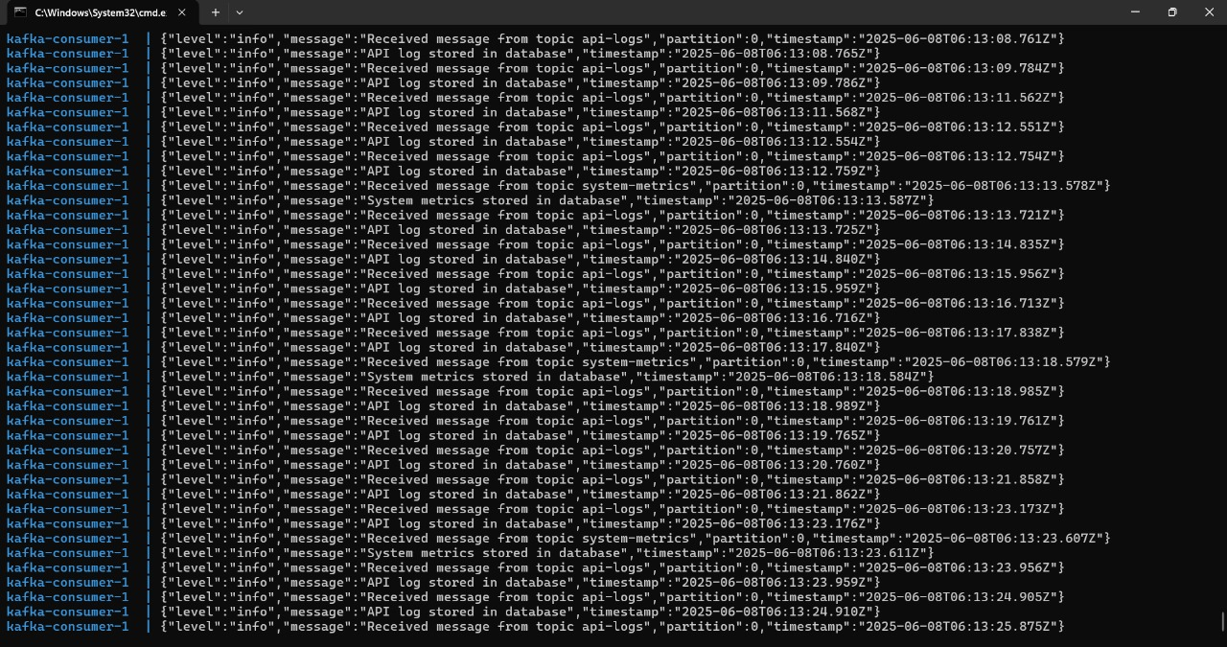

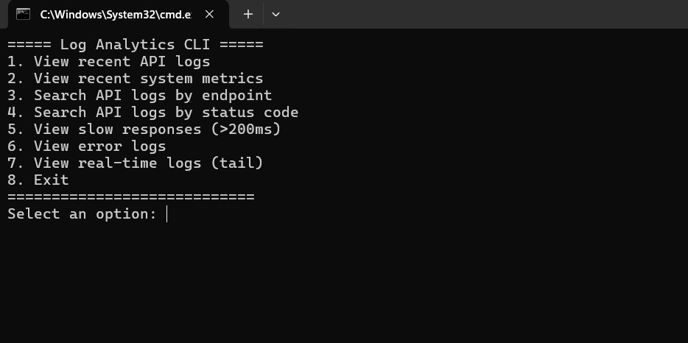

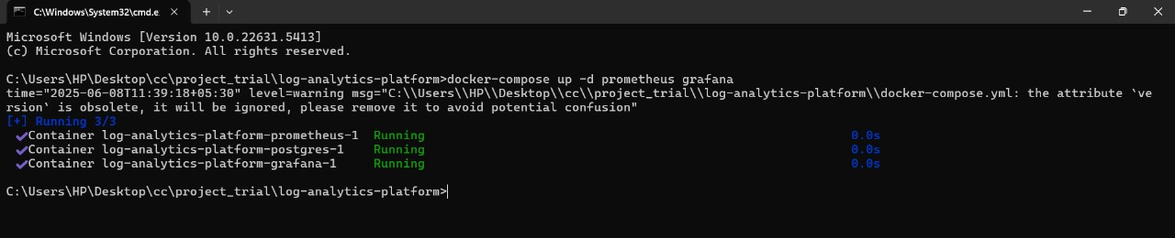

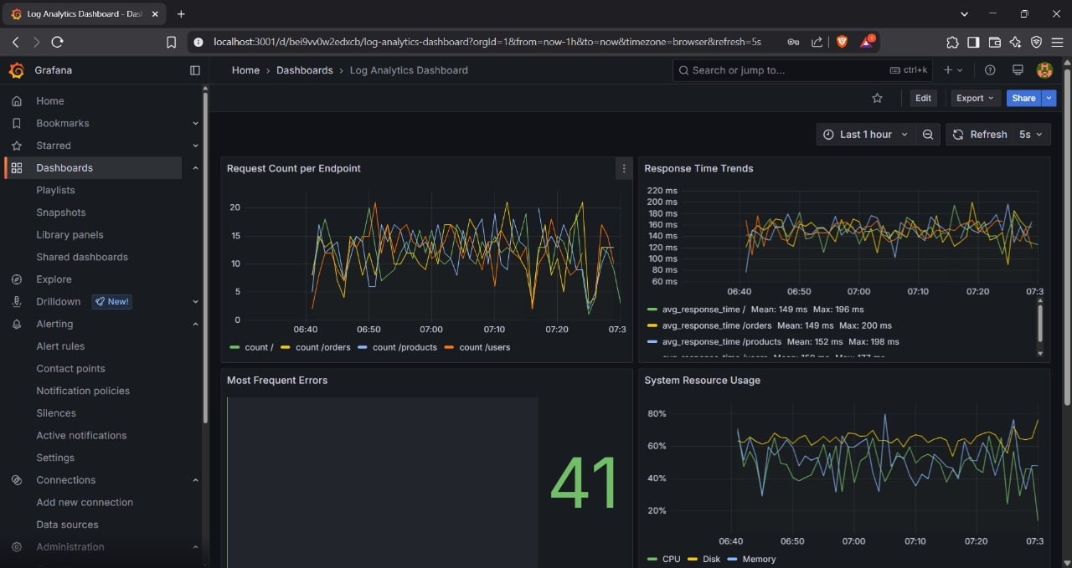

🙌 Contributors

Amisha Jain – Developer