1 How To Use This Document
Highly regulated industries, such as banking and insurance, must comply with government regulations for model validation before a model can be put into production. This includes creating robust model development documentation. DataRobot automates the generation of model documentation, expediting the process required for regulatory compliance and following best practice for reducing model risk.
This document is split into two components: those sections that are automatically produced by DataRobot and those that require further input by the user. The sections in blue italicized font include specific instructions for the documenter and require additional user input of organization-specific information, such as business use cases, data sources, and implementation details. Once the sections are complete, remove the instructions. The remaining sections in non-blue italicized font are automatically populated by DataRobot and require no further input.
Copyright ©2026, DataRobot, Inc.


Table of Contents
- 1 How To Use This Document
- 2 DataRobot Model Development Documentation
- 3 Executive Summary and Model Overview
- 3.1 Model Stakeholders
- 3.2 Model Development Purpose and Intended Use
- 3.3 Model Description and Overview
- 3.4 Overview of Model Results
- 3.5 Model Interdependencies
- 4 Model Data Overview
- 4.1 Feature Association
- 4.2 Data Source Overview and Appropriateness
- 4.3 Input Data Extraction, Preparation, and Quality & Completeness
- 4.4 Data Assumptions
- 5 Model Theoretical Framework and Methodology
- 5.1 Model Development Overview
- 5.2 Model Assumptions
- 5.3 Model Methodology
- 5.3.1 Elasticnet Classifier model based on block coordinate descent
- 5.3.2 LightGBM Trees Classifier with Grid Search and Early Stopping support
- 5.3.3 Extreme Gradient Boosting Classifier with Grid Search and Early Stopping support
- 5.4 Literature Review and References
- 5.5 Alternative Model Frameworks and Theories Considered
- 5.6 Variable Selection
- 5.6.1 DataRobot Quantitative Analysis
- 5.6.2 Expert Judgement and Variable Selection
- 5.6.3 Final Model Variables
- 5.6.3.1 Model Features and Summary Statistics
- 6 Model Performance and Stability
- 6.1 Model Validation Stability
- 6.1.1 Cross Validation Scores
- 6.1.2 Data Partitioning Methodology
- 6.2 Model Performance (Sample Scores)
- 6.3 Sensitivity Testing and Analysis
- 6.3.1 Lift Chart
- 6.3.2 Key Relationships
- 6.3.3 Sensitivity Analysis (Partial Dependence)
- 6.3.4 Accuracy (Receiver Operating Characteristic)
- 7 Model Implementation and Output Reporting
- 7.1 Version Control
2 DataRobot Model Development Documentation
A key component of effective model risk management is sufficiently detailed documentation for model development, implementation, and use, so that reasonable parties unfamiliar with a model can understand how the model operates, its limitations, and its key assumptions. Additionally, model documentation should contain enough detail for an independent party (e.g., independent model validation) to replicate all aspects of the underlying modeling process.
The purpose of this document is not to be prescriptive in format and content, but rather to serve as a guide in creating sufficiently rigorous model development, implementation, and use documentation. The documentation should provide enough evidence to show that the components of the model work as intended, the model is appropriate for its intended business purpose, and that it is conceptually sound.
3 Executive Summary and Model Overview
3.1 Model Stakeholders
Describe the model's purpose and its intended business use. Describe all stakeholders of this model, including their role, line-of-business, and team. This should include stakeholders of model ownership, model development, model implementation, and model risk management.
Model Owner(s): The individual who owns the business risk addressed by the model and provides approval for the model to be used within the line-of-business or enterprise function.
Model Developer(s): The individual responsible for building new models with DataRobot or maintaining existing models.
Model User(s): Those teams who will use the model output as part of their ongoing business operations.
Model Validator(s): The validators are responsible for independent model review and approval prior to its first use.
3.2 Model Development Purpose and Intended Use
Describe the model's purpose, including a summary of the business need for this particular model. Concisely describe how the model will be used to address this business problem. Furthermore, describe with great precision all model uses covered by this document. These descriptions will address this statement made in regulatory guidance, FRB SR-11-7, "Even a fundamentally sound model producing accurate outputs consistent with the design objective of the model may exhibit high model risk if it is misapplied or misused."
3.3 Model Description and Overview
The particular model referenced in this document: ENET Blender. This model was developed in a project created with v1a6dd0624a2ea197 of DataRobot. This model is denoted within DataRobot by the Project ID: 69386601f427218a5119806d and the Model ID: 6938873d9b902496a1ae4494. The project was created on 2025-12-09 18:10:09.
The model development workflow process (i.e., the model blueprint) is detailed in the figure below.
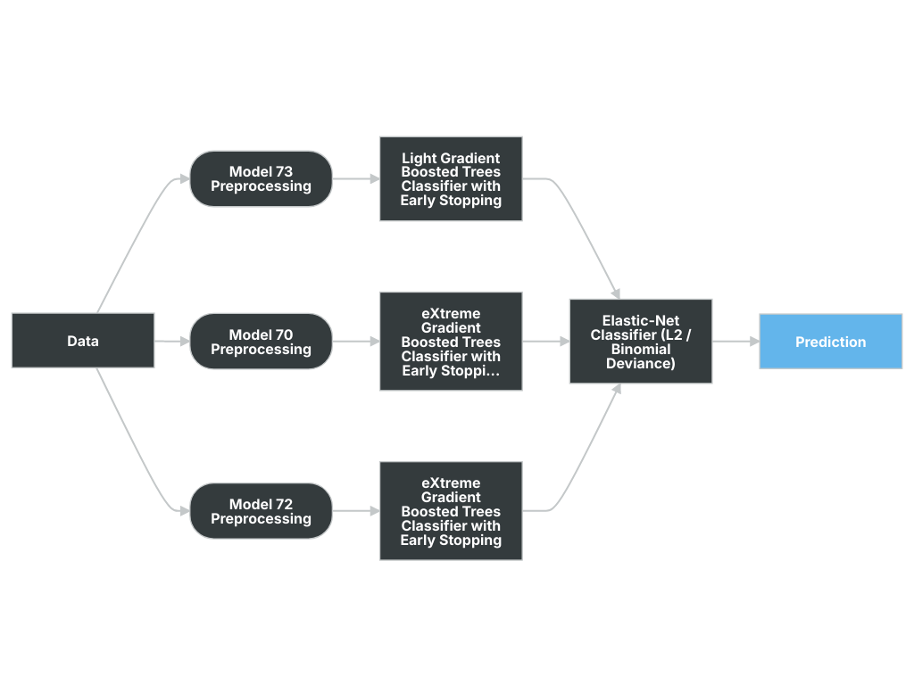
A Blueprint represents the high-level end-to-end procedure for fitting the model, including any preprocessing steps, algorithms, and post-processing. It illustrates the many steps involved in transforming input predictors and targets into a model. Each element (or, “node”) in a blueprint can represent multiple steps.
The following elements connect to create the blueprint:
- Elastic-Net Classifier (L2 / Binomial Deviance)
3.4 Overview of Model Results
DataRobot runs performance testing during the model development process to evaluate model results and reliability. The validation, cross-validation, and holdout (if applicable) out-of-sample performance scores are presented below, as well as the number of observations for each partition. The performance metric used for this project was LogLoss and the project included a total of 78,736 observations. An asterisk (*) next to a score, whether validation or holdout, indicates that DataRobot used in-sample predictions to derive the score. (In-samples predictions are those that include data from the validation or holdout partitions due to sample size used to build the model.)
Scoring Type | Score (LogLoss)
cross_validation | 0.2058*
holdout | 0.2017*
validation | 0.2126*
3.5 Model Interdependencies
Understanding interdependent relationships allows for enhanced understanding and improved ability to manage and aggregate model risk. Explain how this model is interconnected with other models in the model inventory--that is, the relative direction with regard to the model's position in the receiving input/sending output role. In addition to the directional relationship, also provide a brief description of each interconnected model.
4 Model Data Overview
4.1 Feature Association
DataRobot’s Feature Association Matrix is populated by default by features from DataRobot’s Informative Features feature list. The Feature Association Matrix provides information on association strength between pairs of numeric and categorical features that are visually denoted by the opacity of the color (that is, num/cat, num/num, cat/cat, where lighter shades indicate weaker association and vice versa) and feature clusters. Clusters, families of features denoted by color on the matrix, are features partitioned into groups based on their association structure.
Some of the noted benefits of the Feature Association Matrix include:
- Understand the strength and nature of associations within the data;
- Detect families of pairwise association clusters; and,
- Identify clusters of high-association features prior to model building.
The Feature Association Matrix lists up to the top 50 features, selected by Importance Score, on both the X and Y axes, where the intersection of a feature pair provides an indication of their level of association. By default, the matrix displays by the Mutual Information values and sorts by the cluster.
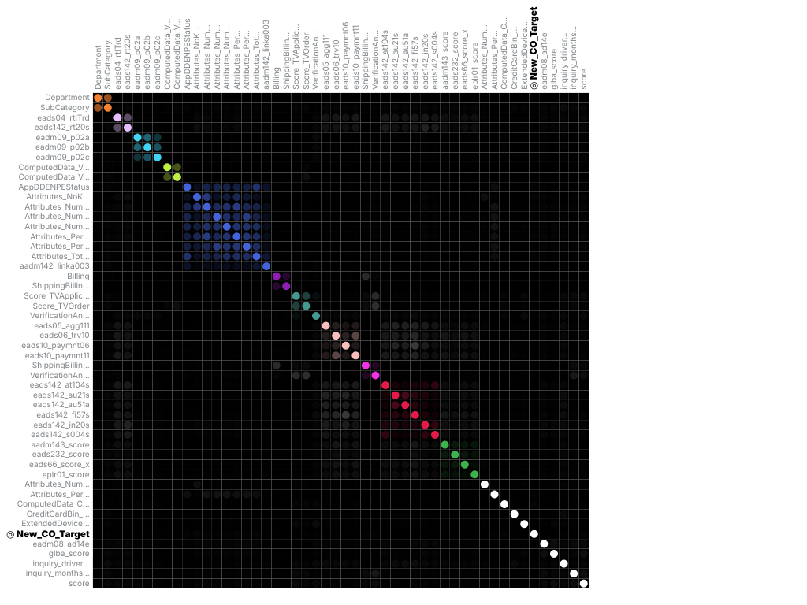
The following are some general takeaways from looking at the matrix above:
- Each dot represents the association between two features (a feature pair), where the opacity of the color denotes the pair-wise strength of association.
- Each cluster is represented by a different color.
- The opacity of color indicates the level of association 0 to 1, between the feature pair. Levels are measured by the set metric, either mutual information or Cramer’s V.
- Shaded gray dots indicate that the two features, while showing some association, are not in the same cluster.
- White dots represent features that were not categorized into a cluster.
- The target feature, if present, is indicated by two small concentric circles next to the feature name.
4.2 Data Source Overview and Appropriateness
Explain how the data is suitable and relevant for the business problem and model use. For example:
Describe how, and from where, the data was obtained.
Provide a detailed description of the data source and its relevance to the business problem being addressed by this model.
Assess whether the data used for model development is appropriate given the populations to which the model will be applied.
If the model development and model implementation data sources differ, provide a detailed explanation justifying the use of different data sources.
4.3 Input Data Extraction, Preparation, and Quality & Completeness
Provide a detailed description of the data extraction and preparation process, and discuss any analysis conducted to confirm the data are complete and of sufficient quality (e.g., data validation). Include a detailed description of the data extraction process, hierarchical by extraction and preparation stage, and calling sequence. Provide data extraction code (e.g., SQL, Spark, etc.) in the Appendix.
Review and comment on any data weaknesses and limitations and their probable potential effects on the model. For example, data truncation, extraction timing, through-the-cycle data, and data exclusions could potentially cause unintended effects on the model.
4.4 Data Assumptions
Comment on data assumptions, the potential effects on the model, and any mitigating data controls. For example, assumptions related to data truncation, extraction timing, through-the-cycle data, reliability of source system, manual data overrides or imputation, and data exclusions could potentially cause unintended effects on the model.
5 Model Theoretical Framework and Methodology
5.1 Model Development Overview
DataRobot simplifies model development by performing a parallel heuristic search for the best model or ensemble of models, based on both the characteristics of the data and the prediction target. While some machine learning techniques tend to consistently outperform others, it is rarely possible to say in advance which will perform best for a given business problem. Therefore, during the modeling process, DataRobot develops dozens of independent challenger models, exposes the details of how these models were built and how they perform, and enables the user to select the best model for the particular business problem being addressed.
The fundamental workflow within DataRobot for model development is as follows:
- Rapid Data Ingestion: User creates a modeling dataset that includes the prediction target and loads into DataRobot
- Target Selection: User selects the prediction target; DataRobot detects whether the target is categorical or continuous. If the target is categorical, DataRobot selects and builds classification blueprints. If the target is continuous, DataRobot selects and builds regression blueprints. DataRobot also selects an optimization performance metric based on the type of supervised learning problem, which can also be changed by the user
- Automated Data Preparation: DataRobot analyzes the input data and automatically performs advanced preprocessing steps that are discussed in detail in this document. DataRobot also automatically partitions the input dataset into learning, validation and holdout dataset; these can also be defined by the user.
- DataRobot uses information about the selected target variable and predictors to define a set of candidate blueprints for analysis. It then trains models for each blueprint and ranks them on the model Leaderboard based on an out-of-sample validation accuracy score.
- Transparent Model Evaluation and Selection: DataRobot has built-in diagnostic tools to assess model accuracy and performance. Once DataRobot has trained and tested models, users can access them from the Leaderboard. From there, users can review model accuracy and, using built-in model diagnostic tools, understand how each independently built model performs. DataRobot provides many metrics for evaluating model accuracy, such as AUC, Log-Loss and RMSE. DataRobot's Leaderboard actively tracks performance of candidate models using out-of-sample data for comparison purposes.
- Model Deployment and Monitoring: Once the final model is selected, DataRobot provides efficient solutions for deployment (i.e., model implementation) and monitoring. These features enable the model owner to effectively manage model controls in accordance with Model Risk Management standards and policies.
5.2 Model Assumptions
This section should include model limitations, potential effects, and any mitigating controls in place. Limitations come in part from weaknesses in the model due to its various shortcomings, approximations, and uncertainties. Regulatory guidance refers to limitations as "...a consequence of assumptions underlying a model that may restrict the scope to a limited set of specific circumstances and situations." This section should include model limitations, potential effects, and any mitigating controls in place. Also include details here about the implementation of the models, what data will be used for scoring and why it is reasonable to think that the training data and the scoring data will be similar.
Machine learning methods can produce more accurate predictive models than traditional statistical regression methods because they are more flexible and rely less on statistical assumptions. For instance, ordinary least squares regression requires that the Gauss Markov assumptions are supported, which ensures that the model is unbiased and efficient.
Traditional statistical regression techniques rely on formal hypothesis testing for variable significance and feature selection (e.g., t-test, p-value, standard error). These hypothesis tests tend to have distributional and independence assumptions that may not be supported by the data. Machine learning methods, on the other hand, offer more flexibility in defining the model structure, which typically results in better model performance. Because machine learning includes methods that do not rely on formal hypothesis testing to demonstrate model validity, and because heuristic-style feature selection methods (e.g., stepwise selection) are not used in most machine learning approaches, no such distributional assumptions are required. In this case, the only assumption being made is that the model training data is representative of the future scoring data. Of course, these assumptions must be closely monitored and tracked by the model's ongoing performance monitoring process.
A common limitation of machine learning methods is the potential for overfitting. Overfitting occurs when the model is trained too closely to the underlying training data and does not perform well out-of-sample. DataRobot utilizes a robust cross-validation and holdout methodology to ensure model performance is sound, reducing the risk of overfitting.
5.3 Model Methodology
The modeling workflow consists of the following elements, which connect to create the blueprint:
- Elastic-Net Classifier (L2 / Binomial Deviance)
The following subsections include details for each node of the modeling blueprint.
5.3.1 Elasticnet Classifier model based on block coordinate descent
Logistic is a class of generalized linear models that uses the binomial distribution to fit regression models to a binary (0/1) response variable. It is probably the most widely used binary classification models and is a good baseline by which to judge the performance of other classifiers. Logistic regression is notable in that it tends to produce well-calibrated classification probabilities without the need for post-processing.
The Elastic Net is an extension of logistic regression where the optimizer makes an attempt to find a parsimonious model, by having a preference for simpler models. A simpler model is defined as having coefficients with smaller absolute values as well as fewer non-zero coefficients. This can help the model deal with co-linear variables, and can also produce models that are less prone to overfitting and generalize better to new data. This “preference for simpler models” is formally defined as “regularization,” and the degree of regularization for non zero coefficients as well as the absolute value of the size of the coefficients are the 2 major meta parameters that control the model.
ElasticNet is a linear regression model trained with L1 and L2 prior as regularizer. This combination allows for learning a sparse model where few of the weights are non-zero like Lasso, while still maintaining the regularization properties of Ridge.
Elastic-net is useful when there are multiple features which are correlated with one another. Lasso is likely to pick one of these at random, while elastic-net is likely to pick both.
A practical advantage of trading-off between Lasso and Ridge is it allows Elastic-Net to inherit some of Ridge’s stability under rotation.
Based on lightning CDClassifier
Type | Name | Description | Best Searched
select | beta_transform (bt) | beta_transform is a parameter used for blenders. If beta_transform is set to ‘blender’, coefficients are non-negative and are all in [0, 1]. Very large weight of the penalty term will get you the average blender. values: ['id', 'blender']
multi | enet_alpha (a) | The ElasticNet mixing parameter, with 0 <= alpha <= 1. For alpha = 0 the penalty is an L2 penalty. For alpha = 1 it is an L1 penalty. For 0 < alpha < 1, the penalty is a combination of L1 and L2. ‘auto’ grid of 11 numbers spaced evenly from 0.0 to 1.0 values: {'floatgrid': [0, 1], 'select': ['auto']}
multi | enet_lambda (lb) | The weight for the penalty term ‘auto’ searches a grid of 50 numbers spaced evenly on a log10 scale from 3.16e-07 to 3.16e-01 values: {'floatgrid':[1e-10,1e10],'select':['auto']}
bool | fit_alpha_scaler (fs) | If it is set to True, the weight of the penalty term is scaled. A weight of 1 would lead to an intercept only model and a weight of 0 won’t apply any penalty. With this parameter set to True, a penalty > 1 would not make sense any more. values: [False, True]
bool | fit_intercept (fi) | whether to calculate the intercept for this model. If set to false, no intercept will be used in calculations (e.g. data is expected to be already centered). values: [False, True]
select | loss (d) | The loss function to be used. values: ['log']
int | max_iter (mi) | The maximum number of iterations values: [1, 1e6]
int | random_state (rs) | The seed of the pseudo random number generator to use. values: [0, int(1e9)]
float | sigma (sg) | Constant used in the line search sufficient decrease condition. values': [0, 1e-6]
float | tol (e) | The tolerance for the optimization: if the updates are smaller than tol, the optimization code checks the dual gap for optimality and continues until it is smaller than tol. values: [1e-10, 1e10]
bool | warm_start (ws) | When set to True, reuse the solution of the previous call to fit as initialization, otherwise, just erase the previous solution. values: [False, True]
5.3.2 LightGBM Trees Classifier with Grid Search and Early Stopping support
LightGBM is a gradient boosting framework. It uses a tree-based algorithm and is designed to be distributed and efficient, providing the following advantages:
Gradient Boosting Machines:
Gradient Boosting Machines (or Generalized Boosted Models, depending on who you ask to explain the acronym ‘GBM’) are an advanced algorithm for fitting extremely accurate predictive models. GBMs have won a number of recent predictive modeling competitions and are considered by many data scientists to be the most versatile and useful predictive modeling algorithm. GBMs require very little preprocessing, elegantly handle missing data, strike a good balance between bias and variance, and are typically able to find complicated interaction terms, making them a useful “Swiss army knife” of predictive models.
GBMs are a generalization of Freund and Schapire’s adaboost algorithm (1995) that handles arbitrary loss functions. They are very similar in concept to random forests, in that they fit individual decision trees to random re-samples of input data, where each tree sees a bootstrap sample of the rows of the dataset and N arbitrarily chosen columns, where N is a configurable parameter of the model. GBMs differ from random forests in a single major aspect: rather than fitting the trees independently, the GBM fits each successive tree to the residual errors from all the previous trees combined. This is advantageous, as the model focuses each iteration on the examples that are most difficult to predict (and therefore most useful to get correct).
Due to their iterative nature, GBMs are almost guaranteed to overfit the training data, given enough iterations. Therefore, the 2 critical parameters of the algorithm are the learning rate (or how fast the model fits the data) and the number of trees the model is allowed to fit. It is critical to tune one of these 2 parameters, and when done correctly, GBMs are capable of finding the exact point in the training data where overfitting begins, and halt one iteration prior to that point. In this manner GBMs are usually capable of squeezing every last bit of information out of the training set and producing a model with the highest possible accuracy without overfitting.
Early Stopping Support:
Early stopping is a method for determining the number of trees to use for a boosted trees model. The training data is split into a training set and a test set, and at each iteration the model is scored on the test set. If test set performance decreases for 200 iterations (tunable in Advanced Tuning), the training procedure stops and the model returns the fit from the best tree seen so far. The approach saves time by not continuing past the point where it is clear that the model is overfitting and further trees will not result in more accuracy.
Note that the early stopping test set uses a 90/10 train/test split within the training data for a given model. For example, a 64% model on the Leaderboard will internally use 57.6% of the data for training, and 6.4% of the data for early stopping. A 100% model on the Leaderboard will internally use 90% of the data for training and 10% of the data for early stopping.
Since the early stopping test set was used for early stopping, it cannot be used for training.
This limitation also applies to grid search: within the grid search train/test split, the model will use a 90/10 train/test split for early stopping.
Grid Search Support:
Grid search is supported in this task. During training, grid search is run to estimate the optimal model parameter values that yield the best performance (evaluated by the configured loss function ). The grid search runs on a 70/30 train/test split within the training data; the estimated score uses 30% of the training data split. After the grid search completes and the best tuning parameters are found, the final model is retrained on 100% of training data. Validation scores of the final model are different from the validation scores of the grid search.
Grid search is run on the task parameter with one of the following types: ‘intgrid’, ‘floatgrid’, ‘listgrid(int)’, ‘listgrid(float)’, ‘selectgrid’, or ‘multi’. Refer to the Parameters section for details of task parameter definitions.
For each grid search parameter, the search space is defined by the parameter values. Refer to the Parameters section for details of task parameter definitions.
Type | Name | Description | Best Searched
floatgrid | colsample_bytree | Subsample ratio of columns when constructing each tree. By default, the value of colsample_bytree for LightGBM classes is 1.0. However, based on the training data, DataRobot may choose a different initial value for this parameter. values: [0, 1] | None
int | early_stopping_rounds | Will stop training if one metric of one validation data doesn’t improve in last early_stopping_round rounds. values: [0, 1e3] | None
select | is_unbalance | Set to true if training data are unbalanced. Used in binary classification. values: [True, False] | None
floatgrid | learning_rate | Shrink the contribution of each tree by learning_rate. There is a trade-off between learning_rate (lr) and n_estimators(n). In dart, it also affects normalization values: [1e-7, 1e2] | None
intgrid | max_bin | Max number of bin that feature values will bucket in. Small bin may reduce training accuracy but may increase general power (deal with overfit). LightGBM will auto compress memory according max_bin. For example, LightGBM will use uint8_t for feature value if max_bin=255. values: [3, 1e4] | None
intgrid | max_depth | Maximum depth of the individual regression estimators. The maximum depth limits the number of nodes in the tree. Tune this parameter for best performance; the best value depends on the interaction of the input variables. Deeper the tree the more variable interactions the model can capture. Tree still grow by leaf-wise. <0 means no limit values: ['none', [1, 1e4]] | None
int | min_child_samples | Minimum number of data need in a child(leaf). values: [0, 1e3] | None
intgrid | min_child_weight | Minimum sum of instance weight(hessian) needed in a child(leaf). values: [0, 1e2] | None
floatgrid | min_split_gain | Minimum loss reduction required to make a further partition on a leaf node of the tree. values: [0, 100] | None
intgrid | n_estimators | Number of boosting stages to perform. Gradient boosting is fairly robust to overfitting so a large number usually results in better performance. values: [1, 1e6] | None
intgrid | num_leaves | Number of leaves in one tree. values: [2, 1e4] | None
floatgrid | reg_alpha | L1 regularization term on weights. values: [0, 1e6] | None
floatgrid | reg_lambda | L2 regularization term on weights. values: [0, 1e6] | None
floatgrid | sigmoid | Parameter for sigmoid function. Used in binary classification and LambdaRank. values: [1e-06, 1e03] | None
floatgrid | subsample | Subsample ratio of the training instance. values: [0.01, 1] | None
int | subsample_for_bin | Number of samples for constructing bins. values: [1, 1e6] | None
intgrid | subsample_freq | Frequency of subsample ‘none’ means it is not enabled. values: ['none', [1, 1e3]] | None
5.3.3 Extreme Gradient Boosting Classifier with Grid Search and Early Stopping support
Gradient Boosting Machines:
Gradient Boosting Machines (or Generalized Boosted Models, depending on who you ask to explain the acronym ‘GBM’) are an advanced algorithm for fitting extremely accurate predictive models. GBMs have won a number of recent predictive modeling competitions and are considered by many data scientists to be the most versatile and useful predictive modeling algorithm. GBMs require very little preprocessing, elegantly handle missing data, strike a good balance between bias and variance, and are typically able to find complicated interaction terms, making them a useful “Swiss army knife” of predictive models.
GBMs are a generalization of Freund and Schapire’s adaboost algorithm (1995) that handles arbitrary loss functions. They are very similar in concept to random forests, in that they fit individual decision trees to random re-samples of input data, where each tree sees a bootstrap sample of the rows of the dataset and N arbitrarily chosen columns, where N is a configurable parameter of the model. GBMs differ from random forests in a single major aspect: rather than fitting the trees independently, the GBM fits each successive tree to the residual errors from all the previous trees combined. This is advantageous, as the model focuses each iteration on the examples that are most difficult to predict (and therefore most useful to get correct).
Due to their iterative nature, GBMs are almost guaranteed to overfit the training data, given enough iterations. Therefore, the 2 critical parameters of the algorithm are the learning rate (or how fast the model fits the data) and the number of trees the model is allowed to fit. It is critical to tune one of these 2 parameters, and when done correctly, GBMs are capable of finding the exact point in the training data where overfitting begins, and halt one iteration prior to that point. In this manner GBMs are usually capable of squeezing every last bit of information out of the training set and producing a model with the highest possible accuracy without overfitting.
Extreme Gradient Boosting (XGBoost) is a very efficient, parallel version of GBM that has won a large number of Kaggle competitions. The base algorithm is very similar to GBM in R or in Python, but it has been heavily optimized and tweaked for faster runtimes and higher predictive accuracy.
Loss Function:
The XGBoost classifier uses deviance (of logistic regression) by default. For multiclassification, it uses softprob loss as the function.
Grid Search Support:
Grid search is supported in this task. During training, grid search is run to estimate the optimal XGBoost parameter values that yield the best performance (evaluated by the configured loss function ). The grid search runs on a 70/30 train/test split within the training data; the estimated score uses 30% of the training data split. After the grid search completes and best tuning parameters are found, the final model is retrained on 100% of training data. Validation scores of the final model are different from the validation scores of the grid search.
Grid search is run on the task parameter with one of the following types: ‘intgrid’, ‘floatgrid’, ‘listgrid(int)’, ‘listgrid(float)’, ‘selectgrid’, or ‘multi’. Refer to the Parameters section for details of task parameter definitions.
For each grid search parameter, the search space is defined by the parameter values. Refer to the Parameters section for details of task parameter definitions.
Early Stopping Support:
The Early Stopping Extreme Gradient Boosting model also uses early stopping to determine the best number of trees. Early stopping is a method for determining the number of trees to use for a boosted trees model. The training data is split into a training set and a test set, and at each iteration the model is scored on the test set. If test set performance decreases for 200 iterations (tunable in Advanced Tuning), the training procedure stops and the model returns the fit from the best tree seen so far. The approach saves time by not continuing past the point where it is clear that the model is overfitting and further trees will not result in more accuracy.
Note that the early stopping test set uses a 90/10 train/test split within the training data for a given model. For example, a 64% model on the Leaderboard will internally use 57.6% of the data for training, and 6.4% of the data for early stopping. A 100% model on the leaderboard will internally use 90% of the data for training and 10% of the data for early stopping.
Since the early stopping test set was used for early stopping, it cannot be used for training.
This limitation also applies to grid search: within the grid search train/test split, the model will use a 90/10 train/test split for early stopping.
Please note: DataRobot DOES NOT use the early stoping logic from open-source XGBoost (also known as early_stopping_rounds). DataRobot instead uses custom early stopping logic with 2 parameters: smooth_interval and interval. DataRobot does a moving average of the loss over the last smooth_interval iterations, and then stops after interval rounds of increasing loss.
To replicate behavior similar to open-source XGBoost, you can set smooth_interval=2 and then interval=desired_early_stopping_rounds. This will still apply some smoothing to the loss function, resulting in it stopping a little bit later than open-source XGBoost.
Type | Name | Description | Best Searched
select | base_margin_initialize (base_init) | If True, the intercept is initialized to the log odds of the target. values: [False, True]
int | class_count | Number of target classes (multiclass only). values: [0, MAX_TARGET_CLASS_COUNT]
floatgrid | colsample_bylevel (cbl) | Subsample of the features before each split in a tree. values: [0.1,1]
floatgrid | colsample_bytree (cbt) | Subsample ratio of columns when constructing each tree. By default, the value of colsample_bytree for XGBoost classes is 1.0. However, based on the training data, DataRobot may choose a different initial value for this parameter. values: [0,1]
int | interval (t_int) | Interval for early stopping. Once the model has hit “smooth_interval” iterations, the early stopping logic checks for errors increasing at a rate of “interval” iterations in a row. For example, if smooth_interval=200 and interval=10, XGBoost will run at least 200 iterations, and will early stop if the moving average of loss for the last 200 iterations increases for 10 iterations in a row. Higher values will make XGBoost run longer. values: [2, 500]
floatgrid | learning_rate (lr) | Shrinks the contribution of each tree by learning_rate. There is a trade-off between learning_rate (lr) and n_estimators(n). values: [5e-4,1]
select | loss (l) | Loss function to be used during optimization. ‘deviance’ refers to deviance (= logistic regression) for classification with probabilistic outputs. values: ['deviance', 'softprob']
int | max_bin (mb) | Used when tree_method is set to ‘hist’. Maximum number of discrete bins to bucket continuous features. Increasing this number improves the optimality of splits at the cost of higher computation time. values: [16, 2048]
floatgrid | max_delta_step (mds) | Maximum delta step allowed for each tree’s weight estimation. If the value is set to 0, there is no constraint. Setting to a positive value makes the update step more conservative. Usually this parameter is not needed, but it might help in logistic regression when class is extremely imbalanced. Setting it to a value of 1-10 might help control the delta step update. values: [0,100]
intgrid | max_depth (md) | Maximum depth of the individual regression estimators. The maximum depth limits the number of nodes in the tree. Tune this parameter for optimal performance; the best value depends on the interaction of the input variables. The deeper the tree, the more variable interactions the model can capture. For frozen models that have larger sample sizes than the parent model, the max_depth value is increased to retain similar accuracy. values: [1, 16]
floatgrid | min_child_weight (mcw) | Minimum sum of instance weight (hessian) needed in a child. If the tree partition step results in a leaf node with the sum of instance weight less than min_child_weight, the building process will give up further partitioning. In linear regression mode, this simply corresponds to the minimum number of instances needed to be in each node. The larger the value, the more conservative the algorithm will be. values: [0.01,float(1e5)]
floatgrid | min_split_loss (msl) | Minimum loss reduction required to make a further partition on a leaf node of the tree. The larger the value, the more conservative the algorithm will be. values: [0,1e5]
float | missing_value (mv) | Float value that should be treated as a missing value. When mono_up or mono_down is set, missing value will be set to -9999.0. values: [float(-1e5),float(1e5)]
string | mono_down (mono_down) | ID of the featurelist that defines the set of features with a monotonically decreasing relationship to the target.
string | mono_up (mono_up) | ID of the featurelist that defines the set of features with a monotonically increasing relationship to the target.
int | n_estimators (n) | Number of boosting stages to perform. Gradient boosting is fairly robust to overfitting, so a larger number usually results in better performance. values: [1,20000]
intgrid | num_parallel_tree (npt) | Number of parallel trees created in each boosting stage. When this value is greater than 1, the model becomes a gradient-boosted random forest with (num_parallel_tree * n_estimators) trees. values: [1,16]
intgrid | random_state (rs) | Seed used in the random number generator 'values': [0, int(1e9)]
floatgrid | reg_alpha (ra) | L1 regularization term on weights; increasing this value will make the model more conservative. values: [0, 1e6]
floatgrid | reg_lambda (rl) | L2 regularization term on weights. Increasing this value will make the model more conservative. values: [0, 1e6]
float | scale_pos_weight (spw) | Scaling factor for examples in the positive class. values: [0,float(1e9)]
int | smooth_interval(t_sint) | Moving average interval for early stopping. Loss over the last n intervals is averaged for determining early stopping. For example, if smooth_interval=200, XGBoost will not stop early until it hits at least 200 iterations. After 200 iterations, it will use a moving average of loss over the last 200 iterations to determine early stopping. This helps remove noise in the loss function. Higher values will make XGBoost run longer. values: [2, 1000]
floatgrid | subsample | Subsample ratio of the training instance. Setting it to 0.5 means that XGBoost randomly collected half of the data instances to grow trees, which will prevent overfitting.
select | tree_method (tm) | Tree construction algorithm to use. ‘auto’: Heuristic to choose the faster algortihm. For small to medium datasets (<4M rows), exact greedy will be used. For large datasets (>=4M rows), approximate algorithm will be used. ‘exact’:Exact greedy algorithm. ‘approx’:Approximate greedy algorithm using sketching and histogram. ‘hist’:Fast histogram-optimized approximate greedy algorithm. It uses some performance improvements (e.g., bin caching). values: ['auto', 'exact', 'approx', 'hist']
5.4 Literature Review and References
- Blondel, Mathieu, Kazuhiro Seki, and Kuniaki Uehara. “Block coordinate descent algorithms for large-scale sparse multiclass classification.” Machine Learning 93.1 (2013): 31-52. http://www.mblondel.org/publications/mblondel-mlj2013.pdf
- Hosmer Jr, David W., and Stanley Lemeshow. “Applied logistic regression” John Wiley & Sons, 2004.
- Harrell, Frank E. “Regression modeling strategies: with applications to linear models, logistic regression, and survival analysis.” Springer Science & Business Media, 2013. http://biostat.mc.vanderbilt.edu/tmp/course.pdf
- Chen, T, and He, T. Higgs Boson Discovery with Boosted Trees.” Cowan et al., editor, JMLR: Workshop and Conference Proceedings. No. 42. 2015. http://proceedings.mlr.press/v42/chen14.pdf
- Freund, Yoav, and Robert E. Schapire. “A decision-theoretic generalization of on-line learning and an application to boosting.” Journal of computer and system sciences 55.1 (1997): 119-139. https://doi.org/10.1006/jcss.1997.1504
- Friedman, Jerome H. “Greedy function approximation: a gradient boosting machine.” Annals of statistics (2001): 1189-1232. https://statweb.stanford.edu/~jhf/ftp/trebst.pdf
- Breiman, Leo. Arcing the edge. Technical Report 486, Statistics Department, University of California at Berkeley, 1997. https://www.stat.berkeley.edu/~breiman/arcing-the-edge.pdf
- Chen, T, and He, T. Higgs Boson Discovery with Boosted Trees.” Cowan et al., editor, JMLR: Workshop and Conference Proceedings. No. 42. 2015. http://proceedings.mlr.press/v42/chen14.pdf
- Freund, Yoav, and Robert E. Schapire. “A decision-theoretic generalization of on-line learning and an application to boosting.” Journal of computer and system sciences 55.1 (1997): 119-139. https://www.face-rec.org/algorithms/Boosting-Ensemble/decision-theoretic_generalization.pdf
- Friedman, Jerome H. “Greedy Function Approximation: A Gradient Boosting Machine.” Annals of statistics (2001): 1189-1232. https://statweb.stanford.edu/~jhf/ftp/trebst.pdf
- Hastie, T., Tibshirani, R., and Friedman, J.. “Elements of Statistical Learning.” Springer, 2009. http://statweb.stanford.edu/~tibs/ElemStatLearn/
- Breiman, Leo. Arcing the edge. Technical Report 486, Statistics Department, University of California at Berkeley, 1997. https://statistics.berkeley.edu/sites/default/files/tech-reports/486.pdf
5.5 Alternative Model Frameworks and Theories Considered
As stated by regulatory guidance, comparison with alternative theories and approaches provides guidance for final model selection and is a fundamental component of a sound modeling process.
DataRobot develops dozens of alternative models, exposes the details of how these models were built and how they perform, and enables the user to select the best model for the particular business problem being addressed.
During the model development process, DataRobot considered the following alternative models. The final model was selected based on model performance as well as an analysis of model diagnostics and expert business judgment.
The performance metric used for this project was LogLoss. The model types considered during the model selection process included the following models, which are sorted by the Holdout score.
Model Name | Validation Score | Cross Validation Score | Holdout Score | Sample Percentage
eXtreme Gradient Boosted Trees Classifier with Early Stopping (learning rate =0.01) | 0.2137 | 0.2071 | 0.2026 | 100.0
eXtreme Gradient Boosted Trees Classifier with Early Stopping (learning rate =0.02) | 0.2157 | 0.2089 | 0.2033 | 100.0
eXtreme Gradient Boosted Trees Classifier with Early Stopping - Forest (10x) | 0.2154 | 0.2085 | 0.2042 | 100.0
Light Gradient Boosted Trees Classifier with Early Stopping | 0.2143 | 0.2081 | 0.2044 | 100.0
eXtreme Gradient Boosted Trees Classifier with Early Stopping and Unsupervised Learning Features | 0.2224 | N/A | 0.2141 | 64.0
Light Gradient Boosting on ElasticNet Predictions | 0.2242 | N/A | 0.2144 | 64.0
eXtreme Gradient Boosted Trees Classifier with Early Stopping | 0.2227 | N/A | 0.2149 | 64.0
LightGBM Random Forest Classifier | 0.234 | N/A | 0.2292 | 64.0
Logistic Regression | 0.2521 | N/A | 0.2454 | 64.0
Decision Tree Classifier (Gini) | 0.2926 | N/A | 0.3105 | 64.0
5.6 Variable Selection
The model's variable selection process includes a balance of quantitative analysis and key domain knowledge about the underlying business problem (i.e., expert judgment). The subsections below describe:
- DataRobot Quantitative Analysis: Key components related to variable selection that are automated by DataRobot.
- Expert Judgment and Variable Selection: Summary of the expert judgment used during the variable selection process.
- Final Model Variables: Final feature list chosen.
5.6.1 DataRobot Quantitative Analysis
A feature list is a defined set of features (variables) that DataRobot can use for modeling. DataRobot automatically creates three feature lists (described below) for each project. Users, however, can create customized feature lists that contain a subset of the total feature set, and use the new list to train new, alternative models. The default feature lists are described below:
- Informative Features (default): Features that pass a "reasonableness" check that determines whether they contain useful information. For example, DataRobot excludes features it determines are low information, such as a column containing all ones, duplicate columns, or a feature with too few values. The Informative Features list is sorted by each feature's correlation with the target variable.
- Raw Features: All features (variables) in the dataset, including those excluded from the Informative Features list.
- Univariate Selection: Features that meet a certain threshold for non-linear correlation with the selected target. DataRobot calculates, for each entry in the Informative Features list, the feature's individual relationship against the target.
Users also have the option to create user-defined feature transformations, which can then be included in a feature list for model exploration and to determine relative feature importance. Importance is measured using the information content of the variable; the calculation is done independently for each feature in the dataset. Features are then ranked on the Project Data from most to least important. This score represents a measure of predictive power using only that variable to predict the target. The score is measured using the project's accuracy metric that is defined by either the user (e.g., LogLoss) or the default assigned by DataRobot.
5.6.2 Expert Judgement and Variable Selection
This section should include additional detail regarding the variable selection process and any expert judgment used during feature selection.
5.6.3 Final Model Variables
Below is a list of the final set of model feature/independent variables, as well as summary statistics for the ENET Blender model.
The Model Features and Summary Statistics table provides a brief overview of the summary statistics of model features. This includes Feature Name, variable type (Var Type), number of unique values (Unique), Number of missing values (Missing), Mean, Standard Deviation (Std Dev), Median, Minimum Value (Min), Maximum Value (Max) and Assessment of target leakage risk (Target Leakage).
5.6.3.1 Model Features and Summary Statistics
Feature Name | Var Type | Unique | Missing | Mean | Std Dev | Median | Min | Max | Target Leakage
Billing | Numeric | 2 | 0 | 0.022 | 0.15 | 0.0 | 0.0 | 1.0 | Low
Attributes_TotalActiveAgreementCount | Numeric | 16 | 20537 | 0.74 | 1.207 | 0.0 | 0.0 | 16.0 | Low
Attributes_NumberTotalAgreements | Numeric | 73 | 20537 | 4.45 | 5.65 | 3.0 | 0.0 | 158.0 | Low
Attributes_NumberAgreementsChargedOff | Numeric | 5 | 32 | -0.066 | 0.304 | 0.0 | -2.0 | 2.0 | Low
Attributes_PercentageAgreementsChargedOff | Numeric | 35 | 20537 | -0.0408 | 0.17 | 0.0 | -2.0 | 0.67 | Low
Attributes_NumberAgreementsReturned | Numeric | 53 | 23896 | -1.87 | 3.41 | -1.0 | -155.0 | 0.0 | Low
Attributes_PercentageAgreementsReturned | Numeric | 107 | 20537 | -0.31 | 0.37 | -0.17 | -3.0 | 0.0 | Low
Attributes_NumberAgreementsPaidout | Numeric | 46 | 23896 | -2.069 | 3.27 | -1.0 | -55.0 | 0.0 | Low
Attributes_PercentageAgreementsPaidOut | Numeric | 110 | 20537 | -0.35 | 0.38 | -0.25 | -2.5 | 0.0 | Low
Attributes_NoKBADueToPriorPayouts | Categorical | 2 | 32 | N/A | N/A | N/A | N/A | N/A | Low
New_CO_Target | Numeric | 2 | 0 | 0.082 | 0.27 | 0.0 | 0.0 | 1.0 | N/A
inquiry_monthsataddress | Numeric | 645 | 238 | -220174.54 | 1467609.65 | 30.0 | -9999999.0 | 1109.0 | Low
inquiry_driverslicensestate | Categorical | 52 | 238 | N/A | N/A | N/A | N/A | N/A | Low
ExtendedDeviceInfo_Details_Device_BlackBoxMetadata_Age | Numeric | 1277 | 238 | -652065.803 | 2469997.65 | 161.0 | -9999999.0 | 1806268.0 | Low
RawData_ScreenHeight | Numeric | 492 | 238 | -567447.13 | 2315336.11 | 857.0 | -9999999.0 | 2160.0 | Low
VerificationAnalysis_PhoneNumberVerification | Categorical | 6 | 238 | N/A | N/A | N/A | N/A | N/A | Low
score | Numeric | 1001 | 1208 | -6366.408 | 263743.35 | 623.0 | -9999999.0 | 999.0 | Low
eplr01_score | Numeric | 313 | 238 | -41786.84 | 648504.44 | 456.0 | -9999999.0 | 722.0 | Low
eads06_trv10 | Numeric | 17 | 238 | -4934.017 | 222209.92 | 7.0 | -9999999.0 | 12.0 | Low
aadm143_score | Numeric | 377 | 238 | -3987.53 | 211199.26 | 485.0 | -9999999.0 | 782.0 | Low
eads10_paymnt11 | Numeric | 263 | 238 | -4919.67 | 222210.24 | 14.0 | -9999999.0 | 409.0 | Low
eads232_score | Numeric | 301 | 238 | -3907.77 | 211200.94 | 562.0 | -9999999.0 | 819.0 | Low
cvtg03_finscore | Numeric | 465 | 238 | -3909.54 | 211200.91 | 560.0 | -9999999.0 | 833.0 | Low
eads05_agg111 | Numeric | 27383 | 238 | 13180.504 | 224412.84 | 7915.0 | -9999999.0 | 584313.0 | Low
glba_score | Numeric | 390 | 238 | -4123.75 | 211196.37 | 331.0 | -9999999.0 | 766.0 | Low
eads66_score_x | Numeric | 367 | 238 | -3911.38 | 211200.88 | 561.0 | -9999999.0 | 820.0 | Low
evtg04_finscore | Numeric | 433 | 238 | -3918.89 | 211200.71 | 550.0 | -9999999.0 | 844.0 | Low
eads19_score | Numeric | 480 | 238 | -3935.52 | 211200.37 | 535.0 | -9999999.0 | 834.0 | Low
eads142_in20s | Numeric | 462 | 238 | -4845.6 | 222211.9 | 94.0 | -9999999.0 | 605.0 | Low
eads142_rt20s | Numeric | 398 | 238 | -4893.48 | 222210.83 | 31.0 | -9999999.0 | 744.0 | Low
eads142_g213a | Numeric | 7105 | 238 | -3474.46 | 222259.98 | 734.0 | -9999999.0 | 128234.0 | Low
eads142_g960s | Numeric | 69 | 238 | -4934.89 | 222209.901 | 4.0 | -9999999.0 | 121.0 | Low
eads10_paymnt06 | Numeric | 1247 | 238 | -4940.209 | 222209.78 | 0.8 | -9999999.0 | 50.0 | Low
eadm09_p02c | Numeric | 27 | 238 | -4938.91 | 222209.81 | 1.0 | -9999999.0 | 34.0 | Low
aadm142_linkf195 | Numeric | 2500 | 238 | -1303052.49 | 3368570.16 | 1773.0 | -9999999.0 | 2498.0 | Low
eadm08_ad14e | Numeric | 67 | 238 | -4928.28 | 222210.049 | 5.0 | -9999999.0 | 100.0 | Low
eads142_s004s | Numeric | 287 | 238 | -4886.19 | 222210.99 | 50.0 | -9999999.0 | 497.0 | Low
eads142_in21s | Numeric | 264 | 238 | -4918.16 | 222210.28 | 11.0 | -9999999.0 | 513.0 | Low
eads142_re21s | Numeric | 226 | 238 | -4923.017 | 222210.17 | 9.0 | -9999999.0 | 497.0 | Low
aadm142_linkf189 | Numeric | 2494 | 238 | -4255627.89 | 4944845.3 | 335.0 | -9999999.0 | 2498.0 | Low
eads142_g003s | Numeric | 175 | 238 | -4923.44 | 222210.16 | 12.0 | -9999999.0 | 245.0 | Low
eads142_at104s | Numeric | 100 | 238 | -4911.19 | 222210.43 | 23.0 | -9999999.0 | 100.0 | Low
eads142_g417s | Numeric | 28 | 238 | -4934.66 | 222209.906 | 4.0 | -9999999.0 | 24.0 | Low
eads11_cv05 | Numeric | 86 | 238 | -4931.81 | 222209.97 | 5.0 | -9999999.0 | 82.0 | Low
eads142_au21s | Numeric | 196 | 238 | -4915.73 | 222210.33 | 14.0 | -9999999.0 | 302.0 | Low
eads142_au51a | Numeric | 146 | 238 | -4898.82 | 222210.706 | 54.0 | -9999999.0 | 364.0 | Low
eads06_trv04 | Numeric | 85 | 238 | -4936.37 | 222209.87 | 2.0 | -9999999.0 | 86.0 | Low
eadm09_p02b | Numeric | 23 | 238 | -4939.52 | 222209.8 | 0.0 | -9999999.0 | 29.0 | Low
eads04_rtlTrd | Numeric | 41 | 238 | -4938.41 | 222209.82 | 1.0 | -9999999.0 | 47.0 | Low
eads142_fi57s | Numeric | 2611 | 238 | -4734.205 | 222218.46 | -1.0 | -9999999.0 | 44005.0 | Low
eadm09_p02a | Numeric | 14 | 238 | -4939.83 | 222209.79 | 0.0 | -9999999.0 | 22.0 | Low
aadm142_linka003 | Numeric | 20 | 238 | -5042308.69 | 4999821.38 | -9999999.0 | -9999999.0 | 38.0 | Low
Score_TVApplication | Numeric | 979 | 1208 | -208731.79 | 1429843.081 | 20.0 | -9999999.0 | 2505.0 | Low
Department | Categorical | 6 | 34 | N/A | N/A | N/A | N/A | N/A | Low
SubCategory | Categorical | 98 | 34 | N/A | N/A | N/A | N/A | N/A | Low
AppDDENPEStatus | Categorical | 3 | 0 | N/A | N/A | N/A | N/A | N/A | Low
ShippingBillingLastNameMatch | Boolean | 2 | 0 | 0.9 | 0.304 | 1.0 | 0.0 | 1.0 | Low
ShippingBillingZipCodeMatch | Boolean | 2 | 0 | 0.808 | 0.39 | 1.0 | 0.0 | 1.0 | Low
CreditCardBin_Payment | Numeric | 3358 | 16 | 461058.19 | 48770.71 | 442756.0 | 341165.0 | 601198.0 | Low
DebitCreditIndicator_Payment | Categorical | 3 | 16 | N/A | N/A | N/A | N/A | N/A | Low
Score_TVOrder | Numeric | 1285 | 8 | 92.74 | 178.73 | 28.0 | 0.0 | 2872.0 | Low
ComputedData_Customer_Email_IsAgeHigh_TVOrder | Categorical | 2 | 8 | N/A | N/A | N/A | N/A | N/A | Low
ComputedData_Customer_HasSuspiciousHistory_TVOrder | Categorical | 2 | 8 | N/A | N/A | N/A | N/A | N/A | Low
ComputedData_Velocity_DecisionsWithin24Hours_TVOrder | Numeric | 11 | 8 | 0.3 | 0.63 | 0.0 | 0.0 | 11.0 | Low
ComputedData_Velocity_DecisionsWithin30Days_TVOrder | Numeric | 26 | 8 | 0.63 | 1.14 | 0.0 | 0.0 | 35.0 | Low
ExtendedDeviceInfo_Details_Device_Type_TVOrder | Categorical | 9 | 3927 | N/A | N/A | N/A | N/A | N/A | Low
ExtendedDeviceInfo_Details_Device_IsNew_TVOrder | Categorical | 2 | 3927 | N/A | N/A | N/A | N/A | N/A | Low
VerificationAnalysis_LastNameVerification_TVOrder | Categorical | 5 | 83 | N/A | N/A | N/A | N/A | N/A | Low
VerificationAnalysis_CurrentAddressVerification_TVOrder | Categorical | 5 | 83 | N/A | N/A | N/A | N/A | N/A | Low
VerificationAnalysis_SsnVerification_TVOrder | Categorical | 6 | 83 | N/A | N/A | N/A | N/A | N/A | Low
SSNMatchIndicator | Categorical | 4 | 4797 | N/A | N/A | N/A | N/A | N/A | Low
timeCategory | Categorical | 4 | 0 | N/A | N/A | N/A | N/A | N/A | Low
The last column in this table is an assessment of target leakage risk. DataRobot automatically tests for target leakage on a per-feature basis during the Autopilot process. Target leakage, sometimes called data leakage, occurs when a model is trained using a dataset that includes information that would not be available at the time of prediction. This can produce overly optimistic model performance results during training, given a feature will near-completely describe the target (e.g., the number of late payments on a loan as a predictor for loan default at loan application date.)
DataRobot tests for target leakage risk using Alternating Conditional Expectation (ACE) to measure the association between each feature and the target; the ACE score is normalized using the project optimization metric so that its value is in the range [0,1]. If above a certain threshold (see below), DataRobot will create a new feature list with those features flagged and possibly removed, and the user is notified by a banner in the user interface during modeling. Notably, because the definition of target leakage is directly tied with prediction time and not strength of association between a feature and the target, it's possible for DataRobot to not identify all sources of target leakage. Therefore, to reduce the risk for potential target leakage in the feature list, it's important to apply subject matter expertise.
The thresholds for target leakage risk are based on a normalized ACE score:
- High risk: > 0.975, flagged and removed
- Moderate risk: > 0.85, flagged but not removed
- Low risk: < 0.85, no action
6 Model Performance and Stability
6.1 Model Validation Stability
To find patterns in a dataset from which it can make predictions, an algorithm must first learn from a historical example – typically from a historical dataset that contains the output variable you want to predict. However, if a model is trained too closely on its training data then it may be overfit. Overfitting is a modeling error that occurs when a model is too closely fit to training data and therefore performs poorly on out-of-sample data (data that was not used to train the model). Overfitting generally results in an overly complex model that explains idiosyncrasies and random noise in the training data, rather than the underlying trends that the model was intended to capture. To avoid overfitting, the best practice is to evaluate model performance on out-of-sample data. If the model performs very well on in-sample data, (the training data) but poorly on out-of-sample data, that may be an indication that the model is overfit.
DataRobot uses standard modeling techniques to validate model performance and ensure that overfitting does not occur. DataRobot used a robust model k-fold cross-validation framework to test the out-of-sample stability of a model's performance. In addition to cross-validation partitioning, DataRobot uses a holdout sample to further test out-of-sample model performance and ensure the model is not overfit.
The following procedure was used during development to insure that overfitting did not occur:
- DataRobot set aside 19.99975% of the training data as a holdout dataset. This dataset is used to verify that the final model performs well on data that has not been touched throughout the training process.
- For further model validation, the remainder of the data is divided into 5 cross validation partitions. To compensate for the overhead when working with large datasets, DataRobot first trains models on a smaller part of the data and uses only one cross-validation fold to evaluate model performance. Then, for the highest performing models, DataRobot increases the subset sizes. This results in only the best model being trained on the total cross-validation partition. For those models, DataRobot completes 5-fold cross-validation training and scoring. As a result, the mean score of complete model cross-validation is calculated across all folds. Those models that did not perform well will not have a cross-validation score. Instead, because they only had a "one-fold" validation, their score is reported in the Validation column.
The following figure summarizes the CV process used by DataRobot, where the blue denotes 80.00025% of the data available for training, which is then divided into 5-folds for cross-validation and and red denotes the holdout sample.
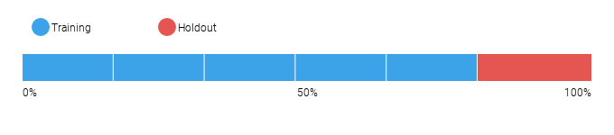
DataRobot calculates the Cross Validation scores for each of the training data partitions or folds. The project metric used to calculate the score is LogLoss.
6.1.1 Cross Validation Scores
Fold | Cross Validation Score (LogLoss)
Fold 1 | 0.21258
Fold 2 | 0.20249
Fold 3 | 0.20905
Fold 4 | 0.20372
Fold 5 | 0.20106
6.1.2 Data Partitioning Methodology
Because the distribution of the target in a binary classification project may be imbalanced, the modeling partitions were randomly selected using a stratified sample to preserve the distribution of the target for each partition.
6.2 Model Performance (Sample Scores)
As an additional layer of model validity, DataRobot not only evaluated the statistical metrics underlying the model, but also performed testing on in-sample records.
The performance metric used for this project was LogLoss. The model performance results are presented below for in-sample testing:
Scoring Type | Score (LogLoss)
cross_validation | 0.2058*
holdout | 0.2017*
validation | 0.2126*
6.3 Sensitivity Testing and Analysis
6.3.1 Lift Chart
The Lift Chart sorts and groups numeric feature values into equal sized bins, depicting how well a model segments the target population and how capable it is of predicting the target. This helps the user to visualize model accuracy for each bin. The chart is sorted by predicted values -- lowest to highest predictions, for example -- which provides transparency to the model performance for different ranges of values of the target variable. Looking at the Lift Chart, the left side of the curve indicates where the model predicted a low score on one section of the population while the right side of the curve indicates where the model predicted a high score. The model Lift Chart is presented in the figure below.
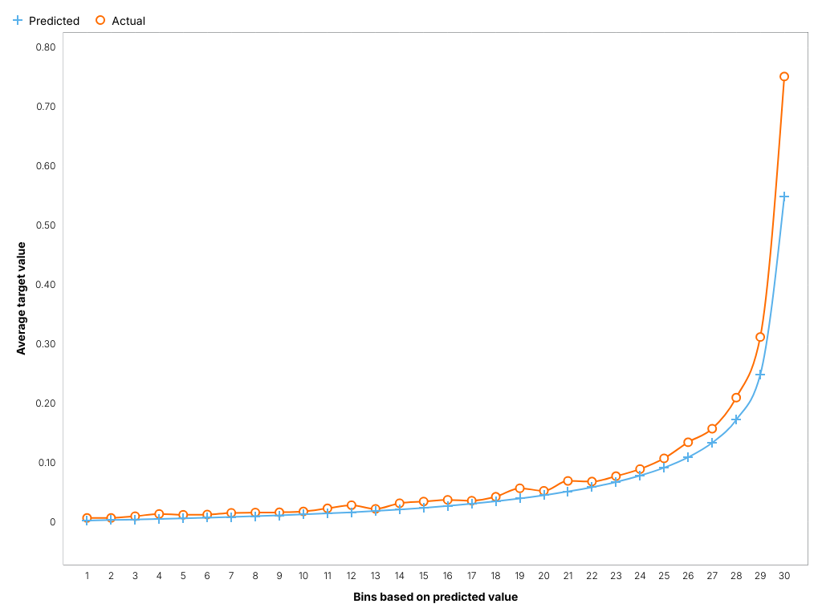
The points on the Lift Chart indicate the average percentage in each bin. The "Predicted" blue line displays the average prediction score for the rows in that bin. The "Actual" orange line displays the actual percentage for the rows in that bin. In general, the steeper the Actual line is, and the more closely the Predicted line matches the actual line, the better the model. A close relationship between these two lines is indicative of the predictive accuracy of the model; a consistently increasing line is another good indicator of satisfactory model performance.
6.3.2 Key Relationships
Feature Impact, which is available for all model types, works by altering input data and observing the effect on a models score. This technique is sometimes called Permutation Importance. The Feature Impact for a given column measures how much worse a models error score would be if DataRobot made predictions after randomly shuffling that column (while leaving other columns unchanged). DataRobot normalizes the scores so that the value of the most important feature column is first and the other subsequent features are normalized to it.
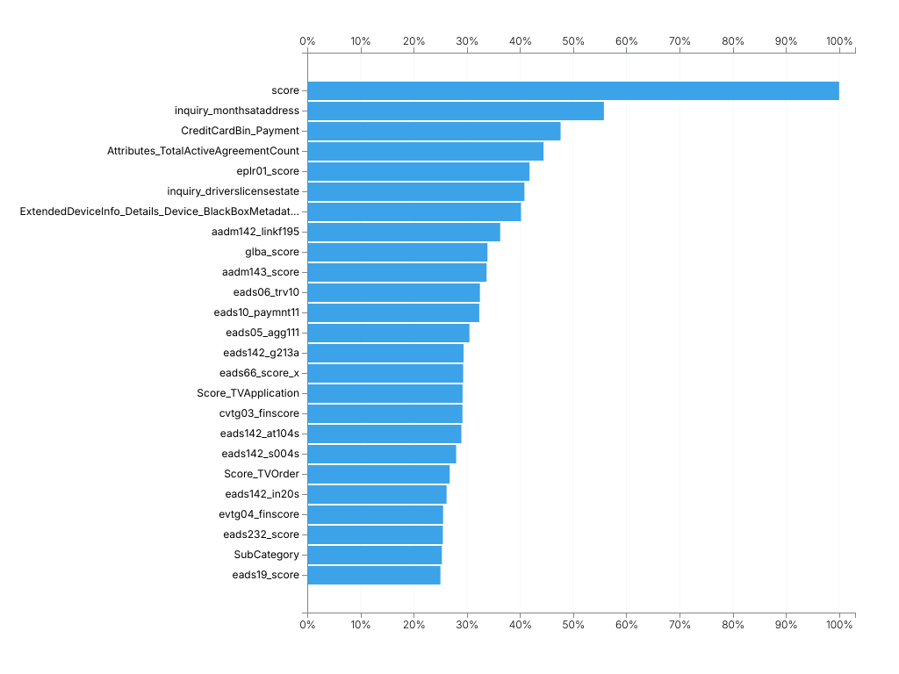
Feature Name | Impact Normalized | Impact Unnormalized
score | 1.0 | 0.025
inquiry_monthsataddress | 0.5577 | 0.014
CreditCardBin_Payment | 0.4763 | 0.0119
Attributes_TotalActiveAgreementCount | 0.4442 | 0.0111
eplr01_score | 0.4178 | 0.0105
inquiry_driverslicensestate | 0.4082 | 0.0102
ExtendedDeviceInfo_Details_Device_BlackBoxMetadata_Age | 0.4019 | 0.0101
aadm142_linkf195 | 0.3627 | 0.0091
glba_score | 0.3388 | 0.0085
aadm143_score | 0.3371 | 0.0084
eads06_trv10 | 0.3246 | 0.0081
eads10_paymnt11 | 0.3234 | 0.0081
eads05_agg111 | 0.3049 | 0.0076
eads142_g213a | 0.2938 | 0.0074
eads66_score_x | 0.2931 | 0.0073
Score_TVApplication | 0.292 | 0.0073
cvtg03_finscore | 0.2918 | 0.0073
eads142_at104s | 0.2897 | 0.0072
eads142_s004s | 0.2799 | 0.007
Score_TVOrder | 0.2677 | 0.0067
eads142_in20s | 0.2619 | 0.0066
evtg04_finscore | 0.2554 | 0.0064
eads232_score | 0.2549 | 0.0064
SubCategory | 0.253 | 0.0063
eads19_score | 0.2503 | 0.0063
Attributes_NumberAgreementsPaidout | 0.2285 | 0.0057
eads142_re21s | 0.2228 | 0.0056
aadm142_linkf189 | 0.2207 | 0.0055
RawData_ScreenHeight | 0.2146 | 0.0054
eads11_cv05 | 0.2078 | 0.0052
eads142_rt20s | 0.2069 | 0.0052
VerificationAnalysis_PhoneNumberVerification | 0.2005 | 0.005
eads142_g960s | 0.1948 | 0.0049
eads142_g003s | 0.1928 | 0.0048
eads142_in21s | 0.1887 | 0.0047
ExtendedDeviceInfo_Details_Device_Type_TVOrder | 0.1873 | 0.0047
eadm08_ad14e | 0.1859 | 0.0047
eads142_g417s | 0.1769 | 0.0044
Attributes_PercentageAgreementsPaidOut | 0.176 | 0.0044
Attributes_PercentageAgreementsChargedOff | 0.1717 | 0.0043
eads10_paymnt06 | 0.1715 | 0.0043
eads142_au21s | 0.1693 | 0.0042
ShippingBillingZipCodeMatch | 0.1603 | 0.004
Attributes_NumberTotalAgreements | 0.1584 | 0.004
ComputedData_Customer_Email_IsAgeHigh_TVOrder | 0.1572 | 0.0039
ComputedData_Velocity_DecisionsWithin30Days_TVOrder | 0.1571 | 0.0039
eads142_fi57s | 0.1469 | 0.0037
eads142_au51a | 0.1463 | 0.0037
eads06_trv04 | 0.1326 | 0.0033
eadm09_p02c | 0.1219 | 0.003
eadm09_p02b | 0.1107 | 0.0028
timeCategory | 0.1096 | 0.0027
Department | 0.1096 | 0.0027
VerificationAnalysis_CurrentAddressVerification_TVOrder | 0.1076 | 0.0027
Attributes_NoKBADueToPriorPayouts | 0.0984 | 0.0025
aadm142_linka003 | 0.0938 | 0.0023
ShippingBillingLastNameMatch | 0.0913 | 0.0023
VerificationAnalysis_LastNameVerification_TVOrder | 0.0897 | 0.0022
eads04_rtlTrd | 0.0895 | 0.0022
Attributes_PercentageAgreementsReturned | 0.0777 | 0.0019
eadm09_p02a | 0.0746 | 0.0019
Attributes_NumberAgreementsReturned | 0.0725 | 0.0018
Attributes_NumberAgreementsChargedOff | 0.0706 | 0.0018
AppDDENPEStatus | 0.053 | 0.0013
ExtendedDeviceInfo_Details_Device_IsNew_TVOrder | 0.0323 | 0.0008
ComputedData_Velocity_DecisionsWithin24Hours_TVOrder | 0.0276 | 0.0007
DebitCreditIndicator_Payment | 0.0215 | 0.0005
SSNMatchIndicator | 0.0127 | 0.0003
Billing | 0.0105 | 0.0003
ComputedData_Customer_HasSuspiciousHistory_TVOrder | 0.0053 | 0.0001
VerificationAnalysis_SsnVerification_TVOrder | 0.0028 | 0.0001
6.3.3 Sensitivity Analysis (Partial Dependence)
In the case of linear regression, users can gain considerable insight into the structure and interpretation of the model by examining its coefficients. For more complex models like support vector machines, random forests, or the blenders considered here, no comparably simple parametric description is available, making the interpretation of these models more difficult. To address this difficulty for his gradient boosting machine, Friedman (2001) proposed the use of partial dependence plots. Partial dependence plots show the average partial relationship between a set of predictors and the predicted response. The partial dependence plots below capture the top features in our model, as measured by Feature Impact.
score
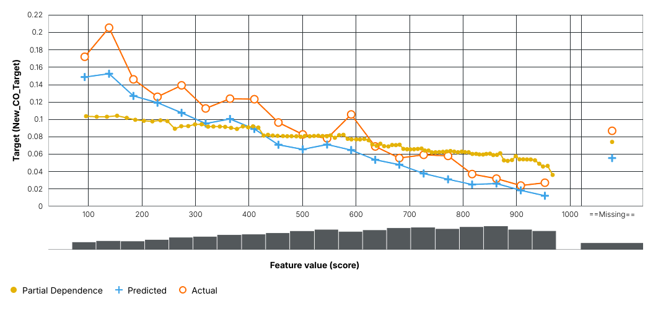
inquiry_monthsataddress
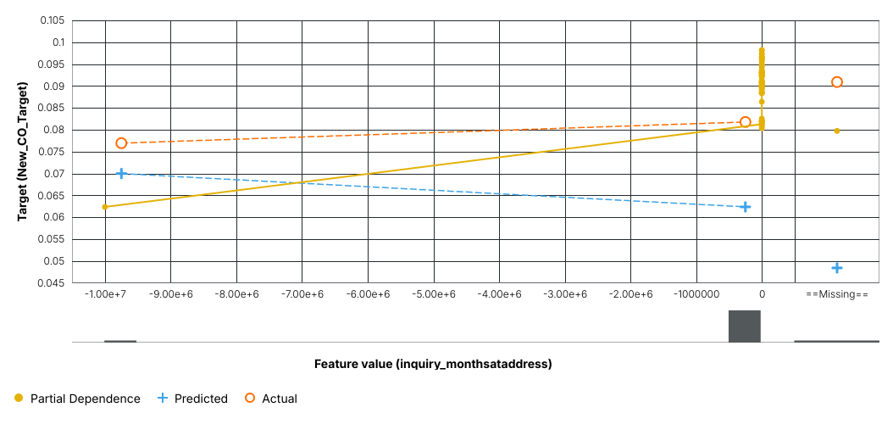
CreditCardBin_Payment
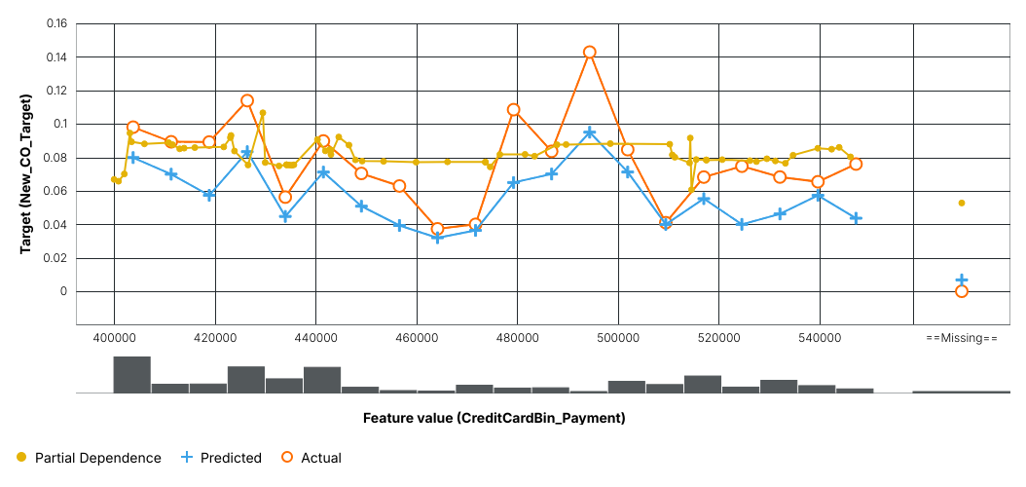
The orange circles depict, for the selected feature, the average target value for the aggregated feature values. The blue crosses depict, for the selected feature, the average prediction for a specific value. From the graph you can see that DataRobot also averages the predicted feature values. Comparing the actual and predicted points can identify segments where model predictions differ from observed data. This typically occurs when the segment size is small. In those cases, for example, some models may predict closer to the overall average.
The yellow partial dependence data points depict the marginal effect of a feature on the target variable after accounting for the average effects of all other predictive features. It indicates how, holding all other variables constant, the value of this feature affects prediction. DataRobot holds constant the values of all columns in the sample except the feature of interest. The value of the feature of interest is then reassigned to each possible value, calculating the average predictions for the sample at each setting. These values help determine how the value of each feature affects the target. The shape of the yellow data points describes the model's view of the marginal relationship between the selected feature and the target.
6.3.4 Accuracy (Receiver Operating Characteristic)
A confusion matrix is a table that reports true versus predicted values. The name "confusion matrix" refers to the fact that the matrix makes it easy to see if the model is confusing two classes (consistently mislabeling one class as another class). The table below presents key sensitivities that support the creation of a confusion matrix.
F1 Score | True Positive Rate | False Positive Rate | True Negative Rate | Positive Predictive Value | Negative Predictive Value | Accuracy | Matthews Correlation Coefficient
0.503 | 0.4502 | 0.0302 | 0.9698 | 0.5699 | 0.952 | 0.9274 | 0.4682
Where the values reported are:
- F1 Score: A measure of the model's accuracy, computed based on precision and recall.
- True Positive Rate: Sensitivity or recall. The ratio of true positives (correctly predicted as positive) to all actual positives.
- False Positive Rate: Fallout. The ratio of false positives to all actual negatives.
- True Negative Rate: Specificity. The ratio of true negatives (correctly predicted as negative) to all actual negatives.
- Positive Predictive Value: Precision. For all the positive predictions, the percentage of cases in which the model was correct.
- Negative Predictive Value: For all the negative predictions, the percentage of cases in which the model was correct.
- Accuracy: The percentage of correctly classified instances.
- Matthews Correlation Coefficient: Measure of model quality when the classes are of very different sizes (unbalanced).
The Receiver Operating Characteristic (ROC) Curve allows the user to explore classification, performance, and statistics related to a selected model at any point on the probability scale. Because choosing the best model can be based on a number of parameters, it is important to understand whether the classification performance of a particular model meets predetermined specifications. The ROC Curve plots the true positive rate against the false positive rate for a given data source. The two important characteristics of the curve to consider are the area under the curve (AUC) and the shape of the curve. The AUC is a metric for binary classification that considers all possible thresholds and summarizes performance in a single value.
Below is the ROC curve for this model based on holdout.
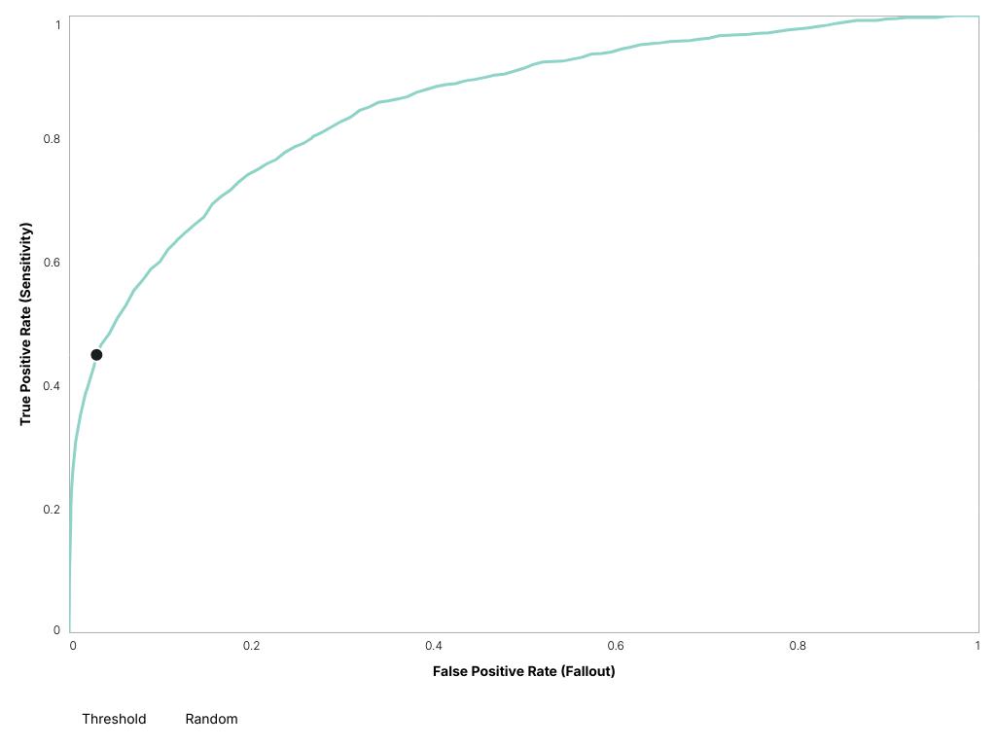
The Prediction Distribution graph shown below illustrates the distribution of actual distribution density in relation to the threshold (a dividing line for interpretation of the graph). Every prediction to the left of the dividing line is classified as false and every prediction to the right of the dividing line is classified as true. Therefore, this graph illustrates how well the model discriminates between prediction classes.
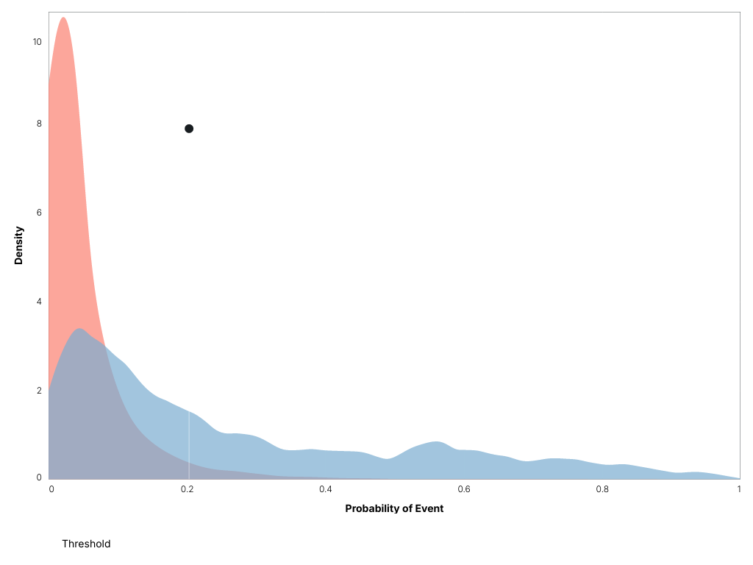
7 Model Implementation and Output Reporting
7.1 Version Control
DataRobot handles model and project version control automatically by tagging each model on the Leaderboard with a unique Model ID. The Model ID represents a single instance of a model type, feature list, sample size, and set of tuning parameter values. DataRobot also maintains unique Project IDs for each project, allowing accessibility to all models built for the project dataset. DataRobot's version control allows for reproducibility and traceability of the models it creates, which greatly increases the auditability of the model development process.
Users may also export Scoring Code for a DataRobot model in Java. You can download both a pre-compiled .jar file (with all dependencies included), plus the source code. Scoring Code is easy to deploy, test, and maintain on a variety of platforms, and you can inspect the generated Java code for complete transparency. DataRobot Scoring Code employs advanced features to ensure that predictions computed using generated Java code are the same as predictions computed inside DataRobot.

