What is Marketing? How Marketing Works? What is Digital Marketing?
- Pick any two apps you use daily and describe one marketing strategy each app uses to attract or retain users.
- App | - Marketing Strategy
- Instagram | - Shows personalized Reels and posts based on users' interests to keep them engaged.
- Zomato | - Sends discount offers and food coupons through notifications to encourage more orders.
- Create a simple poster for a new food delivery service and mention one digital marketing channel.
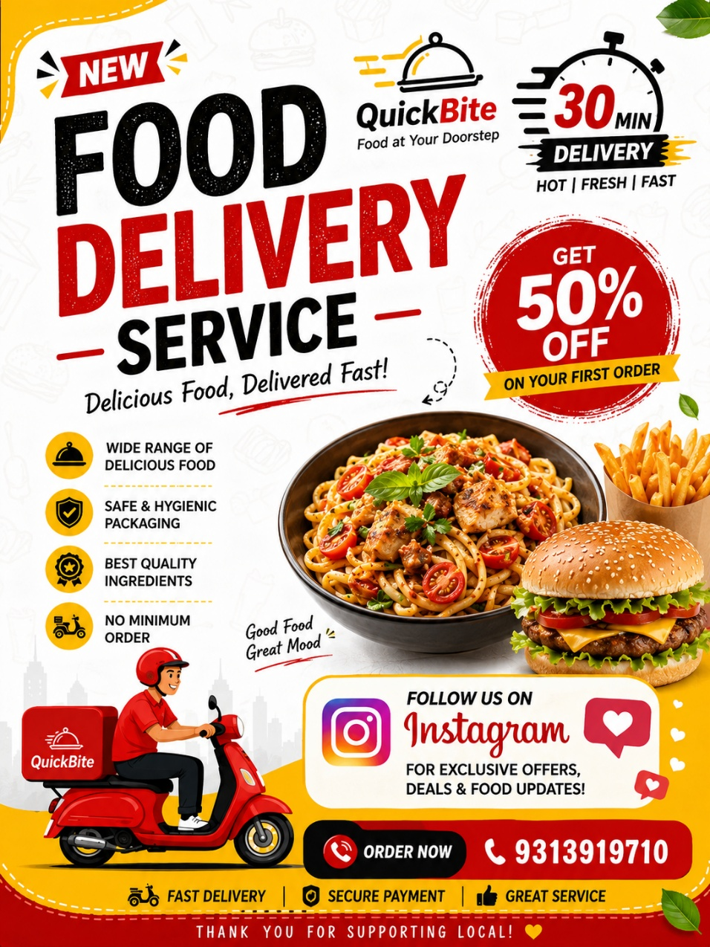

- List 5 differences between traditional marketing and digital marketing.
- Traditional Marketing | - Digital Marketing
- Uses newspapers, TV, and flyers | - Uses social media, websites, and emails
- More expensive | - More affordable
- Difficult to measure results | - Easy to track results
- Mostly reaches local people | - Can reach people worldwide
- One-way communication | - Two-way communication with customers
- Imagine you are launching a new playlist feature for a music app like Spotify. Write a short digital marketing plan.
- Create Instagram Reels to promote the new playlist feature.
- Run YouTube ads for college students.
- Share funny music memes on social media.
- Ask influencers to promote the feature.
- Offer rewards or a free trial for trying the new playlists.
- Send app notifications to invite users to use the feature.

