WebRTC c0d3l4b

Summary | In this codelab, you’ll be acquainted with the WebRTC base components, and all the protocols that work under the hood, which will give you a deep overview and understanding this field.
URL | webrtc-c0d3l4b
Category | Web
Environment | web
Status | Draft
Feedback Link | https://github.com/misi/codelab/issues
Analytics Account | UA-114682180-1
Author | Mészáros Mihály

Introduction
What is WebRTC?
WebRTC Official Definitions:
The WebRTC Project
This c0d3l4b
What you’ll learn
What you’ll need
Getting set up
Setup a web server with TLS to support https
You could Download the Sample Code
Ready? => Let’s start the theory lesson!
WebRTC Design Goals
Goals
Base components:
Standardization
Standardization bodies
WebRTC 1.0
WebRTC NV (In progress)
Codecs
Mandatory to Implement Audio codec
Mandatory to Implement Video codecs
Alliance for Open Media
History
The beginning
Early birds
Onboarding on webRTC train
Nowadays
Mind the Gap!
Adapter.js
Mind the gap between
Breaking Changes
Changes
Media Capture Changes:
Constraint changed
Stats Changes
Streams => Tracks
WebRTC 1.0 Architecture
Protocol Stack
WebRTC native Architecture
WebRTC Trapezoid
Direct Peer to Peer Connection
Address and Port-Dependent Mapping & Address and Port-Dependent Filtering (Symmetric) NAT
Why NAT/Firewall traversal needed in WebRTC?
Firewall / Packet Filter
Network Address Translation(NAT)
NAT Behaviors / Types
RFC 3489
RFC 4787 NAT behavioral Requirements for UDP
RFC 4787 main class definitions:
NAT Behavior Discovery (RFC5780)
Mapping Discovery
Filtering
coTURN natdiscovery utility
NAT behaviors in the real-world
Port Randomization
Summary of NAT behaviors
NAT/Firewall traversal & ICE (STUN/TURN)
TL;DR
STUN/TURN
STUN - Binding:
TURN - Allocate
ICE
Design Goals
ICE Steps
Discovery Candidates
ICE prioritization
ICE User Agent (UA) Role
Pair priority formula
Foundation
Frozen Algorithm
ICE Agent States
Trickle ICE
Establish connection faster
Congestion Avoidance
Session Description Protocol (SDP)
Plans
Example SDP
Offer
Answer
Offer Answer
WebRTC Offer/Answer Model
PeerConnection States
WebRTC Security Architecture
GetUserMedia
Offer Answer without Identity Check
Offer Answer with Identity Check
Offer + Identity
Answer + Identity
Media/Data Encryption is mandatory: SRTP / DTLS
Multipoint (SFU/MCU, Media Server)
Some examples from open source space:
Screensharing
Chrome Screen Share extension:
inline install
Standard
Summary of the Theory
WebRTC 1.0 is stable to build reliable service on it.
WebRTC - Next Version (NV)
Lab 1: GetuserMedia (GuM)
What you'll learn
Lab1
HTML Skeleton with an autoplay Video tag
JavaScript
Manipulate with css
Bonus exercises:
Lab 2: GuM Constraints
What you'll learn
Lab2
Supported Constraints
Constraints
Basic/Required, Advanced Constraint list
Constraints Values
Further examples
OverconstrainedError
Bonus Exercises
Lab 3: GuM I/O Select
What you'll learn
Lab3
EnumarateDevices
Select Audio Output
Select Audio/Video Input
Lab 4: GuM Record
What you'll learn
Lab4
MediaStream Recording API
Supported media recording formats
Start/Stop Recording
MediaRecorderOptions
Replay and Download
Bonus Exercises
Lab 5: GuM + PC state
What you'll learn
Lab5
Call
Offer-Answer
Hangup
Bonus Exercises
Lab 6: PC DataChannel Chat
What you'll learn
Lab6
DataChannel (DC)
Bonus Exercises
Lab 7: Nodejs Signaling Server (socket.io) Chat
What you'll learn
Lab7
Copy your key/cert
server.js
Start Socket.io server
client.js
Bonus Exercises
Lab 8: Install KnockPlop
What you'll learn
Lab8
Main Features
Install
Copy configs
Setup Certificate
Setup TURN Server
Start Server
Bonus Exercises
Congratulations
What we've covered
Let's start to play and experience with WebRTC
WebRTC Demos and Samples
Learn more about related API-s
Bonus: Debugging Browsers
Firefox:
about:webrtc
Debug and Trace
ICE media log:
Debug Chrome
chrome://webrtc-internals
Debug and Trace

- Install the Preview Codelab Chrome extension in your browser. It should create a button in your browser that looks like this →
- Preview your codelab by clicking the Chrome extension’s button (pictured above) while you’re in your codelab Google Doc tab. It will open a new tab to preview.

Introduction
Duration: 5:00
This codelab is focused on WebRTC Apps.

What is WebRTC?

WebRTC is  - An open source project  - A new protocol framework  - Working groups in standardization bodies (IETF, W3C)  - A new market  - Etc.  WebRTC’s Mission is to  - Enhance the web with Real Time Communication (RTC) capabilities, and define a simple JS API for web developers.  - make the browser capable to act like VC terminal (Audio/Video/Data).  - Beyond basic VC, it gives a toolkit and playground to create any brand-new unusual advanced Media Application. | 

WebRTC Official Definitions:
- WebRTC: “A framework, protocols and application programming interface that provide real time interactive voice, video and data in web browsers and other applications”
- WebRTC is a free, open project that provides browsers and mobile applications with Real-Time Communications (RTC) capabilities via simple APIs. The WebRTC components have been optimized to best serve this purpose.
- Mission: To enable rich, high-quality RTC applications to be developed for the browser, mobile platforms, and IoT devices, and allow them all to communicate via a common set of protocols.

The WebRTC Project
- Web: https://webrtc.org
- WebRTC Project Logo: https://webrtc.org/press/

This c0d3l4b
This codelab will walk you through creating your first own WebRTC App, including all the theory needed to understand the JS API and under the hood protocols, and design considerations, as well as all implementation details, to ensure that your app work properly in every network conditions and environment.

What you’ll learn
- How to design a WebRTC App
- How to use the basic WebRTC API-s
- How to grab a MediaDevice. e.g. How to grab your WebCam’s VideoStream.
- How to set mediaStream Input and Output devices
- How to setup a PeerConnection(PC)
- How to setup PC for proper NAT Traversal
- How to use a DataChannel(DC)
- How to record a MediaStream locally

What you’ll need
- A recent version of Chrome and Firefox Browser.
(Note, this should work in other browsers as well.)
- The CodeLab Samples
- A text editor
- SSH client
- Basic knowledge of HTML, CSS, JavaScript.

Last but not least:
This c0d3l4b is strongly inspired by Google WebRTC CodeLab! (Special thx to Sam Dutton!)
https://codelabs.developers.google.com
And also many thanks Google for the codelab framework!
- https://github.com/googlecodelabs/
- https://g.co/codelabs/guide​

Getting set up
Duration: 10:00

Setup a web server with TLS to support https
- even on Your host: Install on your host your favorite web server with a certificate from let’s encrypt.
- Or as an easy alternative: If you use chrome you could also use web-server-for-chrome extension: Install Web Server for Chrome

Tip: Those who are participating in NWS18 we have already created pre install VM with certificate and web server.
Please test it and login on your VM with your ssh client.

You could Download the Sample Code
Click the following link to download all the code for this codelab:

Download source code

Or

git clone https://github.com/misi/codelab.git

Unpack the zip file in your web server root directory. This will unpack a root folder (codelab), which contains one labN folder for each step of this codelab, along with all of the resources you will need. It also contains this codelab web part.

The labN folders contain the desired end state of each step of this codelab. They are there for reference. We’ll be doing all our coding work in a directory called work.

Ready? => Let’s start the theory lesson!
WebRTC is complex and could be hard to understand for a web developer for the first sight without proper understanding of WebRTC Architecture (technologies working under the hood), therefore we try to give you an overview about the under the hood Concepts and Architectures.

WebRTC Design Goals

Goals
- Easy to use, Out of the box experience for the end user (Without Plugins, Without Install, Always up2date client)
- Multi platform (Even exotic platforms (Linux, BSD))
- Push the envelope: Improved Standards like Advanced congestion avoidance, Adaptive Audio Video encoding and Forward Error Correction (FEC) to reach Reliability, Fair Share Low Delay/Latency, Low Jitter. Advanced Noise suppression and echo cancellation etc.
- Firewall and NAT Traversal ICE(STUN/TURN)
- Focus on Security and Privacy and Identity validation by design. Encrypted Secure End to End communication, User consent before access any MediaDevice(WebCam) to avoid any fingerprinting (as possible)
- Open Source Native Implementation (for browser vendors and beyond browsers)
- Open Standard (W3C, IETF)
- Interwork with any Signaling
- Backward compatibility in WebRTC 1.0 (e.g. Offer/Answer, SDP, G.711 audio codec)

Base components:

- GetUserMedia (GuM): Grab MediaStream from a MediaDevice
- PeerConnection (PC): Establish and Maintain Peer to Peer Media Connection
- DataChannel(DC): P2P Data connection on top of PeerConnection

Standardization
Duration: 5:00

Standardization bodies

- World Wide Web Consortium | 
- Internet Engineering Task Force | 

WebRTC 1.0
- W3C WebRTC Working Group
- IETF rtcweb, rmcat, mmusic, avtcore, ice, tram, perc Working Groups

WebRTC NV (In progress)
- QUIC transport for DataChannel/(Media?)
- More ORTC like deeper API
  - No more Session Description Protocol (SDP)
- More control on ICE Agent
- Scalable Video Codec (SVC)

Codecs

Mandatory to Implement Audio codec
- G711 (backward compatibility)
- Opus (48 kHz: fullband codec, both for music and speech)

Mandatory to Implement Video codecs
It took a long to build consensus in the IETF RTCWEB workgroup (“Codec war..”)
- VP8 vs H.264
- (VP9 vs H.265)

Alliance for Open Media
- AOMedia Video 1 (AV1) development
- Amazon, Cisco, Google, Intel, Microsoft, Mozilla, Netflix, etc.

History
Duration: 5:00
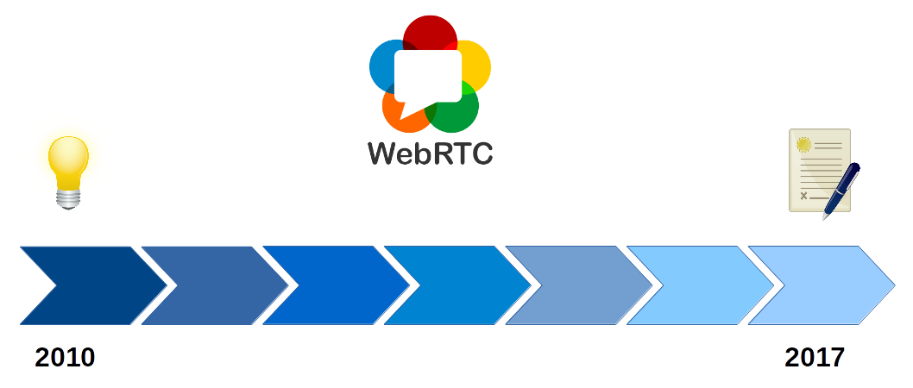

The beginning
- 2009 - Google Chrome Team Idea
- 2010 Summer - IETF 98 Informal lunch (Google, Microsoft, Apple, Mozilla, Skype, Ericsson,etc.)
- 2010 October - RTC Web Workshop http://rtc-web.alvestrand.com/
- 2011 January - Google Global IP Solution (GIPS) acquired.
- 2011 May - W3C WebRTC WG started officially
- 2011 June - Googe Announce WebRTC project(based on GIPS) and chrome integration
- 2011 Nov - Chrome 23 WebRTC support

Early birds
- 2013 January - Firefox 20 first WebRTC support (only GuM)
- 2013 February - Chrome Mozilla first call interoperability
- 2013 July - Chrome for Android support
- 2013 September - Firefox for Android support
- 2013 October - Open H.264 Cisco (Mozilla)
- 2013 October - Opera 18 Beta WebRTC debut.

Onboarding on webRTC train
- 2014 September - OpenWebRTC (Ericsson)
- 2014 October - Microsoft Edge ORTC Announcement
- 2014 November - Consensus on Mandatory to Implement Video Codecs :-)
- 2015 September - Microsoft Edge ORTC/WebRTC support
- 2015 November - Mozilla Canvas CaptureStream
- 2016 January - VP9 Chrome
- 2016 April - ICE Restart Firefox 48

Nowadays
- 2017 June - Safari 11 WebRTC Support
- 2017 October - KITE WebRTC platform test
- 2017 October - Third Party Audio Codec Support
- 2017 November - WebRTC PeerConnection CR (W3C)

Mind the Gap!
Duration: 5:00

Source: http://art.fritsahlefeldt.com/photo/2414/Mind-the-gap-with-text-Color-illustration.html

Adapter.js
Standardization is a moving target!
To build world consensus takes time. :-) Webrtc 1.0 standardization has started in 2011, and it still does not reached the Draft Recommendation status. Hopefully it will reach in Q4 2018 (according the current roadmap). Standard is moving target, and implementation fall behind the standardization and Web Application based on it may also fall behind the implementation. All in all some glue/shim needed here.

Mind the gap between
- Standard and Browser Implementations
- Between bowser and browser implementations
- Application and Standard
The adapter.js is a shim to insulate apps from spec changes and prefix differences.
- https://github.com/webrtc/adapter
- https://webrtc.org/web-apis/interop/

Breaking Changes
- Chrome and Firefox adds deprecation warnings
- Carefully age out, pull down not too soon

Changes
- Async API => Move from callbacks, forward to Promises

Warning!
Only read further if you already familiar with WebRTC. Beginners could safely skip this part of the codelab.

Media Capture Changes:
MediaDevice selection, detection on changes (discovery)
- Old: navigator.getUserMedia is deprecated
- New: navigator.mediaDevices.getUserMedia
Media source
- Old: video.createObjectURL is deprecated
- New: video.srcObject

Constraint changed
Legacy deprecated Constraint
{
mandatory: {width: {min: 640, max:1920}},
optional [{width: 1280}]
}

New modern Constraint
{width: {min:1024, ideal: 1280, max: 1920}}

- Chrome constraints are deprecated
- “optional” renamed to “advanced”

Stats Changes
Legacy deprecated Stats

pc.getStats(function(stats){
Object.keys(stats).forEach(key =>...)
}
)

New modern Stats (promise)

pc.getStats().then(stats =>stats.forEach(value=>...)

Streams => Tracks
Manipulating (replacing tracks) after added a stream to peerconnection makes confusion, so add tracks instead of streams to peerconnection.
addStream is deprecated
- Old: pc.addStream(stream)
- New: stream.forEach(track => pc.addTrack(track,stream))
getLocalStreams is deprecated
- Old: var streams = pc.getLocalStreams();
- New: var senders = pc.getSenders();

Tip:
For more details see Jan-Ivar’s presentation: https://www.crowdcast.io/e/webrtcstandards13

WebRTC 1.0 Architecture
Duration: 5:00

Protocol Stack
As you can see encryption is mandatory is applied everywhere (SRTP/DTLS).
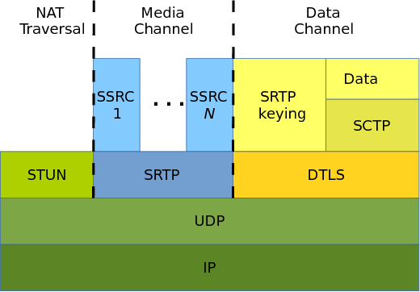

WebRTC native Architecture
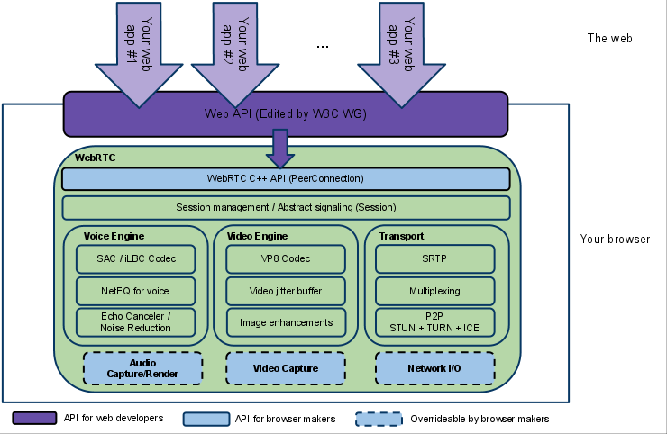
https://webrtc.org/architecture/

WebRTC Trapezoid

Direct Peer to Peer Connection
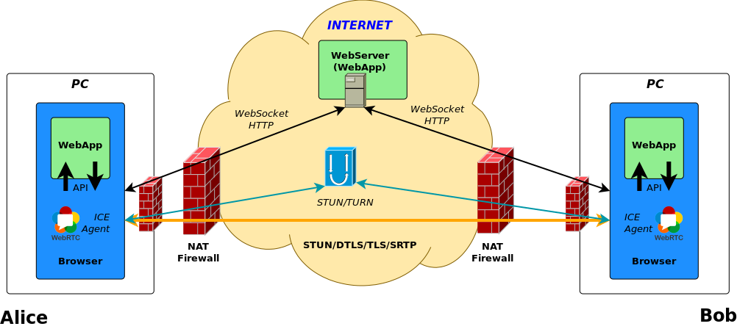

Note:
Direct Browser to Browser connection is prefered by default to keep the end to end delay low. ICE preferes by default TURN in last resort.

Of course there are other reasonable preferences, like more reliable connection first or short connection establishment time, that may override ICE default behavior and prefer TURN first.

Address and Port-Dependent Mapping & Address and Port-Dependent Filtering (Symmetric) NAT
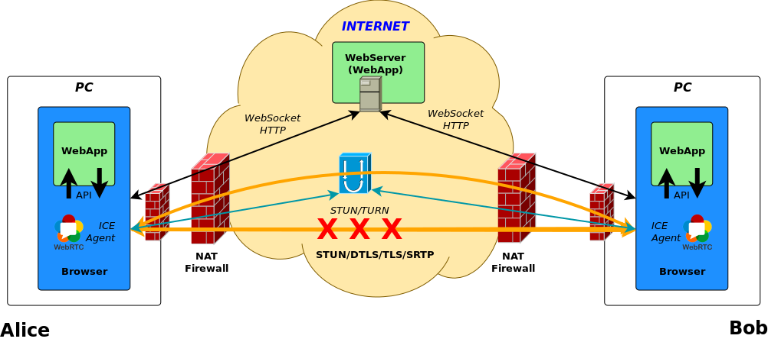

Why NAT/Firewall traversal needed in WebRTC?
Mainly because usage of Network Address Translation(NAT) and Packet Filters made difficult (or impossible) the direct Peer to Peer communication. As we will see in the next step, Interactive Connection Establishment protocol (ICE) has been designed to solve these problems.

Firewall / Packet Filter
For Media communication the Real-time Transport Protocol(RTP) use random port numbers. We need to find a ip:port pair that is not filtered between the two peers. ICE have to run 2 way checks on the candidate pairs, on the “5 Tuple” transport connections, to make sure that the communication channel has established and working properly. The transport connection needs to work properly before any Real-time communication could be started on top of it.

Network Address Translation(NAT)
In this section we focus on NAT. Let’s look it little bit closer.
The NAT behavior standardization started much later than the first NAT implementation existed. NAT traversal is complex. It is confusing mainly because of the so big variety of different NAT behaviors and types. ICE have to deal with any topology, and so any types and levels of NATs!

NAT Behaviors / Types

RFC 3489
The RFC 3489, also known as “classic STUN” defined four NAT types
- Full Cone
- Restricted Cone
- Port Restricted Conde

RFC 4787 NAT behavioral Requirements for UDP
RFC 4787 defined much much more fine grained classification of NATs.

RFC 4787 main class definitions:
Mapping
- Endpoint Independent Mapping
- Address-Dependent Mapping
- Address and Port-Dependent Mapping
Filtering
- Endpoint Independent Filtering
- Address-Dependent Filtering
- Address and Port-Dependent Filtering
And it defines much more NAT behaviors too.
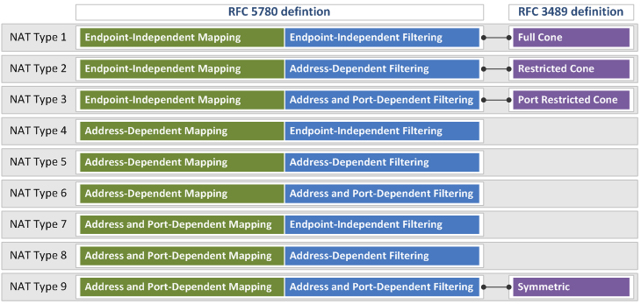
Image Source: https://www.netmanias.com/en/?m=view&id=techdocs&no=6065

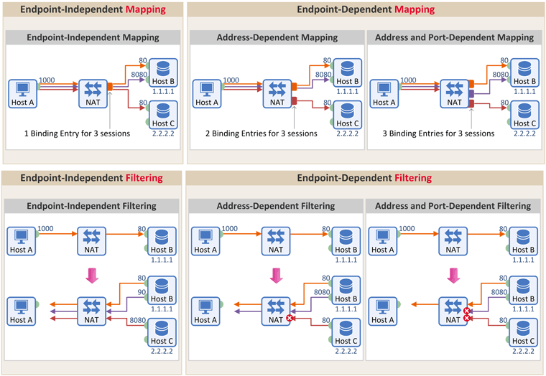
Image Source: https://www.netmanias.com/ko/?m=view&id=blog&no=6263

NAT Behavior Discovery (RFC5780)
RFC5780 is a STUN protocol extension.

Mapping Discovery
- TEST I (Primary IP, Primary Port)
- TEST II (Alternate IP, Primary Port)
- TEST III (Alternate IP, Alternate Port)
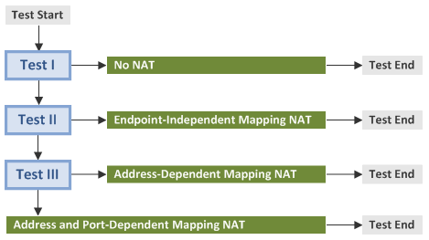
Image Source: http://www.netmanias.com/en/post/techdocs/6067/nat-stun/nat-behavior-discovery-using-stun-rfc-5780

Filtering
- TEST I (Primary IP, Primary Port)
- TEST II (Change Request IP and Port)
- TEST III (Change Request Port)
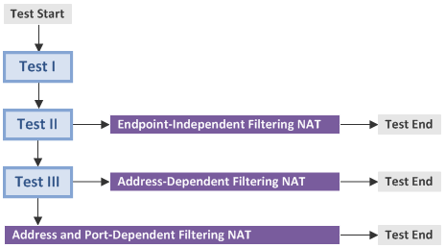
Image Source: http://www.netmanias.com/en/post/techdocs/6067/nat-stun/nat-behavior-discovery-using-stun-rfc-5780

Thanks to www.netmanias.com for the nice illustrations!
Read for a more detailed step by step explanation with similar nice graphs:
- http://www.netmanias.com/en/post/techdocs/6067/nat-stun/nat-behavior-discovery-using-stun-rfc-5780
- https://www.netmanias.com/en/?m=view&id=techdocs&no=6065
- https://www.netmanias.com/ko/?m=view&id=blog&no=6263

coTURN natdiscovery utility
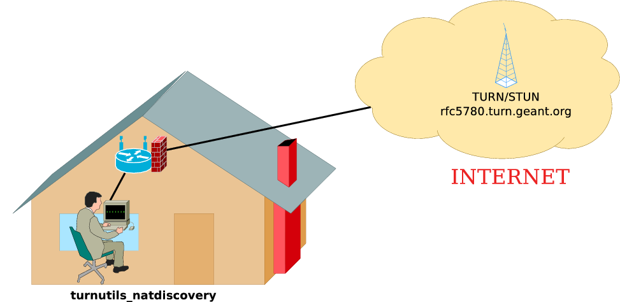

$ turnutils_natdiscovery -f -m rfc5780.turn.geant.org
…
========================================
NAT with Address and Port Dependent Mapping!
========================================
…
========================================
NAT with Address and Port Dependent Filtering!
========================================
$

Tip:
See coTURN turnutils_natdiscovery README for options https://github.com/coturn/coturn/blob/master/README.turnutils

NAT discovery in browser:
We reuse the same idea here that we used earlier in RFC 5780 NAT behavior discovery.
If a NAT translates traffic originating from the same internal port to different external source ports, because of the different destination ip:port (in our case different destination STUN servers), then
It could be:
- Address Dependent Mapping
- Address and Port Dependent Mapping
See WebRTC article about howto discover a symmetric NAT.
- https://webrtchacks.com/symmetric-nat/
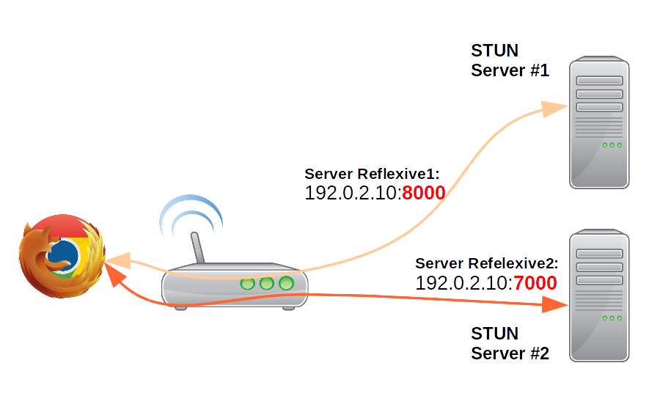

Notice: coTURN utility gives much detailed and more precise and reliable information about the NAT behaviour than the browser test could do.

NAT behaviors in the real-world

Warning:
Mind the gap between RFC 4787 behaviour model and the real-world NAT implementations! Not every implementation behavior fits perfectly in the defined categories.

I have collected the NAT behaviors in the following table. In this table you could find OS/vendors/appliances, and the default NAT behavior that belongs to it. Furthermore you could find the options that could be used to modify the default behavior.
(These are only my experiences and test results according my actual knowledge. Please correct me if you think I am wrong!)
Vendor/Behavior | EIM/EIF | EIM/ADF | EIM/APDF | APDM/APDF
Linux /  Netfilter  (Campus) | X | X | Default | --random  --random-fully
BSD /PF  (Campus) | X | X | static-port | Default
Juniper  vSRX  (Campus) | persistent-nat  any-remote-host | persistent-nat  target-host | persistent-nat  target-host-port | Default
Cisco ios  (Campus) | X | X | Default | X
Checkpoint 21400  (Campus) | X | X | X | Default
TP-Link  (SOHO) | X | X | Default | X
Mikrotik  RouterBOARD  (SOHO) | X | X | Default | X
Lede 17.0.2 Linux  (SOHO) | X | X | Default | --random  --random-fully
PF-Sense  BSD  (SOHO) | X | X | static-port | Default
Win 10 Pro  (Internet Sharing) | Default | X | X | X
macOS  (Internet Sharing) | Default | X | X | X
iOS  (Internet Sharing) | X | X | Default | X
Android  (Internet Sharing) | X | X | Default | X

To clarify further the options in the table above with an example:
In Linux case, the Netfilter‘s (iptables) default behavior is Endpoint Independent Mapping with Address and Port Dependent Filtering (EIM/APDF)
iptables -t nat -A POSTROUTING -o eth0 -j MASQUERADE

If you use --random or --random-fully option, then you could change NAT behavior to Address and Port dependent Mapping with Address and Port dependent Filtering (APDM/APDF)
iptables -t nat -A POSTROUTING -o eth0 -j MASQUERADE --random

Port Randomization
Why port randomization? It is proposed solutions to e.g. DNS cache poisoning / Kaminsky dns vulnerability.
The 5 tuple (source and destination ip port and transport protocol) Transport-Protocol Port Randomization is recommended according RFC 6056.
And RFC 7857 updates to Network Address Translation (NAT) Behavioral Requirements according it.
(But even port randomization could be derandomized with fine grained attacks: https://arxiv.org/pdf/1205.5190.pdf. To avoid Kaminsky DNS vulnerability the safe way to use DNSSEC.)

Summary of NAT behaviors
According my experiences
- Campus/Enterprise NATs most commonly use Port Randomization with Address and Port dependent Mapping with Address and Port dependent Filtering
- SOHO NATs most commonly use Endpoint Independent Mapping with Address and Port Dependent Filtering

NAT/Firewall traversal & ICE (STUN/TURN)
Duration: 15:00



TL;DR
- STUN is a binary protocol
- STUN Discover Client global IP:port
- TURN is a STUN protocol extension
- TURN is about Allocate a global IP:port and tunnel and Relay traffic
- ICE finds the shortest working path between two ICE agents

Nice ICE Tutorials:
- https://sdstrowes.co.uk/talks/20081031-ice-turn-stun-tutorial.pdf
- http://www.jdrosen.net/uploads/1/5/0/0/15008848/ice-ietf-tutorial2.pptx

STUN/TURN

STUN - Binding:
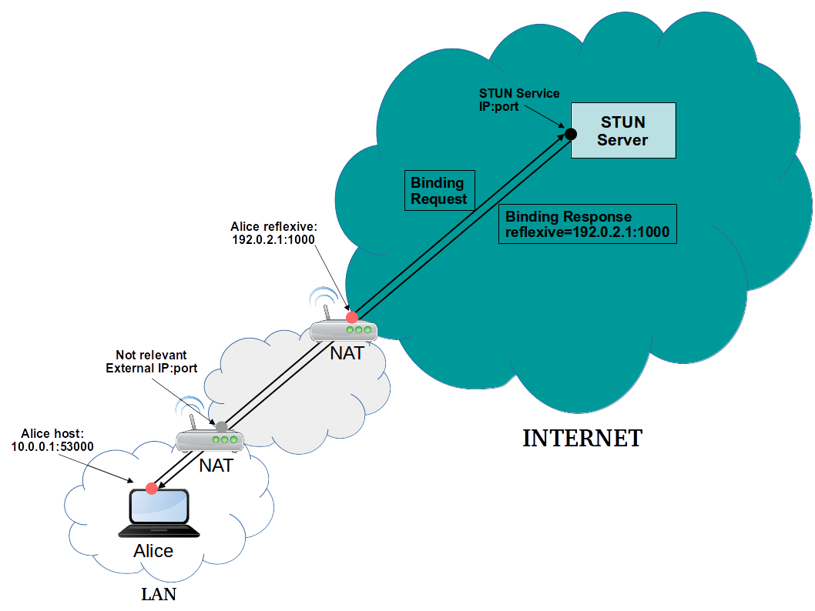

TURN - Allocate
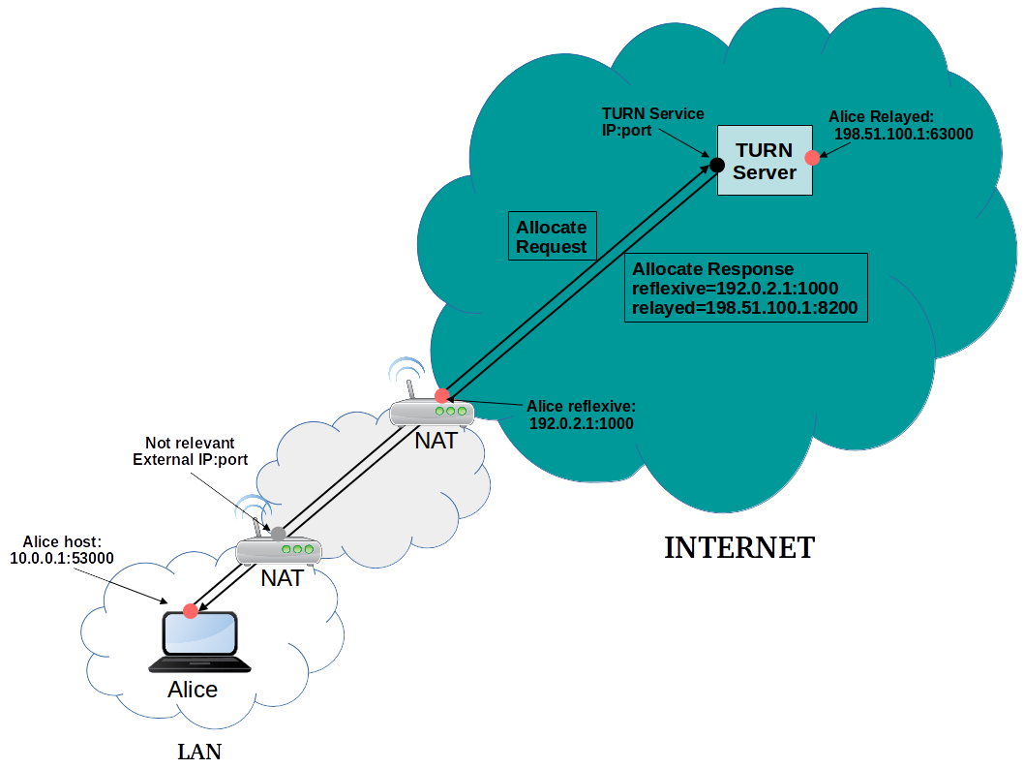

Note:
- Discover your candidate: https://webrtc.github.io/samples/src/content/peerconnection/trickle-ice/

ICE

Design Goals
- High reliability is essential during connection establishments
- Minimize the "length" of the path between clients
- Negotiate IP protocol version (IPv4/IPV6) and preference
- No assumption on: (Network topologies, NAT or Firewall presence, NAT behaviours)

ICE Steps
- Discovery and Candidate gathering (Allocation)
- Prioritisation
- Eliminating redundant candidates
- Exchange (SDP)
- Connectivity Check (Binding Request + Short Term Credential)
- Coordination (Controlling/Controlled, Nomination)
- Communication

Discovery Candidates
- Multiple interfaces
- Multiple type of interface (WIFI, Mobile, LAN, VPN)
- Multiple protocols (IPv4, IPv6)

ICE prioritization
priority = (2^24)*(type preference)
+(2^8)*(local preference)
+(2^0)*(256 - component ID)
priority (32bit)
- Type preference (8 bit): 0-126 The RECOMMENDED values are 126 for host candidates, 100 for server reflexive candidates, 110 for peer reflexive candidates, and 0 for relayed candidates.
- Local preference(16 bit): Version(IPv4/IPv6), network interfaces(VPN/LAN)
- Component ID (8 bit) 256 - component ID

ICE User Agent (UA) Role
- Controlling
- Controlled
The Controlling is the one that’s sent the initial Offer. (In case of both agents are a full
implementation).

Pair priority formula
Let
- G the controlling priority (Offer)
- D the controlled priority (Answer)
pair priority = 2^32*MIN(G,D) + 2*MAX(G,D) + (G>D?1:0)

Foundation
Candidates has the same foundation and are similar when they are of the same type and obtained from the same interface and STUN or TURN server.

Frozen Algorithm
The idea is to use the results of a previous check to predict the likelihood of a future one working.

ICE Agent States
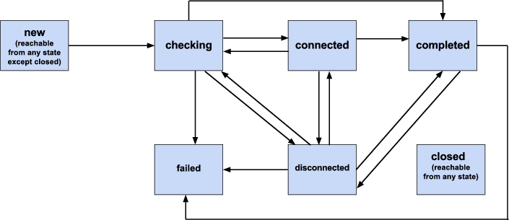
For more details please see the ICE tutorials mentioned above.

Trickle ICE
Connection establishment time could be long if we need to wait to finish the candidate discovery.
Even worse, in case of any error is occuring during the discovery. Waiting for the timeouts could take long, and could cause an unacceptable very long connection establishment.

Establish connection faster
The primary idea is to start ICE check as fast as we discover a candidate. The only drawback is that we need to send more signaling messages. WebRTC Application nowadays use mostly Trickle ICE to establish connection.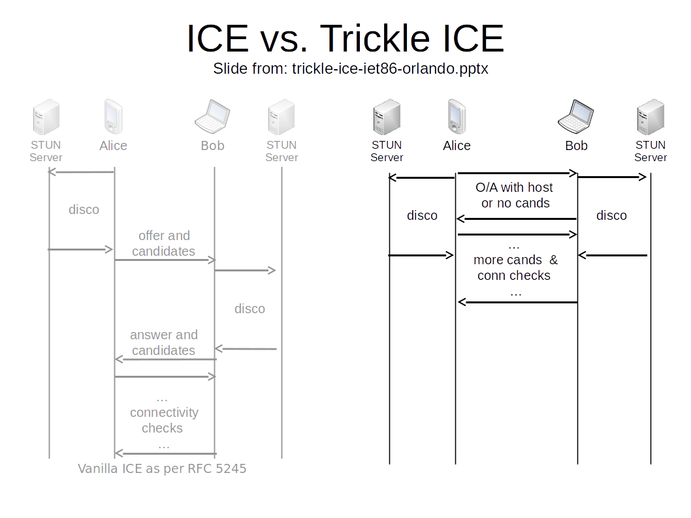Multiplex/Bundle
- RTP/RTCP multiplex
- Bundle RTP (multiplex rtp streams e.g. audio+video)

Congestion Avoidance
Duration: 5:00
It is very important part of WebRTC to use an intelligent congestion control algorithm, that estimates the maximum bandwidth and share the available bandwidth fairly.
Standardization happens in IETF RMCAT working group
- Receiver Estimated Maximum Bandwidth (REMB)
- Sender Side Bandwidth Estimation
- Forward Error Correction (FEC)

More Details:
- http://www.rtcbits.com/2017/01/bandwidth-estimation-in-webrtc-and-new.html
- https://blog.mozilla.org/webrtc/what-is-rmcat-congestion-control/
- TF-WebRTC_5_Congestion_Luca.pdf
- https://www.callstats.io/2016/11/14/fec-congestion-control/
- https://www.callstats.io/2017/10/16/acm-multimedia/

Session Description Protocol (SDP)
Duration: 10 min

Tip: SDP Anatomy on webrtcH4cKS https://webrtchacks.com/sdp-anatomy

Plans
Unified Plan:
- https://webrtcglossary.com/unified-plan
- https://tools.ietf.org/html/draft-roach-mmusic-unified-plan-00
Plan B: (Obsoleted!)
- https://webrtcglossary.com/unified-plan
- https://tools.ietf.org/html/draft-uberti-rtcweb-plan-00
- Chrome / Chromium is still working the transition to Unified Plan https://bugs.chromium.org/p/chromium/issues/detail?id=465349

Plan Adapter:
It is very hard to polyfill plan differences, but here is an example: https://www.npmjs.com/package/sdp-interop

Example SDP

Offer

v=0
o=mozilla...THIS_IS_SDPARTA-58.0.2 1392930692610468855 0 IN IP4 0.0.0.0
s=-
t=0 0
a=sendrecv
a=fingerprint:sha-256 97:73:D6:F9:B8:4C:4A:29:3B:E0:B4:3E:E6:37:F6:D0:B7:8A:88:D9:E5:D2:C4:F8:74:66:18:B7:84:18:BB:42
a=group:BUNDLE sdparta_0 sdparta_1
a=ice-options:trickle
a=msid-semantic:WMS *
m=audio 51644 UDP/TLS/RTP/SAVPF 109 9 0 8 101
c=IN IP4 193.224.69.74
a=candidate:0 1 UDP 2122252543 192.0.2.1 53693 typ host
a=candidate:4 1 TCP 2105524479 192.0.2.1 9 typ host tcptype active
a=candidate:0 2 UDP 2122252542 192.0.2.1 40157 typ host
a=candidate:4 2 TCP 2105524478 192.0.2.1 9 typ host tcptype active
a=candidate:3 1 UDP 92217087 193.224.69.74 51644 typ relay raddr 193.224.69.74 rport 51644
a=candidate:3 2 UDP 92217086 193.224.69.74 64126 typ relay raddr 193.224.69.74 rport 64126
a=sendrecv
a=end-of-candidates
a=extmap:1/sendonly urn:ietf:params:rtp-hdrext:ssrc-audio-level
a=extmap:2 urn:ietf:params:rtp-hdrext:sdes:mid
a=fmtp:109 maxplaybackrate=48000;stereo=1;useinbandfec=1
a=fmtp:101 0-15
a=ice-pwd:957d8d9d754992a1d5a7706d5cb2e1fe
a=ice-ufrag:732f8881
a=mid:sdparta_0
a=msid:{69779578-0a01-46d5-afb8-c1ce8eb8b4f7} {3b93eb2f-9bf4-4955-95d0-5379eeba3e11}
a=rtcp:64126 IN IP4 193.224.69.74
a=rtcp-mux
a=rtpmap:109 opus/48000/2
a=rtpmap:9 G722/8000/1
a=rtpmap:0 PCMU/8000
a=rtpmap:8 PCMA/8000
a=rtpmap:101 telephone-event/8000
a=setup:actpass
a=ssrc:2764815782 cname:{08b8c6e5-8963-4a02-825f-d55ddb7076ba}
m=video 51644 UDP/TLS/RTP/SAVPF 120 121 126 97
c=IN IP4 193.224.69.74
a=candidate:0 1 UDP 2122252543 192.0.2.1 55556 typ host
a=candidate:4 1 TCP 2105524479 192.0.2.1 9 typ host tcptype active
a=candidate:0 2 UDP 2122252542 192.0.2.1 42946 typ host
a=candidate:4 2 TCP 2105524478 192.0.2.1 9 typ host tcptype active
a=candidate:3 1 UDP 92217087 193.224.69.74 52200 typ relay raddr 193.224.69.74 rport 52200
a=candidate:3 2 UDP 92217086 193.224.69.74 65354 typ relay raddr 193.224.69.74 rport 65354
a=sendrecv
a=extmap:1 http://www.webrtc.org/experiments/rtp-hdrext/abs-send-time
a=extmap:2 urn:ietf:params:rtp-hdrext:toffset
a=extmap:3 urn:ietf:params:rtp-hdrext:sdes:mid
a=fmtp:126 profile-level-id=42e01f;level-asymmetry-allowed=1;packetization-mode=1
a=fmtp:97 profile-level-id=42e01f;level-asymmetry-allowed=1
a=fmtp:120 max-fs=12288;max-fr=60
a=fmtp:121 max-fs=12288;max-fr=60
a=ice-pwd:957d8d9d754992a1d5a7706d5cb2e1fe
a=ice-ufrag:732f8881
a=mid:sdparta_1
a=msid:{69779578-0a01-46d5-afb8-c1ce8eb8b4f7} {c4e521ab-ac5c-468d-bda4-102fa8c63ad1}
a=rtcp:65354 IN IP4 193.224.69.74
a=rtcp-fb:120 nack
a=rtcp-fb:120 nack pli
a=rtcp-fb:120 ccm fir
a=rtcp-fb:120 goog-remb
a=rtcp-fb:121 nack
a=rtcp-fb:121 nack pli
a=rtcp-fb:121 ccm fir
a=rtcp-fb:121 goog-remb
a=rtcp-fb:126 nack
a=rtcp-fb:126 nack pli
a=rtcp-fb:126 ccm fir
a=rtcp-fb:126 goog-remb
a=rtcp-fb:97 nack
a=rtcp-fb:97 nack pli
a=rtcp-fb:97 ccm fir
a=rtcp-fb:97 goog-remb
a=rtcp-mux
a=rtpmap:120 VP8/90000
a=rtpmap:121 VP9/90000
a=rtpmap:126 H264/90000
a=rtpmap:97 H264/90000
a=setup:actpass
a=ssrc:1307424569 cname:{08b8c6e5-8963-4a02-825f-d55ddb7076ba}

Answer

v=0
o=mozilla...THIS_IS_SDPARTA-58.0.2 8465178051030770266 0 IN IP4 0.0.0.0
s=-
t=0 0
a=sendrecv
a=fingerprint:sha-256 F7:8B:D4:93:EC:66:10:17:A7:88:E2:DB:E2:02:D8:A8:0E:78:0C:47:D1:CF:AC:A8:4A:7F:B0:F8:9C:22:54:DD
a=group:BUNDLE sdparta_0 sdparta_1
a=ice-options:trickle
a=msid-semantic:WMS *
m=audio 9 UDP/TLS/RTP/SAVPF 109 101
c=IN IP4 0.0.0.0
a=candidate:0 1 UDP 2122252543 198.51.100.65 39578 typ host
a=candidate:4 1 UDP 2122187007 198.51.100.177 34202 typ host
a=candidate:8 1 TCP 2105524479 198.51.100.65 9 typ host tcptype active
a=candidate:9 1 TCP 2105458943 198.51.100.177 9 typ host tcptype active
a=candidate:3 1 UDP 92217087 193.224.69.74 55675 typ relay raddr 193.224.69.74 rport 55675
a=sendrecv
a=extmap:2 urn:ietf:params:rtp-hdrext:sdes:mid
a=fmtp:109 maxplaybackrate=48000;stereo=1;useinbandfec=1
a=fmtp:101 0-15
a=ice-pwd:36acccb528a6c8502e42656cc6c7b8cd
a=ice-ufrag:14888916
a=mid:sdparta_0
a=msid:{9cc1f70c-c78b-44b4-86fa-fcd82c530b1e} {4662f9ed-4a45-4f9f-964d-4ffff5535e5f}
a=rtcp-mux
a=rtpmap:109 opus/48000/2
a=rtpmap:101 telephone-event/8000
a=setup:active
a=ssrc:1899896363 cname:{0cc05c74-02a9-4474-9885-9ea7674b8299}
m=video 9 UDP/TLS/RTP/SAVPF 120
c=IN IP4 0.0.0.0
a=sendrecv
a=extmap:1 http://www.webrtc.org/experiments/rtp-hdrext/abs-send-time
a=extmap:2 urn:ietf:params:rtp-hdrext:toffset
a=extmap:3 urn:ietf:params:rtp-hdrext:sdes:mid
a=fmtp:120 max-fs=12288;max-fr=60
a=ice-pwd:36acccb528a6c8502e42656cc6c7b8cd
a=ice-ufrag:14888916
a=mid:sdparta_1
a=msid:{9cc1f70c-c78b-44b4-86fa-fcd82c530b1e} {425480c1-460a-4b92-8b43-59cc59062d0d}
a=rtcp-fb:120 nack
a=rtcp-fb:120 nack pli
a=rtcp-fb:120 ccm fir
a=rtcp-fb:120 goog-remb
a=rtcp-mux
a=rtpmap:120 VP8/90000
a=setup:active
a=ssrc:377924797 cname:{0cc05c74-02a9-4474-9885-9ea7674b8299}

Offer Answer
Duration: 5:00

WebRTC Offer/Answer Model
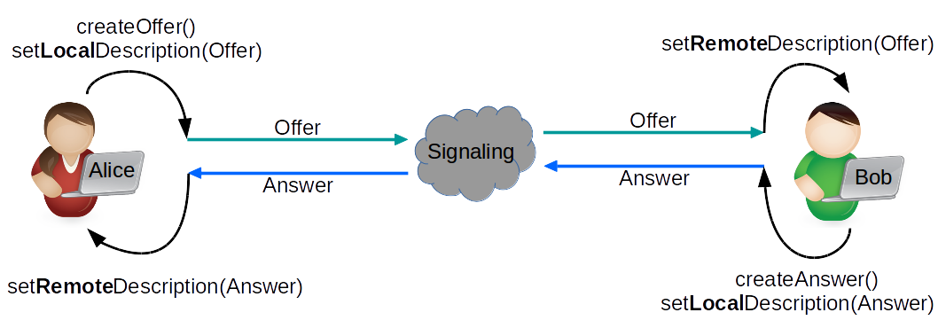

PeerConnection States
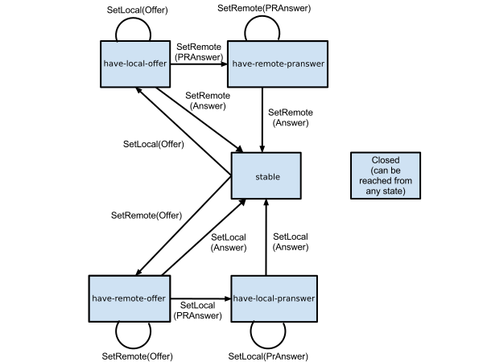

WebRTC Security Architecture
Duration: 5:00

GetUserMedia
- Secure User Interface opt-in (e.g. Camera, audio access)
- User can allow/deny audio video source usage

Tip! See EKR IETF presentation for detailed more information: http://www.ietf.org/proceedings/82/slides/rtcweb-13.pdf

Offer Answer without Identity Check
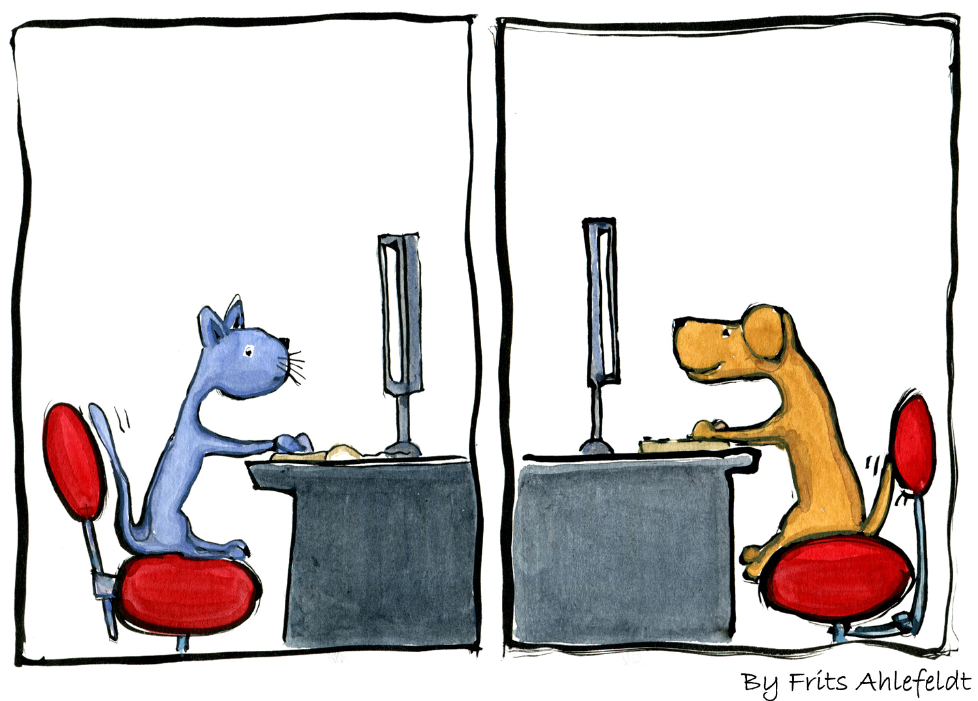
Image Source: https://hikingartist.com/2012/01/03/cat-and-dog-online-2-0/

Offer Answer with Identity Check
The trust base is the Browser.

+----------------+ Unspecified +----------------+
| | protocol | |
| Signaling |<----------------->| Signaling |
| Server | (SIP, XMPP, ...) | Server |
| | | |
+----------------+ +----------------+
^ ^
| |
HTTPS | | HTTPS
| |
| |
v v
JS API JS API
+-----------+ +-----------+
| | Media | |
Alice | Browser |<--------------------------->| Browser | Bob
| | DTLS+SRTP | |
+-----------+ +-----------+
^ ^--+ +--^ ^
| | | |
v | | v
+-----------+ | | +-----------+
| |<-------------------------+ | |
| IdP1 | | | IdP2 |
| | +------------------------>| |
+-----------+ +-----------+
A federated call with IdP-based identity

The following two slides are from EKR IETF Presentation mentioned above

Offer + Identity
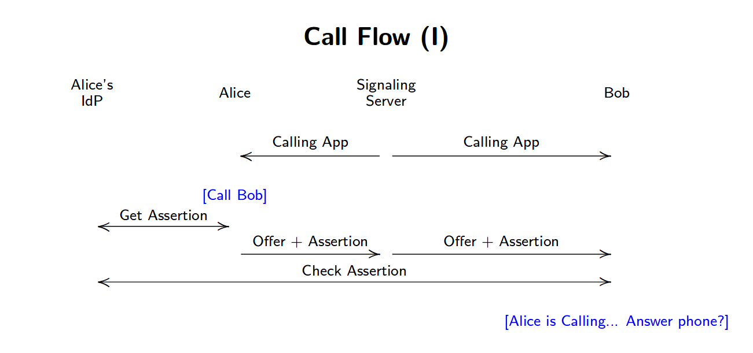

Answer + Identity
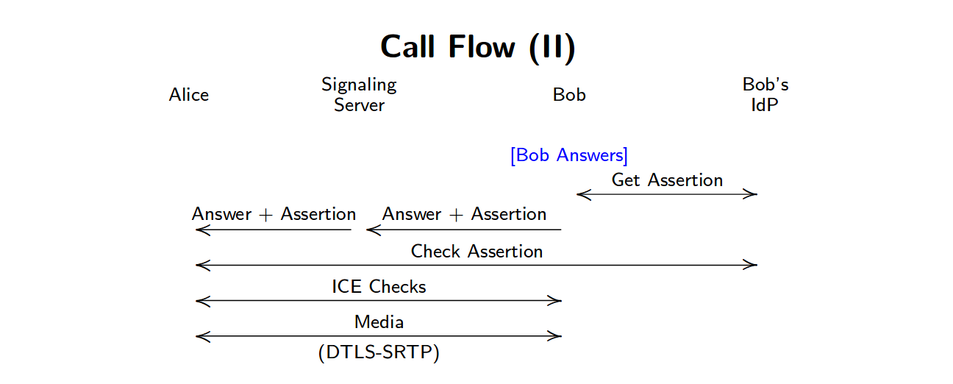

Media/Data Encryption is mandatory: SRTP / DTLS
- DTLS-SRTP: DTLS and Certificate based key.
- SDES-SRTP "MUST NOT implement" according IETF 87

Important: SDES-SRTP is obsoleted, mainly because to avoid any surveillance possibility. This was a design decision, and it could add interop issues with legacy systems!

Note: Identity is a must! We don't trust fully anymore in the signaling provider. Earlier, in SDES-SRTP case we have trusted in signaling service provider, and assumed that it is authenticating the parties in the communication in some form.
Be aware that WebRTC designed to use E2E encryption, and without Identity validation security is not complete and leaky(!), this way it is extremely important to validate the Peers Identity.

Multipoint (SFU/MCU, Media Server)
Duration: 5:00

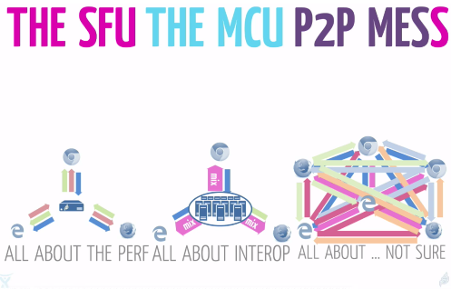
Image Source: Emil Ivov (Jitsi /Atlassian)

Some examples from open source space:
- https://mediasoup.org
- https://www.kurento.org
- https://janus.conf.meetecho.com
- https://jitsi.org

Screensharing
Duration: 5:00

Chrome Screen Share extension:

inline install
- https://developer.chrome.com/webstore/inline_installation

Standard
- https://www.w3.org/TR/screen-capture/
Mozilla
- https://blog.mozilla.org/webrtc/share-browser-windows-entire-screen-sites-trust/
- https://wiki.mozilla.org/Screensharing
mediaConstraints = {
video: {
mediaSource: "screen"
},
};

Summary of the Theory
Duration: 5:00

Image Source: http://art.fritsahlefeldt.com/photo/2045/Goal-is-closer-than-you-think-Color-illustration.html

WebRTC 1.0 is stable to build reliable service on it.
- Strong and wide community
- Fast New market
- 3,5-4 Billion of potential Browsers
- More than 1300+ Vendor and Project based on WebRTC
- Wide support in browsers: Chrome,Firefox, Opera, Edge, Safari, etc.

WebRTC - Next Version (NV)
Actual Focus is on finishing 1.0 and only after start WebRTC-NV.

Lab 1: GetuserMedia (GuM)
Duration: 5:00

What you'll learn
- Get a MediaStream from your WebCam (promise)
- MediaStream and MediaStreamTrack differences
- How a browser asks for consent to access your (Web)Camera
- Manipulate the video with CSS

Lab1
You could find this simple sample code in Lab1 directory

HTML Skeleton with an autoplay Video tag
<!DOCTYPE html>
<html>
<head>
<meta charset="utf-8">
<meta name="viewport" content="width=device-width, initial-scale=1">

<title>WebRTC CodeLab</title>

<link rel="stylesheet" href="css/main.css" />
<link rel="icon" href="img/favicon-flask.ico" type="image/x-icon">
<script src="https://cdnjs.cloudflare.com/ajax/libs/webrtc-adapter/6.1.0/adapter.js" defer></script>
<script src="js/main.js" defer></script>
</head>
<body>
<h1>WebRTC CodeLab</h1>
<video autoplay></video>
</body>
</html>

JavaScript
See: js/main.js
// Strict mode changes previously accepted "bad syntax" into real errors.
'use strict';

const mediaStreamConstraints = {
video: true,
};

var myStream;

navigator.mediaDevices.getUserMedia(mediaStreamConstraints)
.then(function(mediaStream) {
/* use the stream */
myStream=mediaStream;
var video = document.querySelector('video');
video.srcObject = mediaStream;
})
.catch(function(err) {
/* handle the error */
console.error(err);
});

Manipulate with css
main.css
video {
filter:saturate(8) opacity(70%);
}

Tip! Filter: https://www.w3schools.com/cssref/css3_pr_filter.asp

Bonus exercises:
- Try to use instead of <video autoplay> in index.html a Java Script in main.js video.onloadedmetadata= (e) => {e.target.play();}
- Try out on browser JS dev console: myStream.getVideoTracks() myStream.getAudioTracks() myStream.getTracks()[0]
- Try to stop track myStream.getTracks()[0].stop
- Try out to add audio to constraint const mediaStreamConstraints = {audio:true, video: true};
- Get Video width: document.querySelector('video').videoWidth
- Set video width and max-width

Note:
- MediaStream is synchronized group of MediaStreamTracks.
- Even a single MediaStreamTrack can represent multi-channel content, such as stereo or 5.1 audio or stereoscopic video!
- If you don’t use autoplay or similar function to start playing the video, then you will see only one still picture.
- Make sure your video element doesn't overflow its container. Add width and max-width to set a preferred size and a maximum size for the video. (The browser will calculate the height automatically.)

Lab 2: GuM Constraints
Duration: 5:00

What you'll learn
- Find out the supported media constraints
- Constraint sets Basic/Required and Advanced
- Media Constraints values: difference between min, max, exact, and ideal
- Rejected promises (e.g. with OverconstrainedError)

Lab2
You could find the completed Lab in Lab2 directory. Play with the constraints (that are supported by browser) and try to add low and high values.
Check the lab JS code and try to modify it, and experience how video change according the constraint change. Start playing with the width and height.

Supported Constraints
Get the supported constraints list, that the browser supports.
var supportedConstraints = navigator.mediaDevices.getSupportedConstraints();

Constraints

Basic/Required, Advanced Constraint list
- Basic/Required is a ConstraintSet that the Browser MUST to restrict the settings of the corresponding constrainable properties to the specified values or ranges of values.
- Advanced: is the list of ConstraintSets that the Browser MUST attempt to satisfy, in order, skipping only those that cannot be satisfied. The order of these ConstraintSets is significant. The browser MUST try to satisfy them in the order that is specified.

Example:
var constraints =
{
width: {min: 640, ideal: 1280},
height: {min: 480, ideal: 720},
advanced: [
{width: 1920, height: 1280},
{aspectRatio: 1.3333333333}
]
};
In this example above, the browser
- prefers if possible prefers 1920x1280
- if it is not possible then if possible then it prefers the ascpectRatio 4/3
- But the Basic/Required constraints MUST be satisfied in all cases (width minimum 640, and height 480, with “gravity” to ideal width 1280 and ideal height 720).

Constraints Values
- Exact: The exact match of the value
- Min/Max: Specify a Range lower or higher barrier value
- Ideal: Ideal/prefered value, the browser tries to satisfy with some gravity to this value

Note: Bare values are treated as Exact values.

Exact Ideal example:
var constraints = {
video: {
width: { exact: 640},
height: { ideal: 480}
}
}

Further examples
Framerate
var constraints = {
video: {
frameRate: {
ideal: 10,
max: 15
}
}
};

Facing mode
// “user” / “environment” ( / “left” / “right” )
var constraints = {
video: {
facingMode: “user”
}
};

OverconstrainedError
If browser could not satisfy the constraints then promise is rejected with an Overconstrained error. This error object contains the reason.

E.g. Try to add to your constraint a width value that your WebCam is not supporting and see the results on your browser’s developer console log.

For more detailed definitions and examples: see the standard https://w3c.github.io/mediacapture-main

Bonus Exercises
- Define an Constraint with advance constraintset with 1280x720 and 640x480
- See a video track Settings/Constraints/Capabilities
track=document.querySelector('video').srcObject.getTracks()[0];
track.getConstraints();
track.getCapabilities();
track.getSettings();

Lab 3: GuM I/O Select
Duration: 5:00

What you'll learn
- Discovery available MediaDevices
- Select Input Audio/Video Device
- Select Output Audio Device

Lab3
You could find the completed Lab in Lab3 directory.
Select another input/output from the dropdown list to start media capture.

Tip: Try Lab3 on your mobile where multiple webcam (front/back) is available.

EnumarateDevices
Enumarate all Media Devices,and it is added as an option to one of the three dropdown select inputs
- Input Audio
- Input Video
- Output Audio
navigator.mediaDevices.enumerateDevices()
.then(function (devices){
console.log(devices);
devices.forEach(function(deviceInfo) {
var option = document.createElement('option');
option.value = deviceInfo.deviceId;
if (deviceInfo.kind === 'audioinput') {
option.text = deviceInfo.label ||
'Microphone ' + (audioInputSelect.length + 1);
audioInputSelect.appendChild(option);
} else if (deviceInfo.kind === 'audiooutput') {
option.text = deviceInfo.label || 'Speaker ' +
(audioOutputSelect.length + 1);
audioOutputSelect.appendChild(option);
} else if (deviceInfo.kind === 'videoinput') {
option.text = deviceInfo.label || 'Camera ' +
(videoInputSelect.length + 1);
videoInputSelect.appendChild(option);
}
});
})
.catch(errorCallback);

Note: To avoid any fingerprinting, the browser will not reveal all detailed information of the detected mediadevices until user not give consent to access a MediaDevice. This way instead of the name of the WebCam only Id’s will be presented. (To avoid any mislead, if you test this feature don’t use it parallel with persistent consent.)

Select Audio Output

Note:
Audio Output is not part of the main media capture and stream API. It is defined in a separated specification: https://www.w3.org/TR/audio-output/

Set output with function setSinkID(mediaDeviceID)
function outputSelected(){
var audioOutputId = audioOutputSelect.value;
video.setSinkId(audioOutputId);
};

Select Audio/Video Input
We adjust the MediaConstraint, and set the deviceId as constraint to select the proper input device.
function inputSelected(){
if (window.mediaStream){
let tracks = window.mediaStream.getTracks();
tracks.forEach(function(track) {
track.stop();
});
};
var audioInputId = audioInputSelect.value;
var videoInputId = videoInputSelect.value;
var mediaStreamConstraints = {
audio: { deviceId: audioInputId ? {exact: audioInputId } : undefined },
video: { deviceId: videoInputId ? {exact: videoInputId } : undefined }
};

Lab 4: GuM Record
Duration: 5:00

What you'll learn
- Detect supported recording formats
- Record a stream locally
- Playback recording and make available for download

Lab4
You could find the completed Lab in Lab4 directory.
It this lab there are 4 buttons and one dropdown select element.
- Use “GetuserMedia” button to start capturing your webCam MediaStream (give your consent to access webcam in the pop-up)
- Select from the dropdown the format you prefer for the recording. (Only the supported formats will be listed in this select input.)
- Use the “Start Recording” button and record your video message :-).
- “Stop Recording”
- Start “Replay” in another video element, and also add a Link where the recorded file could be downloaded.

MediaStream Recording API
Note:
MediaRecording is not part of the main media capture and stream api. It is defined in a separated specification: https://www.w3.org/TR/mediastream-recording/

Supported media recording formats
Create a dropdown list with the supported encoding format.
var types = ["video/webm\;codecs=vp9",
"video/webm\;codecs=vp8",
"video/webm\;codecs=daala",
"video/webm\;codecs=h264"];
for (var i in types) {
if (MediaRecorder.isTypeSupported(types[i])){
console.log("Yes, \""+types[i] + "\" is probably supported..");
var option = document.createElement('option');
option.value = option.text = types[i];
formatSelect.appendChild(option);
} else {
console.log("Unfortunately \""+types[i] + "\" not yet supported. :(");
};
};

Start/Stop Recording
We construct the MediaRecoderOption. In our example we use only the mimeType option, that’s value is coming from the selected encoding format.

MediaRecorderOptions
- mimeType: The mime type you want to use as the recording container for the new MediaRecorder. The container and codec format(s) [RFC2046] for the recording, which may include any parameters that are defined for the format.
- audioBitsPerSecond: Aggregate target bits per second for encoding of the Audio track(s), if any.
- videoBitsPerSecond: Aggregate target bits per second for encoding of the Video track(s), if any.
- bitsPerSecond: Aggregate target bits per second for encoding of all Video and Audio Track(s) present

After local MediaStream is already captured, we start recording with create and start() MediaRecorderObject and stop() this object at the recording end.
var localStream;
var mediaRecorder;
var chunks = [];

//localStream set by getUserMedia

function record() {
formatSelect.disabled=true;
recordButton.disabled=true;
var mediaRecorderOptions={};
mediaRecorderOptions.mimeType = formatSelect.value;
try {
mediaRecorder = new MediaRecorder(localStream, mediaRecorderOptions);
} catch (e) {
console.error("Error during mediarecorder creation using format(" + format + "): " + e);
alert("Error during mediarecorder creation using format(" + format + ")");
}
mediaRecorder.ondataavailable = dataAvailable;
mediaRecorder.start(25); // collect 25ms of data
stopButton.disabled=false;
};

function dataAvailable(e){
chunks.push(e.data);
};

function stop() {
stopButton.disabled = true;
mediaRecorder.stop();
replayButton.disabled = false;
};

Replay and Download
- We create from the recorded 25 Seconds long recorded chunks a Blob object.
- Get the URL from createObjectURL
- Set this URL as the source of video replay element.
- Create a link with the same URL and add this new anchor element to the document.
function replay() {
vod.controls = true;
var buffer = new Blob(chunks, {type: 'video/webm'});
var recordingUrl = window.URL.createObjectURL(buffer);
vod.src = recordingUrl;
//Add download link
var a = document.createElement('a');
var linkText = document.createTextNode("!!! Download Recording !!!");
a.appendChild(linkText);
a.href = recordingUrl;
a.title = "!!! Download Recording !!!"
a.download = 'recorded.webm';
document.querySelector('#download').appendChild(a);
};

Bonus Exercises
- Set in recorder options the Audio/Video or aggregated bit rate.
- Check MediaRecorder Pause() and Resume() functions
- Modify the media constraints as we learned in previous.

Lab 5: GuM + PC state
Duration: 5:00

What you'll learn
- Grab media (consent to access WebCam)
- Setup a PeerConnection
- Add a MediaStreamTrack to the established connection
- Add STUN/TURN server and iceTransportPolicy
- Setup RTP/RTCP and bundle policy

Lab5
You could find the completed Lab in Lab5 directory.
In this lab we will emulate a Peer to Peer call between two parties in one browser, and this way two PeerConnection object will be created pc1 and pc2.
You see three buttons “GrabMedia”, “Call”, and “Hangup”
- Grab your local WebCam mediastream with “GrabMedia”
- Establish a peerconnection with the “Call“ button
- And finally “Hangup” the call.

States and SDP:
See PeerConnection and ICE States and transitions and the offer/answer SDPs on Browser Developer Console (F12)

Tip!: Check during a call the browser’s under the hood webrtc pages.
- Chrome - chrome://webrtc-internals
- Firefox - about:webrtc

Call
Notice:
- RTCConfiguration.iceServers: set your STUN and TURN servers
- We use Trickle ICE: We don’t wait for detection of local candidates but send candidates as soon as they have been discovered.
- We add tracks from localStream to PeerConnection pc1
localStream.getTracks().forEach(track => {pc1.addTrack(track, localStream);});
- We receive media on PeerConnection pc2 when an ontrack (pc2.ontrack) event fired. Remote stream is the: event.streams[0];

function call(){
console.log('Call Start');
callButton.disabled = true;
var videoTracks = localStream.getVideoTracks();
var audioTracks = localStream.getAudioTracks();
if (audioTracks.length > 0) {
console.log('Actual Audio device: ' + audioTracks[0].label);
}
if (videoTracks.length > 0) {
console.log('Actual Video device: ' + videoTracks[0].label);
}
pc1 = new RTCPeerConnection(rtcConfig);
pc2 = new RTCPeerConnection(rtcConfig);
console.log('create peer connection objects');
// signaling state
var signalingStateLog1 = pc1.signalingState;
var signalingStateLog2 = pc2.signalingState;
pc1.onsignalingstatechange = function() {
if (pc1) {
signalingStateLog1 += " -> " + pc1.signalingState;
console.log('PC1 Sinaling: ' + signalingStateLog1);
};
};
pc2.onsignalingstatechange = function() {
if (pc2) {
signalingStateLog2 += " -> " + pc2.signalingState;
console.log('PC2 Sinaling: ' + signalingStateLog2);
};
};
// ice state
var iceConnectionStateLog1 = pc1.iceConnectionState;
var iceConnectionStateLog2 = pc2.iceConnectionState;
pc1.oniceconnectionstatechange = function() {
if (pc1) {
iceConnectionStateLog1 += " -> " + pc1.iceConnectionState
console.log('PC1 ICE: '+ iceConnectionStateLog1);
};
};
pc2.oniceconnectionstatechange = function() {
if (pc2) {
iceConnectionStateLog2 += " -> " + pc2.iceConnectionState
console.log('PC2 ICE: '+ iceConnectionStateLog2);
};
};
pc1.onicecandidate = function (event){
pc2.addIceCandidate(event.candidate);
if(event.candidate) console.log('pc1 ICE Candidate: '+event.candidate.candidate);
}
pc2.onicecandidate = function (event){
pc1.addIceCandidate(event.candidate);
if(event.candidate) console.log('pc2 ICE Candidate: '+event.candidate.candidate);
}
pc2.ontrack = function(event) {
remoteVideo.srcObject = event.streams[0];
remoteVideo.onloadedmetadata = function(e) {
remoteVideo.play();
};
hangupButton.disabled = false;
}
pc2.onnegotiationneeded = () => {
try {
console.log("pc2");
} catch (err) {
console.error(err);
}
};
// add mediastream
localStream.getTracks().forEach(track => {pc1.addTrack(track, localStream);});
var offerOptions = {
offerToReceiveAudio: 1,
offerToReceiveVideo: 1
};
// init call
pc1.createOffer(offerOptions).then( offer => {
pc1.setLocalDescription(offer);
pc2.setRemoteDescription(offer);
console.log('Offer: '+offer.sdp);
pc2.createAnswer().then( answer => {
pc2.setLocalDescription(answer);
pc1.setRemoteDescription(answer);
console.log('Answer: '+answer.sdp);
});
});
}

Offer-Answer

Hangup
Close PeerConnection and stop Tracks
function hangup(){
pc1.close();
pc2.close();
localStream.getTracks().forEach(track => { track.stop();});
grabButton.disabled = false;
hangupButton.disabled = true;
}

Bonus Exercises
- Use media constraints
- Use STUN/TURN server: var rtcConfig={iceServers: [{urls: 'stun:ltc.turn.geant.org'}]}
- Change Rtcconfig and set RTCIceTransportPolicy=”Relay”
- Change Rtcconfig and set RTCRtcpMuxPolicy=”max-compat”
- Set in your Firefox browser a STUN/TURN Server
about:config
media.peerconnection.use_document_iceservers = false
media.peerconnection.default_iceservers= [{urls: “stun:ltc.turn.geant.org”}]

See more: about FireFox privacy options: https://wiki.mozilla.org/Media/WebRTC/Privacy

Lab 6: PC DataChannel Chat
Duration: 5:00

What you'll learn
- No consent required for datachannel establishment (!)
- Setup a PeerConnection with DataChannel

Lab6
You could find the completed Lab in Lab6 directory.
In this lab create a simple Peer to Peer chat application using DataChannel (DC). The same way as in previous Lab we establish a PeerConnection between the two parties in one browser. We have 2 PeerConnection object, pc1 and pc2. We name in this sample the two parties Alice (A) and Bob (B). The chat app is very simple, You will find for each participant one read-only text area for chat log, and an input text box where you could type your message.

Tip! During a call try to check the browser’s under the hood webrtc page:
- Chrome - chrome://webrtc-internals
- Firefox - about:webrtc

DataChannel (DC)
- We setup the DC with pc1.createDataChanel()
- After establishment of DC on pc2 side pc.ondatachannel event is triggered. (We add pc2.onmessage event handler)
- We add pc1.onmessage event handler
- If we press “enter” (keyCode===13) then we send input value with dc.send(msg);
//DataChannel
var dc1;
var dc2;

/* (Un)Ordered / (Un)Reliable etc.
* odrderd: If ordered set to false, data is allowed to be delivered out of order.
* maxRetransmits: Limits the number of times a channel will retransmit data if not successfully delivered.
* maxPacketLifeTime: Limits the time (in milliseconds) during which the channel will transmit or retransmit data if not acknowledged.
* priority: very-low to high See: https://www.w3.org/TR/webrtc/#dom-rtcprioritytype
* binaryType: "blob" / "arraybuffer"
*/
const dcInitOptions = {
ordered: true,
maxRetransmits: 65535,
//maxPacketLifeTime: 65535,
priority: "low",
binaryType: "blob",
};

dc1 = pc1.createDataChannel("chat",dcInitOptions);

dc1.onmessage = function(e) {
log1.value += e.data;
};

pc2.ondatachannel = function(e){
dc2=e.channel;
dc2.onmessage = function(e) {
log2.value += e.data;
}

};

input1.onkeypress = function (e){
if (e.keyCode === 13 || e.which === 13) {
var msg = "Alice: "+input1.value+"\n";
log1.value += msg;
dc1.send(msg);
input1.value="";
}
};

input2.onkeypress = function (e){
if (e.keyCode === 13 || e.which === 13) {
var msg = "Bob: "+input2.value+"\n";
log2.value += msg;
dc2.send(msg);
input2.value="";
}
};

Bonus Exercises
- Examine dc1.readystate to make input1 readonly until dc is established
- See dcInitOptions for (un)reliable and (un)ordered transmission etc.

Lab 7: Nodejs Signaling Server (socket.io) Chat
Duration: 5:00

What you'll learn
- Setup a node.js based websocket server (What later could be used as Signaling server)
- Send and Receive Data on WebSocket

Lab7
You could find the completed Lab in Lab7 directory. In this lab we reuse the previous lab simple chat application interface, but replacing the engine under the hood from datachannel to socket.io.

cd lab7

Copy your key/cert
Copy cert.pem and prikey.pem
Tip:If you use vm and use let’s encrypt cert then use ../utils/certcopy.sh

See: package.json and see the two dependencies

"dependencies": {
"https": "^1.0.0",
"socket.io": "^2.0.4"
}

As alternative of npm install we use yarn install or as shortcut just simple:

yarn

server.js
After socket.io client initiates a connection to the server, and sends a room message with room name, the server will join this client to the chosen room. Any further messages are broadcasted to all client in the room (except the sender).
'use strict';
const https = require('https');
const fs = require('fs');

const options = {
key: fs.readFileSync('privkey.pem'),
cert: fs.readFileSync('cert.pem')
};
const httpsServer = https.createServer(options);
httpsServer.listen(8080);

const io = require('socket.io')(httpsServer);
io.on('connection', function(socket) {
socket.on('room', (room) => {
console.log("Room: "+room);
socket.join(room);
});
socket.on('message', (msg) => {
console.log("Message: "+msg);
socket.broadcast.emit('message', msg);
});
});

Start Socket.io server
node server.js

yarn start

client.js

Connect to server and first send the “room” message to select and join to a room, and after it all further chat messages is broadcasted in this room.
// Strict mode changes previously accepted "bad syntax" into real errors.
'use strict';
const room="testroom";

var log1 = document.querySelector("#textArea1");
var log2 = document.querySelector("#textArea2");

var input1 = document.querySelector("#input1");
var input2 = document.querySelector("#input2");

var signaling=new URL(window.location.href);
signaling.port = 8080;
signaling.pathname = '/';
console.log('Signaling Server: '+signaling);

var socket1 = io(signaling.href);
var socket2 = io(signaling.href);

socket1.on('connect', () =>{
console.log("Alice / socket1 ready");
socket1.emit('room',room);
});

socket2.on('connect', () =>{
console.log("Bob / socket2 ready");
socket2.emit('room',room);
});

socket1.on('message', msg =>{
log1.value += msg;
});

socket2.on('message', msg =>{
log2.value += msg;
});

input1.onkeypress = function (e){
if (e.keyCode === 13 || e.which === 13) {
var msg = "Alice: "+input1.value+"\n";
log1.value += msg;
socket1.emit('message',msg);
input1.value="";
}
}

input2.onkeypress = function (e){
if (e.keyCode === 13 || e.which === 13) {
var msg = "Bob: "+input2.value+"\n";
log2.value += msg;
socket2.emit('message',msg);
input2.value="";
}
}

Bonus Exercises
- Set chat input to readonly by default, and remove readonly attribute only after room message already sent.

Lab 8: Install KnockPlop
Duration: 5:00

What you'll learn
- Install a simple room based VC service
- This service is composited and combined mainly from the components thats have been presented earlier in this codelab.

Lab8
KnockPlop is an Open Source basic multi participant peer-to-peer Web-Application that is based on WebRTC technology. It provides Audio and Video conferencing with Screen Sharing, Chat, and Web Torrent based File Sharing. The service is based on videorooms, and simply connects every participants the same room if they visiting the same URL. Private meetings based on random and long room id-s, and it has a very simple moodle integration too.

Main Features
- Simple room based VideoConferencing
- Mute Audio/Video
- Screen Sharing
- Chat
- File Sharing
- Moodle integration

https://github.com/so010/knockplop

Install
Checkout from git
git clone https://github.com/so010/knockplop.git
cd knockplop
yarn

Copy configs

cp server-config.js.dist server-config.js
cp client-config.js.dist client-config.js

Setup Certificate
Copy cert.pem and prikey.pem and Setup cert and key in server-config.js
Tip:If you use the codelab vm and use let’s encrypt cert, then use ../utils/certcopy.sh

Setup TURN Server
Warning! To access turn.geant.org eduGAIN access required!
Go to https://turn.geant.org to acquire credential to TURN service:
- Setup REST key in server-config.js for Time Limited Long Term Credential.
- Or Setup the old fashioned Long Term Credential == User/Password Authentication and configure the client-config.js according to your credential.

Start Server
yarn start

Warning! May you need to stop other server listening on port 80/443, or reconfigure port in server-config.js

Bonus Exercises
- https://demo.mediasoup.org/
- https://meet.jit.si/
- https://janus.conf.meetecho.com/demos.html

Congratulations
Duration: 5:00

What we've covered
- Grab your local WebCam Audio/Video Stream.
- Get and Configure the Mediadevice supported parameters/constraints
- Discover MediaDevices, specify Input/Output Mediadevice
- Record localy a MediaStream using MediaRecorder API
- Setup PeerConnection and howto follow it's states
- Use DataChannel
- Use a simple (socket.io based) Signaling Channel
- Install KnockPlop

Let's start to play and experience with WebRTC
Let's start making mistakes on WebRTC field..
“An expert is a person who has found out by his own painful experience all the mistakes that one can make in a very narrow field.” Niels Bohr

WebRTC Demos and Samples
- Google: https://webrtc.github.io/samples/
- Mozilla: https://mozilla.github.io/webrtc-landing/
- Muaz Kahn: https://www.webrtc-experiment.com/

Learn more about related API-s
GetUserMedia API
- W3C: https://www.w3.org/TR/mediacapture-streams/
- Mozilla Developers: developer.mozilla.org/en-US/docs/Web/API/MediaDevices/getUserMedia
WebRTC API
- W3C: www.w3.org/TR/webrtc/
- Mozilla Developers: developer.mozilla.org/en-US/docs/Web/API/RTCPeerConnection
WebAudio API
- W3C: www.w3.org/TR/webaudio/
- Mozilla Developers: developer.mozilla.org/en-US/docs/Web/API/Web_Audio_API
MediaStream Recorder API
- W3C: www.w3.org/TR/mediastream-recording/
- Mozilla Developers: developer.mozilla.org/en-US/docs/Web/API/MediaRecorder/MediaRecorder
Media Capture from DOM Elements API
- W3C: www.w3.org/TR/mediacapture-fromelement/
- Mozilla Developers: developer.mozilla.org/en-US/docs/Web/API/CanvasCaptureMediaStream
Audio Output Devices API
- W3C: www.w3.org/TR/audio-output/

Bonus: Debugging Browsers
Duration: 0:00

Firefox:

about:webrtc
Open the URL above to see the under the hood informations about the MediaStreams and PeerConnections

Debug and Trace
export NSPR_LOG_FILE=/home/ehugg/tmp/nspr.log
export NSPR_LOG_MODULES=signaling:5,mtransport:5,timestamp:1
export R_LOG_LEVEL=9
export R_LOG_DESTINATION=stderr

ICE media log:
For ICE/STUN/TURN:
- Set R_LOG_DESTINATION=stderr
- Set R_LOG_LEVEL=3 (can be anything between 1 and 9)
- Set R_LOG_VERBOSE=1 if you want to include the module name generating the message

For "signaling" (SDP offer/answer handling) and media transport, we use the normal Mozilla logging infrastructure, which uses a comma-separated list of modules, each one with its indicated log level; for WebRTC, you'll be most interested in these:
- Set NSPR_LOG_MODULES=signaling:5,mtransport:5
- You can also add ",timestamp:1" to that list if you want each log message to include timestamps.

Debug Chrome

chrome://webrtc-internals
Open the URL above to see the under the hood informations about the MediaStreams and PeerConnections

Debug and Trace
google-chrome --enable-logging=stderr --v=4 --vmodule=*libjingle/*=9 --vmodule=*media/*=9

linux log file: .config/chromium/chrome_debug.log
Basic info: https://www.chromium.org/for-testers/enable-logging
- a) --vmodule=*source*/talk/*=3
- b) --vmodule=*third_party/libjingle/*=3
- c) --vmodule=*libjingle/source/talk/*=3
--enable-logging=stderr --log-level=3 --vmodule=*libjingle/*=3,*=0

