Project Change Request Form Template

Request a change to the project scope, timeline and/or budget

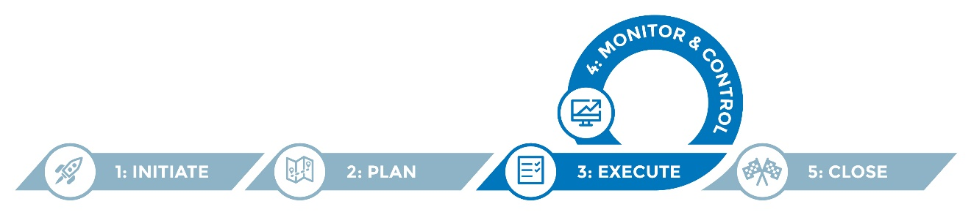

## This form is for documenting any proposed changes to the scope, timeline or budget for a project, including the reasons and impacts if the changes are approved or denied. Such documentation provides formal and rigorous control over changes to a project which otherwise could severely and negatively impact the quality, timeframe and/or cost of project deliverables. Instructions

1. Complete the change request form for any proposed changes that would or might impact the scope, budget and/or timeline of the project.
2. Review/validate the requested change with those most likely to understand the implications/potential impacts of the change. This might include the vendor depending on your change control process.
3. Submit to whomever your project charter or regulations require to review and approve or disapprove the change request. This could be the project sponsor or the project change control team/board.
4. If approved:
   1. Update the project plan(s), schedule and/or budget as appropriate.
   2. File the approved change request form for tracking purposes.

5. If denied:

1. Communicate the decision and rationale to the requestor.
2. Log the decision and rationale for denial to avoid having the same change being re-requested.
3. File the denied change request for reference in the project repository.

## Helpful hints

* This template is intended to serve as a framework for consideration and should be adapted to suit your needs.
* Keep all such change request forms archived in one folder/location and numbered sequentially so that the entire history of change requests can be readily viewed/re-constructed if needed.

# Project Change Request Form

|  |  |  |  |
| --- | --- | --- | --- |
| **Submitted by** | <Name>  <Title> | **Change number** | # |
| **Change title** | **<Title>** | **Date of request** | <date> |

|  |
| --- |
| **Description of change** |
|  |

|  |
| --- |
| Reason for change |
|  |

|  |
| --- |
| Potential impact on schedule/cost |
|  |

|  |
| --- |
| Potential impact on deliverables |
|  |

|  |
| --- |
| Potential impact on organization |
|  |

|  |
| --- |
| Potential impact of *not* approving this change |
|  |

|  |  |  |  |  |
| --- | --- | --- | --- | --- |
| Project sponsor approval/rejection | | | | |
| **☐ Approved** | **Signature:** |  | | |
| **☐ Rejected** | **Title:** |  | **Date:** |  |

|  |
| --- |
| Reason for rejection (if applicable) |
|  |