*H2R: APPLY DATA CLEANING (CLEAN THE DATA)*

“H2R_one_to_many_Cleaning.R” applies the changes proposed in the cleaning log to the raw data and outputs the “cleaned” dataset.

**Proposed H2R folder structure:**

**How to use H2R_one_to_many_Cleaning.R**

1. Change the working directory to the equivalent of the “Data_cleaning” folder
2. Define the uncleaned data as an Excel or .csv, and sheet (if excel).
3. Define the folder where the cleaning log and raw data is stored (“H2R_data”)
4. Define the output folder for the updated data (“updated_data”) and cleaning log (“updated_cleaning_log”).
5. Define the delimiter separating words in the column headers.
6. Define the (if any) alternative ID column (besides the “uuid”).

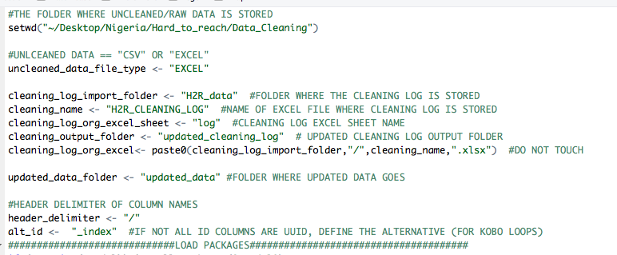

**Select-all and run.**